Diabetes Disease Prediction
Exploratory Data Analysis, Preprocessing, PCA, and Classification Report
UNI: MISR INTERNATIONAL UNIVERSITY
Course: Machine Learning
Instructor: Dr. Manal
Team : Nour Waleed , Hagar Ali: ,
Mohamed Sameh: , Ahmed Khalid: , Abdelrahman:
Item | Value / Notes
Dataset | Diabetes prediction dataset
Target variable | diabetes: 0 = No Diabetes, 1 = Diabetes
Main deliverables | Python pipeline file and written report
Current report status | Filled with EDA, preprocessing, PCA, all available model results, separate model summaries, learning curves, and final model selection from the submitted notebook.

Prepared by: Nour Waleed, Hagar Ali, Mohamed Sameh, Ahmed Khalid, Abdelrahman Emad
Submission date: 18/5/2026

Table of Contents
1. Executive Summary 3
2. Dataset Understanding and EDA 3
2.1 Outlier Analysis 6
Outlier detection code snippet 6
3. Cleaning and Preprocessing 7
Cleaning code snippet 7
4. PCA Dimensionality Reduction 7
5. Implemented Models: Logistic Regression and Random Forest 8
5.1 Logistic Regression Thought Process 8
5.2 Random Forest Thought Process 8
6. Results and PCA Comparison 9
7. Learning Curves 11
8. Placeholder Sections for Teammates 13
MLP 13
Linear SVM 13
RBF / Gaussian SVM with Grid Search 13
RBF / Gaussian SVM with Particle Swarm Optimization 14
Naive Bayes 14
Gradient Boosting 14
AdaBoost / XGBoost 14
9. Final Model Selection Placeholder 14
10. Appendix: Main Code Snippets 15
10.1 Train / Validation / Test Split 15
10.2 Preprocessing Pipeline 15
10.3 Shared Evaluation Function 15

1. Executive Summary
This report summarizes the completed work for the diabetes prediction machine learning assignment. The analysis covers data understanding, preprocessing, PCA, multiple classification models, evaluation metrics, confusion matrices, PCA-vs-no-PCA comparisons, learning curves, and final model selection according to the submitted notebook outputs.
The target variable is diabetes, where 0 means no diabetes and 1 means diabetes. The dataset is imbalanced: the positive diabetes class represents only about 8.82% after cleaning. Because of this, accuracy alone is not enough; sensitivity/recall, precision, F1 score, balanced accuracy, and confusion matrix values are reported.
Metric | Value
Rows | 100,000
Columns | 9
Missing values | 0
Exact duplicate rows | 3,854
Duplicate percentage | 3.854%
Rows after cleaning | 96,128

Dataset Split | No Diabetes | Diabetes
Original dataset | 91.50% | 8.50%
Cleaned dataset | 91.18% | 8.82%
Training set | 91.18% | 8.82%
Validation set | 91.17% | 8.83%
Test set | 91.18% | 8.82%

2. Dataset Understanding and EDA
The EDA phase focused on understanding the shape, missing values, duplicate records, class distribution, categorical feature behavior, numeric feature distributions, and potential outliers.
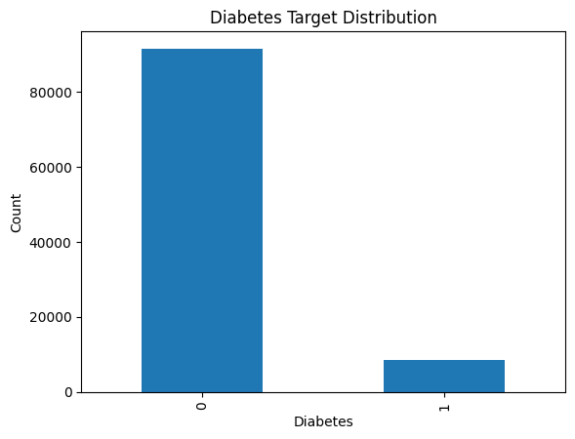
Figure 1. Target distribution showing class imbalance.
Category / Group | Diabetes Rate
Female | 7.9183%
Male | 10.0958%
No Info smoking | 4.3946%
Current smoker | 10.3077%
Ever smoker | 11.8089%
Former smoker | 17.0986%
Never smoker | 9.7020%
Not current smoker | 10.8508%
No hypertension | 7.2135%
Hypertension | 27.9587%
No heart disease | 7.8250%
Heart disease | 32.2967%

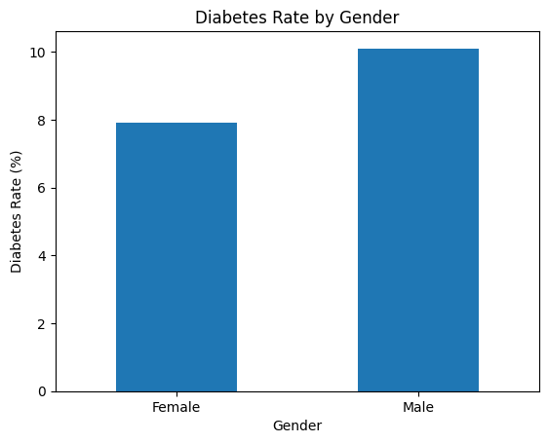 | 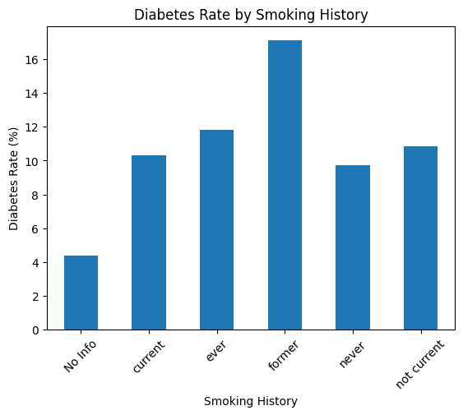
Diabetes rate by gender | Diabetes rate by smoking history

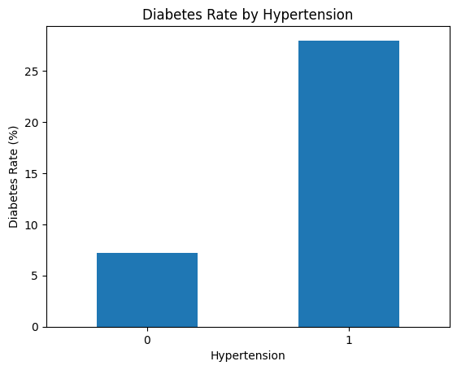 | 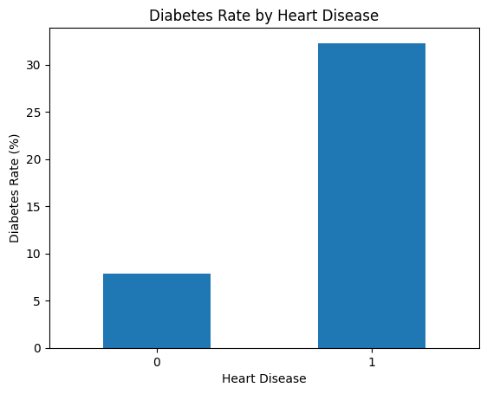
Diabetes rate by hypertension | Diabetes rate by heart disease

Diabetes Status | Mean Age | Mean BMI | Mean HbA1c | Mean Glucose
No diabetes | 39.9454 | 26.8689 | 5.3969 | 132.8171
Diabetes | 60.9260 | 31.9978 | 6.9348 | 194.0262

The strongest visible numeric differences were found in HbA1c level, blood glucose level, and age. BMI also showed a difference, but with more overlap between the classes.
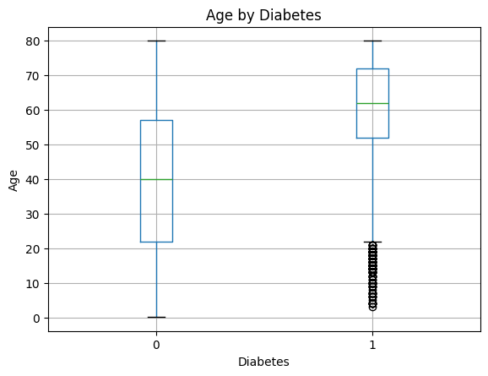 | 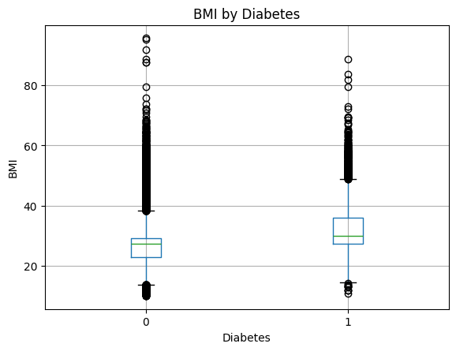
Age by diabetes | BMI by diabetes

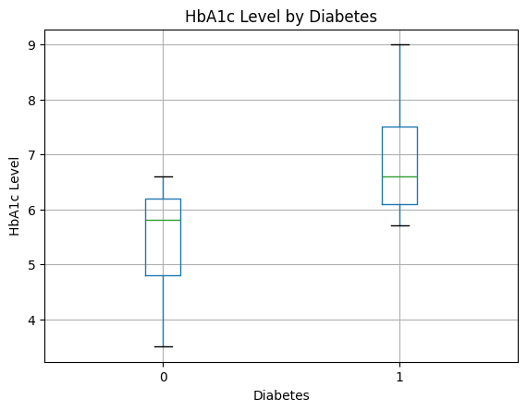 | 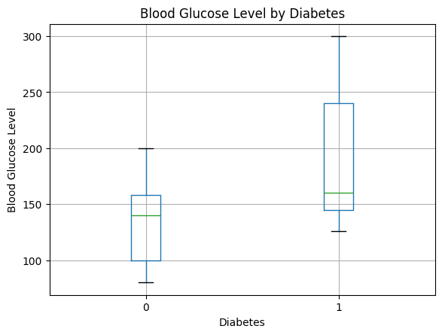
HbA1c level by diabetes | Blood glucose level by diabetes

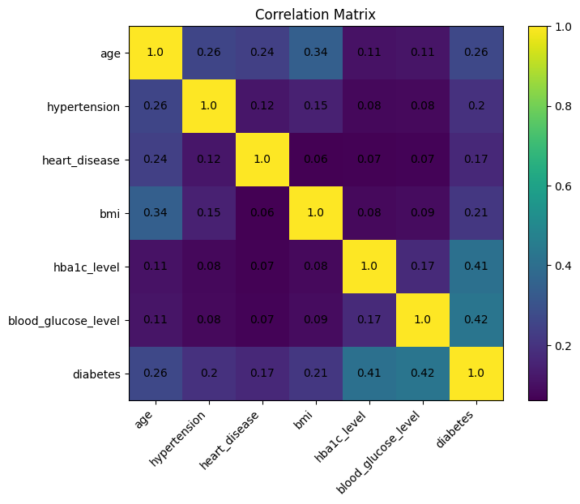
Figure 2. Correlation matrix for numeric variables.

2.1 Outlier Analysis
Outliers were detected using the standard IQR method based on the 25th and 75th percentiles. The medical variables with outliers were retained because extreme BMI, HbA1c, and blood glucose values can represent real high-risk patient conditions rather than data-entry mistakes.
Feature | Outlier Count | Outlier % | Decision
Age | 0 | 0.00% | Kept
BMI | 5,354 | 5.57% | Kept
HbA1c level | 1,312 | 1.36% | Kept
Blood glucose level | 2,031 | 2.11% | Kept

Outlier detection code snippet
numeric_features = ['age', 'bmi', 'hba1c_level', 'blood_glucose_level']
for col in numeric_features:
Q1 = df_clean[col].quantile(0.25)
Q3 = df_clean[col].quantile(0.75)
IQR = Q3 - Q1
lower_limit = Q1 - 1.5 * IQR
upper_limit = Q3 + 1.5 * IQR
outliers = df_clean[(df_clean[col] < lower_limit) | (df_clean[col] > upper_limit)]
print(col)
print('Lower limit:', lower_limit)
print('Upper limit:', upper_limit)
print('Number of outliers:', len(outliers))
print('Outlier percentage:', len(outliers) / len(df_clean) * 100)
print()

3. Cleaning and Preprocessing
The cleaning decisions were conservative. Exact duplicate rows were removed. The rare gender category Other was removed because it contained only 18 rows and no diabetes-positive examples. The No Info category in smoking_history was kept because it represented a large part of the dataset and deleting it would remove too much data.
Preprocessing Item | Value
Train rows | 57,676
Validation rows | 19,226
Test rows | 19,226
Original feature count | 8
Processed feature count | 14
PCA components | 8
PCA variance retained | 95.8565%

Cleaning code snippet
df.columns = df.columns.str.lower().str.strip()
# Create cleaning copy
df_clean = df.copy()
# Remove exact duplicate rows
df_clean = df_clean.drop_duplicates()
# Remove extremely rare gender category for this academic experiment
df_clean = df_clean[df_clean['gender'] != 'Other']
df_clean = df_clean.reset_index(drop=True)
df_clean.shape
df_clean.duplicated().sum()
df_clean['diabetes'].value_counts(normalize=True) * 100

The dataset was split into training, validation, and test sets using stratification to preserve the diabetes class ratio across all splits. Numerical features were scaled, categorical features were one-hot encoded, and binary indicators were passed through unchanged.

4. PCA Dimensionality Reduction
PCA was applied after preprocessing because PCA requires fully numeric input. The PCA version kept 95% of the variance. This reduced the processed feature space from 14 features to 8 principal components while retaining about 95.86% of the variance.
pca = PCA(n_components=0.95, random_state=42)

X_train_pca = pca.fit_transform(X_train_processed)
X_val_pca = pca.transform(X_val_processed)
X_test_pca = pca.transform(X_test_processed)

print("Original number of features:", X_train_processed.shape[1])
print("Number of PCA components:", pca.n_components_)
print("Explained variance ratio:", pca.explained_variance_ratio_.sum())

5. Implemented Classification Models
The implemented models include Logistic Regression, MLP, Linear SVM, RBF/Gaussian SVM, Naive Bayes, Random Forest, Gradient Boosting, AdaBoost, and XGBoosting. Where available in the notebook, each model was evaluated with and without PCA. Hyperparameter tuning was performed using GridSearchCV for several models, and PSO was used for the RBF SVM hyperparameter search as required.
Model | PCA | Best Hyperparameters / Setting | CV / Search Score Recorded
Logistic Regression | No | C=0.01, penalty='l2', solver='lbfgs', class_weight='balanced' | GridSearchCV balanced accuracy: 0.8876
MLP | No | activation='tanh', alpha=0.01, hidden_layer_sizes=(100, 50), learning_rate_init=0.01 | GridSearchCV score printed: 0.9062
Linear SVM | No | kernel='linear', C=1, class_weight='balanced' | No GridSearchCV score shown
RBF SVM Basic | No | kernel='rbf', C=1, gamma='scale', class_weight='balanced' | Baseline setting
RBF SVM Grid Search | No | kernel='rbf', C=1, gamma='scale' | GridSearchCV score: 0.9033
RBF SVM PSO | No | C=33.9269, gamma=0.6876 | Best PSO F1: 0.6189
Naive Bayes | No | GaussianNB(var_smoothing=3.16e-02) | GridSearchCV score printed: 80.23%
Random Forest | No | n_estimators=100, max_depth=10, min_samples_split=5, min_samples_leaf=2 | GridSearchCV balanced accuracy: 0.9076
Gradient Boosting | No | n_estimators=200, learning_rate=0.1, max_depth=5, subsample=0.8 | GridSearchCV balanced accuracy: 0.8449
AdaBoost | No | n_estimators=100, learning_rate=1.0, estimator max_depth=3, min_samples_split=2 | GridSearchCV score printed: 0.9144
XGBoosting | No | n_estimators=300, learning_rate=0.05, max_depth=3, scale_pos_weight used | GridSearchCV score printed: 91.44%
Logistic Regression | Yes | C=0.01, penalty='l2', solver='lbfgs', class_weight='balanced' | GridSearchCV balanced accuracy: 0.8837
MLP | Yes | activation='tanh', alpha=0.01, hidden_layer_sizes=(50, 25), learning_rate_init=0.001 | GridSearchCV balanced accuracy: 0.9058
Linear SVM | Yes | kernel='linear', C=1, class_weight='balanced' | No GridSearchCV score shown
RBF SVM Grid Search | Yes | kernel='rbf', C=1, gamma='scale' from non-PCA grid params | No PCA-specific grid score shown
Naive Bayes | Yes | GaussianNB(var_smoothing=3.16e-05) | GridSearchCV score printed: 77.39%
Random Forest | Yes | n_estimators=100, max_depth=10, min_samples_split=2, min_samples_leaf=2 | GridSearchCV balanced accuracy: 0.8893
Gradient Boosting | Yes | n_estimators=200, learning_rate=0.1, max_depth=5, subsample=1.0 | GridSearchCV balanced accuracy: 0.8316
AdaBoost | Yes | n_estimators=200, learning_rate=1.0, estimator max_depth=3, min_samples_split=10 | GridSearchCV balanced accuracy: 0.8982
XGBoosting | Yes | n_estimators=300, learning_rate=0.1, max_depth=3, scale_pos_weight used | GridSearchCV score printed: 90.29%

5.1 Logistic Regression Thought Process
Logistic Regression was used as a simple and interpretable baseline classifier. Because the dataset is imbalanced, class_weight="balanced" was used to reduce the risk of the model ignoring the minority diabetes class. The C parameter was tuned because it controls regularization strength.
log_reg = LogisticRegression(
max_iter=1000,
class_weight="balanced",
random_state=42
)

log_reg_param_grid = {
"C": [0.01, 0.1, 1, 10, 100],
"penalty": ["l2"],
"solver": ["lbfgs"]
}

log_reg_grid = GridSearchCV(
estimator=log_reg,
param_grid=log_reg_param_grid,
scoring="f1",
cv=5,
n_jobs=-1
)

5.2 Random Forest Thought Process
Random Forest was used as an ensemble model that can capture nonlinear relationships and feature interactions. The tuned parameters controlled the number of trees and the complexity of each tree. In the final notebook outputs, Random Forest showed strong balanced accuracy and sensitivity, while Gradient Boosting achieved stronger F1 and XGBoosting was selected by the final selection code.
rf = RandomForestClassifier(
class_weight="balanced",
random_state=42,
n_jobs=-1
)

rf_param_grid = {
"n_estimators": [100, 200],
"max_depth": [None, 10, 20],
"min_samples_split": [2, 5],
"min_samples_leaf": [1, 2]
}

rf_grid = GridSearchCV(
estimator=rf,
param_grid=rf_param_grid,
scoring="f1",
cv=3,
n_jobs=-1
)

6. Results and PCA Comparison
The tables below show the available validation and test performance outputs extracted from the submitted notebook. Models are compared using accuracy, balanced accuracy, precision, sensitivity/recall, F1 score, and confusion matrix values. Balanced accuracy is especially important because the dataset is imbalanced.
Table legend: LR = Logistic Regression; RF = Random Forest; GB = Gradient Boosting; XGB = XGBoosting.
Model | PCA | TN | FP | FN | TP | Accuracy | Balanced Acc. | Precision | Sensitivity | F1
LR | No | 15499 | 2030 | 208 | 1489 | 0.8836 | 0.8808 | 0.4231 | 0.8774 | 0.5709
MLP | No | 16411 | 1118 | 245 | 1452 | 0.9291 | 0.8959 | 0.5650 | 0.8556 | 0.6806
Linear SVM | No | 15476 | 2053 | 208 | 1489 | 0.8824 | 0.8802 | 0.4204 | 0.8774 | 0.5684
RBF SVM Basic | No | 15537 | 1992 | 154 | 1543 | 0.8884 | 0.8978 | 0.4365 | 0.9093 | 0.5898
RBF SVM Grid | No | 15537 | 1992 | 154 | 1543 | 0.8884 | 0.8978 | 0.4365 | 0.9093 | 0.5898
RBF SVM PSO | No | 16184 | 1345 | 332 | 1365 | 0.9128 | 0.8638 | 0.5037 | 0.8044 | 0.6195
Naive Bayes | No | 16705 | 824 | 585 | 1112 | 0.9267 | 0.8041 | 0.5744 | 0.6553 | 0.6122
RF | No | 15843 | 1686 | 160 | 1537 | 0.9040 | 0.9048 | 0.4769 | 0.9057 | 0.6248
GB | No | 17477 | 52 | 532 | 1165 | 0.9696 | 0.8418 | 0.9573 | 0.6865 | 0.7996
AdaBoost | No | 15819 | 1710 | 147 | 1550 | 0.9034 | 0.9079 | 0.4755 | 0.9134 | 0.6254
XGB | No | 16257 | 1272 | 239 | 1458 | 0.9214 | 0.8933 | 0.5341 | 0.8592 | 0.6587
LR | Yes | 15453 | 2076 | 205 | 1492 | 0.8814 | 0.8804 | 0.4182 | 0.8792 | 0.5668
MLP | Yes | 15688 | 1841 | 156 | 1541 | 0.8961 | 0.9015 | 0.4556 | 0.9081 | 0.6068
Linear SVM | Yes | NA | NA | NA | NA | NA | NA | NA | NA | NA
RBF SVM Grid | Yes | NA | NA | NA | NA | NA | NA | NA | NA | NA
Naive Bayes | Yes | 17360 | 169 | 785 | 912 | 0.9504 | 0.7639 | 0.8437 | 0.5374 | 0.6566
RF | Yes | 15903 | 1626 | 235 | 1462 | 0.9032 | 0.8844 | 0.4734 | 0.8615 | 0.6111
GB | Yes | 17453 | 76 | 578 | 1119 | 0.9660 | 0.8275 | 0.9364 | 0.6594 | 0.7739
AdaBoost | Yes | 15620 | 1909 | 169 | 1528 | 0.8919 | 0.8958 | 0.4446 | 0.9004 | 0.5952
XGB | Yes | 15648 | 1881 | 165 | 1532 | 0.8936 | 0.8977 | 0.4489 | 0.9028 | 0.5996

Model | PCA | TN | FP | FN | TP | Accuracy | Balanced Acc. | Precision | Sensitivity | F1
LR | No | 15539 | 1991 | 214 | 1482 | 0.8853 | 0.8801 | 0.4267 | 0.8738 | 0.5734
MLP | No | 16347 | 1183 | 248 | 1448 | 0.9256 | 0.8931 | 0.5504 | 0.8538 | 0.6693
Linear SVM | No | 15534 | 1996 | 206 | 1490 | 0.8855 | 0.8823 | 0.4274 | 0.8785 | 0.5751
RBF SVM Basic | No | 15514 | 2016 | 152 | 1544 | 0.8872 | 0.8977 | 0.4337 | 0.9104 | 0.5875
RBF SVM Grid | No | 15514 | 2016 | 152 | 1544 | 0.8872 | 0.8977 | 0.4337 | 0.9104 | 0.5875
RBF SVM PSO | No | 16158 | 1372 | 351 | 1345 | 0.9104 | 0.8574 | 0.4950 | 0.7930 | 0.6096
Naive Bayes | No | NA | NA | NA | NA | NA | NA | NA | NA | NA
RF | No | 15815 | 1715 | 167 | 1529 | 0.9021 | 0.9019 | 0.4713 | 0.9015 | 0.6190
GB | No | 17464 | 66 | 508 | 1188 | 0.9701 | 0.8484 | 0.9474 | 0.7005 | 0.8054
AdaBoost | No | 15807 | 1723 | 157 | 1539 | 0.9022 | 0.9046 | 0.4718 | 0.9074 | 0.6208
XGB Grid output | No | 15790 | 1740 | 142 | 1554 | 0.9021 | 0.9085 | 0.4718 | 0.9163 | 0.6228
XGB final selected | No | 16219 | 1311 | 227 | 1469 | 0.9200 | 0.8957 | 0.5284 | 0.8662 | 0.6564
LR | Yes | 15496 | 2034 | 212 | 1484 | 0.8832 | 0.8795 | 0.4218 | 0.8750 | 0.5692
MLP | Yes | 15701 | 1829 | 173 | 1523 | 0.8959 | 0.8968 | 0.4544 | 0.8980 | 0.6034
Linear SVM | Yes | 15436 | 2094 | 205 | 1491 | 0.8804 | 0.8798 | 0.4159 | 0.8791 | 0.5647
RBF SVM Grid | Yes | 15341 | 2189 | 144 | 1552 | 0.8787 | 0.8951 | 0.4149 | 0.9151 | 0.5709
Naive Bayes | Yes | NA | NA | NA | NA | NA | NA | NA | NA | NA
RF | Yes | 15912 | 1618 | 227 | 1469 | 0.9040 | 0.8869 | 0.4759 | 0.8662 | 0.6143
GB | Yes | 17455 | 75 | 546 | 1150 | 0.9677 | 0.8369 | 0.9388 | 0.6781 | 0.7874
AdaBoost | Yes | 15617 | 1913 | 188 | 1508 | 0.8907 | 0.8900 | 0.4408 | 0.8892 | 0.5894
XGB | Yes | NA | NA | NA | NA | NA | NA | NA | NA | NA

Current observation from the notebook outputs: the final selection code selected XGBoosting without PCA using Balanced Accuracy. Gradient Boosting without PCA achieved the highest test F1 score among the recorded test outputs, while several models such as XGBoosting, AdaBoost, and Random Forest had stronger balanced-accuracy/sensitivity tradeoffs. PCA did not consistently improve performance across all models.
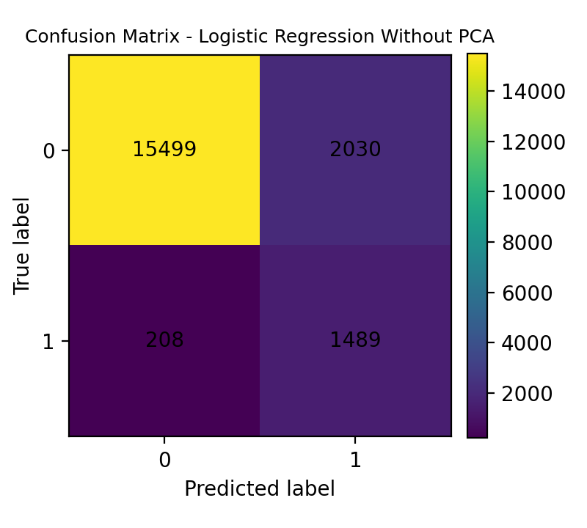 | 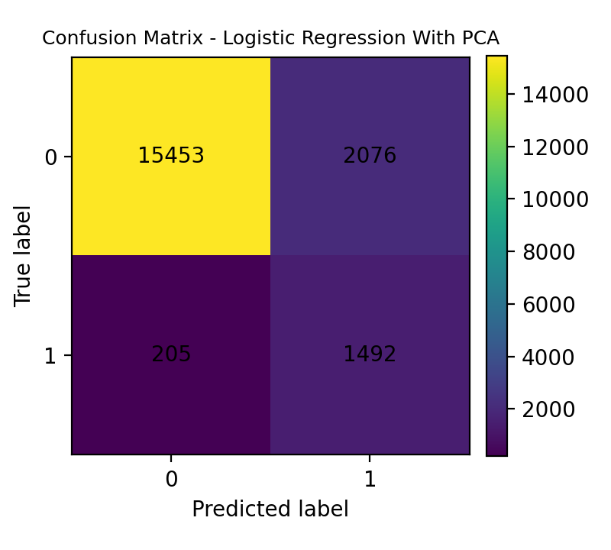
Logistic Regression without PCA | Logistic Regression with PCA

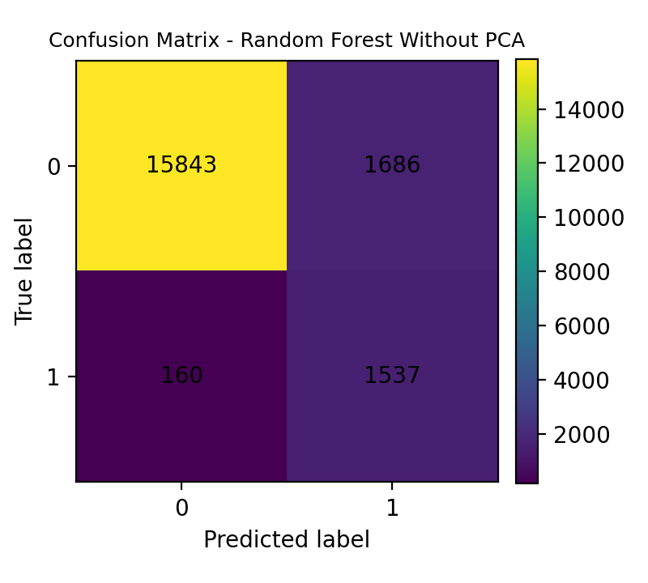 | 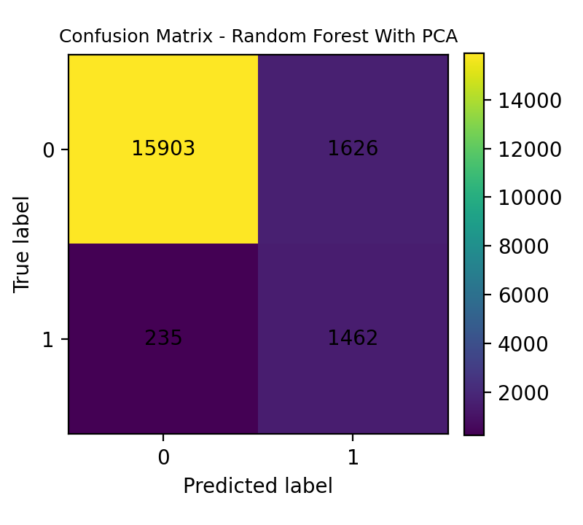
Random Forest without PCA | Random Forest with PCA

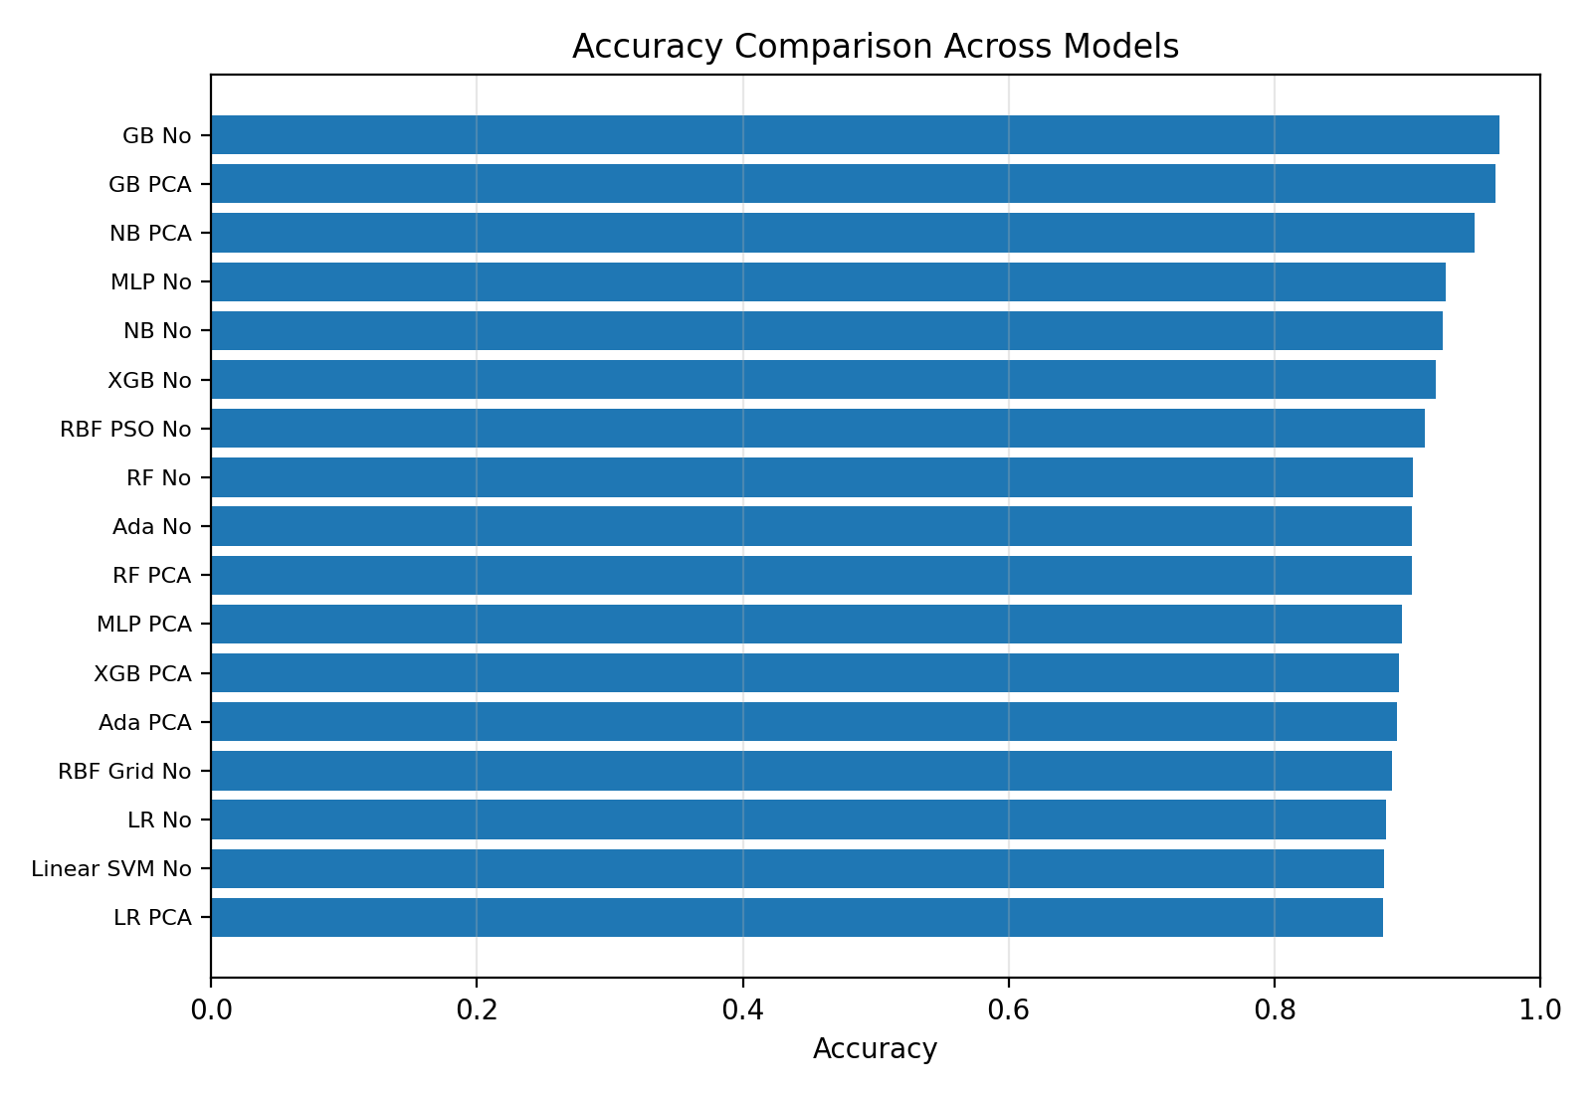 | 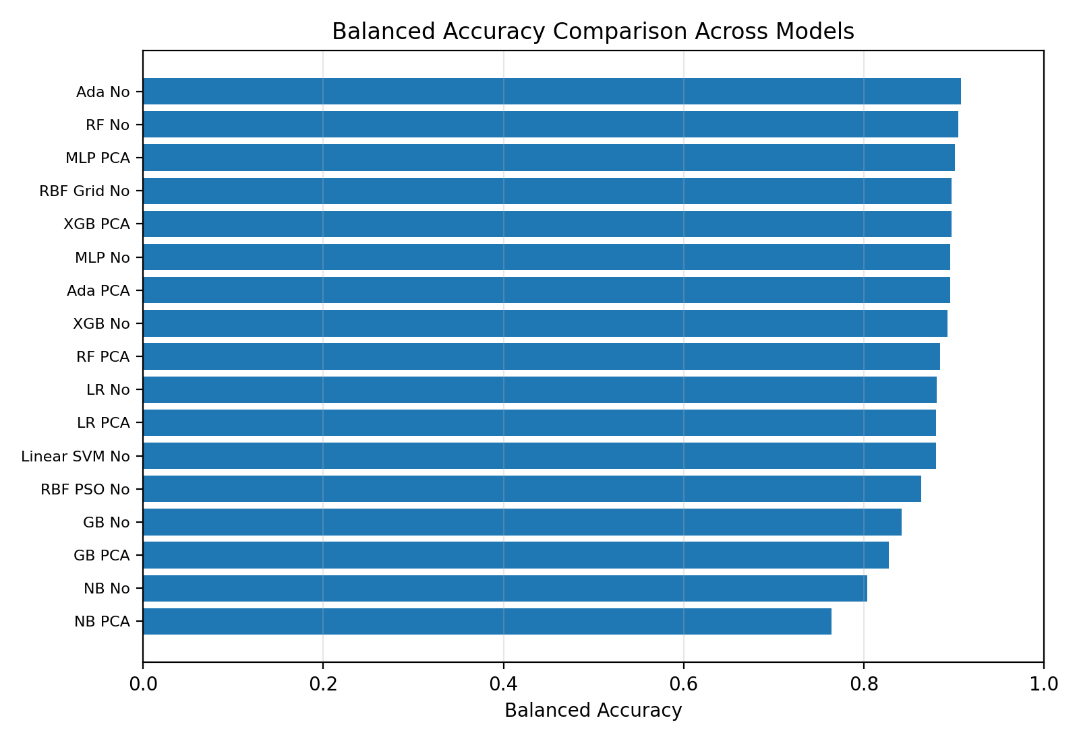
Accuracy comparison | Balanced accuracy comparison

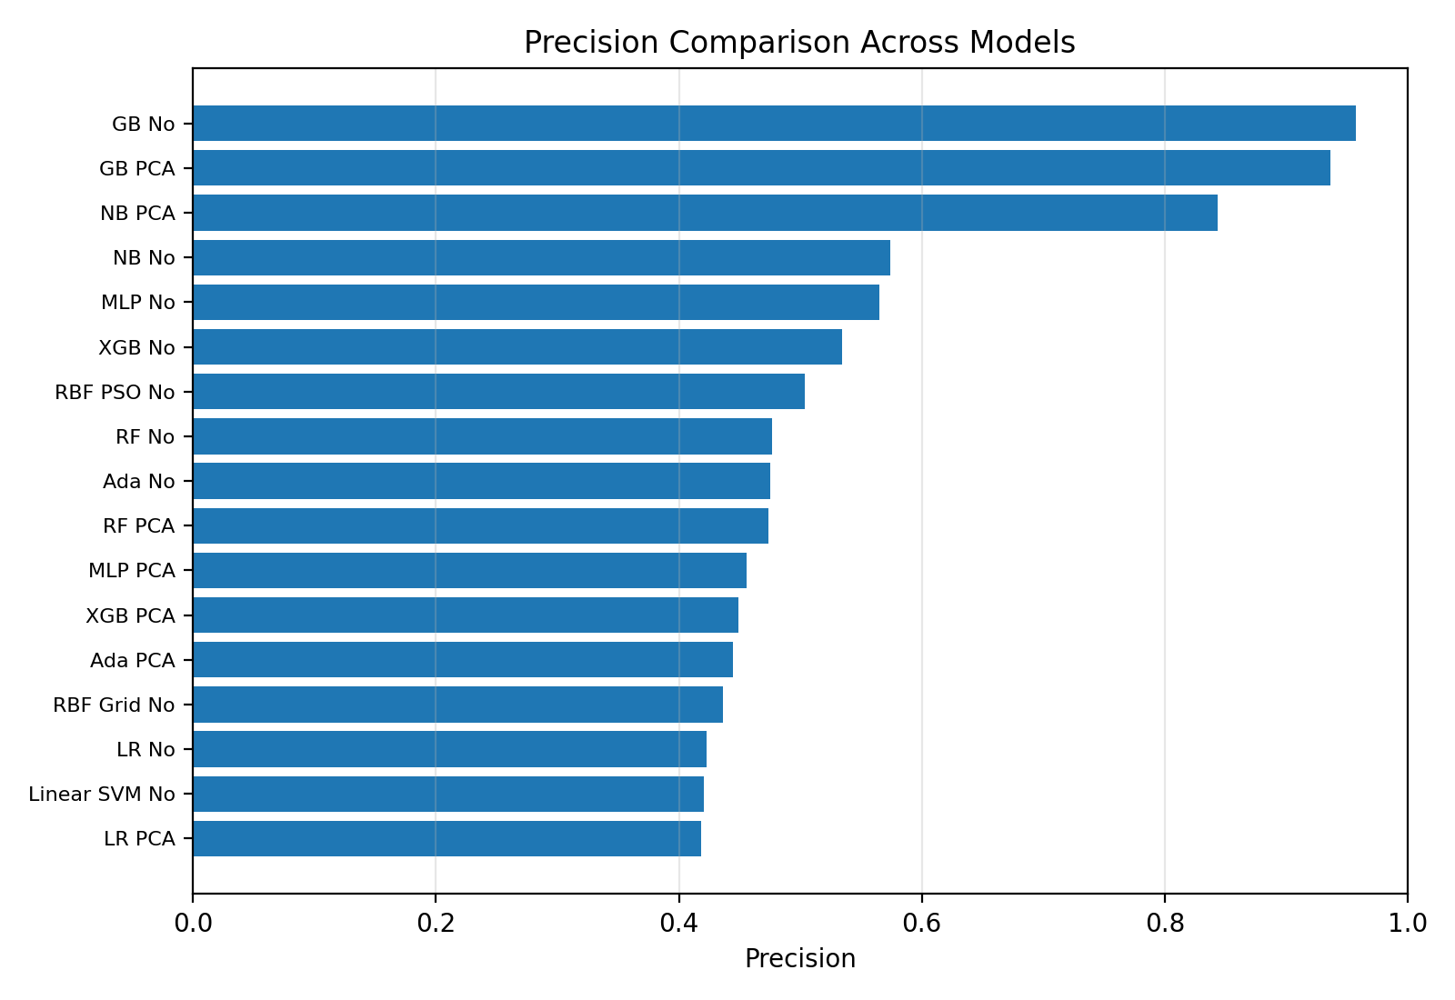 | 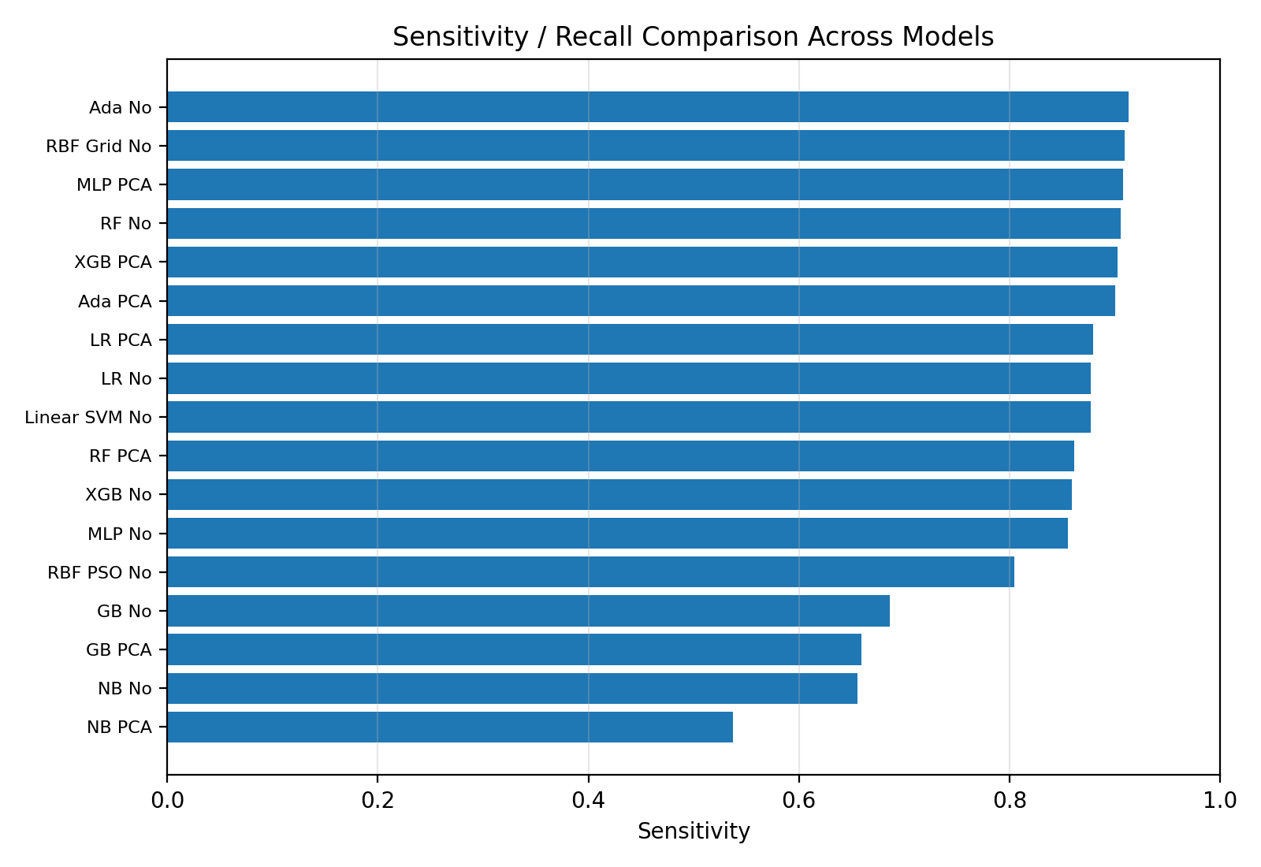
Precision comparison | Sensitivity comparison

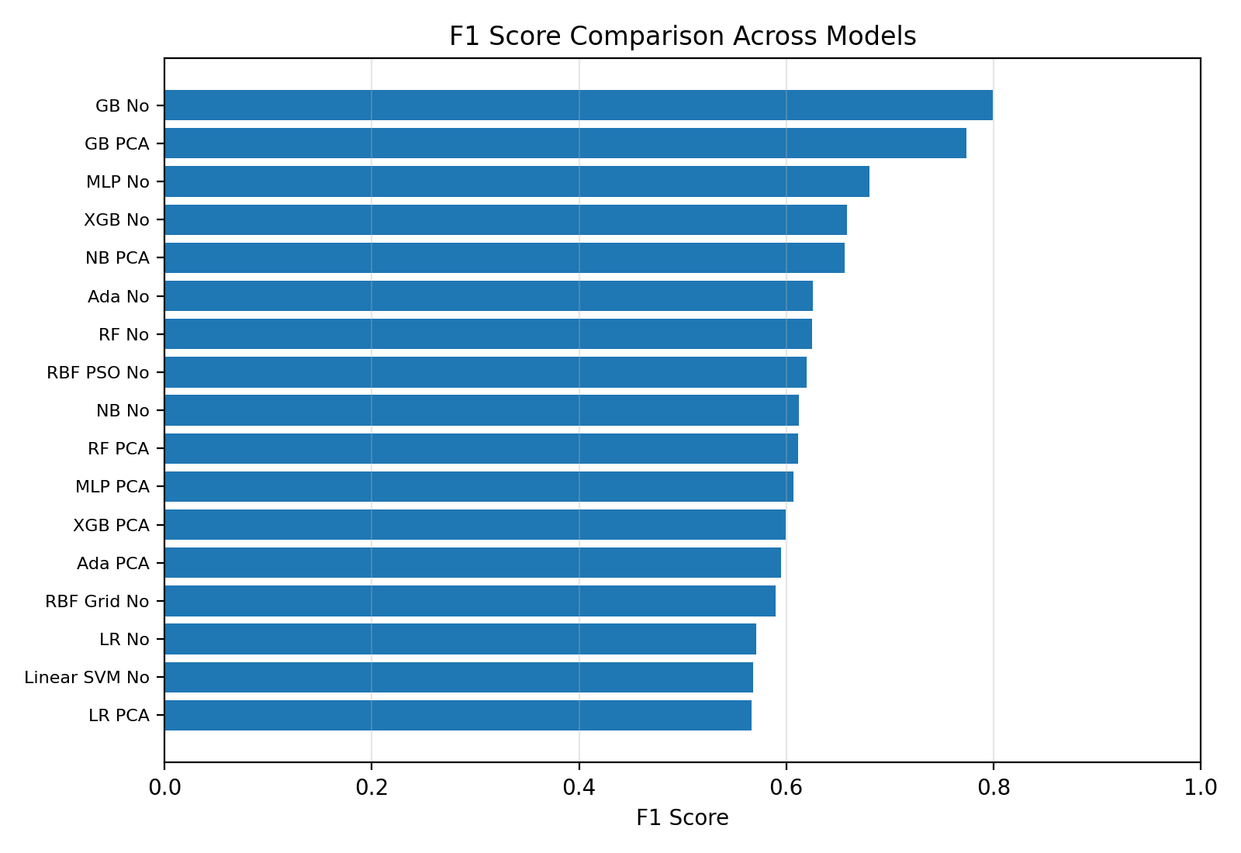
F1 score comparison with and without PCA.

7. Learning Curves
The learning curve plots show training and validation performance as the training data size increases. Accuracy and F1 score were plotted because the assignment requires two key learning metrics and the dataset is imbalanced.
def plot_learning_curve(model, model_name, X_train_data, y_train_data, X_val_data, y_val_data):
train_sizes = [0.1, 0.25, 0.5, 0.75, 1.0]
train_acc_scores, val_acc_scores = [], []
train_f1_scores, val_f1_scores = [], []

for size in train_sizes:
sample_size = int(len(X_train_data) * size)
X_subset = X_train_data[:sample_size]
y_subset = y_train_data.iloc[:sample_size]
model_copy = clone(model)
model_copy.fit(X_subset, y_subset)
y_train_pred = model_copy.predict(X_subset)
y_val_pred = model_copy.predict(X_val_data)
train_acc_scores.append(accuracy_score(y_subset, y_train_pred))
val_acc_scores.append(accuracy_score(y_val_data, y_val_pred))
train_f1_scores.append(f1_score(y_subset, y_train_pred, zero_division=0))
val_f1_scores.append(f1_score(y_val_data, y_val_pred, zero_division=0))

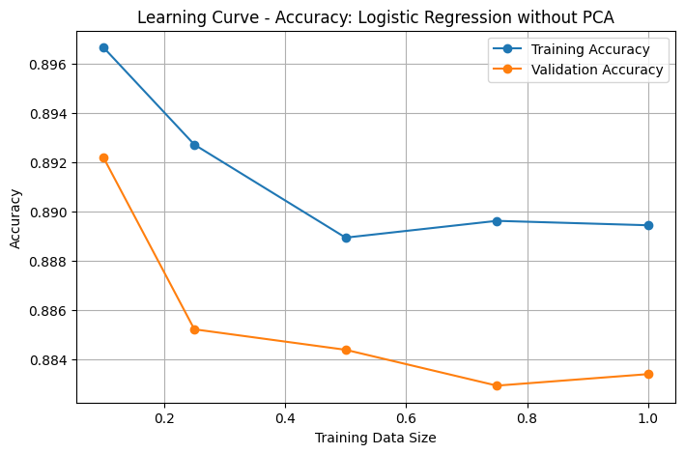 | 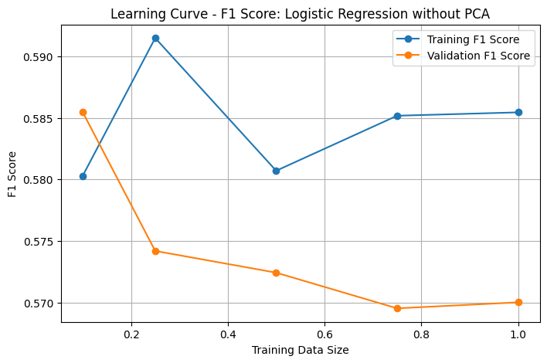
Learning curve accuracy: Logistic Regression without PCA | Learning curve F1: Logistic Regression without PCA

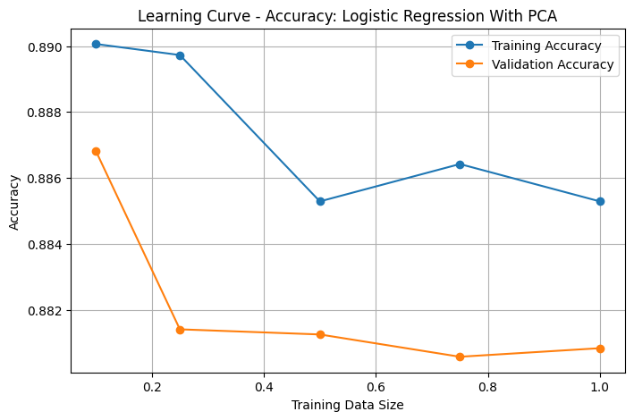 | 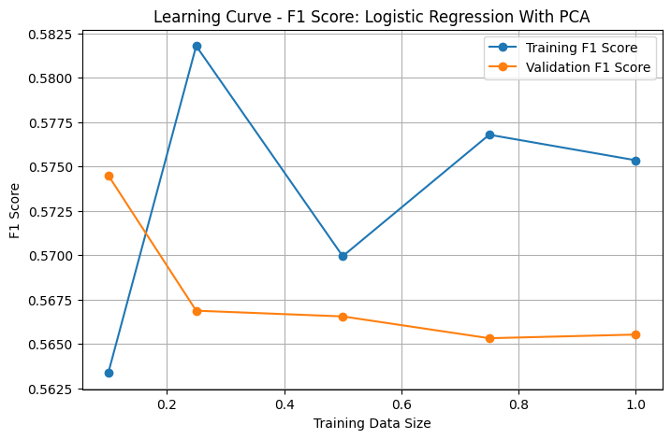
Learning curve accuracy: Logistic Regression with PCA | Learning curve F1: Logistic Regression with PCA

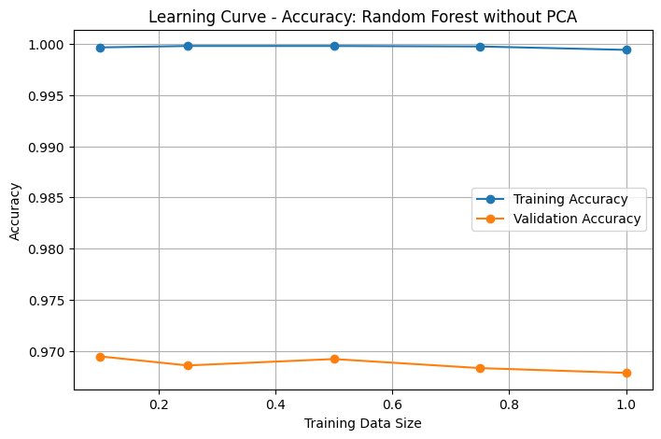 | 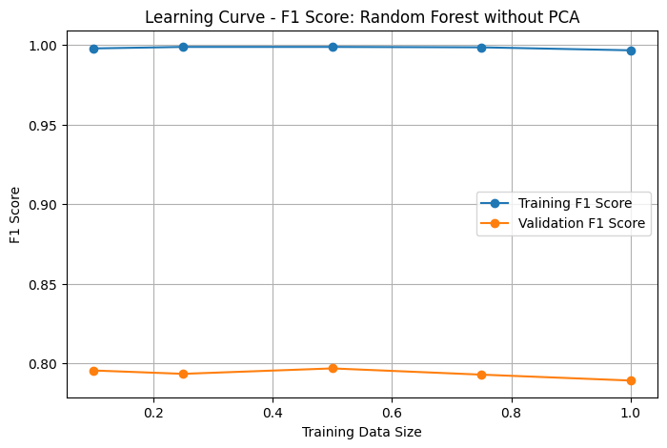
Learning curve accuracy: Random Forest without PCA | Learning curve F1: Random Forest without PCA

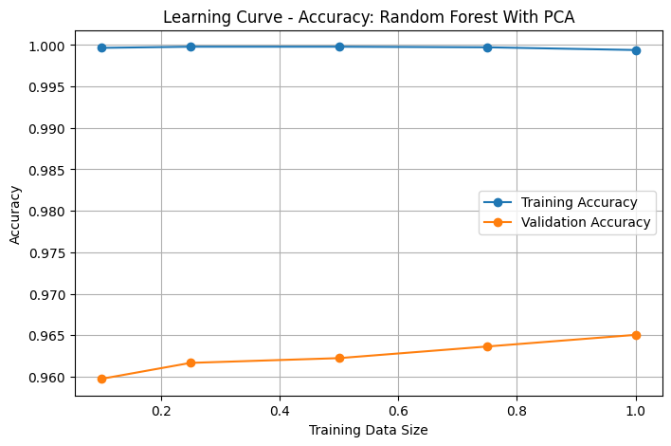 | 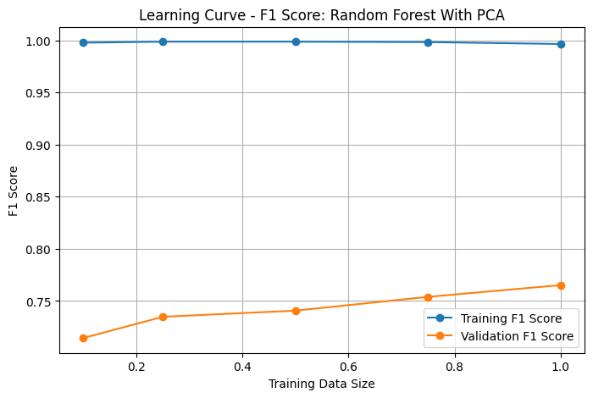
Learning curve accuracy: Random Forest with PCA | Learning curve F1: Random Forest with PCA

8. Additional Implemented Model Sections
The following sections summarize the remaining implemented models using the hyperparameters, metrics, and outputs available in the submitted notebook. Each model is discussed separately as far as the provided report layout allows.

MLP
Filled from submitted notebook output.
Item | Details
Preprocessing used | Processed features without PCA and PCA-transformed features. Scaling and one-hot encoding were already applied before the MLP pipeline.
Hyperparameters / tuning | GridSearchCV with MLPClassifier. No PCA best params: activation='tanh', alpha=0.01, hidden_layer_sizes=(100, 50), learning_rate_init=0.01. PCA best params: activation='tanh', alpha=0.01, hidden_layer_sizes=(50, 25), learning_rate_init=0.001.
PCA version tested? | Yes. No-PCA and PCA versions were both implemented.
Validation metrics | No PCA: Accuracy=0.9291, Balanced Acc.=0.8959, Precision=0.5650, Sensitivity=0.8556, F1=0.6806. With PCA: Accuracy=0.8961, Balanced Acc.=0.9015, Precision=0.4556, Sensitivity=0.9081, F1=0.6068.
Test metrics, if required | No PCA: Accuracy=0.9256, Balanced Acc.=0.8931, Precision=0.5504, Sensitivity=0.8538, F1=0.6693. With PCA: Accuracy=0.8959, Balanced Acc.=0.8968, Precision=0.4544, Sensitivity=0.8980, F1=0.6034.
Graphs / learning curve | Confusion matrices and learning curves were generated for MLP without PCA and with PCA in the notebook.
Short interpretation | The MLP without PCA achieved stronger F1 and accuracy, while the PCA version increased sensitivity but reduced precision and F1.
MLP graphs
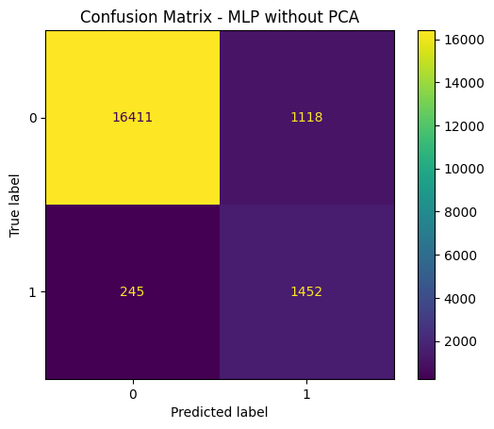  Confusion Matrix - MLP without PCA | 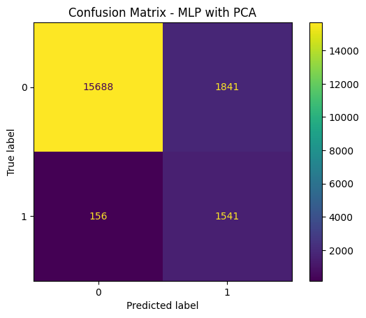  Confusion Matrix - MLP with PCA
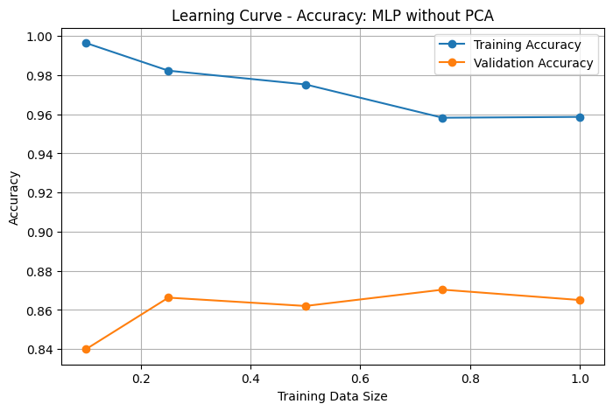  Learning Curve Accuracy - MLP without PCA | 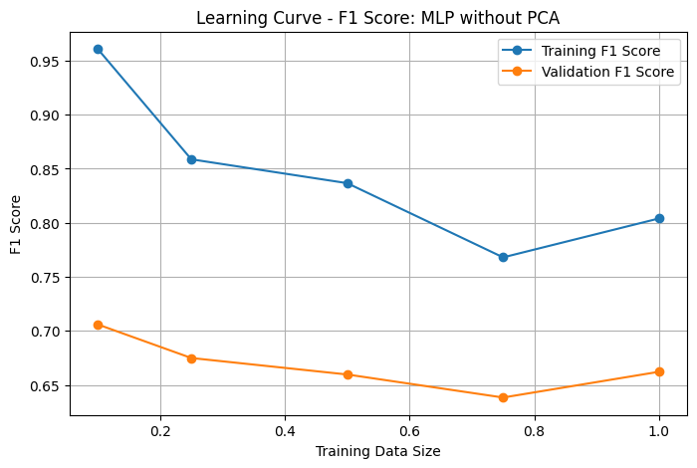  Learning Curve F1 - MLP without PCA
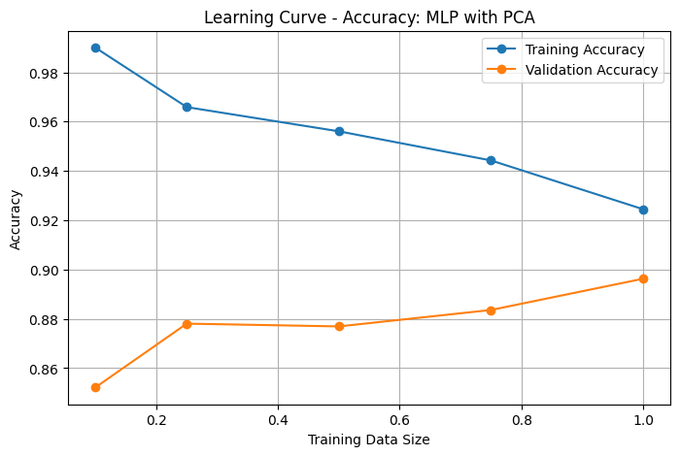  Learning Curve Accuracy - MLP with PCA | 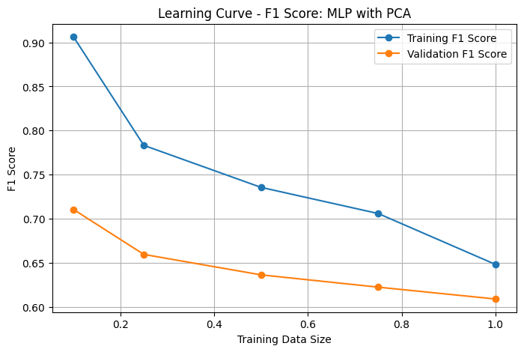  Learning Curve F1 - MLP with PCA
Graphs inserted from the submitted notebook output. Missing graph types are not fabricated.

Linear SVM
Filled from submitted notebook output.
Item | Details
Preprocessing used | Standard processed features for no-PCA Linear SVM; PCA-transformed features for the PCA version.
Hyperparameters / tuning | SVC(kernel='linear', C=1, class_weight='balanced', random_state=42). No GridSearchCV output was shown for Linear SVM.
PCA version tested? | Yes. No-PCA test output and PCA test output were available; no PCA validation output was printed for Linear SVM with PCA.
Validation metrics | Without PCA validation: Accuracy=0.8824, Balanced Acc.=0.8802, Precision=0.4204, Sensitivity=0.8774, F1=0.5684. With PCA validation: NA in notebook output.
Test metrics, if required | Without PCA test: Accuracy=0.8855, Balanced Acc.=0.8823, Precision=0.4274, Sensitivity=0.8785, F1=0.5751. With PCA test: Accuracy=0.8804, Balanced Acc.=0.8798, Precision=0.4159, Sensitivity=0.8791, F1=0.5647.
Graphs / learning curve | Confusion matrix and learning curve were generated for Linear SVM. PCA confusion matrix was generated on the test set.
Short interpretation | Linear SVM behaved similarly to Logistic Regression, with high sensitivity but low precision due to many false positives.
Linear SVM graphs
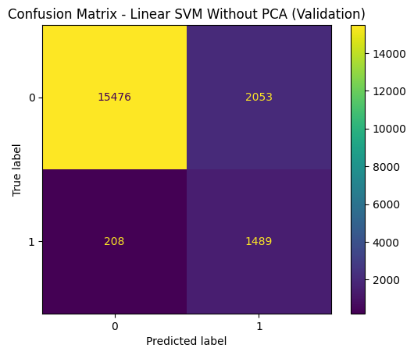  Confusion Matrix - Linear SVM without PCA (Validation) | 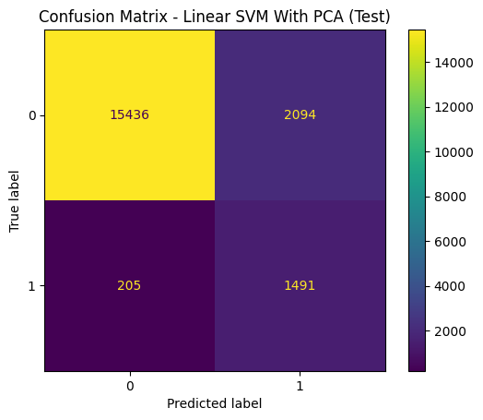  Confusion Matrix - Linear SVM with PCA (Test output in notebook)
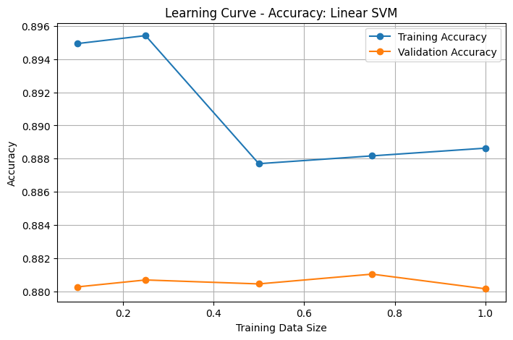  Learning Curve Accuracy - Linear SVM without PCA | 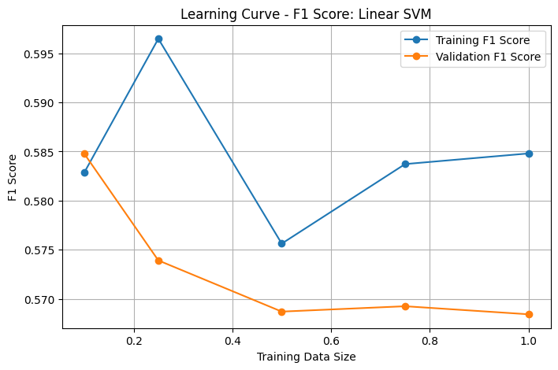  Learning Curve F1 - Linear SVM without PCA
Graphs inserted from the submitted notebook output. Missing graph types are not fabricated.

RBF / Gaussian SVM with Grid Search
Filled from submitted notebook output.
Item | Details
Preprocessing used | Processed features without PCA for Grid Search. PCA-transformed features were also evaluated using the selected grid parameters.
Hyperparameters / tuning | GridSearchCV on RBF SVM using C=[0.1, 1, 10, 100] and gamma=[0.001, 0.01, 0.1, 1, 'scale']. Best parameters: C=1, gamma='scale'. Best Grid Search CV score: 0.9033.
PCA version tested? | Yes. No-PCA RBF Grid Search was evaluated on validation and test. PCA RBF Grid Search was evaluated on test using the selected parameters.
Validation metrics | Without PCA validation: Accuracy=0.8884, Balanced Acc.=0.8978, Precision=0.4365, Sensitivity=0.9093, F1=0.5898. With PCA validation: NA in notebook output.
Test metrics, if required | Without PCA test: Accuracy=0.8872, Balanced Acc.=0.8977, Precision=0.4337, Sensitivity=0.9104, F1=0.5875. With PCA test: Accuracy=0.8787, Balanced Acc.=0.8951, Precision=0.4149, Sensitivity=0.9151, F1=0.5709.
Graphs / learning curve | Confusion matrices and learning curves were generated for RBF SVM Grid Search without PCA and with PCA.
Short interpretation | The grid search selected the same parameters as the basic RBF setup (C=1, gamma='scale'), so the no-PCA grid results matched the basic RBF SVM results.
RBF / Gaussian SVM with Grid Search graphs
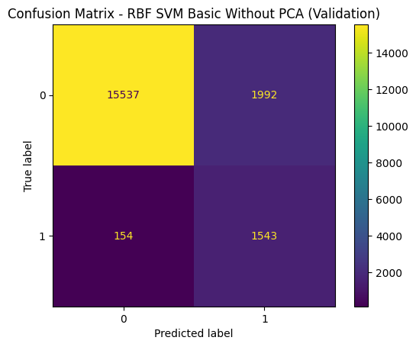  Confusion Matrix - RBF SVM Basic without PCA | 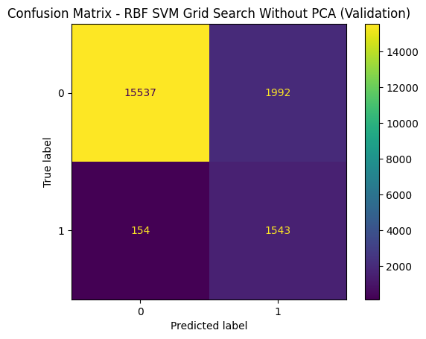  Confusion Matrix - RBF SVM Grid Search without PCA
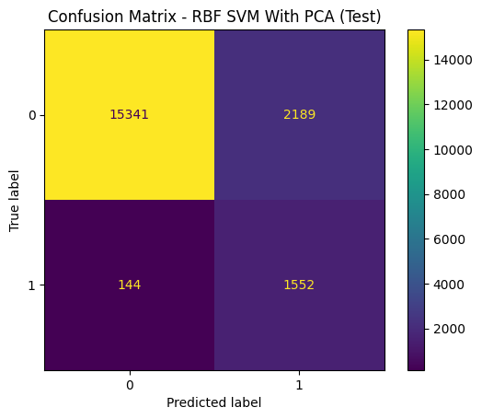  Confusion Matrix - RBF SVM with PCA (Test output in notebook) | 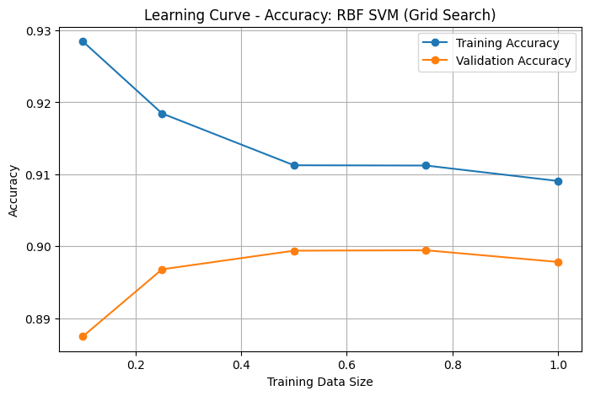  Learning Curve Accuracy - RBF SVM Grid Search
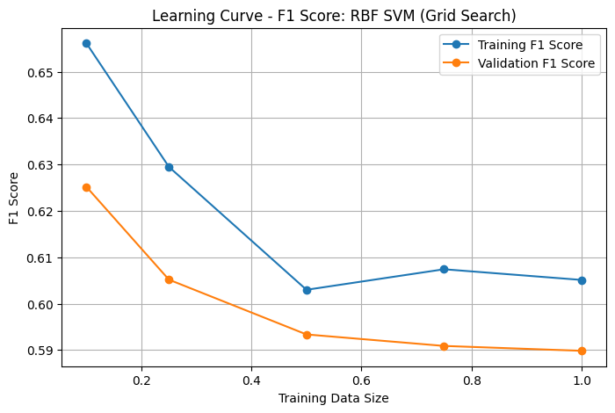  Learning Curve F1 - RBF SVM Grid Search | 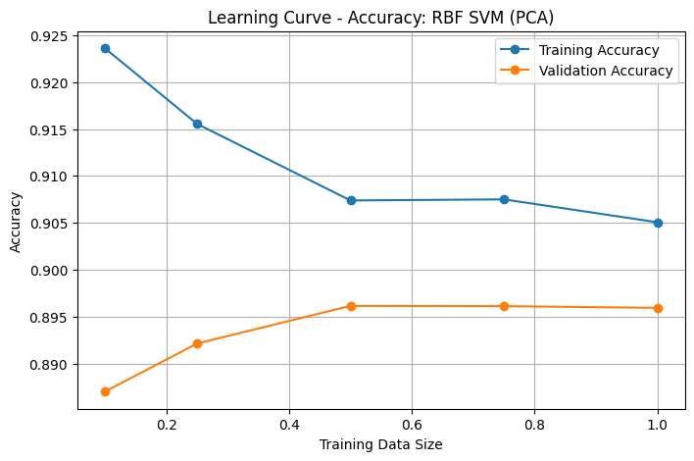  Learning Curve Accuracy - RBF SVM with PCA
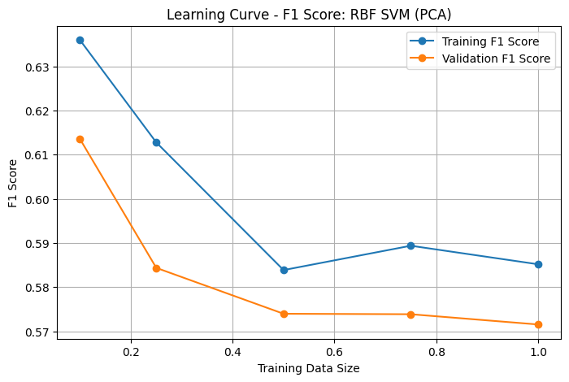
Learning Curve F1 - RBF SVM with PCA
Graphs inserted from the submitted notebook output. Missing graph types are not fabricated.

RBF / Gaussian SVM with Particle Swarm Optimization
Filled from submitted notebook output.
Item | Details
Preprocessing used | Processed features without PCA. PSO used sampled training and validation subsets for optimization, then the final RBF SVM was trained on the full processed training set.
Hyperparameters / tuning | Particle Swarm Optimization searched C and gamma. Bounds: C from 0.1 to 100, gamma from 0.0001 to 1. Best PSO C=33.9269, gamma=0.6876, Best PSO F1=0.6189.
PCA version tested? | No PCA PSO version was shown in the notebook. PCA PSO version was not shown.
Validation metrics | Accuracy=0.9128, Balanced Acc.=0.8638, Precision=0.5037, Sensitivity=0.8044, F1=0.6195.
Test metrics, if required | Accuracy=0.9104, Balanced Acc.=0.8574, Precision=0.4950, Sensitivity=0.7930, F1=0.6096.
Graphs / learning curve | Confusion matrix and learning curve were generated for the PSO RBF SVM model.
Short interpretation | The PSO model improved precision compared with basic/grid RBF SVM but reduced sensitivity and balanced accuracy.
RBF / Gaussian SVM with Particle Swarm Optimization graphs
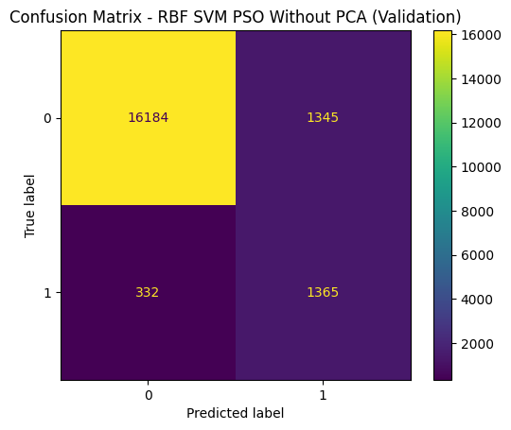  Confusion Matrix - RBF SVM PSO without PCA (Validation subset) | 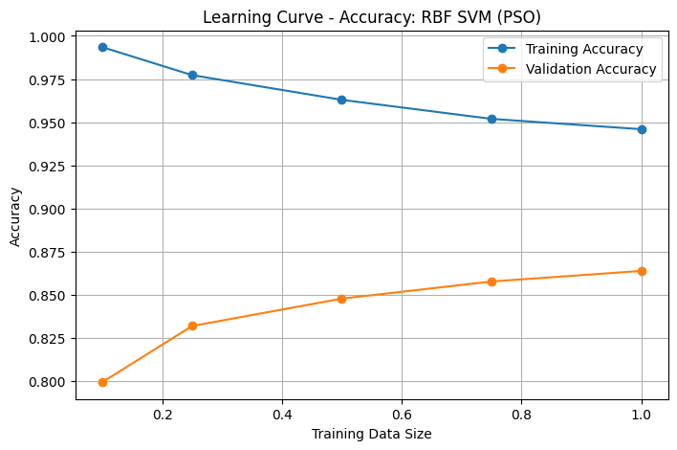  Learning Curve Accuracy - RBF SVM PSO
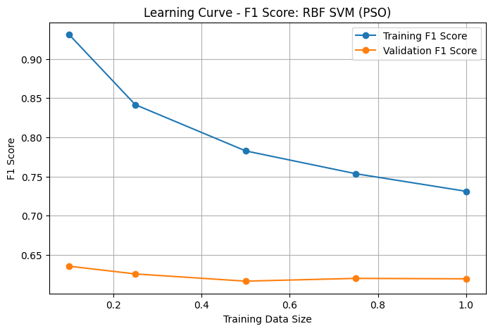
Learning Curve F1 - RBF SVM PSO
Graphs inserted from the submitted notebook output. Missing graph types are not fabricated.

Naive Bayes
Filled from submitted notebook output.
Item | Details
Preprocessing used | Processed features and PCA-transformed features were both tested with GaussianNB.
Hyperparameters / tuning | GridSearchCV tuned var_smoothing. No PCA best var_smoothing=3.16e-02. PCA best var_smoothing=3.16e-05.
PCA version tested? | Yes. No-PCA and PCA validation outputs were available.
Validation metrics | No PCA: Accuracy=0.9267, Balanced Acc.=0.8041, Precision=0.5744, Sensitivity=0.6553, F1=0.6122. With PCA: Accuracy=0.9504, Balanced Acc.=0.7639, Precision=0.8437, Sensitivity=0.5374, F1=0.6566.
Test metrics, if required | NA in notebook output for both Naive Bayes versions.
Graphs / learning curve | Confusion matrices and learning curves were generated for Naive Bayes without PCA and with PCA.
Short interpretation | PCA increased precision and accuracy for Naive Bayes but reduced sensitivity and balanced accuracy, meaning it missed more diabetes-positive cases.
Naive Bayes graphs
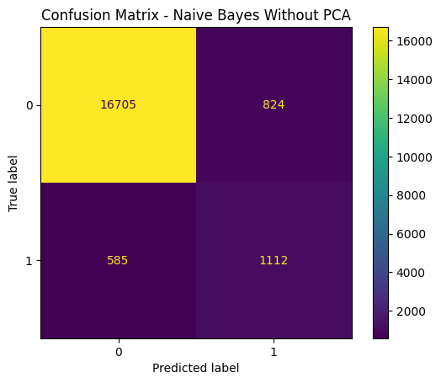  Confusion Matrix - Naive Bayes without PCA | 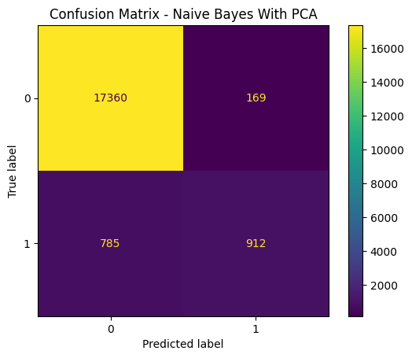  Confusion Matrix - Naive Bayes with PCA
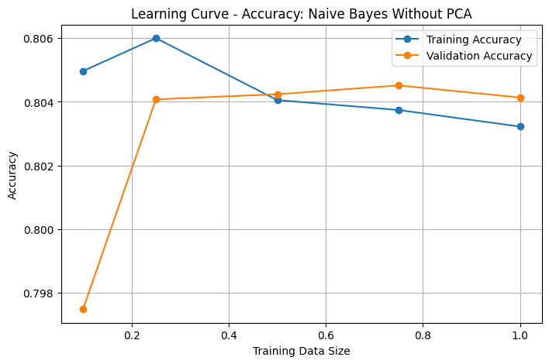  Learning Curve Accuracy - Naive Bayes without PCA | 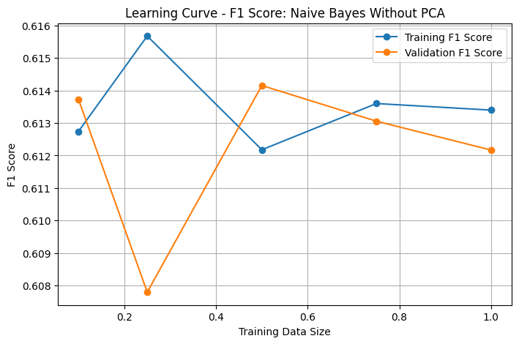  Learning Curve F1 - Naive Bayes without PCA
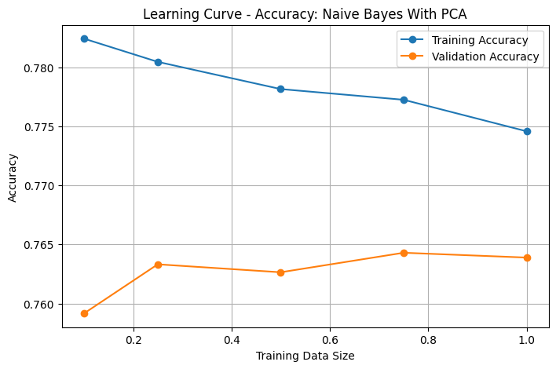  Learning Curve Accuracy - Naive Bayes with PCA | 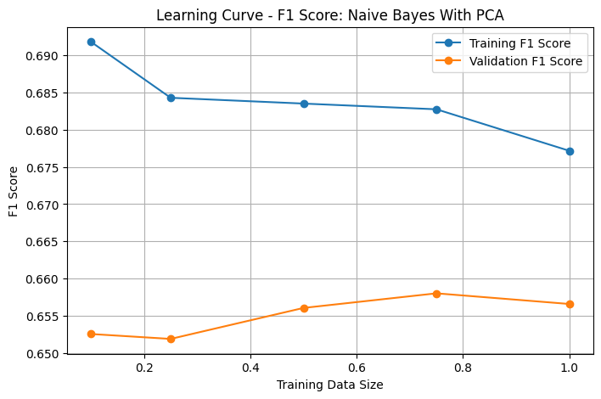  Learning Curve F1 - Naive Bayes with PCA
Graphs inserted from the submitted notebook output. Missing graph types are not fabricated.

Gradient Boosting
Filled from submitted notebook output.
Item | Details
Preprocessing used | Processed features and PCA-transformed features were both tested.
Hyperparameters / tuning | GridSearchCV tuned n_estimators, learning_rate, max_depth, and subsample. No PCA best: n_estimators=200, learning_rate=0.1, max_depth=5, subsample=0.8. PCA best: n_estimators=200, learning_rate=0.1, max_depth=5, subsample=1.0.
PCA version tested? | Yes. Both no-PCA and PCA versions were implemented.
Validation metrics | No PCA: Accuracy=0.9696, Balanced Acc.=0.8418, Precision=0.9573, Sensitivity=0.6865, F1=0.7996. With PCA: Accuracy=0.9660, Balanced Acc.=0.8275, Precision=0.9364, Sensitivity=0.6594, F1=0.7739.
Test metrics, if required | No PCA: Accuracy=0.9701, Balanced Acc.=0.8484, Precision=0.9474, Sensitivity=0.7005, F1=0.8054. With PCA: Accuracy=0.9677, Balanced Acc.=0.8369, Precision=0.9388, Sensitivity=0.6781, F1=0.7874.
Graphs / learning curve | Confusion matrices and learning curves were generated for Gradient Boosting without PCA and with PCA.
Short interpretation | Gradient Boosting achieved the strongest F1 score among the recorded test outputs, but its sensitivity was lower than models optimized for catching more diabetes-positive cases.
Gradient Boosting graphs
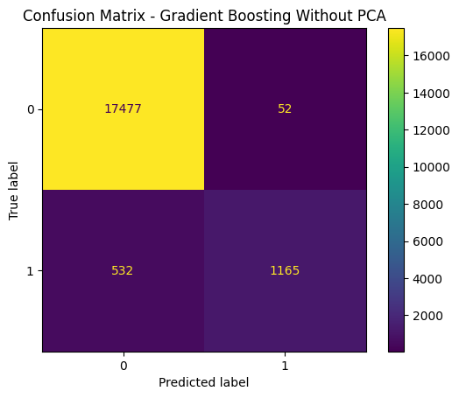  Confusion Matrix - Gradient Boosting without PCA | 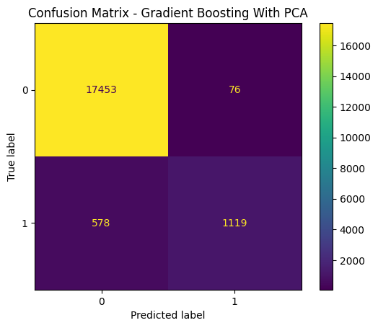  Confusion Matrix - Gradient Boosting with PCA
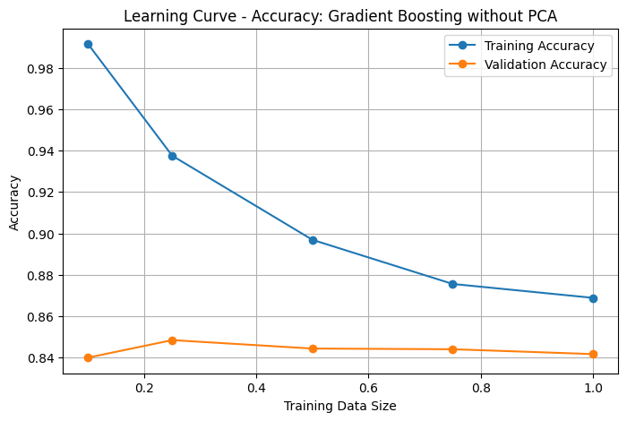  Learning Curve Accuracy - Gradient Boosting without PCA | 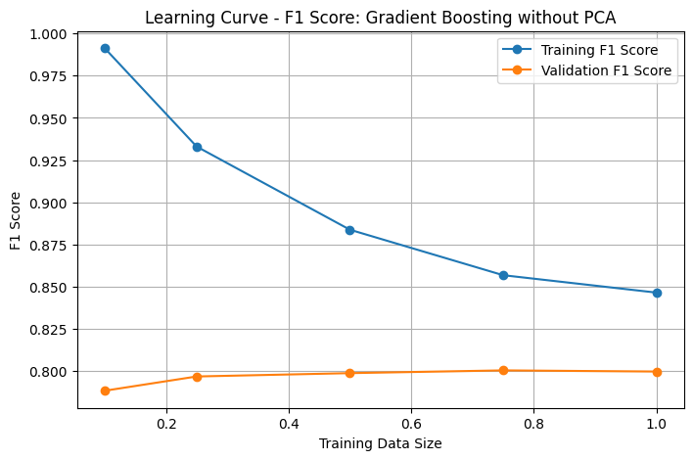  Learning Curve F1 - Gradient Boosting without PCA
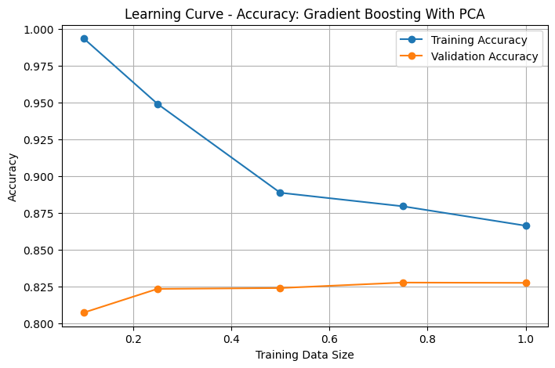  Learning Curve Accuracy - Gradient Boosting with PCA | 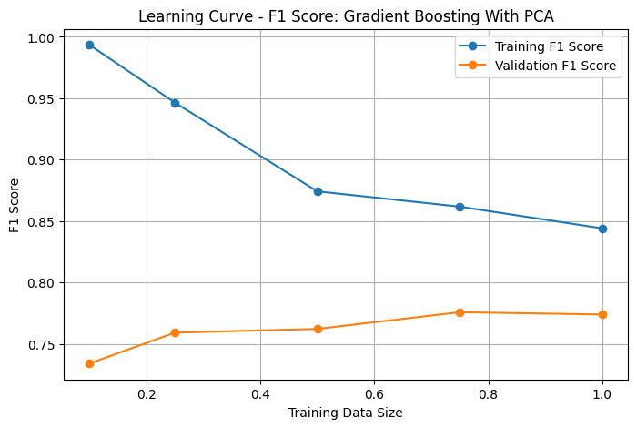  Learning Curve F1 - Gradient Boosting with PCA
Graphs inserted from the submitted notebook output. Missing graph types are not fabricated.

AdaBoost
Filled from submitted notebook output.
Item | Details
Preprocessing used | AdaBoost was evaluated on processed features. A PCA version was also tested.
Hyperparameters / tuning | GridSearchCV tuned n_estimators, learning_rate, estimator__max_depth, and estimator__min_samples_split. No PCA best: n_estimators=100, learning_rate=1.0, estimator max_depth=3, min_samples_split=2. PCA best: n_estimators=200, learning_rate=1.0, estimator max_depth=3, min_samples_split=10.
PCA version tested? | Yes. Both no-PCA and PCA AdaBoost versions were implemented.
Validation metrics | No PCA: Accuracy=0.9034, Balanced Acc.=0.9079, Precision=0.4755, Sensitivity=0.9134, F1=0.6254. With PCA: Accuracy=0.8919, Balanced Acc.=0.8958, Precision=0.4446, Sensitivity=0.9004, F1=0.5952.
Test metrics, if required | No PCA: Accuracy=0.9022, Balanced Acc.=0.9046, Precision=0.4718, Sensitivity=0.9074, F1=0.6208. With PCA: Accuracy=0.8907, Balanced Acc.=0.8900, Precision=0.4408, Sensitivity=0.8892, F1=0.5894.
Graphs / learning curve | Confusion matrices and learning curves were generated for AdaBoost without PCA and with PCA.
Short interpretation | AdaBoost achieved strong balanced accuracy and sensitivity, meaning it detected many diabetes-positive cases but produced more false positives than high-precision models.
AdaBoost graphs
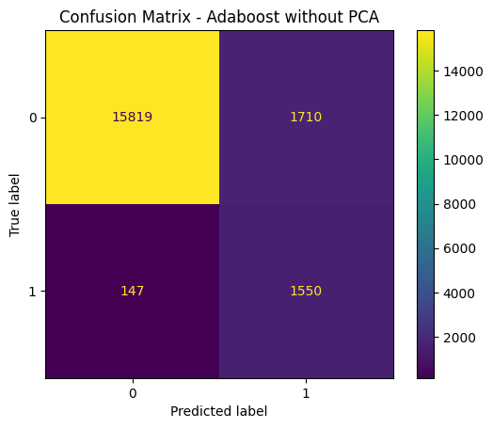  Confusion Matrix - AdaBoost without PCA | 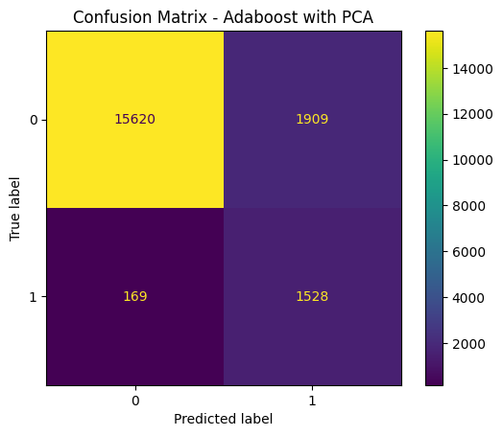  Confusion Matrix - AdaBoost with PCA
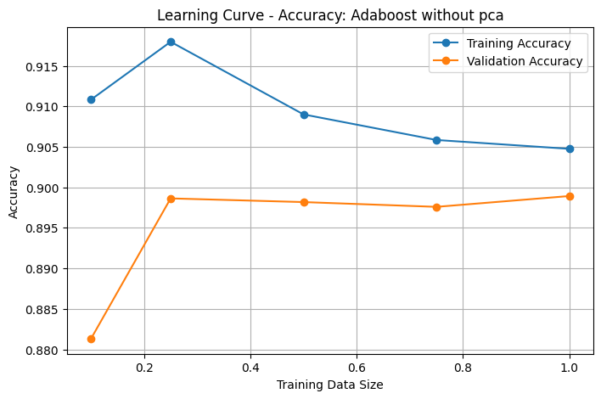  Learning Curve Accuracy - AdaBoost without PCA | 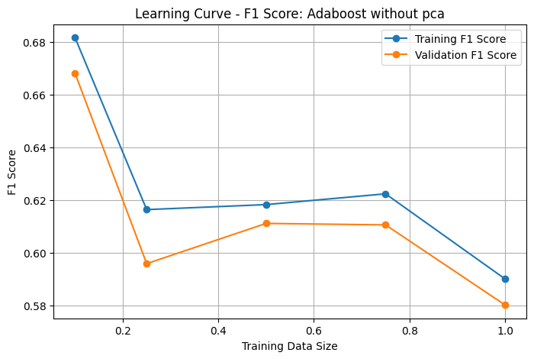  Learning Curve F1 - AdaBoost without PCA
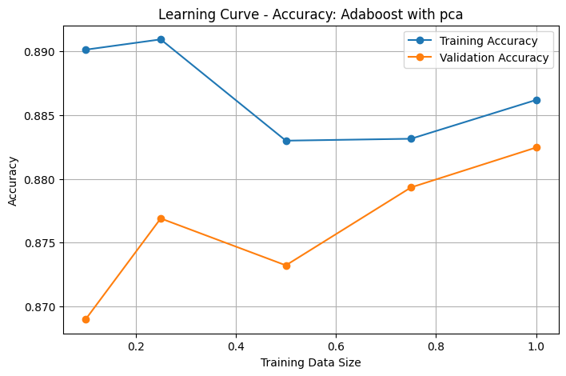  Learning Curve Accuracy - AdaBoost with PCA | 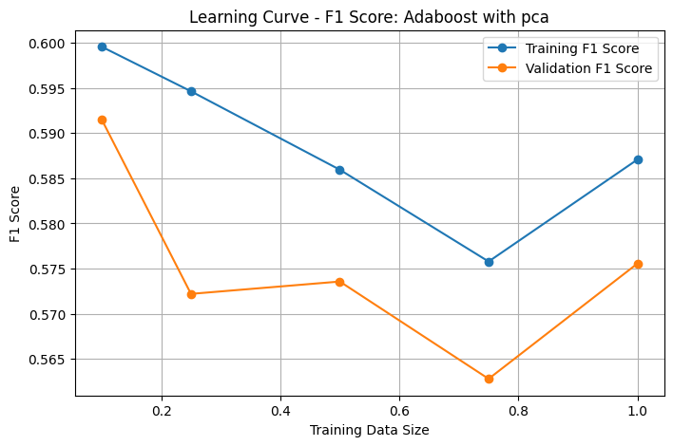  Learning Curve F1 - AdaBoost with PCA
Graphs inserted from the submitted notebook output. Missing graph types are not fabricated.

XGBoosting
Filled from submitted notebook output.
Item | Details
Preprocessing used | XGBoosting was evaluated on processed features. A PCA version was also tested where validation output was available. scale_pos_weight was used to handle class imbalance.
Hyperparameters / tuning | GridSearchCV tuned n_estimators, max_depth, and learning_rate. No PCA best: n_estimators=300, max_depth=3, learning_rate=0.05. PCA best: n_estimators=300, max_depth=3, learning_rate=0.1.
PCA version tested? | Yes. XGBoosting without PCA and XGBoosting with PCA were both implemented. The PCA version had validation output; no separate test output was shown in the notebook.
Validation metrics | No PCA eval-set validation: Accuracy=0.9214, Balanced Acc.=0.8933, Precision=0.5341, Sensitivity=0.8592, F1=0.6587. With PCA validation: Accuracy=0.8936, Balanced Acc.=0.8977, Precision=0.4489, Sensitivity=0.9028, F1=0.5996.
Test metrics, if required | No PCA grid test output: Accuracy=0.9021, Balanced Acc.=0.9085, Precision=0.4718, Sensitivity=0.9163, F1=0.6228. Final selected No-PCA XGBoosting test: Accuracy=0.9200, Balanced Acc.=0.8957, Precision=0.5284, Sensitivity=0.8662, F1=0.6564. PCA test: NA in notebook output.
Graphs / learning curve | Confusion matrices, learning curves, and logloss learning plots were generated for XGBoosting in the notebook.
Short interpretation | XGBoosting without PCA was selected by the final notebook code using Balanced Accuracy and then evaluated on the test set. The final test result had Balanced Accuracy=0.8957 and F1=0.6564.
XGBoosting graphs
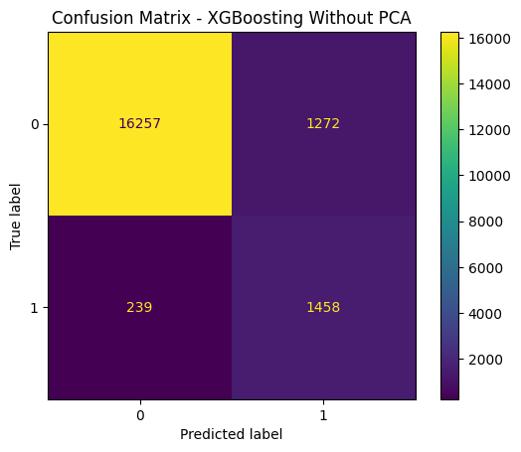  Confusion Matrix - XGBoosting without PCA | 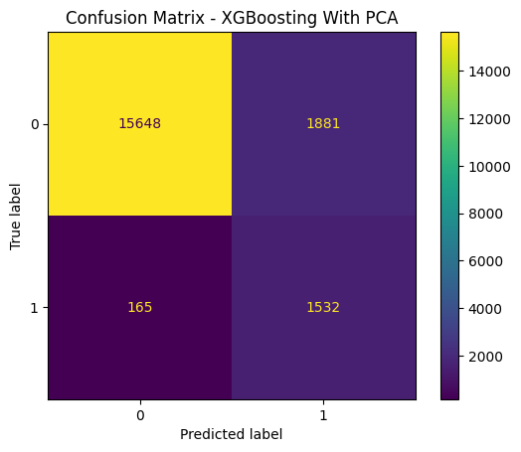  Confusion Matrix - XGBoosting with PCA
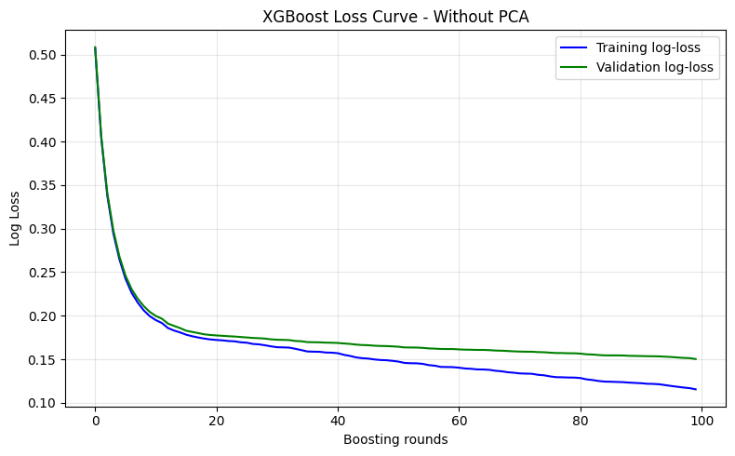  Training/Validation Log-Loss - XGBoosting without PCA | 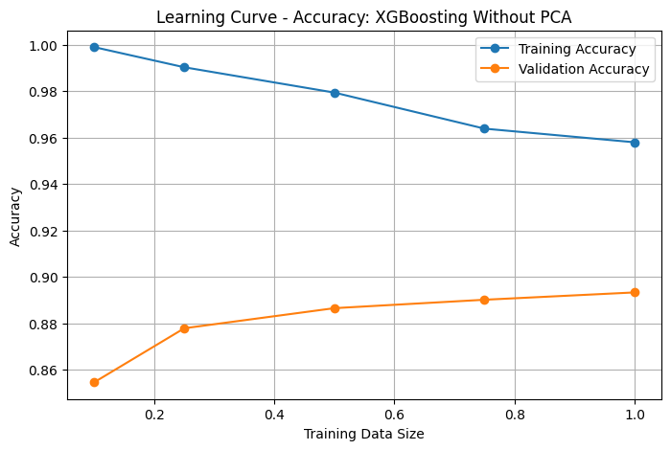  Learning Curve Accuracy - XGBoosting without PCA
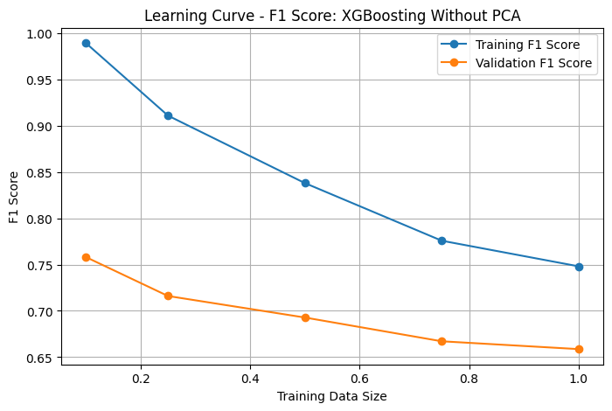  Learning Curve F1 - XGBoosting without PCA | 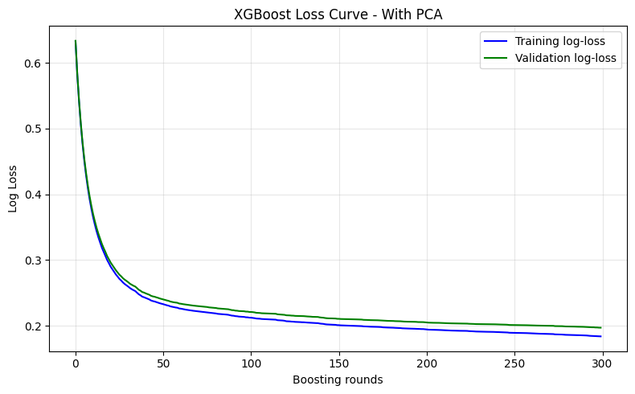  Training/Validation Log-Loss - XGBoosting with PCA
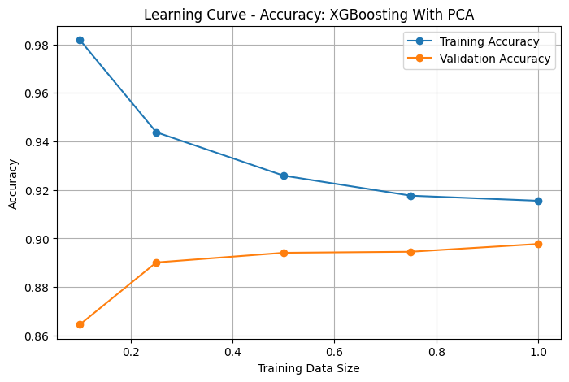  Learning Curve Accuracy - XGBoosting with PCA | 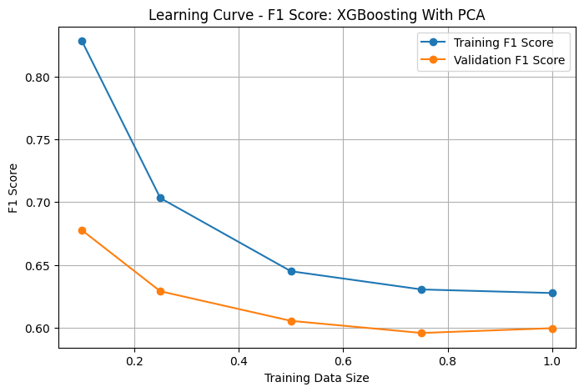  Learning Curve F1 - XGBoosting with PCA
Graphs inserted from the submitted notebook output. Missing graph types are not fabricated.

9. Final Model Selection
This section was filled using the final model selection output from the submitted notebook. The selection metric used in the code was Balanced Accuracy.
Field | Final Value
Selection metric | Balanced Accuracy
Best model name | XGBoosting
PCA status | No
Final test accuracy | 0.9200
Final test balanced accuracy | 0.8957
Final test precision | 0.5284
Final test sensitivity / recall | 0.8662
Final test F1 score | 0.6564
Final confusion matrix | TN=16219, FP=1311, FN=227, TP=1469

Final selection logic used in the notebook: the results table was sorted by Balanced Accuracy, the best row was selected, and the selected model was evaluated on the test set. Because the dataset is imbalanced, Balanced Accuracy is a suitable selection metric alongside F1 score and sensitivity.

10. Appendix: Main Code Snippets

10.1 Train / Validation / Test Split
X = df_clean.drop("diabetes", axis=1)
y = df_clean["diabetes"]

X_temp, X_test, y_temp, y_test = train_test_split(
X, y, test_size=0.2, random_state=42, stratify=y
)

X_train, X_val, y_train, y_val = train_test_split(
X_temp, y_temp, test_size=0.25, random_state=42, stratify=y_temp
)

10.2 Preprocessing Pipeline
numeric_features = ["age", "bmi", "hba1c_level", "blood_glucose_level"]
binary_features = ["hypertension", "heart_disease"]
categorical_features = ["gender", "smoking_history"]

preprocessor = ColumnTransformer(
transformers=[
("num", StandardScaler(), numeric_features),
("cat", OneHotEncoder(handle_unknown="ignore", sparse_output=False), categorical_features),
("bin", "passthrough", binary_features)
]
)

X_train_processed = preprocessor.fit_transform(X_train)
X_val_processed = preprocessor.transform(X_val)
X_test_processed = preprocessor.transform(X_test)

10.3 Shared Evaluation Function
def evaluate_model(model_name, pca_status, y_true, y_pred, print_report=True):
cm = confusion_matrix(y_true, y_pred)
tn, fp, fn, tp = cm[0, 0], cm[0, 1], cm[1, 0], cm[1, 1]
accuracy = accuracy_score(y_true, y_pred)
balanced_accuracy = balanced_accuracy_score(y_true, y_pred)
precision = precision_score(y_true, y_pred, zero_division=0)
sensitivity = recall_score(y_true, y_pred, zero_division=0)
f1 = f1_score(y_true, y_pred, zero_division=0)
return {
"Model": model_name, "PCA": pca_status,
"TN": tn, "FP": fp, "FN": fn, "TP": tp,
"Accuracy": accuracy, "Balanced Accuracy": balanced_accuracy,
"Precision": precision, "Sensitivity": sensitivity, "F1 Score": f1
}

