Melodify Music Player Project

Quality Management
Project Name: Melodify Music Player
Prepared By: Nour Waleed, Hagar Aly, Ahmed Khalid
Project Sponsor: Marwan Mousa

1. Plan Quality Management

1.1 Quality Management Plan

Quality Standards That Will Be Used By The Project
Area | Standard
Performance | Song loading time less than 3 seconds
Availability | System uptime ≥ 98%
Security | Secure authentication and protected user data
Functionality | All system features must work correctly
Reliability | System should not crash during normal use
Testing | Unit, Integration, System, and UAT testing
Quality Standard | ISO 9001 Quality Management Practices

Quality Objectives Of The Project
- Song loading time must not exceed 3 seconds.
- System uptime must be equal to or greater than 98%.
- AI-generated sessions must correctly generate playlists based on selected genres.
- Login and signup functions must securely authenticate users.
- User Acceptance Testing (UAT) must achieve at least 95% pass rate.
- The platform must pass security testing with no critical vulnerabilities.

Quality Roles And Responsibilities
Role | Responsibility
Project Manager | Monitor project quality and conduct weekly quality meetings
QA Team | Prepare test cases, execute testing, and report defects
Frontend Developers | Ensure UI quality and responsiveness
Backend Developers | Ensure backend performance and security
AI Team | Validate AI recommendation accuracy
Testing Team | Perform unit, integration, system, and performance testing
Stakeholders | Review and approve final deliverables

How Project Quality Requirements Will Be Met
The Melodify project quality requirements will be achieved through:
- Code reviews before merging features.
- Unit testing for every module.
- Integration testing between connected modules.
- System testing for the full platform.
- Security testing for authentication and APIs.
- Performance testing for song loading and response time.
- User Acceptance Testing (UAT).
- Weekly quality review meetings.

How The Quality Aspect Of The Project Will Be Managed
- Weekly quality review meetings will be conducted.
- Defects will be documented and tracked.
- QA reports will be reviewed weekly.
- Developers will fix issues before deployment.
- Quality audits will be performed during development.
- Testing progress will be monitored continuously.

Major Procedures Relevant For The Project

Procedures For Handling Problems
- Tester identifies defect.
- Defect is documented.
- Severity level is assigned.
- Developer fixes the issue.
- QA team retests the issue.
- Defect is closed after verification.

Procedures For Improving Quality
- Conduct weekly review meetings.
- Analyze recurring defects.
- Improve testing procedures.
- Optimize backend performance.
- Improve UI responsiveness.
- Apply feedback from users and stakeholders.

1.2 Quality Metrics
Item | Metrics | Measurement Method
Song Loading Speed | Response Time | Performance Testing
Login System | Login Success Rate | Functional Testing
System Availability | Uptime Percentage | Server Monitoring
AI Recommendation | Recommendation Accuracy | User Testing
Security | Number of Vulnerabilities | Security Testing
User Interface | UI Responsiveness | Cross-Browser Testing
Database | Data Retrieval Accuracy | Database Testing
Bug Fixing | Number of Unresolved Bugs | Bug Tracking Reports

2. Manage Quality

2.1 Lean
- The frontend and backend teams will reuse tested components instead of rebuilding repeated functions.
- The QA team will remove repeated manual testing steps by organizing fixed testing procedures.
- The project manager will reduce unnecessary meetings and only schedule weekly quality meetings.
- Developers will immediately fix defects after testing instead of delaying corrections.
- The team will organize tasks clearly between frontend, backend, AI, and QA members to avoid duplicated work.
- The testing team will prioritize critical modules first such as login, playback, AI sessions, and admin dashboard.

2.2 Benchmarking

Platforms Used For Benchmarking
- Spotify
- Anghami
- Amazon Music

Comparison Areas
- The UI/UX team will compare Melodify interfaces with Spotify and Anghami interfaces.
- The backend team will compare song loading speed with Amazon Music.
- The AI team will compare recommendation quality with existing music recommendation systems.
- The development team will review how other platforms organize playlists and lyrics features.
- The project manager and QA team will document improvement points and apply them during development.

2.3 Quality Audit

Audit Activities
- The project manager and QA team will review whether developers follow coding standards.
- The QA team will verify that testing procedures are completed correctly.
- The backend team will review database security and API handling.
- The frontend team will review responsiveness and UI consistency.
- The testing team will review bug reports and ensure defects are closed correctly.
- Audit reports will be documented weekly and corrective actions will be assigned.

3. Control Quality

3.1 Cause-And-Effect Diagram (Fishbone Diagram)

Problem: Songs Load Slowly
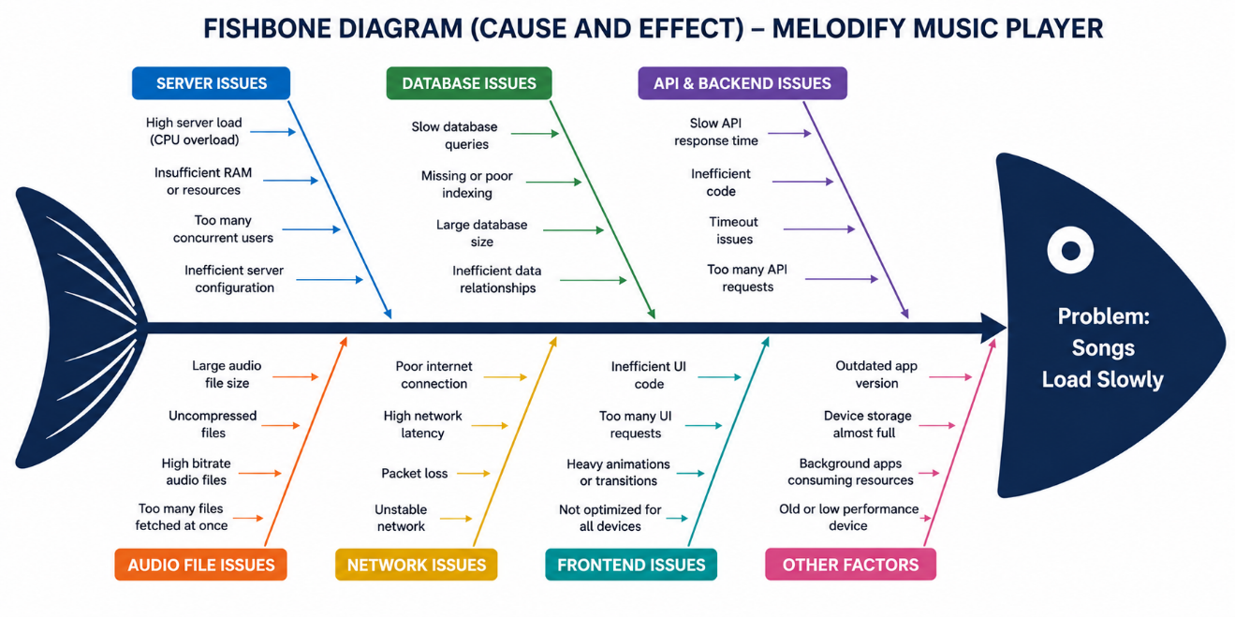
Observation
The fishbone analysis shows that slow song loading is mainly caused by backend response delays, weak internet connection, database latency, inefficient API handling, and server overload during high user activity. Performance optimization and caching mechanisms are required to reduce loading time.

3.2 Control Chart

Song Loading Time
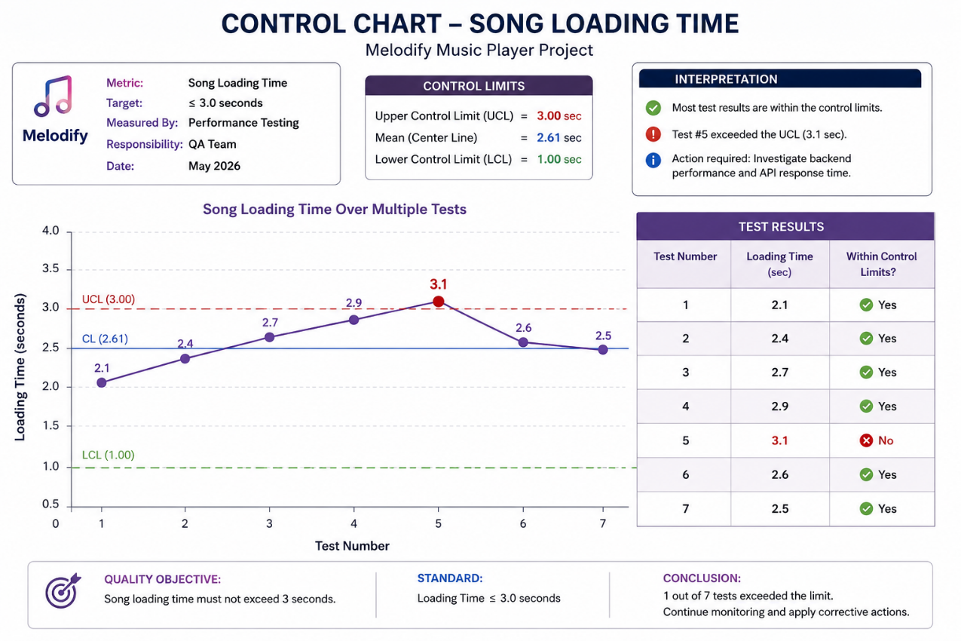

Observation
Most test results are within the acceptable control limits, indicating that the system performance is generally stable. However, one test exceeded the upper control limit of 3 seconds, which indicates a temporary backend or network performance issue that requires corrective action.

3.3 Scatter Diagram

Song Loading Time vs Concurrent Users
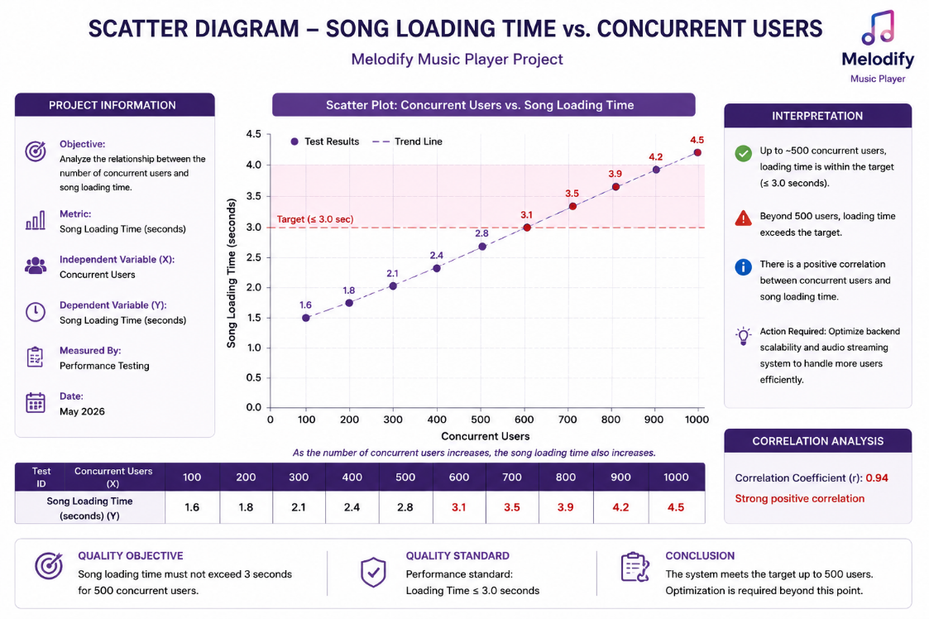

Observation
The scatter diagram shows a strong positive relationship between the number of concurrent users and song loading time. As user traffic increases, loading time also increases, indicating that backend scalability and server optimization are important for maintaining performance.

3.4 Histogram

Song Loading Time Distribution
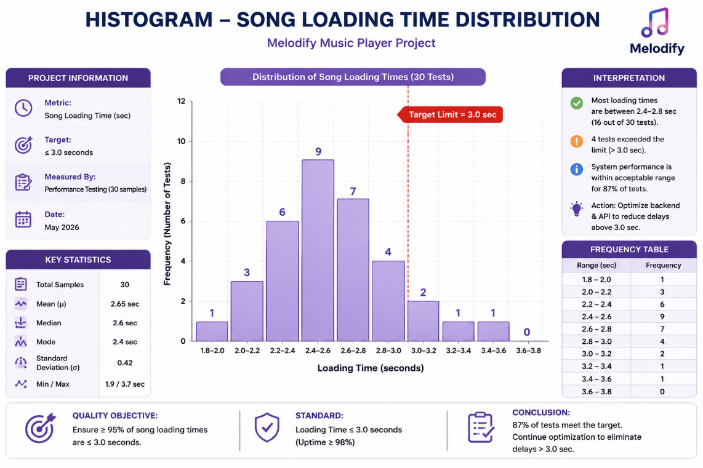

Observation
The histogram shows that most song loading times are concentrated between 2.0 and 3.0 seconds, which meets the project quality objective. A smaller number of tests exceeded the target limit, indicating occasional performance bottlenecks during heavy usage.

3.5 Pareto Chart

Defects By Cause
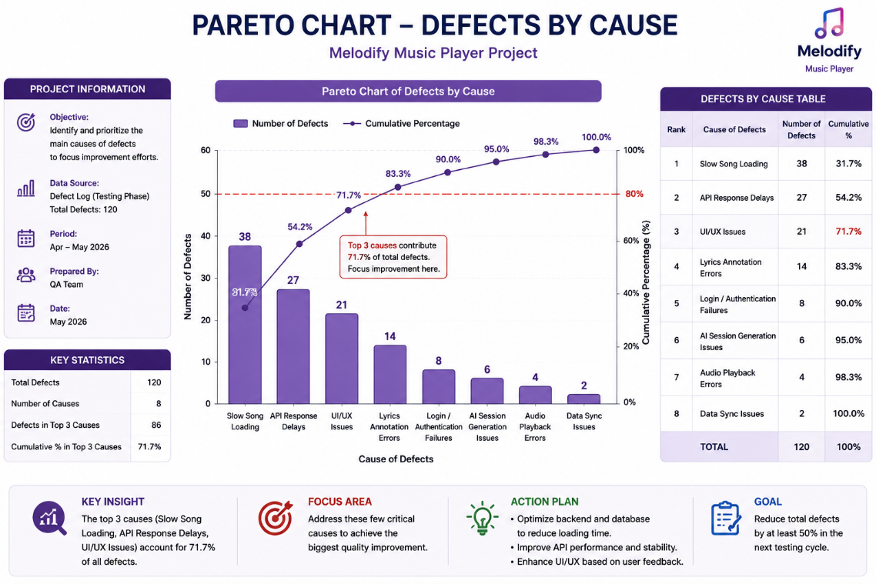

Observation
The Pareto chart indicates that the majority of defects are caused by slow song loading, API response delays, and UI/UX issues. Focusing improvement efforts on these major causes can significantly reduce the overall number of defects in the Melodify system.

3.6 Flowchart

Song Loading Process
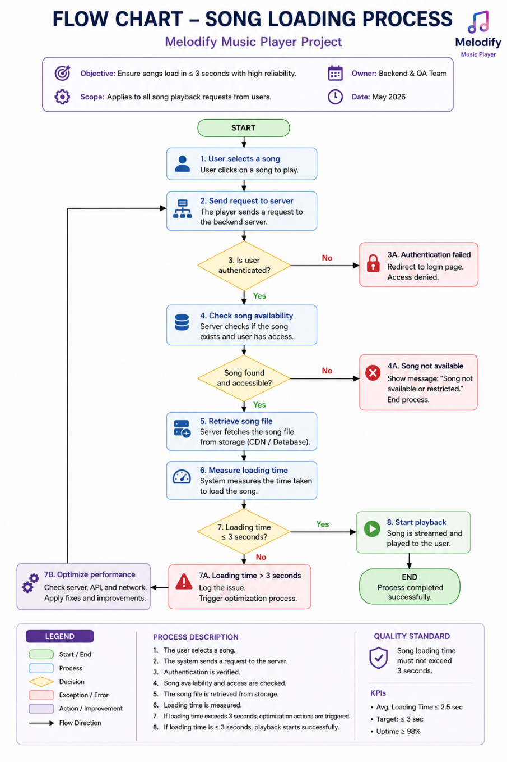
Observation
The flowchart demonstrates the complete process of song playback from user request to playback execution. The process includes authentication, availability checking, loading-time validation, and performance optimization to ensure reliable and efficient streaming.

3.7 Run Chart

Song Loading Time Over Time

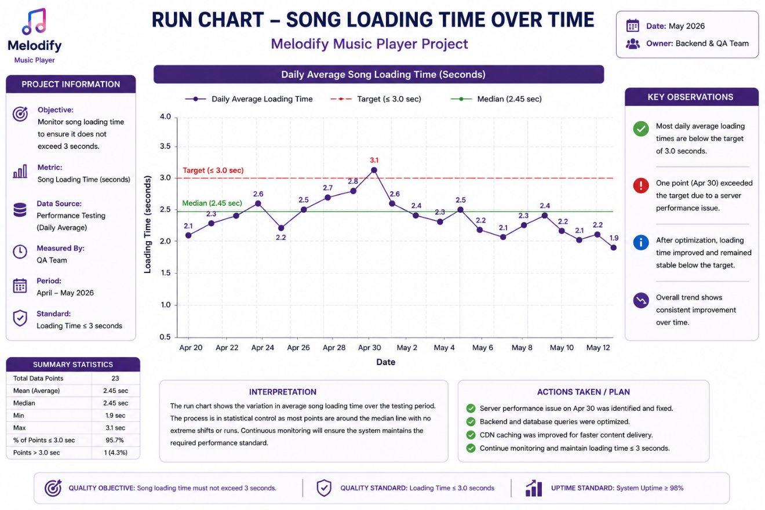

Observation

The run chart shows that song loading performance improved over time after optimization activities were applied. Most daily average loading times remained below the 3-second target, indicating stable system performance and effective quality monitoring.

