Morse Communicator Project
Bidirectional Infrared Morse Messaging Terminal
Embedded Systems Project Documentation

Prepared By: Nour Waleed, Hagar Ali
Course / Subject: Embedded Systems
Instructor: Dr. Alaa Hamdi
Date: 2026-05-10

Table of Contents
1. Project Overview 3
2. Objectives 3
3. System Overview 3
4. Hardware Components 3
5. Pin Mapping 3
6. Button Functions 4
7. Software Architecture 4
8. Code Pipeline 4
9. Main Functions and Their Roles 5
Representative Function Calls 5
10. Simulation Section 5
11. Difference Between Simulation and Hardware Implementation 6
12. Testing and Validation 6
13. Issues Faced and Applied Fixes 6
14. Limitations 7
15. Conclusion 7

1. Project Overview
This project implements a two-way Morse communication system using two Arduino-based terminals. Each terminal allows the user to compose English text through dedicated Morse buttons, transmit the message through an infrared link, receive a reply from the opposite side, and maintain a lightweight chat history on a 16x2 I2C LCD.

2. Objectives
- Build a working bidirectional embedded communication system using two identical stations.
- Convert Morse button input into readable English text before transmission.
- Transmit data over IR and reconstruct it on the receiver side.
- Allow both sides to send, receive, and reply using the same firmware.
- Display the latest chat history on the LCD for demonstration and validation.

3. System Overview
The user does not type letters directly. Instead, each letter is entered in Morse code using six control buttons. The current Morse sequence is decoded locally into an English character when END LETTER is pressed. The system then stores the full message, sends it over IR character by character, detects the end-of-message marker, and displays sent and received lines as chat history.

4. Hardware Components
- 2 × Arduino Uno boards
- 2 × VS1838B IR receiver modules
- 2 × IR LEDs with series resistors for transmission
- 2 × 16x2 I2C LCD modules (address 0x27)
- 2 × buzzers for feedback
- 12 × push buttons (6 per station)
- Pulldown resistors for button inputs
- Breadboards, jumper wires, and power connections

5. Pin Mapping
Signal | Arduino Pin
DOT button | D4
DASH button | D5
END LETTER button | D6
BACKSPACE button | D7
SPACE button | D8
SEND button | D9
Buzzer | D10
IR TX | D3
IR RX | D11
LCD SDA | A4
LCD SCL | A5

6. Button Functions
Button | Function | Description
DOT | Appends . | Adds one dot to the current Morse sequence.
DASH | Appends - | Adds one dash to the current Morse sequence.
END LETTER | Decode current code | Converts the current Morse sequence into one English character.
BACKSPACE | Edit current input | Deletes the last Morse symbol or the last text character.
SPACE | Insert space | Closes the current letter if valid, then inserts a word gap.
SEND | Transmit message | Sends the composed text over IR and returns the station to receive mode.

7. Software Architecture
The sketch is structured into small functional blocks so the same firmware can run on both stations.
- Pin definitions and hardware initialization
- Morse lookup table and local Morse decoding
- Button scanning and one-shot press handling
- LCD rendering for send mode and receive mode
- IR transmission routine
- IR reception and message reconstruction
- Chat history storage and display update

8. Code Pipeline
The execution pipeline of the final code is shown below:
1. setup() initializes pins, LCD, buzzer, IR sender, and IR receiver.
2. loop() continuously calls checkButtons() and checkReceive().
3. checkButtons() detects a new valid press and calls handleButton(index).
4. handleButton() updates the Morse sequence, composed text, or sends the message depending on the pressed button.
5. sendMessageIR() transmits the outgoing string character by character and appends an end-of-message marker.
6. checkReceive() reconstructs incoming characters until the end marker is received.
7. addToLog() stores both sent and received lines in chat history.
8. updateLCD() refreshes the visible state of the system on the LCD.

9. Main Functions and Their Roles
Function | Role | Notes
setup() | Initializes all peripherals and displays startup state. | Runs once on power-up.
loop() | Main program loop. | Continuously checks buttons and incoming IR data.
checkButtons() | Scans button states with debounce and one-shot handling. | Prevents repeated triggers while button stays pressed.
handleButton(index) | Processes the action of each button. | Updates Morse, message, send, delete, or space operations.
decodeMorse(code) | Converts Morse symbols into one English character. | Returns null if the code is invalid.
sendMessageIR(msg) | Sends a message over the IR transmitter. | Transmits each character and then a terminator.
checkReceive() | Reads IR packets and rebuilds incoming messages. | Adds completed incoming message to history.
addToLog(msg) | Stores sent and received chat lines. | Keeps the latest conversation entries.
updateLCD() | Refreshes the LCD display. | Shows compose mode or latest chat history depending on state.

Representative Function Calls
setup() -> lcd.init() -> IrSender.begin(IR_TX_PIN) -> IrReceiver.begin(IR_RX_PIN, DISABLE_LED_FEEDBACK)
loop() -> checkButtons() -> handleButton(index)
loop() -> checkReceive() -> addToLog("<<" + receivedMessage) -> updateLCD()
handleButton(SEND) -> sendMessageIR(composedMessage) -> addToLog(">>" + composedMessage)

10. Simulation Section

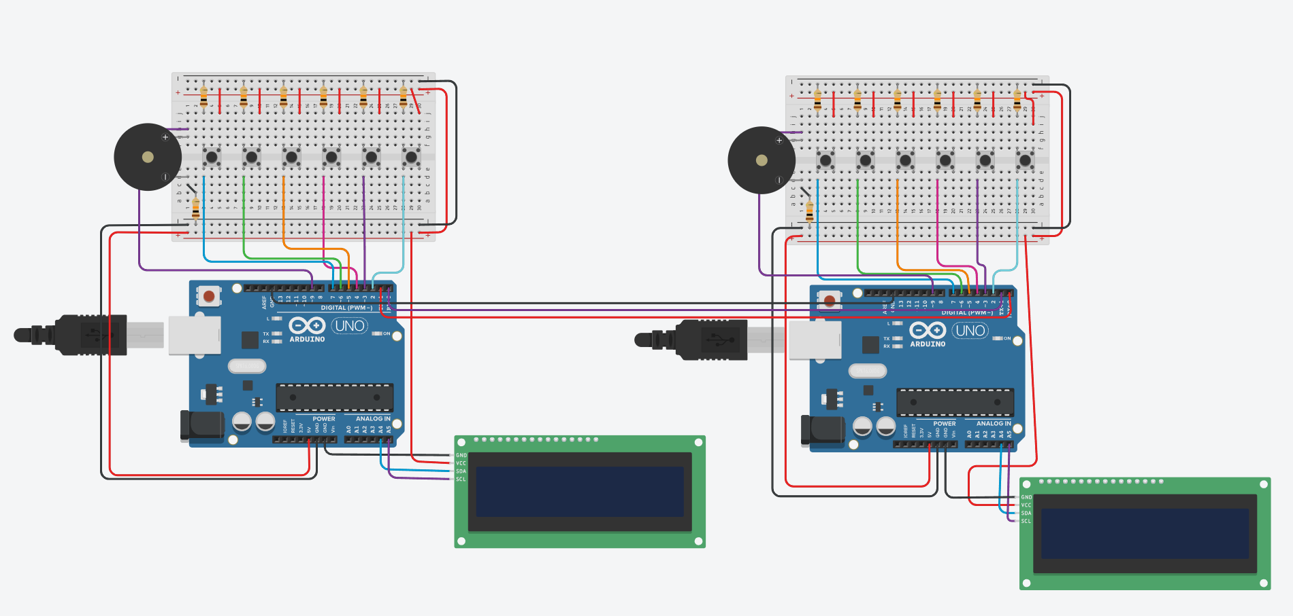

11. Difference Between Simulation and Hardware Implementation
Aspect | Simulation | Hardware Implementation
Execution environment | Runs in Wokwi or software-only environment. | Runs on two real Arduino boards with actual sensors and emitters.
Communication medium | Often simplified or emulated. | Uses a real infrared LED and a real IR receiver with line-of-sight constraints.
Debugging | Fast to iterate, easy to rewire, and easy to inspect visually. | Requires physical wiring checks, alignment checks, and component-level troubleshooting.
Timing behavior | Usually more controlled and predictable. | Affected by blocking code, IR timing, ambient light, and hardware tolerances.
Hardware faults | No loose wires or reversed components unless modeled. | Real issues include wrong polarity, bad rows, weak transmission, and receiver saturation.
Validation value | Good for logic verification and UI flow. | Good for proving the full embedded system works in real conditions.

12. Testing and Validation
- Verified button operation for all six controls.
- Verified buzzer feedback and LCD updates.
- Verified one-way IR transmission.
- Verified reply transmission in the opposite direction.
- Verified repeated exchanges after fixing button and receive-state issues.
- Verified chat history update for both sent and received messages.

13. Issues Faced and Applied Fixes
Issue | Impact | Applied Fix
Button mapping and breadboard row confusion | Buttons triggered the wrong actions or stayed active continuously. | Rebuilt the button area and aligned each signal path with its intended pin.
Buzzer activated without pressing buttons | Made debugging impossible and indicated a short or wrong row usage. | Isolated the buzzer into a clean two-row connection.
IR protocol mismatch | One side sent but the other side did not rebuild characters correctly. | Matched transmit and receive handling to the same NEC command-byte workflow.
Reply path instability | The first exchange worked, but later replies failed. | Reduced blocking behavior and re-armed the receiver after sending.
History too limited | Only a minimal or incomplete conversation state was visible. | Added a larger chat history and logged both sent and received messages.

14. Limitations
- The 16x2 LCD can only display two lines at a time, so history is stored but not fully visible at once.
- IR communication still depends on distance, alignment, and line of sight.
- History depth is limited by available Arduino RAM.
- The system currently targets letters and digits only; punctuation support is limited.

15. Conclusion
The Morse Communicator project successfully demonstrates a complete embedded communication workflow: button-based Morse input, local English decoding, infrared transmission, message reception, reply handling, and chat-style history display. The final system is symmetrical, practical for demonstration, and strong enough to represent a complete embedded systems project.

