Software Requirements Specification

Version 1.0

<<Annotated Version>>

May 17, 2021

***Web Consultation Medical Clinic System***

Nour ward (team leader)

Ayat Alaranji

<<this SRS document is a homework for Software Engineering 2 course in IT engineering, 4th year, Al_Baath University >>

*Table of Contents*

Table of Contents ................................................................................................................................. i

List of Figures ....................................................................................................................................... ii

1.0. Introduction ............................................................................................................3

1.1. Purpose ..............................................................................................................................3

1.2. Scope of Project .................................................................................................................3

1.3. Glossary ............................................................................................................................. 4

1.4. References ........................................................................................... 5

1.5. Overview of Document ...................................................................................................... 5

2.0. Overall Description ............................................................................................ 6

2.1 System Environment ....................................................................................................................... 6

2.2 Functional Requirements Specification ....................................................... 7

2.2.1 Reader Use Case ..................................................................................................................... 7

Use case: Search Medical Article .................................................................................................... 7

2.2.2 Patient Use Case ..................................................................................................................... 8

Use case: Find A Doctor ………………………………………………………………………….8

2.2.3 Doctor Use Cases……………………………………………………………………………8

Use case: communication with the patient………………………………………………………...8

Use case: Submit medical articles …………………………………………………………………9

2.2.4 Editor Use Case ……………………………………………………10

Use case**:** Receive Article……………………………………………………….10

2.3 User Characteristics ………………………………………………………11

2.4 Non-Functional Requirements…………………………………………11

3.0. Requirements Specification …………………………….11

3.1 External Interface Requirements …………………………11

3.2 Functional Requirements ………………………………………12

3.2.1 Search Medical Article ………………………………………………12

3.2.2 Find A Doctor……………………………………………………………13

3.2.3 communication with the patient …………………………14

3.2.4*:* Submit Medical Articles ……………………………………14

3.2.5*:* Receive Article……………………………………………………15

3.3 Detailed Non-Functional Requirements ………………………….17

3.3.1 Logical Structure of the Data ……………………………………17

***1.0. Introduction***

***1.1. Purpose:***

The purpose of this document is to present a detailed description of the Web Consultation Medical Clinic System. It will explain the purpose and features of the system, the interfaces of the system, what the system will do, the constraints under which it must operate and how the system will react to external stimuli. This document is intended for both the stakeholders and the developers of the system and will be proposed to the Regional Historical Society for its approval.

***1.2. Scope of Project:***

This system will be designed to reduce the percentage of diseases and epidemics in the community in addition to treating the largest possible number of patients in Syria and providing medicines and medical assistance that are difficult to obtain.

By providing doctors and therapists at all times for medical advice and advice

This system will meet the needs of different segments of society, whether they are mothers, people with chronic diseases or others, in addition to helping doctors to reach their patients and communicate with them in an easy, fast and organized way.

The site uses review and revision processes for the medical articles that are published on the site

The site also contains a relational database that contains lists of patients, doctors, administrators, and others.

***1.3. Glossary:***

|  |  |
| --- | --- |
| Definition | Term |
| An article describes a specific disease and the ways to prevent it, or describes a medical advices for a healthy live. | Medical Article |
| Collection of all the information monitored by this system. | Database |
| A member of the Historical Society listed in the HS database. | Member |
| Anyone visiting the site to read articles. | Reader |
| Consultation Medical Clinic | CMC |
| A document that completely describes all of the functions of a proposed system and the constraints under which it must operate. For example, this document. | Software Requirements Specification |
| Any person with an interest in the project who is not a developer. | Stakeholder |
| The person how gives medical advices, treats patients and performs the clinical examination. | Doctor |
| The person how is infected or has a disease. | Patient |
| Person who receives articles, sends articles for ministry of health and makes final judgments for publications. | Editor |

***1.4.*** *References*

IEEE. *IEEE Std 830-1998 IEEE Recommended Practice for Software Requirements Specifications.* IEEE Computer Society, 1998.

*1.5. Overview of Document* :

The next chapter, the Overall Description section, of this document gives an overview of the functionality of the product. It describes the informal requirements and is used to establish a context for the technical requirements specification in the next chapter. The third chapter, Requirements Specification section, of this document is written primarily for the developers and describes in technical terms the details of the functionality of the product.

Both sections of the document describe the same software product in its entirety, but are intended for different audiences and thus use different language.

***2.0. Overall Description***

***2.1 System Environment***

editor

Web CMC system

site manager

Online website

Doctor

Raeder

HS DB

Patient

Ministry of health

The Web CMC System has four active actors and one cooperating system.

The patient, Reader, or Reviewer accesses the website through the Internet. Any reader or doctor or patient communication with the system is through email. The Editor accesses the entire system directly.

***2.2 Functional Requirements Specification***

2.2.1 Reader Use Case

Use case: **Search medical Article**

**Diagram:**

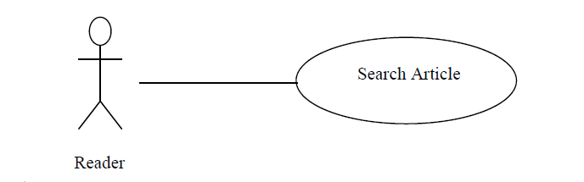

**Brief Description**

The Reader accesses the Online CMC Website, searches for an article in a particular medical field and read it online.

**Initial Step-By-Step Description**

Before this use case can be initiated, the Reader has already accessed the Online CMC Website.

1. The Reader chooses the medical field to search .

2. The Reader Search about the article by its name.

3. The system displays the choices to the Reader.

4. The Reader selects the article desired.

5. The system provides the requested article.

2.2.2 patient Use Case

***Use case:*** find a doctor

**Diagram:**

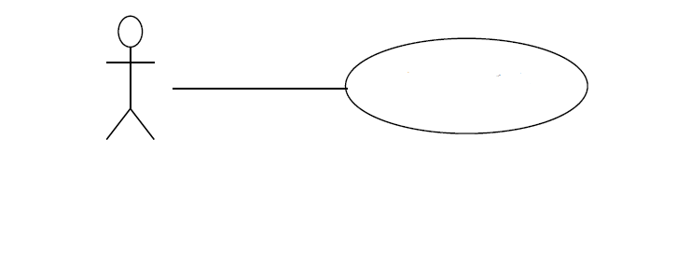

Patient

Find a doctor

The patient press the find a doctor button and choose the doctor's specialize so he can communicate with the doctor online.

**Initial Step-By-Step Description**

Before this use case can be initiated, the patient has already connected to the Online CMC Website.

1 . the patient press the "find a doctor " button .

2. the patient select the doctor's specialize.

3 . the system displays a list of the doctor who are in the choosen specialize and available in this time.

4. the patient and the doctor begin a secret conversation, the patient descripts his esymptoms and the doctor gives him the correct medicine.

5. the patient end the conversation after getting the correct treatment .

2.2.3 Doctor Use Cases

<<we'll put more than a use case to make clear who to publishing articles>>

In case of multiple doctors, this term refers to the ***principal doctor***, with whom all communication is made.

***Use case***: communication with the patient.

**Diagram:**



Communication with patient

Doctor

**Brief Description**

The Doctor responses the patient's messages , diagnosis his disease and gives him the right medicine or reserves an appointment for him.

**Initial Step-By-Step Description**

Before this use case can be initiated, the Doctor has already connected to the Online CMC Website.

1 . The Doctor receives a notification from a patient.

2. The Doctor opens his messages box and start a secret conversation with the patient.

3. The Doctor diagnosis patient's disease.

4. The Doctor describes the correct medicine to the patient or reserves an appointment for him.

**Use case**: Submit medical articles.

**Diagram:**

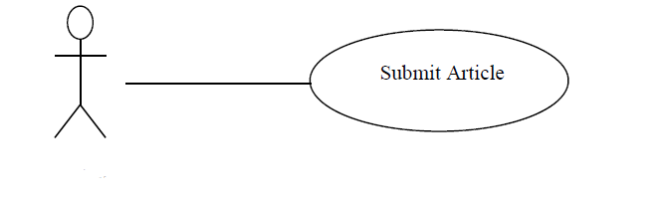

Doctor

**Brief Description**

The Doctor submits a medical article in his specialization or edits one.

**Initial Step-By-Step Description**

Before this use case can be initiated, the Doctor has already connected to the Online CMC Website.

1. The Doctor chooses the publish article button.

2. The Doctor chooses the subject/category of the article.

3. The Doctor writes the medical article.

4. The doctor clicks on submit button.

5. The System generates the article so the readers can read it.

**2.2.4 Editor Use Case:**

**Use case:** Receive Article

**Diagram:**

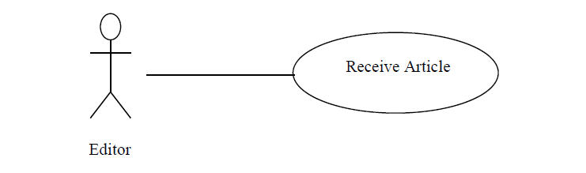

**Brief Description**

The Editor enters a revised article into the system.

**Initial Step-By-Step Description**

Before this use case can be initiated, the Editor has already accessed the main page of the Article Manager and has a file containing the article available.

1. The Editor selects to *Receive Article*.

2. The system presents a choice of entering a new article or updating an existing article.

3. The Editor chooses to add or to update.

4. If the Editor is updating an article, the system presents a list of articles to choose from and presents a grid for filling with the information; else the system presents a blank grid.

5. The Editor fills in the information and submits the form.

6. The system verifies the information and returns the Editor to the Article Manager main page.

***2.3 User Characteristics***:

The both Patient and Reader are expected to be Internet literate and be able to use a search engine.

The main screen of the Online CMC website will have the both search functions (search for a doctor or for an article).

The both Doctor and Patient are expected to be able to use email with attachments.

The Editor is expected to be Windows literate and to be able to handle with buttons, lists ,menus ,.. etc

***2.4 Non-Functional Requirements*:**

The Online CMC website will be on a server with high speed Internet capability, and it will have Interactive graphical interfaces, it will be easy to use, fast to response .

The software developed here assumes the use of a tool such as Tomcat for connection between the Web pages and the database.

The medical articles Manager will run on the editor’s PC and will contain an Access database. Access is already installed on this computer and is a Windows operating system.

***3.0. Requirements Specification****:*

***3.1 External Interface Requirements***

The first link to an external system is the link to the Historical Society (HS) Database to verify the membership *of the doctors, readers, patients.*

The HS Database fields of interest to the Web CMC Systems are member’s name, membership (ID) number, and email address , and medical specialization field for Doctors.

The second link is with the ministry of health. A daily, monthly, annual reports sends regularly to it by the editor , the doctors make reports about the situations they are handling with. And The editor send them to the Ministry Email .

***3.2 Functional Requirements***

3.2.1 Search Medical Article*:*

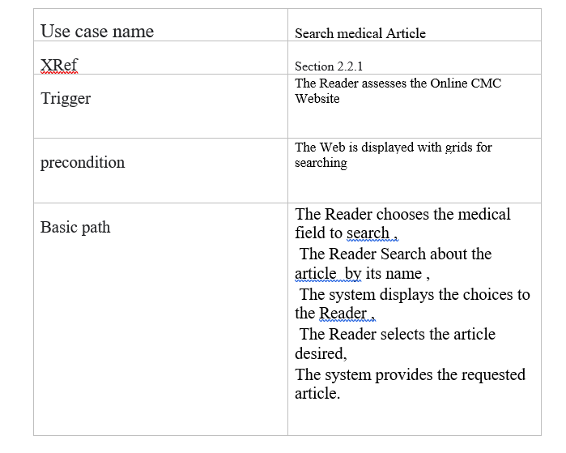

3.2.2 Find A Doctor *:*

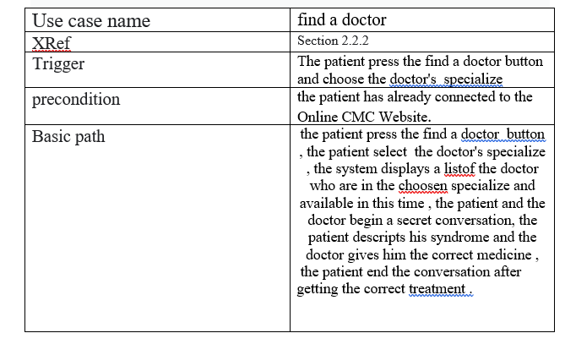

3.2.3 communication with the patient *:*

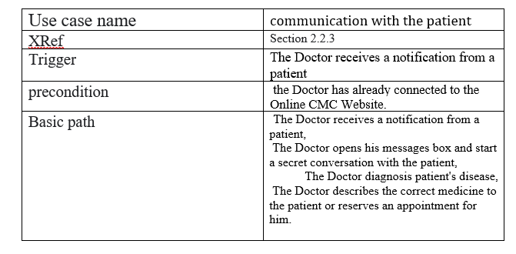

3.2.4*:* Submit Medical Articles

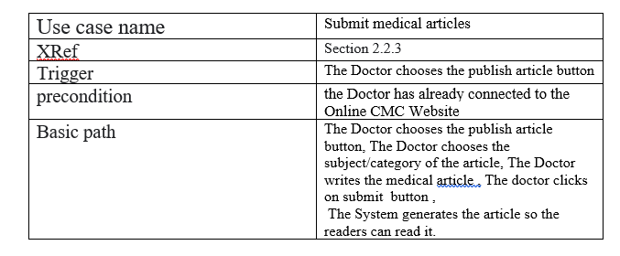

3.2.5*:* Receive Article:

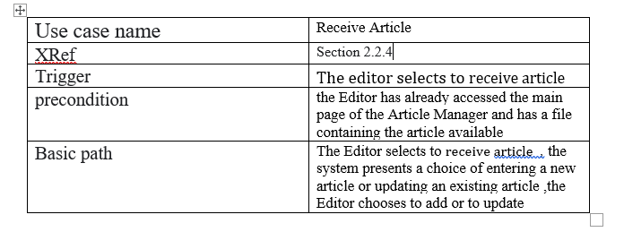

***3.3 Detailed Non-Functional Requirements:***

*3.3.1 Logical Structure of the Data*

The logical structure of the data to be stored in the internal CMC Manager database is given below.

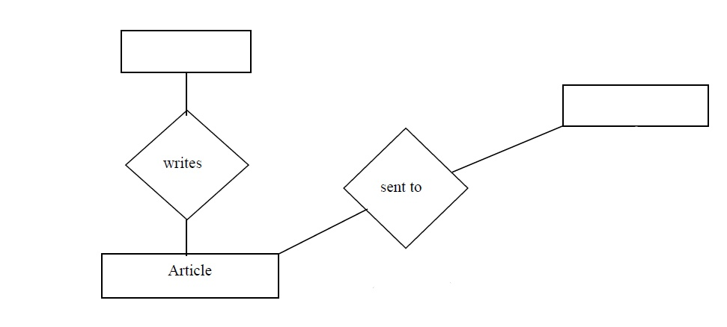**Figure - Logical Structure of the CMC Manager Data**

patient

treats

doctor

editor

The data descriptions of each of these data entities is as follows:

**Doctor Data Entity**

|  |  |  |  |
| --- | --- | --- | --- |
| **Comment** | **Description** | **Type** | **Data Item** |
|  | Name of principle doctor | Text | Name |
|  | Internet address | Text | Email Address |
| May be several | Article entity | Pointer | Article |
| May be several | Patient pointer | pointer | patient |

**Patient data entity:**

|  |  |  |  |
| --- | --- | --- | --- |
| **Comment** | **Description** | **Type** | **Data Item** |
|  | Name of patient | Text | Name |
|  | Internet address | Text | Email Address |
| May be several | Doctor pointer | pointer | doctor |

**Editor data entity:**

|  |  |  |  |
| --- | --- | --- | --- |
| **Comment** | **Description** | **Type** | **Data Item** |
|  | Name of principle doctor | Text | Name |
| Used as key in Historical Society Database | ID number of Historical Society member | Integer | ID |
|  | Internet address | Text | Email Address |
| May be several | Article entity | Pointer | Article |
|  | Comments on past performance | Text | History |
| May be several | Area of expertise | Category | Specialty |

**Article data entity:**

|  |  |  |  |
| --- | --- | --- | --- |
|  |  |  |  |
|  | Name of Article | Text | Name |
| May be several | Doctor entity | Pointer | doctor |
| Contains Abstract as first paragraph. | Body of article | Text | Contents |
| May be several | Area of content | Text | Category |
| Needs Copyright form returned | Article has been accepted for publication | Boolean | Accepted |
| Not relevant unless Accepted is True. | Copyright form has been returned | Boolean | Copyright |
| Not relevant unless Accepted is True. Article is no longer active and does not appear in status checks | Sent to Online CMC | Boolean | Published |