Wastewater Treatment Aeration Tank Control Using PER-DQN and Rule Extraction
Final technical report | November 2026 | Experimental results from three trained seeds

Executive summary
This project implements a simplified wastewater aeration simulator and compares fixed-blower, rule-based, DQN and PER-DQN controllers. Models trained for 600 episodes at seeds 42, 43 and 44 were evaluated on a chronological held-out dry test using 20 episodes per model seed. DQN achieved better mean reward and lower normalized energy proxy than PER-DQN across the three seeds. A rule-based controller had fewer low-DO violations. Explainability outputs include SHAP and decision-tree surrogate rules for seed 42.

1. Problem statement and objectives
Aeration must maintain dissolved oxygen while limiting energy demand. The project objective is to formulate the task as a Markov decision process, train and compare value-based controllers, evaluate oxygen and energy outcomes, and produce interpretable approximations of neural policy decisions.

2. Data and simulation methodology
The project uses BSM1-derived influent profiles with dry, rain and storm scenarios. The simulated state contains dissolved oxygen, a COD-derived BOD proxy, previous blower setting, influent BOD proxy and flow. Actions are discrete blower fractions of 0%, 25%, 50%, 75% and 100%. Reward combines control objectives and penalties. The model is illustrative rather than a validated ASM1/BSM1 plant simulation. Energy proxy is normalized, not measured electricity consumption.

3. Training and evaluation protocol
DQN and PER-DQN each completed 600 training episodes for model seeds 42, 43 and 44. The chronological held-out dry test used 20 evaluation episodes per model seed and evaluation seed 123. Both algorithms were evaluated under the same configuration. Summary statistics are means and sample standard deviations across the three model seeds, not confidence intervals or formal significance tests.

4. Held-out multi-seed results
Metric | DQN mean ± SD | PER-DQN mean ± SD
reward | -61.54 ± 0.74 | -62.35 ± 0.59
do below 2 pct | 13.85 ± 2.71 | 13.37 ± 2.99
do above 3 pct | 2.12 ± 1.51 | 5.28 ± 2.49
energy proxy sum | 22.56 ± 0.34 | 23.38 ± 0.48
blower switches | 25.42 ± 2.08 | 23.70 ± 5.30
Baseline held-out test: rule-based reward −64.164; DO below 2 mg/L 3.229%; DO above 3 mg/L 4.375%; energy proxy 25.909. Fixed-50 reward −88.222, fixed-75 reward −420.776. These baseline values were identical across the three repeated evaluation runs.
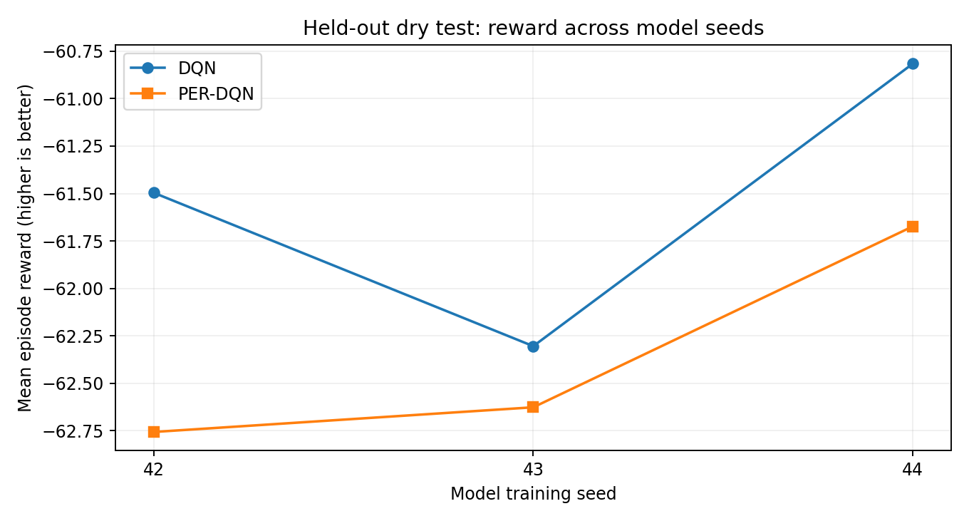

5. Interpretation
DQN had higher (less negative) reward and lower energy proxy in each tested model seed. PER-DQN had a marginally lower mean low-DO violation percentage, but seed variation is large relative to this difference. The rule-based controller had substantially lower low-DO violations, emphasizing that reward optimization does not necessarily ensure operational safety. With only three model seeds, findings should be treated as descriptive.

6. Explainable AI
Seed-42 SHAP analyses rank influent flow first, followed by tank BOD proxy, influent BOD proxy, DO and previous blower. These SHAP values explain selected-action predicted Q-values and do not establish physical causation. Decision-tree surrogate fidelity was 85.24% for DQN and 93.49% for PER-DQN; balanced fidelity was 56.87% and 61.76%, respectively. Majority-action baseline accuracy was 82.38% and 89.84%, so overall fidelity must be interpreted alongside class imbalance.
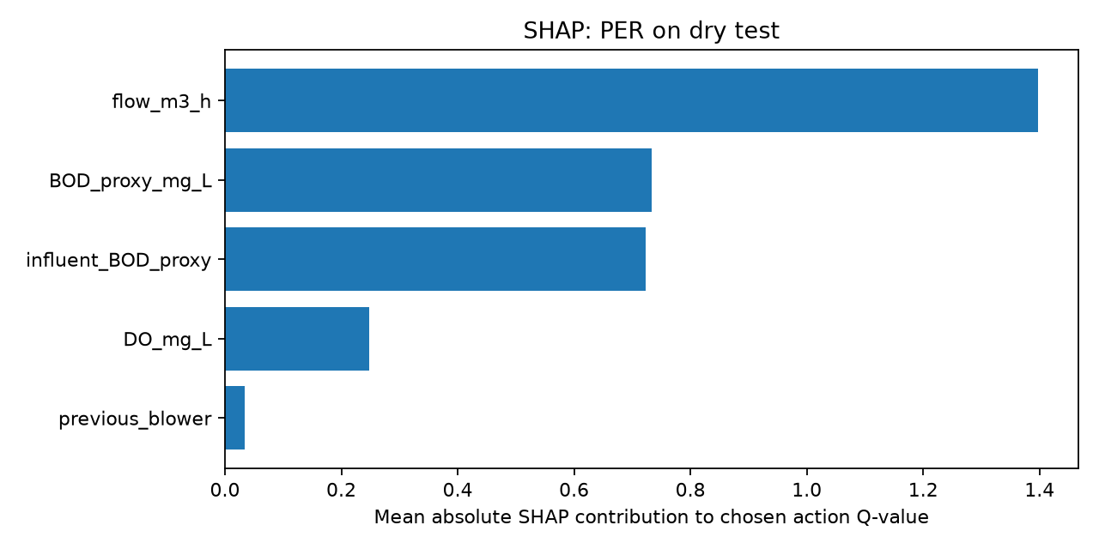

7. Interactive simulator and scenario diagnostics
The Pygame simulator demonstrates manual, automatic DO, DQN and PER-DQN modes with CSV exports of 24-hour trajectories. These runs are demonstrations, not substitutes for the chronological held-out test. Earlier rain and storm event-window diagnostics intersect training/validation periods and therefore must not be described as independent out-of-sample generalization tests.

8. Limitations and future work
The aeration tank is simplified and has not been calibrated against measured plant DO, effluent BOD or real energy consumption. The BOD variable is a proxy. Results cover only three training seeds and one held-out dry split. Future work should include more independent seeds, realistic oxygen safety constraints, blower-switching penalties, scenario-specific held-out events, physical calibration and statistical testing.

9. Submission evidence and provenance
Source: project outputs previously supplied in Wastewater_AI_Results.zip..zip (SHAP/rules, seed-42 metrics), plus the user-provided PowerShell console results for the three seed-specific held-out evaluations. The newly generated multiseed_results_transcribed.csv is transcribed from console output; original seed-specific CSVs are saved on the user’s computer but were not uploaded here. Include those originals and all six checkpoints in the final submission.

Appendix: per-seed results
Seed 42: DQN reward -61.496, PER-DQN reward -62.756; DQN energy 22.916, PER-DQN energy 23.922.
Seed 43: DQN reward -62.304, PER-DQN reward -62.626; DQN energy 22.244, PER-DQN energy 23.194.
Seed 44: DQN reward -60.816, PER-DQN reward -61.673; DQN energy 22.528, PER-DQN energy 23.009.

