BPMN To-Be Model for a Real Estate Marketplace System

Introduction

In this report I introduce a Business Process Model and Notation (BPMN) “To-Be” model for a real estate marketplace system. The model is built on the property classification flowchart provided but expanded into a formal and structured business process. The flowchart is originally based on defining property types based on certain characteristics. Real-world systems go beyond classification, however. So, the model brings property classification together with listing, selling, and renting properties. The purpose of this report is to share the rationale behind the BPMN model development, justify the design decisions taken, and provide an insight into the system that is designed to facilitate property purchase and rental. This model also considers time and cost per process cycle to provide a more realistic representation.

Modelling Approach
This flowchart was treated as the As-Is model and a simplification of how property classification is currently done. This was transformed into a To-Be BPMN model in turn. Its structure, clarity, and completeness increase. BPMN was selected because its standard elements like tasks, gateways, events, and swimlanes can represent and describe processes. It is easier to visualise the flow of activities and clearly delineate responsibilities. Instead of translating the flowchart directly, the process was reimagined to add other elements that reflect real-life actions. This involves validation, interaction between the various participants, and the transaction process for both sales and rentals.

Process Structure (Pools and Lanes)
The model utilizes one pool, Real Estate Marketplace, that embodies the whole of the system, in terms of a single system where all the activities take place. Within this pool the process is divided into the following lanes:
Property Owner – supplying property details and making final decisions on offers and applications.
Real Estate Agent – is the lead coordinator, communicating, reviewing information, and managing listings.
Real Estate System – validating, classifying, and storing information.
Buyer – uses the system to look for listings, request inspections, and complete transactions.
Broker – the official on legal and financial matters when a property is sold.
External Authority (Council) – where relevant, verifies zoning and regulatory information.
Due to the clarity of roles, it strengthens accountability, as activity can now easily be assigned to the correct role.

Entities and Attributes
It incorporates various categories of properties, including houses, apartments, townhouses, duplexes, commercial or rural properties. The property characteristics are then defined for:
• Address
• Land size
• Property size
• Property type
• Council rates
• Local government area (LGA).
These are the attributes you need for classification and how the property is processed on the system. The model reflects in detail the way real estate platforms store and analyse property data by including these attributes

Property Classification Process
The process begins when the Property Owner submits property information. The Real Estate Agent ensures that this information is complete before sending it to the Real Estate System. It performs address validation. If the address is invalid, the process loops back to the agent asking for corrections. This ensures data accuracy before proceeding. Once validated, the system captures property attributes and determines whether the property is residential or non-residential. This decision relies on criteria including land use and structure. Zoning or regulatory details which are important for accurate decisions can also be checked by the External Authority (Council). The system then assigns a property type and stores the property record. Once classification is done, the Real Estate Agent examines the classification results and generates a property listing. So, at this stage the route becomes two different paths with listing the property as either being for sale or rent.

Property Purchase (Sale) Process
Buyer search property listings and ask for inspection starts the sale process. Inspection is arranged by the Real Estate Agent so that the buyer can assess the property. The buyer presents a purchase offer after inspection. This offer is presented to the Property Owner by the agent, who considers the offer and decides whether to accept or reject it. Upon rejection of the offer the agent conveys this news to the buyer. If the offer is accepted, the Broker gets it in place, checks legal and financial matters. A broker then prepares the contractual paperwork and fills in the settlement. This system for vetting the deal provides the necessary checks to know that ownership passes. The process concludes with the property being successfully sold.

Property Rental Process
It all starts when the buyer looks up rental listings, shows up at an inspection, and then files a rental application. The application is evaluated by the Real Estate Agent as per the above process, after which a Property Owner makes the ultimate decision. As a result of this two-step review, operational and ownership perspectives are considered. The agent immediately gives the applicant notice if the application is declined. If approved, the owner approves the tenant, and when approved, the agent creates the lease document. The tenant then pays the bond and first rent, and an agent directs the property handover. This enables a seamless handoff along with correct paperwork. It ends with the rent being done.

Design Justification
Many design decisions were made to ensure that the model can be realistically built and understood. First, a single pool is used to represent a real estate marketplace as one unified system. This facilitates model simplification, while preserving the separation of functions by way of lanes. Second, tasks were assigned to lanes based on real-world duties. For example:
• Validation and Classification: In Real Estate System
• Approval decisions are made by the Property Owner
• The Broker manages legal, and settlement matters
Key decision points, like were represented using gateways
• Address validity
• Property type classification
• Offer acceptance
• Rental approval
Such decisions are fundamental in managing the progress of the process. Finally, loops (e.g., address correction) were added to represent real scenarios in which information might need to be amended.

Time and Cost Estimation
To enhance realism, estimated time and cost were included for both sale and rental processes.

Sale Process (Estimated Time)
- Property search and inspection: 2–5 days
- Offer review and negotiation: 1–3 days
- Legal and financial checks: 7–14 days
- Settlement: 14–30 days

Rental Process (Estimated Time)
- Property search and inspection: 1–3 days
- Application review: 2–4 days
- Approval decision: 1–2 days
- Lease preparation and payment: 1–3 days
Costs associated with these processes may include:
- Administrative and listing costs
- Legal and conveyancing fees
- Application processing fees
These values can be considered reasonable estimates as they are consistent with typical real estate workflows and are utilized to show processing time and complexity

Conclusion
The BPMN To-Be model provides a structured and comprehensive representation of a real estate marketplace system. It extends the original classification flowchart into a complete business process that includes both sale and rental workflows. The model promotes the transparency and understanding of the process through delineation of roles, responsibilities, and decision points. It also illustrates the usefulness of BPMN in modelling complicated systems in a clear and logical way. Overall, the model highlights the importance of structured process design in supporting efficient and reliable real estate operations.

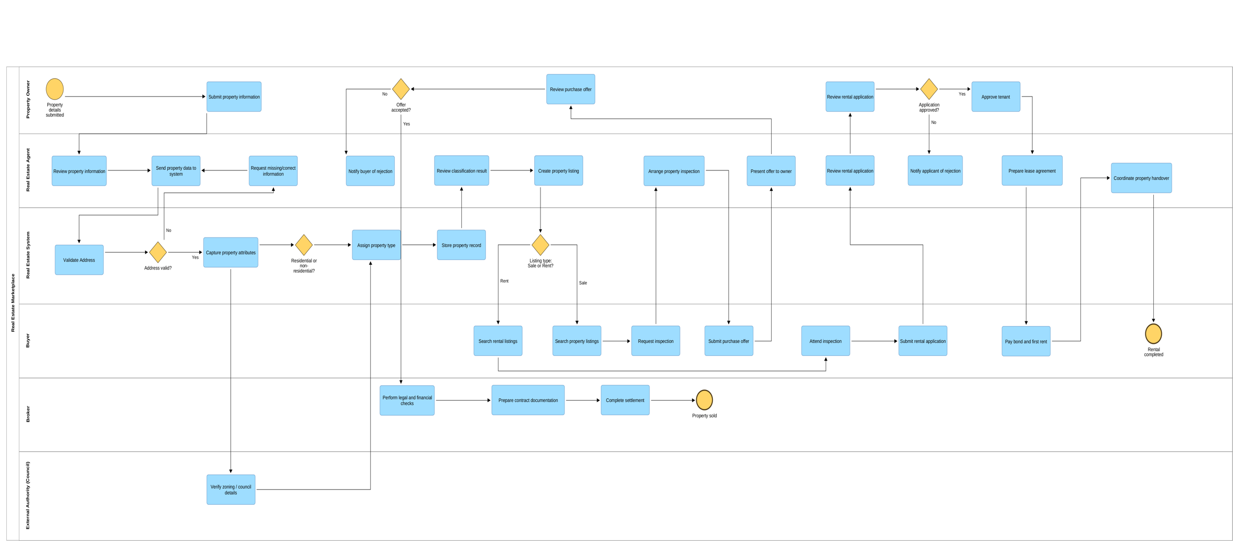
Figure1: Overview of BPMN Model
Appendix A
The diagram should be read sequentially from Figure 1 to 8, following the process flow from left to right and across swimlanes.

Figure 1:Property submission and initial validation process
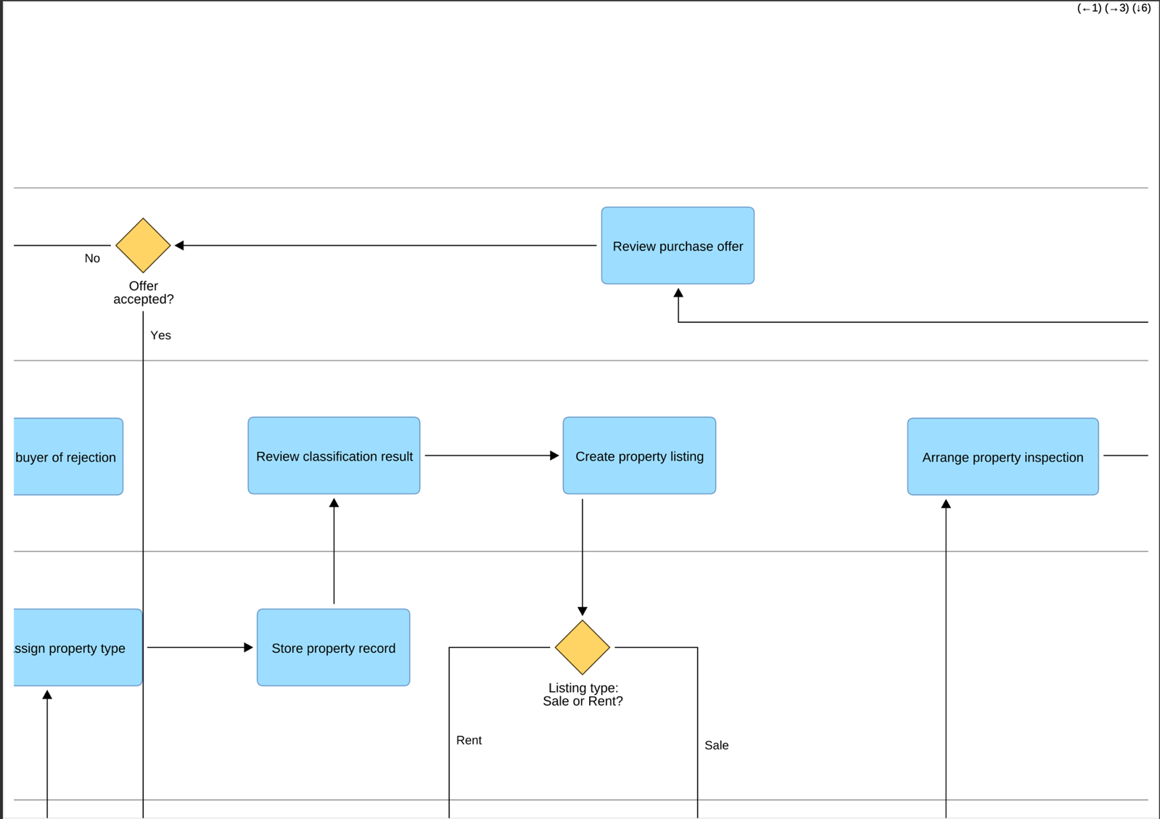
Figure 2: Property classification and listing creation process
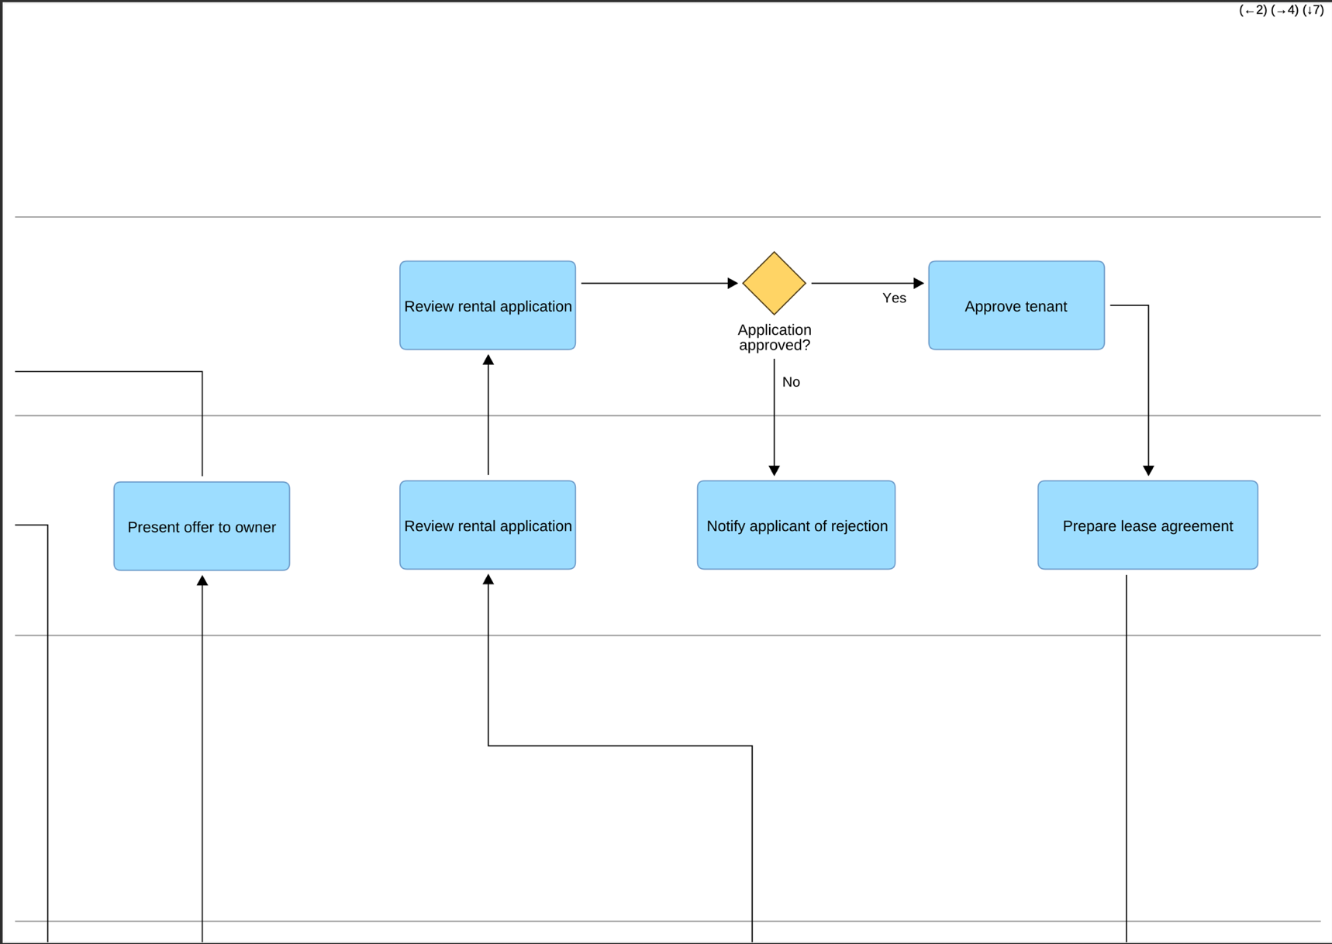
Figure 3: Property classification and listing creation process
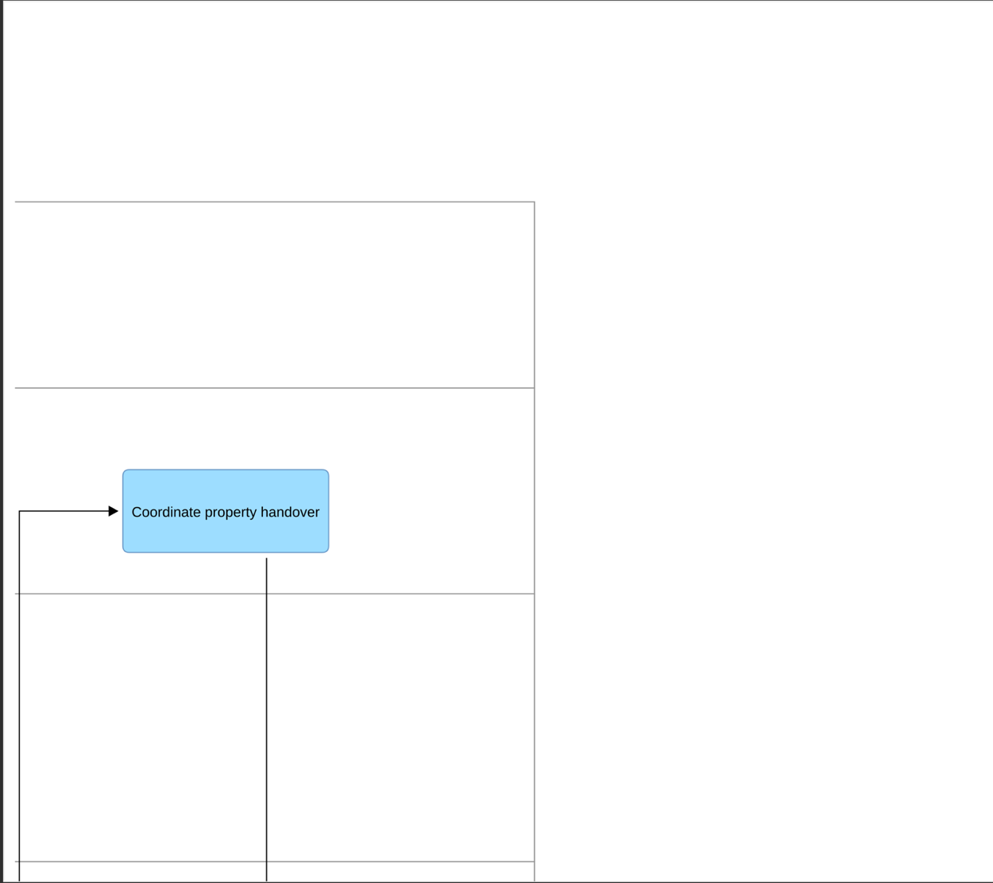
Figure 4: Rental process continuation and tenant onboarding
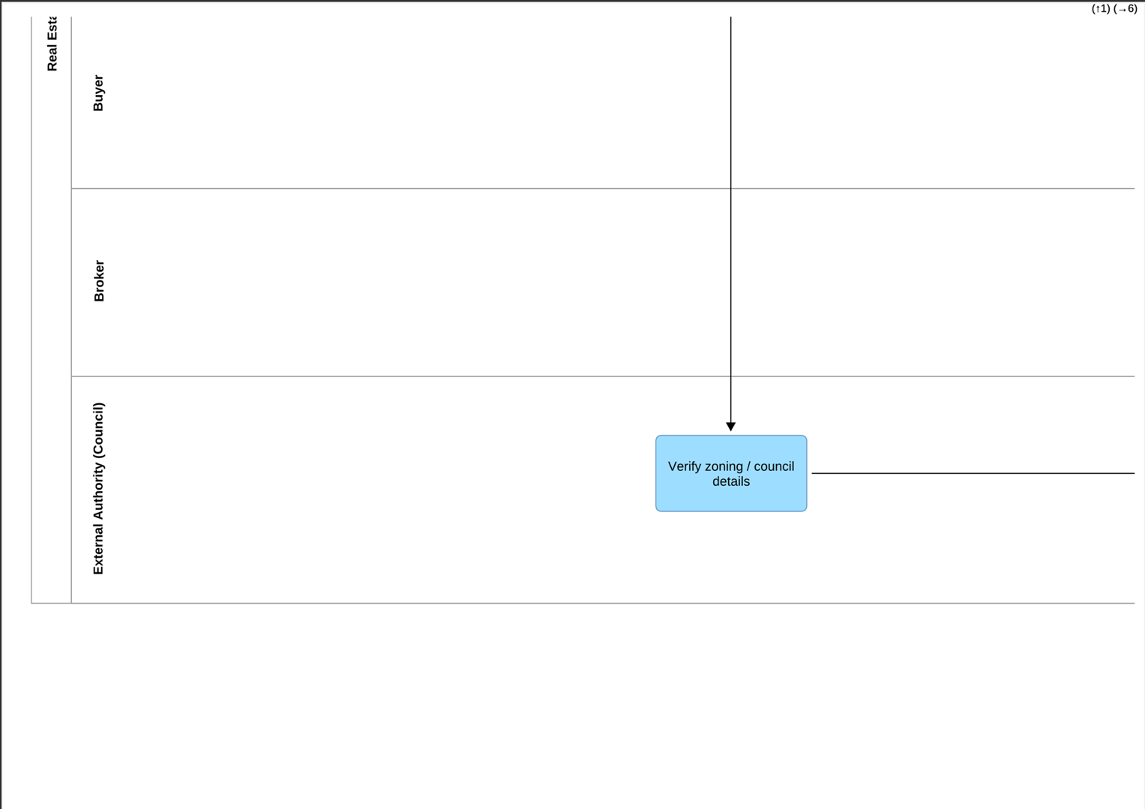
Figure 5: External authority verification and compliance process
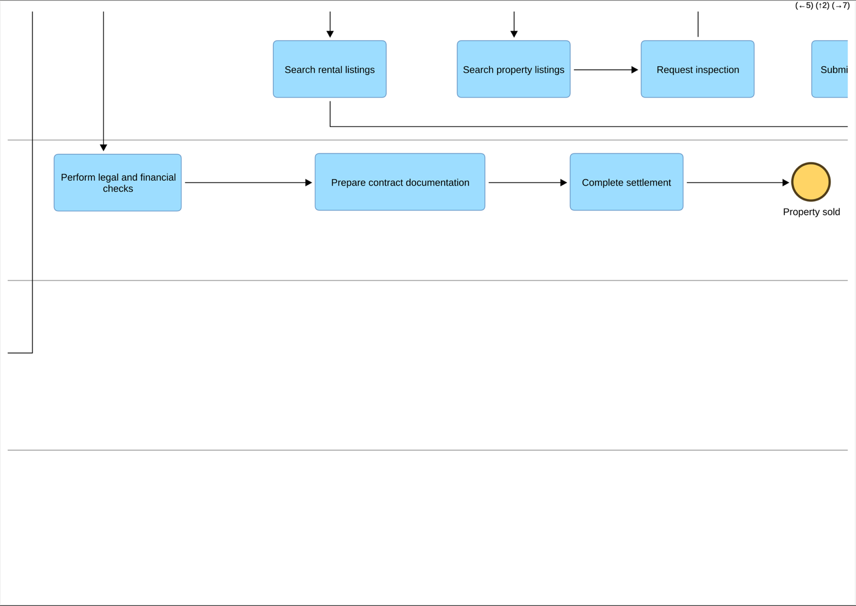
Figure 6: External authority verification and compliance process
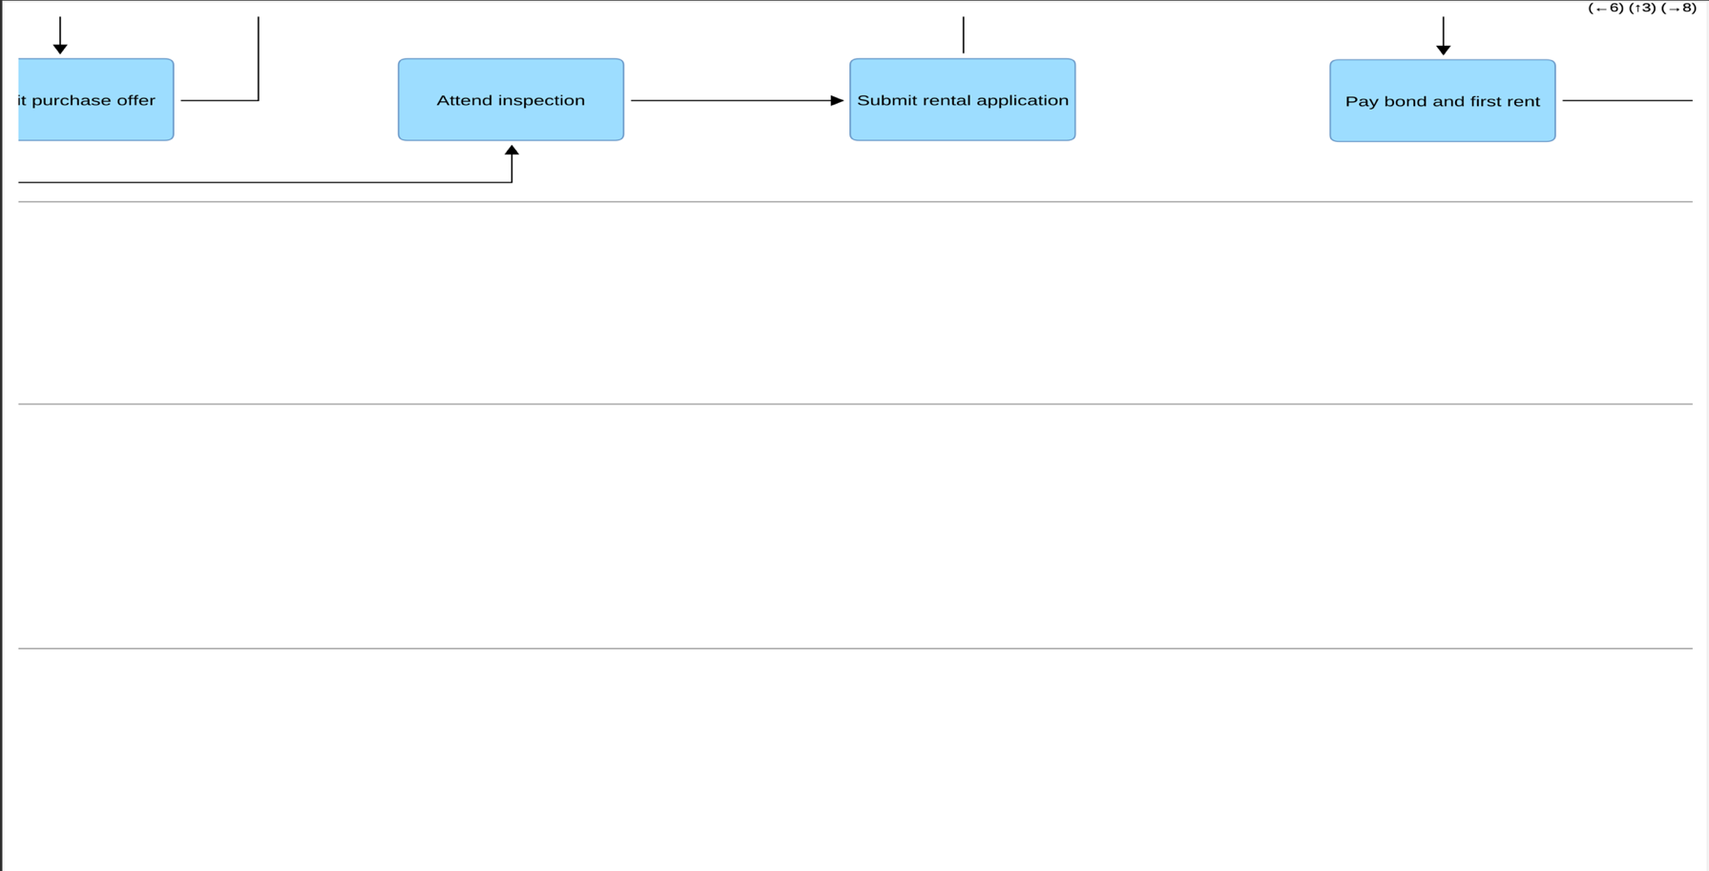
Figure 7: Property sale process including legal and financial checks

Figure 8: Process completion and finalisation of property transaction

