create table maman (

cinMama NUMBER(10) primary key,

nomMama VARCHAR2(15) not NULL,

prenMama VARCHAR2(15) not NULL,

dateMaman date

);

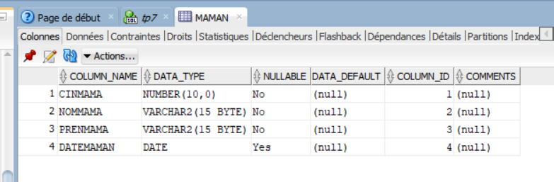

create table enfant(

NumEnf NUMBER(7),

CinMama NUMBER(10),

PrenEnf VARCHAR2(15),

NomEnf VARCHAR2(15),

dateEnf date,

Poids number(5,2),

taille NUMBER(10),

constraint Fk_1 FOREIGN KEY(CinMama)REFERENCES maman(cinMama),

CONSTRAINT PK_1 PRIMARY KEY(NumEnf,CinMama),

CONSTRAINT UN_1 UNIQUE(PrenEnf,NomEnf)

);

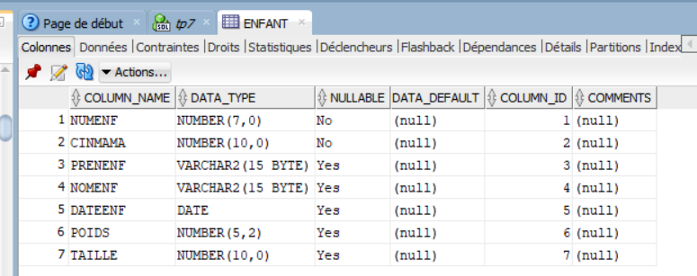

create table vaccin(

CodeVacc VARCHAR2(15) primary key ,

LibVacc VARCHAR2(40) UNIQUE,

AgeVacc NUMBER(4),

uniteAge varchar2(1) CHECK(uniteAge in('J','M','A'))

);

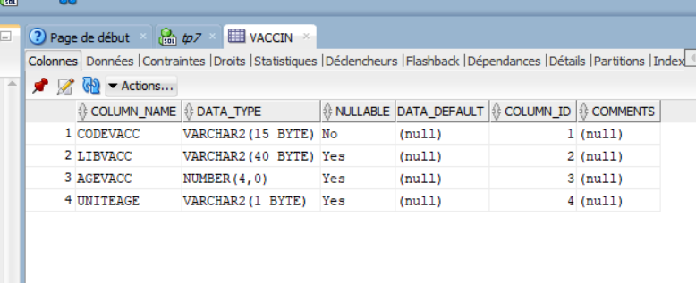

CREATE table effectuerVaccin(

NumEnf NUMBER(7),

CinMama NUMBER(10),

CodeVacc varchar2(15) REFERENCES vaccin(CodeVacc),

dateRealVacc date,

CONSTRAINT FK_2 FOREIGN key(NumEnf,CinMama)REFERENCES enfant(NumEnf,CinMama),

CONSTRAINT Pk_2 PRIMARY key(NumEnf,CinMama,CodeVacc)

);

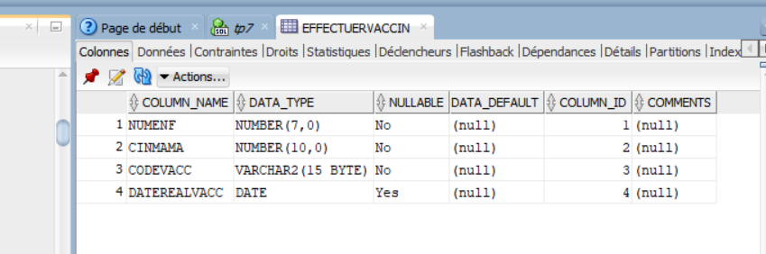

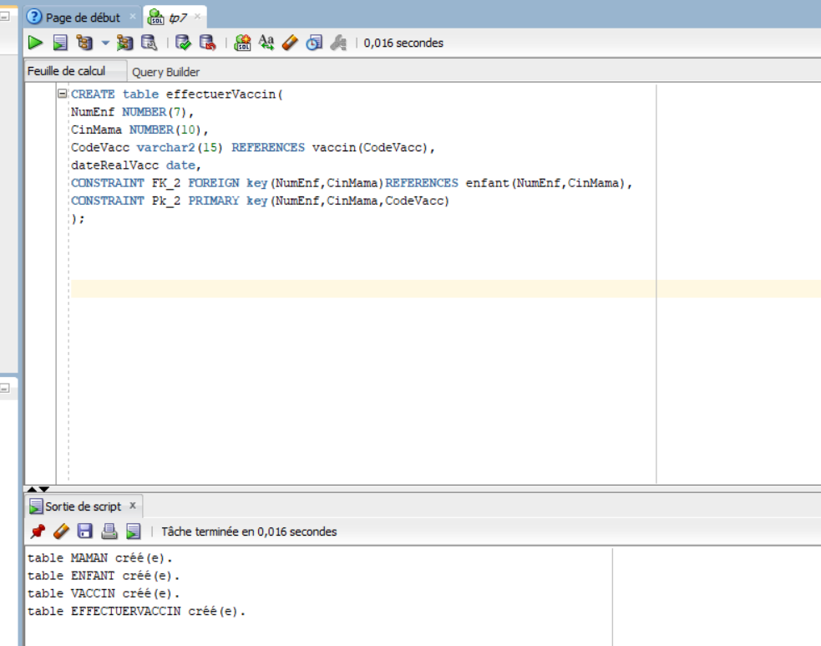

2-

insert into MAMAN VALUES(05020203,'Tounsi','Alia','05/04/1990');

insert into ENFANT VALUES(1,5020203,'Ali','Derbel','10/10/2017',3.5,53);

insert into VACCIN VALUES('VHB-0','Vaccin de lhepatite B',1,'J');

insert into EFFECTUERVACCIN VALUES(1,5020203,'VHB-0','11/10/2017');

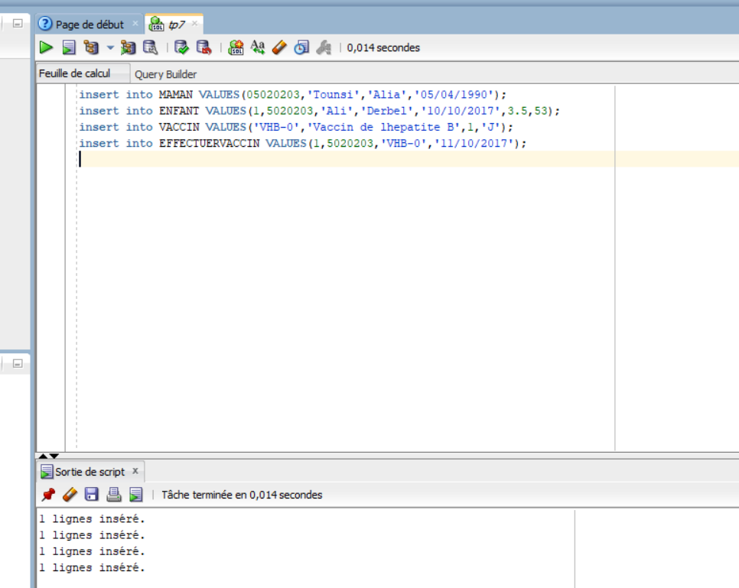

3)

-select* from VACCIN where (upper(uniteAge )='J' and AgeVacc <365)or (upper(uniteAge )='M' and AgeVacc <12);

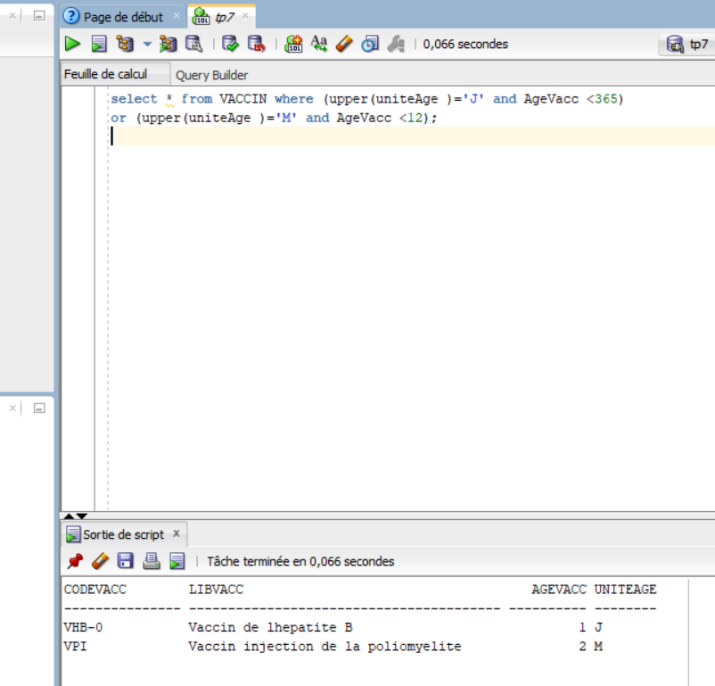

-select e.*,floor(months_between(e.dateEnf,m.dateMaman)/12)"Age" from ENFANT e,maman m where e.cinMama =m.cinMama ;

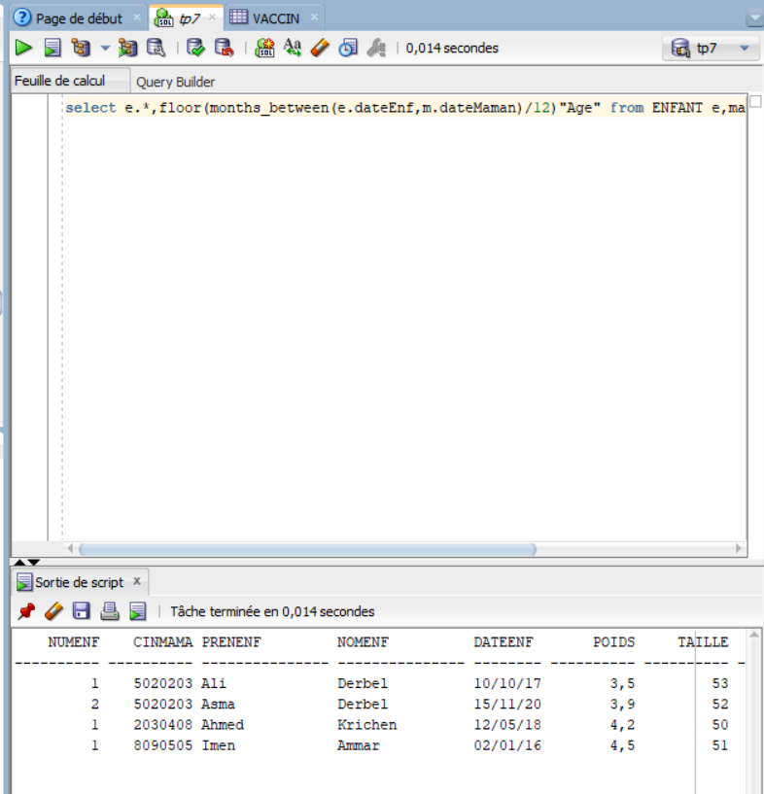

-select V.* FROM VACCIN V, EFFECTUERVACCIN E,ENFANT T where E.CODEVACC=V.CODEVACC and E.NUMENF=T.NUMENF and upper(T.PRENENF)='ALI' and upper(T.NOMENF)='DERBEL';

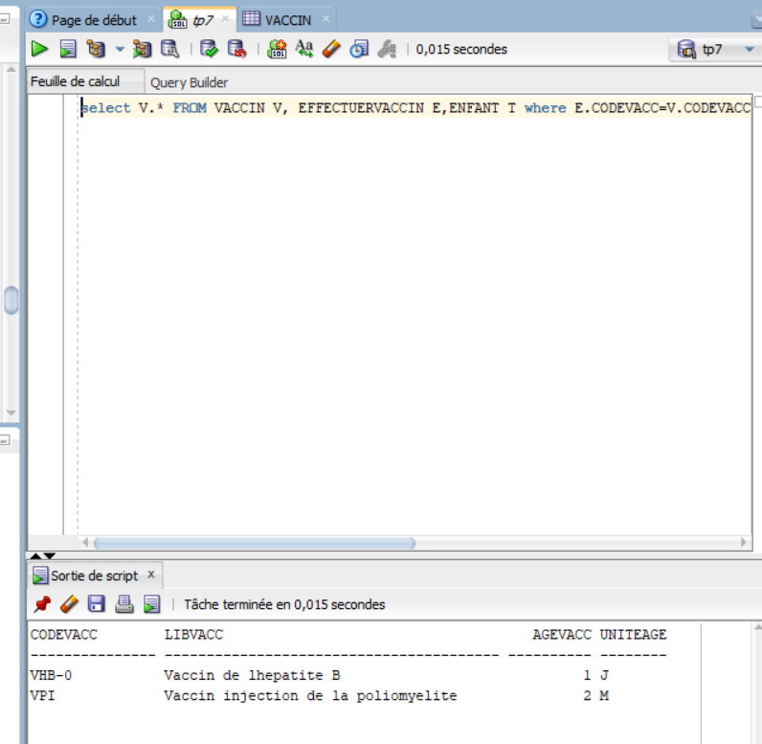

-SELECT * FROM VACCIN ORDER BY AGEVACC ;

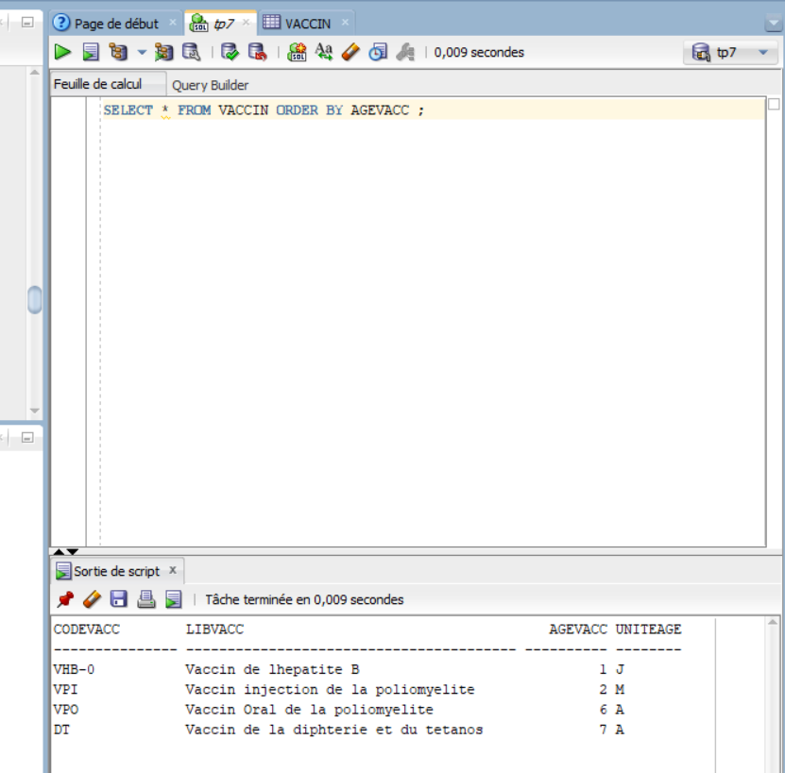

-SELECT M.cinMama,count(E.NumEnf) from MAMAN M,ENFANT E WHERE M.CINMAMA=E.CINMAMA GROUP BY M.CINMAMA;

-select M.* from MAMAN M,ENFANT E where E.CINMAMA=M.CINMAMA and E.DATEENF=(select MIN(E.DATEENF) from ENFANT);

OU

select CinMama ,e.PrenEnf ,e.NomEnf from enfant e

where e.dateEnf =(select max(dateEnf ) from enfant e1 where e.CinMama =e1.CinMama );

-select F.CinMama , PrenEnf , NomEnf from enfant e, EFFECTUERVACCIN F where e.CinMama = F.CinMama and e.NumEnf = F.NumEnf group by(F.CinMama , PrenEnf , NomEnf ) having(count(*)=(select count(*)from ENFANT))

-select e.* from enfant e,vaccin where upper(CodeVacc) = 'VPI' and decode(upper(uniteAge),'J',dateEnf+AgeVacc,'M',add_months(dateEnf,AgeVac),'A' , add_months(dateEnf,AgeVacc*12))=sysdate + 1;

-select m.*from maman m,ENFANT e where months_between(e.dateEnf,dateMaman)>40*12 and m.cinmama=e.CINMAMA;

-select e.CinMama,PrenEnf, NomEnf from ENFANT e,vaccin v,effectuerVaccin ev where e.CINMAMA=ev.CINMAMA and ev.CodeVacc=v.CodeVacc and count(ev.NumEnf)=4 group by e.CinMama,PrenEnf, NomEnf;

-select dateRealVacc, codevacc, count(*)"Nbre vaccins effectue"

from effectuerVaccin where TO_CHAR(dateRealVacc,'MM/RR')=TO_CHAR(sysdate,'MM/RR')

group by dateRealVacc,CodeVacc;

-select E.CinMama,E.PrenEnf,E.NomEnf from enfant E,effectuerVaccin ev

where E.NumEnf=ev.NumEnf ev.CodeVacc in (select CodeVacc from VACCIN

where months_between(E.dateEnf,sysdate)/12<AgeVacc);