Name: NourElDin Nabil Salah Desouky  
Track: ITI Full Stack Using Python R2 2024/2025

1: Find your mac address 🡺 Physical Address ` 🡺 18-C0-4D-9A-3E-56

2: Find your real IP addresses

3: Find your private IP addresses 🡺 IPv4 Address 🡺 192.168.1.100

**Ipconfig /release** 🡺 will release the **IP** and **Ipconfig /renew** 🡺 will renew the **IP**

4: Find current session and ports on your device

5: Find The IP of the domain Yahoo.com

**6:** How to use your local firewall to block a port and stop DOS attack from a zombie device

**Open Resource Monitor:** Look for the ports that are experiencing high traffic, which could indicate a DOS attack.

**Open Windows Defender Firewall with Advanced Security:** Control Panel **>>** System and Security **>>** Windows Defender Firewall **>>** advanced settings.

**Create an Outbound Rule to Block the Port**:

* Click **Outbound Rules** on the left panel.
* Select **New Rule** on the right-hand side.
* Choose **Port** and click **Next**.
* Select **TCP** or **UDP** depending on the protocol of the port being attacked.
* Enter the specific port number to block and click **Next**.
* Select **Block the connection** and click **Next**.
* Choose when the rule applies (Domain, Private, Public) and click **Next**.
* Name the rule and click **Finish**.

**Use IP Blocking to Isolate Zombie Device:**

**Identify the IP of the zombie device:** open **CMD** and type **netstat -n**, Look for repeated suspicious connections from the same IP.

**Block the IP Address:**

* In the **Windows Defender Firewall with Advanced Security**, create a **New Rule**.
* Select **Custom** and click **Next**.
* Select **All Programs** to apply to all programs.
* Under **Protocol and Ports**, leave it as-is and click **Next**.
* Under **Scope**, enter the zombie device's IP in the **Which remote IP addresses this applies to** section.
* Select **Block the connection** and click Next.
* Choose when the rule applies (Domain, Private, Public) and click **Next**.
* Name the rule and click **Finish**.

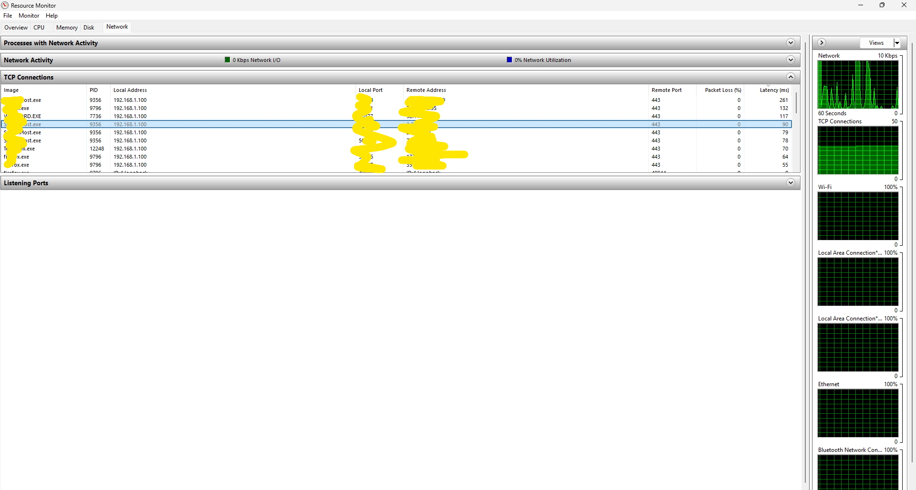

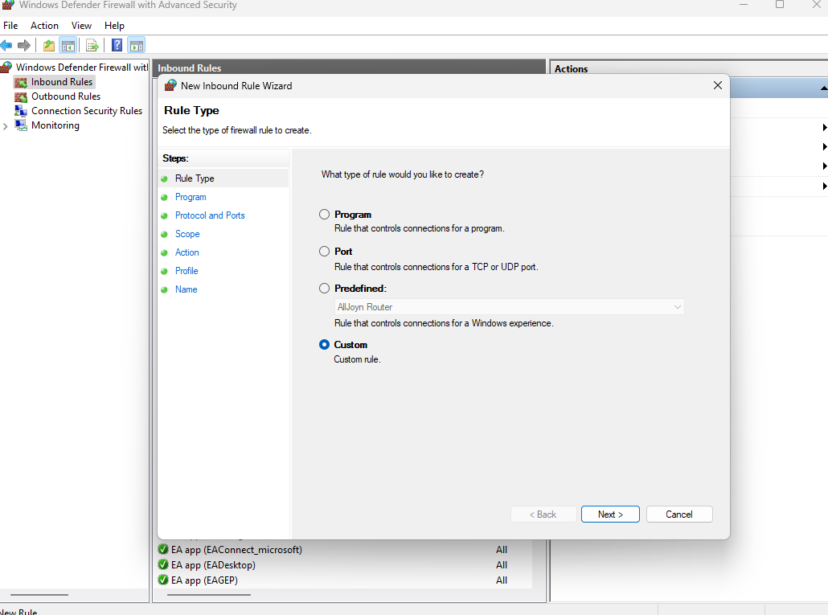

7: Use the VirtualBox tool to host the two different OS on your machine

1. **Open VirtualBox** and click New.
2. **Name Your VM**
3. **Select the ISO File**
4. **Allocate Resources and click finish**
5. **Start the VM**

