

COE324 – Microprocessors Lab – Fall 2025

Department of Electrical and Computer Engineering
Instructor: Shaza Khatib

Final Project
“Design and Implementation of a 3-Stage Elevator System Using HCS12 Microcontroller”
Fall 2025

Section #32
Instructor: Mrs. Shaza Khatib

Student Names and IDs:
Nour El Mais – 202302510 / Edward Mouawad – 202300736
Elissa Saad – 202301670 / Omar Chehab – 202300923

Table of Contents
Table of Figures 3
Introduction 4
Connections on the Board 5
Push Button Connections 6
LED Connections 7
Buzzer Connections 7
Code Explanation 8
Configuration 8
Comparison Logic 9
MOVE UP 13
MOVE DOWN 15
Idle State 17
Delay Subroutine 18
Interrupt Subroutine 19
Weight Block 20
Read Weight Subroutine 22
LCD Subroutine 23
Challenges 26
Conclusion 27

Table of Figures
Figure 1: Connections (3) 5
Figure 2: Connections (2) 5
Figure 3: Connections (1) 5
Figure 4: J1 Connector 6
Figure 5: Configuration Code 8
Figure 6: Comparison (2) 9
Figure 7: Comparison (1) 9
Figure 8: Comparison (3) 9
Figure 9: MOVE UP 13
Figure 10: MOVE DOWN 15
Figure 11: IDLE state 17
Figure 12: Delay subroutine 18
Figure 13: Interrupt subroutine 19
Figure 14: Weight block 20
Figure 15: Read weight subroutine 22
Figure 16: LCD subroutine 1 23
Figure 17: LCD subroutine 2 23

Introduction
In this project, we designed and implemented a 3-stage elevator system using the HCS12 microcontroller, and the MCCNT underflow interrupt to periodically check the pressed buttons and drive the elevator’s behavior accordingly.
The elevator responds to internal and external push-button requests, manages the elevator’s upward or downward movement, and provides indicators of the movement direction through LCD messages, LEDs, and an audible buzzer. A potentiometer-based weight sensor is integrated to detect overload conditions, ensuring that the elevator door remains open until the weight returns to a safe level.
By completing this project, we demonstrated our ability to implement multi-stage logic, schedule simultaneous floor requests, and integrate hardware safety mechanisms. The final implementation shows a complete and functional embedded system controlled entirely through HCS12 assembly.

Connections on the Board
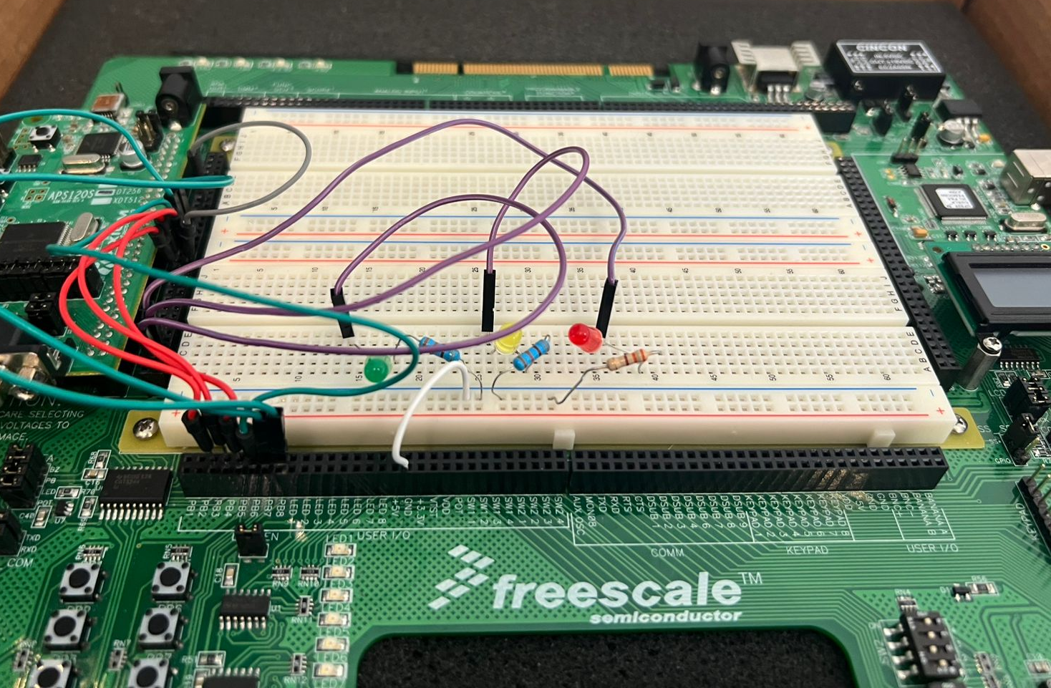
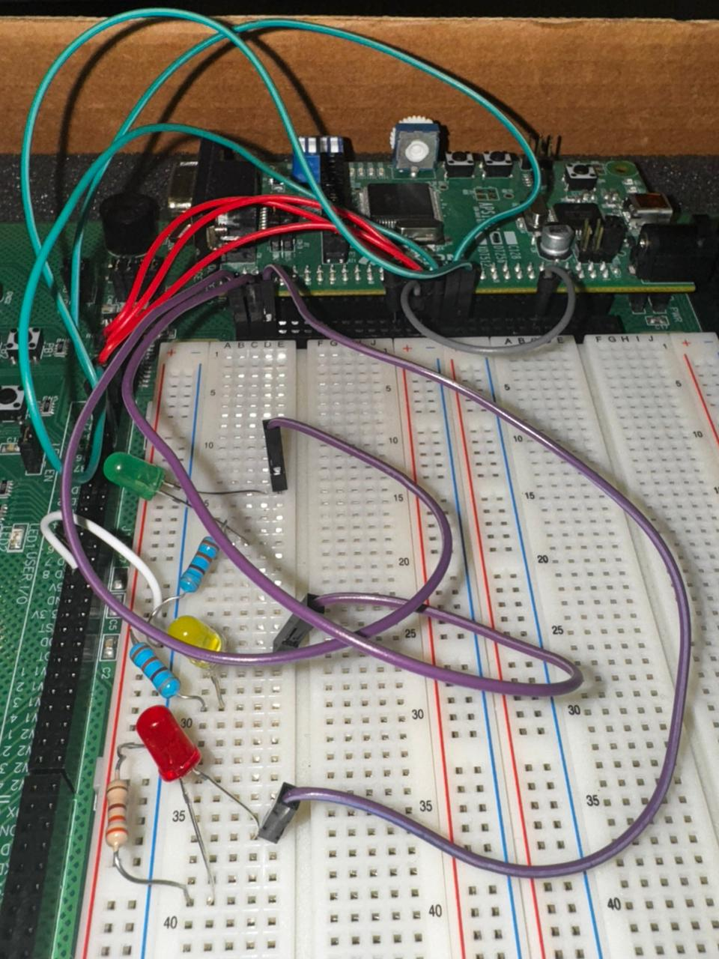
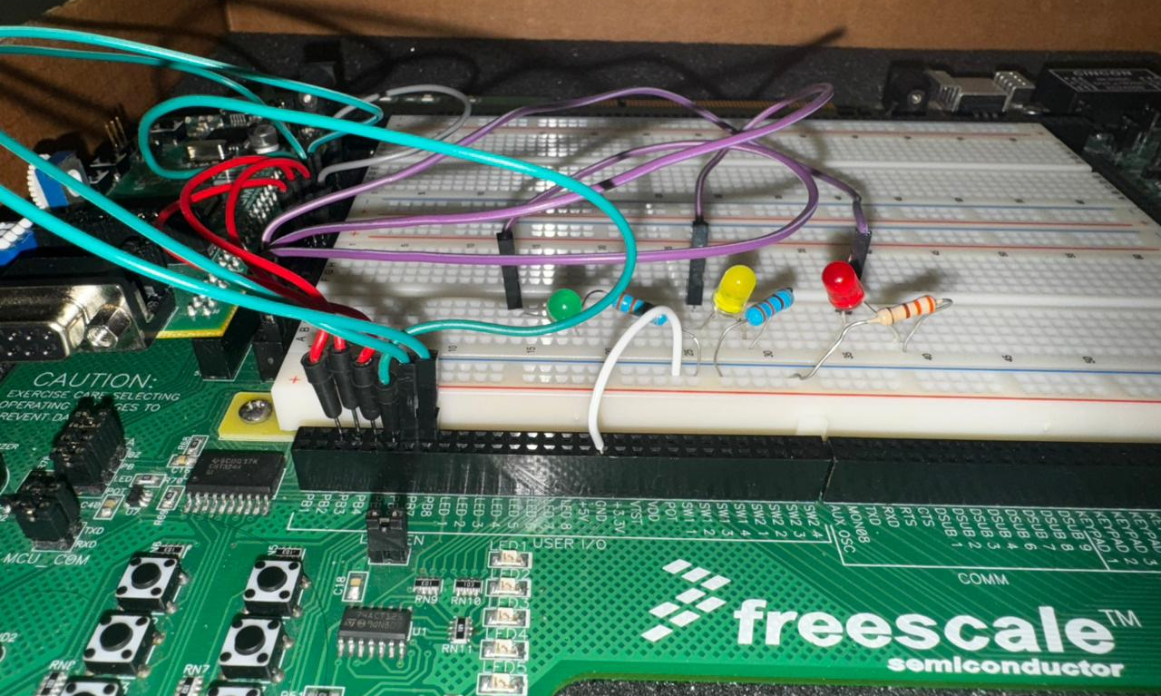
Figure 1: Connections (3)
Figure 2: Connections (2)
Figure 3: Connections (1)

Push Button Connections
The elevator includes:
- Three internal push buttons for floor selection inside the elevator PB3-PB4-PB5 connected to PORTA pins: PA2-PA3-PA4 respectively.
- Three external push buttons, one on each floor for requests outside the elevator: PB6-PB7-PB8 connected to PORTA pins: PA5-PA6-PA7
So, in our code, pushing a certain button will be reflected in PORTA, since they are all connected to this PORT.
Physically, we connected:
- PB3 to pin 35
- PB4 to pin 33
- PB5 to pin 31
- PB6 to pin 29
- PB7 to pin 27
- PB8 to pin 25
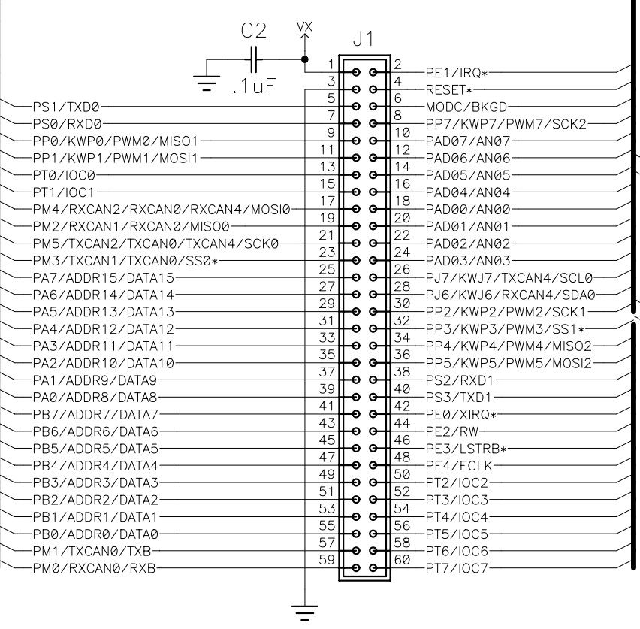
Figure 4: J1 Connector

From the configuration of the J1 connector (from the CSMB12_SCH_A1_0_0 file), we can see that PA2 is on pin 35, PA3 on pin 33, PA4 on pin 3, which justifies the connections of the internal push buttons of the elevator (PB3, PB4, PB5).
PA5 is on pin 29, PA6 on pin 27, PA7 on pin 25, which justifies the connections of the external push buttons of the elevator (PB6, PB7, PB8).

LED Connections
The elevator includes three LEDs used to indicate its movement and door status:
- A green LED connected to PORT T pin 7 (PT7), which blinks whenever the elevator is moving upward.
- A yellow LED connected to PORT T pin 6 (PT6), which blinks during downward movement.
- A red LED connected to PORT T pin 5 (PT5), which blinks when the elevator door opens.
From the diagram above, PT7 corresponds to pin 60, so we connected the green LED’s anode to this pin, and its cathode through a resistor to ground.
Similarly, PT6 corresponds to pin 58, where we connected the yellow LED’s anode and routed the cathode to ground through a resistor.
PT5 is mapped to pin 56, so the red LED’s anode was connected there, with its cathode also going to ground through a resistor.

Buzzer Connections
To drive the buzzer, we connected its input pin (pin 13) to pin 34, which corresponds to PWM channel 4 output on the HCS12. Since our design uses PWM channel 4 to generate the warning sound, this connection allows the buzzer to operate correctly.

Code Explanation

Configuration
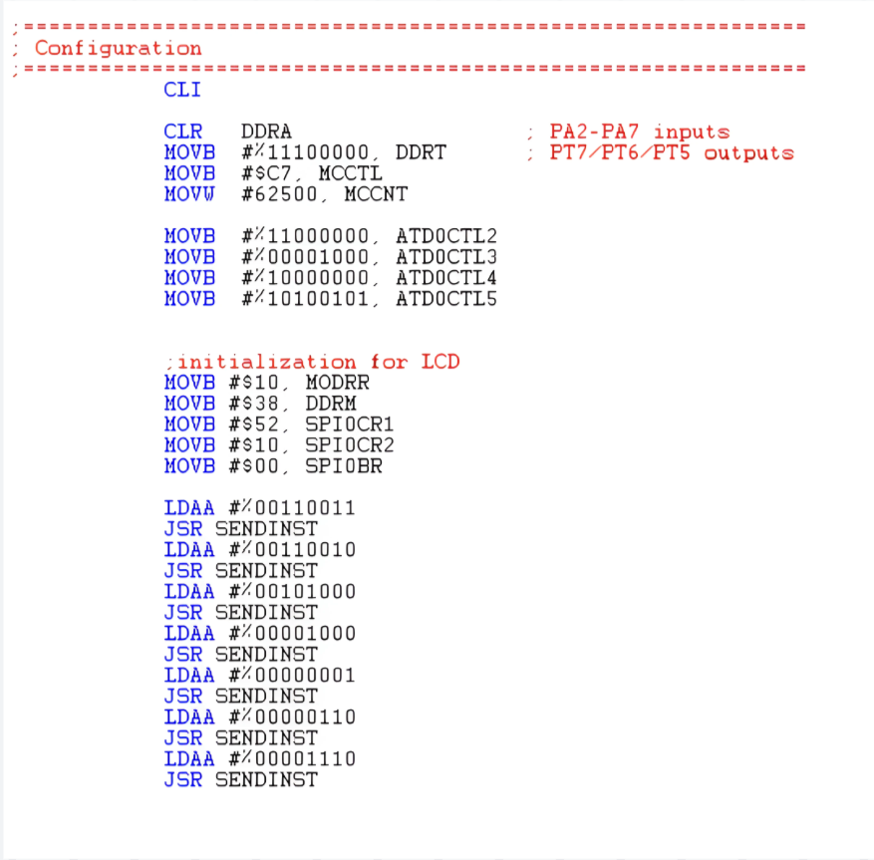

Figure 5: Configuration Code

DDRA is cleared to make PA2–PA7 work as inputs (for the 6 push buttons).
DDRT is configured so that PT7, PT6, and PT5 work as outputs (for the green, yellow, and red LEDs).
The registers needed for the MCCNT underflow interrupt to function correctly are initialized (MCCTL and MCCNT).
This enables the periodic interrupt, which is used to regularly check the push buttons and update the elevator state.
Several ATD registers are set up to turn ON the ADC module, choose the conversion mode, set the sampling rate, and select result register 0 for reading the weight sensor
The ADC is initialized so that the system can read the weight sensor value.
MODRR, DDRM, SPI0CR1, SPI0CR2, and SPI0BR configure the SPI communication used to send data to the LCD.
The series of LDAA then SENDINST instructions send the standard LCD initialization commands, to turn on the display.
This sets up the LCD so it can display messages for the elevator system.

Comparison Logic
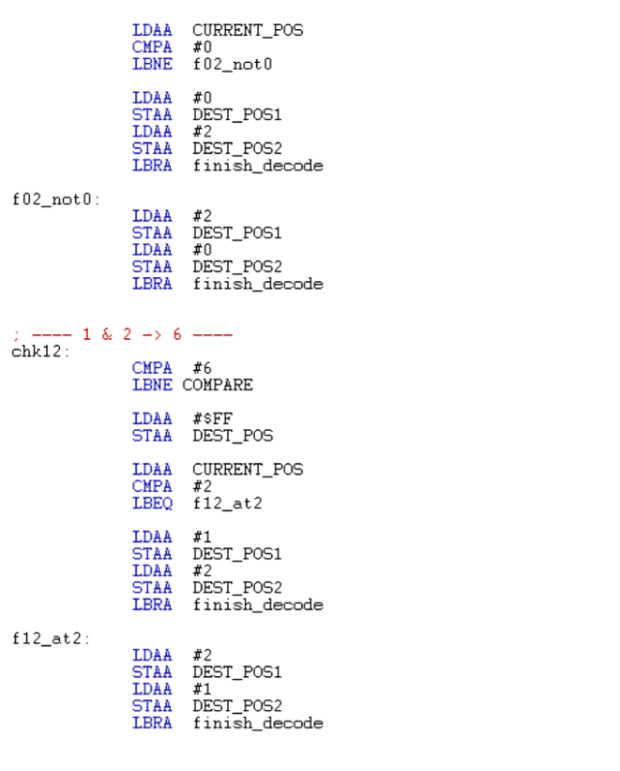
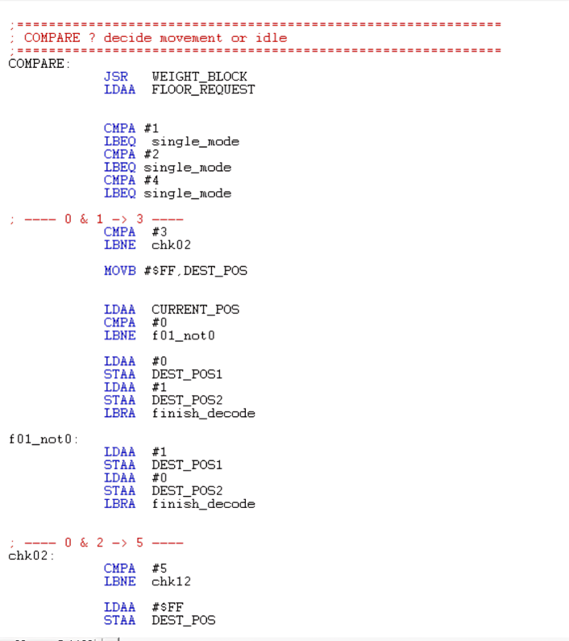
Figure 6: Comparison (2)
Figure 7: Comparison (1)
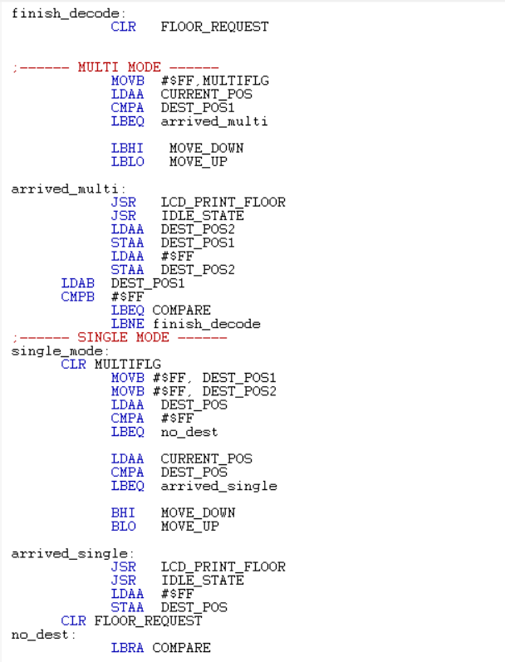
Figure 8: Comparison (3)

This part of the code is responsible for deciding where the elevator should go next based on the pressed buttons, and whether it should work in single-destination or multi-destination mode.
1. Safety Check (Weight)
At the beginning of COMPARE, the program calls WEIGHT_BLOCK.
This makes sure the weight is within the allowed limit before the elevator moves. If the elevator is overloaded, the movement logic is not executed.
2. Detecting Single vs. Multiple Requests
The variable FLOOR_REQUEST represents which floor buttons were pressed.
If it is equal to 1, 2, or 4, it means only one floor is requested (one push button was pressed), so the program goes to single_mode (this logic works because the binary representation of 1, 2 and 4 contain a single “1”).
If it is equal to 3, 5, or 6, it means that two different floors are requested at the same time (two push buttons were pressed at the same time), so the program enters multi-destination mode and prepares two destinations, that will be stored in DEST_POS1 and DEST_POS2.
If FLOOR_REQUEST is equal to:
- 3 → Floors 0 & 1 (1 + 2)
- 5 → Floors 0 & 2 (1 + 4)
- 6 → Floors 1 & 2 (2 + 4)
For each of these combinations, the code looks at the current floor (CURRENT_POS):
- Decides which floor to visit first and which to visit second.
- Stores these in DEST_POS1 (first stop) and DEST_POS2 (second stop)
After that, it clears FLOOR_REQUEST and continues to the movement part.
For example, if FLOOR_REQUEST was equal to 3:
This indicates that the user has pressed two buttons at the same time: floor 0 and floor 1. In this case, the elevator must operate in multi-destination mode, meaning it will serve two stops during the same trip.
The purpose of this block is to decide which floor should be visited first and which should be visited second, based on the elevator’s current position. The steps to do this are:
1. Switch to Multi-Destination Mode
The system disables the single-destination value by setting DEST_POS to $FF. This tells the program that we now have two destinations instead of one.
2. Determine the Order of the Two Requested Floors
The elevator decides which floor to visit first by comparing the current floor with the requested ones:
If the elevator is currently at floor 0, we serve floor 0 first, then move to floor 1.
→ DEST_POS1 = 0, DEST_POS2 = 1
If the elevator is at any other floor, the elevator serves floor 1 first, then goes down to floor 0.
→ DEST_POS1 = 1, DEST_POS2 = 0
3. Continue with the Movement Logic
Once the two destination floors are assigned, the program exits this block and returns to the main decoding logic to begin moving the elevator.
If FLOOR_REQUEST was equal to 5:
When FLOOR_REQUEST equals 5, it means the user has pressed floor 0 and floor 2 at the same time. This is another multi-destination situation where the elevator needs to visit two floors in one trip.
The goal of this code block is to determine the order in which the elevator should visit floors 0 and 2, depending on its current position.
1. Switch to Multi-Destination Mode
The program first sets DEST_POS to $FF, which disables the single-destination setting and activates multi-destination mode, since two floors are now required.
2. Choose the Correct Order of Service
The elevator compares the current floor (CURRENT_POS) with the requested floors (0 and 2) to determine which one should be served first:
If the elevator is currently at floor 0, we serve floor 0 first, then move up to floor 2.
→ DEST_POS1 = 0, DEST_POS2 = 2
If the elevator is not at floor 0, the elevator serves floor 2 first, then goes down to floor 0.
→ DEST_POS1 = 2, DEST_POS2 = 0

3. Return to the Main Logic
Once the two stops are assigned in the correct order, the program leaves this block and continues with the multi-destination movement routine. Same steps are taken if FLOOR_REQUESTS = 6 (if floors 1 and 2 were requested at the same time).
So, as a summary of the logic in this block of code:
If the user presses only one floor button, the system detects a single request and enters single-mode. The program clears any multi-mode flags and uses only the variable DEST_POS to store the target floor. If there is no pending destination, the system returns to the main loop and waits for a new request.
Otherwise, the elevator compares its current floor with the requested floor:
- If the requested floor is above, it moves up.
- If the requested floor is below, it moves down.
- If it is already at that floor, it goes directly to the arrival routine.
Arrival routine:
- The elevator displays the floor number on the LCD.
- It enters an idle state (doors open / waiting).
- It clears the destination and waits for new requests.
If two floor buttons are pressed simultaneously, the program enters multi-mode.
- The system first determines which two floors were selected.
- It then chooses the most logical order to serve them by comparing the elevator’s current position with both requested floors.
- The closer floor becomes DEST_POS1 (first stop).
- The farther floor becomes DEST_POS2 (second stop).
Arrival routine (first stop):
Once the elevator reaches DEST_POS1:
- It updates the LCD & enters the idle state (opens the door, i.e., to blink red LED)
Then the program shifts the second destination:
DEST_POS1 ← DEST_POS2
DEST_POS2 ← $FF (to signal that there is no longer a second stop)
If there is still a second destination, the elevator immediately starts moving towards it.
If both destinations are done, the system returns to the main loop and waits for new requests.

MOVE UP
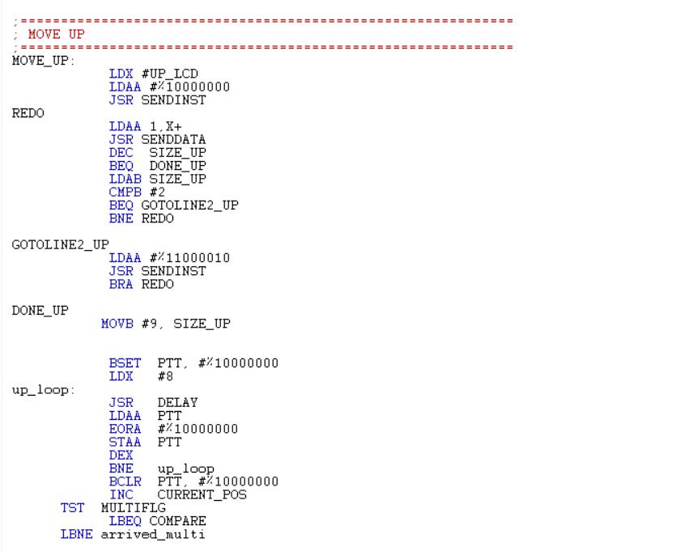

Figure 9: MOVE UP

The MOVE_UP routine is responsible for handling the elevator’s behavior when it needs to move one floor upward. It does three things:
- Displays a message on the LCD (MOVING UP)
- Blinks the green LED while moving
- Updates the current floor and returns to the main control logic

1. Display the “moving up” message
At the beginning of the routine:
A pointer is loaded to a predefined text stored in memory (UP_LCD), which contains the message to be shown when the elevator is moving up (“MOVING UP”). The program first positions the LCD cursor at the start of the first line. Then, inside the loop, it sends each character of the message to the LCD. The word MOVING is displayed on the first line of the LCD, and the rest of the text appears on the second line.
After finishing, SIZE_UP is reset so that the message can be printed again the next time the elevator moves up.
2. Blink the green LED during upward movement
After finishing with the LCD:
The program turns on the green LED connected to PT7.
It then enters a loop where it:
Calls a delay routine (250ms), toggles the state of the green LED (ON/OFF), repeats this a fixed number of times.
Due to the elevator needing 2 seconds to reach a floor, then the LED should keep blinking for 2s. The delay subroutine generates a delay of 250ms, so the LED should repeat the blinking 8 times. $8 × (250 × 10^{-3}) = 2s$
At the end of the loop, the green LED is turned off.

3. Update the current floor and return to control logic
At the end of the routine:
The variable CURRENT_POS is incremented by 1, since the elevator has moved up one floor.
The program then checks the MULTIFLG flag:
If MULTIFLG is 0 → the elevator is in single-destination mode, so it returns to COMPARE to check if it has reached the requested floor or needs to keep moving.
If MULTIFLG is not 0 → the elevator is in multi-destination mode, so it jumps to arrived_multi to handle the logic of serving multiple requested floors.

MOVE DOWN
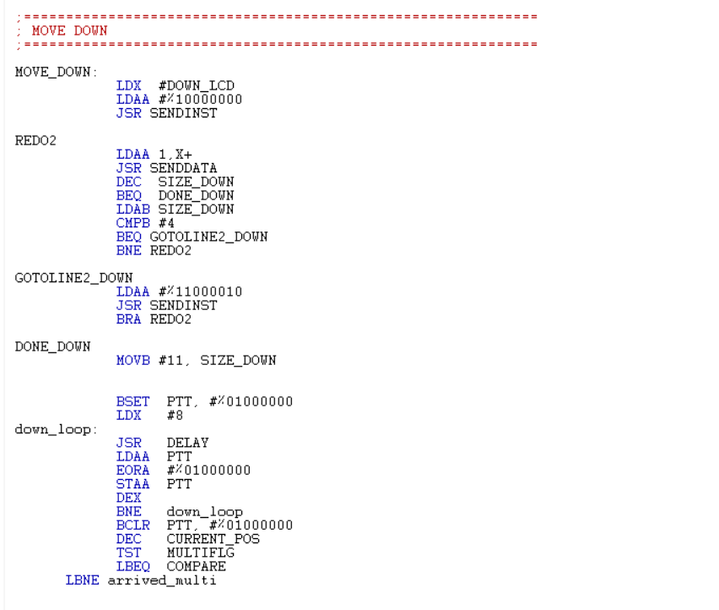
Figure 10: MOVE DOWN

The MOVE_DOWN routine is responsible for handling the elevator’s behavior when it needs to move one floor downward. It performs three main tasks:
- Displays a message on the LCD (“MOVING DOWN”)
- Blinks the yellow LED while the elevator is moving down
- Updates the current floor value and returns to the main control logic
1. Display the “MOVING DOWN” message
At the beginning of the routine:
A pointer is loaded to a predefined text stored in memory (DOWN_LCD), which contains the message to be shown when the elevator is moving down (“MOVING DOWN”).
The program positions the LCD cursor at the start of the first line.
Inside the loop, each character of the message is sent to the LCD one by one.
The program first positions the LCD cursor at the start of the first line. Then, inside the loop, it sends each character of the message to the LCD. The word MOVING is displayed on the first line of the LCD, and the rest of the text appears on the second line. After completing the printing, SIZE_DOWN is reset so that the message can be printed again the next time the elevator moves down.
2. Blink the yellow LED during downward movement
After finishing with the LCD:
The program turns on the yellow LED connected to PT6.
It then enters a loop where it:
Calls a delay routine (of 250ms), toggles the state of the green LED (ON/OFF), repeats this a fixed number of times.
Since moving between floors takes 2 seconds, and the delay subroutine produces 250 ms, the LED must blink:
$$\frac{2\text{ s}}{0.25\text{ s}}=8\text{ times}$$
So the yellow LED blinks exactly 8 times while the elevator moves down one floor.
At the end of the loop, the LED is turned off.
3. Update the current floor and return to control logic
At the end of the routine:
The variable CURRENT_POS is decremented by 1, since the elevator has moved down by one floor.
The program then checks the MULTIFLG flag:
If MULTIFLG = 0 → the elevator is in single-destination mode, so it returns to COMPARE to check if it has reached the requested floor.
If MULTIFLG ≠ 0 → the elevator is in multi-destination mode, so it jumps to arrived_multi to continue processing the second requested stop.

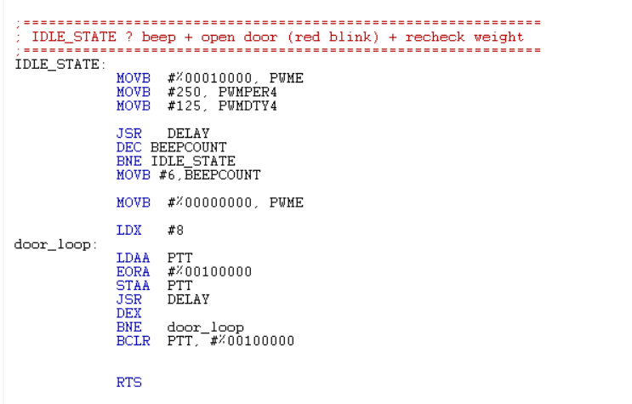
Idle State
8
Figure 11: IDLE state
The IDLE_STATE routine is executed when the elevator arrives at the floor. It is responsible for simulating the door opening phase and giving a short audible alert. It performs two main actions:
- Generates a beep using the buzzer
- Blinks the red LED to indicate that the door is open
After the following routine finishes, control returns to the main program so the system can resume checking weight and handling new requests.
At the start of the subroutine, we configure the registers responsible for the correct functioning of the buzzer, which are mainly PWME (to select channel 4), PWMPER4, and PWMDTY4 to generate a square-wave signal that produces a clear audible tone on the buzzer (here, a 50% duty cycle: PWMDTY4 = 125 when PWMPER4 = 250).
The program first calls the DELAY subroutine (250ms), and after each delay, it decrements BEEPCOUNT and repeats the same block until BEEPCOUNT reaches zero.
The buzzer stays ON for 1.5 seconds.
After the loop finishes, BEEPCOUNT is reset to 6 for future use, and PWME is cleared to disable the PWM output, turning off the buzzer.
After the buzzer is turned off, the routine controls the red LED:
The red LED is connected to bit 5 of port T (PT5).
Inside the loop:
- The program toggles the bit corresponding to the red LED (ON/OFF) using EORA #%00100000.
- It calls DELAY each time (250 ms).
- It repeats this 8 times.
If the delay is 250 ms, then the total blinking time is:
$$8×250\text{ ms}=2 seconds$$
So, the red LED blinks for about 2 seconds, simulating the door being open during that period.
At the end, BCLR PTT, #%00100000 ensures the red LED is turned off.
Once the beep and door-blinking sequence are finished, the routine returns to the caller (through RTS)

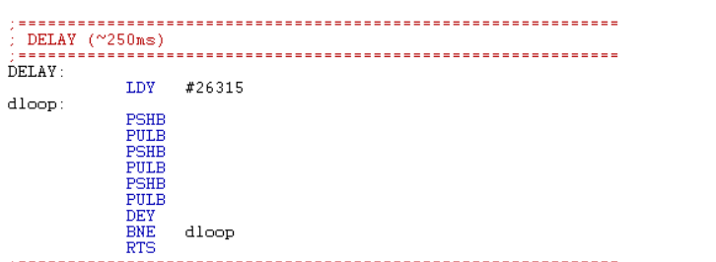
Delay Subroutine
Figure 12: Delay subroutine
Since we want a delay of 250ms, then the preset value is given by:
$$\frac{250×{10}^{3}}{9.5}=26,315$$

Interrupt Subroutine
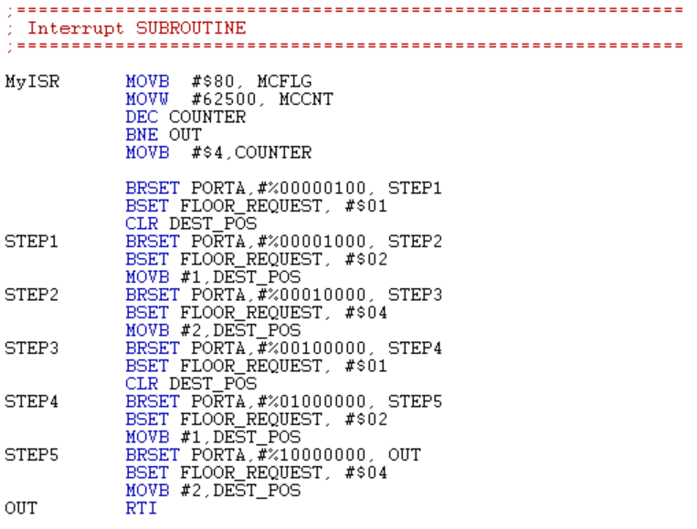
Figure 13: Interrupt subroutine
The interrupt service routine “MyISR” in our case is responsible for periodically scanning all elevator push buttons and updating the floor request variables that is used by the main control logic.
This interrupt service routine is triggered whenever the MCCNT counter underflows, and it performs the following:
- Acknowledging and reloading the timer
- Reading the six push buttons & encoding the corresponding floor requests in FLOOR_REQUEST and DEST_POS.
At the start of the routine, the interrupt flag is cleared and the timer is reloaded. Writing $80 to MCFLG clears the MCCNT underflow flag, allowing new interrupts to generate in the future, and the value 62500 is reloaded into the MCCNT so that it restores the same time interval between successive underflows. By that, we are able to ensure that the interrupt continues to occur with a constant period in a periodic manner.
The routine also used the variable COUNTER to check how often the button are pressed and this variable gets decremented on each interrupt. As long as the counter is not 0, the routine will branch to OUT and returns from the interrupt without pressing any buttons. The program checks the inputs only when COUNTER reaches 0. There, COUNTER would get an updated value of 4 indicating that push buttons are being scanned once every 4 interrupts. The routine proceeds to scan the six push buttons connected to PORTA (pins PA2 – PA7).
As previously stated, FLOOR_REQUEST is used as a three-bit mask to indicate which floors have been requested (0, 1, and 2), and DEST_POS stores the current target floor in single-mode.
In this interrupt routine, whenever any internal or external push button is detected as pressed, the corresponding bit in FLOOR_REQUEST is set, and DEST_POS is updated with that floor number. Thus, all active floor requests are recorded, and the most recent one becomes the immediate destination for the elevator control logic.
At the end of the subroutine, the code reaches the OUT label and exits the subroutine via the RTI instruction and will lead to normal program flow. Here, FLOOR_REQUEST and DEST_POS contain an updated set of requested floors, and the main loop would then decide the elevator’s trajectory (move up, down, idle state) based on COMPARE.

Weight Block
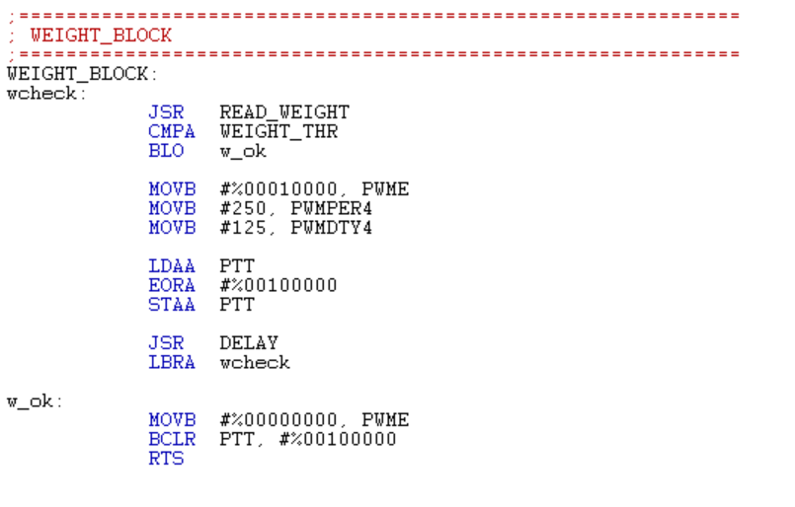
Figure 14: Weight block

The weight block subroutine is used to monitor the weight inside of the elevator. This means that it won’t allow elevator movement if the weight exceeds a specific threshold. It checks the reading in a continuous manner and keeps on returning to the main loop as long as the weight doesn’t exceed the limit. However, when it overloads, the buzzer starts buzzing and the red LED starts to blink.
At the beginning of the subroutine the label “wcheck” is used to call another subroutine called READ_WEIGHT that reads the current weight value and places it in accumulator A. This value is then compared to the threshold WEIGHT_THR. If the weight measured is below the threshold, the program branches to “w_ok”, indicating that the weight is still acceptable and the elevator can move. If the weight value is above the threshold, then the program will treat it as an overload.
In the overload case, the subroutine enables the overload warning were as previously discussed in the buzzer configuration, the PWM channel 4 is activated (via PWME, PWMPER4, and PWMDTY4) to generate a square wave signal with a 50% duty cycle to produce a clear sound from the buzzer.
Simultaneously, the routine toggles bit 5 of PORTT, which is connected to the red LED, and through calling to DELAY subroutine, we manage to make it blink.
By that, when overload occurs, the buzzer starts buzzing and the red LED starts to blink (approx. every 250ms).
After the delay, the code branches to “w_check” where we are able to read the weight again. Doing this will lead to a loop creation where as long as the elevator is overloaded, the buzzer remains buzzing and the LED keeps on blinking. The main loop is blocked from letting the elevator move.
When the weight is below the threshold, the comparison branches to the label “w_ok” where the PWM output is disabled. So, the buzzer is now turned off, and the LED stops blinking and turns off. The subroutine returns to the caller via RTS. The overload issue is now done and the main program is no longer blocked and can continue working normally (ex: COMPARE subroutine).

Read Weight Subroutine
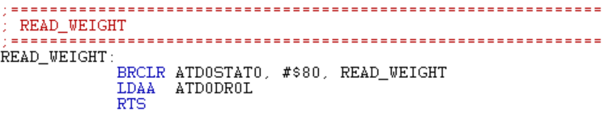
Figure 15: Read weight subroutine
As previously mentioned, the READ_WEIGHT subroutine is responsible for reading the current weight value from the ADC channel. It makes sure that the program only uses a valid conversion result before returning to the caller.
At the start of the subroutine, BRCLR ATD0STAT0, #$80, READ_WEIGHT checks the bit 7 of the ATD0STAT0 register, which is the “conversion complete” flag for the ATD module. The program keeps on branching to READ_WEIGHT and waits if this bit is 0. When the bit is 1 (conversion is complete), the program continues to the next instruction.
LDAA ATD0DR0L loads the low byte of the result from ATD0DR0L into accumulator A. This value would be representing the weight reading. We end the subroutine with an RTS and the weight reading is used in WEIGHT_BLOCK to see if the weight reading is above or below the threshold and will take actions accordingly.

LCD Subroutine
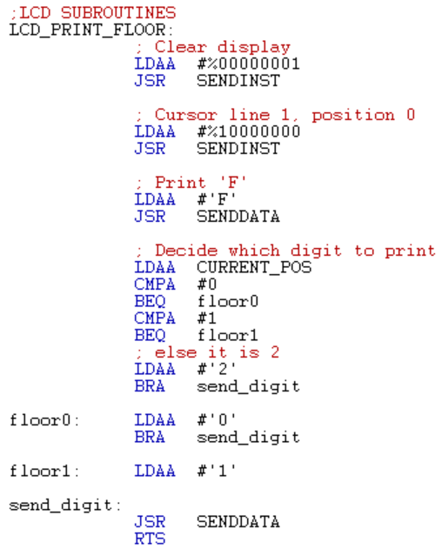
Figure 16: LCD subroutine 1
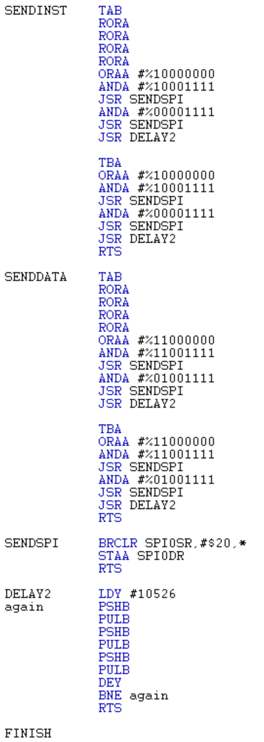
Figure 17: LCD subroutine 2
The LCD subroutines are used to display characters on the screen using the SPI interface. Here, they are used to show the current floor number (F0, F1 & F2).
The LCD_PRINT_FLOOR subroutine is used to update the LCD with the elevator’s current floor. First, it sends the instruction %00000001 to clear the display, then %10000000 to move the cursor to the beginning of the first line. After that, it prints the character 'F' using SENDDATA, as a label for “Floor”.
Then the subroutine reads the variable CURRENT_POS and decides which digit to print next.
- If CURRENT_POS is 0, it prints '0';
- If CURRENT_POS is 1, it prints '1'
- Otherwise, it prints '2'.
The selected digit is sent to the LCD through SENDDATA at the label send_digit. Therefore, every time this subroutine is called, the LCD shows the current floor by writing either F0, F1, or F2 depending on the elevator location.
The SENDINST subroutine is used to send instruction bytes (commands) to the LCD. The command is first saved in register B, then accumulator A is rotated right four times so that the high nibble moves into the lower four bits and can be sent first. Control bits are added to select instruction mode (RS = 0) and to toggle the Enable signal (E), the value with E = 1 is sent using SENDSPI to latch the nibble, then E is cleared and sent again to generate the falling edge.
After sending the high nibble, the original command is restored from B and the same sequence is repeated to send the low nibble. A short delay (DELAY) is then applied to satisfy the LCD timing.
The SENDDATA subroutine is used to send data bytes (characters) to be displayed on the LCD. Its operation is similar to SENDINST, but here the control bits are set for data mode (RS = 1). The data byte in A is first copied to B, then A is rotated right four times so that the high nibble moves into the lower four bits. Control bits are added to set RS = 1 and E = 1, and this value is sent using SENDSPI to latch the high nibble. Then E is cleared and sent again to generate the falling edge, followed by a short delay.
After that, the original data byte is restored from B, and the same sequence is repeated for the low nibble, again with RS = 1 and E toggling from 1 to 0. In this way, SENDDATA sends an 8-bit character as two 4-bit transfers in data mode, allowing the LCD to correctly display characters such as “F0”, “MOVING UP”, and the other messages.

The SENDSPI subroutine handles the low-level SPI transfer of a single byte to the LCD. It waits until the SPI module is ready by checking bit 5 of the SPI0SR register via BRCLR SPI0SR,#$20,*, which corresponds to the SPI transfer-complete flag.
Once this flag is set, the byte stored in accumulator A is written to SPI0DR, starting the actual transmission over SPI to the LCD. The subroutine then returns with RTS.
Finally, the DELAY2 subroutine generates a short delay required by the LCD between successive nibbles and commands. It loads register Y with the value 10,526 and enters a loop where it performs several PSHB/PULB pairs to consume clock cycles, then decrements Y and repeats until Y reaches zero. When the loop finishes, the subroutine returns. This delay is shorter than the main DELAY routine and is specifically used to meet the timing constraints of the LCD interface.
The above subroutines when combined, allow the system to:
- Clear the display
- Position the cursor
- Send commands
- Print characters
- Display the current floor & status of the elevator

Challenges
- Configuring and debugging the MCCNT interrupt
Setting up the MCCNT timer interrupt to generate a stable, periodic signal and then adjusting the software counter so that the button scan rate was neither too fast nor too slow (causing delayed elevator response).
- Handling multiple button requests (single vs multi-mode logic)
Designing the logic for FLOOR_REQUEST, DEST_POS, DEST_POS1, and DEST_POS2 was difficult, especially when interpreting combinations like 3, 5, and 6 and deciding the correct order of service for multi-destination trips without skipping or repeating floors.
- Synchronizing main logic with the interrupt
Since the push buttons are read and encoded inside the interrupt routine (MyISR) while the movement and decision-making are handled in the main loop (COMPARE), it was challenging to ensure that shared variables (such as FLOOR_REQUEST and destination flags) were always consistent and did not lead to unexpected behavior.
- General debugging in assembly
Debugging the system in assembly language was itself a challenge, because small mistakes in branch conditions, bit masks, or register usage often caused the entire elevator behavior to fail, requiring careful step-by-step tracing and repeated testing on the HCS12 hardware.
- Managing control flags and state variables
Using flags such as MULTIFLG and special values like $FF to indicate “no destination” made the control flow more compact but also more complex, and it was challenging to correctly set, clear, and test these flags so that the elevator would switch reliably between single-mode, multi-mode, idle, and arrival states.

Conclusion
Through this project, we finally achieved a fully functional 3-floor elevator controller on the HCS12. This was completed by integrating push-button requests, movement control, LCD display, LEDs, buzzer, and weight protection into one system. Using interrupts, ADC, PWM, and SPI, the program can safely decide when to move, which floors to serve, in what mode (single or double), and how to communicate status to the user. Despite challenges in configuring the timer, handling flags, and debugging in assembly, the implementation strengthened our understanding of real-time microcontrollers and hardware to software interaction.

