Part 1: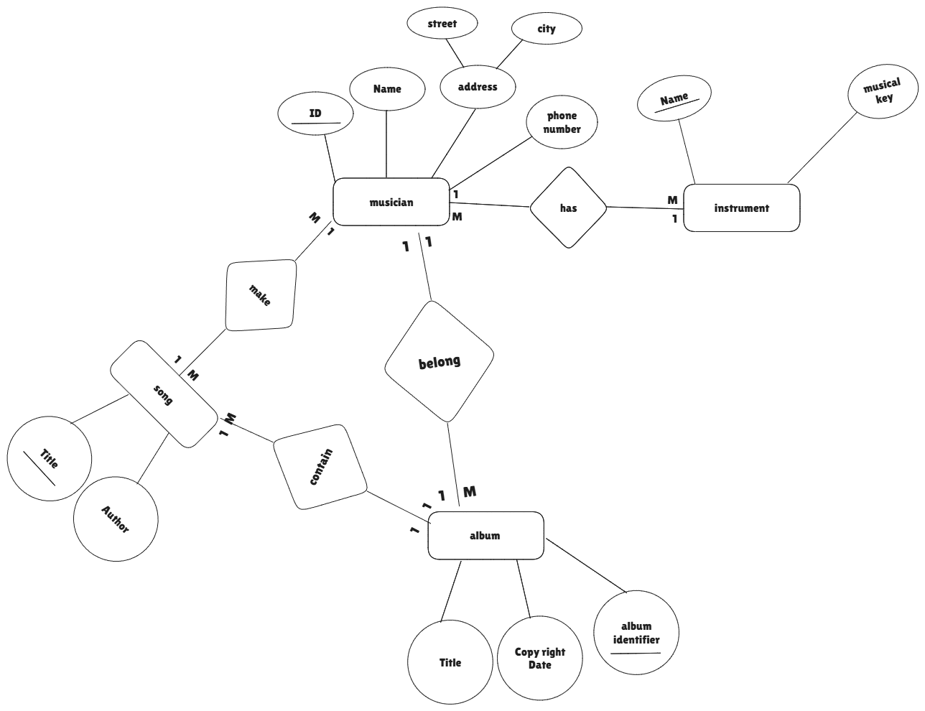
_____________________________________________________________________________________
part 2:
