Course Name: COMP20131
Assignment Title: Data Analytics Techniques and Programming
Student Name: Nour Ghousheh Alhuseini
Student ID: T0326796
Date of submission: March 28, 2025

This coursework is designed to cover Module Learning Outcomes 2, 3, 4, 5 and 6 of the module specification. Max words: 5,000 with template included.

Problem 1: Applications of iterative and bisection search
There is no written report element for this problem except for attribution of sources you used. Correctness for this problem is demonstrated by code only.
Attribution:
Google Books, 2021. Python Object-Oriented Programming.

Problem 2: Modelling knowledge with Python classes – designing a Fraction class

Objective: Describe the class design and how it fits into the Python data model.

In my program the fraction class is created to represent rational numbers. It allows to complete fraction arithmetic, comparisons, and conversions, all while making sure that the fractions stay in simplified form.
Class design:
Encapsulation
- The numerator and denominator in the program are stored as attributes inside the class, makes sure that the data reliability.
- The constructor (__init__) confirms and simplifies fractions automatically.
- Users cannot accidentally modify fraction values in a wrong manner.

Methodology: Explain key OOP principles used (abstraction, decomposition)

In the fraction class created in my program, abstraction is used to automatically simplify fractions when they are created. The user does not need to reduce fractions, which happens inside the class and handle error cases.
Example of abstraction/ fractions simplification:
f = Fraction (10, 20) the user enters 10/20, but it is stored as 1/2.
While decomposition is breaking down complex logic into smaller, pieces. In the fraction class, decomposition is applied by splitting different tasks into separate methods like (__add__ (), __sub__ (), reduce (), instead of handling everything in one function. Next, keeping the __init__ () method focused only on initialization, while simplification is handled separately in reduce (). Then, made each arithmetic method handle one specific job.

Implementation: Discuss coding structure

Structure of the Code
The Fraction class is divided into three key sections:
- Initialization and Data Validation (__init__())
- Arithmetic and Comparison Operations.
- Utility Methods such as simplification, reciprocal, float conversion, power, and absolute value.
What data attributes did you create and why?
Two data attributes were created:
- Numerator, for example, in 3/4, the numerator is 3.
- Denominator, 3/4, the denominator is 4.
What methods did you create and why?
The methods in the class are into three sections:
- Core Methods for fundamental operations
- Arithmetic and Comparison Methods
- Utility Methods for additional functionality.
What were the design principles behind the following methods?
- Encapsulation
- Abstraction
- Decomposition
- Operations and operators.

Part A: __init__, __str__, __add__, __sub__, __float___

__init__(self, num, den)
- The encapsulation makes sure that the fractions are always stored in a valid format.
- Reduce () is used to store the fraction in its simplest form immediately.
- The data consistency makes sure that the negative sign is always stored in the numerator, making fractions easier to compare.

__str__ (self)
- Converts the fraction into the format num/den.
- Makes fractions easy to read when printed.

__add__ (self, other) and __sub__ (self, other)
- Allows addition and subtraction to work with fractions.
- Uses cross multiplication to handle fractions with different denominators.
- Simplification of the result is reduced before being stored.

__float__ (self)
Allows to use fractions normally in calculations.
- Makes sure that the correct decimal conversion.
- Allows fractions to work well with floating point arithmetic.
Part B: What were the design principles behind any further methods you chose to design?
__mul__ (self, other)
- Multiplies num/den
- Makes sure that the result is stored in simplest form.
__truediv__ (self, other)
- Division of two fractions.
- Does not allow division by zero.
- Simplifies the resulting fraction before returning it.
__pow__ (self, power)
- Makes the fraction to a given power
- Makes both num/den to the specific integer power.
Reciprocal (self)
- Swaps the num/den
- Gives an error if the numerator is 0.
__eq__ (self, other)
- Checks if 2 fractions are equal.
__gt__ (self, other)
- Checks if one fraction is greater than another
__lt__ (self, other)
- Checks if one fraction is less than another.

Part C: What were the design principles behind your reduce () method?
Design principles behind reduce ()
- Use of gcd () to simplify without checking every factor.
- Keeps fractions in their simplest form.
- Stops fractions from getting bigger than they need to be.

Results: briefly show evidence of functionality and correctness.

The reduce () method makes sure that all fractions are stored in their simplest form.
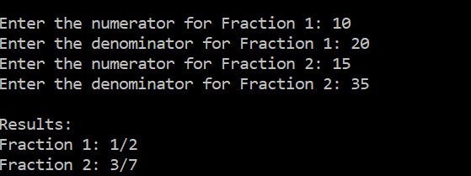

The output shows that the code allows arithmetic operations to work normally and correctly.
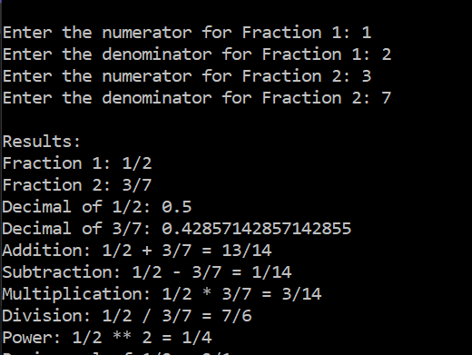

The output shows that it allows fractions to be converted into decimal values.
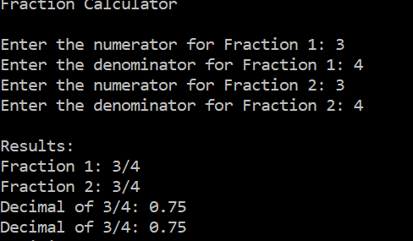

The output shows that it returns the flipped version of a fraction and shows that the code makes it possible to compare fractions. It also shows if two fractions are equal, greater, or less than another.
.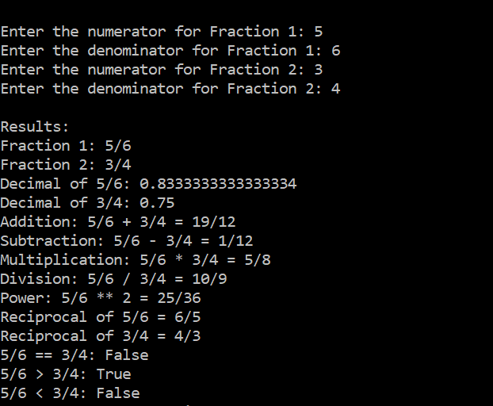

As shown in the output the code prevents fractions with zero denominators and division by zero.
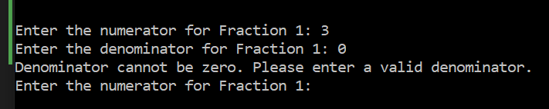
Attribution:
I used Lecture 4 Data Analytics Techniques and Programming from Now NTU to guide me in this problem.

Problem 3: Understanding program design and efficiency - runtime comparison of sorting algorithms

Objective: Compare the different sorting algorithms based on runtime with respect to the number of operations.

Bubble Sort and Selection Sort are both the same in which they have a time complexity of O(n²).

Merge Sort is much faster for large lists because it always runs in O(n log n) time.

Methodology: explain the sorting algorithms being compared – Bubble Sort, Selection Sort, Merge Sort – and the method of comparison:
- Bubble sort goes through the list, swapping items if they’re in the wrong order. It keeps doing this until everything is sorted. If no swaps are needed, it stops early which is making it faster for sorted lists.

- Selection sort finds the smallest item and moves it to the front. Then repeats that for the rest. It doesn’t stop early, even if the list is already sorted.

- Merge sort splits the list into shares, sorts them, then merges them back together.
Libraries used:
Random- I used it to create a random list of integers using random.sample ().
Time- I used it to measure the execution time of each sorting algorithm with time.perf_counter().
Method of comparison

The same random and presorted lists were used across all three sorting methods. The metrics were measured, was the total number of comparisons made during sorting. The execution time recorded using time.perf_counter () method for exact measurement.

Implementation: describe how operations are counted and how lists to sort are generated.

- The operations are each sorting algorithm maintains a counter to track how many times elements are compared. The Bubble Sort comparisons occur every time two together elements are checked. Includes an early stopping mechanism that exits early if no swaps occur in a full pass. The selection sort comparisons occur each time an element is checked against the current minimum. No early stopping mechanism, which means that it always performs O(n²) comparisons.
- The lists for sorting operations is for all sorting algorithms are tested on the same lists, made in two ways one which is random lists which is created using random.sample (), to make sure that the unique elements in a shuffled order and it is used to test how each algorithm handles an unsorted list.
Functions:
Bubble_sort(L)- sorts the list using the bubble sort algorithm, returns the number of comparisons made during sorting, and includes an early exit if no swaps occur in a pass.
Selection_sort(L)- creates the selection sort algorithm, finds the smallest item and places it in the correct position at each pass, and it returns the total number of comparisons.
Merge_sort(L)- creates the merge sort algorithm, splits it into halves, and merges them back. It then returns the sorted lists and the numbers of comparisons.
Merge(left,right)- merges 2 sorted sub lists and counts the number of comparisons, used by merge_sort () to combine the left and right.
Sort_comparisons(list_size, sorted=false)- it creates a sorted or random list of the given size, it calls 3 sorting functions bubble_sort, selection_sort, merge_sort on separate copies of the list.

Results: Present insights gained through comparing the result of Part A with Part B.

Part A: outcome of experiments on random lists
Sorting a random list of 5
Results:
- Bubble sort made 7 comparisons, slightly fewer than Selection Sort, to its ability to stop early when no more swaps are needed.
- Selection sort made 10 comparisons, since it always checks every remaining element.
- Merge sort made only 6 comparisons, proving its good organization in handling sorting operations with fewer steps, for larger lists.
Execution time:
- Bubble Sort finished in 0.000062 seconds.
- Selection Sort was a quicker at 0.000046 seconds, but this disappears as the list grows.
- Merge Sort took 0.000134 seconds, slightly longer, it scales much better for larger inputs, making it the best option when sorting bigger lists.
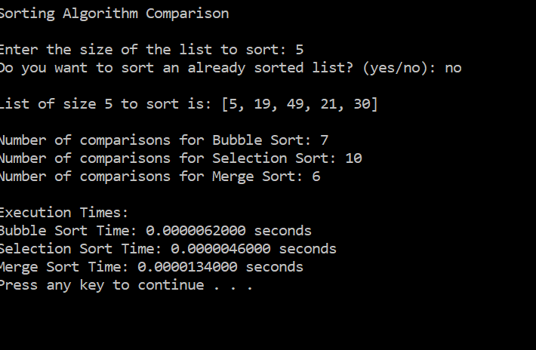

Sorting a random list of 10
Results:
- Bubble sort required 44 comparisons, lower than Selection Sort due to its early stopping.
- Selection sort required 45 comparisons, following its usual O(n²) complexity, meaning it checked each remaining element in every pass.
- Merge sort required only 25 comparisons, reinforcing its O(n log n) efficiency, as it sorts by dividing the list into smaller parts.
Execution time:
- Bubble sort completed in 0.000155 seconds, showing a noticeable increase in runtime compared to the n=5 case.
- Selection sort was slightly faster at 0.000092 seconds, but its inefficiency will become clearer as n increases.
- Merge sort took 0.000273 seconds, slightly higher due to its recursive nature, but this overhead is negligible for larger inputs.
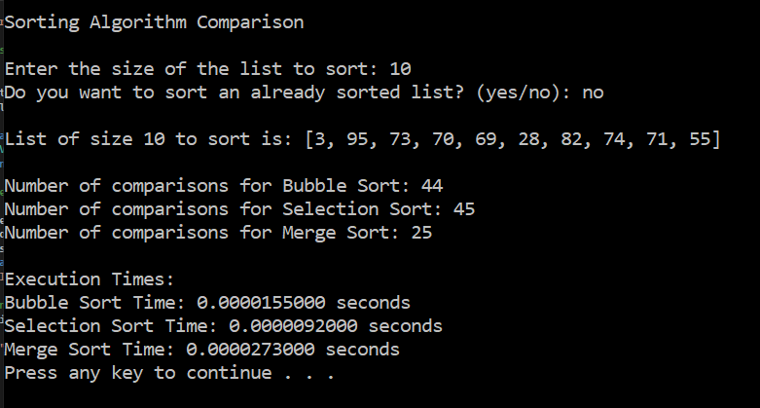
These results show that as the list size increases, bubble sort and selection sort start becoming inefficient, while merge sort continues to perform well with significantly fewer comparisons.
Sorting a random list of 100
Results:
- Bubble sort required 4,944 comparisons.
- Selection sort performed 4,950 comparisons.
- Merge sort required only 543 comparisons, fewer than the other two, showing its O(n log n) efficiency.
Execution time:
- Bubble sort took 0.000878 seconds, an increase compared to smaller lists.
- Selection sort took 0.000484 seconds.
- Merge sort was the fastest at 0.0003256 seconds, proving that it is the most efficient sorting method as it grows.
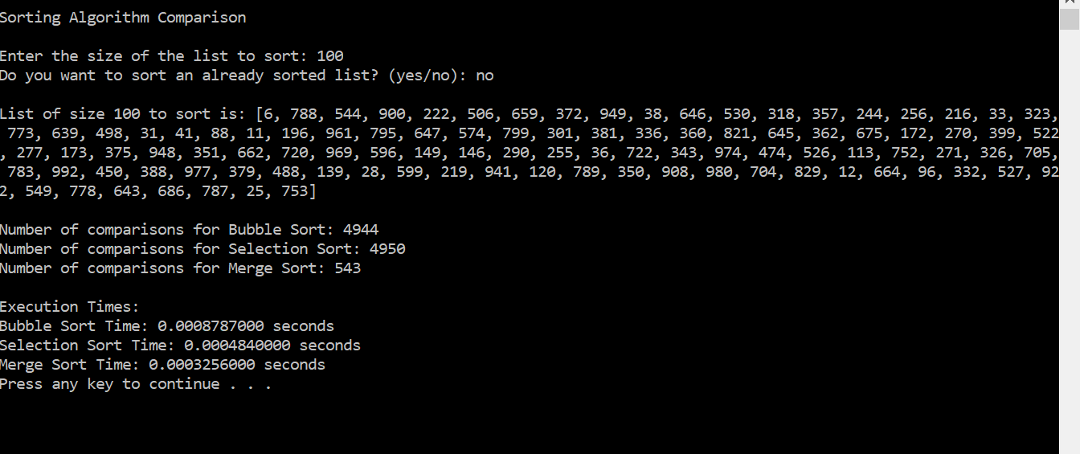
These results confirm that bubble sort and selection sort become impractical for large lists, while merge sort continues to perform efficiently with fewer operations.

Part B: the outcome of experiments on random lists after they have already been sorted.
Sorting an already sorted list of 5
Results:
- Bubble sort which required only 4 comparisons.
- Selection sort still performed 10 comparisons.
- Merge sort performed 5 comparisons, slightly reducing its operations but still maintaining its O(n log n) behavior.
Execution time:
- Bubble sort completed in 0.0000253 seconds, showing that improvement compared to when sorting random data.
- Selection sort completed in 0.0000053 seconds, a bit faster, however still inefficient for larger lists.
- Merge sort took 0.0000133 seconds, performing similarly to Part A.
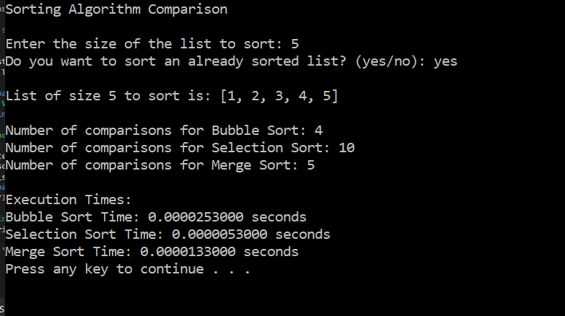
This confirms that bubble sort benefits the most from sorted data, while selection sort remains inefficient regardless of input order. Merge sort performs consistently, as expected.

Sorting an already sorted list of 10
Results:
- Bubble sort which required only 9 comparisons.
- Selection sort which required 45 comparisons.
- Merge sort which required 15 comparisons, slightly reducing its operations.
Execution time:
- Bubble sort completed in 0.0000650 seconds, showing an improvement compared to unsorted lists.
- Selection sort was slightly faster at 0.0000092 seconds.
- Merge sort took 0.0000321 seconds, performing similarly to its previous results.
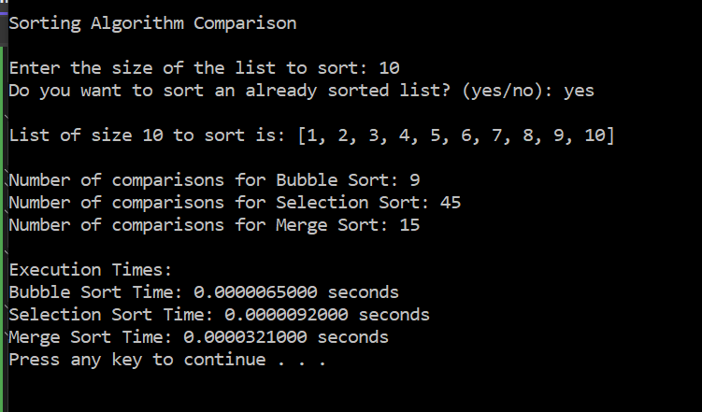
Sorting an already sorted list of 100
Results
- Bubble sort required only 99 comparisons, benefiting from its early stopping mechanism, which allowed it to run in O(n) time instead of O(n²).
- Selection sort required 4,950 comparisons.
- Merge sort required 316 comparisons,
Execution time:
- Bubble sort completed in 0.000352 seconds, showing a significant speed improvement compared to sorting a random list.
- Selection sort took 0.000470 seconds, making it the slowest and confirming its inefficiency.
- Merge sort finished in 0.000221 seconds, demonstrating stable performance.
These results confirm that bubble sort benefits the most from sorted data, while selection sort remains inefficient regardless of input order. Merge sort remains stable but does not gain much advantage from sorted lists.
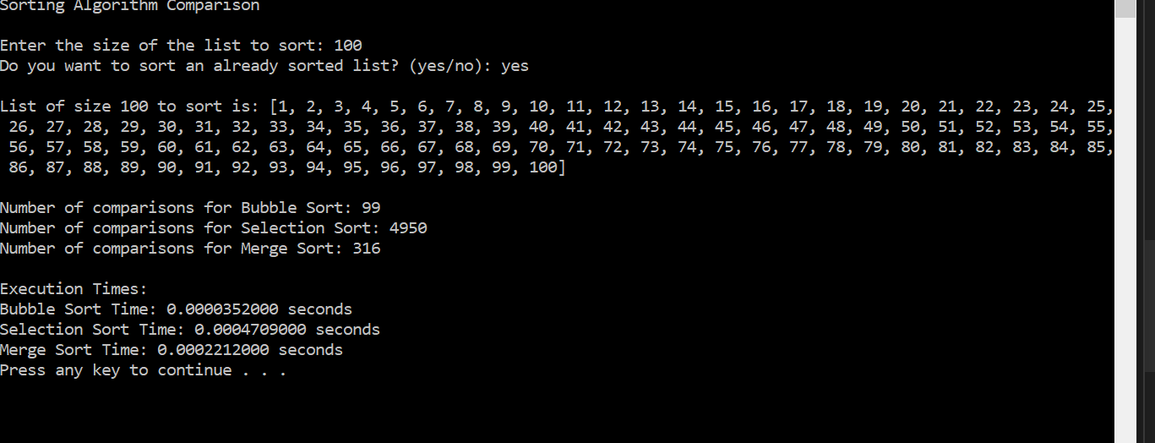
Part C: What are the best and worst case runtimes of the three algorithms? Which of the three sorting algorithms are stable sorts and why?
Best and worst case runtimes of sorting algorithms
- Bubble sort has a best case runtime of O(n) when the list is already sorted since it stops early if no swaps are needed. However, in the worst case, when the list is completely reversed, it takes O(n²) operations, making it inefficient for large lists.
- Selection sort always runs in O(n²) regardless of input order because it always scans the entire unsorted portion of the list, even if it's already sorted.
- Merge sort runs in O(n log n) in both best and worst cases, as it always divides and merges the list recursively, making it the most consistent in performance.
Which algorithms are stable?
Bubble sort is stable because it swaps elements only when necessary, preserving the order of equal elements, while Selection Sort is not stable because it swaps elements not together, which can change the order of equal elements. Merge Sort is stable because it makes sure that when merging two sorted lists, equal elements appear in the same order as in the original list.

Attribution:
Fontenrose, J., 2020. Python. Berkeley, CA: University of California Press. Reprint 2020.

Problem 4: Optimization Problems - Dynamic Programming

Objective: Implement dynamic programming solutions to solve the given problems efficiently and correctly and justify the correctness of the solution.

In the Coin change the bigger amounts are solved using answers to smaller ones.

In the word segmentation the longer words are built by checking shorter, valid words first.

Methodology: Describe the ideas upon which dynamic programming is based (optimal substructure, overlapping subproblems).
- Optimal substructure is bigger problems use answers from smaller ones, such as finding the fewest coins and segmenting words.
- The program uses dynamic programming which saves results of solved subproblems in tables like min_coins, coin_tracker.

Implementation: Explain how the ideas of dynamic programming apply to each of the two given problems and how you implement them.
- Coin change (Parts A & B) shows best substructure because bigger amounts are solved using answers to smaller ones. The methods make_change() and make_change2() use min_coins and coin_tracker to save the best results and then track to find the exact coins used.

- Word segmentation (Part C) also uses optimal substructure by building effective segments from checked parts of the string. It uses dynamic programming and previous_index to find and rebuild the correct word splits clearly and efficiently.

Results: discuss the correctness and computational efficiency of your solutions (each separately).

Part A: Minimum number of coins
Correctness:
- The make_change function properly finds the smallest number of coins needed.
- For example, to make 6 using coins [1, 3, and 4], it knew that using two 3s (3, 3) is the best way.
Computational efficiency:
- The dynamic programming solution uses a single loop nested within another, resulting in a complexity of O(n×m).
- Where n is the change amount and m is the number of coin denominations.
Part B: optimal set of coins
Correctness:
- As to part A the make_change2 function correctly finds the best set of coins to make the desired amount.
Computational efficiency:
- The solution efficiently rebuilds the optimal set of coins by using an additional tracking array (coin_tracker) with no significant additional complexity.
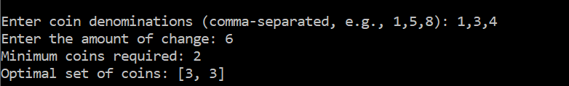
The output shows how the program works when tested for Parts A and B. In this case, I provided coin of 1, 3, and 4, and requested a total change of 6. As seen in the ouput, the program found that only 2 coins are needed and specifically returned the coins [3, 3] as the solution.
Part C: Word segmentation
Correctness:
- The word_break function precisely checks if a string can be split into valid dictionary words and rebuilds the full segmented sentence.
- For example, it correctly split "catanddog" into "cat and dog" and also handled cases where no valid split was possible.
Computational efficiency:
- The implemented dynamic programming solution operates with a time complexity of O(n²), where n is the length of the input string.
- It verifies each substring exactly once, eliminating redundant checks, which would occur in a naive recursive solution, drastically improving performance.
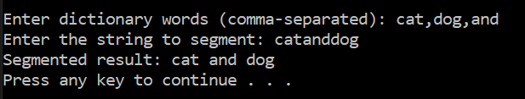
The output above shows the result of testing the word segmentation problem. I provided with the words "cat," "dog," and "and," and the program successfully segmented the input string "catanddog" into the correct words: "cat and dog."

Problem 5: Problem modelling and analysis through simulation with Numpy – The Knight’s Tour Problem

Objective: use randomness to automatically generate candidate knight’s tours to study the structure of the Knight’s Tour problem. Investigate a heuristic approach to the problem. Visualize results effectively.

I created a knight’s tours using both a brute force approach with random movement and a heuristic strategy based on Warnsdorff’s Rule.

The goal is to analyze and compare the effectiveness of these methods in completing full tours

To visualize the results using graphical tools such as heatmaps and histograms.

Methodology: explain the approach you used for Parts A-C.
I developed the program with both interactive and automatic modes. The knight's allowed moves were shown based on chess rules using NumPy. In interactive mode, users can click on the red x on the squares valid positions to move the knight. In automatic mode, the knight selected random valid moves with a delay for visualization.
Two strategies were created:
- A brute force approach using random moves.
- A heuristic approach using Warnsdorff’s Rule to avoid early ends.
Each simulation tracked move counts, success rates, and visual results using Seaborn heatmaps and histograms.

Implementation: describe the algorithms used in Parts A-C.

Part A – Basic Knight’s Tour
- I created an 8x8 board using generate_board () and place the knight at a starting position of (4, 3), which is then is marked the starting square as number 1.
- I used get_valid_moves x, y, board to find all allowed knight moves from the current position.
- In interactive mode, the on_click () function spots when the user clicks a red ‘X’, and the knight moves there.
- In automatic mode, the run_automatic_tour () function randomly selects one of the valid moves and updates the knight’s position.
- The update_board () function is to visually update the chessboard, label visited squares, and show the knight’s current location.
- The process repeats until either, all 64 squares are visited which is complete tour, or no valid moves remain which is an incomplete tour.
- The chessboard is always updated using Matplotlib and Seaborn.
Part B – Brute Force Knight’s Tour
    - The function brute_force_knights_tour() is created and runs the tour for a large number of trials which is 1,000,000.
    - I created board using generate_board(), and the knight starts at a fixed position.
    - The function get_valid_moves() retrieves available moves.
    - One move is randomly selected with random.choice().
    - The knight moves and the step is recorded on the board.
    - The number of moves completed is stored for each trial, and up to 5 successful paths are saved for visualization.
    - A histogram is plotted using Seaborn to show move completion frequency.
    - Up to 5 completed tours are visualized using heatmaps showing step numbers on the board.
Part C – Heuristic Knight’s Tour
- I implemented the heuristic_knights_tour(num_trials), applying move selection process.
- I used get_valid_moves() to identify candidates.
- It evaluates how many onward moves it allows by get_valid_moves() function.
- It selects the move with the minimum onward options based on Warnsdorff’s Rule.
- It splits using random.choice().
- It then tracks completed steps and successful tours, storing full paths like in Part B.
- Lastly, it generates performance histograms using seaborn.histplot() and visualizes successful tours with seaborn.heatmap().

Results: Give an informative visualization of a basic Knight’s Tour. Describe the results of the random simulations in Part B. Did you successfully find a tour? How many? Give an informative visualization of this experiment. Describe the heuristic approach in Part C. Did you successfully find a tour? How many? Giva an informative visualization of this experiment. Finally, compare and interpret the outcome of your experiments.
Basic knight’s tour – Visualization (Part A)
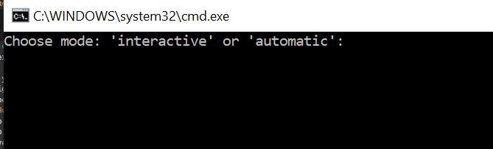
This output shows the starting message where the user picks between 'interactive' or 'automatic' mode. I added both options to make the program more have different options, it can either be played manually or let the knight move on its own. It makes it more engaging and confirms that the code is running.
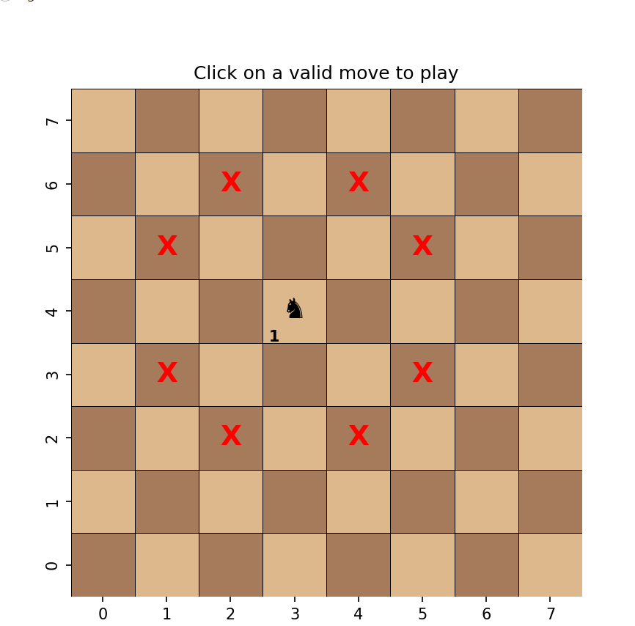
This output shows the interactive mode, with the knight starting at position (4, 3). Red x square shows all the valid moves. The knight icon and move number 1 the starting point.
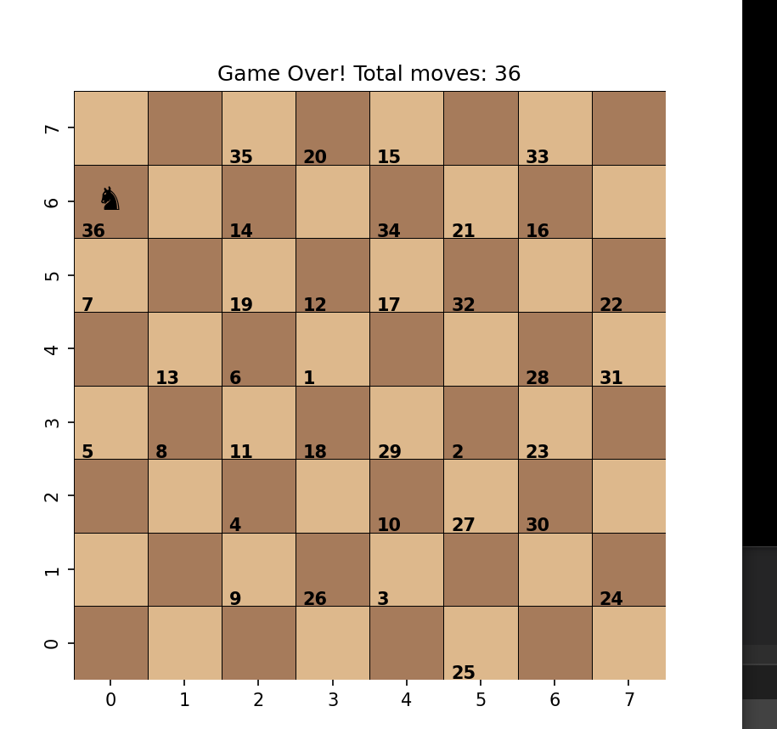

This shows the automatic mode, which the knight started from the center and is on move 36 valid moves before no further moves available, the black knight showing its final position. The tour did not reach all 64 squares.
Brute force simulation – results and visualization (Part B)
- The knight randomly selected one of the available valid moves at each step.
- Out of the 1,000,000 simulations, 0 successful tour was completed.
Visualization:
- The histogram was displayed to show the delivery of how many moves were completed per simulation.
- Most attempts ended between 30–50 moves before the knight became stuck.
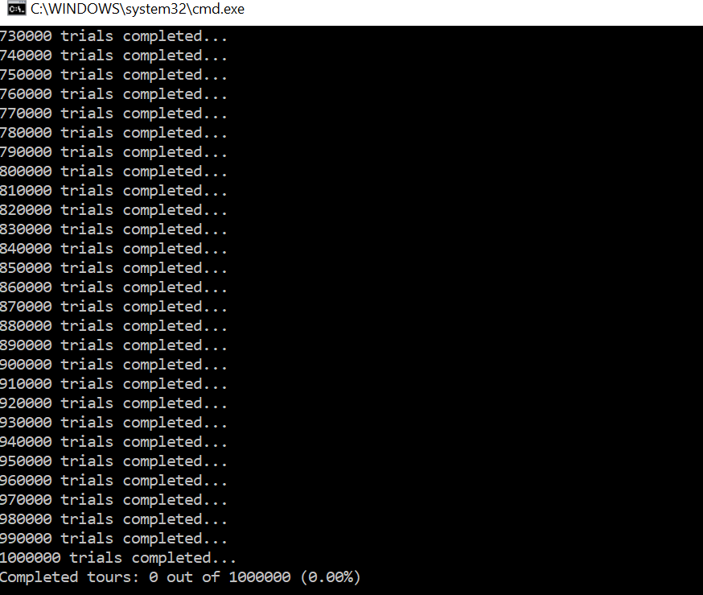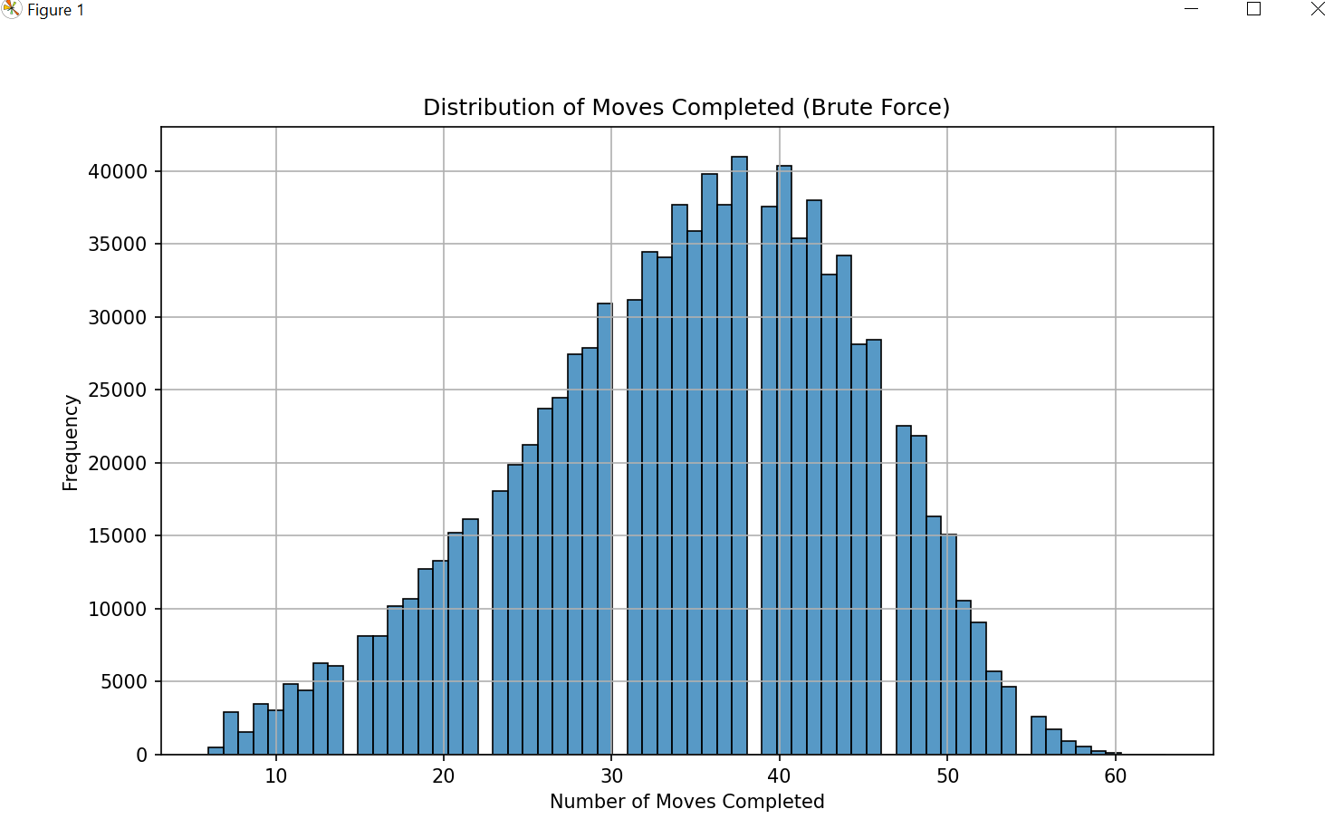
The first image shows the program successfully running 1,000,000 brute force simulations. It confirms the final result, are completed tours 0 out of 1000000 (0.00%). Which means we did not complete a knight’s tour and was not found using the brute force method. The second image is the histogram visualization of those trials. It shows that the delivery of how many moves were completed in each run. Most attempts got stuck between 35 to 45 moves.
Heuristic Search – results and visualization (Part C)
- Warnsdorff’s Rule chooses the next move by selecting the square that has the fewest onward moves.
- At each step, the knight chose the move that led to the square with the fewest onward moves.
- This strategy helped avoid early ends and improved the success rate.
- Warnsdorff’s rule increases the chance of completing a full tour compared to random movement.
Visualization:
- The histogram was showing that every trial reached the full 64 moves, with the distribution toward the maximum.
- This differences with the brute force histogram, where most trials ended early.
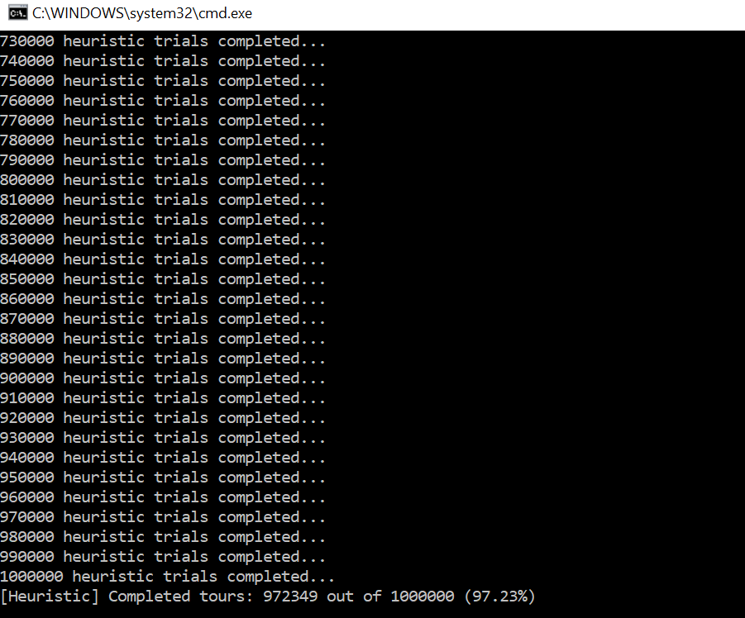
This output displays that 972,349 out of 1,000,000 heuristic based simulations successfully completed the full knight's tour.
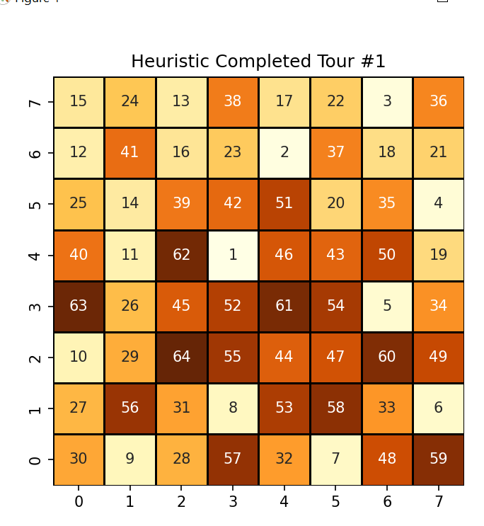
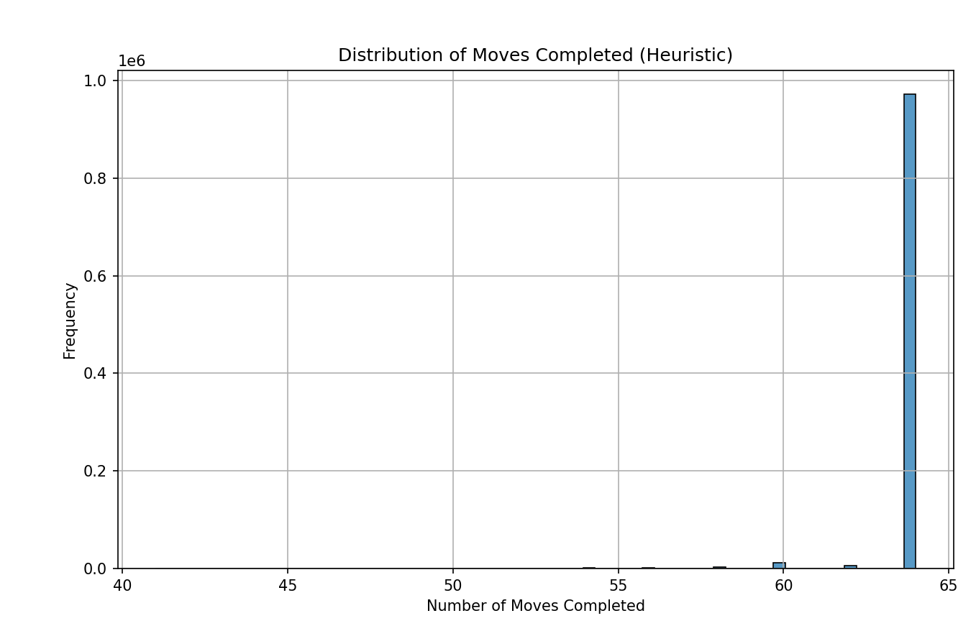

This output shows that the heuristic, which always chooses movements with the fewest onwards alternatives.
Comparison between the two:
The brute force method didn’t complete any full tours, repeatedly getting stuck after between 35-45 moves. However, the heuristic approach was much better, it completed nearly 972,349 full tours, achieving a 97.23% success rate. Most of its results completed the full 64 moves, proving that using strategy makes a difference compared to random guessing.

Attribution:
Root, B.V., 2015. Interactive applications using Matplotlib: don't just see your data, experience it! Birmingham, England: Packt Publishing.

Problem 6: Developing a tool for text analysis using Python, Graph Algorithms, Pandas and Project Gutenberg.

Objective: Use various techniques to explore texts form the Project Gutenberg e-text corpus. Show evidence of data analytical skills of preparing, modelling, analysing and displaying results to the user.
I developed a text analysis program by data analytical techniques, including text preprocessing, graph modeling, and statistical analysis, this allows to explore and extract insights from texts.

Methodology: describe the techniques used for functions implemented.

The techniques used are:
- The text processing technique is used so the input text is read from a file inside text_analyser() function using open () and normalized by converting to lowercase and removing punctuation using regular expressions using (re.sub()).
- The graph construction technique is used to direct graph is built using NetworkX, this is created inside the text_analyser() function where nx.DiGraph() is used to create the graph, and G.add_edges_from(edges) connects each word to the next word in the text, making each word a node and each word pair an edge.
- The Statistical Analysis technique is used by Pandas I used in my program, pd.Series(words).value_counts() to count frequency distributions of words and word pairs. Descriptive statistics are calculated using describe(), and word pair frequencies are tracked with pd.DataFrame(edges) value_counts() stored in edge_counts.
Graph Algorithms:
- I used out degree G.out_degree() in options 3 and 4 to find words with the most or fewest connections.
- I used Breadth first search (BFS) in option 6, implemented using nx.shortest_path() in order to find the shortest path between words.
- I used Depth first search(DFS) to create random sentences from a starting word, using G.successors(current) and selects the next word with random.choice().

Implementation: describe coding approach – models, data structures and additional libraries used.

The text analyser tool was created in order to, combine graph algorithms, natural language processing, and data analysis techniques.
Libraries:
- The re library was used for text normalization removing punctuation, lowercasing using the function re.sub().
- The pandas library was used to construct DataFrames for word frequencies and edge statistics, and for computing descriptive statistics. Functions used are pd.Series(), value_counts(), reset_index(), describe().
- The Networkx library was used to build a directed word graph, and directed edges represent sequential word relationships. While using the functions nx.DiGraph(), G.add_edges_from(), G.out_degree(), G.successors(), nx.shortest_path(), nx.NetworkXNoPath.
- The Random library with the function used random.choice(). was used for generating random sentences using depth first traversal of the word graph.
- The os library was used for listing available .txt files in the current folder to be able to choose a file to analyze, while using the function os.listdir().
Data structures:
- List was used for storing cleaned words using os.listdir(), for tracking generated sentences (DFS) sentence = [start_word], and (neighbors = list(G.successors(node))) was used to hold node neighbours
- Tuple was used for representing pairs of connected words using ("word1", "word2").
- Sets was used for keeping track of the visited nodes during DFS visited = set() and len(set(edges)) was used to counting unique edges.
- A directed graph (networkx.DiGraph) was used to model word sequences.
- DataFrames were used for showing and analyzing word frequencies (word_counts) and edge frequencies (edge_counts).
Functionality:
- The text_analyser() function gives out the input and presents the command menu with 12 options to choose from.
- Text cleaning and word extraction using re library to remove punctuation and normalize text to lowercase using (re.sub()).
- Graph construction with nodes and directed edges using the NetworkX library.
- Frequency analysis using pandas library by converting the words list into a series (pd.Series(words)) and applying value_counts() to count word occurrences.

Results: show evidence of functionality, as well as examples of visualizations used and analyse and reflect on the resultant tool you have created.
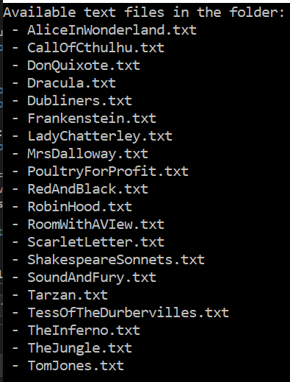
As shown in the image, as soon as I run the code a list of the available txt files show up in the console for users to select which they want to analyse. 2
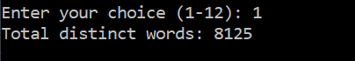
This output shows a consoled text tool run on tarzan.txt. Which is the first option I tested in the txt files, option 1 is selected, and it returned distinct words from the text.
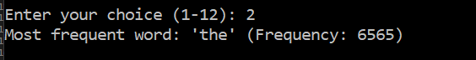
This output shows the output for option 2 of the text analysis tool. It identifies 'the' as the most frequent word in tarzan.txt.
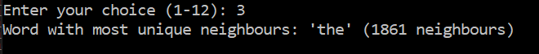
This output shows option 3 was selected. The word 'the' has the most unique neighbours in the word graph.
The output shows that the word "anywhere" appears in the text and is a unique word.
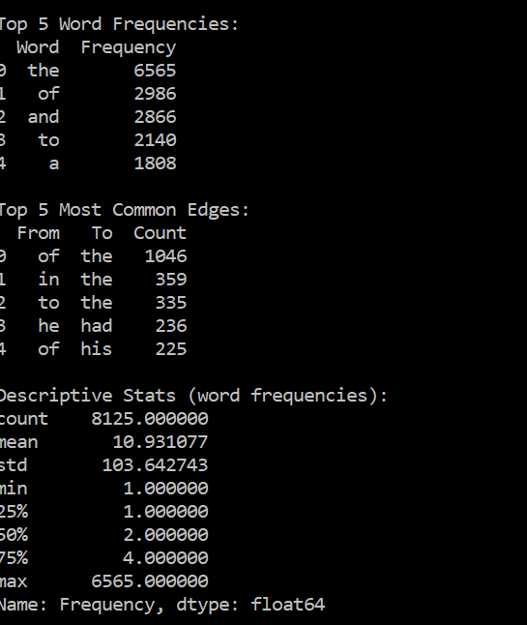
This output shows the result of selecting option 6, I searched for a path from "tarzan" to "jane" in the word graph. And the program used Breadth First Search (BFS) to find the shortest sequence of word connections where each word which follows the previous one in the text.
This output displays the results of option 5 from the text analysis tool, top 5 word frequencies top 5 most common edges which shows frequently occurring word pairs, and descriptive Statistics which provides numeric summaries.

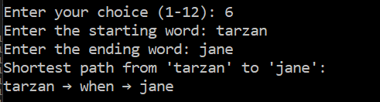
This output shows the result of selecting option 7 which generates a random sentence. I chose not to specify a start word, so the program picked a random word from the text to begin with. It then used depth first search (DFS) to walk through the word graph.
Here, it shows the result of selecting option 7 and specified word of tarzan.
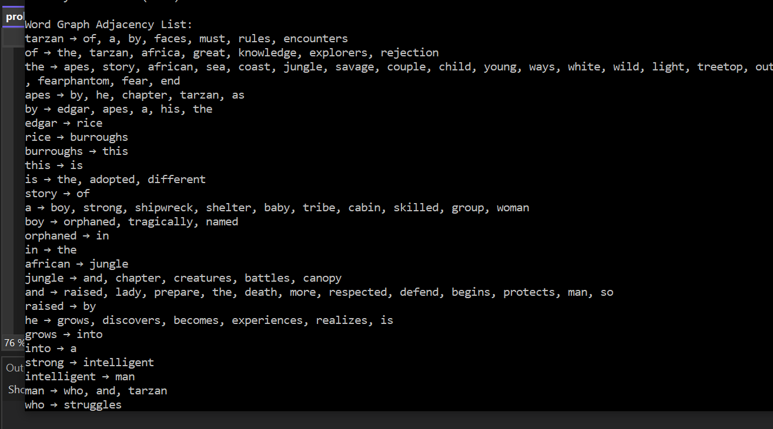
The output shown is the word graph adjacency list, which represents how words are connected based on their order in the text analysed.

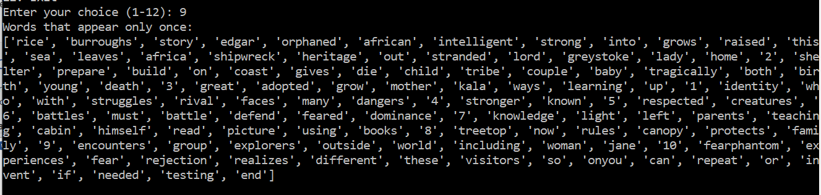
The output displays all the words in the text that appear only once

The output shows the longest words in the text, each with 11 characters.

The output shows the unique edges in the word graph, showing distinct word to word connections.
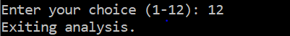
The output shows exiting the program
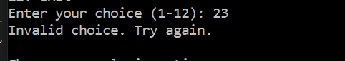
The output shows that the program will not proceed unless the number from the menu is being input into the consol.

