**Homework Assignment 1:**

**Part1: VirtualBox & Ubuntu Installation**

1. VirtualBox downloaded and installed.
2. Latest Ubuntu ISO file downloaded and installed.
3. Ubuntu ISO installed on the VirtualBox and virtual machine created from the ubuntu images and configured with the following specs:

Memory: 4096

Processors: 4

Hard Drive Space: 80GB

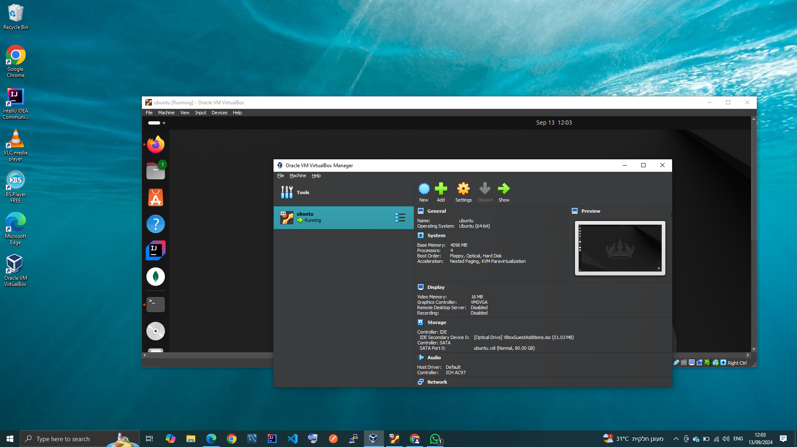

**Part 2: Linux Directories and Files Creation**

1. **Create Directories and Files:**
   1. In linux terminal creation of the directories structure is done with the command:  
      **mkdir -p ~/homework/{dir1,dir2,dir3}**

**mkdir**: creates directory.  
**-p**: make parent directory if it does not exist.

* 1. Creation of the files inside dir1 is done with the command:  
     **touch ~/homework/dir1/{file1.txt,file2.txt,file3.txt}**

**touch**: updates the access and modification times of each FILE to the current time and if does not exist creates an empty one.

1. **Add Content to Files:**

adding text to file1.txt for example ‘hello world’ text, is done with the command:  
**echo 'hello world' > ~/homework/dir1/file1.txt  
echo**: display a line of text or a string to the terminal.  
**> or >>**: output redirection to write the output to a file, > overrides, >> updates.

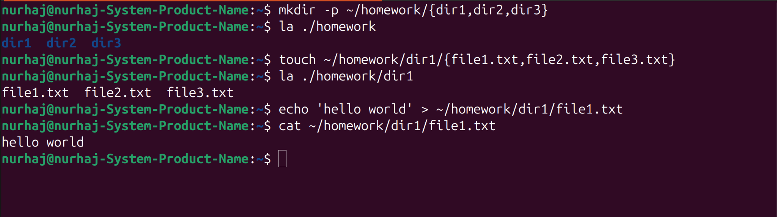

**Part 3: Using grep and find Commands**

1. **grep Command:**

grep command used to greb the text “hello” from any text in dir1:  
 **grep 'hello' ~/homework/dir1/*.txt**

1. **find Command**
   1. Finding files in a directory is done with the command:  
      **find ~/homework/dir1 -type f -name '*.txt'**

**find**: search for files directories

**-type:** specifying the type whether a file or a directory

**-name:** specifying the name

* 1. finding files modified within the last 7 days is done with this command:

**find ~/homework/dir1 -type f -mtime -7**

**-mtime**: modified before/after number of days

