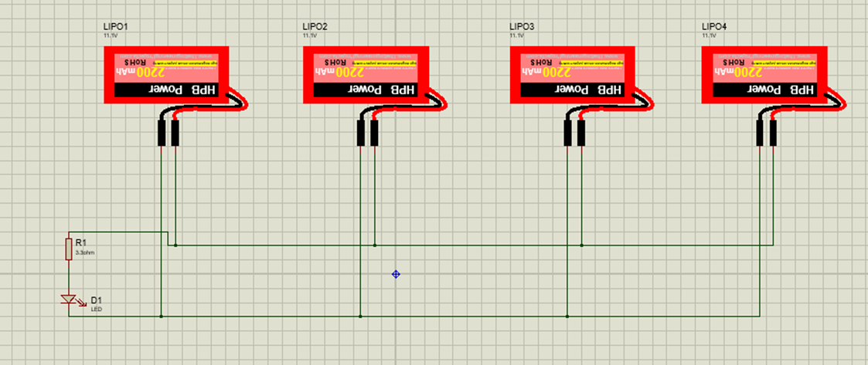From ohm law we can calculate the current needed for the battery:

I= 12/3.3 = 3.6363 amp.

The capacity of the battery = 5200 Mah it means that

The time taken by the battery to discharge if we only need the led to operate will be equal to 5200/(3636) which equates to 1.43 hour. So, one battery will keep the led open for 1.43 hour.

When lipo batteries connected in parallel the capacity will increase so the time taken until the batteries discharge

To calculate the number of batteries we will divide the time needed by the time taken by one battery which will be 3.5 batteries approximately 4 batteries connected in parallel.

Bonus part

**BMS**

The batteries in real life are not ideal that’s because the chemical reaction that produce the electricity in the batteries slow down as the batteries discharge.

The problems that might happen because of this, if you connected two different voltage pack batteries in parallel the higher one will try to charge the smaller also it might catch fire.

Bms which stands for battery management system will help in this case by balancing the charge of the batteries which means all the batteries in your circuit will have the same charge and it will increase the life span.

There are many ways to do this, bms can monitor the battery and when the voltage come across certain level it will disconnect the battery, or balance the charge from more charged battery to less charged.

It happened in two ways which are active and passive.

Active balancing: Active balancing uses a small amount of current to transfer charge from the higher-charged batteries to the lower-charged batteries. This can be done by connecting the batteries in a series and then using a resistor to create a voltage difference between the batteries. The higher-charged battery will then discharge through the resistor, transferring charge to the lower-charged battery.

Passive balancing: Passive balancing uses the natural self-discharge of the batteries to balance the charge. This is done by connecting the batteries in parallel and then connecting a resistor between each pair of batteries. The resistor will create a voltage difference between the batteries, causing the higher-charged battery to discharge through the resistor, transferring charge to the lower-charged battery.

Active balancing is more effective but higher in price.

It prevent the circuit from overcharging or over discharging also when it detect short circuit it disconnect the battery.

