Most important Linux command
Pwd
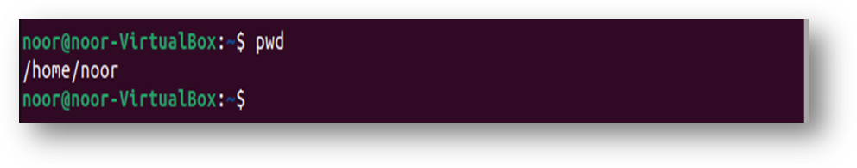
(present working directory):
mkdir
It used to make a new directory
ls
it used to see the files and the dir
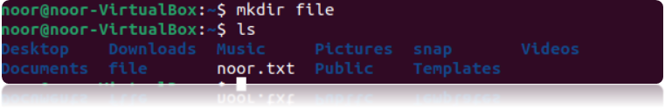

cd
It used to choose the directory
touch
It is used to make a new file.
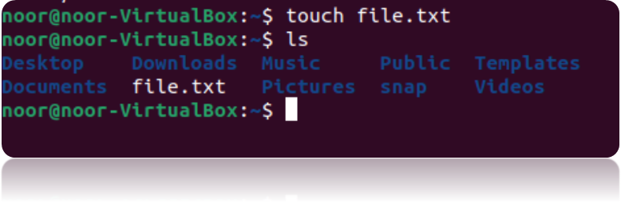

mv
It used to change the file name or to move the file to new dir
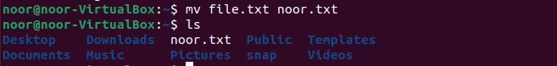

cat
It used to see the content of the file
nano
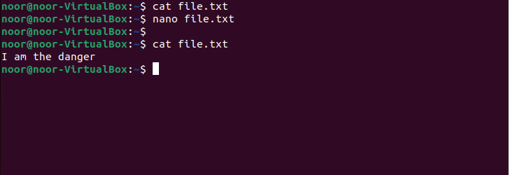
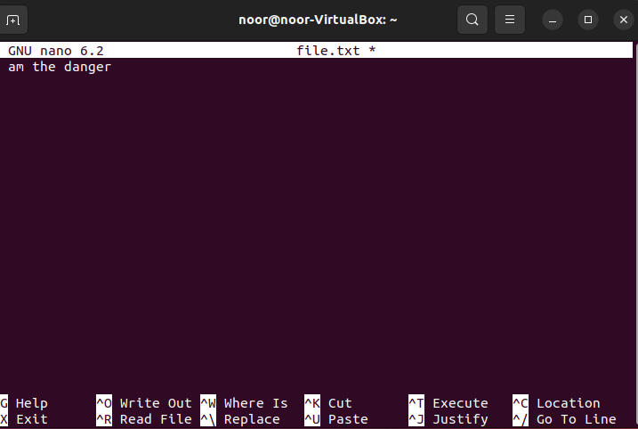
It used to edit in the file
>
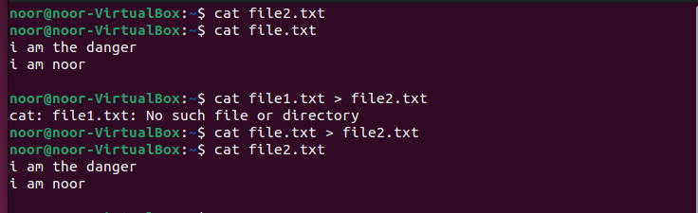
It used to redirect something from file to another file
echo
it allows users to display texts and string
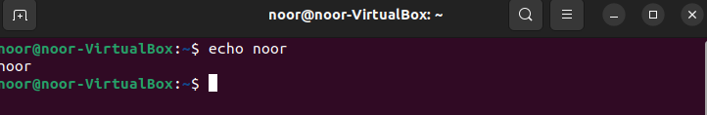
&>
redirect error to another file

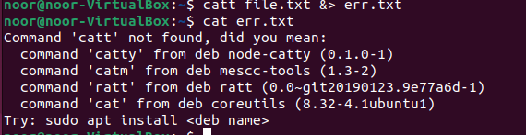

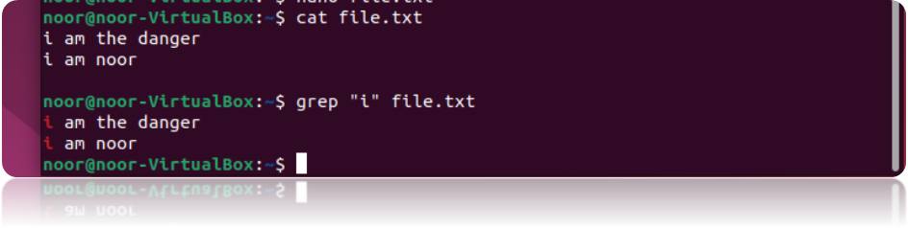
grep
it used to find and search for specific feature in the text file content

rm
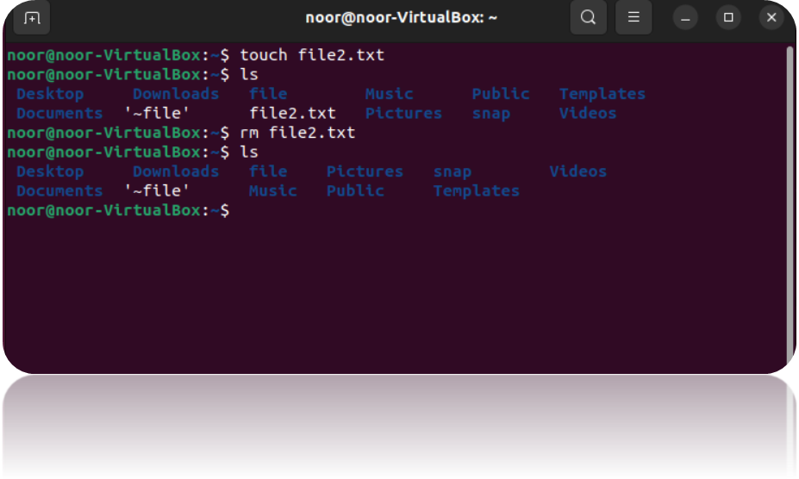
it used to delete file

