1. Introduction
1.1 Purpose of the Document
The purpose of this Design Document is to convert the requirements in the Software Requirements Specification (SRS) into a technical guide for building the UniConnect system. It gives a detailed description of the system’s architecture, user interfaces, and the use of the Model-View-Controller (MVC) design pattern. This document is the reference for the development team to make sure the software is built according to the requirements and design standards.

1.2 Scope of the Design Phase
This document covers the architectural and detailed design of UniConnect web platform. The scope includes:
- System Architecture: Defining the architecture and how the Client and Server interact.
- MVC Implementation: Mapping the system components to the Model, View, and Controller layers.
- Data Design: Defining the structure of the in-memory data storage (Python lists and dictionaries) used to manage users, clubs, and offices.
- User Interface Design: Providing frames for actions such as browsing clubs and viewing contact details.

1.3 Intended Audience
This document is meant for:
- The Development Team: To understand the system structure and implement the features consistently.
- Future Maintainers: To understand the code structure for future updates or to add external database in the future.

1.4 Overview of Contents
The rest of this document is organized as follows:
- Section 2 (System Overview): A description of UniConnect and its design goals.
- Section 3 (Architectural Design): A visual and descriptive look at the system’s architecture.
- Section 4 (Detailed Design): A close examination of the MVC pattern application, UML class and sequence diagrams, UI frames, and data models.

2. System Overview
2.1 Brief Description of the System
UniConnect is a web-based system designed for Zewail City of Science and Technology. It acts as a platform connecting students with university clubs, committees, and administrative offices. The system allows students to browse club details, view their details, and contact leaders. It makes communication easier by bringing together contact information (emails, roles, and photos) into one clear interface. The system uses the Flask framework and follows an MVC architecture.

2.2 Key Design Goals and Constraints
Design Goals:
- Modularity: The system follows the Model-View-Controller (MVC) pattern to separate data, logic, and user interface, which makes the code easier to maintain.
- Simplicity and Usability: The interface is designed to be clear for all students and staff, focusing on clear navigation and responses.
Constraints:
- Technology Stack: The backend implemented using Python Flask and the frontend uses HTML with CSS.
- Data Storage: Currently, there is no external database (SQL) used, data is temporarily stored in Python lists and dictionaries, meaning data resets when the server stops.
- Deployment: The system operates in Localhost.
3. Architectural Design
3.1 System Architecture Diagram

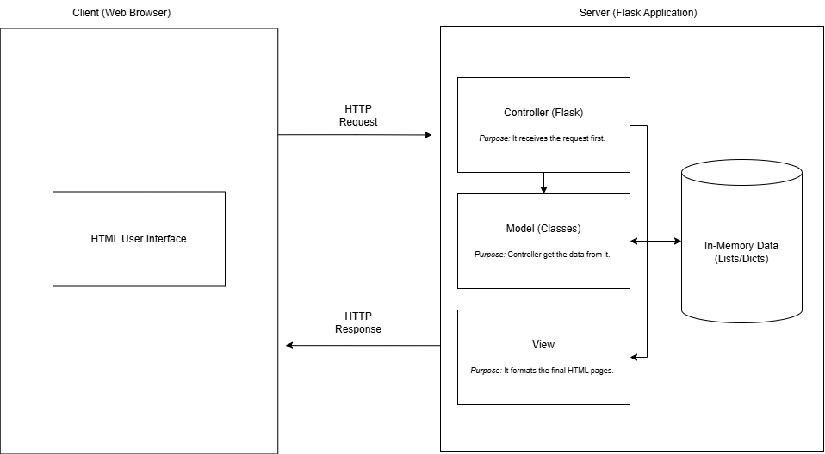
3.2 Discussion of Architectural Style and Components
Architectural Style: Monolithic
We built UniConnect using a Monolithic Architecture. This simply means that the whole application, the design, the code, and the data storage runs together as one single program on our Flask server. We chose this style because it is simple to build and easy for our team to test without needing complex setups.
The Main Components:
- Client (Web Browser)
- HTML User Interface: This is what the student or admin sees on their screen. It shows our web pages with the forms, buttons, and club details.
- How it works: When a user clicks a button, the browser sends a request to our server. When the server is done, the browser displays the new page sent back to it.
- Server (Flask Application) This is the brain of the system. It runs the Flask code and follows the MVC (Model-View-Controller) pattern to keep things organized.
- Controller (Flask): Let’s think of this as the manager. It is the first thing that receives a request from the user. It decides what to do, asks the Model for information, and picks the right page to show.
- Model (Classes): This part handles the logic and data. The Controller talks to the Model to get data or save updates.
- In-Memory Data (Lists/Dicts): Since we are not using a real external database (like SQL) yet, we store all our data inside Python lists and dictionaries. This allows the system to work fast, but the data resets if we turn off the server.
- View: This handles the look of the system. Once the Controller has the data, it passes it to the View. The View uses Jinja2 templates to build the final HTML page that the user sees.

3.3 Technology Stack and Tools
- Backend: Python Flask (handles the logic).
- Frontend: HTML and CSS (makes the pages look beautiful).
- Data Storage: Python Lists and Dictionaries (stores data temporarily).
- Tools: GitHub (for saving our codes) and VS Code (for writing code).

