

Faculty of Engineering & Technology

Department of Electrical & Computer Engineering

AI-assisted Rehabilitation Using Camera

**Prepared by**

Eman Maraita 1190768

Nour Naji 1190270

Rasha Dar Abu Zidan 1190547

**Supervised by**

Dr. Mohammad Jubran

BIRZEIT

July 2023

# **Abstract**

# **المستخلص**

تعد إصابات المفاصل من أكثر المشاكل شيوعًا بين العديد من الرياضيين وكبار السن. وغالبًا ما يتطلب علاج هذه الإصابات الالتزام ببرنامج العلاج الطبيعي أو إجراء عمليات جراحية. وفي بعض الأحيان، يتم استكمال الشفاء من خلال سلسلة من تمارين العلاج الطبيعي. ومع تطور التكنولوجيا، تأثر القطاع الصحي بهذا التطور، وأصبح هناك حاجة لاستكشاف تقنيات وطرق جديدة لتحقيق تواصل أفضل بين المرضى والأطباء. يجب علينا العمل على تسهيل تلقي المرضى للخدمات وتوفير وقتهم لراحتهم وتسريع شفائهم..

تطبيق التقنيات الجديدة في مجال الرعاية الصحية يساهم في تحقيق هذا الهدف. واحدة من هذه التقنيات هي التواصل والمتابعة عن بُعد. نظرًا لأن معظم برامج العلاج الطبيعي الحديثة تشمل تمارين منزلية يمارسها المرضى بمفردهم، بدون إشراف مباشر من المعالجين المتخصصين، فقد أصبح من الضروري تطوير طرق للتواصل المستمر والمتابعة للمرضى، حتى عندما يكونون في منازلهم. يتم ذلك لضمان تنفيذ التمارين بشكل صحيح وتسريع عملية الشفاء، وضمان استفادة كاملة من العلاج..

# **Table of Contents**

**Abstract** ii

**المستخلص** iii

**Table of Contents** i

**List of Figures** i

**Introduction and Motivation** 1

1.1 Background and Motivation 1

1.2 Problem Statement 2

1.3 Methodology 3

**Literature review** 4

2.1 A Deep Learning Framework for Assessing Physical Rehabilitation Exercises 4

**System Analysis** 6

3.1 Data Set 6

3.2 Gaussian Filter 9

3.3 Normalization Process 10

**3.3.1**  **Min-Max Normalization** 11

3.4 Segmentation Process 12

**3.4.1**  **Masking Technique** 13

**3.4.2**  **Moving Average Function** 16

3.5 Segments Period 19

3.6 Features Extraction 20

3.7 Random Forest 23

**References** 24

# **List of Figures**

Figure 1 (Signal before and after applying threshold 10) 9

Figure 2 (Signal before and after applying GF) 10

Figure 3 (Signal before and after min-max normalization) 12

Figure 4 (Ideal signal after masking) 14

Figure 5 (Non-ideal signal after masking) 15

Figure 6 (Non-ideal signal after masking with more details) 15

Figure 7 (Masked signal after applying MV) 17

Figure 8 (Converting MA signal into mask) 18

Figure 9 (Start and end of segments) 20

Figure 10 (Segments intervals) 20

**Chapter 1**

# **Introduction and Motivation**

**Contents ________________________________________________________________________________________________________**

1.1 Background and Motivation 1

1.2 Problem Statement 2

1.3 Methodology 3

**_________________________________________________________________________________________________________**

## **1.1 Background and Motivation**

With the technological development in various fields, including medical and therapeutic fields, and the tendency of people to use modern technologies that facilitate their lives and save time and effort. Therefore, it has become possible to obtain modern, advanced alternatives to carry out simple medical treatments, such as physiotherapy, so that it can be done at home in a correct way to help recover after injuries without the need to reach medical centers which has become an issue facing many challenges and difficulties.

Successful rehabilitation after injuries begins with the patient's desire to do his/her best and take care of all therapeutic activities in order to return to a normal lifestyle. To make it easier for patients and injured people, especially the elderly, to carry out physical therapy after suffering from injuries in a correct way while they are in their homes, without the need to travel long distances to reach medical centers and hospitals, which includes difficulties and obstacles that may prevent them from reaching these centers easily. Especially for us, Palestinians, with what we suffer from the placement of checkpoints and closures of the country at sudden times because of the Israeli occupation.

According to the annual report of physiotherapy in Palestine, which was announced by the Palestinian Ministry of Health in 2020, the number of cases that need physiotherapy in medical centers and hospitals amounted to about 21,000 cases, which is expected to increase in the coming years [1].

Therefore, the existence of a modern system to follow up on doing physiotherapy at home by monitoring the movement of the joints in the body and judging these movements to classify them and give an indication of the extent to which they are performed correctly. This will help save the patient's time and effort, as well as recovery from injury, if done in the right way.

## **1.2 Problem Statement**

After an injury or surgery, it is important to rehabilitate the injured part through a set of exercises that are practiced at home to help patients return to their normal and healthy lives, and to make sure that these exercises are performed correctly and given the difficulty of accessing health centers constantly, this project is an application proposal that depends On artificial intelligence using a camera with a learning machine or a sensor with a learning machine so that this application determines whether the videotaped exercise is correct or not and gives a percentage of validity to this exercise and focuses on the upper body, which is the shoulder and arms.

In view of the huge number of injuries that face problems that require rehabilitation of the injured part with physiotherapy, a technical method must be found to conduct the correct treatment process using the technological resources available to almost every Palestinian citizen, which is the mobile phone device. The application will enable patients to track the correctness of performing these exercises more effectively and ultimately achieve the goal of physiotherapy and help patients recover from injury.

## **1.3 Methodology**

This project is a cutting-edge application/framework designed to monitor patients' physical therapy exercises while they are in the comfort of their own homes . Initially, we considered using the leap motion sensor for tracking patient movements, but we ultimately decided against it due to its limited ability to track only the hand and not the entire body. Therefore, we opted for the Orbbec Astra camera as an alternative, but this option was not accessible to all patients due to its high cost and limited availability. Consequently, we chose to utilize the mobile phone camera as a more widely available and affordable option.

Patients can create their own personalized exercise regimen from a list of tasks recommended by their therapists. Once they have selected a particular exercise, they will be provided with a comprehensive description and accompanying how-to video. Additionally, an option to initiate the exercise will be available. Upon selecting this option, the mobile phone's camera will activate, and the patient will receive real-time feedback on their exercise performance accuracy. This feedback will be provided through the patient's device screen by leveraging our proprietary deep learning-based pre-trained computer vision model, which processes the patient's exercise recording on our server. The exercise-specific performance metrics will then be recorded in the patient's log, which can be later reviewed by the therapist.

In summary, our innovative application/framework is designed to offer patients a seamless and convenient means of monitoring their physical therapy exercises remotely while providing therapists with valuable performance data.

**Chapter 2**

# **Literature review**

**Contents** _____________________________________________________________________________________

2.1 A Deep Learning Framework for Assessing Physical Rehabilitation Exercises 4

_________________________________________________________________________________________________________

## **2.1 A Deep Learning Framework for Assessing Physical Rehabilitation Exercises**

In this paper, a deep learning-based framework for automated assessment of the quality of physical rehabilitation exercises from a sensor system was discussed. The skeleton joint coordinates acquired by the sensory system are processed via dimensionality reduction, performance quantification, and scoring mapping to obtain movement quality scores that are subsequently used for training an NN model. The trained NN model is afterward used to automatically generate movement quality scores for input movement data acquired by the sensory system. For dimensionality reduction, a deep auto-encoder Neural Network (NNs) was used, which composed of an encoder network, which maps the input data to a lower-dimensional latent space, and a decoder network, which reconstructs the original input data from the encoded representation.

The model takes as input sequences of joint angles and outputs a numerical score indicating the quality of the movement. The framework is designed to recognize movement patterns at different levels of abstraction using temporal pyramids and multi-branch convolutional layers. The model is trained on a small dataset, the UI-PRMD, which consists of skeletal data collected from 10 healthy subjects performing 10 different rehabilitation exercises both correctly and incorrectly. The proposed model shows promising results in accurately assessing movement quality, providing a potential tool for physical therapists and clinicians to monitor and improve rehabilitation progress.

In Performance Quantification discusses the evaluation of the classification performance for different metrics and dimensionality reduction techniques. The four performance metrics used were Euclidean distance, DTW distance, Mahalanobis distance, and GMM log-likelihood. The results showed that GMM log-likelihood performed the best in terms of separating correct and incorrect movements. The auto-encoder NN technique resulted in the least information loss in compressing high-dimensional data compared to PCA and maximum variance. Finally, the number of Gaussian components used for GMM was set to 6.

The Neural Networks Performance section of the research paper focuses on evaluating the scoring function and performance of the proposed model. The scoring function is used to calculate the quality scores for the movements, with the parameters selected empirically. The neural network evaluation involves inputting pairs of repetition data containing 117-dimensional joint measurements and quality scores, and predicting the movement quality score for each input repetition. The proposed model includes separate neural networks trained for each of the 10 exercises in the dataset, and each network is run five times. The average absolute deviation between the ground truth quality scores and the network predictions is reported. The results show low errors in predicting the quality scores for input data, with the proposed framework closely following the ground truth quality scores for the movements. Overall, the research highlights the effectiveness of the proposed model in accurately assessing movement quality, which could be a valuable tool for physical therapists and clinicians in monitoring and improving rehabilitation progress.

**Chapter 3**

# **System Analysis**

**Contents**

3.1 Data Set 6

3.2 Gaussian Filter 9

3.3 Normalization Process 10

**3.3.1 Min-Max Normalization 10**

3.4 Segmentation Process 12

**3.4.1 Masking Technique 13**

**3.4.2 Moving Average Function 16**

3.5 Segments Period 19

3.6 Features Extraction 20

3.7 Random Forest 22

**_____________________________________________________________________________________**

## **3.1 Data Set**

In the field of computer vision and video analysis, converting video data into a more accessible and manageable format is a crucial step. One such format widely used for storing and processing video data is the. npz format, by converting videos into .npz files using Python packages, we can easily manipulate and extract valuable information from the video frames.

Python provides a great environment for video processing and data manipulation. Two popular libraries, OpenCV and NumPy, make it easy to read, process, and convert video data into the .npz format.

The process of converting a video into .npz involves reading the video frames, performing desired operations such as feature extraction or frame selection, and organizing the extracted data into an appropriate structure. NumPy arrays offer a convenient and efficient way to store and manipulate video data, making them suitable for further analysis and machine learning tasks.

By converting videos into .npz files, we enable easy access to individual frames, features, or other relevant data, eliminating the need to process the entire video each time. This format preserves the structure of the data, allowing for efficient storage and retrieval of video-related information.

To Convert our video to a .npz extension, we did the following:

.

.

Once the .npz file is obtained, we can load it using the numpy library in Python and extract the data as an array. This array contains information such as the exercise number, frame number, joints, and dimensions.

The .npz file consists of data from a specific exercise that is repeated 10 times. It is captured using three cameras positioned at an angle of 60 degrees from each other. The captured data is divided into two categories: 2D (2 dimensions) and 3D (3 dimensions).

In order to differentiate between the ten movements and distinguish them from each other, we computed the energy per frame. By calculating the energy value for each frame in the captured video, we were able to quantify the level of activity or movement present at that particular point in time.

The energy per frame serves as a measure of the intensity or magnitude of movement within the video sequence. It allows us to identify the segments with higher energy levels, indicating more significant movement, and potentially marking the start and end points of individual movements.

By analysing the energy values across frames, we can effectively segment the video into distinct movements. This enables us to isolate and study each movement separately, facilitating further analysis and understanding of the exercise dynamics.

The energy calculation process involved comparing each element in the 3D or 2D matrix of the video with the corresponding element in the first frame. By measuring the difference between these elements and squaring those differences, we obtained the squared differences. These squared differences were then summed using the equation:

, Here, n represents the frame index and array3D[0][0] and array3D[0][n] denote the corresponding elements in the first frame and the current frame, respectively.

After calculating the energy for each frame, we observed significant differences in the values. To ensure data consistency, we performed experiments and found that if the maximum energy value for a particular movement exceeded 10, it was replaced with the energy value of the previous frame. This adjustment helped bring the energy values to a more reasonable level, maintaining data integrity and allowing for reliable analysis and comparison of different movements in the video.

The Figure 1 below shows the shape of the movements before and after applying the threshold of 10

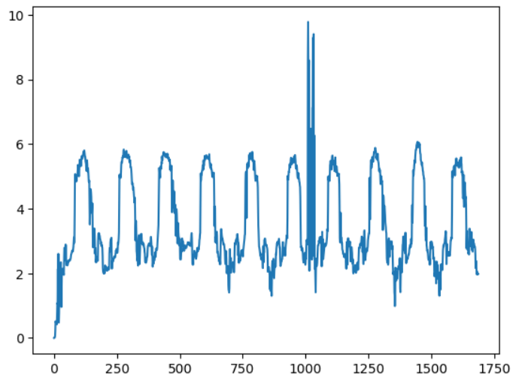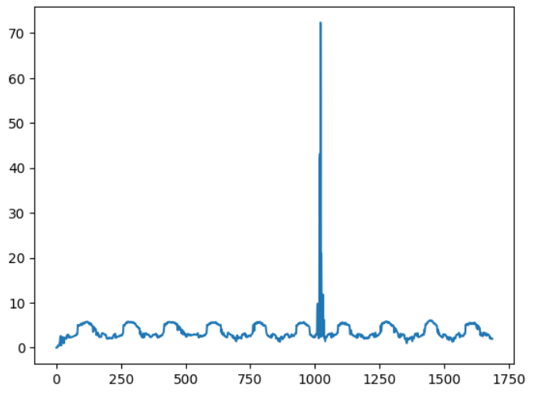

Figure 1 (Signal before and after applying threshold 10)

This approach addresses disparities and outliers in the data, enhancing its accuracy and enabling meaningful interpretation of the captured motions.

## **3.2 Gaussian Filter**

In order to address the noticeable noise present in many of the files, we employ a Gaussian filter to smooth the motion data. The purpose of this filtering technique is to reduce unwanted noise and discrepancies that can arise from various resources, including sensor inaccuracies, motion, or errors that may occur during the video to .npz file conversion process [2].

By applying a Gaussian filter, it effectively mitigates high-frequency noise components while preserving the overall structure and important features of the motion patterns. This approach allows us to maintain the integrity of the motion data while reducing the impact of unwanted noise.

By utilizing the Gaussian filter, our main objective is to enhance the quality and clarity of the motion data, making it more suitable for further analysis. This enables us to focus on the essential characteristics of the movements, while minimizing the influence of undesirable noise or disturbances.

The Figure below shows the movements before and after applying the Gaussian filter.

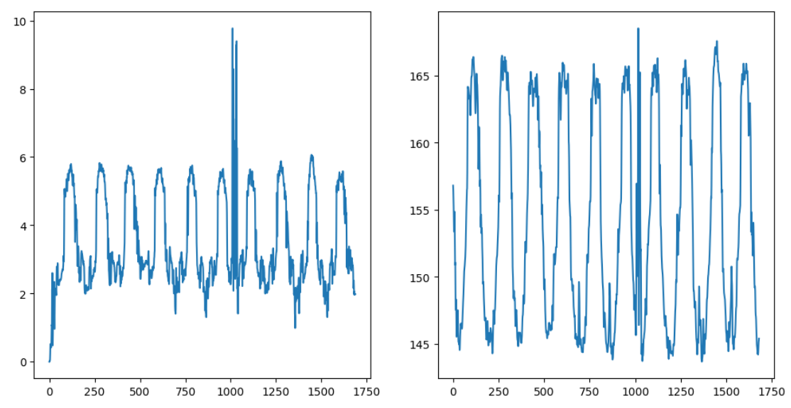

Figure 2 (Signal before and after applying GF)

After applying the Gaussian filter to the motion data, we proceeded to calculate the energy of the resulting movement. The energy calculation equation is employed to quantify the intensity or magnitude of the motion.

## **3.3 Normalization Process**

The process of converting a certain data set's values to a particular range is known as normalization. This method is important for machine learning algorithms since many of these algorithms depend on the scale of the input data and perform better when the data falls within a specific range [3].

There are different methods to apply the normalization process on a data set, such as Min-Max **normalization, Z-score normalization, Decimal Scaling, Logarithmic transformation, Root transformation [3].**

**In our case, a Min-Max normalization process is used to normalize the energy values to the range of 0 and 1.**

### **3.3.1 Min-Max Normalization**

Min-Max Normalization is a widely employed method for normalizing data. It involves transforming the lowest and highest values of each feature in a dataset to 0 and 1, respectively. Meanwhile, all other values are proportionally scaled to decimals ranging between 0 and 1. The core principle of this technique centers around identifying the minimum and maximum values within the dataset. By performing this normalization process, the data is adjusted to a standardized range, facilitating comparisons and analysis across different features or variables [4].

The steps for applying a Min-max normalization technique on a data is as follow:

1. The minimum and maximum values should be noted: Finding the feature's minimum and maximum values over the whole dataset using the notation min and max.
2. Subtract the minimal value: Take the minimum value out of each feature's data point. As a result, the minimum value is guaranteed to reach zero but the relative differences between other values are preserved.
3. Divide by the range: Divide each data point by the range of the feature, which is the difference between the maximum and minimum values.
4. The normalized data: Following the above calculations, the normalized data, which will now fall within the range of 0 to 1, will be obtained. The original dataset's smallest value is represented by a value near to 0, while its greatest value is represented by a value close to 1.

Once the energy values for each exercise are calculated, it is observed that the range of these values differs across different exercises. To address this, a normalization process is applied using the Min-Max normalization technique, to ensure that the energy values are adjusted to a specific range for all exercises. As a first step, the minimum and maximum values of energy is obtained, after that the Min-Max normalization is calculated.

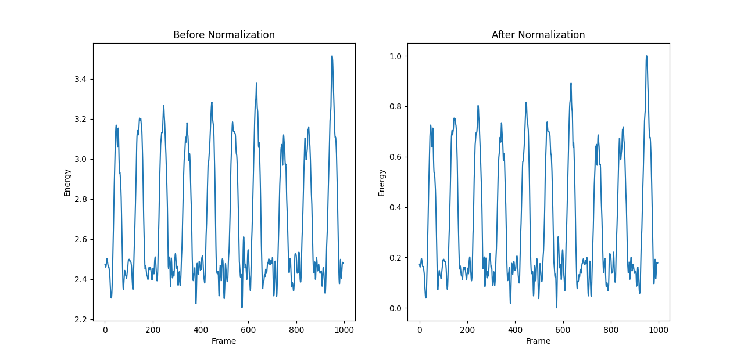

Figure 3 (Signal before and after min-max normalization)

The above Figure 3, shows the impact of normalization process on a specific data. The plots are for the exercise file “E2_P1_T2_C0”, the first plot in the left represent the original energy

values for the file which seems to be in the range from 2.2 to approximately 3.4. The other plot in the right, represent the energy values after normalize it to the range of 0 and 1.

## **3.4 Segmentation Process**

In data analysis, segmentation refers to the process of dividing the data into separate segments or groups according to specific features or criteria. Identification of patterns, similarities, and differences within the dataset is the aim of segmentation, which can lead to useful insights or support decision-making.

The result from the normalization process show that there are ten repetitions of the same movement or exercise, this can be seen in some files by looking at the plot as the smoothed energy values goes up and down. Therefore, in order to further analyze and interpret the data, the entire set of exercises needs to be divided into ten segments using the segmentation process. This division will enable a more precise analysis of each repetition and facilitate the extraction of meaningful information from the dataset.

The segmentation process in general, goes through these steps:

1. Data Preparation: The data needed for segmentation should be gathered and preprocessed. In order to do this, the data may need to be filtered, missing values handled, variables transformed, and the data may need to be normalized or standardized as necessary.
2. Select Segmentation Variables: Identify the key variables that will be used for segmenting the data. These variables should be relevant to the objective of the analysis and have the potential to differentiate the data points.
3. Choose Segmentation Technique: Choosing the right segmentation approach depending on the goal and the nature of the data.
4. Apply Segmentation Technique: Use the data to apply the selected segmentation method. Based on the chosen segmentation variables, related data points are grouped together in this process. The particular strategy for grouping the data will depend on the algorithm or method employed.

There are different techniques to apply segmentation on data, one of them is masking technique.

### **3.4.1 Masking Technique**

Masking is the process of choosing or filtering particular data points according to predetermined criteria. In essence, a mask is a boolean array that identifies the data parts that match the required criteria. Only the data points that match the True values in the mask are kept, the remainder are either ignored or deleted.

Masking is often used in uncomplicated segmentation situations when the selection criteria do not need sophisticated patterns or algorithms and are really simple. Masking is useful for quickly isolating specific subsets of data based on a particular condition or criteria.

In our case, the segmentation variable is the Threshold of the exercises energies, after normalization process, the threshold of the exercises have to be in the range of 0 and 1. Each exercise will have it’s own threshold obtained by experience. After obtaining the threshold, the comparison process between the energy value and the threshold is done, so that the energy values which above the threshold, is added to the mask, and the other values is considered as zero, the final result is a pluse wave with values 0’s and 1’s as shown in the below figure:

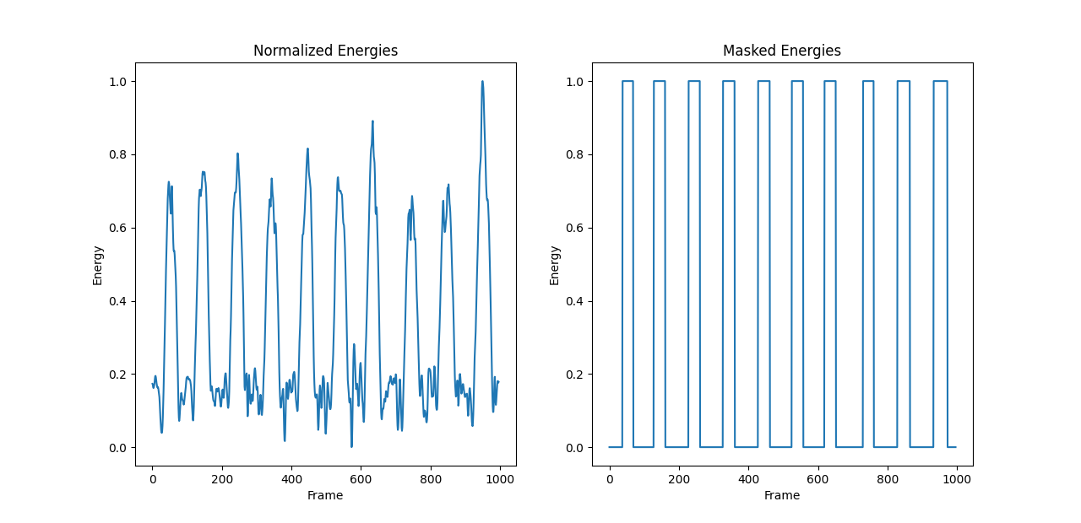

Figure 4 (Ideal signal after masking)

As appear that the plot in the right which contained masked energies contain 10 pulses, with each pulse represent a different repetition of the same exercise.

The case appear above is an ideal case, where the mask recognize each repetition easily, but we have exercises which contain noises that seems to be an exercise, but in actual it’s not. This case is shown in the figure below:

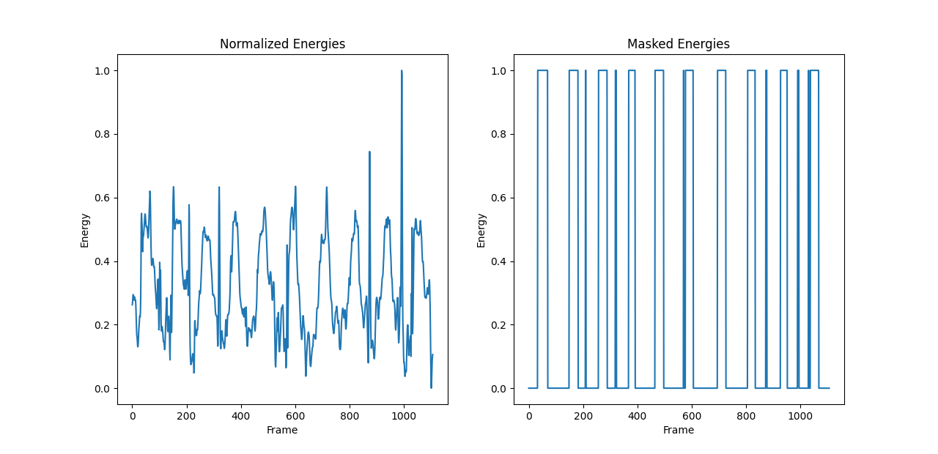

Figure 5 (Non-ideal signal after masking)

The masked energies plot, have more than 10 pluse waves, and this can be easily recognized. This happen because in the normalized energies there are up-down movements that don’t represent exercise repetition as in the following case:

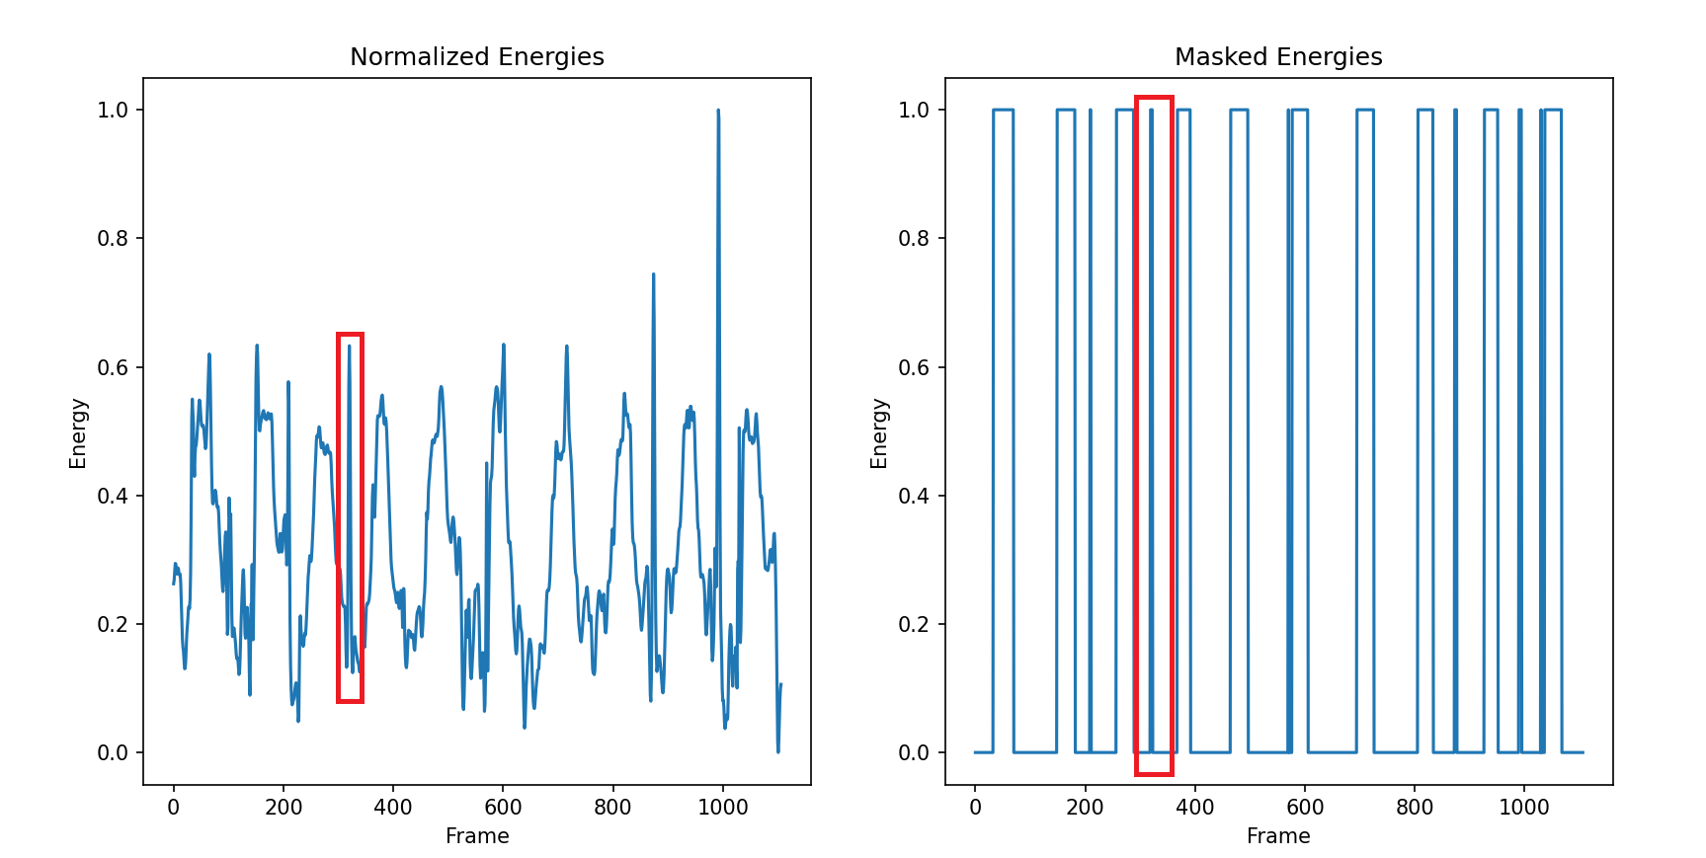

Figure 6 (Non-ideal signal after masking with more details)

From the plot in the left, and identified by the red rectangle, the normalized energy value in red after applying the masking technique to it, it will be classified to be above the threshold so masking technique will assume it as a separate repetition, and which is false in actual.

So at this point, a need for a technique that will recover this un-correct assumption is appear, this technique is calling Moving Average Function.

### **3.4.2 Moving Average Function**

The Moving Average (MA) function is a commonly used statistical technique in time series analysis and forecasting. It used to smooth out noises in data and identify underlying trends or patterns. The MA function calculates the average of a specified number of previous data points, creating a moving average that moves along with the data.

The concept of Moving Average Function is that there are a specific window size to move according it. At each time, move one-step then calculate the average according to the window size.

To provide a more detailed explanation, the moving average function initiates by determining the desired period or window size for the moving process. This including selecting data point’s equivalent to the specified period. The selected data points then summed and divided by the period, resulting the moving average value for that specific point in time. As a final step, the window shifted by one data point, allowing the selection of a new set of data points and the subsequent calculation of the average, then drop the oldest data point from the previous calculation and include the next data point. This updates the moving average for the next point in time.

Choose a suitable window size, help to control the sensitivity of the moving average to changes in the data. A shorter period moving average is more sensitive to immediate changes, while a longer period moving average provides a broader perspective and is better suited for identifying long-term trends. The choice of period depends on the specific analysis or forecasting objectives, the characteristics of the data, and the desired balance between responsiveness and stability in the moving average calculation.

In our case, the moving average function help in determining how many times does the number 1 is repeated, if the one is repeated more and more, this mean that there is a repetition of the exercise. This done by obtaining a suitable window size for each exercise by experimenting with different values and obtaining the most appropriate window size for the exercise.

The figure below shows the effect of the moving average function when apply it into a specific exercise:

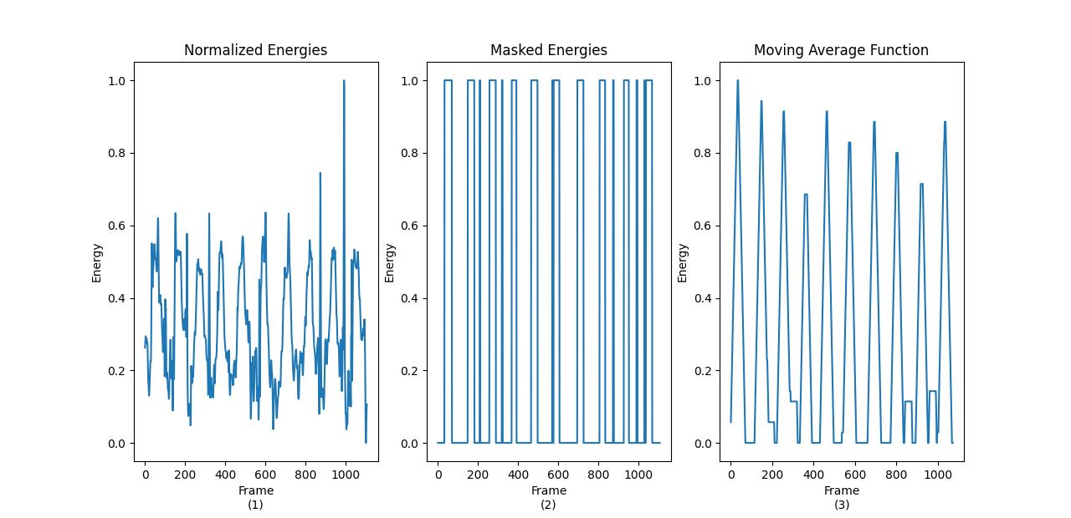

Figure 7 (Masked signal after applying MV)

In this case, the window size was 35, which means that starting with zero, and take a window of 35, then sum the values and divide by 35. The first top value in the moving average is one, this mean that there are 35 ones after each other presented at masked energy. The other top values of the moving average result are less than one, this mean that less than 35 one is appear in the masked signal, and so on.

By the moving average method, we are able to solve the problem that appear in some exercises file as mentioned earlier.

The step come after moving average calculation is to convert the moving average signal into masked signal, but the resulting masked signal in this point, will contain only 10 repetition of the same exercises without any noises or errors as the figure below:

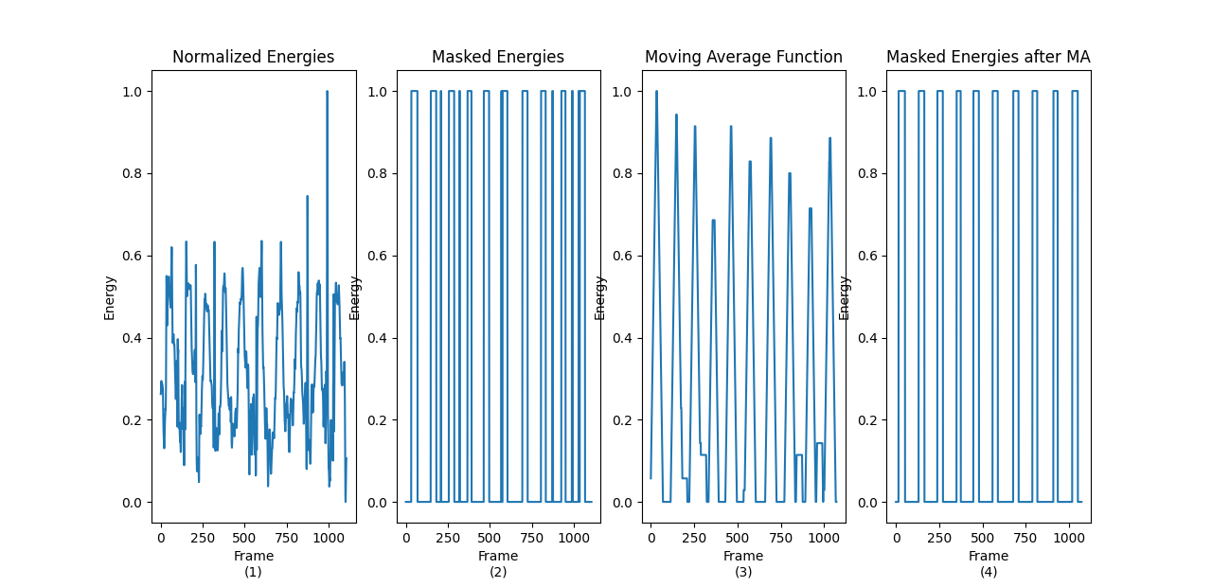

Figure 8 (Converting MA signal into mask)

After applying all of the above techniques, we unfortunately still have exercises files, that do not divided into 10 segments correctly. To avoid errors, we have deleted the files that give the number of repetitions of the exercise more or less than 10, because this will cause us a problem when doing features extraction, and we will solve this problem in 5300.

## **3.5 Segments Period**

In this part, we calculate the time for each exercise by using the pulses for each key[k] that’s happen by detect the start and the end of pulse by using the values of mask after moving average. In mask after moving average, the value will be 1 or 0.

The process is:

1. **Detect the start and the end of the pulse**: In order to be able to determine the beginning and the end, we used the result of the Mask after moving average (its value is equal to 1 or 0), and we also defined a variable called pulse active whose value is true when it is during the pulse, and when it ends, the value of the pulse becomes false, so we made conditional statements to specify the beginning and the end based on these values and store the starting and ending values in Arrays
2. **Calculate exercise intervals based on pulse positions:** In this step, we developed an equation to take only the part that two exercises do not overlap together, and we did that through an equation that is

**pulseEndDic[k][i] + pulseStartDic[k][i + 1]) / 2**

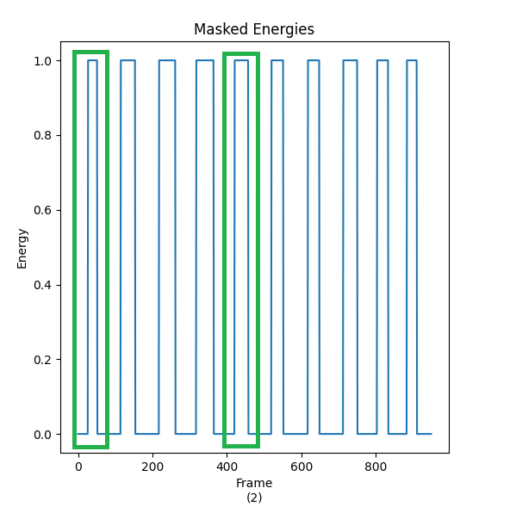فظ

Figure 9 (Start and end of segments)

As the result from above equation, we obtain the start and the end of each segment as shown below:

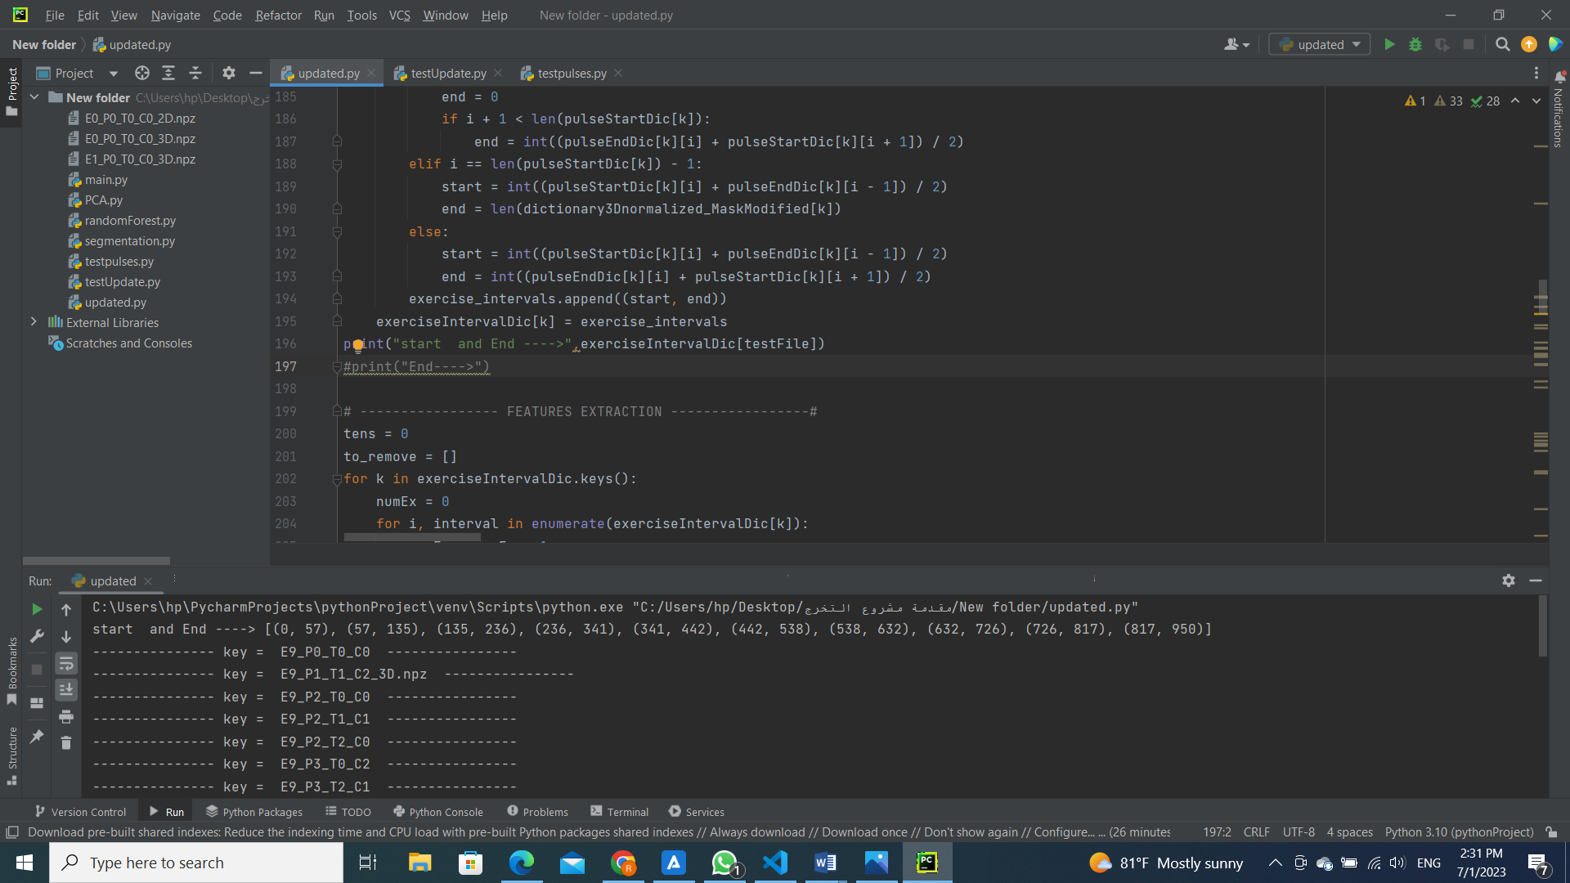

Figure 10 (Segments intervals)

## **3.6 Features Extraction**

At this stage, we will calculate a number of features for the exercises to use them later in the Random Forest to distinguish between one exercise and another.

To create the features vectors for the identified segments and train the recognition model, a group of well-designed features was proposed. Time-Domain (TD) and Frequency-Domain (FD) signal characteristics are included in the feature set. For the sensors on each of the three axes (x, y, and z), these features were retrieved. Time-domain characteristics, because they demonstrate how the signals vary over time, time-domain properties are significant. Statistics such as mean, variance, skewness, autocorrelation, kurtosis, entropy, Root Mean Square (RMS), Signal-Magnitude Area (SMA), and the window Integration (Itot) are all included in the proposed time-domain features set. The statistical time-domain features can be represented mathematically as follows with our signal represented by s[n] in the time domain and sampled with length Ns:

* The features:

1. Mean: divide the total number of values in a data set by the sum of all the values produced [5].

Mean = μs = E{s} = 1 / Ns

1. Variance: measures how far each number in the set is from the mean and every number in the set [6].

Variance = σ2 = E{ } = 1 / Ns

1. Skewness: measurement of a data set's asymmetrical or symmetrical distribution distortion [7].

Skewness = =

1. Autocorrelation: The degree of similarities between a given time series when presented twice—once in its original form and then with one or more time periods lag—is represented mathematically. [8]

Autocorrelation = Rss(Δ) =

where Δ = 0, 1, …, Ns – 1

1. Kurtosis: The amount of data in the tails furthest from the mean of the data set is described when plotting a graph curve which is usually bell shaped [9].

Kurtosis = =

1. Entropy: The average amount of units of information required for any symbol is tightly limited by the entropy's tight lower restriction [10].

Entropy =−

1. sRMS (Root mean square): is the square root of the values' squared values' arithmetic mean [11].

SRMS=

1. SMA (signal magnitude area): is a statistical evaluation of the size of a fluctuating quantity [12].

SMA =

1. Integrand: An integral is the continuous equivalent of a sum in mathematics, where sums are used to compute areas, volumes, and their generalizations [13].

Integrand=

* Frequency-domain Features:

X(f) =

The linear normalization approach was used to accomplish length normalizing to create a constant array length because the DFT transform feature creates arrays with variable length. In order to have a fixed amount of features to combine with the other extracted characteristics to create the final features vector for training the classifier, we did array length normalization. We have extracted an additional set of characteristics to reduce the information loss from the normalization process outlined above.

1. Argmax:

ArgMax = i|i ∈ N&∀j ∈ N : Xi⩾Xj

1. Argmin:

ArgMin = i|i ∈ N&∀j ∈ N : Xi⩽Xj

1. argavg_indices:

ArgAvg = i|i ∈ N&∀j ∈ N : |Xi − average|⩽|Xj − average|

1. dc_bias:

DC bias =

The features for all exercises are calculated for the 17 joints and the 3 axis’s for all segments, then all features of one exercise stored in a list to use them in random forest as testing and training vectors, to be able to recognize each exercise.

## **3.7 Random Forest**

Random forest is a commonly-used machine learning algorithm that combines the output of multiple decision trees to reach a single result. Each decision tree in the ensemble of the random forest method is made up of a data sample taken from the training set, with one-third of it being set aside as test data. The prediction will be determined differently depending on the type of issue. The individual decision trees will be averaged for the regression job, and for the classification task, the predicted class will be determined by a majority vote, or the most common categorical variable. Cross-validation is subsequently applied on the test sample to complete that prediction [14].

So In our project we start split the data into training and testing sets then create the random forest and training classifiers then make the prediction on test data and evaluate the accuracy

**Chapter 4**

# **References**

1. Palestinian Ministry of Health, the number of physiotherapy cases in Palestine in 2020, <https://www.moh.gov.ps/portal/> [Accessed 18 May 2023]
2. About Gaussian Filter, <https://www.southampton.ac.uk/~msn/book/new_demo/gaussian/> [Accessed 28 June 2023]
3. Normalization process, <https://www.geeksforgeeks.org/data-normalization-in-data-mining/> [Accessed 29 June 2023]
4. Min-Max normalization, <https://www.codecademy.com/article/normalization> [Accessed 29 June 2023]
5. Mean feature, <https://www150.statcan.gc.ca/n1/edu/power-pouvoir/ch11/mean-moyenne/5214871-eng.htm> [Accessed 1 July 2023]
6. Variance feature, <https://www.investopedia.com/terms/v/variance.asp> [Accessed 1 July 2023]
7. Skewness feature, <https://www.investopedia.com/terms/s/skewness.asp> [Accessed 1 July 2023]
8. Autocorrelation feature, <https://www.investopedia.com/terms/a/autocorrelation.asp> [Accessed 2 July 2023]
9. Kurtosis feature, <https://www.investopedia.com/terms/k/kurtosis.asp> [Accessed 2 July 2023]
10. Entropy feature, <https://docs.scipy.org/doc/scipy/reference/generated/scipy.stats.entropy.html> [Accessed 2 July 2023]
11. Entropy feature, <https://en.wikipedia.org/wiki/Root_mean_square> [Accessed 2 July 2023]
12. Signal Magnitude Area (SMA) feature , <https://handwiki.org/wiki/Signal_magnitude_area> [Accessed 2 July 2023]
13. Integrand feature, <https://en.wikipedia.org/wiki/Integral> [Accessed 2 July 2023]
14. Random Forest Algorithm, <https://www.ibm.com/topics/random-forest> [Accessed 2 July 2023]