**Ain Shams University**

**Faculty of Computer and Information Science**

**Scientific Computing department**

**Ain shams university**

**Faculty of computer and information science**

**Bioinformatics department**

**Project Title**

**Parallel Median Filter**

**By Team 31 SC**

|  |  |  |
| --- | --- | --- |
| **Name** | **ID** | **Section** |
| **Nour Mohamed Hussein Kamaly** | **20191700701** | **5** |
| **Nourhan Abdel-Karim Khalaf Abdel-Hafez** | **20191700716** | **5** |
| **Mohammed Nour-Elden Abbas Ismael** | **20191700583** | **4** |
| **Abdul-Rahman Sayed Ali Mohammed** | **20191700339** | **3** |

**Under the supervision of**

**Dr. Heba Khaled**

**Scientific Computing Department,**

**Faculty of computer and Information Science**

**Ain Shams University**

**What is salt and pepper noise?**

Salt-and-pepper noise, also known as impulse noise, is a form of [noise](https://en.wikipedia.org/wiki/Image_noise) sometimes seen on [digital images](https://en.wikipedia.org/wiki/Digital_image). This noise can be caused by sharp and sudden disturbances in the image signal. It presents itself as sparsely occurring white and black [pixels](https://en.wikipedia.org/wiki/Pixel).

An effective [noise reduction](https://en.wikipedia.org/wiki/Noise_reduction) method for this type of noise is the [median filter](https://en.wikipedia.org/wiki/Median_filter)

**Median filter**

The median filter is a non-linear [digital filtering](https://en.wikipedia.org/wiki/Digital_filter) technique, often used to remove [noise](https://en.wikipedia.org/wiki/Signal_noise) from an image or signal. Such [noise reduction](https://en.wikipedia.org/wiki/Noise_reduction) is a typical pre-processing step to improve the results of later processing (for example, [edge detection](https://en.wikipedia.org/wiki/Edge_detection) on an image). Median filtering is very widely used in digital [image processing](https://en.wikipedia.org/wiki/Image_processing) because, under certain conditions, it preserves edges while removing noise (but see the discussion below), also having applications in [signal processing](https://en.wikipedia.org/wiki/Signal_processing).

**Enhancements and findings**

* The time complexity of the median filter in sequential code is O(Width*Height* filterSize^2). Width * Height to filter each pixel in the image and filterSize^2 as each pixel is filtered according to its (filterSize^2) neighbors.
* By using MPI (message passing interface), the image was distributed across N number of processors, each executing the code of the median filter, and the results were gathered at a specific core, to reconstruct the filtered image.
* As we increased the number of cores in parallel programming, the time taken used to decrease, until a threshold then it started to increase afterwards, this is due to the overhead on the processor to distribute the data and the tasks.
* The optimal number of processors to use is 8.

**Results**

|  |  |  |  |  |
| --- | --- | --- | --- | --- |
|  | N*N | 2N*2N | 5N*5N | 10N*10N |
| Sequential | 61 | 197 | 1230 | 5133 |
| MPI solution | 23 | 78 | 323 | 1313 |

**Unfiltered 10N*10N picture**

**Sequential filtering**

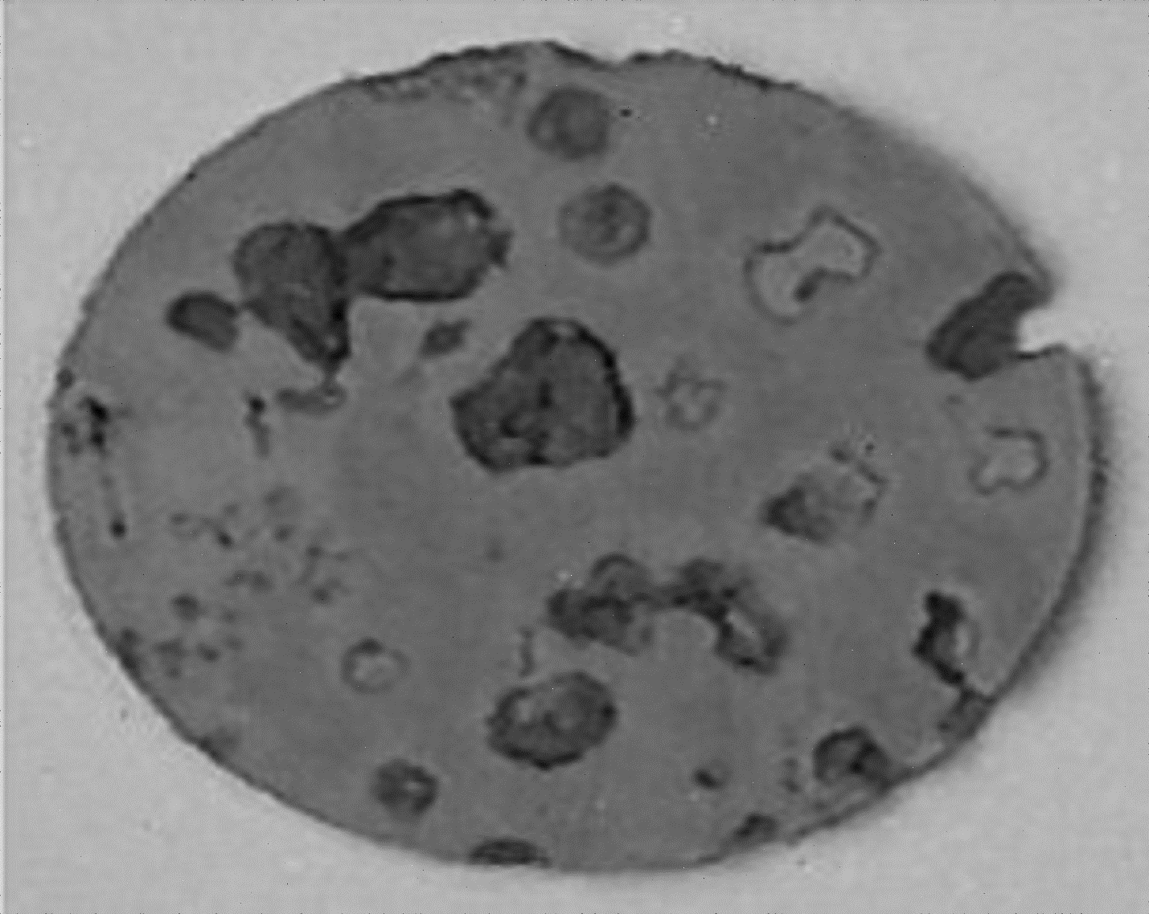

**Parallel filtering**

