**Reflect API**

It is a built-in object that provides methods for interceptable JavaScript operations.

Reflect is not a function object, so it's not constructible.

=====================================================================

**Reflect.apply()**

* It calls a target function with arguments as specified.

**Reflect.apply(target, thisArgument, argumentsList)**

target: The target function to call.

thisArgument: The value of this provided for the call to target.

argumentsList: An array-like object specifying the arguments with which target should be called.

The result of calling the given target function with the specified this value and arguments.



=====================================================================

**Reflect.construct()**

* It acts like the *new* operator, but as a function, It is equivalent to calling new target(...args)

**Reflect.construct(target, argumentsList)**

**Reflect.construct(target, argumentsList, newTarget)**

target: The target function to call.

argumentsList: An array-like object specifying the arguments with which target should be called.

newTarget Optional: The constructor whose prototype should be used. See also the new.target operator. If newTarget is not present, its value defaults to target.

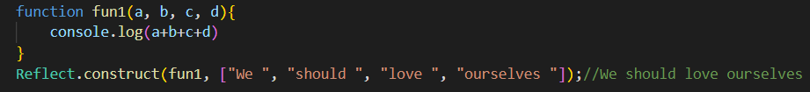

====================================================================

**Reflect.defineProperty()**

* It is like *Object.defineProperty()* but returns a Boolean

**Reflect.defineProperty(target, propertyKey, attributes)**

target: The target object on which to define the property.

propertyKey: The name of the property to be defined or modified.

attributes:The attributes for the property being defined or modified.

A Boolean indicating whether or not the property was successfully defined.

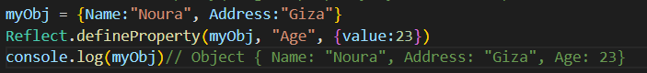

**======================================================**

**Reflect.deleteProperty()**

* It allows to delete properties. It is like the *delete* operator as a function.

**Reflect.deleteProperty(target, propertyKey)**

target: The target object on which to delete the property.

propertyKey: The name of the property to be deleted.

A Boolean indicating whether or not the property was successfully deleted.

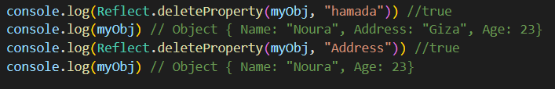

**Reflect.get()**

* It works like getting a property from an object *(target[propertyKey])* as a function.

**Reflect.get(target, propertyKey)**

**Reflect.get(target, propertyKey, receiver)**

target: The target object on which to get the property.

propertyKey: The name of the property to get.

receiver Optional: The value of this provided for the call to target if a getter is encountered. When used with Proxy, it can be an object that inherits from target.

Returns the value of the property.

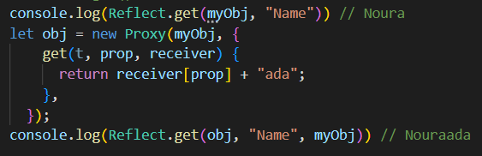

===================================================================

**Reflect.getOwnPropertyDescriptor()**

* It is similar to *Object.getOwnPropertyDescriptor()*. It returns a property descriptor of the given property if it exists on the object, undefined otherwise.

**Reflect.getOwnPropertyDescriptor(target, propertyKey)**

target: The target object in which to look for the property.

propertyKey: The name of the property to get an own property descriptor for.

Returns a property descriptor object if the property exists in target object; otherwise, undefined.



====================================================================

**Reflect.getPrototypeOf()**

* It is almost the same method as *Object.getPrototypeOf()*. It returns the prototype (i.e. the value of the internal *[[Prototype]]* property) of the specified object.

**Reflect.getPrototypeOf(target)**

target: The target object of which to get the prototype.

Returns the prototype of the given object. If there are no inherited properties, null is returned.



=====================================================================

**Reflect.has()**

* It works like the *in* operator as a function.

**Reflect.has(target, propertyKey)**

target: The target object in which to look for the property.

propertyKey: The name of the property to check.

Returns a Boolean indicating whether or not the target has the property.



=====================================================================

**Reflect.isExtensible()**

* It determines if an object is extensible (whether it can have new properties added to it). It is similar to *Object.isExtensible()*, but with some differences.

**Reflect.isExtensible(target)**

target: The target object which to check if it is extensible.

Returns a Boolean indicating whether or not the target is extensible.

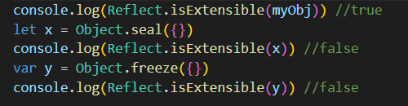

=====================================================================

**Reflect.ownKeys()**

* It returns an array of the target object's own property keys.

**Reflect.ownKeys(target)**

target: The target object which to get the own keys.

Returns an Array of the target object's own property keys.



**=====================================================================**

**Reflect.preventExtensions()**

It prevents new properties from ever being added to an object (i.e., prevents future extensions to the object). It is similar to *Object.preventExtensions()*, but with some differences.

**Reflect.preventExtensions(target)**

target: The target object object on which to prevent extensions.

Returns a Boolean indicating whether or not the target was successfully set to prevent extensions.



**====================================================================**

**Reflect.set()**

* It works like setting a property on an object.

**Reflect.set(target, propertyKey, value)**

**Reflect.set(target, propertyKey, value, receiver)**

target: The target object on which to set the property.

propertyKey: The name of the property to set.

receiver Optional: The value of *this* provided for the call to the setter for *propertyKey* on *target*. If provided and target does not have a setter for *propertyKey*, the property will be set on *receiver* instead.

Returns a Boolean indicating whether or not setting the property was successful.

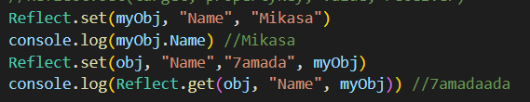

**====================================================================**

**Reflect.setPrototypeOf()**

* It is the same method as *Object.setPrototypeOf()*, except for its return type. It sets the prototype (i.e., the internal *[[Prototype]]* property) of a specified object to another object or to null, and returns true if the operation was successful, or false otherwise.

**Reflect.setPrototypeOf(target, prototype)**

target: The target object of which to set the prototype.

prototype: The object's new prototype (an object or null).

Returns a Boolean indicating whether or not the prototype was successfully set.



**====================================================================**

**Name: Noura Mahmoud**

**Track: Mobile Cross-platform**