# installing new windows server VM on lamad server:

1. First of all access to main Lamad server using:

<http://192.168.100.104:8006>

root

LMD@LAMFLOW

1. On the left panel chose Datacenter then pve then Create VM.
2. Set the Node(Pve), Name(try to follow the naming convention). In the OS tab you have to define the iso image of vm for windows server it will be 17763.3650.221105-17…..then choose the version of your system for windows server 2019 choses 10/2016/2019

And don’t forget to check the option (Additional driver for virtIO drivers) for windows server it will be virtio-win-0.1.240.iso

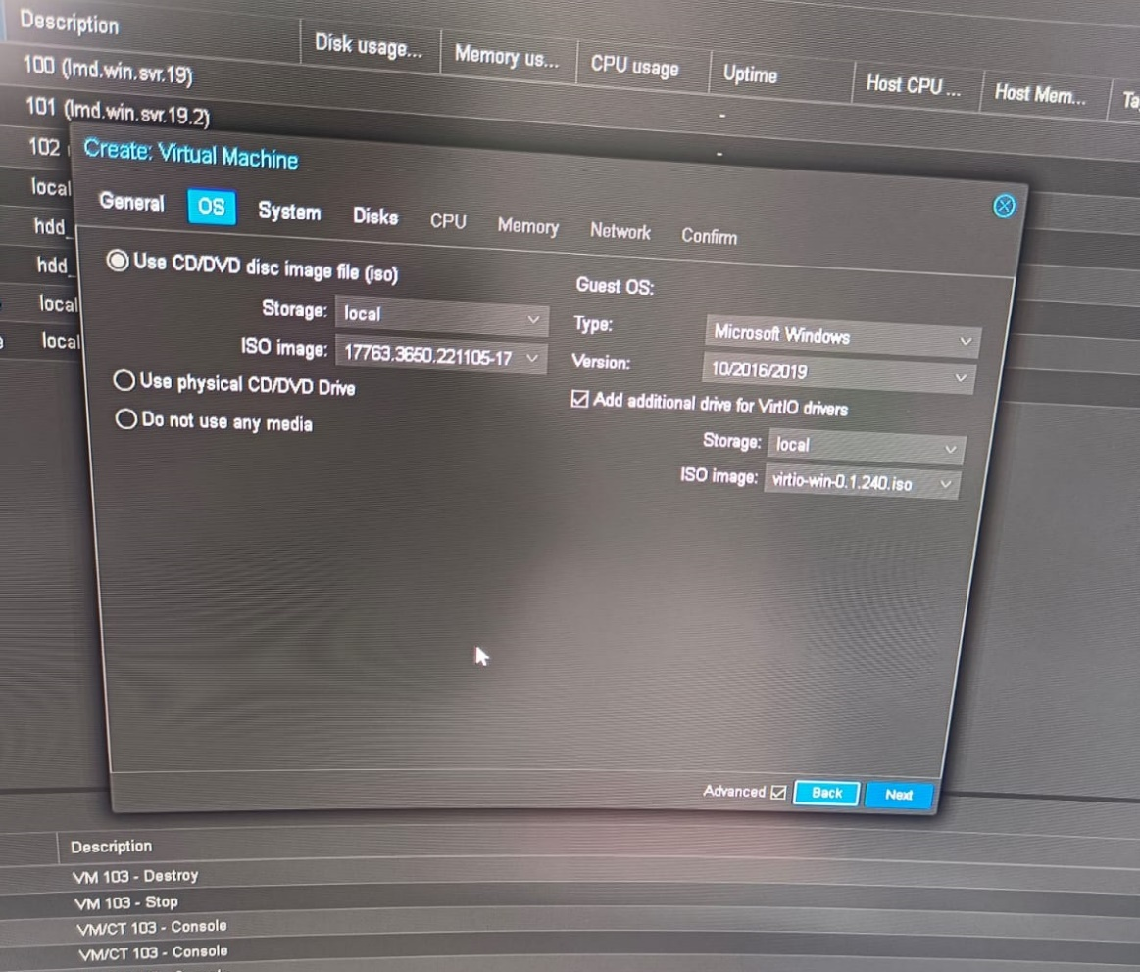

1. In System tab check the Qemu Agent option.
2. In Disk tab be sure you are using hdd-1 as storage and define the Disk size Then start launching the installing steps when you arrived to Select the driver to install select browse then navigate to (D:virtio-win-0.1.240🡪vioscsi🡪2k19🡪amd64)
3. After vm is ready go to the same D:virtio-win-0.1.240 path and press on .exe to install all required drivers.
4. Connect to new vmw using remote desktop connection:

192.168.100.135 (to be able to share files between the host and vmw windows server).

# what we need to run pi server on this server:

1. Install Microsoft SQL Server (express is free).
2. Install Visual Studio.
3. Install DataArchive to get msf file (to use it in create pi License key)
4. Install Microsoft .NET Framework 4.7.1 SDK
5. see #Request new pi server trial license key to know how to request new trail license.
6. Download pi License key folder after uploading (msf) file then extract the downloaded folder and define the path of pilicence.dat from extracted folder while you are installing pi server or take pilicence.dat and put it inside c->program files->pi->dat in case pi installed before and just want to renew it.
7. Install pi server.
8. Install PISMT_2018_SP3(PI System Management Tools)(should be compatible with pi server version)
9. Then copy PI.API (pi interface application) Open it as project in visual studio edit the pi_server_name in the webcomic file then build and publish it.
10. Create new folder called it pi inside C:\inetpub\wwwroot copy publisher files inside it.
11. Now open IIS Manager select Site🡪 Add Website.
12. Define the name (pi) and port should be 44372.
13. Then we have to make this port exposed to access this pi interface from postman.
14. to make it exposed go to Windows Defender Firewall 🡪advanced Settings🡪Inbound Rules 🡪New Rule🡪port🡪TCP 🡪define the port(44372)
15. download the postman to use it in read and write tags from pi.

Types of requests from postman to PIAPI:

* Read list of tags:

post request : <http://192.168.100.135:44372/api/pi/read>

Body should look likes:

{'Tags': ['tag1',’tag2’,’tag3’],

"Interval":100}

* Create list of tags:

Post request: <http://192.168.100.135:44372/api/pi/create>

Body should look likes:

{'Tags': ['tag1’,’tag2’,’tag3’]}

* Write tag value:

<http://192.168.100.135:44372/api/pi/write/>

Body should look likes:

{"tag": tag1, "value": value}

* Write list of tags and list of values for them at the same time:

<http://192.168.100.135:44372/api/pi/write_all/>

Body should look likes:

{"Tags": ["tag1","tag2",”tag3”,”tag4”],

"Values":[value1,value2,value3,value4]}

#Request new pi server trial license key:

1. Visit <https://registrations.osisoft.com/s/>
2. Then register in a any company email and wait response from them.
3. Wait the second email with trail serial number.
4. Got to <https://registrations.osisoft.com/s/redeemtrial> and you the details from the second email to get access to pi server license key and software downloads.
5. Create msf file of your machine by installing PI Data Archive.

1. Upload this file to create license key.

1. Extract the download folder then take pilicence.dat and put it inside c->program files->pi->dat.
2. To download all the installation kits for pi server from previous screen too but the first icon.