# Download tags for new/old wells from pi server:

1. Log in to the server: nmdwlam1-s with credential:

srv-LamFlow@oxy.com

1. Navigate to path: (D:\Install Files\PICollectData\PICollectData\PI2 – Copy) Inside this folder we have to create a text file with a list of all the wells that we need to download tags for it (each well in separate line).
2. Define the tags that we want to read for all these wells … may tags already been specified or we need to read new tags in this situation we have to get this tags from pi process book take the tags we want then save them in excel file in the same format as next:

|  |  |  |  |  |  |
| --- | --- | --- | --- | --- | --- |
| Name |  |  |  |  |  |
| 99_99210_CPF_ESP__@@WELL_NAME@@__MOT_RUN_FREQ | | | | | |
| 99_99210_CPF_ESP__@@WELL_NAME@@__WH_PRESS | | | | | |
| 99_99210_CPF_ESP__@@WELL_NAME@@__FL_PRESS | | | | |  |

1. Generate the range that we want to download the data within it. this done by (genrate_data.ps1) power shell file.

For example: by editing the next parts we can define ranges starting from '5/2/2023 and ending after 6 * 2 months (one year) for each well.

$namesFilePath = "mkn_new_wells.txt"

$startDate = Get-Date '5/2/2023'

for ($i = 0; $i -lt 6; $i++)

then execute this power shell file by typing: .\genrate_date.ps to generate data_ranges.csv .

1. Edit PICollectData.exe.Config (existing in the same path)by defining :

<add key="tag_path" value="D:\Install Files\PICollectData\PI2 - Copy\tags_MKN.csv" />

<add key="well_path" value="D:\Install Files\PICollectData\PI2 - Copy\data_ranges.csv" />

<add key="auto" value="0" />

O: means take the ranges from data_ranges.csv .

1: means start from last date defined in the config file.

<add key="last_date" value="7/4/2024 1:01:05 PM" /> until now.

1. Run PICollectData.exe this will create a new folder with the date of running .exe inside Result folder for example:

(24-July-05).

Note: if there is any error this will create a log file inside Result folder.

1. Take the folder of the downloaded tags and now you can insert them into Lamflow project.

# Insert new wells with their tags and static data into Lamflow project:

1. by using the DataCollection url

<http://localhost:8000/admin>

navigate to Wells tab insert the new wells then navigate to Well Features tags and insert the new tags one by one and finally add the output features and static data for each well by navigating to Well Outputs.

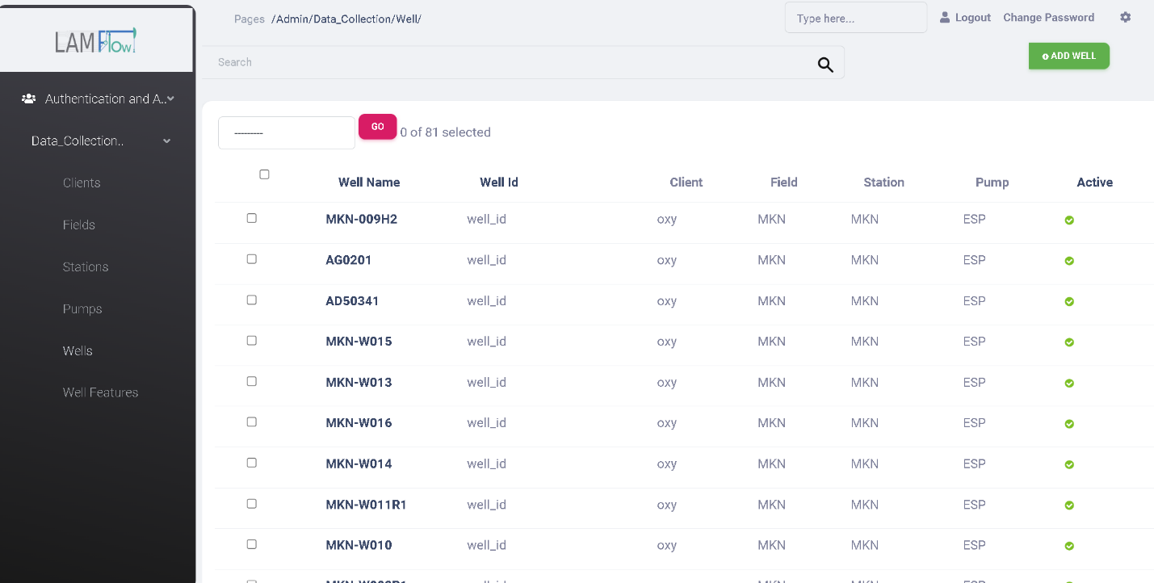

1. Or you can use a script to insert them all in one step.

For inserting wells and features and output you can use the script exists inside lamflow project in (apps stack\lmf_data_collection\data_collection\management\commands\insert_new_wells.py)  
you can run it in terminal root_folder(folder of downloaded tags) and keywords(required tags) by navigate to apps-stack\ lmf_data_collection then write: python manage.py insert_new_wells

Note: Output tags should have the same beginning of tags: for example:

99_99250_MKN_ESP_AJ05341_  
but should ends with one of the output_tags:

['LMFoilVolume','LMFwaterVolume',"LMFgasVolume","LMFedlGross","LMFedlWater","LMFedlOil","LMFedlGrossLower","LMFedlWaterLower","LMFedlOilLower","LMFedlGrossUpper","LMFedlWaterUpper","LMFedlOilUpper"]

99_99250_MKN_ESP_AJ05341_ LMFoilVolume

99_99250_MKN_ESP_AJ05341_ LMFwaterVolume

99_99250_MKN_ESP_AJ05341_ LMFgasVolume

…….etc

1. Insert the input (in case we are not working on oxy pi server)and output tags in pi-server by using postman post request:

(<http://pi-server-ip:port/api/pi/create>)

In the body:

{Tags:[list of tags]}

Or there is a def inside the same script file just takes all the input and output features then create them in pi server.

1. Inserting the metadata for all the wells:

first of all we have to download install Details files for all the wells from Nex­­­us ([Dashboard (oxy.com)](https://nexus-om.oxy.com/wells/list/dashboard)). Search per well then go to equipment tab🡪chose the latest version then export.

after that navigate to: Apps -stack\lmf_data_collection\data_collection\management\commands\new_static_data.py

In Lamflow project then define the path of install details folder and well_names path and run in terminal:

PS lamflow-platform-ecosystem\apps-stack\lmf_data_collection> python manage.py new_static_data