# Installing LAMFLOW on ubuntu

Use WinSCP or Filezilla to transfer lamflow folder from host to ubuntu server.

Access the server from vs code using SSH:

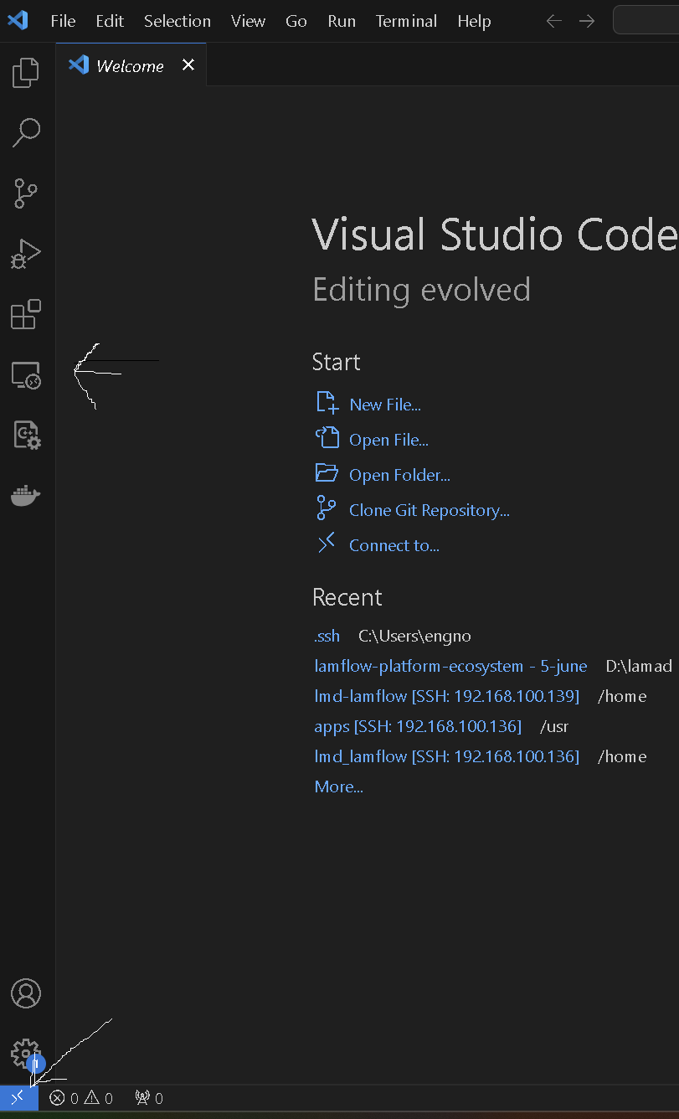

Then type ssh user@ip here it is

(ssh [lmd-lamflow@192.186.100.139](mailto:lmd-lamflow@192.186.100.139)) #dont forget to remove known hosts in case any problem

This will try to connect to server….then will ask about the password (123@pass)

After connecting open new terminal(if not being able to connect from vs code open Git Bash)

Switch to root user: sudo su

And create new folder: mkdir /usr/apps

Then copy/move the lamflow project (you put it on the root folder using WinSCP) to the new folder (apps):mv /name/lmd-lamflow /usr/apps

Then navigate to inside this folder after that we have to execute a script of installing docker..

Nano install.sh (copy what is inside install_docker_on_ubuntu.sh abd past it)

chmod +x install.sh

./install.sh

Then navigate to inside the lamflow project and type make install