# Steps to install Ubuntu on main server:

1. First of all access to main Lamad server using:

<http://192.168.100.104:8006>

root

LMD@LAMFLOW

1. Create new vmw

1. Define the ISO image of linux, type and version (latest)A screenshot of a computer

   Description automatically generated
2. Check Qemu Agent option.

1. Define hdd_1 as storage and Disk size (500 gigabyte)A screenshot of a computer

   Description automatically generated
2. Change the number of Cores(10):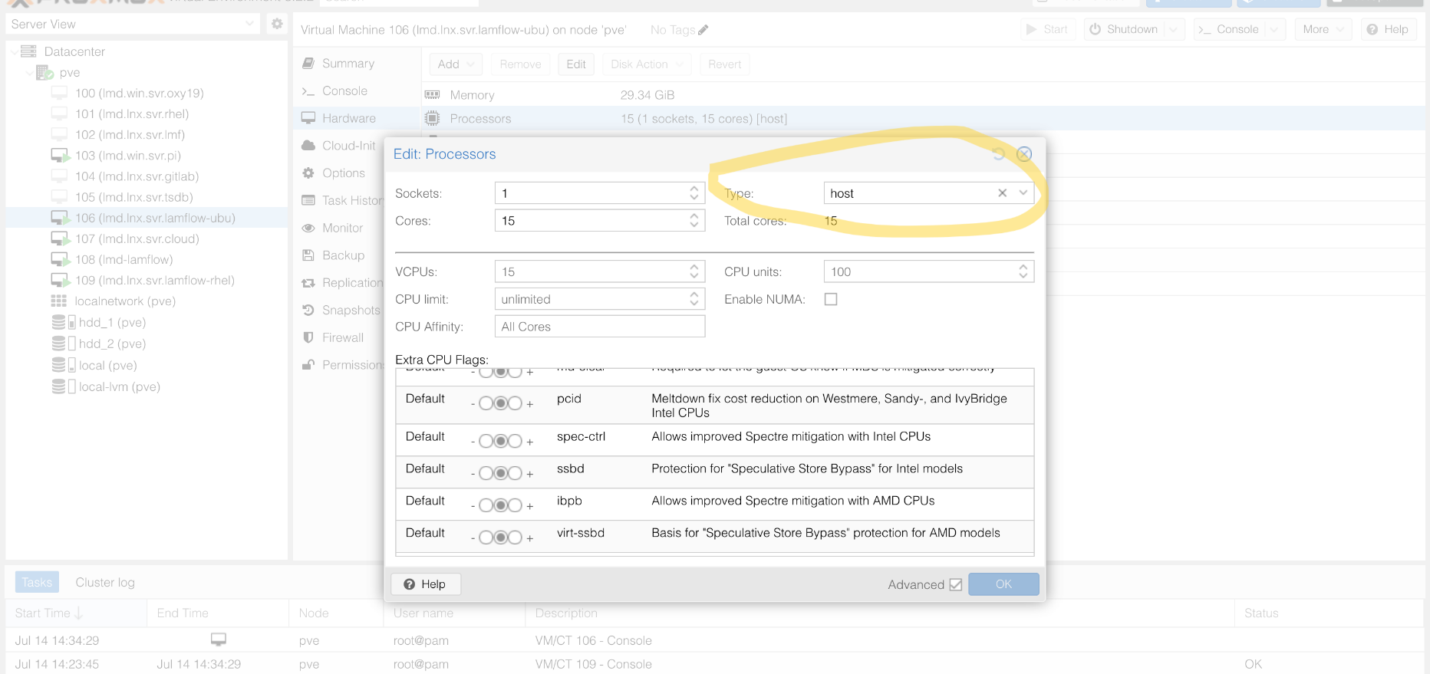
3. Memory should be bigger enough to run linux and docker(docker by itself needs 9 Gigabyte)

1. Netwrok keep it as it is default

1. Then confirm

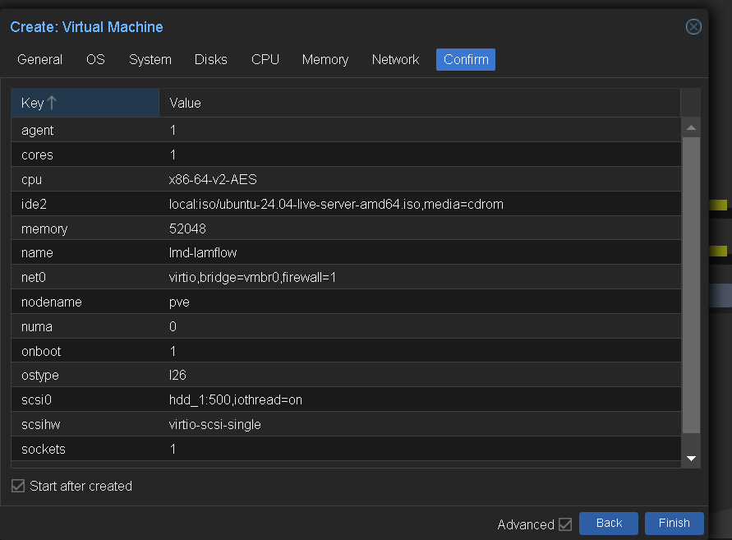

1. Start installing the system.

1. Continue the steps…

1. Continue..be sure the network is configured..   
   A computer screen with white text

   Description automatically generated
2. As it is…

1. Continue…

1. Continue..

1. continue ..

1. continue..
2. 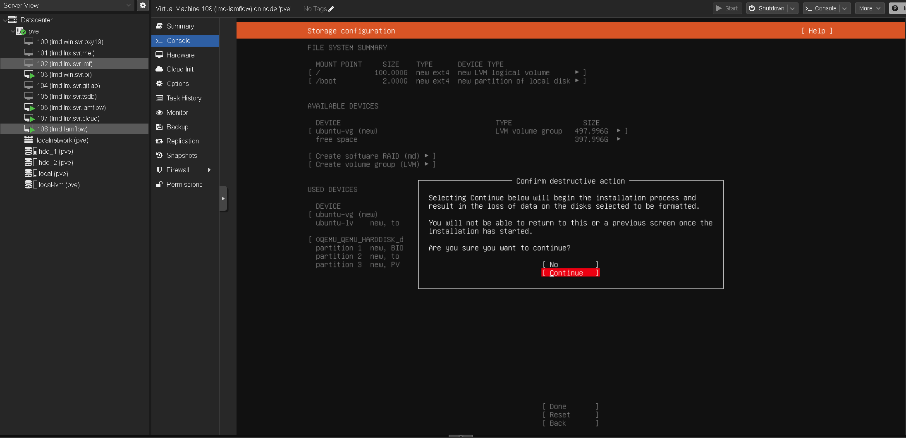insert the details..

1. just continue.

1. Make sure to check Install OpenSSH server so you access this server using ssh.
2. A computer screen with white text

   Description automatically generatedA screenshot of a computer

   Description automatically generatedDone…(prefer to install them from inside docker itself)
3. Done
4. A screenshot of a computer

   Description automatically generatedit is running now

