**Linux commands:**

* **ls**: Lists directory contents

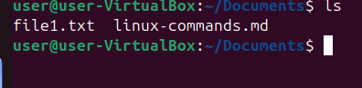

* **pwd**: Prints the current working directory.

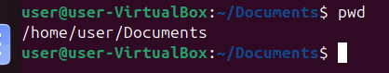

* **mkdir**: Creates a new directory.

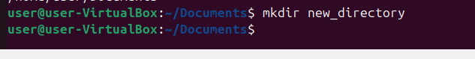

* **rmdir**: Removes an empty directory.

