Quick Sorting:

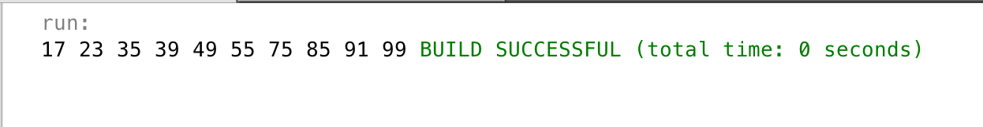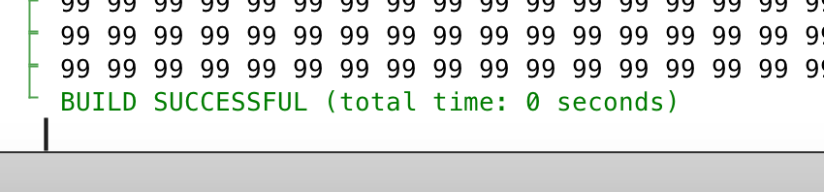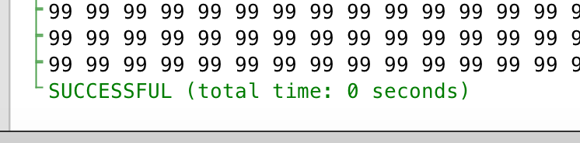

Heap Sorting:

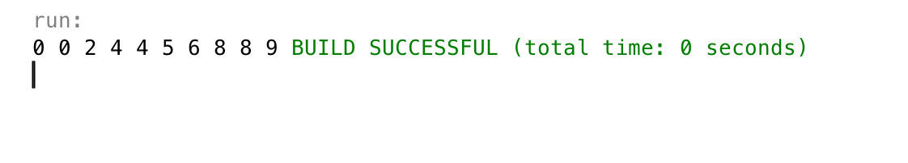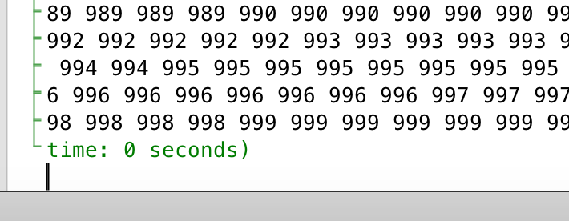

Bubble Sorting:

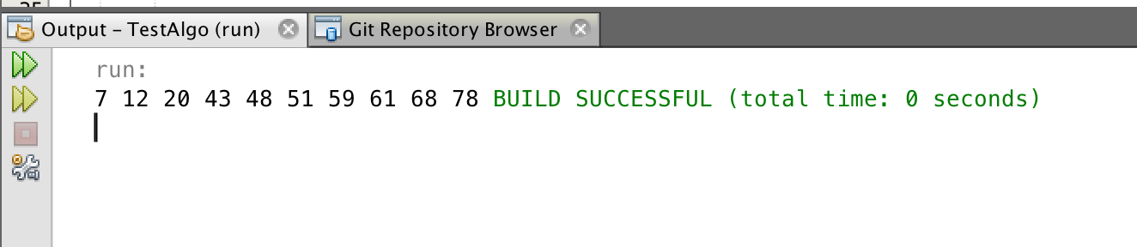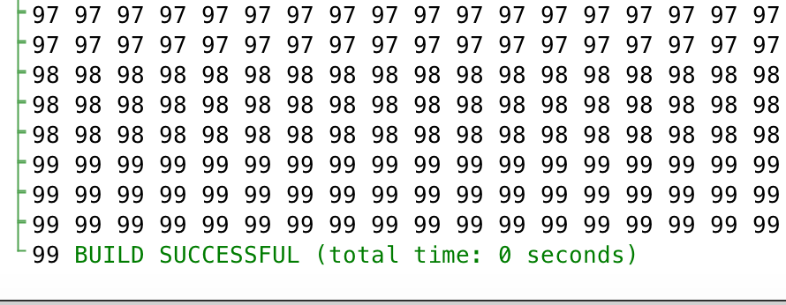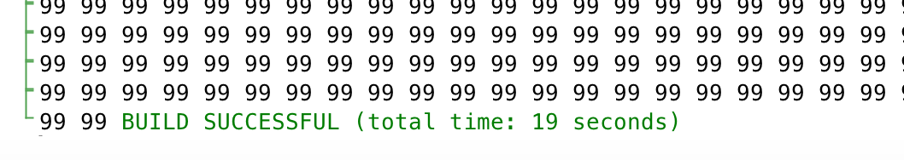

Selection Sorting:

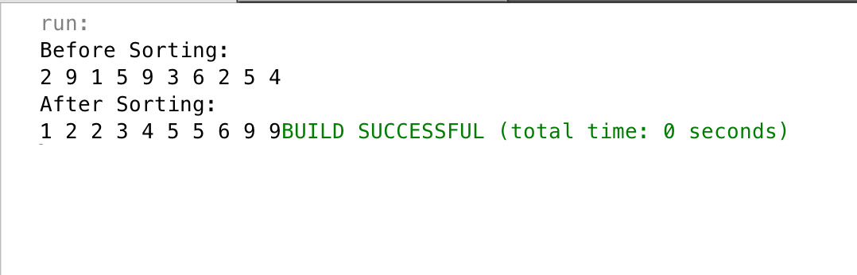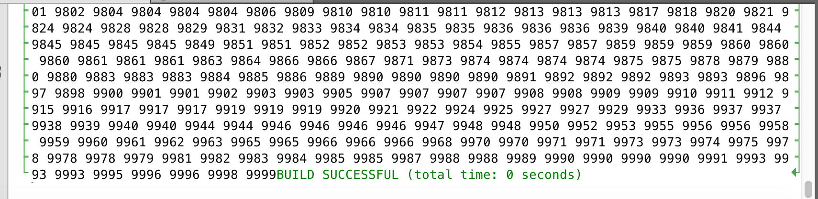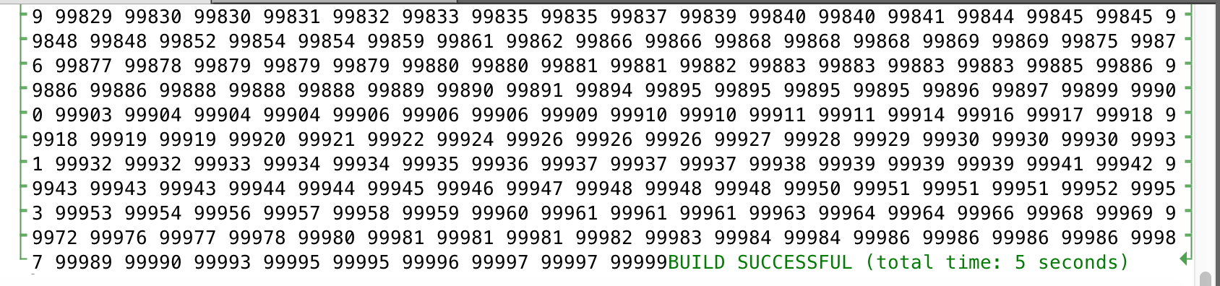

Radix Sorting:

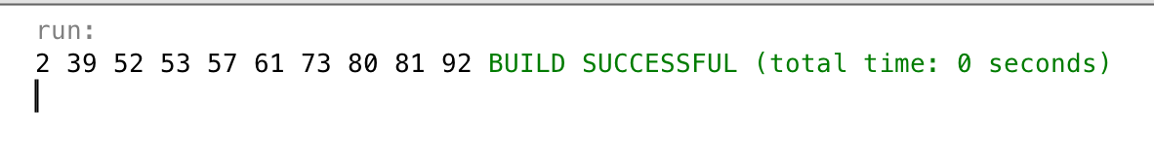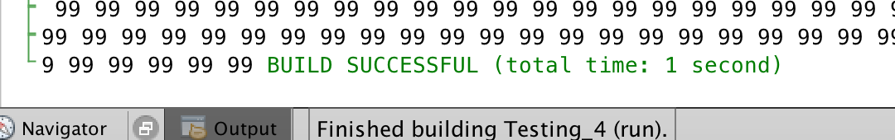

Result:

|  |  |  |  |
| --- | --- | --- | --- |
|  | 10 | 10000 | 100000 |
| Quick Sort | 0 seconds | 0 seconds | 0 seconds |
| Heap Sort | 0 seconds | 0 seconds | 0 seconds |
| Selection Sort | 0 seconds | 0 seconds | 5 seconds |
| Bubble Sort | 0 seconds | 0 seconds | 19 seconds |
| Radix Sort | 0 seconds | 0 seconds | 1 seconds |