Mechanical Design of a Simple Quadruped Robot (Robot Dog)

Student Name: NOURAH OUDAH AL_ghamdi
Course: Mechanical Engineering

Mechanical Design of a Simple Robot Dog

Introduction
A quadruped robot is a robot with four legs that can walk similarly to animals such as dogs. Compared with wheeled robots, legged robots can move over uneven surfaces, climb small obstacles, and maintain better stability.
The objective of this report is to design a simple mechanical model of a robot dog and explain the basic mechanical principles required for standing and walking.

- Body Shape and Chassis Design
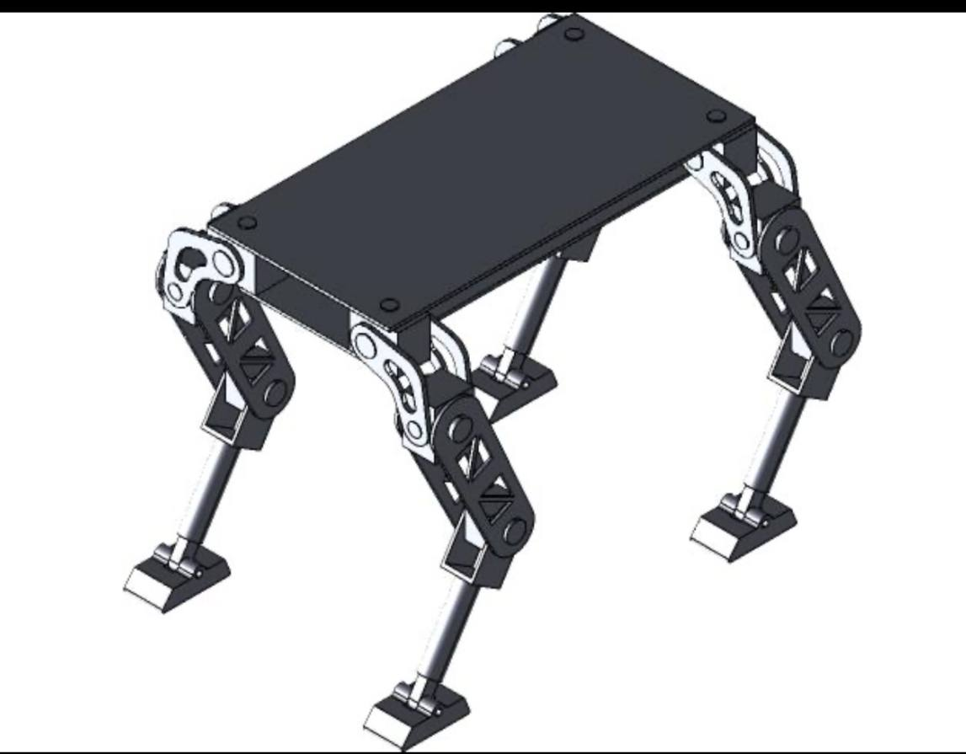
The robot body is designed as a rectangular chassis because it is:
Easy to manufacture.
Lightweight.
Provides enough space for batteries and electronics.
Keeps the center of gravity near the middle.
Suggested Material
Aluminum sheet
Acrylic plate
Carbon fiber (optional)
Estimated Dimensions
Length: 30 cm
Width: 18 cm
Height: 8 cm
These dimensions are suitable for a lightweight educational robot.

- Leg Design

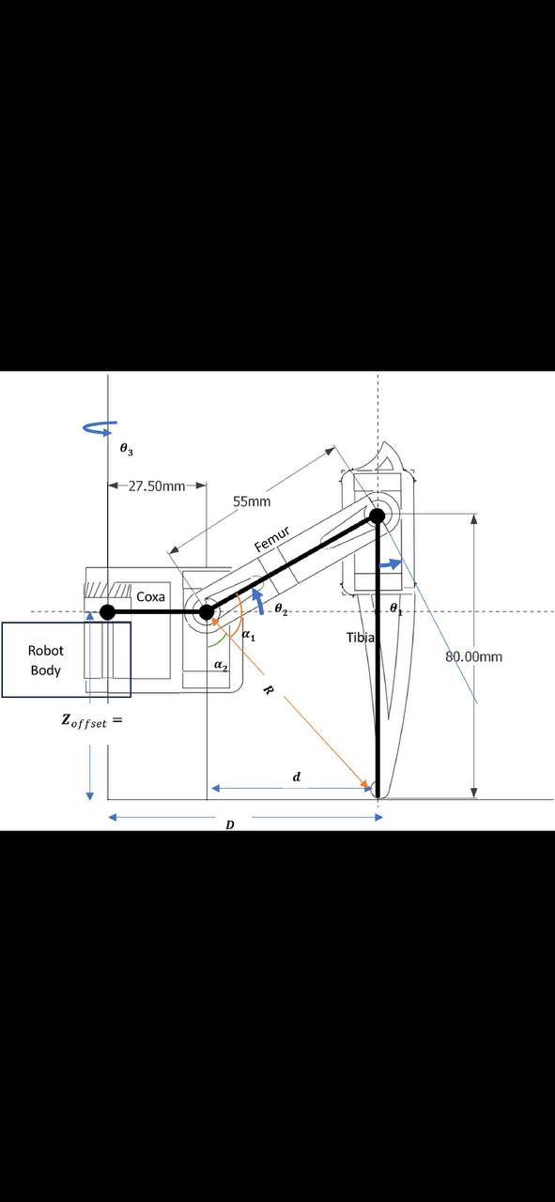
Each leg consists of two sections:
Upper leg (Femur)
Lower leg (Tibia)
Each leg contains two joints:
Hip Joint
Knee Joint
This simple structure reduces cost while allowing stable walking.
3. Number of Joints and Degrees of Freedom (DOF)
The robot has four legs.
Each leg has:
Hip Joint = 1 DOF
Knee Joint = 1 DOF
Therefore:
DOF per leg:
2 DOF
Total DOF:
4 × 2 = 8 Degrees of Freedom
This is sufficient for basic walking.
4. Servo Motor Selection

Suitable servo motors include:
MG996R
DS3218
Reasons:
High torque
Easy control using PWM
Affordable price
Widely used in educational robots
Typical specifications:
Voltage: 6V
Torque: 10–20 kg·cm
Rotation: 180°
5. Initial Torque Calculation

The hip joint experiences the highest load.
Assume:
Weight of one leg:
0.5 kg
Distance from joint:
10 cm
Torque equation:
Torque = Force × Distance
Force:
F = m × g
F = 0.5 × 9.81
F = 4.905 N
Distance:
0.10 m
Therefore:
Torque
T = 4.905 × 0.10
T = 0.49 N·m
Adding a safety factor of 2:
Required torque:
≈ 1 N·m
This means a servo capable of about 10 kg·cm or more is appropriate.

6. Stability and Center of Gravity
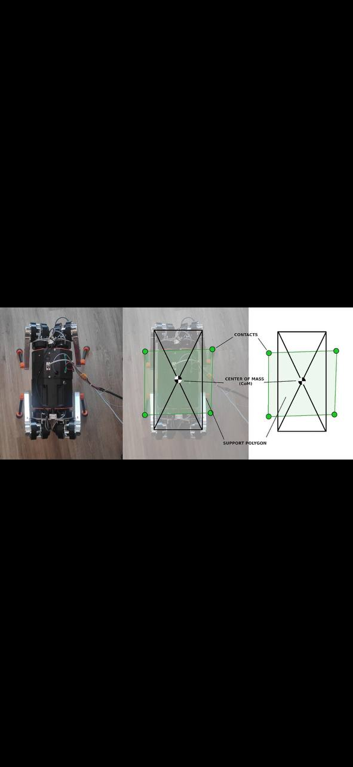

The center of gravity should remain close to the center of the robot body.
Methods to improve stability:
Place the battery in the middle.
Keep heavy components low.
Use symmetrical leg placement.
Maintain at least three legs on the ground during walking.
These methods reduce the chance of tipping over.
7. Proposed Walking Method
The recommended gait is the Crawl Gait.
Walking sequence:
Front Left
Rear Right
Front Right
Rear Left
Advantages:
Very stable.
Easy to program.
Suitable for beginners.
Disadvantage:
Slow walking speed
8. Expected Mechanical Problems
Possible challenges include:
Servo motors may not provide enough torque.
Leg vibration during movement.
Loose screws after repeated use.
Battery weight affecting balance.
High power consumption.
Friction in moving joints.
Solutions:
Use stronger servo motors.
Tighten mechanical connections.
Use lightweight materials.
Place the battery at the center.
Lubricate joints when necessary.
Conclusion
This report presented the preliminary mechanical design of a simple quadruped robot. The design uses a rectangular chassis, four legs with two degrees of freedom each, servo motors with adequate torque, and a crawl gait for stable movement. Although simple, this design demonstrates the essential mechanical principles required for a robot to stand, balance, and walk.

