Musical Instrument Detection Using Deep Learning

By: Nouran Hassan Ahmed 2022/00062

Course: Advanced AI

Presented to: Dr. Alaa Hamdy

Date: May 2025

Contents

Abstract 3

1. Introduction 3

2. Dataset 3

3. Methodology 3

4. Results & Evaluation 5

5. Model Insights 6

6. Conclusion 8

7. Future Work 8

8. Recommendations 9

9. Saved Model 9

10. References 9

### ****Abstract****

This project focuses on classifying musical instruments using deep learning techniques, utilizing a dataset of 30 classes. Multiple pre-trained CNN models (MobileNet, GoogLeNet, ResNet, VGG) were evaluated. With image augmentation and fine-tuning, MobileNet achieved 98% test accuracy.

### ****1. Introduction****

Musical instrument detection has applications in music education, automated tagging, and sound processing. This project explores image-based classification using convolutional neural networks (CNNs) including GoogleNet, MobileNet, ResNet, and VGG to identify 30 different musical instrument categories.

### ****2. Dataset****

* **Source:** Kaggle - gpiosenka/musical-instruments-image-classification
* **Classes:** 30 musical instruments
* **Format:** JPG, 224x224 pixels
* **Distribution:**
  + ~4793 training images
  + 150 validation images
  + 150 test images
* **Note:** Class imbalance was addressed through augmentation and class weighting.

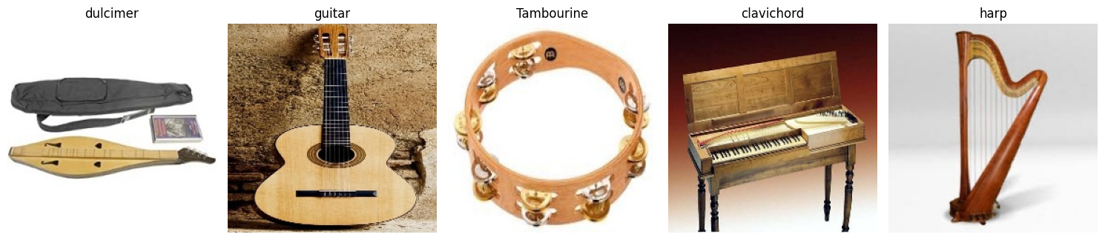

### ****3. Methodology****

#### ****3.1 Data Preprocessing****

* Resizing: 224×224 pixels
* Normalization: [0,1] pixel values
* Data Augmentation:
  + Random rotations (±20°)
  + Width/height shifts (±20%)
  + Shearing, zooming, horizontal flipping

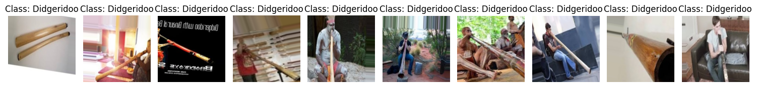

#### ****3.2 Handling Class Imbalance****

Given that some instrument classes were underrepresented in the dataset, special attention was given to this issue during model training. A **dual approach** was employed to address class imbalance:

1. **Data Augmentation:**  
   As described above, aggressive augmentation was applied to the training set to artificially boost underrepresented classes and reduce overfitting.
2. **Class Weighting:**  
   In addition to augmentation, **class weights were computed** using sklearn.utils.class_weight.compute_class_weight from the scikit-learn library. These weights ensure that underrepresented classes contribute more significantly to the loss function during training.

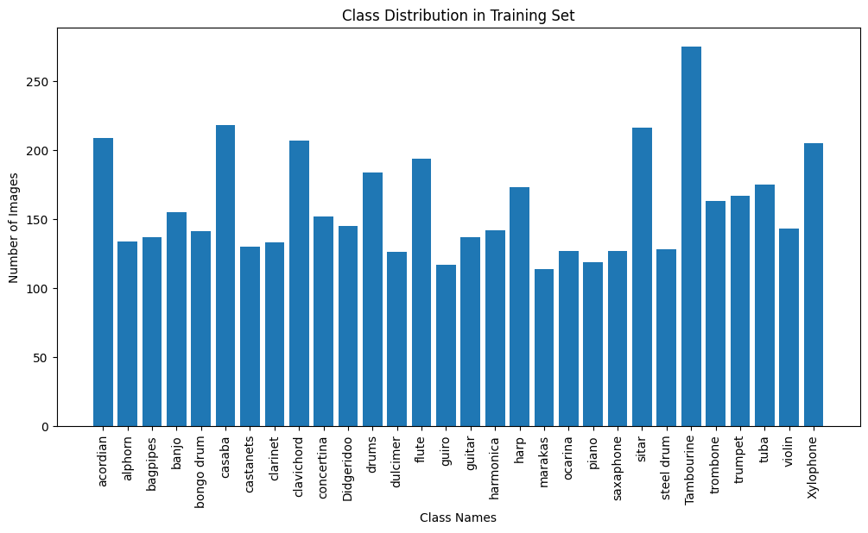

#### ****3.3 Models Used****

Pre-trained CNNs with transfer learning:

* MobileNet
* GoogLeNet
* ResNet50
* VGG16

**Model customization:**

* include_top=False
* GlobalAveragePooling2D
* Dense layers
* Dropout (0.5)
* Softmax output

#### ****3.3 Training Process****

* Phase 1: Train with frozen base layers
* Phase 2: Fine-tune top 100 layers
* **Hyperparameters:**
  + Learning rate: 0.0001
  + Batch size: 64
  + Callbacks: EarlyStopping (patience=10), ReduceLROnPlateau

### ****4. Results & Evaluation****

#### ****4.1 MobileNet Performance****

* Accuracy: 98%
* Loss: 0.0564
* Best generalization on unseen images

#### ****4.2 Model Comparison Table****

| **Model** | **Accuracy** | **Training Time** | **Parameters** | **Notes** |
| --- | --- | --- | --- | --- |
| MobileNet | 98% | ~120 mins | 4.2M | Lightweight, fast, efficient |
| InceptionV3 | 98% | ~180 mins | 23.8M | Parallel convolutions |
| ResNet50 | 94.67% | ~150 mins | 25.5M | Deep residual architecture |
| VGG16 | 89.33% | ~210 mins | 138M | Simple but memory intensive |

### ****5. Model Insights****

#### ****5.1 Key Architecture Features****

# MobileNet

x = GlobalAveragePooling2D()(x)

x = Dense(512)(x)

x = Dropout(0.5)(x)

# InceptionV3

x = GlobalAveragePooling2D()(x)

x = Dense(1024)(x)

x = Dropout(0.5)(x)

# ResNet50

x = GlobalAveragePooling2D()(x)

x = Dense(512)(x)

x = BatchNormalization()(x)

# VGG16

x = GlobalAveragePooling2D()(x)

x = Dense(1024)(x)

x = Dropout(0.5)(x)

#### ****5.2 Observations****

* MobileNet and InceptionV3 tied at 98% accuracy.
* MobileNet trained 1.5× faster than InceptionV3.
* MobileNet had the most stable validation curve.
* VGG16 used 3× more memory than MobileNet.

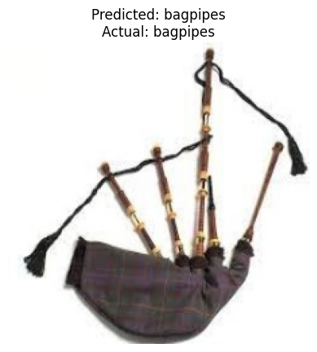

### ****6. Conclusion****

* MobileNet achieved the best overall performance.
* Data augmentation mitigated class imbalance.
* Transfer learning was highly effective.
* Potential applications: music education tools, inventory systems, real-time classification apps.

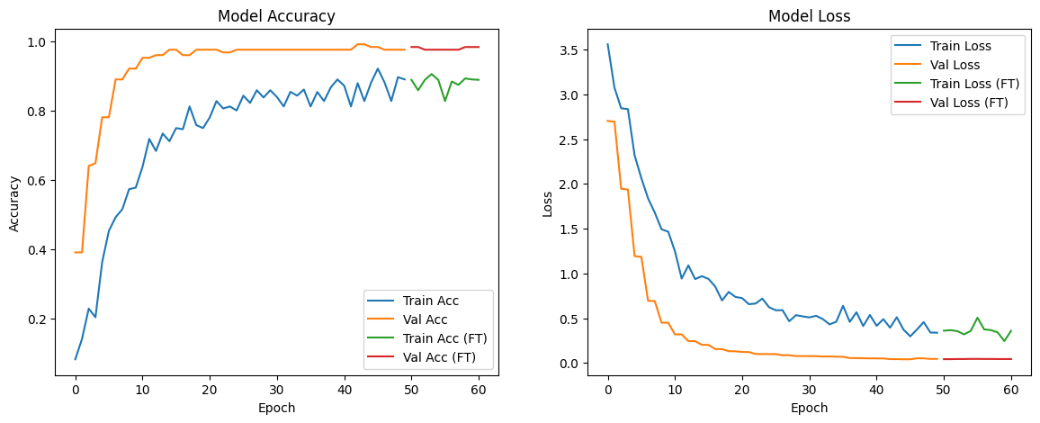

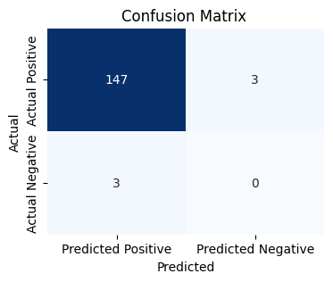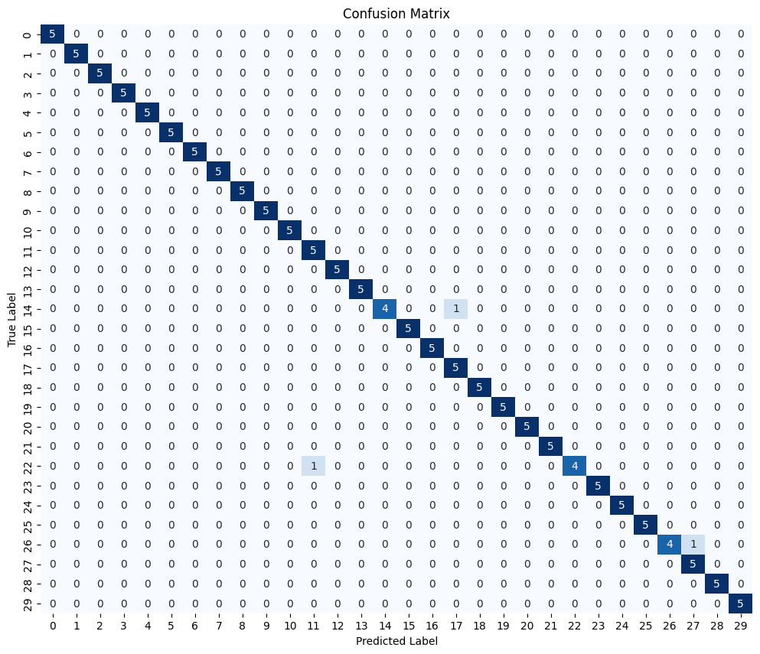

### ****7. Future Work****

* Integrate audio-based detection
* Experiment with ensemble methods
* Deploy as a web or mobile application

### ****8. Recommendations****

# Use MobileNet for:

# - Mobile apps

# - Real-time detection

# - Low-resource environments

# Alternatives:

# - InceptionV3: Best for server-side applications

# - ResNet50: Best for complex visual patterns

# - VGG16: Avoid due to inefficiency

# Possible Improvements:

# 1. Ensemble MobileNet + InceptionV3

# 2. Add attention mechanisms

# 3. Use test-time augmentation

### ****9. Saved Model****

* File: musical_instruments_model_Mobile_Net.h5

### ****10. References****

* Kaggle: gpiosenka/musical-instruments-image-classification
* TensorFlow & Keras Documentation
* CNN & Transfer Learning Research Papers