Arduino Custom Remote Control System Using Pulse-Duration Encoding
Course: Selected Topics in CS

Presented To: Alaa Hamdy
Prepared By:
Roaa Khaled — ID: 2022/05885
Nouran Hassan — ID: 2022/00062

Contents
Abstract 2
1. Introduction 3
2. Project Objectives 3
3. System Overview 3
4. Components Used 3
5. Transmitter Design 4
5.1 Hardware Configuration 4
5.2 Signal Encoding Strategy 4
5.3 Transmitter Code 4
6. Receiver Design 5
6.1 Hardware Configuration 5
6.2 Signal Decoding Strategy 5
6.3 Receiver Code 6
7.Simulator Design 6
8. Conclusion 7

Abstract
This project presents the design and implementation of a custom remote control system using Arduino microcontrollers. The system transmits commands using pulse-duration–based signaling rather than standard infrared communication protocols. Commands are generated using push buttons on a transmitter Arduino and decoded on a receiver Arduino to control RGB LEDs. The system was validated through both hardware implementation and a software-based simulator.

1. Introduction
Remote control systems are widely used in embedded and IoT applications. Most commercial systems rely on standardized infrared protocols; however, this project focuses on understanding low-level communication by implementing a custom timing-based protocol. The project emphasizes signal generation, timing measurement, and decoding using Arduino digital I/O.

2. Project Objectives
- Implement a custom communication protocol using pulse durations
- Design transmitter and receiver Arduino systems
- Decode commands without using IR libraries
- Verify system behavior using a simulator
- Demonstrate reliable LED control based on transmitted commands

3. System Overview
The system consists of two main units:
- Transmitter Unit: Reads button inputs and generates pulse-duration signals
- Receiver Unit: Measures incoming pulse duration and activates corresponding LEDs

4. Components Used

Component | Quantity | Description
Arduino Uno | 2 | Transmitter and Receiver
Push Buttons | 3 | User input
LEDs / RGB LED | 1 RGB / 3 LEDs | Output indicators
220 Ohm Resistor | 7 | Current limiting
Jumper Wires | 17 | Connections
Breadboard | 2 | Circuit assembly
IR LED 5mm Infrared Transmitter | 1 | IR signal detection on receiver side
TCRT5000 Infrared Line Tracking Sensor Module | 1 | IR signal transmission

5. Transmitter Design
5.1 Hardware Configuration
Arduino Uno reads three push buttons (pins 4, 5, 6). A 5mm IR LED connected to pin 3 emits pulse-duration signals corresponding to each button.

5.2 Signal Encoding Strategy
- Button 1 → multiple short pulses (~100 ms)
- Button 2 → medium pulses (~300 ms)
- Button 3 → single long pulse (~600 ms)
This approach ensures unique timing patterns for each command.

5.3 Transmitter Code

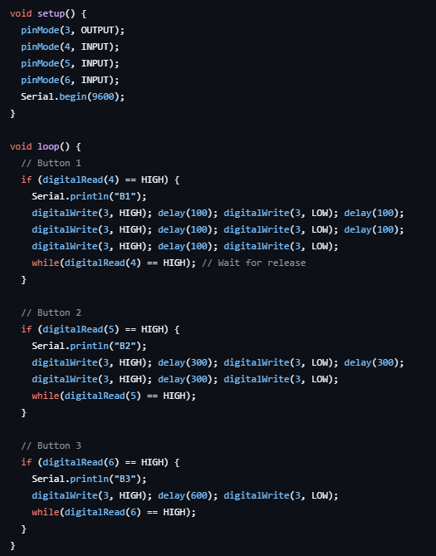

6. Receiver Design
6.1 Hardware Configuration
TCRT5000 sensor input connected to Arduino detects transmitted pulses. RGB LED connected to output pins displays the received command.
6.2 Signal Decoding Strategy
Arduino measures the LOW pulse duration and compares it to predefined thresholds to identify the button pressed:
- 80–120 ms → RED LED
- 250–350 ms → GREEN LED
- 550–650 ms → BLUE LED

6.3 Receiver Code
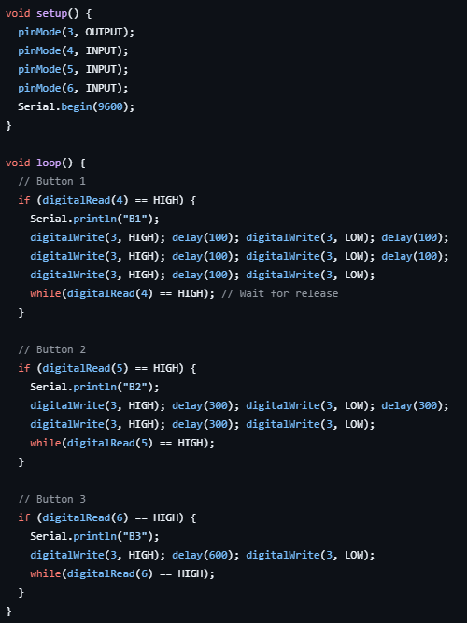

7.Simulator Design
A software-based simulator was created to emulate button presses and pulse-duration signals. This allowed verification of encoding and decoding logic without using physical hardware.

8. Conclusion
This project successfully demonstrates a custom Arduino-based remote control system using pulse-duration encoding. It provided practical insight into low-level communication, timing analysis, and embedded system debugging.

