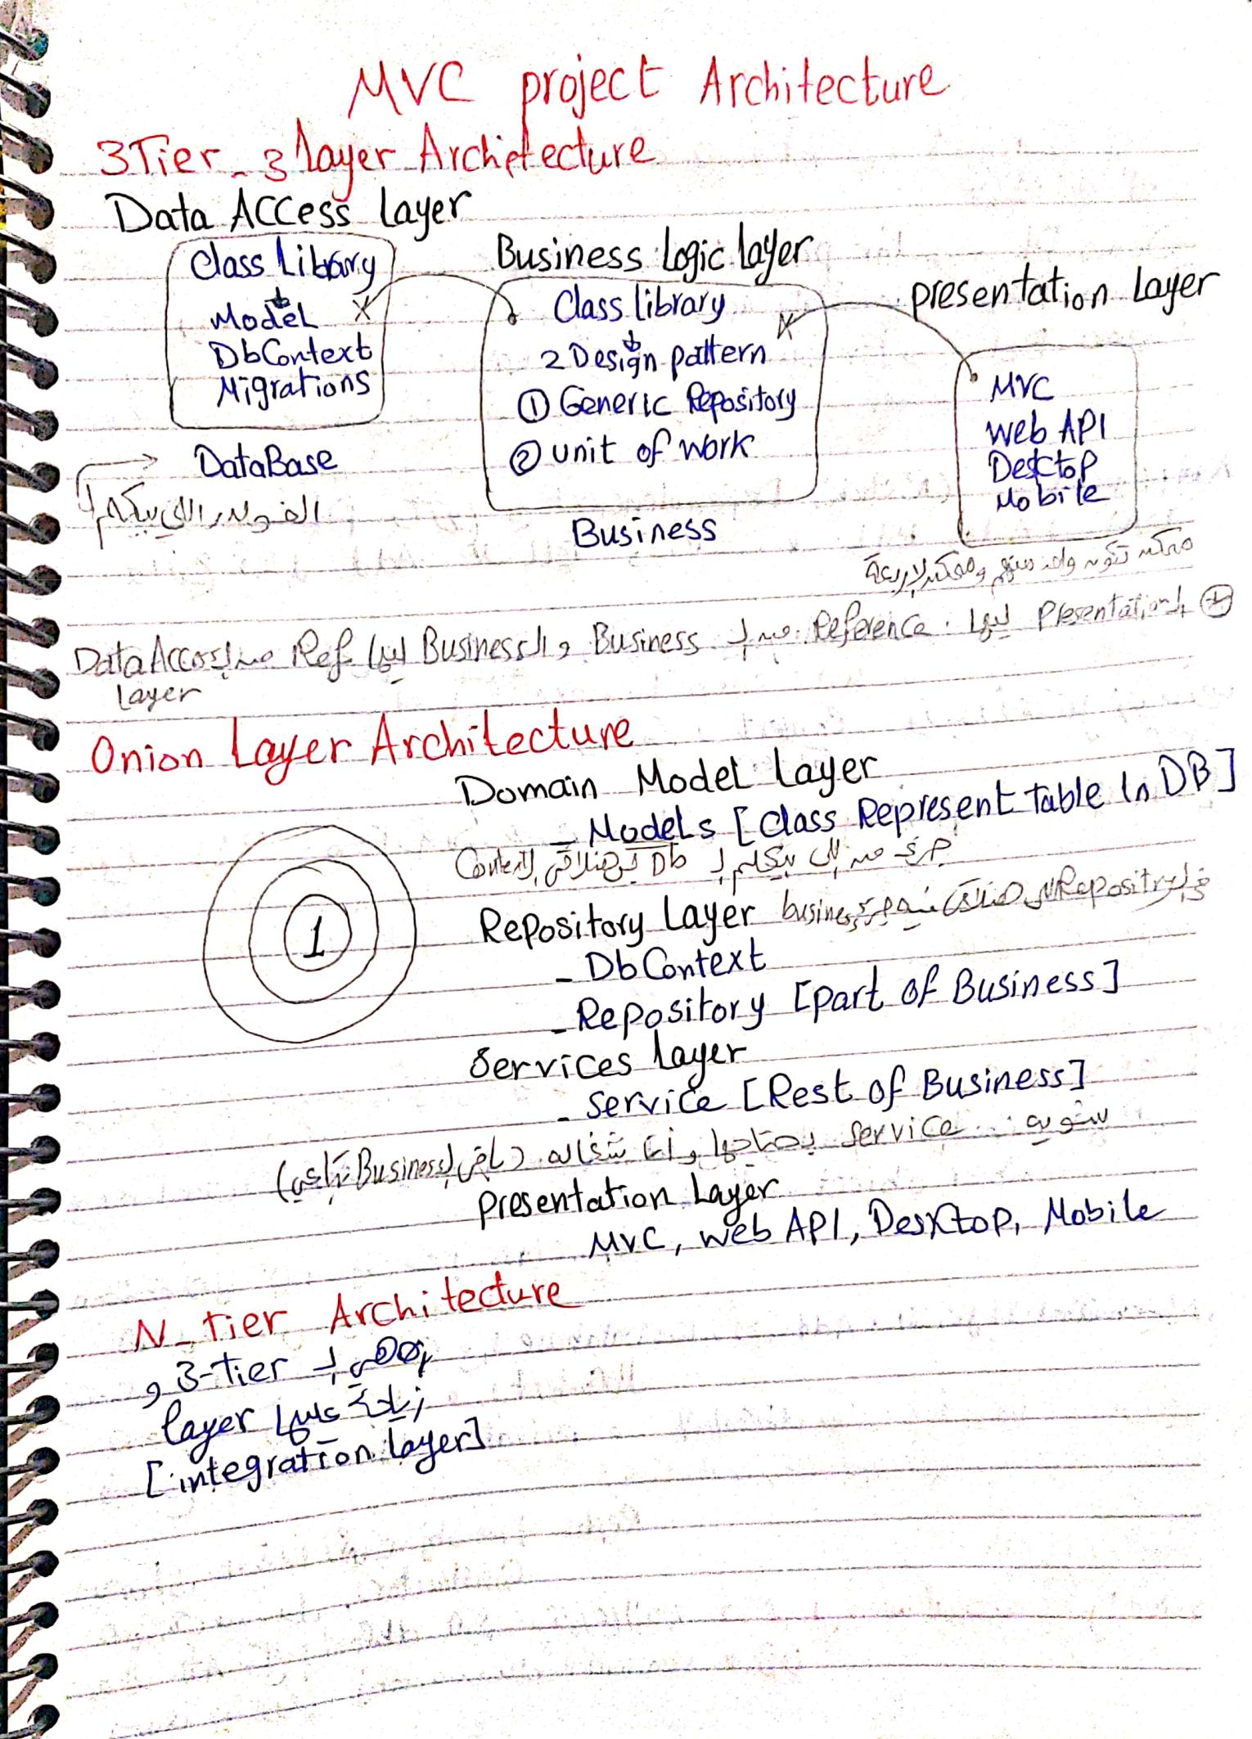

 [CamScanner](https://v3.camscanner.com/user/download)

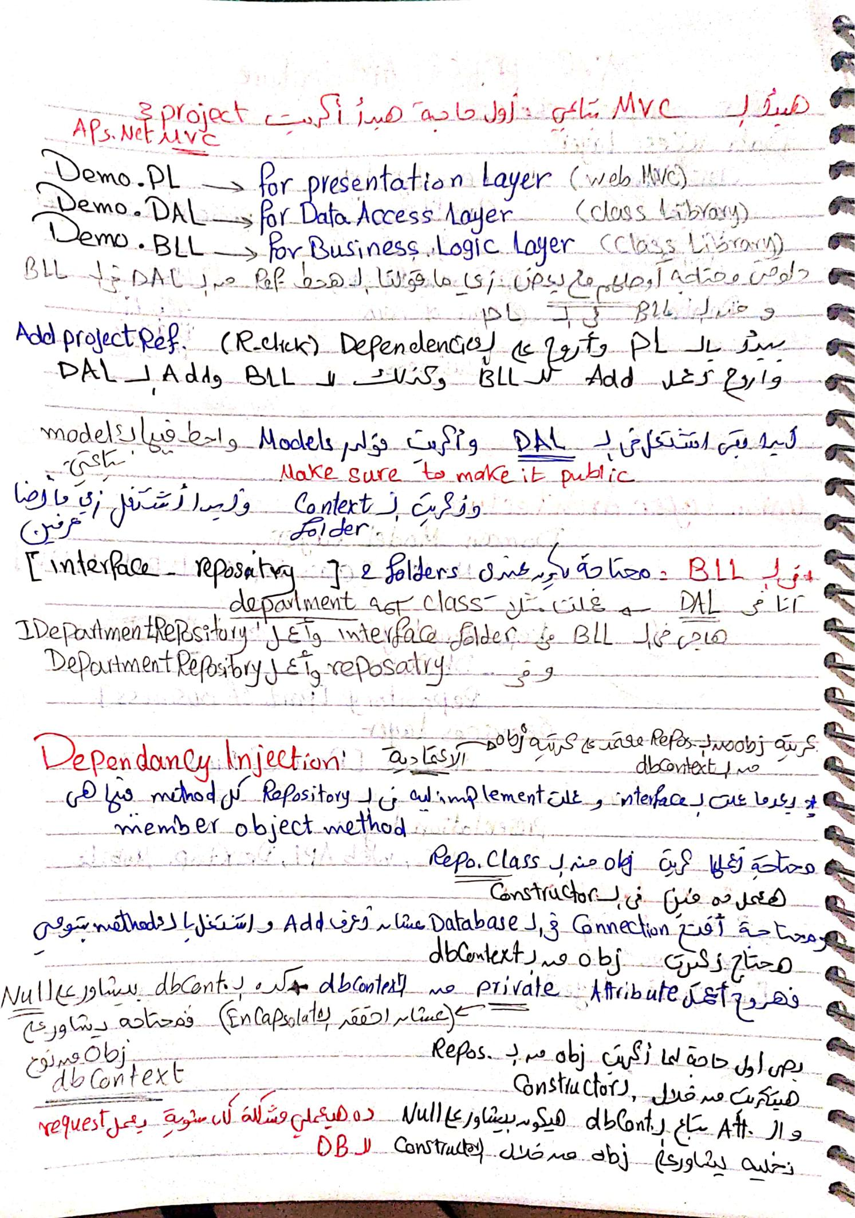

 [CamScanner](https://v3.camscanner.com/user/download)

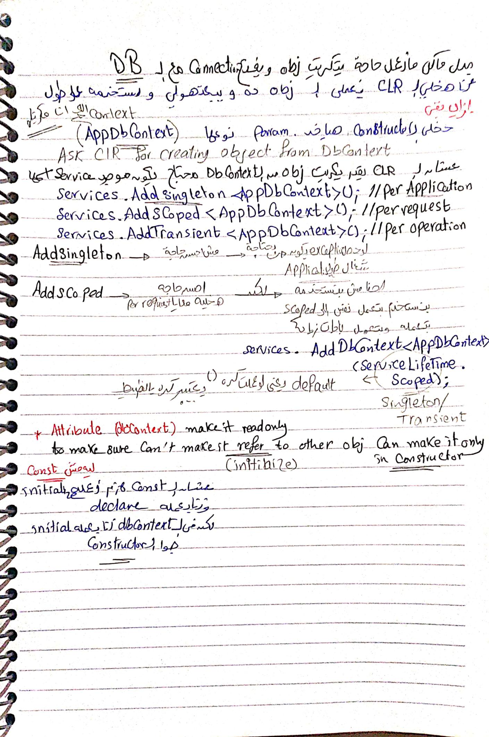

 [CamScanner](https://v3.camscanner.com/user/download)