***Customer Churn Analysis Documentation***

This Case is the process of measuring the rate at which customers quit the service and what is the churn rate and how can we retain an existing customers since it is less expensive than attracting new customers.

**1- Data Preparation**

In this stage I started the Data Cleaning using Tableau tool following some steps:

1. **Data Check**

By using Data Interpreter Option I checked that the dataset doesn’t have any Duplicates or missing values.

1. **Data Transformation**

I created one measure Number of Customers using COUNT Function,

Number of Customers = 2666.

I thought that it’ll be extremely useful when I have a measure that calculates churn before deep diving into analysis, there is a column called Churn that indicates “True” or “False” but this column isn’t the easiest to work with.

I converted this column to a binomial column Churned that will contain a 1 or 0, indicating 1 if the customer churned and 0 in case the customer didn’t churned, and I used that to calculate the churn rate.

Then, I created a calculated field Number of Churned Customers using Sum of Churned Column

I Calculated the Churn Rate and I formatted it as Percentage.

(Dividing the Churned Customers by the Number of Customers)

Churn Rate = 14.55%

I created calculated field which calculates **Total Charges** (Total Day Charge + Total Evening Charge + Total Night Charge + Total International Charge).

I created calculated field which calculates **Total Calls** (Total Day Calls + Total Evening Calls + Total Night Calls +and Total International Calls)

I Created Calculated Field which Calculates (Average International calls) based in this following Code:

IF [Total intl calls] < 5 THEN "0-5"

ELSEIF [Total intl calls] < 10 THEN "5-10"

ELSEIF [Total intl calls] < 15 THEN "10-15"

ELSE">15"

END

The Company’s goal is to retain the existing customers and avoid any reasons of causing Customers Churn So, I thought that it would be better if we can allow stakeholders to investigate the number of churned customers and their charges and the number of the Customer service calls.

That’s why I started to create a new Parameter called it **Pick Metric** by listing the Average of total charges, Number of Customers, Number of Churned Customers, and Customer service calls.

And then I created a calculated field called **Metric** uses a case statement to select a different measure based on the parameter.

1. **Chart Documentation**

**The Dashboard contains 3 Key Performance Indicators (KPIs)**

1. Total Number of Customers
2. Number of Churned Customers
3. Churn Rate

**Here’re the Technical and Business details about the Dashboard**

1. **The most State which has Churn Rate is the State which has The Abbreviation TX refers to Texas State.**

**With churn rate = 29.09 % and Number of Churned Customers = 16**

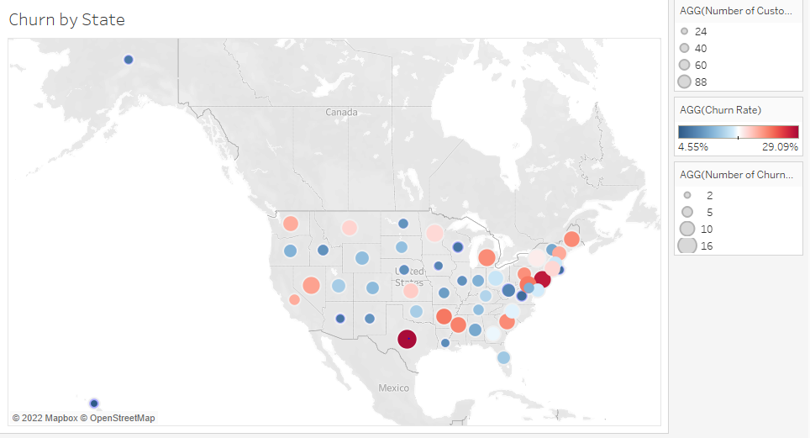

1. **I drilled down on Texas State (TX) to see in which period the customers in this state mostly charge. (By the Average of total charges).**

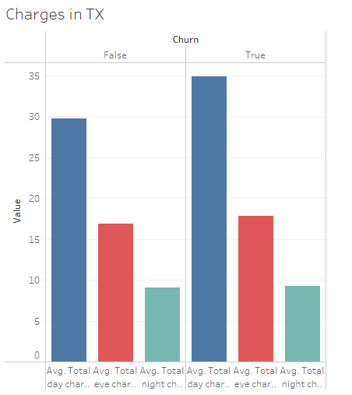

**Customers who receive high bills churn twice as much as other customers.**

The chart declares that the most of customers’ charges are happening in the day not in the evening or night.

And that means that we have the chance to keep our existing customers by offering bundles with extra sales on the day charges.

1. **In this Part I started to analyze the Numbers of Customers in by Area Code and which is the most Area that has number of Customers and Churned Customers.**

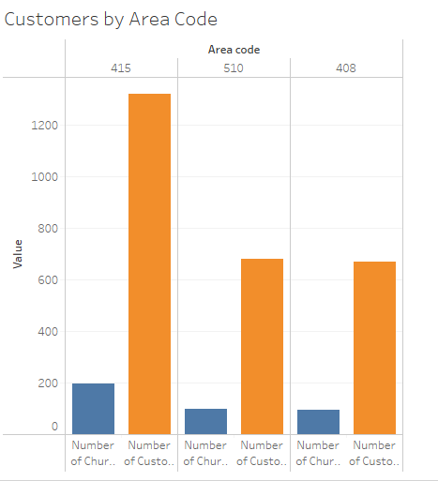

The Area which has the code 415 has the most number of Customers which is 1,318 with Number of Churned Customers = 159 Customers.

By tracking this Area to investigate the number of total calls that Churned Customers do

I found that the number of calls for Churned Customers is **59,595 which is very low** comparing with the number of calls for the existing customers which is **343,918**

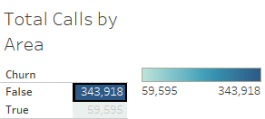

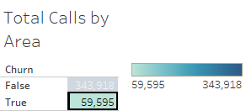

1. **How Does International Plan influence churn Rate? (Most Important)**

In this part I had a Hypothesis that People who are not on an International Plan are more likely to churn, and it was Surprising!

It actually appeared that customers who are on international plan “Yes” are more likely to churn!

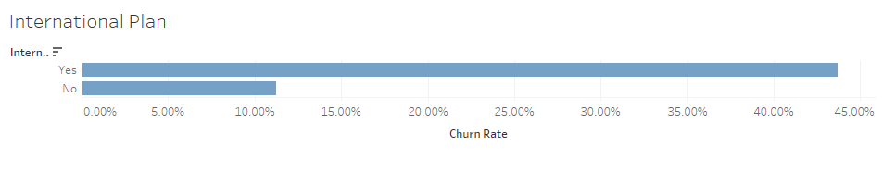

**It would be good to have an idea on how many international calls they’re doing.**

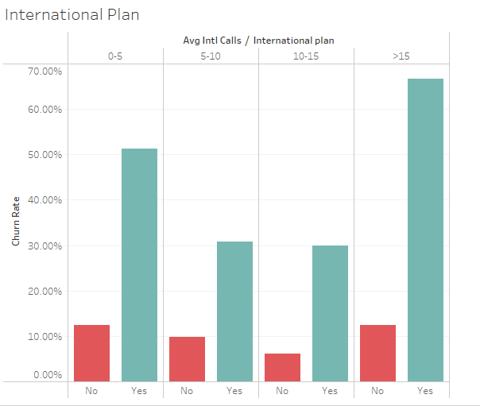

This chart declares that the churn rate for people on an international plan who consume less than 5 calls is **51.20 %** and it’s large percentage.

**By following this insight, I found that there is Correlation between the international calls and the number of Vmail Messages.**

**When the number of Vmail Messages = 0,**

**The Number of International calls is higher than expected using Scatter Plots as it shown:**

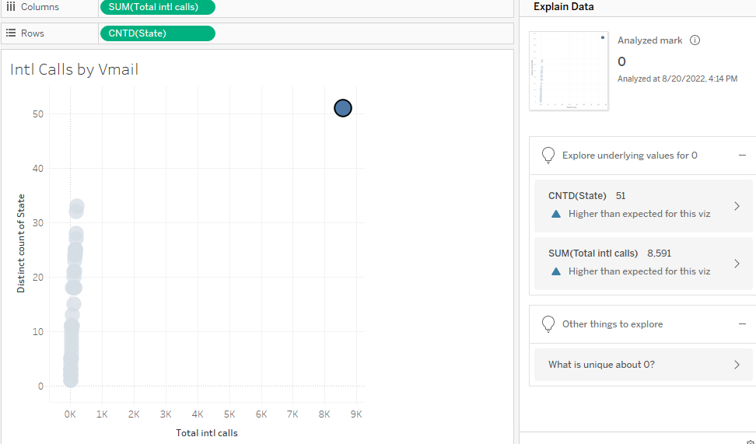

**The Number of International calls in this case =8.591**

**The purpose of this chart is to declare the status of the number of the international calls and the number of Vmail messages for number of Sates.  
And in the all states, when the number of Vmail messages =0**

**The number of International calls is very high.**

1. **I found that we have to considerate the most category of Customers, That’s why I started Analyzing the Customers based on Subscribing the bundles (International Plan, Voice mail Plan) and how it effects Churn Rate.**

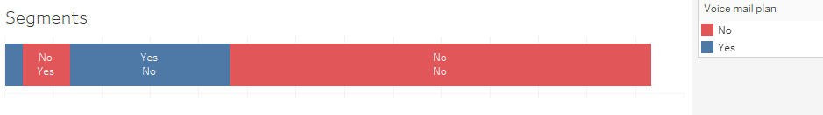

The segment which has the most Rate of Churn is the category which has the customers who aren’t subscribing any of Voice mail Plan or International Plan.

The number of customers in this category =1,738 Customers = 65.19 %

**Advice**

We can use this insights by offering bundles have Voicemail Plan and International plan together since **our main goal is to retain our existing customers and avoid any churning.**

**I started Investigating are customer service calls influence churn rate or not**

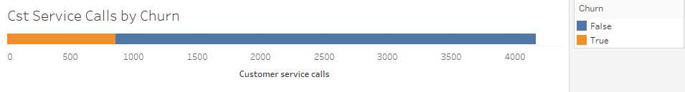

**I found that churned customers has the lowest percentage of customer service calls.**

I was curious about the behavior of customers who call internationally, and/or if paying for an international plan influences their loyalty.

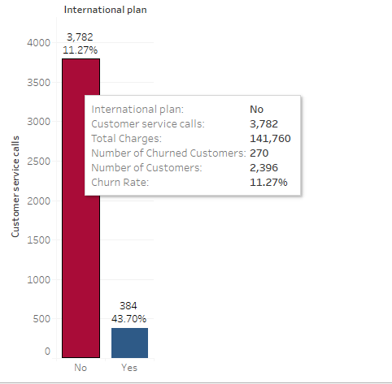

**Customers who aren’t subscribing the International plan are the most ones who contact customer service.**

**3- Target Audience**

**Target Audience are Decision Makers who have the right to take action of Churn reduction, such as Customer Value Management or Customer Success Department.**

Decision Makers can use the Insights for developing the service and keeping the customers by these ways:

**1- Eliminate Reasons for Churn**  
* There are many reasons may cause churn and we have to ask the customer before churned why he is going to churn, because It can be many reasons like (Prices, Competitors ...).

* Improve Company Offers, and investigate why most of the clients don't like to subscribe.  
* improve technical services, listen to your customer, and understand why he is not satisfied.  
* Prices need to be fixed in some states which are in **Area 415**  
* Give attention to **Texas and New Jersey** which have the highest churn rate.  
  
**2- Retain your loyal customers**  
* Offering some bundles contain both (International Plan and Voice mail Plan)

* listen to your loyal customers and ask them if there is something to be fixed or improved to avoid losing them also  
  
Now, I would like to highlight an important matter, (The Analysis is a Process, not a Project) this report includes only some insights and there are many others we can extract if we collected more information like (Payment Method, Internet Plan, Reasons of Churn) and track the behavior every month.