**Self-Driving and**

**Video Streaming Car**

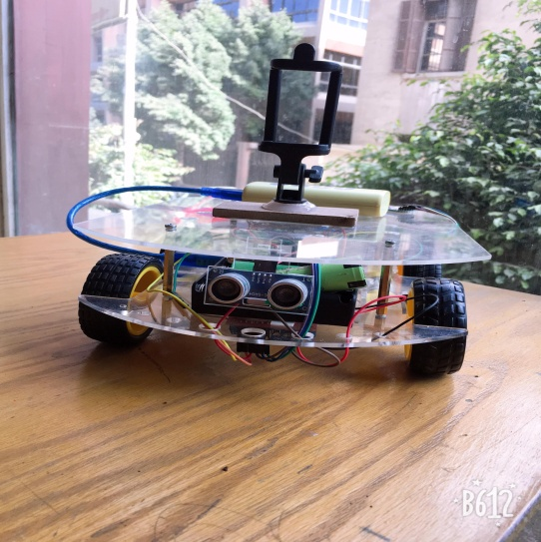

Hadeel Emad El-din Hassan

Hend El-Sayed El-Sayed

Nourhan Mohamed Fathy

Wafaa Mohamed Abd El-Razek

Yomna Abd El-Razek Ashry

Submitted to   
Dr.Rania Darwesh

**Abstract:**

* Our Car is built to detect the arrows, then determine its direction based on the given data.
* Our Car is based on Arduino and python coding.
* Also we used Ultrasonic to detect the distance between the car and any object infront of it**.**

**Introduction:**

* A self driving car, is a vehicle that is capable of sensing its environment and moving with little or no human input.
* Humans are fond of technology trends, so the race of self-driving and hybrid cars has started.
* It combines a varity of sensors to perceive their surrondings such as radar, computer vision.
* We used Computer vision using mobile camera and labtop to analayze videos, and recognize arrows then detect its direction.

**Objective:**

* The main purpose of the project is to detect arrow directions and follow it, using python Open CV library and Arduino to control the directions of the motors, using bluetooth serial communication between them.

**Components:**

* 1 x Arduino Uno.
* 4 x Dc motor.
* 4 x wheels.
* 2 x L298N motor driver.
* 6 x Li-ion 3.6 volt Battery.
* 1 x Ultrasonic.
* 1 x Mobile camera.
* 1 x Power bank.
* 2 x Aclyric sheets.
* 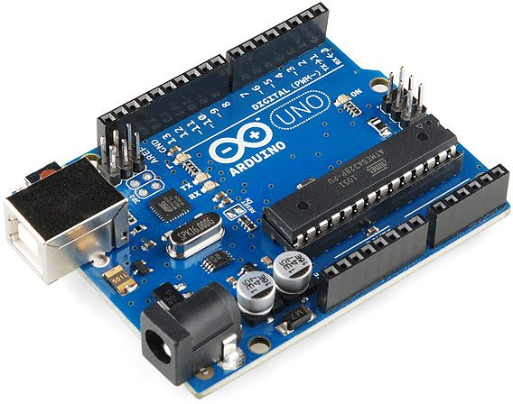1 x Mobile holder.
* Connecting wires.

**How It Works?**

**a- Arduino Uno:**

The main controller of the project, Atmega328 this microcontroller is based on Atmel 8-bit AVR RISC. It comes with 23 general purpose I/O lines,1 KB EEPROM,2KB SRAM, 32 KB ISP flash memory, 32 general purpose registers, 3 timer/counters, internal and external interrupts, SPI serial port, 6- channel 10-bit A/D converter, serial programmable USART, 5 programmable selectable power saving modes, 2-wire serial interface with byte orientation, programmable watchdog timer with internal oscillator and it has read-while-write capabilities. The device operating voltage is between 1.8-5.5 volts.

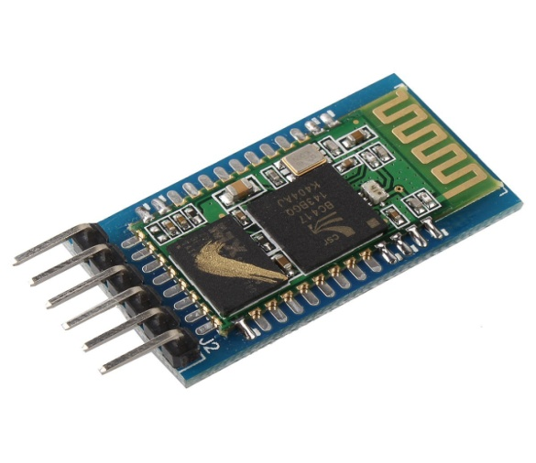**b- Bluetooth module HC-05:**

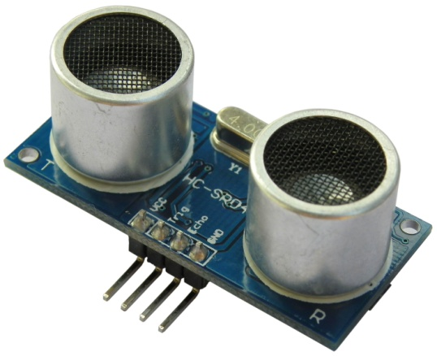We used Bluetooth module for communication between arduino and python. It can be used for a serial port replacement to establish connection between any Bluetooth enabled device and the robot. It operates at a frequency of 2.4GHz and Gaussian frequency shift keying (GFSK). It has a sensitivity of -84dBm and works within a temperature range of -20 to +75 centigrade. if the transmission is asynchronous then it happens at a speed of 2.1 Mbps and if it is synchronous then it happens at speed of 1Mbps. It requires a +3.3VDC 50mA power supply for its operation.

**c- Ultrasonic sensor:**

Used as a crash detection sensor for our car, to detect any obstacle on its way, and also to detect the arrow itself, the module is used where measuring distance or sensing objects are required. It has two eyes the ultrasonic transmitter and recifier ,it works with the following formula **Distance = Speed × Time**, The Ultrasonic transmitter transmits an ultrasonic wave, this wave travels in air and when it gets objected by any material it gets reflected back toward the sensor this reflected wave is observed by the Ultrasonic receiver module.

Operating voltage: +5V

* Theoretical  Measuring Distance: 2cm to 450cm
* Practical Measuring Distance: 2cm to 80cm
* Accuracy: 3mm
* Measuring angle covered: <15°
* Operating Current: <15mA
* Operating Frequency: 40Hz

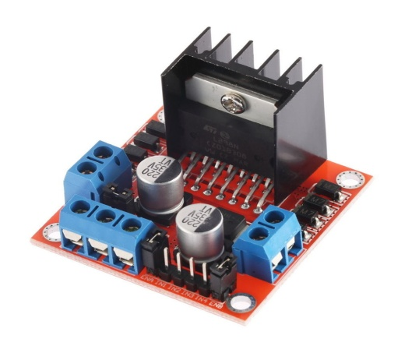**d-Motor driver L298N(H-bridge):**

To control the speed of the motors , we used 2 motor driviers, the L298N is a dual H-Bridge motor driver which allows speed and direction control of two DC motors at the same time. The module can drive DC motors that have voltages between 5 and 35V, with a peak current up to 2A. the Input 1 and Input 2 pins are used for controlling the rotation direction of the motor A, and the inputs 3 and 4 for the motor B. Using these pins we actually control the switches of the H-Bridge inside the L298N IC. If input 1 is LOW and input 2 is HIGH the motor will move forward, and vice versa, if input 1 is HIGH and input 2 is LOW the motor will move backward. In case both inputs are same, either LOW or HIGH the motor will stop. The same applies for the inputs 3 and 4 and the motor B.And the same for the other two motors.

**Robot circuit Diagram**:

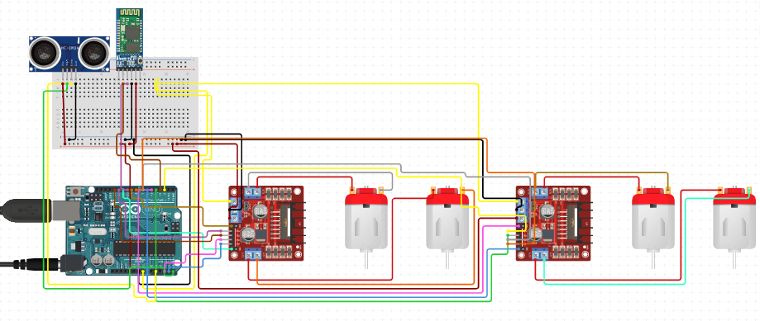

**1. Arduino Code:**

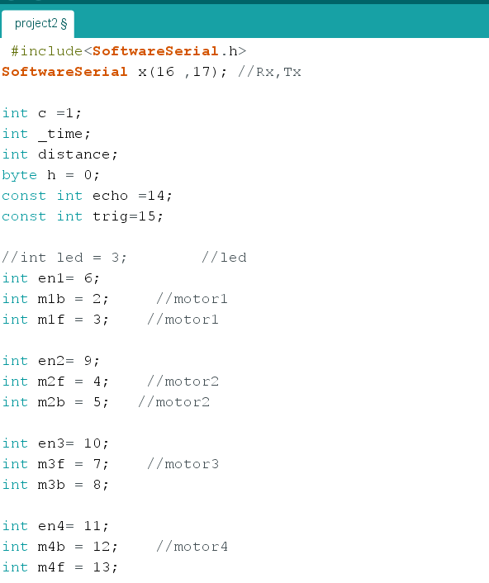

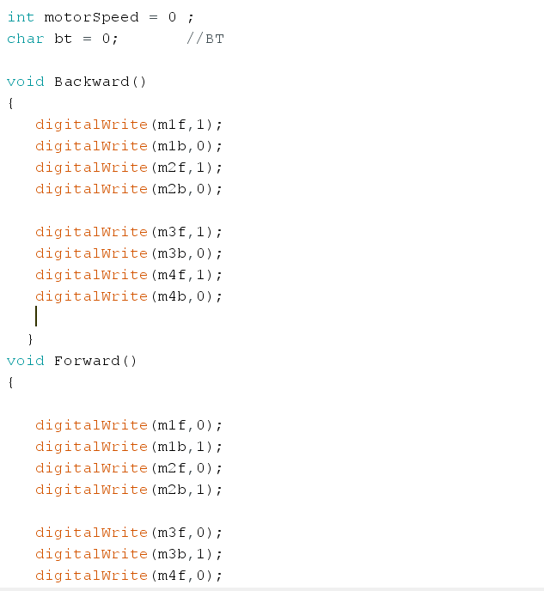

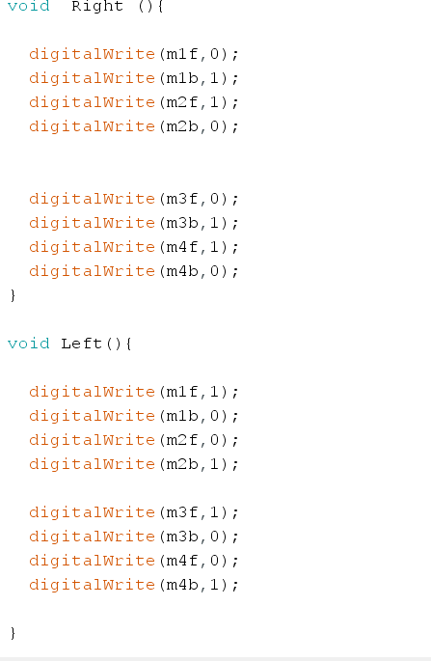

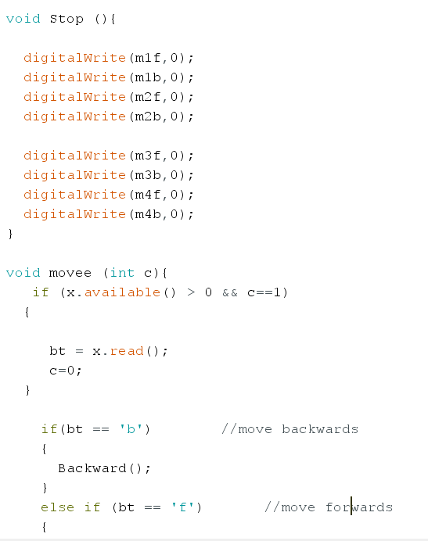

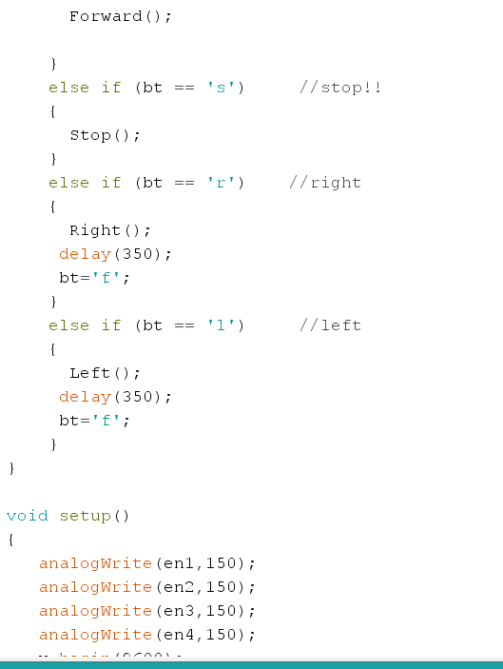

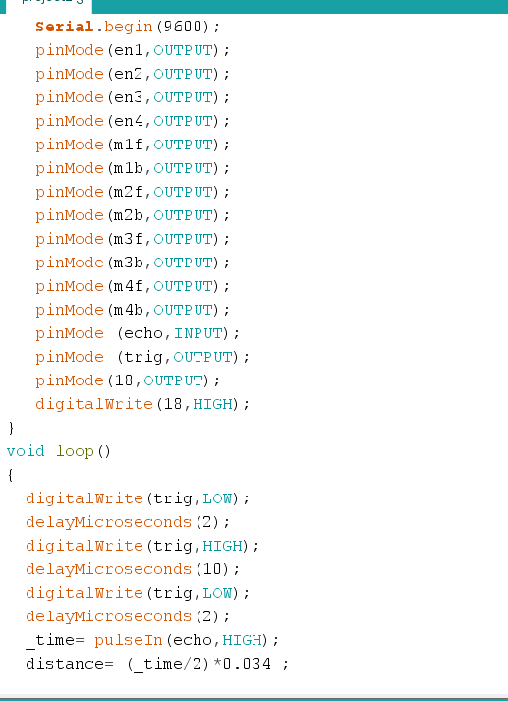

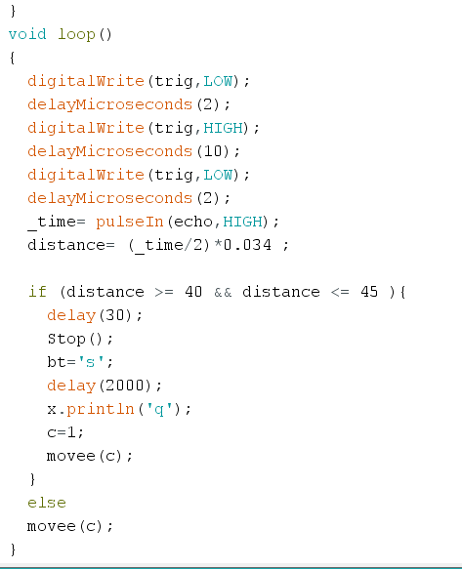

**2. Python Code:**

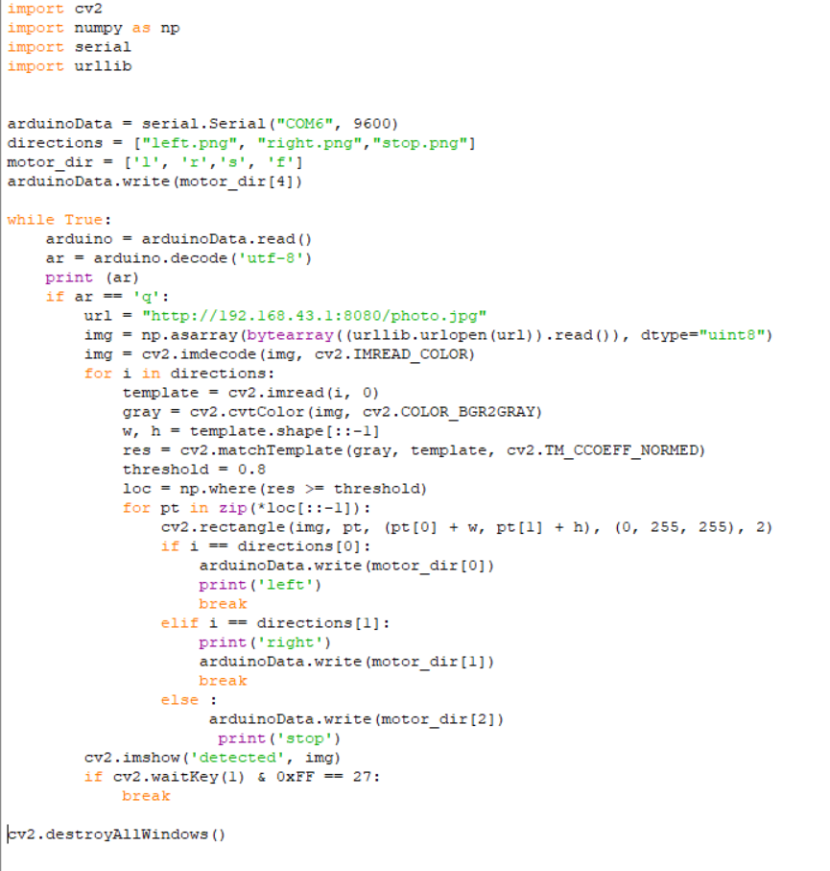

**3. Android Code:**

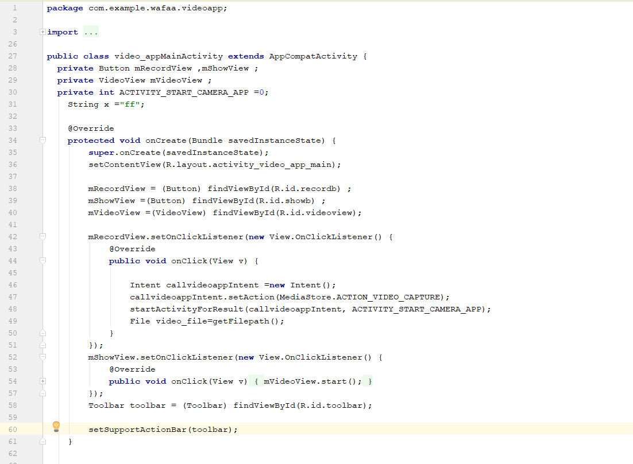

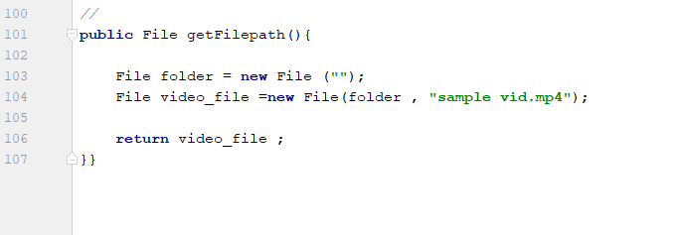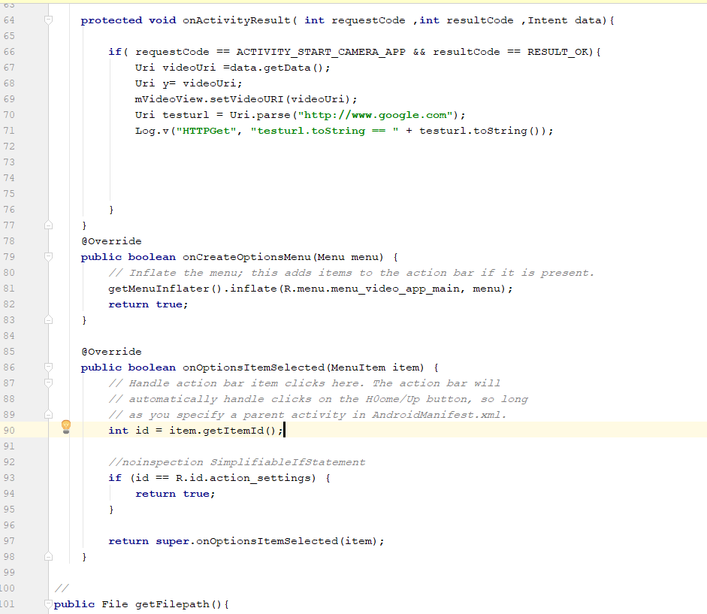

**Conclusion:**First, when we run the python code , it sends ‘f’ to bluetooth using Pyserial, the arduino reads the bluetooth signal and convert it into motors move forward, then if the ultrasonic module find any object in the specified distance, it send ‘s’ to arduino directly , which stops the motors, after that arduino sends a ‘q’ to python ,then the mobile takes a picture of the object and send it to the labtop using urllib which allows the python code to process that picture using openCV and if that picture matches one of our stored data, Finally python sends the direction of the image been recognized to move the robot in that direction.

**Referances:**

**-**Simply OpenCv textbook المهندس خالد الدبش

-OpenCv with python for image and video analysis Tutorial(<https://www.youtube.com/watch?v=Z78zbnLlPUA&list=PLQVvvaa0QuDdttJXlLtAJxJetJcqmqlQq>)

- Arabic pyhton and image Tutorial Eng.Hazem Khaled(<https://www.youtube.com/watch?v=Z78zbnLlPUA&list=PLQVvvaa0QuDdttJXlLtAJxJetJcqmqlQq>)