https://docs.microsoft.com/en-us/azure/devops/boards/work-items/guidance/cmmi-process?view=azure-devops
https://www.youtube.com/c/TechWorldwithNana
https://www.youtube.com/watch?v=AtRa9Ezz9j4

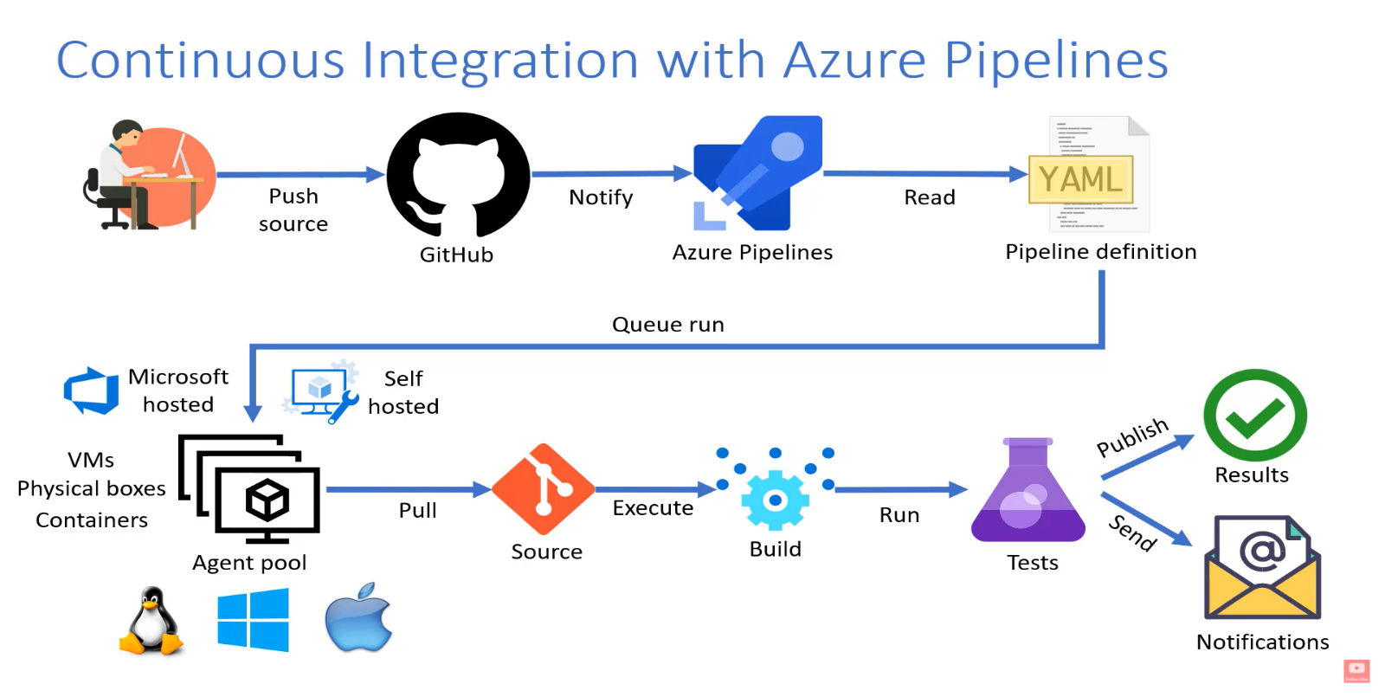

Lab 04: Version Controlling with Git in Azure Repos

Student lab manual

Lab overview
Azure DevOps supports two types of version control, Git and Team Foundation Version Control (TFVC). Here is a quick overview of the two version control systems:
- Team Foundation Version Control (TFVC): TFVC is a centralized version control system. Typically, team members have only one version of each file on their dev machines. Historical data is maintained only on the server. Branches are path-based and created on the server.
- Git: Git is a distributed version control system. Git repositories can live locally (such as on a developer's machine). Each developer has a copy of the source repository on their dev machine. Developers can commit each set of changes on their dev machine and perform version control operations such as history and compare without a network connection.
Git is the default version control provider for new projects. You should use Git for version control in your projects unless you have a specific need for centralized version control features in TFVC.
In this lab, you will learn how to work with branches and repositories in Azure DevOps.

Objectives
After you complete this lab, you will be able to:
- Work with branches in Azure Repos
- Work with repositories in Azure Repos

Lab duration
- Estimated time: 30 minutes

Instructions

Before you start

Sign in to the lab virtual machine
Ensure that you're signed in to your Windows 10 virtual machine by using the following credentials:
- Username: Student
- Password: Pa55w.rd

Review applications required for this lab
Identify the applications that you'll use in this lab:
- Microsoft Edge
- Git for Windows download page 2.29.2 or later. This will be installed as part of prerequisites for this lab.
- Visual Studio Code with the C# extension. These will be installed as part of prerequisites for this lab.

Set up an Azure DevOps organization
If you don't already have an Azure DevOps organization that you can use for this lab, create one by following the instructions available at Create an organization or project collection.

Note
If you completed Lab 02: Version Controlling with Git in Azure Repos, you have already finished the steps in Exercise 0: Configure the lab prerequisites and Exercise 1: Clone an existing repository and can skip ahead to Exercise 2: Manage branches from Azure DevOps.

Exercise 0: Configure the lab prerequisites
In this exercise, you will set up the prerequisites for the lab, which include the preconfigured Parts Unlimited team project based on an Azure DevOps Demo Generator template and a Visual Studio Code configuration.

Task 1: Configure the team project
In this task, you will use Azure DevOps Demo Generator to generate a new project based on the Parts Unlimited template.
- On your lab computer, start a web browser and navigate to Azure DevOps Demo Generator. This utility site will automate the process of creating a new Azure DevOps project within your account that is prepopulated with content (work items, repos, etc.) required for the lab.
Note: For more information on the site, see https://docs.microsoft.com/en-us/azure/devops/demo-gen.
- Click Sign in and sign in using the Microsoft account associated with your Azure DevOps subscription.
- If required, on the Azure DevOps Demo Generator page, click Accept to accept the permission requests for accessing your Azure DevOps subscription.
- On the Create New Project page, in the New Project Name textbox, type Version Controlling with Git in Azure Repos, in the Select organization dropdown list, select your Azure DevOps organization, and then click Choose template.
- In the list of templates, locate the PartsUnlimited template and click Select Template.
- Back on the Create New Project page, click Create Project
Note: Wait for the process to complete. This should take about 2 minutes. In case the process fails, navigate to your DevOps organization, delete the project, and try again.
- On the Create New Project page, click Navigate to project.

Task 2: Install and configure Git and Visual Studio Code
In this task, you will install and configure Git and Visual Studio Code, including configuring the Git credential helper to securely store the Git credentials used to communicate with Azure DevOps. If you have already implemented these prerequisites, you can proceed directly to the next task.
- If you don't have Git 2.29.2 or later installed yet, start a web browser, navigate to the Git for Windows download page download it, and install it.
- If you don't have Visual Studio Code installed yet, from the web browser window, navigate to the Visual Studio Code download page, download it, and install it.
- If you don't have Visual Studio C# extension installed yet, in the web browser window, navigate to the C# extension installation page and install it.
- On the lab computer, open Visual Studio Code.
- In the Visual Studio Code interface, from the main menu, select Terminal | New Terminal to open the TERMINAL pane.
- Make sure that the current Terminal is running PowerShell by checking if the drop-down list at the top right corner of the TERMINAL pane shows 1: powershell
Note: To change the current Terminal shell to PowerShell click the drop-down list at the top right corner of the TERMINAL pane and click Select Default Shell. At the top of the Visual Studio Code window select your preferred terminal shell Windows PowerShell and click the plus sign on the right-hand side of the drop-down list to open a new terminal with the selected default shell.
- In the TERMINAL pane, run the following command below to configure the credential helper.
- git config --global credential.helper wincred
- In the TERMINAL pane, run the following commands to configure a user name and email for Git commits (replace the placeholders in braces with your preferred user name and email):
- git config --global user.name "<John Doe>"
- git config --global user.email <johndoe@example.com>

Exercise 1: Clone an existing repository
In this exercise, you use Visual Studio Code to clone the Git repository you provisioned as part of the previous exercise.

Task 1: Clone an existing repository
In this task, you will step through the process of cloning a Git repository by using Visual Studio Code.
- If needed, start a web browser, navigate to your Azure DevOps organization, and open the Version Controlling with Git in Azure Repos project you generated in the previous exercise.
Note: Alternatively, you can access the project page directly by navigating to the https://dev.azure.com/<your-Azure-DevOps-account-name>/Version%20Controlling%20with%20Git%20in%20Azure%20Repos URL, where the <your-Azure-DevOps-account-name> placeholder, represents your account name.
- In the vertical navigational pane of the of the DevOps interface, select the Repos icon.
- In the upper right corner of the PartsUnlimited pane, click Clone.
Note: Getting a local copy of a Git repo is called cloning. Every mainstream development tool supports this and will be able to connect to Azure Repos to pull down the latest source to work with. Navigate to the Repos hub.
- On the Clone Repository panel, with the HTTPS Command line option selected, click the Copy to clipboard button next to the repo clone URL.
Note: You can use this URL with any Git-compatible tool to get a copy of the codebase.
- Close the Clone Repository panel.
- Switch to Visual Studio Code running on your lab computer.
- Click the View menu header and, in the drop-down menu, click Command Palette.
Note: The Command Palette provides an easy and convenient way to access a wide variety of tasks, including those implemented as 3rd party extensions. You can use the keyboard shortcut Ctrl+Shift+P to open it.
- At the Command Palette prompt, run the Git: Clone command.
Note: To see all relevant commands, you can start by typing Git.
- In the Provide repository URL or pick a repository source text box, paste the repo clone URL you copied earlier in this task and press the Enter key.
- Within the Select Folder dialog box, navigate to the C: drive, create a new folder named Git, select it, and then click Select Repository Location.
- When prompted, log in to your Azure DevOps account.
- After the cloning process completes, once prompted ,in the Visual Studio Code, click Open to open the cloned repository.
Note: You can ignore warnings you might receive regarding problems with loading of the project. The solution may not be in the state suitable for a build, but we're going to focus on working with Git, so building the project is not required.

Exercise 2: Manage branches from Azure DevOps
In this exercise, you will work with branches by using Azure DevOps. You can manage your repo branches directly from the Azure DevOps portal, in addition to the functionality available in Visual Studio Code.

Task 1: Create a new branch
In this task, you will create a branch by using the Azure DevOps portal and use fetch it by using Visual Studio Code.
- Switch to the the web browser displaying your Azure DevOps organization with the Version Controlling with Git in Azure Repos project you generated in the previous exercise.
Note: Alternatively, you can access the project page directly by navigating to the [https://dev.azure.com/<your-Azure-DevOps-account-name>/Version%20Controlling%20with%20Git%20in%20Azure%20Repos) URL, where the <your-Azure-DevOps-account-name> placeholder, represents your account name.
- In the web browser window, navigate to the Commits pane of the project and select Branches.
- On the Branches pane, click New branch.
- In the Create a branch panel, in the Name textbox, type release, ensure that master appears in the Based on dropdown list, in the Work items to link drop-down list, select one or more available work items, and click Create.
- Switch to the Visual Studio Code window.
- Press Ctrl+Shift+P to open the Command Palette.
- At the Command Palette prompt, start typing Git: Fetch and select Git: Fetch when it becomes visible. This command will update the origin branches in the local snapshot.
- In the lower left corner of the Visual Studio Code window, click the master entry again.
- In the list of branches, select origin/release. This will create a new local branch called release and check it out.

Task 2: Delete and restore a branch
In this task, you will use the Azure DevOps portal to delete and restore the branch you created in the previous task.
- Switch to the web browser displaying the Mine tab of the Branches pane in the Azure DevOps portal.
- On the Mine tab of the Branches pane, hover the mouse pointer over the release branch entry to reveal the ellipsis symbol on the right side.
- Click the ellipsis, in the pop-up menu, select Delete branch, and, when prompted for confirmation, click Delete.
- On the Mine tab of the Branches pane, select the All tab.
- On the All tab of the Branches pane, in the Search branch name text box, type release.
- Review the Deleted branches section containing the entry representing the newly deleted branch.
- In the Deleted branches section, hover the mouse pointer over the release branch entry to reveal the ellipsis symbol on the right side.
- Click the ellipsis, in the pop-up menu and select Restore.
Note: You can use this functionality to restore a deleted branch as long as you know its exact name.

Task 3: Lock and unlock a branch
In this task, you will use the Azure DevOps portal to lock and unlock the master branch.
Locking is ideal for preventing new changes that might conflict with an important merge or to place a branch into a read-only state. Alternatively, you can use branch policies and pull requests instead of locking if you just want to ensure that changes in a branch are reviewed before they are merged.
Locking does not prevent cloning of a repo or fetching updates made in the branch into your local repo. If you lock a branch, share with your team the reason for locking it and make sure they know what to do to work with the branch after it is unlocked.
- Switch to the web browser displaying the Mine tab of the Branches pane in the Azure DevOps portal.
- On the Mine tab of the Branches pane, hover the mouse pointer over the master branch entry to reveal the ellipsis symbol on the right side.
- Click the ellipsis and, in the pop-up menu, select Lock.
- On the Mine tab of the Branches pane, hover the mouse pointer over the master branch entry to reveal the ellipsis symbol on the right side.
- Click the ellipsis and, in the pop-up menu, select Unlock.

Task 4: Tag a release
In this task, you will use the Azure DevOps portal to tag a release in the Azure DevOps Repos.
The product team has decided that the current version of the site should be released as v1.1.0-beta.
- In the vertical navigational pane of the of the Azure DevOps portal, in the Repos section, select Tags.
- In the Tags pane, click New tag.
- In the Create a tag panel, in the Name text box, type v1.1.0-beta, in the Based on drop-down list leave the master entry selected, in the Description text box, type Beta release v1.1.0 and click Create.
Note: You have now tagged the project at this release. You could tag commits for a variety of reasons and Azure DevOps offers the flexibility to edit and delete them, as well as manage their permissions.

Exercise 3: Manage repositories
In this exercise, you will use the Azure DevOps portal to create and delete a Git repository in Azure DevOps Repos.
You can create Git repos in team projects to manage your project's source code. Each Git repo has its own set of permissions and branches to isolate itself from other work in your project.

Task 1: Create a new repo from Azure DevOps
In this task, you will use the Azure DevOps portal to create a Git repository in Azure DevOps Repos.
- In the web browser displaying the Azure DevOps portal, in the vertical navigational pane, click the plus sign in the upper left corner, directly to the right of the project name and, in the cascading menu, click New repository.
- In the Create a repository pane, in the Repository type, leave the default Git entry, in the Repository name text box, type New Repo, leave other settings with their default values, and click Create.
Note: You have the option to create a file named README.md. This would be the default markdown file that is rendered when someone navigates to the repo root with a web browser. Additionally, you can preconfigure the repo with a .gitignore file. This file specifies which files, based on naming pattern and/or path, to ignore from source control. There are multiple templates available that include the common patterns and paths to ignore based on the project type you are creating.
Note: At this point, your repo is available. You can now clone it with Visual Studio Code or any other git-compatible tool.

Task 2: Delete and rename Git repos
In this task, you will use the Azure DevOps portal to delete a Git repository in Azure DevOps Repos.
Sometimes you'll have a need to rename or delete a repo, which is just as easy.
- In the web browser displaying the Azure DevOps portal, at the bottom of the vertical navigational pane, click Project settings.
- In the Project Settings vertical navigational pane, scroll down to the Repos section and click Repositories.
- On the Repositories tab of the All Repositories pane, hover the mouse pointer over the New Repo branch entry to reveal the ellipsis symbol on the right side.
- Click the ellipsis, in the pop-up menu, select Delete, in the Delete New Repo repository panel, type New Repo, and click Delete.

Review
In this lab, you used the Azure DevOps portal to manage branches and repositories.

