# CHE NEWSLETTERDB form | Qatar University

**Qatar University**

**College of Engineering**

**Computer Science and Engineering**

**Operating System**

**CMPS405 - Spring 2024**

**Section: LB52**

**Date: 5May 2024**

**Student Name: Noor Ahmed QUID: 201905802**

**Student Name: Thoraya Aldosari QUID: 201703993**

**Student Name: Maha Albazeli QUID: 201901699**

# 

**Contributions**:

1. Server 🡪 Thoraya
2. Client 🡪 Maha
3. Game 🡪 Noor

**Screenshots of game:**

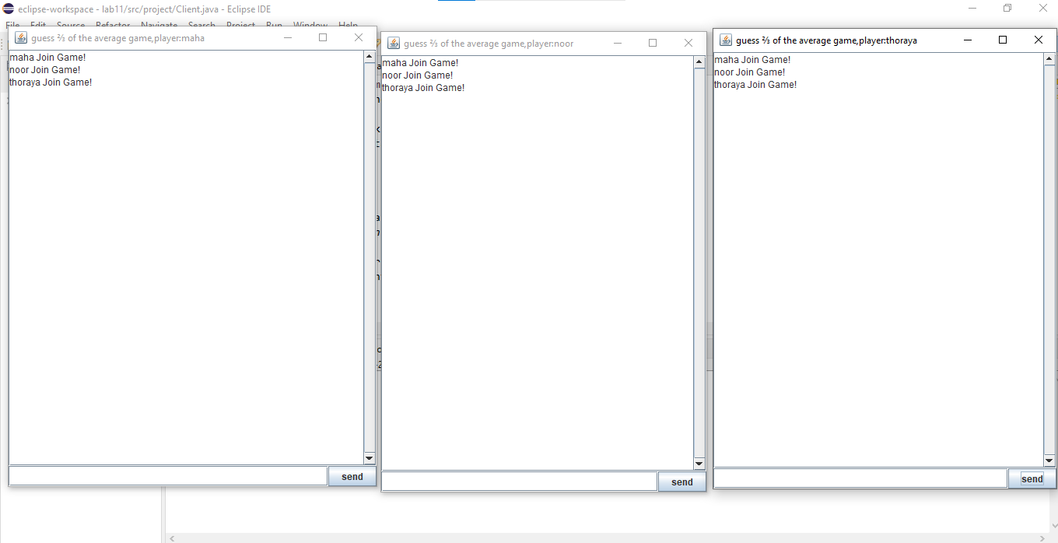

**To start the game the players should enter “Join” to enter the game.**

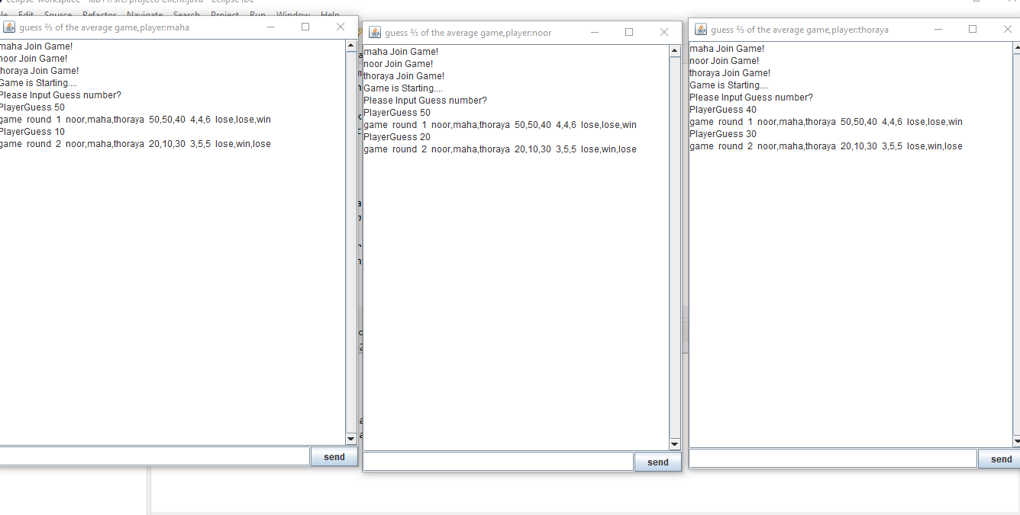

**After the all players join one of them should enter “Start” then each player should guess the number. For example Maha write “PlayerGuess 50”**

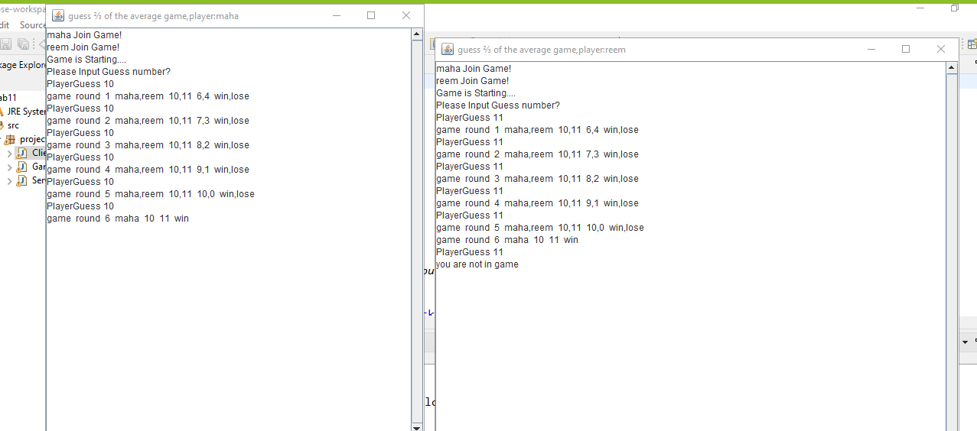

**If the player loses all points and reach 0, he will be exit from the game.**

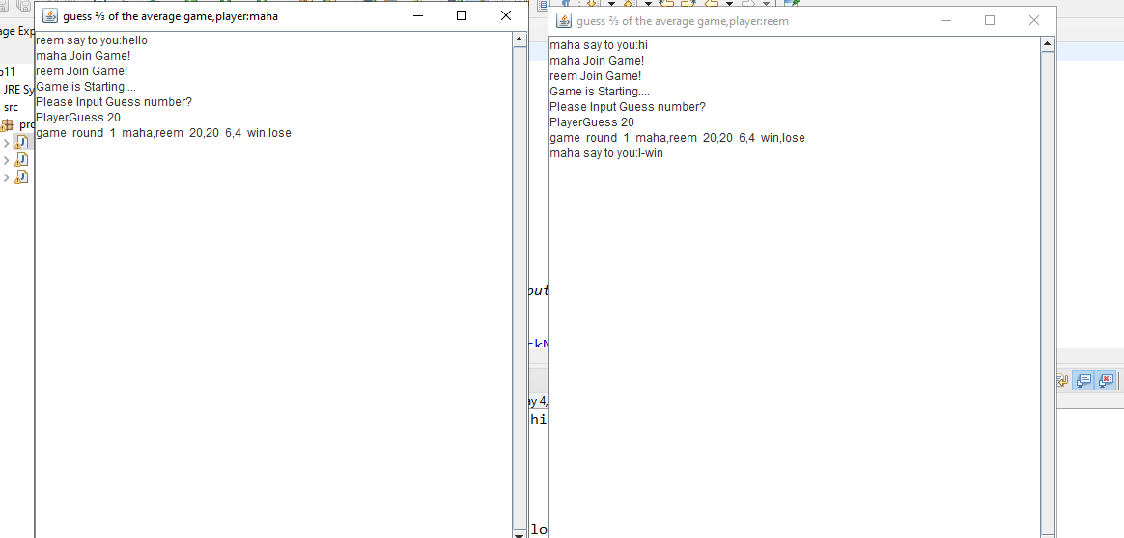

**The player can chat with each other any time by enter “SendMeesage” then the player’s name that will reactive the message then message.**

**Another Screenshots from different device:**