LSTM report contribution
Daniel Alejandro Castillo Martin | Advanced Deep Learning | MVPs

Recurrent model
The recurrent experiment classifies Enron emails as ham (0) or spam (1). The standard LSTM achieved test macro F1 of 0.9815 ± 0.0008 across three training seeds. Changing the initial forget-gate bias to +1 produced a small validation improvement, but did not improve average test performance.
Each email is lowercased and split into word tokens and individual punctuation marks. A vocabulary of 10,000 entries is fitted on training text only, including padding and unknown tokens. Emails are limited to 256 tokens and padded within each batch. After cleaning and removing normalized text overlap, the shared partitions contain 22,524 training, 5,632 validation, and 1,981 test emails. Training and validation contain approximately 51.86% ham and 48.14% spam.
The model learns 64-dimensional embeddings and passes them through one unidirectional LSTM layer with 128 hidden units. Its final hidden state represents the email; dropout of 0.1 and a linear layer produce two class scores. The embedding layer contributes 640,000 parameters, the LSTM 99,328, and the classifier 258, for a total of 739,586. Embeddings are learned from scratch.
An LSTM was chosen to process words in order while using a cell state and gates to control retained information. This connects to the course discussion of recurrence, memory, and gradient stability. LSTMs were introduced to address difficulties learning long time dependencies (Hochreiter & Schmidhuber, 1997). Here, the final hidden state gives a compact representation with a modest parameter budget. Packed sequences exclude padding from recurrent processing; adding extra padding was verified to leave predictions unchanged.

Training and model selection
Training uses cross-entropy loss, AdamW with weight decay 0.01, batches of 64, and gradient clipping at norm 1.0. Both learning-rate candidates, 0.001 and 0.0003, receive five epochs with tuning seed 42. Their best validation macro F1 scores are 0.9792 and 0.9744, respectively, so 0.001 is used for the remaining runs. Each checkpoint is selected by its highest validation macro F1 within the five-epoch budget. The selected seed-42 tuning run is reused rather than trained again.
The split seed remains fixed at 42. Training seeds 42, 123, and 2026 vary initialization and training order while preserving the data partitions. The test partition is excluded from vocabulary fitting and hyperparameter selection. Macro F1 averages the ham and spam F1 scores equally; spam F1 is reported separately in the saved experiment results.

Results
Seed | Best epoch | Validation macro F1 | Test macro F1
42 | 5 | 0.9792 | 0.9823
123 | 5 | 0.9815 | 0.9813
2026 | 5 | 0.9778 | 0.9808
Mean ± SD | — | 0.9795 ± 0.0019 | 0.9815 ± 0.0008
Spread is the sample standard deviation across seeds. Test accuracy and spam F1 both average approximately 0.9815. These results show stable performance across the three runs on this cleaned Enron split; they do not establish performance on other email sources.

Ablation of forget gate initialization
The ablation changes only the effective initial forget-gate bias from 0 to +1. Both LSTM bias vectors are zeroed, then +1 is assigned to the forget-gate slice of the input bias vector. All other settings, seeds, and the selected learning rate remain unchanged. This increases the initial tendency to retain cell-state information without changing parameter count. It tests an initialization choice rather than removing a model component.
Seed | Validation bias 0 | Validation bias +1 | Test bias 0 | Test bias +1
42 | 0.9792 | 0.9803 | 0.9823 | 0.9833
123 | 0.9815 | 0.9799 | 0.9813 | 0.9793
2026 | 0.9778 | 0.9799 | 0.9808 | 0.9783
Mean ± SD | 0.9795 ± 0.0019 | 0.9800 ± 0.0002 | 0.9815 ± 0.0008 | 0.9803 ± 0.0027
The modification improves validation macro F1 for seeds 42 and 2026 and reduces it for seed 123. Its mean validation advantage is approximately 0.0005, or 0.05 percentage points. On test, its mean macro F1 is approximately 0.12 percentage points lower, with greater variation. This provides no consistent evidence that +1 initialization is better for this task under the chosen budget.
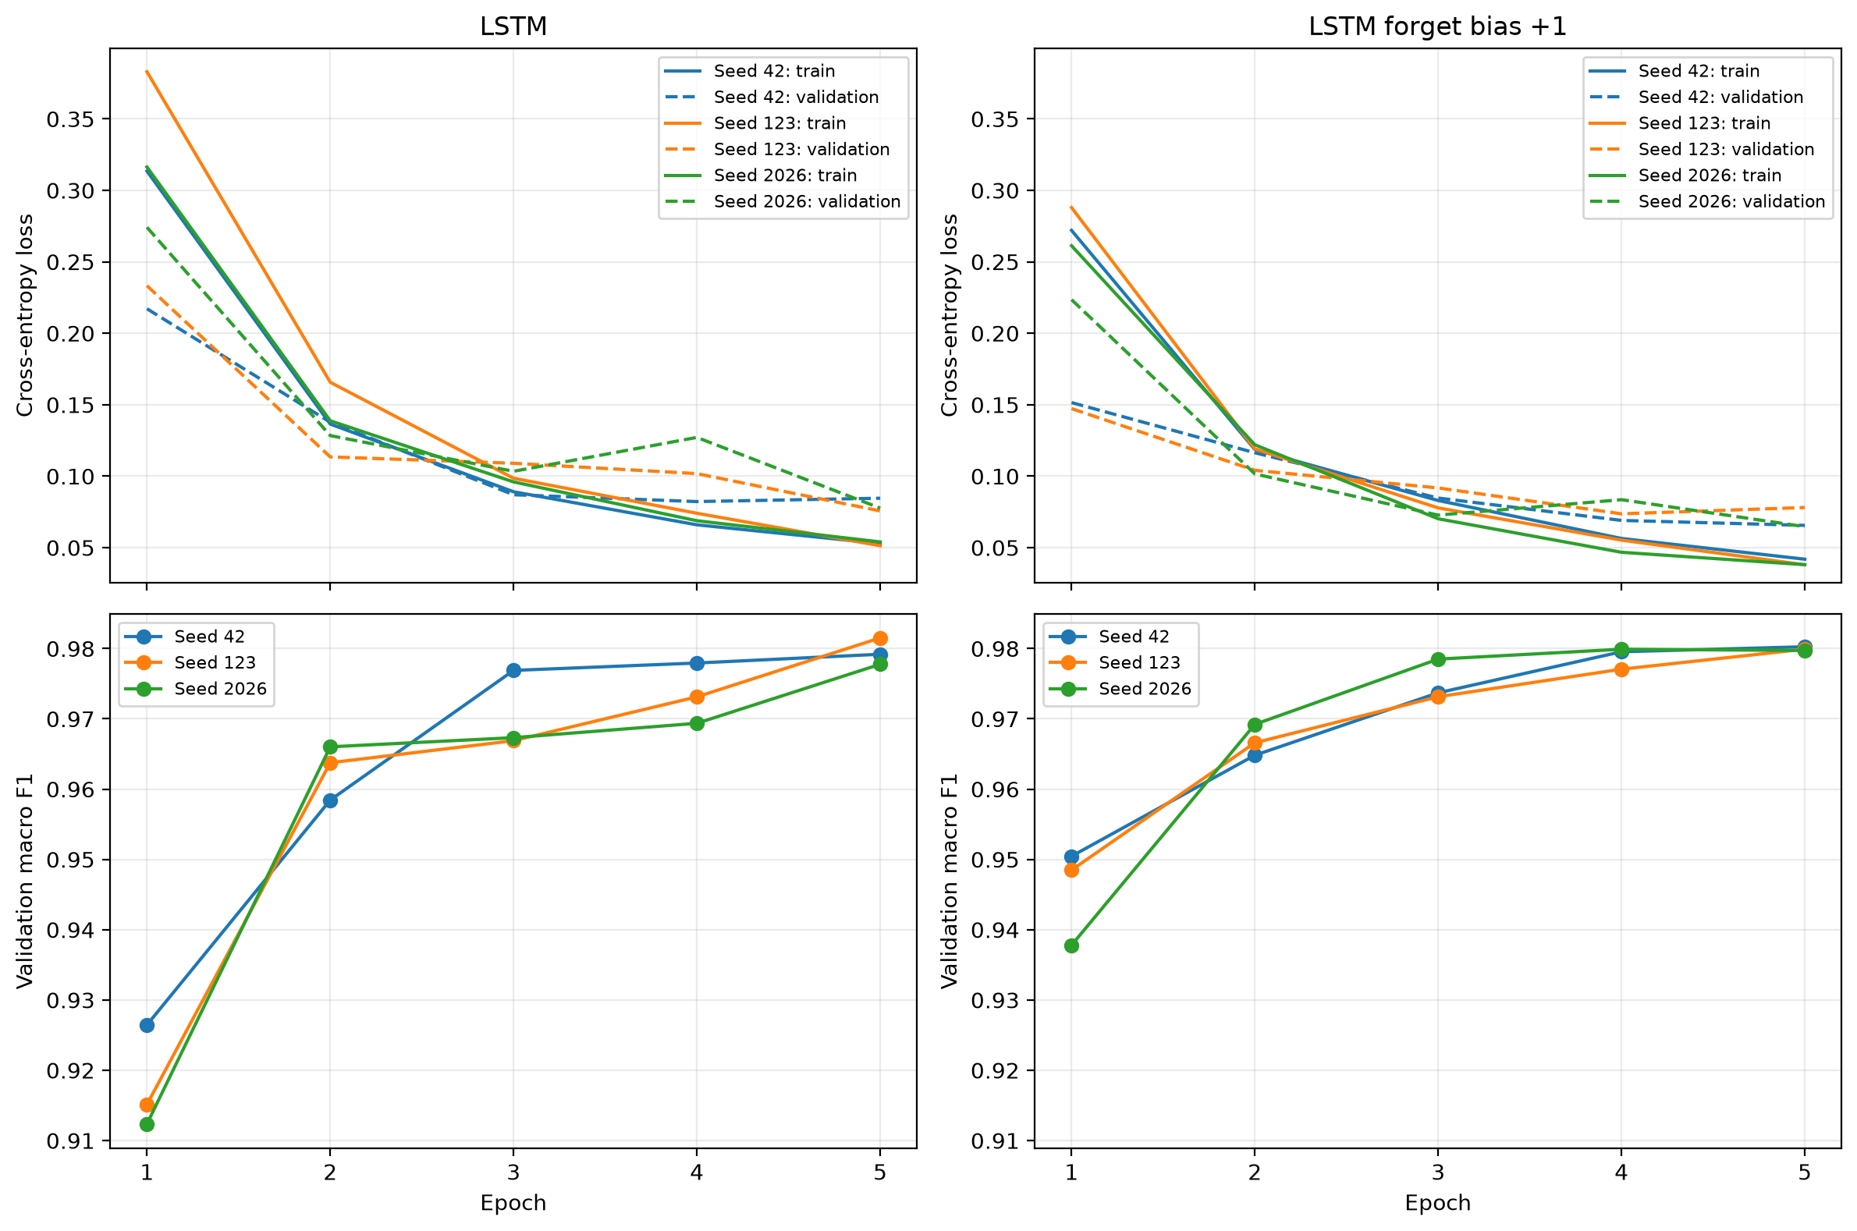
Figure 1. Training and validation loss (top) and validation macro F1 (bottom) across three seeds. Dashed loss curves represent validation. Both variants approach similar validation scores within five epochs. Source: LSTM experiment histories.

Inference cost
Inference is measured on the same fixed validation batch for both seed-42 checkpoints, using an NVIDIA GeForce RTX 3060 Laptop GPU and PyTorch 2.9.1+cu128. The batch contains 64 emails, padded to 256 positions, with a mean real length of 176.92 tokens. Ten warm-up passes precede 50 timed forward passes. CUDA synchronization brackets each measurement.
Measure | LSTM | Forget bias +1
Parameters | 739,586 | 739,586
Parameter storage | 2.82 MiB | 2.82 MiB
Batch time mean ± SD | 6.93 ± 0.23 ms | 7.69 ± 1.33 ms
Amortized time per email | 0.1082 ms | 0.1202 ms
Additional peak GPU memory | 43.15 MiB | 43.15 MiB
Timing excludes tokenization, data loading, and input transfer. Time per email is batch time divided by 64, not latency for a single-email request. GPU memory is the additional peak allocated memory above the existing model and input baseline; it is not total process or device memory. The timing difference should not be interpreted as an architectural cost of the bias change, since both variants execute the same operations. Comparisons with teammates require the same hardware, input batch, and measurement procedure.

Limitations
The 256-token limit truncates 32.2% of training emails and discards 49.6% of training tokens, so information later in longer messages is unavailable. A final hidden-state representation may also compress useful evidence from earlier positions. The experiment does not directly measure long-range memory or compare pooling strategies.
Three seeds and two learning-rate candidates provide limited evidence about variability and tuning sensitivity. Five epochs define the available budget; results do not show what longer training would achieve. Exact normalized duplicates were removed, but similar messages, templates, or sender patterns can remain. Generalization beyond this dataset requires separate evidence. CUDA execution was verified; CPU execution has not been tested.
The final comparison across model families must disclose any differences in epoch budgets, tuning, selection metrics, and hardware. All three frozen LSTM checkpoints were evaluated on test and are reported above. These results are descriptive; test scores were not used to change training settings.

Contributions and references
Daniel Alejandro Castillo Martin developed the shared data preparation workflow and reusable preprocessing modules, implemented the LSTM model and its training and evaluation pipeline, and ran the learning-rate search, three-seed experiments, forget-bias ablation, and inference benchmarks. ChatGPT assisted with implementation guidance, debugging, and preparation of this report section.
Hochreiter, S., & Schmidhuber, J. (1997). Long short-term memory. Neural Computation, 9(8), 1735–1780. https://doi.org/10.1162/neco.1997.9.8.1735
SetFit. (n.d.). enron_spam [Data set]. Hugging Face. https://huggingface.co/datasets/SetFit/enron_spam
MVPs. (2026). AIGC5500 Midterm Project [Source code and experiment outputs]. GitHub. https://github.com/erictsaily/AIGC5500-Midterm-Project

