Cairo University  
Faculty of Computers and Artificial Intelligent

**CS251**

**Software Engineering I**

Parking Garage Application

Software Design

|  |  |
| --- | --- |
| **Name** | **ID** |
| Abdelrahman Mohamed Ramadan | 20200293 |
| Ziyad Ashraf Ali (s24) | 20200197 |
| Nouran Ahmed Abdelaziz | 20200609 |

May / 2022

Contents

Instructions [To be removed] 3

Team 3

Document Purpose and Audience 3

System Models 3

I. Class diagrams 3

Important Algorithm 4

II. Sequence diagrams 5

Class - Sequence Usage Table 6

Ownership Report 6

Policy Regarding Plagiarism: 7

# Team

|  |  |  |  |
| --- | --- | --- | --- |
| **ID** | **Name** | **Email** | **Mobile** |
| 20200609 | Nouran Ahmed Abdelaziz | noranahmed5617@gmail.com | 01115743944 |
| 20200293 | Abdelrahman Mohamed Ramadan | abdra1396@gmail.com | 01145062539 |
| 20200197 | Ziyad Ashraf Ali (s24) | ziyadazab36@gmail.com | 01026603488 |

# Document Purpose and Audience

**Document Purpose:** The purpose of this document is to specify the Parking Garage Application design, using class diagrams, sequence diagrams, and their tables that specify them.

**Document Audience:** The Customer.

# 

# System Models

## Class diagrams

| **Class ID** | **Class Name** | **Description & Responsibility** |
| --- | --- | --- |
| **1** | **Garage** | Class Garage is an entity class, which we stores data in it, as we set the max number of slots and the configuration the system will use in this class. |
| **2** | **vehicle** | Class vehicle is responsible for entering the driver’s vehicle data. |
| **3** | **Slots** | Class Slots is responsible for Entering slots dimensions. |
| **4** | **Display** | Class Display is responsible for displaying slots available, and it’s a boundary class. |
| **5** | **VehicleData** | Class VehicleData is responsible for entering the data of the vehicle, and it’s a boundary class. |
| **6** | **vehicleFees** | Class vehicleFees is a controller class, as it calculates the fees of each vehicle parking out. |
| **7** | **ParkIn** | Class ParkIn is a controller class, as it captures the arrival time, and it’s an abstract class. |
| **8** | **BestFit** | Class BestFit inherits from ParkIn, and we implement function park in it, in this function it should choose the suitable slot for each vehicle parking in. |
| **9** | **FirstCome** | Class FirstCome inherits from ParkIn, and we implement function park in it, in this function, the vehicle parks in any suitable place for it. |
| **10** | **totalVehicles** | Class totalVehicles has an association relationship with class slots, as we call index attribute from it, in this class we calculate the total vehicles available in the garage. |
| **11** | **ParkOut** | Class ParkOut captures the departure time of the vehicle and parks the car out of the garage. |

## 

## II. Sequence diagrams

**Park in sequence diagram, ID : 1.**

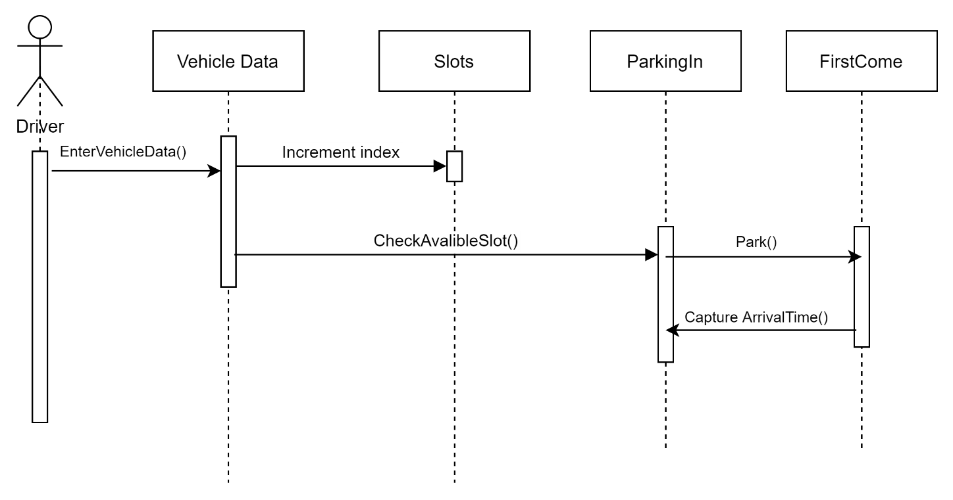

**Park out sequence diagram, ID : 2.**

**Set up sequence diagram, ID : 3.**

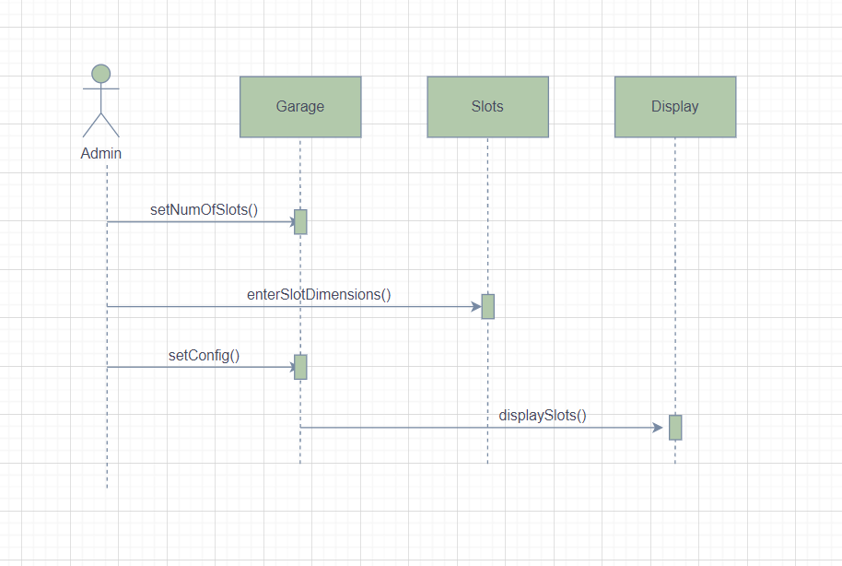

### Class - Sequence Usage Table

| **Class Name** | **Sequence Diagrams** | **Overall used methods** |
| --- | --- | --- |
| **Garage** | IDs: 3 | setMaxNumOfSlot()  setConfig() |
| **Slots** | IDs: 1, 3 | EnterSlotDimensions() |
| **Display** | IDs: 3 | DisplaySlots() |
| **VehicleData** | IDs: 1 | EnterVehicleData() |
| **ParkIn** | IDs: 1 | checkAvailableSlot()  captureArrivalTime() |
| **ParkOut** | IDs: 2 | parkingOut() captureDepartureHour() |
| **FirstCome** | IDs: 1 | Park() |
| **BestFit** | IDs: 1 | Park() |
| **vehicleFees** | IDs: 2 | Calculate() |

# Ownership Report

|  |  |
| --- | --- |
| **Item** | **Owners** |
|  |  |
|  |  |