1- Create a folder called learn_git_again.

2- cd into the learn_git_again folder.



3- Create a file called third.txt.



4- Initialize an empty git repository.

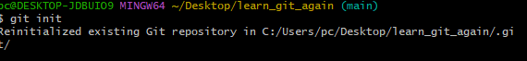

5- Add third.txt to the staging area.



6- Commit with the message "adding third.txt".

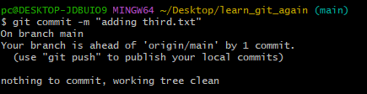

7- Check out your commit with git log.

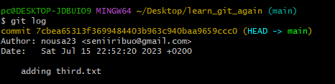

8- Create another file called fourth.txt.



9- Add fourth.txt to the staging area.



10- Commit with the message "adding fourth.txt"

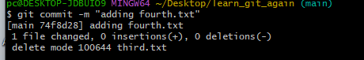

11- Remove the third.txt file



12- Add this change to the staging area



13- Commit with the message "removing third.txt"

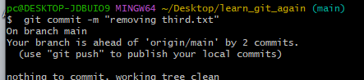

14- Check out your commits using git log

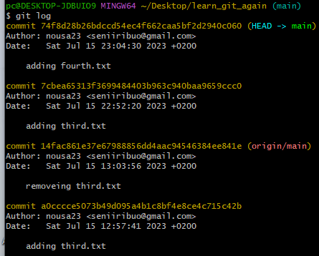

15- Change your global setting to core.pager=cat - you can read more about that here https://git-scm.com/book/en/v2/Customizing-Git-Git-Configuration.

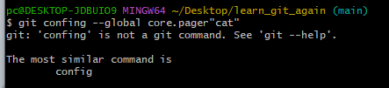

16- Write the command to list all the global configurations for git on your machine.

You can type git config --global to find out how to do this

