Initiating an Experiment

Noushin Nabavi

2020-10-27

# Preface

Welcome to the first edition of initiating an experiment in the public service. I’m so excited to work on this chapter for the experimentation course and work with my vibrant colleagues in the EW2 cohort.

This is a repository to house course materials related to module 2 of Government of Canada’s Experimentation Course: *Initiating an Experiment: what do you need to consider before starting an experimental project?*

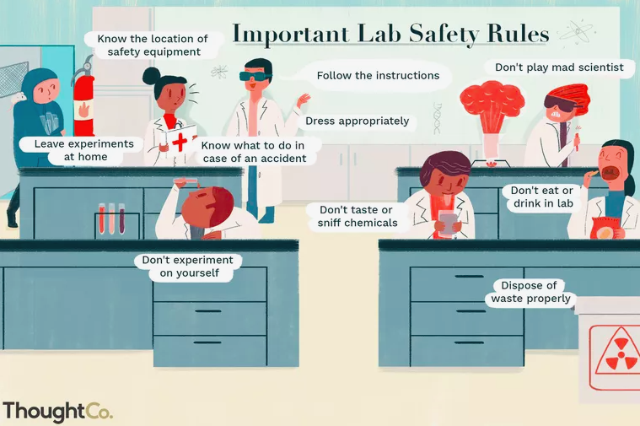

I hope this resource will be useful in clarifying **when** to experiment, **which** experiments are useful and **why**, **what** pitfals to consider, as well as simplifying scientific and technological jargon and common misperceptions. As innovators seeking social good, we have a duty to put our ideas to tests of assessments and evaluations to discover what doesn’t work, what does, and find out how to improve people’s lives.

I am tremendously grateful for the mentorship I have received from the EW2 leading team (Pierre-Olivier Bedard, Dan Monafu, and Sarah Chan) as well as the graphical design work lead by Jordana Globerman.

I will appreciate to know how this course can be improved and what additional topics can be added. I also love to hear how public servants foresee using the experimentation concepts in their projects towards evidence-based transformation of policies, programs, and services.

A big thanks to Preet Chauhan, EW2 expert, for proof-reading and helping with the many examples.

## Prerequisites / Assumptions

This course is intended for anyone with a curiosity and interest in making scientific observations through experimentation, and does not require previous experience of studying the subject.

An interest in experimentation, willingness to experiment, and an appetite for informed consummation of evidence. It means admitting that we don’t know all the answers but we can put our ideas to test.

Experimentation necessitates a mature attitude from leaders and decision-makers, one that is willing to experiment and learn positively from “good failure” rather than pretending we have all the answers.

A team of knowledgeable partners with expertise in experimentations methodologies with a transparent and “open-by-default” approach.

## Themes

We will explore the following themes in this module to help us answer the question of what we need to consider before starting an experiment: (1) opportunities to experiment in government, and (2) identifying problems and devising hypotheses as part of existing programs/services.

## Recap of Module 1

* Experimentation is about finding what does and does not work in order to inform decisions.
* Experimentation can be considered a de-risking strategy – it can be implemented at a small scale to determine impact early on before (costly) scaling.
* Experimentation is part of a learning process where robust and relevant evidence is gathered in order to inform course corrections, if needed.
* Experimentation is advantageous over other approaches because it deals more effectively with questions of a causal nature (does X have an impact on Y).

## Learning objectives

By the end of this module, you will be able to:

* Identify the steps needed before starting an experimental project
* Devise a problem statement for an experimental project
* Develop a research question
* Share the project with stakeholders and get buy-in
* Apply experimentation knowledge to initiate an experiment (example)

## Outline

|  |  |
| --- | --- |
| Chapter | Title |
| 1 | Deciding to experiment |
| 2 | Experiment components |
| 3 | Literature Review |
| 4 | Defining the problem |
| 5 | Developing a research question |
| 6 | Mechanics of endorsement |
| 7 | Examples of Experimentation |
| 8 | References |

# Deciding to experiment

Before embarking on the experimentation journey, you should ask the question ‘Do you have to run an experiment?’ As discussed in Module 1, experiments provide answers to very specific questions – they will likely not answer questions that are not causal in nature.

Designing an implementing an experiment can take time, motivation, skills, and often financial resources. It is not always immediately clear what combination of resources you will need for your experiment, given that they’re not the first thing considered when trying to answer a question.

Embarking on the experimentation journey will require significant cross-functional collaboration, stakeholder buy-in, and lots of preparatory work – but it all starts with having clear and thoughtful design for your research question, and then landing on an implementation plan before starting.

## What is an experiment?

An experiment is a procedure designed to test a hypothesis as part of the scientific method.

Experimentation is often described as a method, approach, a test, a tool to generate evidence. All of these are true, but first and foremost experimentation is a problem-solving process. The starting point for any experiment should be the problem you are trying to solve.

The two key variables in any experiment are the independent (explanatory) and dependent (response) variables. The independent variable is controlled or changed to test its effects on the dependent variable. Three key types of experiments are controlled experiments, field experiments, and natural experiments.

**Controlled Experiments:** Lab experiments are controlled experiments, although you can perform a controlled experiment outside of a lab setting! In a controlled experiment, you compare an experimental group with a control group. Ideally, these two groups are identical except for one variable, the independent variable.

**Field Experiments:** A field experiment may be either a natural experiment or a controlled experiment. It takes place in a real-world setting, rather than under lab conditions. For example, an experiment involving an animal in its natural habitat would be a field experiment.

**Natural Experiments:** A natural experiment also is called a quasi-experiment. A natural experiment involves making a prediction or forming a hypothesis and then gathering data by observing a system. The variables are not controlled in a natural experiment.

To summarize: an experiment is simply the test of a hypothesis. A hypothesis, in turn, is a proposed relationship or explanation of phenomena.

## Do we need to experiment?

To embark on an experimentation project, we really need to consider whether *experimentation* is needed in the first place. One way of determining this is to consider whether there is a very specific question that requires a specific answer? And, is the answer worthy to know? If we are after questions that are not causal in nature, then an experiment is likely not the best fit. Making observations or trying something after making a prediction about what you expect will happen, is a type of experiment. For example, predicting/hypothesizing that your coffee will taste sweeter after the addition of sugar and then going ahead to testing that is an experiment.

The following examples, on the other hand, are not experiments:  
- making a model dashboard  
- making a poster  
- changing many factors at once, so one can’t truly test the effect of the variables  
- trying something, just to see what happens.

At this point in the **experimentation cycle**, there are more questions than answers and the more questions one asks, the more clarifying answers one will seek on whether an experiment is really needed.

*What would experimentation look like in policy or practice? why would an experiment be worth investing in? What data or program performance tracking is already in place? What experimental tools and expertise are available and are they sufficient? What are the risks? What could be a risk management strategy?*

**Decision tree**

To help make whether an experiment is needed and set one’s direction, the following decision tree from Nesta is a great starting point for a project journey. In this journey, only the two red bubbles refer to an experiment. The rest are only explorations or validations. What makes the two red bubbles an experiment? What do they have in common? The two red bubbles focus on the trial and error to find out what works and what doesn’t, which is central to any experimental project.

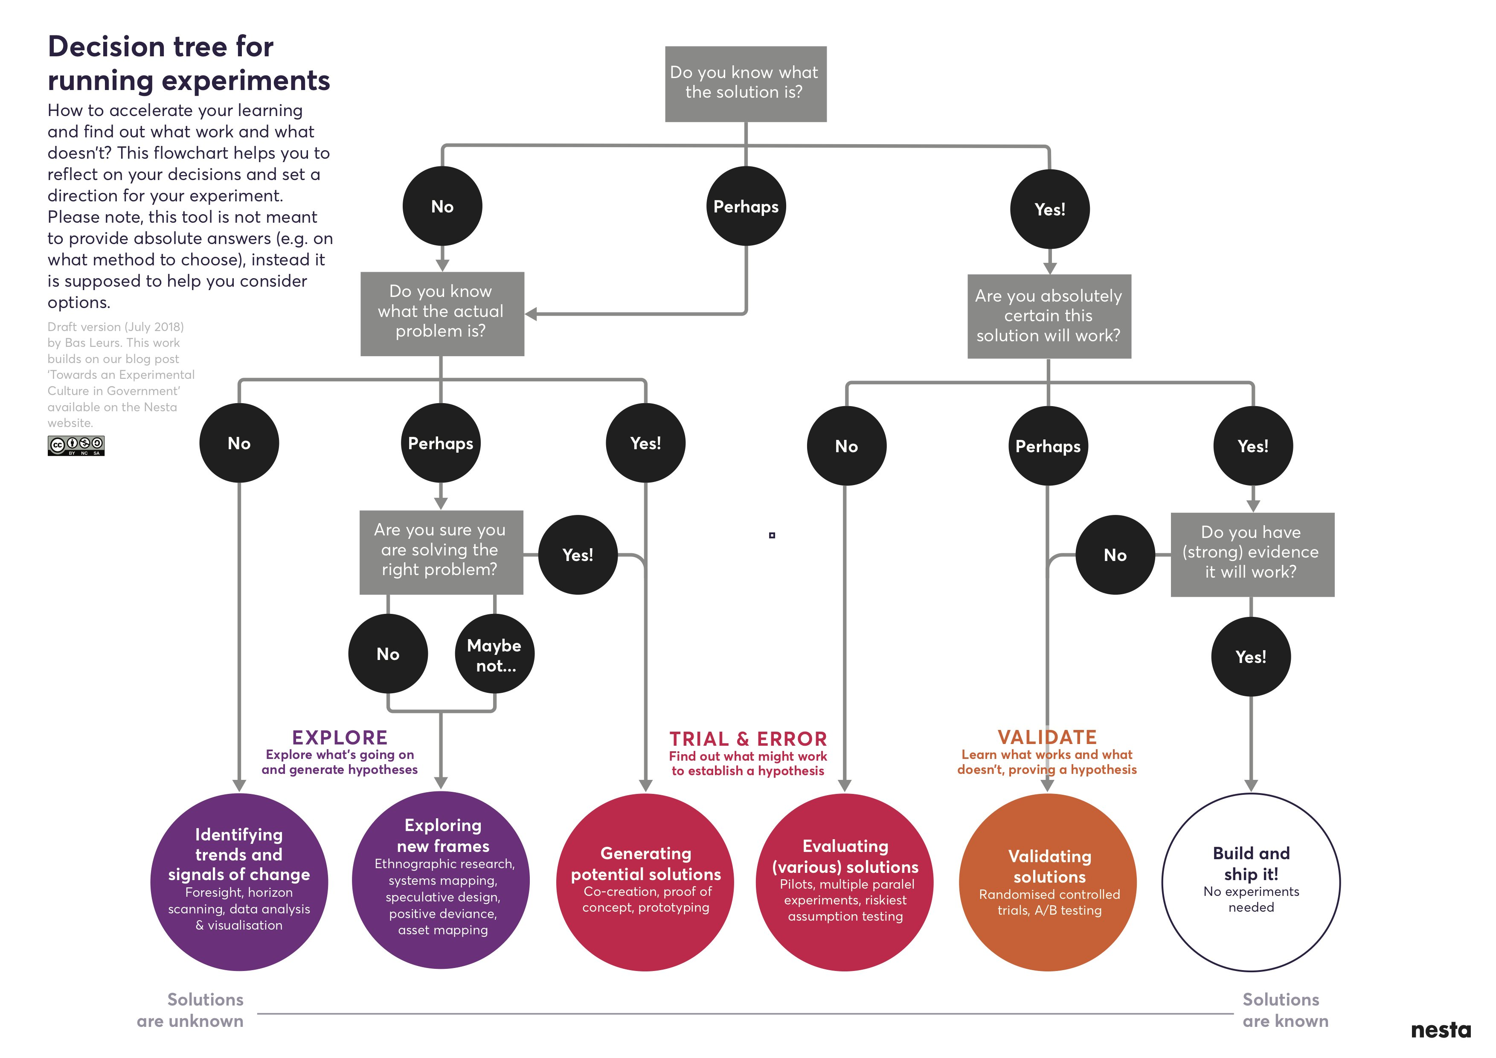

## The experimentation cycle

A problem well-stated is half-solved!

To help others understand the problem as we see it, one of the first things an experiment needs is well-framed question and clearly articulated goals. To help formulate the why as well as the what, the following experimentation lifecycle is helpful in that it encourages to reiteratively (1) brainstorm and form vague ideas, (2) group vague ideas, (3) make general observations, (4) hypothesize, (5) determine a model/method to test the hypotheses, (6) do the experiment to test hypothesis, (7) gather data, analyze, and interpret the results, and (8) learn and communicate learnings to stakeholders

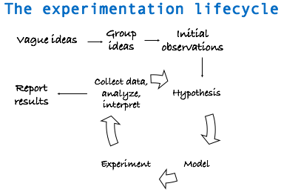

This lifecycle presumes that we can:

* sketch out what information we need to collect (or already have) to get from a vague idea to the hypothesis stage for a planned project
* get invested in the problem before the solution nor in a particular result (any biases will work against us here)
* not get stuck in a fishing expedition (i.e. grouping ideas forever)
* understand the problem well enough to clearly articulate the goals, questions, and hypotheses before building metrics
* select metrics that will help answer the questions. This can include system parameters, workload parameters, behaviours, etc. “If all you have is a hammer, everything looks like a nail.” - Bernard Baruch
* identify parameters that affect behaviour or observations and decide which parameters or interactions to study, or vary.

## Design considerations

Don’t land your plane in forests, and don’t do experimental designs before you have considered its drawbacks

It is important to keep in mind that no experimental design is really perfect in that it can consider all aspects of an issue. This is not to discourage us. In a way, George Box’s (British statistician) quote that “All models are wrong, but some are useful” applies to experimental designs as well. As long as we remember that one single experimental design cannot be comprehensive and all-encompassing and that it is ok to be specific and clear about limitations. A perfect design doesn’t exist because we cannot possibly control for the many factors and behaviours that may affect a situation.

Therefore, since all models are wrong to some extent, researchers should check the scope of applicability and limitations of their method/model. We should choose the designs that best answer the research question, and not try to tailor the research question to the method at hand.

For instance, we may decide to base our tests on a set of observations derived from survey findings and not be aware that survey data can fail in several aspects: (1) people act differently when they realize they are under study. If asked about questions on sensitive topics (e.g., homosexuality, immigration, abortion, or Donald Trump), people understand there is a “standard” answer and so, they may hide their true feelings and give socially acceptable answers. (2) having a representative sample is difficult and expensive. In social sciences, one of the basis of experiments is recognizing regional diversity (e.g. British Columbia is different from Ontario and Ontario is different from Quebec). This can affect the interpretation of our findings and their generalizability. (3) determining the causal relations between two events is usually the goal of experimentation. However, direction of causal inference in social situations can be problematic. Traditional quantitative methods are particularly ill-designed for causal questions when the answer can go in either directions. A solution here is a carefully designed experiment with control groups, more on this later.

Nevertheless, experiments can produce many types of evidence that can be used in program and policy designs. With sufficient sample sizes, for example, randomised control trials can provide useful evidence through pre- and post-experiment analysis.

For example, a behavioural insights group examined the effect of nudges on health and wellbeing and demonstrated a massive effect *default choices* have on organ donation compliance rates. Those countries where people are required to opt-out of organ donation report significantly higher consent than those with an opt-in policy (Johnson & Goldstein (2003), Do Defaults Save Lives?, Science, Vol. 302).

Another example is another group who examined whether manipulating the positon of food on a restaurant menu would have any effect on consumer choices. They found that items placed at the beginning or end of the menu were up to twice as popular as when the same items were placed in the centre of the menu (Dayan & Hillel (2011), Nudge to nobesity II: Menu positions influence food orders, Judgment and Decision Making).

# Examine Assumptions and account for Pitfalls

Before designing and running experiments, it helps to examine our assumptions about the topic and clearly track and communicate them. In a similar fashion, statistical models that are later used to analyze collected data also work under assumptions. For example, a simple linear regression model requires four assumptions:

- E(y) = Xβ  
- Independence  
- Equal variance (σ²)  
- Normality

Without checking these assumptions, we are using the wrong models and generating misguided insights or misinformation. Thus, to reduce reliance on models with un-intended consequences, we need to clearly and transparently examine our assumptions about the topic of interest.

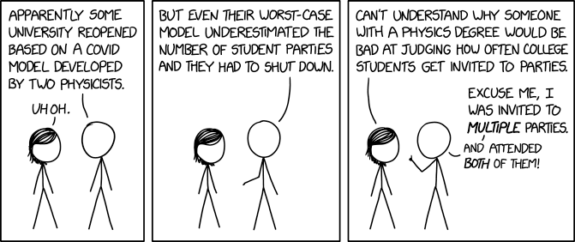

Another consideration is measuring how much information we need and can get from an experiment (degrees of freedom). Generally, the more variables are included, the less information is left out. In contrast, our data analysis models can run out of steam if there are too many variables (problem of big data). Thus, we need to strike a balance between information/data gathering and analysis methods.

To summarize, experiments can be more prone to failure if disregard the following points (not an exhaustive list):

* Devise wrong metrics (i.e. metrics that don’t answer the question at hand)
* Have no clear scope (i.e. what are the boundaries for the ‘system under test’)
* Omit assumptions and limitations of study
* Use unrepresentative metrics, have no comparison groups, or have cross-contamination
* Not recognize the experimental limitations
* Overlook significant parameters that affect the behaviour of a system
* Report average and not variability (fall for tricks of statistics or have no statistics!)
* Have no interpretation of what results mean or overgeneralizing conclusions
* Ignore errors and outliers
* Not consider the ethical issues and scenarios or have informed consent from participants

## It is not all bad

Evidence-based policy making can be a political ideal

Experimentation is not all bad news. Many breakthroughs and transformations on many fronts from medicine and technology to social changes for good have come about by a willingness to experiment. For example, experimentation with design of cell phones has resulted in ease of their usability in time.



There are also many advantages to experimentation. For instance, experiments can result in a higher degree of internal validity. Through random assignment of a treatment condition, experimental designs allow us to examine the effect of one variable while keeping other conditions constant. Note that randomization is the key here because it ensures that the treatment and control groups are comparable. Any differences between the two groups can be attributed to the treatment.

For instance, a group in the U.K. tested differ letter framings on the tax reported behaviour of over 7,300 sole proprietors. The different treatments were offers of assistance with tax forms, rational argument and threats of audit. By and large, the treatments proved effective at encouraging taxpayers to declare more, with the threat messages being the most effective (Hasseldine et al. (2007), Persuasive Communications: Tax Compliance Enforcement Strategies for Sole Proprietors, Contempory Accounting Research).

Experimentation can be good even without prior knowledge. This is because sometimes there may not be a theory or theories may fall short to start with. Since experimentation can directly control how data is generated, the experimental approach can survive and thrive with no previous knowledge. For instance, with no prior knowledge, electoral researchers can carry out a field experiment to examine how different ways of contacting voters would affect the voting turnout.

Experimentation can help clarify mixed results. This is sometimes inherent in observations that are looking at similar phenomena with different measurements or with different data sources. Observational studies often generate mixed results and one way to validate or clarify the existing mixed result is to run an experiment. Again with the example of electoral politics, researchers can chose to run an experiment to detect how campaign spending affects the voters for the incumbent and the challengers differently.

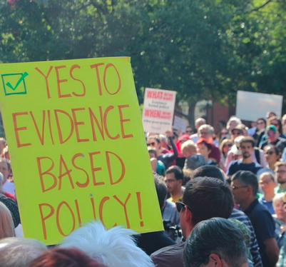

## Communication of intent to experiment

Given that we are considering the option to experiment, we need to have clear and open communications and collaborations with cross-functional teams.

The aim is to get feedback from as many diverse people as possible. These conversations can help us decide which ideas to take forward, reiterate clear questions based on feedbacks, and eventually implement in an experimentation proposal.

These conversations presumes that there is already an executive level buy-in in place and that stakeholders are invested in the experimentation process. This also assumes that a clear and thoughtful design and implementation plan exists before starting to communicate such that it can be communicated wholly and incrementally with the executives. This is not a tautology and hopefully drive the point that iteration, re-iteration, agility, and an open attitude are key qualities in the initial process.

Executive buy-in usually requires a thorough risk assessment and contingency plans more so in the public service space than in academic environments. Therefore, it is important that the executive is aware of the experimentation cycle which can also be thought of as the problem-solving process and endorses the method, approach, tests, and tools that generate evidence. Some, in fact, argue that experimentation is the creation of something new in the face of uncertainty and risk, which requires time, effort and relevant resources.

It is noteworthy that the word “experimental” has come to mean “innovative” or “radical” rather than simply “untested”. [The Experimenter’s Inventory](A%20catalogue%20of%20experiments%20for%20decision-makers%20and%20professionals)

Genuine experimentation is about committing to rigorous assessments and evaluation of evidence, not just freewheeling “trying stuff out” or doing things differently and expecting to succeed.

Therefore, even though a methodology is key to answering a specific question, the starting point is having a problem you are trying to resolve, preferably with the social good in mind. The purpose of experimenting is to test key questions and assumptions using quick, low risk, rigorous experiments.

From the thousands of experiments conducted by Thomas Edison to create the first lightbulb, or the long-running field experiments by Gregor Mendel to examine genetic variability that today underpins modern agriculture concepts, through to trials in medicine, carefully testing ideas in practice is a cornerstone of scientific and technological discovery.

## Experiments in the public sphere

Today, experiments are critical to sectors where innovation and optimization are routine, such as web development, digital transformation, electrical vehicles, etc. This has caught on in business such that the largest financial institutions, retailers and restaurants are also running randomized experiments, along with companies like Google, Facebook, and Amazon running tens of thousands of experiments a year. A/B testing is now the standard means through which Silicon Valley improves its online products. However, in government experimentation remains relatively rare and a new field.

One of the most famous nudge experiments is the ‘Save More Tomorrow’ (SMarT) program that used defaults to increase employees’ savings rates by automatically increasing the percentage of their wage devoted to saving. Average saving rates for SMarT program participants increased from 3.5% to 13.6% over the course of 40 months while savings rates remained stagnant in the other two conditions (Benartzi & Thaler (2004), Save More Tomorrow, Journal of Political Economy).

A small but growing movement of policy experimenters are bringing fresh ideas on how to solve public problems. From crafting better services, to making the back-office of government more efficient, new methods and tools need to be used to develop and test policy. In fact, government must rigorously and systematically put policy to the test – or risk stagnation.

For example, a group conducted three field experiments looking at increasing savings with text message reminders and found that goal-specific reminders were considerably more effective than generic ones (Karlan et al. (2010), Getting to the Top of Mind: How Reminders Increase Saving, NBER Working Paper).

In the context of government agencies, experiments aim to evaluate a program, policy,   
or service and test an idea or innovation by investigating what difference it has   
made or will make for the people it is aiming to help.

Like laboratory experiments, public sphere experiments also need a control group to test an innovation against “business-as-usual”. This doesn’t have to be a large trial like testing a drug and can be fast and flexible. In fact, the best experiments start small and as a prototype before they are extended.

For example, the World Bank advocates for “nimble randomized control trials”. They funded nimble evaluations on how best to improve the take up of health insurance in Azerbaijan, expand the use of contraceptives in Burundi, and support teachers to deliver tailored education to children affected by war and displacement in Lebanon.

## Summary: deciding to experiment

* Do you need to experiment? Why or why not?
* Find a behaviour, program, policy, or service to test
* Try out of the box thinking to brainstorm, make observations
* Look for natural experiments
* Talk to experts and get feedback
* Think small and short term
* Start with a proof-of-concept question and hypothesis
* Keep it simple and try to test one thing at a time
* Measure everything that matters
* Have control and treatment groups when possible

# Experiment components

## Experiment basics

An experiment is the foundation of the scientific method, which is a systematic means of exploring the world around us. Although some experiments take place in laboratories, we could perform an experiment anywhere, at any time.

When we say the *scientific method*, we really mean the following steps: - Making observations. - Formulating a hypothesis. - Designing and conducting an experiment to test the hypothesis. - Evaluating the results of the experiment. - Accepting or rejecting the hypothesis. - If necessary, making and testing a new hypothesis.

Variables are also a key part of an experiment. A *variable* is anything you can change or control in an experiment. Some examples of variables include engagement, duration of the experiment, composition of the study population, behaviours, etc. There are three kinds of variables in an experiment: controlled variables, independent variables and dependent variables.

**Independent variable:** is the one factor that you are changing. It is one factor because usually in an experiment you try to change one thing at a time. This makes measurements and interpretation of the data much easier. If you are trying to determine whether heating milk allows you to dissolve more sugar in the coffee then your independent variable is the temperature of the milk. This is the variable you are purposely controlling.

**Dependent variable:** is the variable you observe, to see whether it is affected by your independent variable. In the example where you are heating milk to see if this affects the amount of sugar you can dissolve, the mass or volume of sugar (whichever you choose to measure) would be your dependent variable.

**Controlled variables:** sometimes called constant variables are variables that are kept constant or unchanging. For example, in an experiment looking at the effects of studying on test scores, studying would be the independent variable and test scores will be dependent variable. Since in the example, we are trying to determine if changes to the independent variable (studying) result in significant changes to the dependent variable (the test results), we may want to keep the test constant or administer the experiment to the students in the same class who are within the same age group and perhaps have the same teachers. Control variables help us reduce the confounding biases in experiments.

It is also important to be aware that there may be other variables that might influence the results of an experiment. There is another kind of variables that might influence the outcome called the extraneous variable. Extraneous variables are variables that might affect the relationships between the independent variable and the dependent variable; experimenters usually try to identify and control for these variables. For instance, they can include demand characteristics (which are clues about how the participants should respond) and experimenter effects (which is when the researchers accidentally provide clues about how a participant will respond). When an extraneous variable cannot be controlled for in an experiment, it is known as a confounding variable.

The main steps in running an experiment is depicted in the following figure. It is useful to know the steps but in this module, we will only focus on the problem statement (step 1).

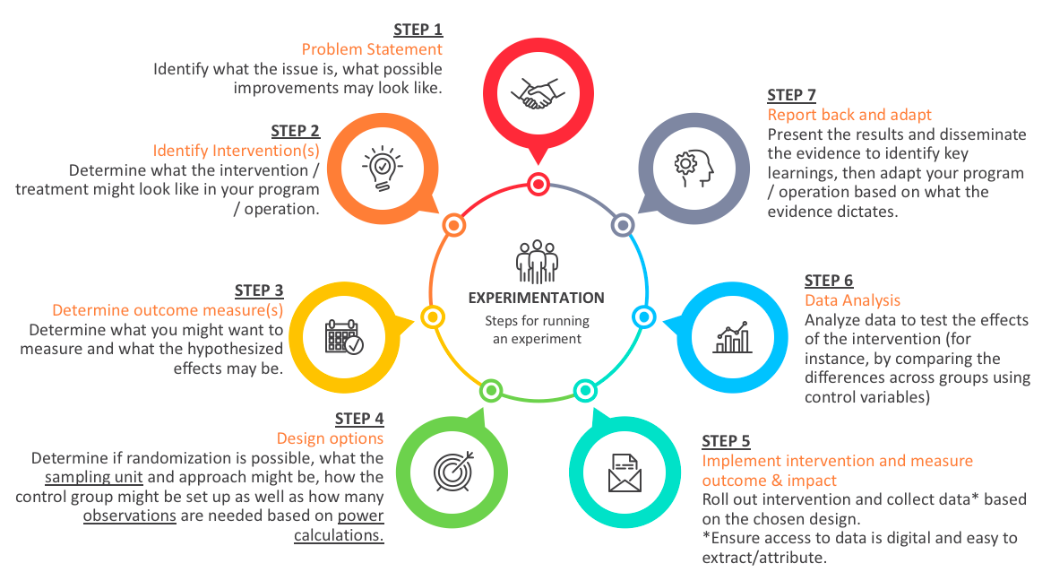

# Defining the problem

## What is a review of the literature?

A literature review is an account of what has been published on a topic by accredited scholars and researchers. Occasionally you will be asked to write one as a separate assignment (sometimes in the form of an annotated bibliography—see the bottom of the next page), but more often it is part of the introduction to an essay, research report, or thesis. In writing the literature review, your purpose is to convey to your reader what knowledge and ideas have been established on a topic, and what their strengths and weaknesses are. As a piece of writing, the literature review must be defined by a guiding concept (e.g., your research objective, the problem or issue you are discussing, or your argumentative thesis). It is not just a descriptive list of the material available, or a set of summaries

Besides enlarging your knowledge about the topic, writing a literature review lets you gain and demonstrate skills in two areas

information seeking: the ability to scan the literature efficiently, using manual or computerized methods, to identify a set of useful articles and books critical appraisal: the ability to apply principles of analysis to identify unbiased and valid studies. A literature review must do these things

be organized around and related directly to the thesis or research question you are developing synthesize results into a summary of what is and is not known identify areas of controversy in the literature formulate questions that need further research

## Ask yourself questions like these:

What is the specific thesis, problem, or research question that my literature review helps to define? What type of literature review am I conducting? Am I looking at issues of theory? methodology? policy? quantitative research (e.g. on the effectiveness of a new procedure)? qualitative research (e.g., studies of loneliness among migrant workers)? What is the scope of my literature review? What types of publications am I using (e.g., journals, books, government documents, popular media)? What discipline am I working in (e.g., nursing psychology, sociology, medicine)? How good was my information seeking? Has my search been wide enough to ensure I’ve found all the relevant material? Has it been narrow enough to exclude irrelevant material? Is the number of sources I’ve used appropriate for the length of my paper? Have I critically analysed the literature I use? Do I follow through a set of concepts and questions, comparing items to each other in the ways they deal with them? Instead of just listing and summarizing items, do I assess them, discussing strengths and weaknesses? Have I cited and discussed studies contrary to my perspective? Will the reader find my literature review relevant, appropriate, and useful?

## Ask yourself questions like these about each book or article you include:

Has the author formulated a problem/issue? Is it clearly defined? Is its significance (scope, severity, relevance) clearly established? Could the problem have been approached more effectively from another perspective? What is the author’s research orientation (e.g., interpretive, critical science, combination)? What is the author’s theoretical framework (e.g., psychological, developmental, feminist)? What is the relationship between the theoretical and research perspectives? Has the author evaluated the literature relevant to the problem/issue? Does the author include literature taking positions she or he does not agree with? In a research study, how good are the basic components of the study design (e.g., population, intervention, outcome)? How accurate and valid are the measurements? Is the analysis of the data accurate and relevant to the research question? Are the conclusions validly based upon the data and analysis? In material written for a popular readership, does the author use appeals to emotion, one-sided examples, or rhetorically-charged language and tone? Is there an objective basis to the reasoning, or is the author merely “proving” what he or she already believes? How does the author structure the argument? Can you “deconstruct” the flow of the argument to see whether or where it breaks down logically (e.g., in establishing cause-effect relationships)? In what ways does this book or article contribute to our understanding of the problem under study, and in what ways is it useful for practice? What are the strengths and limitations? How does this book or article relate to the specific thesis or question I am developing?

## Final Notes:

A literature review is a piece of discursive prose, not a list describing or summarizing one piece of literature after another. It’s usually a bad sign to see every paragraph beginning with the name of a researcher. Instead, organize the literature review into sections that present themes or identify trends, including relevant theory. You are not trying to list all the material published, but to synthesize and evaluate it according to the guiding concept of your thesis or research question

If you are writing an annotated bibliography, you may need to summarize each item briefly, but should still follow through themes and concepts and do some critical assessment of material. Use an overall introduction and conclusion to state the scope of your coverage and to formulate the question, problem, or concept your chosen material illuminates. Usually you will have the option of grouping items into sections—this helps you indicate comparisons and relationships. You may be able to write a paragraph or so to introduce the focus of each section

# Defining the problem

## The problem statement

Experimentation as a problem-solving process carried out under controlled conditions in order to discover an unknown effect or law, to test or establish a hypothesis, or to illustrate a known law

Experimentation is described as many things: a method, an approach, a test, or a tool to generate evidence. All of this is true, but experimentation is first and foremost a problem-solving process.

The starting point for your experiment should not be the methodology, nor a predetermined answer; it should be the problem you are trying to resolve.

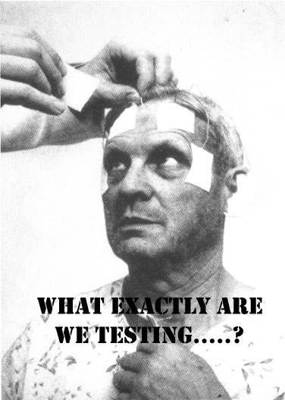

To help us chose the problem statement, we can go through the following steps:

**Step 1: Choose a topic** 1. What do I find interesting about the subject? 2. What is known about the subject? 3. What is missing and what are the gaps?

In theory, the topic could be in any field (for instance, agriculture, but also fiscal policy) and at any level (for instance, it could affect 20 people, or it could reach most of Canada’s population). It could touch upon the realm of policy, program, service delivery, regulatory and internal services.

The problem doesn’t always need to be causal in nature, in which case perhaps an observational study is better.

**Step 2: Narrow the topic** 1. What do you need to know more about on the topic? 2. Are you interested in social, political, economic, gender, religious issues related to your topic? - Find a “slant” on your topic and determine the root causes (physical, social, or organizational causes) - Develop possible solutions and select a solution 3. Will the results reveal something new or unexpected? 4. What is in scope and what is out of scope? 5. Can you clearly define hypotheses (If…then…) and explicitly state research questions?

The problem statement you develop should be clear and precise, but also scoped into a relevant policy area that is within your reach (in terms of jurisdiction, for instance). A problem that has too little impact to be deemed important is likely not a great fit, nor is a problem with little decision-making implications very useful to be explored. Similarly, problem statements that are too vague need to be modified so that they’re scoped appropriately.

For instance, a paper looks at framing effects in healthcare and asks whether patients preference for a therapy change by having positive contextual information? (a specific and clear problem statement) In this case, they tell a group of patients that that **90%** of those who have a certain operation are alive after five years. These patients are more likely to chose the operation than when they are told that after five years, **10%** of patients are dead (McNeil et al. (1982), On the elicitation of preferences for alternative therapies, New England Journal of Medicine).

**Step 3: Find Resources** 1. How do we design a research proposal that builds on existing knowledge to address critical questions? 2. The key here is getting to know what is already done on the topic and how can our design improve or build on current knowledge. 3. Perform a systematic literature search by using the keywords you have compiled and use them to search for books in Library Catalogs, blogs, or articles in online databases 4. Consult with experts and seek feedback

In a government context, the right scale and scope of the experiment will be dictated by what decision-makers need to know coupled with the various practical constraints that inevitably come along through the design process.

In general, this step will help us make the proposal more mutually exclusive and collectively exhaustive, **MECE**. By the end of this process, more so than before, we will be able to make statements that do not overlap in content and fully describe the problem at the highest level.

**Step 4: Seek collaboration** 1. Make sure the question is one that other people can get behind and support 2. Establish collaboration agreements and executive buy-in 3. Peer-review for clarity, scientific accuracy, and feasibility 4. Does the team have the expertise required to complete the project? If not, who else needs to be on team?

Figuring out the problem will take time, and needs to be done in consultation with as many parties directly or indirectly potentially impacted by the experiment’s results. Before starting the problem definition stage, you should take time to discuss alongside colleagues, management and others (experts and practitioners, current users) what exactly you wish you fix.

Each of the steps above should be completed before moving on to the next one. However, steps can be repeated. For example, if you’re on the third step, you can still return to the previous step, and redefine the problem.

## Determine interventions

It’s important to be clear what the different experimental designs can and can’t tell us. What sets observational studies apart from experimental studies is that there is a component of **intervention** in experimentation.

Fore instance, a group looked at encouraging healthier eating in school lunchrooms through strategic placement of certain foods (interventions). One of two lunch lines was arranged so as to display healthier foods. In the healthier line, sales of healthier food increased by 18% and grams of less healthy food consumed decreased by 28% (Hanks et al. (2012), Healthy Convenience:Nudging Students Toward Healthier Choices in the Lunchroom, Journal of Public Health.)

Another group did something similar and found other interventions like making the food harder to reach or changing the serving utensil at a salad bar from a spoon to tongs reduced intake of unhealthy food by 8-16% (Rozin et al. (2011), Nudge to nobesity I: Minor changes in accessibility decrease food intake, Judgment and Decision Making).

Only certain experimental designs are helpful for learning about impact and effectiveness of an intervention. Therefore, we need to select a design that best tells us whether or not our new idea is really making a difference. This approximates a controlled experiment of basic science. When setting up an experimental design, we need to think about what the intervention (treatment) might look like in our program/ operation. It is helpful to think of interventions as steps that help us evaluate the direct impacts of treatment or preventive measures on a situation.

When thinking about interventions, it is helpful to consider the two following points:

**Deciding what to measure**: using a government contractor example, consider what kind of data you’d need to answer your key question. In this case, you’d need to know the number and cost of current staff and the percentage of time they spend on necessary business functions. In answering this question, you likely need to answer many sub-questions (e.g., Are staff currently under-utilized? If so, what process improvements would help?). Finally, in your decision on what to measure, be sure to include any reasonable objections any stakeholders might have (e.g., If staff are reduced, how would the company respond to surges in demand?).

**Deciding how to measure it**: thinking about how you measure your data is just as important, especially before the data collection phase, because your measuring process either backs up or discredits your analysis later on. Key questions to ask for this step include: - What is your time frame? (e.g., annual versus quarterly costs) - What is your unit of measure? (e.g., USD versus Euro) - What factors should be included? (e.g., just annual salary versus annual salary plus cost of staff benefits)

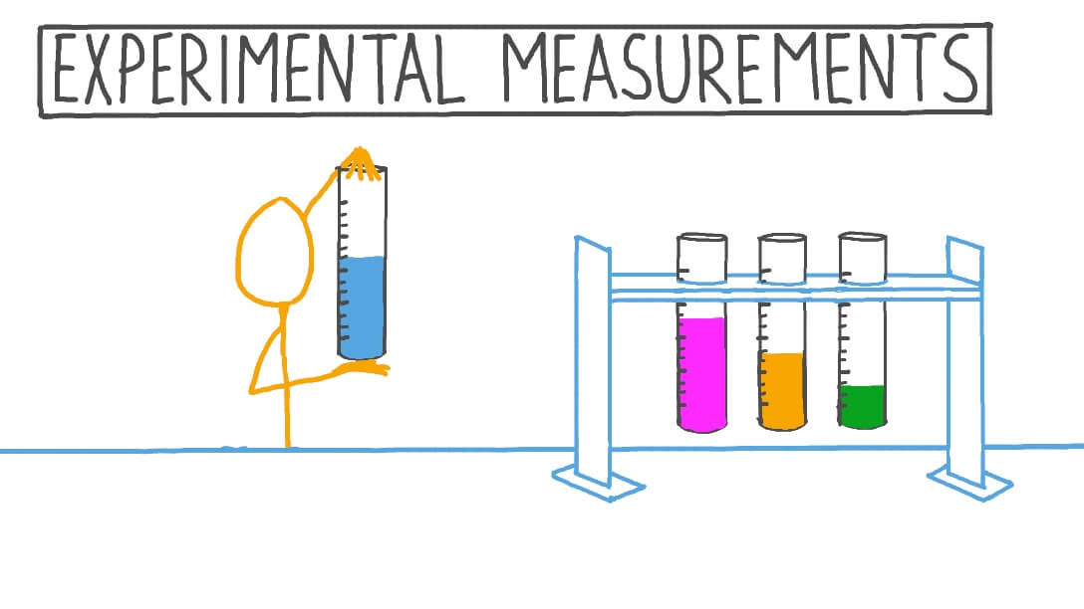

## Determine outcomes

When designing the intervention, it is also important to determine what you want to measure and what the hypothesized effects might be. This will illuminate what data we need to collect, set targets, and develop counter-measures. As part of this, we would want to identify the techniques we will need to perform the measurements and use the collected data for analysis.

An outcome measure, endpoint, effect measure or measure of effect is a measure which is used to assess the effect, both positive and negative, of an intervention or treatment. Measures can often be quantified using effect sizes. They can also be thought of as providing a score, an interpretation of results or at times a risk categorization of study groups. Prior to providing any intervention, an outcome measure provides baseline data on variable.

Also of note is that experimental studies are usually randomized, meaning the subjects are grouped by chance and we study what happens to people in each group (treatment and control). Any difference in outcomes can then be linked to the intervention.

For instance, an old and reasonably famous paper studied the intervention of priming in a wine shop. By playing French or German music in the background, sales of French and German wine seemed to be significantly affected (North (1997), Instore Music Affects Product Choice, Nature). In this case, the intervention is applied randomly to one group of customers and not to another.

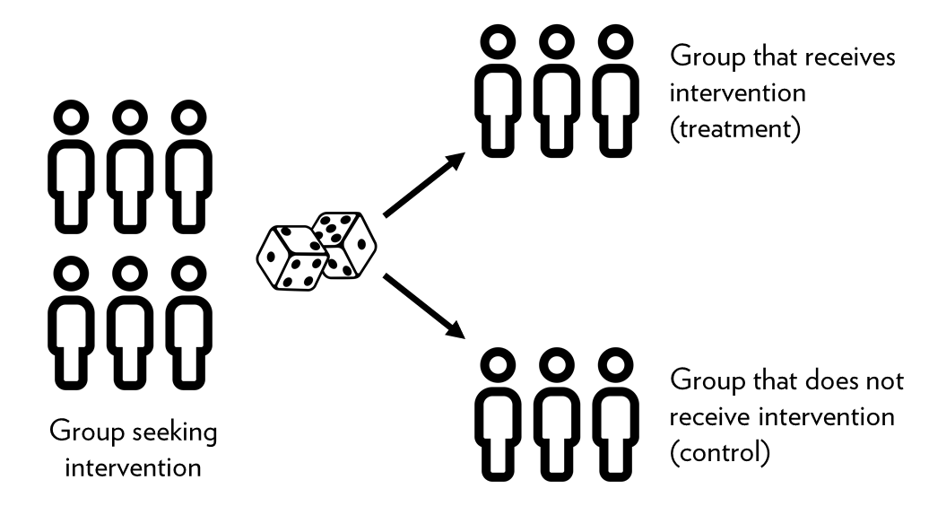

For instance, a well designed randomized control trial (RCT) provides a strong evidence that a given intervention can postulate effectiveness or safety. A RCT is best used when we need to draw conclusions on causality.

An example is when General Electric wanted its employees to stop smoking. A team ran a RCT where the treatment group received cash incentives to quit. The control group received no incentives. Quitting for 6 months earned you $250, and quitting for 12 months $400. The treatment group had 3 times the success rate of the control, an effect which persisted even after financial incentives were discontinued after 12 months (Volpp et al. (2009), A randomized, controlled trial of financial incentives for smoking cessation, New England Journal of Medicine).

There are other experimental designs that will be discussed in Module 3.

It helps to think of outcome measures through visualization of outcomes / prototypes

As well as increasing our understanding of what experimental design to use when, there is scope for experimenters to get much better at using different tools in combination to innovate more effectively. Prototypers, for instance, could use low-cost randomized trials like A/B tests or nimble trials to evaluate prototyped products or services.

Prototyping emphasizes front-loading risk and creating a solution with a better chance of success through stakeholder engagement. Using plastic Lego bricks to build prototypes of engineering products is a low-fi, low-resource way of making early operational or design issues obvious. But it won’t tell you whether or not the new system works in real life, or at scale.

When designing prototypes, we should think of implementing an intervention to measure the outcomes. For this, we need an independent variable or the factor that is manipulated, changed, or intervened. This is usually a variable that is placed on x-axis when grouping. We also need a dependent variable or the factor that is being measured and usually placed on y-axis during grouping and visualization.

For instance, a group examined the average donations received when participants (n=159) were presented with an identifiable victim (a girl named Rokia) versus a dry statistical overview of the problem. The greatest amount of donations were elicited by Rokia alone, even more so than a combination of statistics and a picture of Rokia (Small et al. (2007), Sympathy and callousness: The impact of deliberative thought on donations to identifiable and statistical victims, Organizational Behavior and Human Decision Processes). In this case, the outcome being measured here is ‘donations’. One group is exposed to Rokia, one to statistics, and the other to both Rokia and statistics. We can consider all three as explanatory or independent variables (x-axis) and the donation received as dependant on them (y-axis).

## Experimental design(s)

The following concepts are going to be explained in more detail in Module 5. Here we only provide a brief description of the topics to consider when considering to start an experiment and managing an experimental project. The main takeaway, we hope, is to consider the expertise needed on an experimentation team.

These concepts help when we are determining whether randomization is possible, what the sampling unit and approach might be, how the control group might be set up as well as how many observations are needed based on power calculations.

Randomized experiments, or quasi-experimental designs, sometimes couched in deadly technical language, are uniquely valuable. Despite their unfashionable status among some policy wonks and evaluators, we will also highlight the value and utility of Quasi-Experimental designs in the next module. Other approaches may be also be suited to finding out different things, at different stages of developing a policy solution.

Regardless of what type of experiment we chose to do, it is helpful to think about the following variables:

* A control group is a group of ‘test’ items in an experiment. The control group will be used to compare with the experimental group
* The control group doesn’t get the treatment
* An experimental group is the group(s) of test items where only one change (called the experimental or independent variable) has been made
* The experimental group gets the treatment
* The experimental group may have dependent or independent variables

In the case when a real control group is not available, a synthetic control group or a more inventive statistical methods may be useful.

For instance, a Behavioural Insights team worked with Home Retail Group (50,000 staff & 1,079 stores in the U.K.) and Charities Trust to raise charitable giving through a payroll giving scheme. They have an automatic escalation program called Xtra Factor which increases donations by 3% per year. However, only 10% of new donors were taking it up. By changing the default for the Xtra Factor to opt-out for new donors,the proportion of new donors using it jumped from 6% to 49% (Behavioural Insights Team (2013), Applying behavioural insights to charitable giving).

In another example, a team looked at the effects of reducing plate size and providing social cues on food consumption on food waste in hotel restaurants. An example of the latter is a salient sign saying “Welcome back! Again! And again! Visit our buffet many times. That’s better than taking a lot once”. Both treatments proved to be effective at changing eating behavior, reducing food waste by 20% (Kalbekken (2011), ‘Nudging’ hotel guests to reduce food waste as a win–win, environmental measure, Economics Letters).

It is also in this step that we determine what information we want to collect, set a timeframe for data collection, and determine the data collection methods.

**Source of error considerations** - Mind the constants: the conditions that are kept the same for control and experimental groups - Not controlling for factors or parameters that are kept the same in both control and experimental groups can result in error - Type I error (α) is the rejection of a true null hypothesis (*“false positive”* finding or conclusion, e.g. “an innocent person is convicted”) or finding a difference when a difference does not exist - Type II error (β) is the non-rejection of a false null hypothesis (*“false negative”* finding or conclusion, e.g. a guilty person isn’t convicted) or not detecting a difference when one actually exists

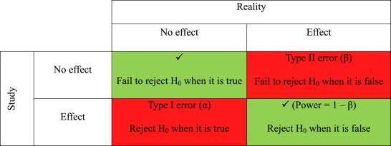

**Sample size considerations** Sample size measures the number of individual samples measured or observations used in a survey or experiment. For example, if you test 100 people for COVID, your sample size is 100.

In general, we want to: - Maximize sample size (n): the larger the number of test items the more accurate the estimate - Use representative groups: the samples must reflect the natural variation in the population. - Use random or systematic sampling to reduce inherent bias in data.

For sample size calculations, we need a hypothesis test, a significance level for the test, the smallest effect size (∆) that is of scientific interest, and the intended power (power = 1 – β) of the test.

There are often softwares that help statisticians decide what sample size and power to chose for a set of sample observations. In general: - The price of increased power is that as standard deviation goes up, so does the probability of a Type I error because - As sample size increases, so does the power of the significance test. This is because a larger sample size narrows the distribution of the test statistic

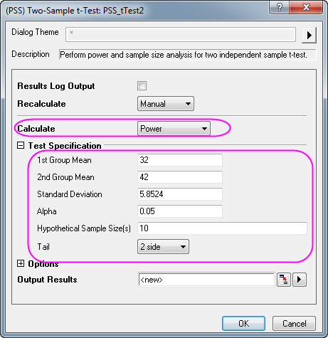

Statistical power is a measure of the likelihood that a researcher will find statistical significance in a sample if the effect exists in the full population. Power is a function of three primary factors: sample size, effect size, significance level.

## Collect and Analyze data

At this point, we have a problem, and intervention, a research plan, and data collection strategies. Therefore, we are ready to start implementing the experimental design to collect the data and then analyze it.

We can treat data as qualitative (descriptive) or quantitative (quantitative values/ numbers). Before you collect new data, determine what information could be collected from existing databases or sources on hand. Collect this data first. Also determine a file storing and naming system ahead of time to help all tasked team members collaborate. This process saves time and prevents team members from collecting the same information twice. If you need to gather data via observation or interviews, then develop an interview template ahead of time to ensure consistency and save time. Keep your collected data organized in a log with collection dates and add any source notes as you go (including any data normalization performed). This practice validates your conclusions down the road.

**Quantitative data** comes in the form of numbers, quantities and values and describes things in concrete and easily measurable terms. Examples include the number of students who applied to a grant, the rating a customer gave a product out of five stars and the number of times a visitor spent on the website.

**Qualitative data** is descriptive, rather than numeric. It is less concrete and less easily measurable than quantitative data. This data may contain descriptive phrases and opinions. Examples include an open ended review a customer writes about a product, an answer to an survey question about what type of applications a customer likes to fill and the conversation an applicant has with a service representative.

Regardless of what kind of data we collect, a proactive data management strategy will make storage, retrieval, and analysis easier.

The analysis phase is also as crucial because it turns raw data into valuable insights that we can use to enhance strategies, products and business decisions. We can often couple data analytics tools to raw data (e.g. power BI softwares, etc) to help with analysis. Visio, Nvivo, Minitab, Stata, and Microsoft Excel are other great tools and software packages for advanced statistical data analysis. The goal of analysis of the data to really to test the effects of the intervention we wanted to measure (e.g. comparing the differences between groups who got a treatment and those who didn’t).

Devote some time to review the results. What happened after you implemented the interventions? What worked, what didn’t, and what did your solution improve? Analyze if your actions made the required impact and if you addressed the root causes of the issue. It’s also time to look for improvements in the solution and to plan ongoing monitoring. You can also analyze what you’ve learned and what still needs to be learned when it comes to problem-solving processes and skills.

As you interpret the results, ask yourself these key questions:

* Does the data answer the original question? How?
* Does the data help defend against any objections? How?
* Are there any limitations to draw conclusions, any factors that haven’t been considered?



Once you have uncovered the patterns and insights, you can start reporting back the findings to stakeholders. This step is also reiterative because as you report back, you can adapt the information. Through the presentation of the results, you disseminate the evidence that identities key learnings and adapt the program/ operation based on what the evidence dictates.

The goal of sharing the results and reporting back the process to executives is to reach consensus, generate additional learnings, and develop a better implementation plan.

**Problem-solving tips**

Problem-solving is a process of constant improvement and reiteration. Don’t expect the perfect solution from the start or that the problem won’t appear in the future. We should make efforts not to avoid problems because they’re part of the learning process. If you adopt an attitude in which you focus on finding solutions every time new challenges emerge, you’ll save yourself a lot of time and stress.

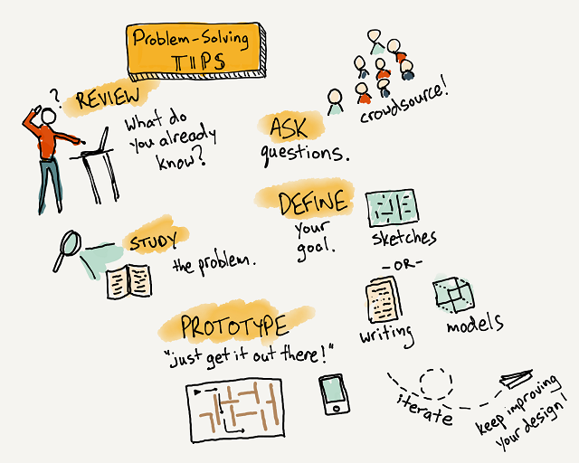

# Developing a research question

With the problem statement and intervention somewhat defined, you should be able to combine these two into a clearly articulated research statement, best depicted in the figure below.

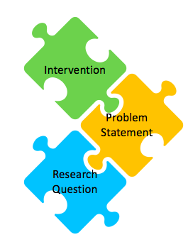

Landing on the right research question might seem trivial given that you have a problem statement, but it is essential to properly guide your experiment. You will use it both during the development stage and constantly revisit it, particularly in the results stage of the experiment cycle. You’ll want to spend a lot of time on this process, expecting a lot of back-and-forth, with multiple versions and revisions – this is all quite normal. This needs to be clearly articulated before you can move on to technical design choices. Each of the design choices depend on these crucial first steps – so don’t rush these! You will be better off if you don’t underestimate the preparatory phases leading to the experiment being conducted.

The characteristics of a good research question, assessed in the context of an intended experimental design, are that it be feasible, interesting, novel, ethical, and relevant. A good research question is often focused on a single topic or on several closely related ideas. If it isn’t, you won’t end up with a good design. If a question is too general or doesn’t stay on one topic, you can fix it by deciding which part of the topic you want to research.

For example, insurance companies usually struggle with honesty issues in their clients. In the case of car insurance, there is often a financial incentive to report less miles driven since reporting more would mean you would pay more (i.e. a higher number implies more honesty). The research question in this case was how the team can implement ways to prime honesty in the client group. The researchers sought to prime honesty by asking people to sign at the start of a form rather than the end when reporting how many miles they had driven on their car for insurance purposes. The rest relates to experimental design and in fact the results indicated that the treatment (those who got the form with signature at the beginning) to be effective at inducing more honest declarations (Shu et al. (2012), Signing at the beginning makes ethics salient and decreases dishonest self-reports in comparison to signing at the end, PNAS vol. 109).

A good research topic is broad enough to allow you to find plenty of material, but narrow enough to fit within the size and time constraints of your experiment

## The SMART strategy

The main elements of a good research question are listed below: - Specific: Not a “fishing expedition”, a good question is usually crisp and concise. - Measurable: Testable (statistically) and purpuseful. It also means you have the expertise, equipment, and resources to tackle it. - Attainable: Something that “you” can do, a good question is relevant. - Realistic: Based on some sort of rationale and logic and can be done in a reasonable time frame. - Timely: It is novel and prefarably based in new technologies but has a past, and is important to current concerns (has a present). It can lead to new directions – i.e. is not an endpoint in itself (has a future). - Important: Meaningful whether the answer is “Yes” or “No.”

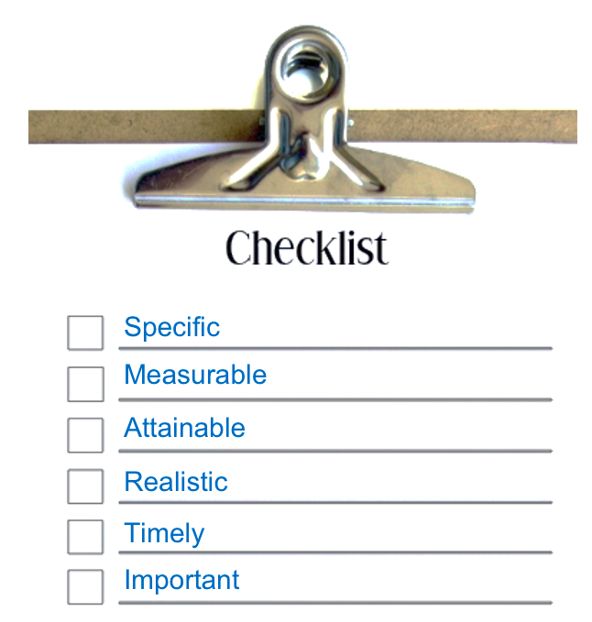

Some examples of research questions include:  
- An investigation looking at whether stress levels influence how often students engage in academic cheating.  
- A study looking at how caffeine consumption impacts the brain.  
- A study assessing whether men or women are more likely to be diagnosed with depression.

As observed above, research question differs from the problem statement in that its question format provides guidance. It defines a limited scope or boudary for the problem statement. It tells us what constitutes an end to the answer. By being open-ended, it gives us guidance for what to do next, i.e. answer it.

In other words, a research question allows us to bite off a section of the problem statement that is big enough to chew and swallow it. It directs our attention to a manageable, defined, and bounded problem and then tells us what constitutes a complete response. As you continue researching, narrowing your broad question into a more refined question by fine-tuning your question with one (or more) of the following question stems: Who? To What Extent? When? Where? and why?

## The five W’s

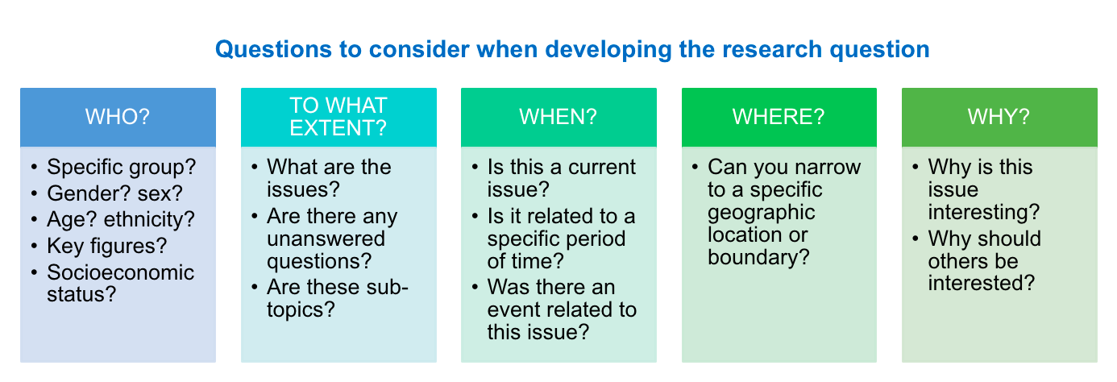

Good research questions usually do not have one-sentence or factual answers. Unfortunately, this eliminates many who, what, and when questions. Good empirical research questions are not ones where you could get the answer from a publicly available source like Wikipedia, or by asking one knowledgeable person. Best research often comes from the best questions, this is why it is ok to spend more time to develop a specific meaningful research question that addresses a gap.

## Narrowing the topic

Once you have developed a research question, consider evaluating it to identify what parts are too broad or too narrow and find a way to rephrase the question to get to a single experimentation project.

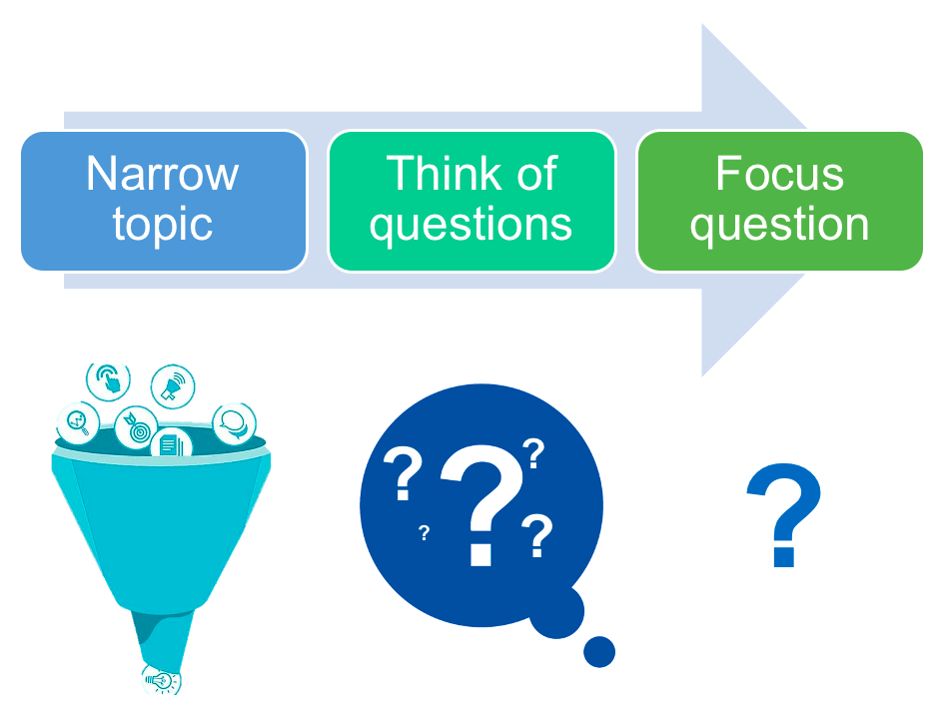

For example, let’s say the research question we developed is: does international law cause countries to change their behaviour? This question is mostly viable, however, it is rather broad and the outcome of interest, change in behaviour is a concept. What larger idea does behaviour change represent here? population trends? social responses? legislative change? what type of law are we considering? trade? social? environmental? Answering these questions depends on the theory you have in mind and the argument you have developed for why you expect international law to influence behaviour change and which laws are you considering. In this case then, adding additional context like a geography, behaviour, chronological boundry, or law context can clarify the point of view and make the question more representative.

# Mechanics of endorsement

## Knowledge co-production

Communicating the project with intention to gain the trust and cooperation of project team is an imperative step prior to starting an experimentation process. More and more, we are moving towards knowledge co-production models as one person isn’t capable of delivering complex multi-faceted projects. To achieve co-production, clear and intentfull communications with team members can affect the success of the project. Buy-in can be difficult to quantify, especially within various stakeholder categories. However, without full buy-in from team members, sponsors and other stakeholders, projects may seem to be progressing smoothly and then suddenly take a sharp turn for the worst, risking the final deliverables and team satisfactions.

Below are the main steps for sustainable co-production research.

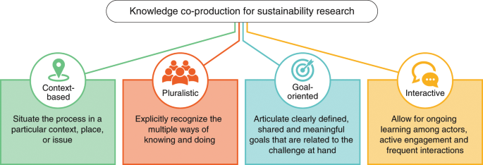

To improve communication with team members at each stage of a project and to make sure they feel like an important part of a team, the following points may be helpful:

1. Identify what motivates the project team and each member individually
2. Focus on telling the truth about the project, even when it isn’t what team members want to hear
3. Make sure all team members understand their contribution to the project
4. Reaffirm goals and communicate progress throughout execution
5. Remain consistent
6. Provide positive feedback throughout the process and after the project ends

## Executive buy-in

Once an experimentation plan has been devised, you will need to make a good case as to why the strategy deserves a dedicated budget and resources and what sets this apart from other program initiatives already in place.



So how do you do it? Below are 3 steps to help in making a convincing case to obtain executive buy-in for your proposal.

1. Figure out who you should be talking to, that is, identify the relevant stakeholders in your organization who have the authority to sign off on a new strategy, allocate budget resources and designate personnel. You can make a list of the people you want to target. Next, you can ask what business needs do they face and what problems does the organization have that an experimentation can solve? Think like a marketer present your plan as a solution to those specific problems. It is also helpful to find a personal advocate within the organization to function as a change agent—someone who believes in you and has enough clout to advocate on your behalf. This will help give your experimental plan some authority when you present it to the executives.
2. Show your accomplishments and what the experimentation can do. This precludes getting to know your organization’s analytics capacity and correlating your experimentation success with the real results already existing. For instance, you can communicate that “you have been doing X, and it’s been contributing to Y”. Evidence-based plans are a powerful formula for getting executive buy-in. What if your community is relatively new, or not yet in existence? If this the case, you can benefit from the experience of others and researching a cache of other success stories ready to be applied to your programs. The question the executives will want to know is, how will you make another’s success your own success. This requires an experimentation plan.
3. Lay out the experimentation’s strategic plan for success. Once you have identified key stakeholders and worked on a compelling vision of how you can solve a key problem, you can start sharing that strategic plan. Your plan should, at a minimum, answer the following questions:

* What specific actions must you take to build a community for your research plan?
* What resources do you need to take those actions?
* What results—concrete and abstract—do you hope to achieve?
* What are the risks? how are the risks managed?
* How will you measure your results against your actions?
* How will you quantify the value of this process?
* Are your expectations realistic? Prove it.
* What are your performance deadlines?

## Communication matrix tips

Communication of the intent to experiment and the experimentation processes is like an onion. We can start in the inner layer with peers and colleagues and close supporters who can understand the message. From there, your secondary networks help build momentum. Once it’s clear your science resonates with people, then you can reach a larger audience such as the executive or to press and media.

To relay the necessary information about the experimentation plan to stakeholders/executive and to reach consensus, the following points can be considered:

* Why do we need to answer this scientific question now? (*importance*)
* Has this question been answered? Has it been attempted? (*novelty*)
* What’s the risk, and what’s the potential upside? (*impact*)
* Is the design of the experiment sound? how? (*design*)
* What are the timelines and milestones? (*logistics*)
* What makes this researcher/research team uniquely qualified? (*qualifications*)

## Code of ethics

Concerns about misinformation and the inability to distinguish the contrived from the authentic is growing be it in journalism, marketing, finance, or medicine.

Unlike traditional *observational* methods where one makes observations about the world, the *experimental* approach learns about the world by measuring how it reacts to interventions. Experimental studies raise a host of ethical concerns that social scientists are not always well equipped to deal with. The absence of clear principles to handle complex issues and address ethical implications and unintended consequences can leave teams in a difficult situation, above and beyond whether they receive formal research approval.

There are, however, opportunities to experiment even on difficult social issues such as interventions in poverty policies, drug use, or healthy-living interventions. Creating a control group can carry its own risk. If, for example, we are experimenting with a new benefits scheme, having a control group allows us to test whether the scheme has actually achieved its goals, but it also means depriving a group of citizens of an improved service, at least initially.

Broadly, ethical concerns can fall into the problem of **audience** (what are the issues), **agency** (who is responsible for interventions), and **consent** (are participants informed and do they consent). Some other points to consider include the following:

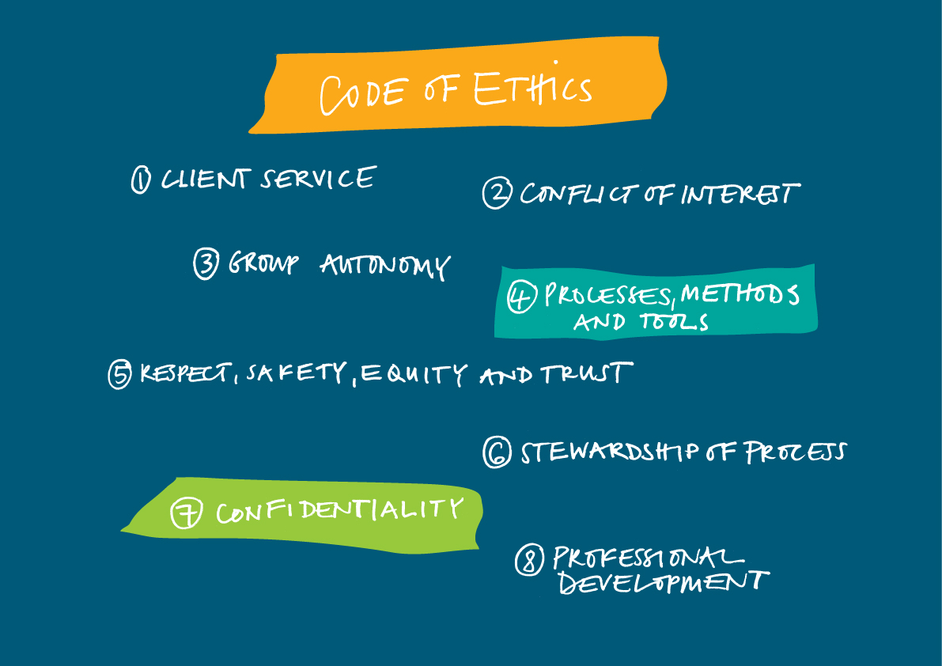

To get around this, a phased policy roll-out can create what’s called a “waiting list” experiment where the control group are the soon-to-have-innovation group. Everybody eventually receives the new policy innovation, negating the risk of push-back from the public. This approach was used by the UK’s Ministry of Housing, Communities and Local Government in their first ever randomized trial on community integration. In 2016, they tested whether English language training could help immigrants engage more in their community.

The results were impressive. They found significant improvements on many social integration outcomes, such as new friendships formed with people from other cultures, and attending more health appointments. The trial helped the Department put together new plans for their 2018 Integrated Communities including a network of conversation clubs and a new English language fund.

Ethical considerations: - Inform users and the study population and get consent of participation - Establish information sharing agreements and memorandums of understanding - Identify situations where experimentations are appropriate and relevant - Perform privacy impact assessments/agreements - Get ethics committee approvals - Check Institutional Review Board (IRB) approval requirements prior to the launch of the experiment

* [City of Vancouver Solution Lab’s Principles of Experimentation](https://vancouver.ca/files/cov/navigating-complexity-solutions-lab.pdf), adapted from [Nesta’s Innovation Playbook](https://www.nesta.org.uk/toolkit/playbook-for-innovation-learning/)
* [Nesta’s Competency Framework for Experimental Problem Solving](https://media.nesta.org.uk/documents/Nesta_CompetencyFramework_Guide_July2019.pdf)
* [States of Change’s Core Elements of Innovation](https://states-of-change.org/assets/images/StatesofChange_Curriculum_Craft.png)
* [Tatyana Mamut’s eight Innovation Elements](https://gww.gov.bc.ca/sites/default/files/group/file/2019/0207/remixtatyanamamutleadingacultureofinnovationlowres.pdf)
* [The Moment’s Culture Scan](https://info.themoment.is/innovationculture)
* [Innovation Designer Capability Map](https://cdn2.hubspot.net/hubfs/3903042/themoment_InnovationDesignersCapabilityMap.pdf)
* [Alliance for useful evidence](https://www.alliance4usefulevidence.org/)
* [Better public services through experimental government](https://www.alliance4usefulevidence.org/publication/better-public-services-through-experimental-government/)
* [The What Works Trial Advice Panel](https://www.gov.uk/government/publications/cross-government-trial-advice-panel-role-and-membership)
* [Integrated Communities Strategy green paper](https://www.gov.uk/government/consultations/integrated-communities-strategy-green-paper)
* [The impact of Sure Start Local Programmes on seven year olds and their families](https://assets.publishing.service.gov.uk/government/uploads/system/uploads/attachment_data/file/495329/The_impact_of_Sure_Start_local_programmes_on_7-year-olds_and_their_families.pdf)
* [National Evaluation of the Troubled Families Programme 2015 - 2020](https://assets.publishing.service.gov.uk/government/uploads/system/uploads/attachment_data/file/786891/National_evaluation_of_the_Troubled_Families_Programme_2015_to_2020_family_outcomes___national_and_local_datasets_part_4.pdf)
* [Social Media and Fake News in the 2016 Election](https://pubs.aeaweb.org/doi/pdfplus/10.1257/jep.31.2.211)
* [Reflections on the Ethics of Social Experimentation](https://www.degruyter.com/view/journals/jgd/6/1/article-p87.xml)
* [From Research Topic to Research Question](https://us.sagepub.com/sites/default/files/upm-assets/72299_book_item_72299.pdf)
* [Facilitating Complex Multi-Stakeholder Processes, A Social Learning Perspective](http://library.enaca.org/mangrove/publications/Woodhill_Facilitating_MSP.pdf)

# Case study

For illustration purpose, we are going to use a contentious example. Following the 2016 U.S. presidential election, many have expressed concerns about the effects of false stories, *“fake news,”* as it has been dubbed, circulated largely through social media on the election results.

Many have speculated that the exposure to fake news has shaped people’s political inclinations in the presidential election. This group argue that the falsified information delivered in a such dramatic way shifts political inclinations. Others, however, argue that consumption of information is more of a selection process: voters choose their sources of political information on the basis on their existing political preferences. As a result, fake news only reinforces the voters’ results but will never change their beliefs.

## Background research

Recent evidence shows that:

1. 62% of US adults get news on social media (Gottfried and Shearer 2016)
2. the most popular fake news stories were more widely shared on Facebook than the most popular mainstream news stories (Silverman 2016)
3. many people who see fake news stories report that they believe them (Silverman and Singer-Vine 2016)
4. the most discussed fake news stories tended to favor Donald Trump over Hillary Clinton (Silverman 2016)

Putting the above observations together, a number of commentators have suggested that Donald Trump would not have been elected president were it not for the influence of fake news (for examples, see Parkinson 2016; Read 2016; Dewey 2016).

## The problem statement

Did fake news affect the election result by making it more difficult for voters to infer which electoral candidate they prefer?

Hypothesis: Fake news is independent of election outcome

## Scenarios

In this example, there are three potential causal relationships.

**1. Fake news affects voting**: Fake news carry certain pieces of information in a way that changes audiences’ preferences.

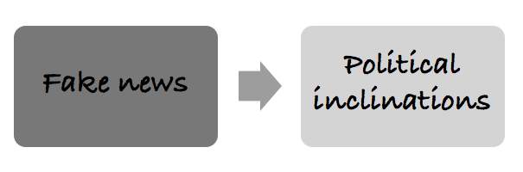

**2. Political affiliations determine consumption of news**: People with certain preferences and orientations choose to watch fake news. So, fake news only reinforces but won’t change the existing beliefs.

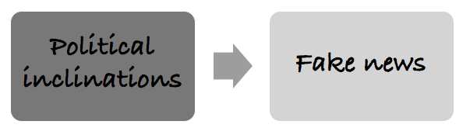

**3. Two-way causation**: Political preferences determine which pieces of political information to receive. In turn, it further shapes the existing preferences and changes voters’ behaviours. To test these scenario, we can apply a simple experimental design and test it.

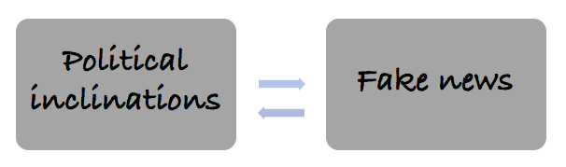

## Experimental solution

**Stage one**: Recruit and randomly assign participants into treatment and control groups; pre-test.

**Stage two**: Expose the treatment group to fake news; apply placebo to the control group.

**Stage three**: Record the results of the treatment and control groups. Due to the randomization process, we can control for any previous differences between the treatment and control groups. Therefore, any differences between Result 1and Result 2 are attributable to the presence of fake news.

