INT - Prism Dotnet Landing Pages - NonPrism ALL OTHERS

Peter A Mayer Advertising Inc
11.01.2011
CNTL11-785B

Landing Page – Top
₁
2

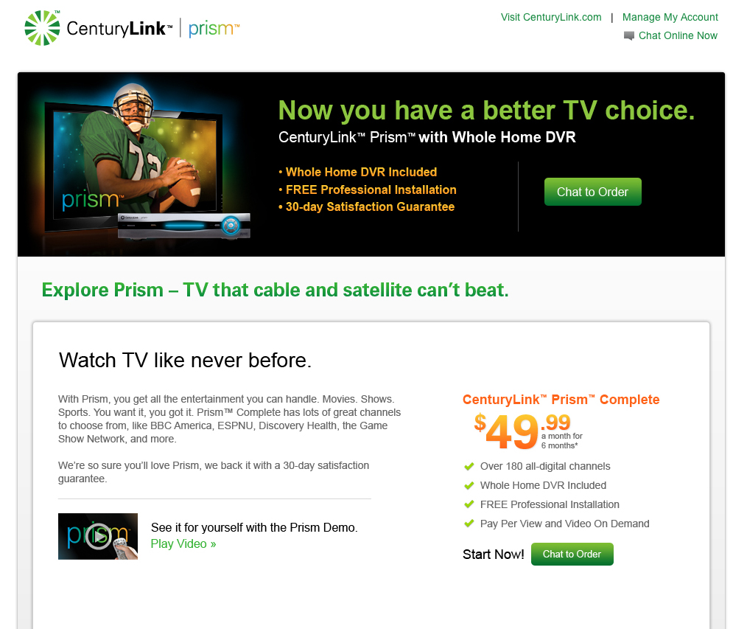
3
4
5
6

 | Asset/Feature/ | Description | P/F | Notes
1 | Meta Data | Awaiting from client.
2 | Omniture Tracking | Awaiting from client.
3 | Header links | 1.) Visit CenturyLink.com - http://www.centurylink.com/  2.) Manage My Account - https://eam.centurylink.com/eam/login.do  3.) Chat Online Now -  https://sncare.centurylink.com/netagent/cimlogin.aspx?questid=03E78ACF-231C-4588-B076-CA693E399261&portid=53BB7F04-97AF-4B41-A9C7-C4BF7A5AC5DB
4 | Header Graphic & Chat Button | Alt text:  Chat to Order links to:  https://sncare.centurylink.com/netagent/cimlogin.aspx?questid=03E78ACF-231C-4588-B076-CA693E399261&portid=53BB7F04-97AF-4B41-A9C7-C4BF7A5AC5DB
5 | Video player | Picking up video player from SPTV.com. Make sure the title card @ the end doesn’t say “Prism is coming”  Cue up Overview Video.  Since we are not employing social sharing on this site, remove the FB and Twitter buttons.
6 | Chat Button | Link to:  https://sncare.centurylink.com/netagent/cimlogin.aspx?questid=03E78ACF-231C-4588-B076-CA693E399261&portid=53BB7F04-97AF-4B41-A9C7-C4BF7A5AC5DB
Additional Notes:
Creating NEW pages here:
Dev: http://staging.promotions.centurylink.com/prism/new/complete/
Live: http://promotions.centurylink.com/prism/new/complete/
IE9
IE8
IE7
Firefox 3.6
Firefox 4
Firefox 6
Chrome 13
Safari/Mac
Firefox/Mac

Landing Page – Bottom

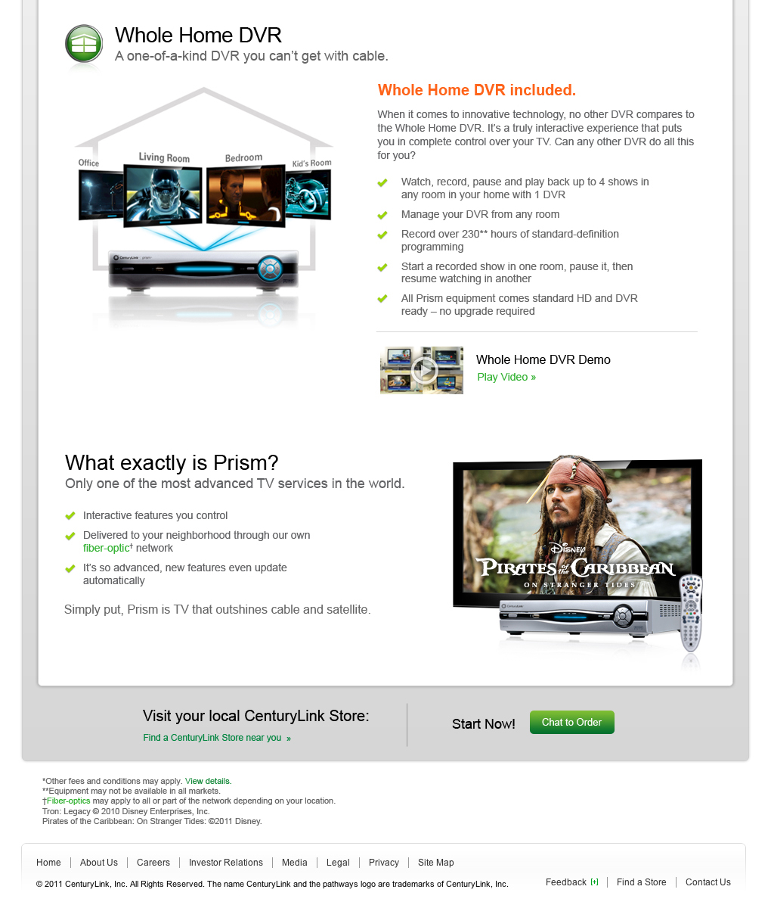
1
1
2
3
4
6
5
7

 | Asset/Feature/ | Description | P/F | Notes
1 | Video player | Picking up video player from SPTV.com. Make sure the title card @ the end doesn’t say “Prism is coming”  Cue up Whole Home DVR Video.  Since we are not employing social sharing on this site, remove the FB and Twitter buttons.
2 | Fiber-Optic Overlay | Pick up fiber-optic overlay from SPTV.com. (see design @ the end of this doc)  Since we are not employing social sharing on this site, remove the FB and Twitter buttons.
3 | Find a store | In same window, link to:  http://www.centurylink.com/Pages/Support/storeLocator.html
4 | Chat Button | Link to:  https://sncare.centurylink.com/netagent/cimlogin.aspx?questid=03E78ACF-231C-4588-B076-CA693E399261&portid=53BB7F04-97AF-4B41-A9C7-C4BF7A5AC5DB
5 | Fiber-Optic Overlay | Pick up fiber-optic overlay from SPTV.com. (see design @ the end of this doc)  Since we are not employing social sharing on this site, remove the FB and Twitter buttons.
6 | Disclaimer | Create a disclaimer (pop-up, per site style) from this doc:  O:\CNTL\CNTL11-785\develop\B\785B_Disclaimer_v.1_-_11.1.11.docx
7 | Footer Nav | Pick up from CNTL11-785D  Live URL: http://promotions.centurylink.com/prism/existing  Dev URL: http://staging.promotions.centurylink.com/prism/existing
Additional Notes:
Creating NEW pages here:
Dev: http://staging.promotions.centurylink.com/prism/new/complete/
Live: http://promotions.centurylink.com/prism/new/complete/
IE9
IE8
IE7
Firefox 3.6
Firefox 4
Firefox 6
Chrome 13
Safari/Mac
Firefox/Mac

Landing Page – Overlay

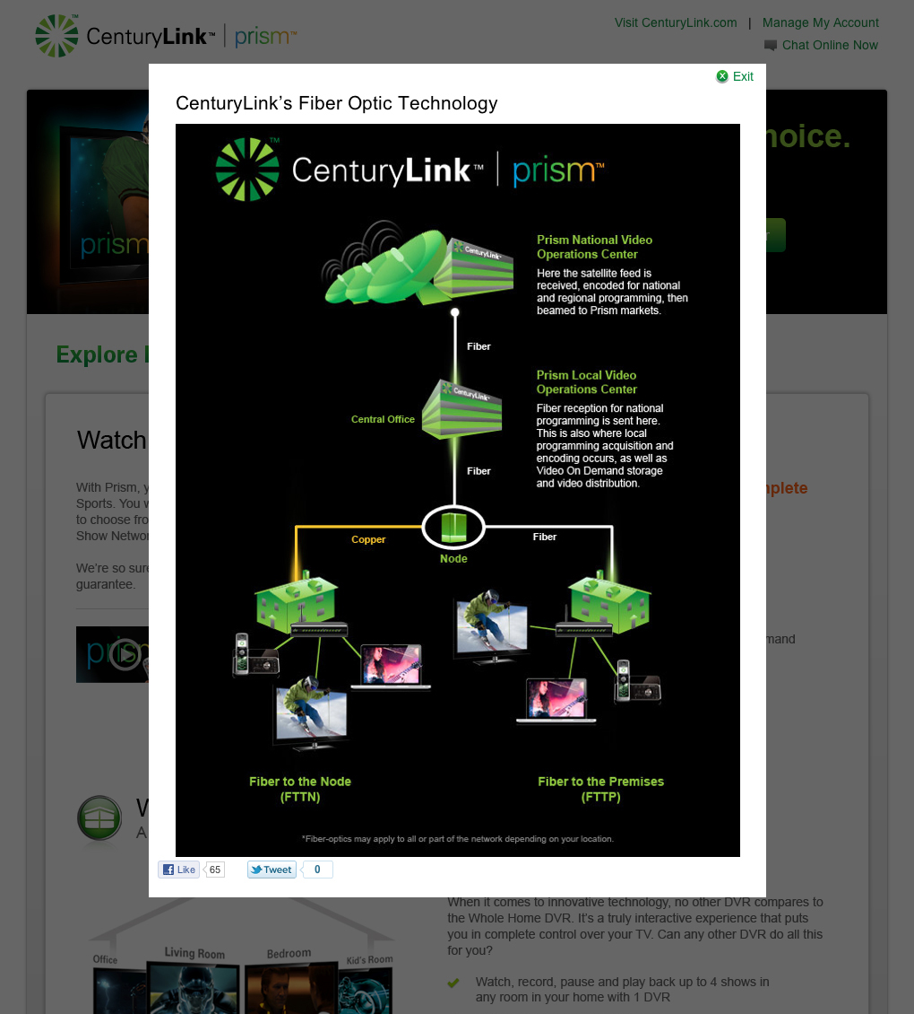
1

 | Asset/Feature/ | Description | P/F | Notes
1 | Fiber-Optic Overlay | Pick up fiber-optic overlay from SPTV.com. (see design @ the end of this doc)  Since we are not employing social sharing on this site, remove the FB and Twitter buttons.
Additional Notes:
Creating NEW pages here:
Dev: http://staging.promotions.centurylink.com/prism/new/complete/
Live: http://promotions.centurylink.com/prism/new/complete/
IE9
IE8
IE7
Firefox 3.6
Firefox 4
Firefox 6
Chrome 13
Safari/Mac
Firefox/Mac

