Uml diagram

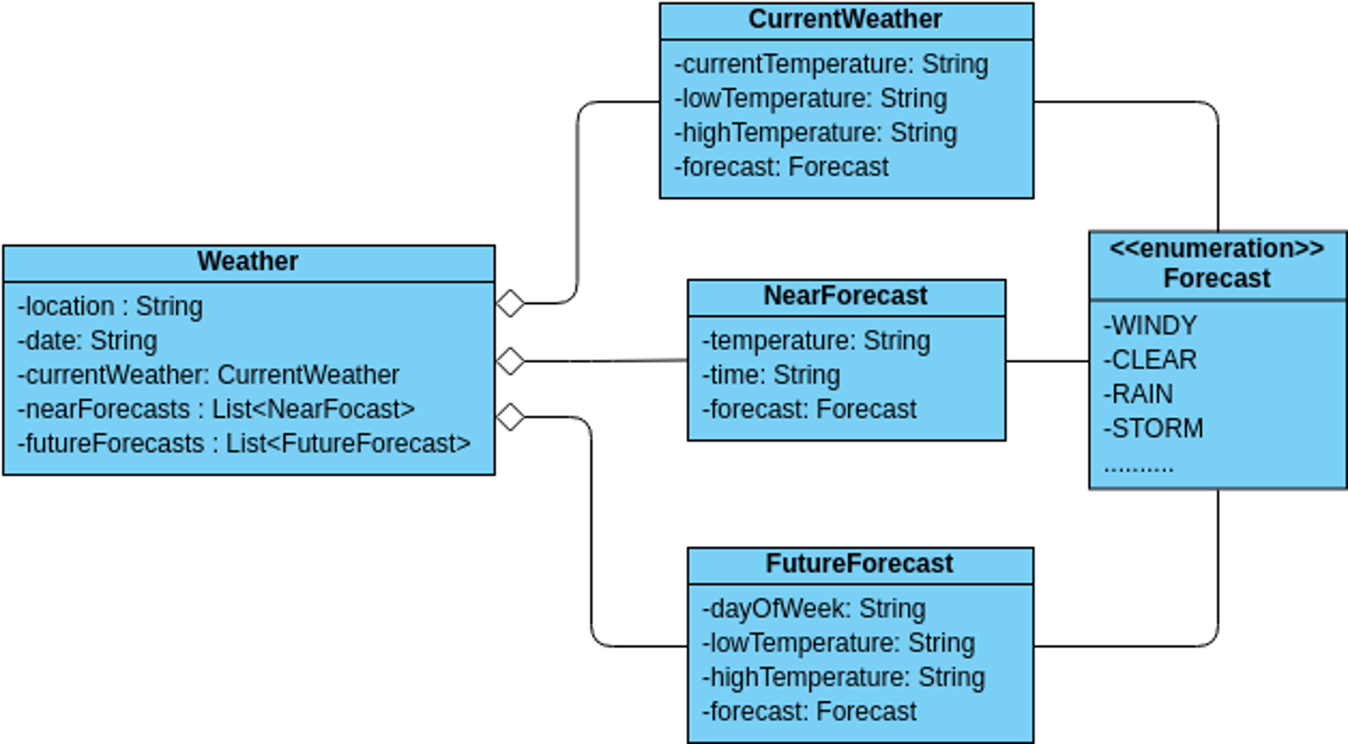

Class diagram

+-----------------------------------+

| WeatherApp |

+-----------------------------------+

| - app: Flask |

+-----------------------------------+

| + run() |

+-----------------------------------+

|

| uses

|

v

+-----------------------------------+

| WeatherAPI |

+-----------------------------------+

| - api_key: str |

+-----------------------------------+

| + get_weather(city: str) -> dict |

+-----------------------------------+

|

| uses

|

v

+-----------------------------------+

| WeatherDB |

+-----------------------------------+

| - connection: DatabaseConnection |

+-----------------------------------+

| + save_weather(data: dict) -> bool|

+-----------------------------------+

|

| uses

|

v

+-----------------------------------+

| DatabaseConnection |

+-----------------------------------+

| + connect() |

| + execute_query(query: str) |

| + close() |

+-----------------------------------+