Sumeet Patil, Shubham Patil, Vrushali Salunkhe, International Journal of Advance Research, Ideas and Innovations in Technology (ISSN: 2454-132X)

AUTOMATED FACE DETECTION AND RECOGNITION WEB-BASED MONITORING SYSTEM

SUMEET PATIL | SHUBHAM PATIL | VRUSHALI SALUNKHE
sumeetpatil987@gmail.com | Patilshubham269@gmail.com | Salunkhevrushali0806@gmail.com
MGMCET | MGMCET | MGMCET

ABSTRACT

The conventional technique of attendance marking is a tedious assignment in lot of colleges, studying rooms , schools and libraries. It may be very time-consuming. While the flow toward digital technology is being multiplied each hour biometrics technology has all started to have an effect on human beings greater and greater. Biometrics verifies the identification via traits which includes fingerprints, faces, palm prints, voice, hand-written signatures, and so on. Face recognition has set an essential biometric feature, which can be effortlessly procurable and can access statistics with no want of unique cooperation from the software. This project involves building face detection and facial recognition for getting statistics of the users, marking their presence through detecting faces, time in of the user, and time out of the users (students, teachers, employees, etc.) at the premises. It is covering features such as face detection, alignment, training the data, recognition, creating reports of data, along with the development of a web application to cater to various use cases of the system such as registration of the latest students, addition of photographs to the training dataset, and viewing attendance reports, etc. This project intends to feature as an efficient alternative for conventional manual attendance structures by changing it with our system. It may be applied in schools, colleges, offices, companies wherein safety is important.

Keywords: attendance, Biometrics, Face, detection, recognition, web, facial, etc

- INTRODUCTION

Automated face detection and recognition web-based monitoring system targets to automate the conventional guide attendance structures that is being redundant. It additionally permits schools, colleges, companies, malls, libraries, and many others to preserve their statistics like in time, out time, breaks time, and attendance of customers digitally.

Digitalization of the machine might additionally assist in higher visualization of the information and information the usage of graphs to show the no. of the user (student) present today, the entire hours spent by each user (student), and their break time. The improved capabilities functions as an efficient and alternative over the conventional attendance structures.
We have 2 types of users of the system:
- Student
- Admin
The following functions can be performed by the admin:

- Login to the system. Register new students to the system.

- Add student photos to the training data set. Train the model.

- View attendance reports of all students.

- Attendance can be filtered by date or student username.

The following functions can be performed by the student:

- Login.

- To Mark his/her time-in and time-out by scanning their face(For prototype purposes)
- View attendance report of self.

2.LITERATURE SURVEY

2.1
- Title: Student Attendance System using Face Recognition

- Publication and year: Proceedings of the International Conference on Smart Electronics and Communication (ICOSEC 2020) IEEE

- Author Name: Samridhi Dev, Tushar Patnaik

- The technique used: OpenCV, Haar classifiers, KNN, CNN, SVM, Generative adversarial

- Advantages:

- KNN is used which gives accuracy, robustness, and less time complexity.

© 2018, IJARIIT - All rights reserved. Website: www.ijariit.com Talk to Counselor: 9056222273 Page: 1

Sumeet Patil, Shubham Patil, Vrushali Salunkhe, International Journal of Advance Research, Ideas and Innovations in Technology (ISSN: 2454-132X)

- GAN is used for its ability to retain texture information.

2.2

- Title: Face Detection and Recognition System using Digital ImageProcessing

- Publication and year: Proceedings of the Second International Conference on Innovative
- Mechanisms for Industry Applications (ICIMIA 2020) IEEE Xplore

- Author Name: Gurlove Singh, Amit Kumar

- Goel, School of Computing Science and engineering, Galgatias University, Noida, India.

- The technique used: Eigenface method, principal component analysis (PCA), Gabor Feature Method

- Advantages:

- As PCA is used it
- Removes Correlated Features,
- Improves Algorithm Performance,
- Reduces Overfitting,
- Improves Visualization.

2.3

- Title: Face Recognition Attendance System Based on Real-Time Video Processing
- Publication and year: SPECIAL SECTION ON GIGAPIXEL PANORAMIC VIDEO WITH VIRTUALReality published July 10, 2020, date of current version September 11, 2020, IEEE

- Author Name: HAO YANG AND XIAO FENG HAN,China

- The technique used: Subspace analysis, Neural Network method, Support Vector Machine method

- Advantages:

The system is based on real-time video processing

2.4

- Title: Face Recognition from Video using Deep Learning

- Publication and year: Proceedings of the Fifth International Conference on Communication and Electronics Systems (ICCES 2020) IEEE Conference

- Author Name: Saibal Manna, Sushil Ghildiyal, Kishankumar

- The technique used: Convolutional neural network, security, FaceNet

- Advantages:

It works with any sort of picture and is sensibly strong to changes in face appearance or orientation, light conditions, and different variables.

3. DESIGN

3.1 State diagram
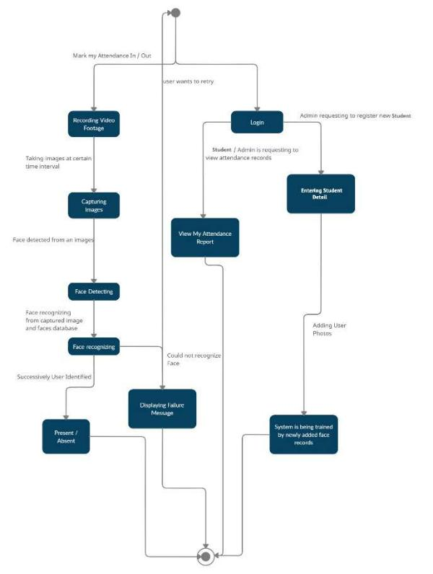

3.2 UseCase diagram
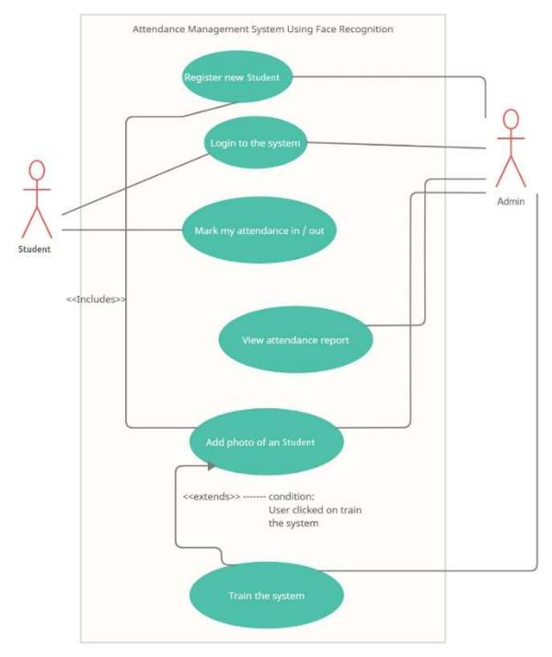

© 2018, IJARIIT - All rights reserved. Website: www.ijariit.com Talk to Counselor: 9056222273 Page: 2

Sumeet Patil, Shubham Patil, Vrushali Salunkhe, International Journal of Advance Research, Ideas and Innovations in Technology (ISSN: 2454-132X)

3.3 Sequence diagram 3.4 Activity diagram
3.4.1 Student
3.3.1 Login process
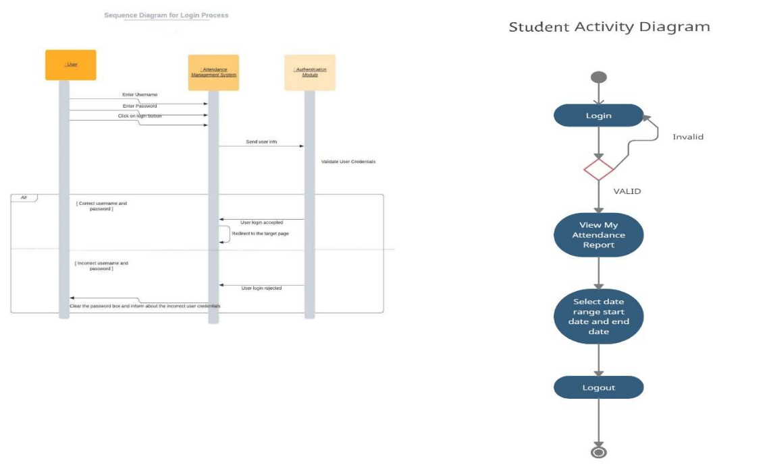

3.3.2Attendence/Monitoring

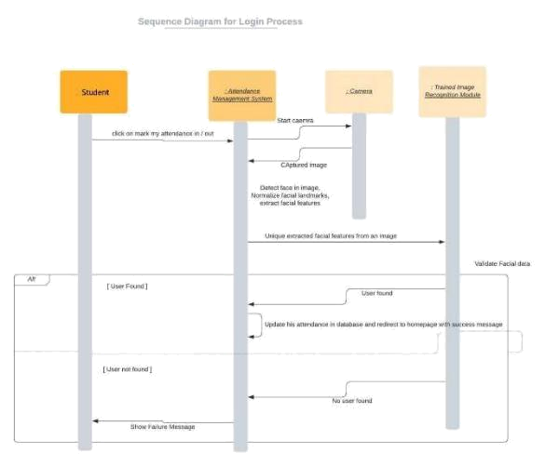

3.4.2 Admin
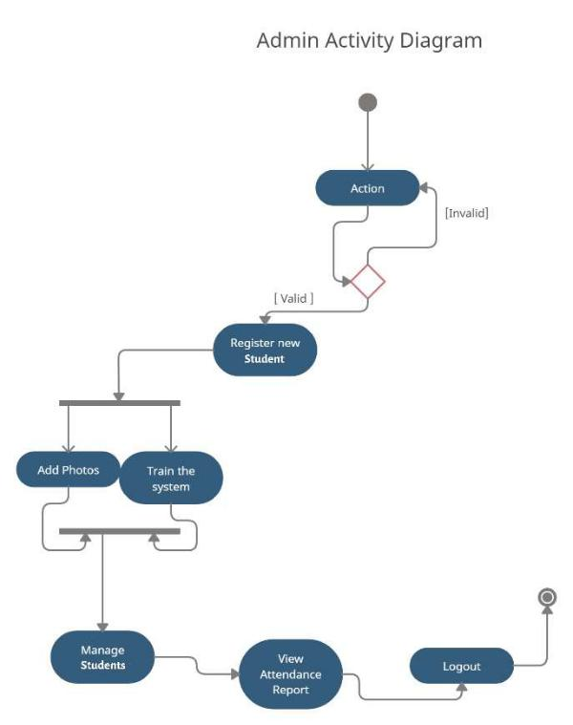

3.3.3 User process
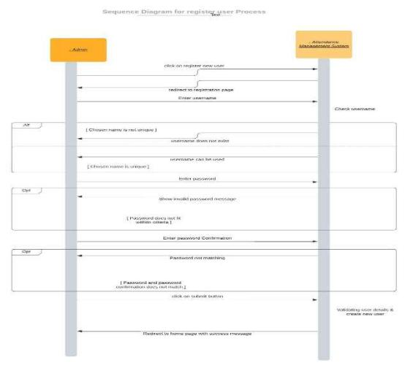

© 2018, IJARIIT - All rights reserved. Website: www.ijariit.com Talk to Counselor: 9056222273 Page: 3

Sumeet Patil, Shubham Patil, Vrushali Salunkhe, International Journal of Advance Research, Ideas and Innovations in Technology (ISSN: 2454-132X)

3.4.3 Attendance tracking
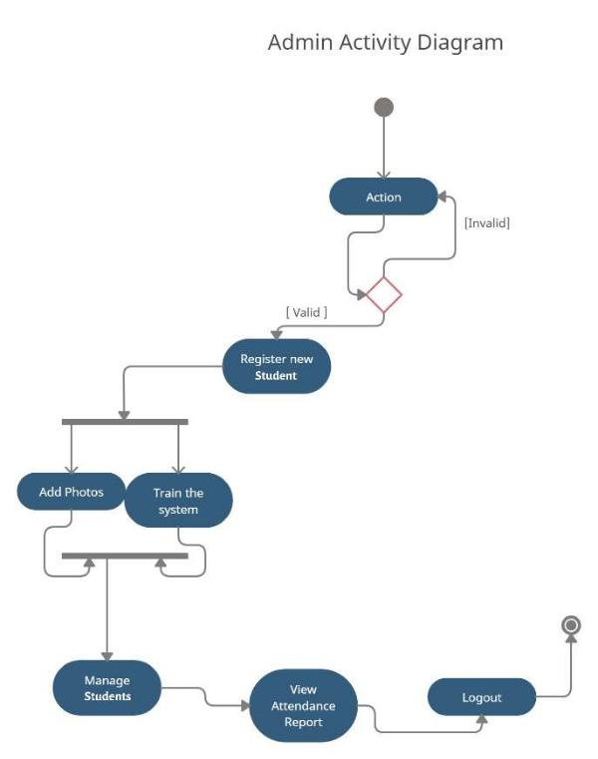

3.5 Deployment diagram
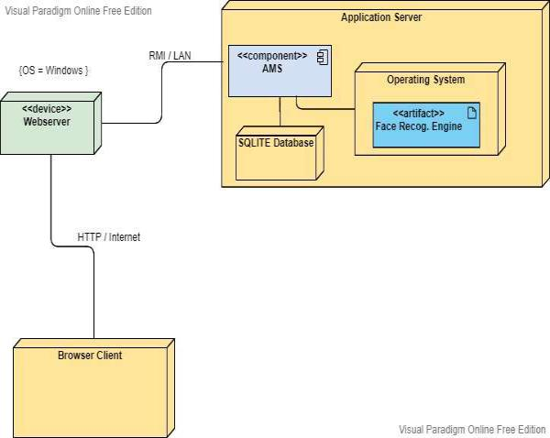

3.FUNCTIONALITIES

4.1 Manage Registration and Login

4.1.2 Register new student

Description: Only Admin can register new students by giving them a unique username

Input: Student username and password

Output: success message will display that a user has been created.

4.1.2 Log-In to the system
Input: User login credentials

Output: If the credentials are correct, the user will be redirected to the dashboard of our system

Exception Flow: If the user’s entered credentials are incorrect then the user will be redirected to the login page again displaying an error message.

4.2 Manage Attendance Details

4.2.1 Mark your attendance-in

Input: The user will scan his/her face using the external web camera(Only for prototype purposes)
Output: the system will identify the user uniquely displaying usernames and will mark his/her in-time to the database. The same success message will transmit to the user.

4.2.2 Mark your attendance-out

Input: The user will scan his/her face using the external web camera(Only for prototype purposes)
Output: the system will identify the user uniquely displaying usernames and will mark his/her out-time to the database. The same success message will transmit to the user.

4.2.3 View my attendance report
Description: Students may often need to see / her

attendance record on a particular date or

throughout the month or year. Using this feature one

can see his / her attendance record as per requirement.

Input: User selection(date and username/ date)

Output: Statistical analytics(record table and graphs) of

the particular student who is currently logged into the

system will be displayed.

4.3 Manage Student Details

4.3.1 Add a photo of the student

Description: Admin only can access this feature by logging in. Admin can add photos of a student during the registration process.

Input: Username of the student.

Output: Success message of record has been added will display.

Process: The system will process an image and will generate necessary system data into a folder to identify each student uniquely.

4.3.2 Train the system

Input: user selection(clicking train)

Output: the system will process all the available records of the students and will generate necessary system data to identify each student uniquely with the graph of classification.

© 2018, IJARIIT - All rights reserved. Website: www.ijariit.com Talk to Counselor: 9056222273 Page: 4

Sumeet Patil, Shubham Patil, Vrushali Salunkhe, International Journal of Advance Research, Ideas and Innovations in Technology (ISSN: 2454-132X)

5.4.Result of above attendance:

5. RESULT AND OUTPUTS
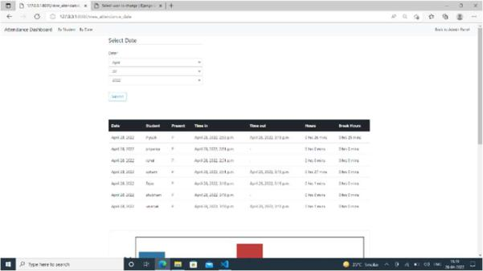

5.1.Main Dashboard (Time-in , Time-out and Login)
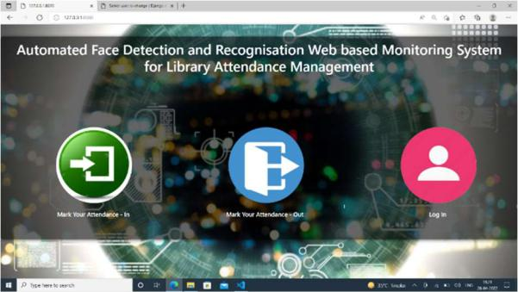

5.5. User Login (Admin & Students):
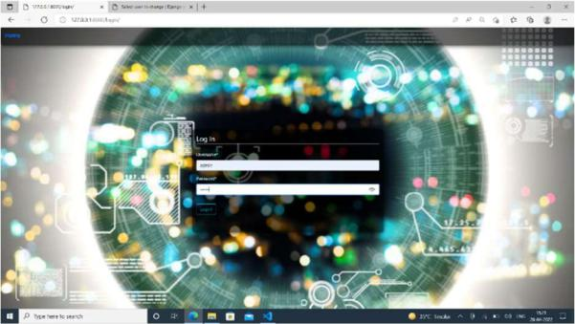

5.2. Marking attendance in the system :
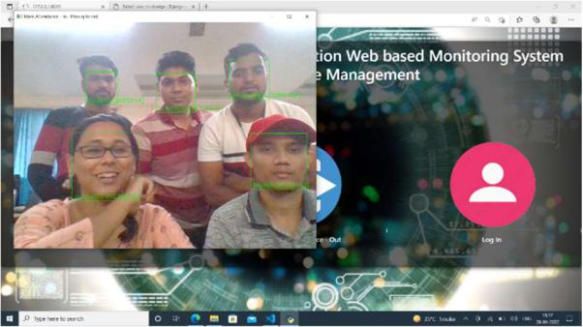

5.3. Marking attendance out the system: | 5.6. Admin Dashboard:
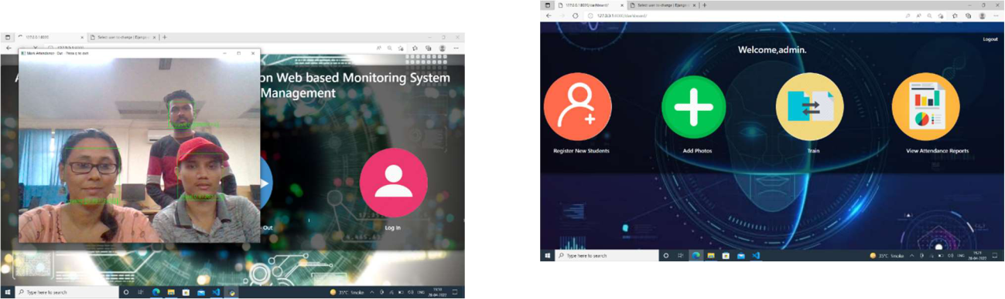

© 2018, IJARIIT - All rights reserved. Website: www.ijariit.com Talk to Counselor: 9056222273 Page: 5

Sumeet Patil, Shubham Patil, Vrushali Salunkhe, International Journal of Advance Research, Ideas and Innovations in Technology (ISSN: 2454-132X)

5.7. Capturing images using web cam:
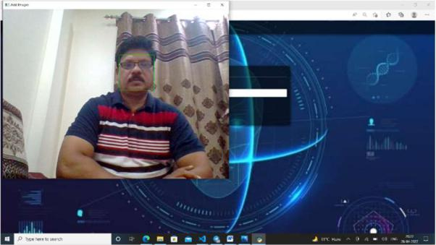

5.8 Training dataset:
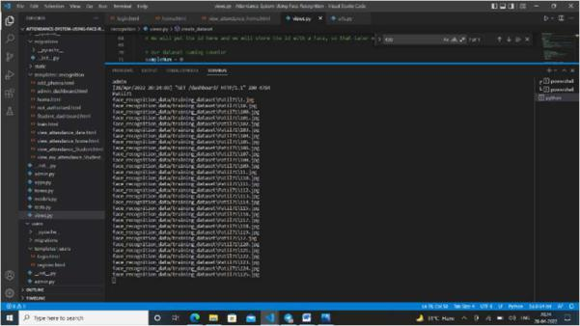

5.9. Classification graph of trained dataset:
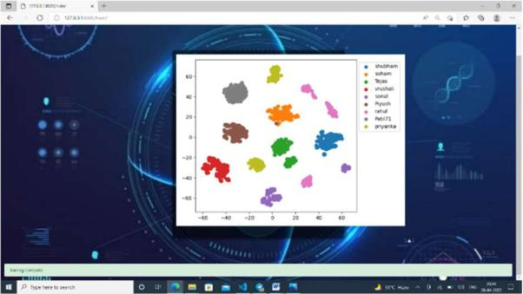

5.10. Attendance Report:
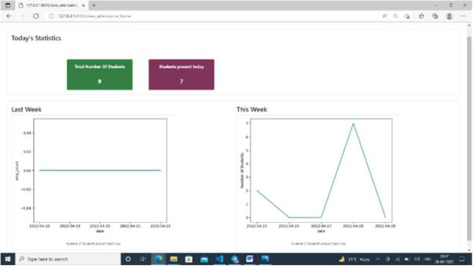

6. CONCLUSIONS

The above system is very efficient in processing the data, detecting, and recognizing the faces of users. The current model is 99.38% Accurate. Functionalities implemented successfully:
- Registration
- Login / Logout
- Manage User Profile

- Update user profile
- View My Attendance
- View Attendance by Date
- View Attendance by Student
- Manage Attendance
- Mark my attendance In

- Mark my attendance Out
- Add photos
- Add new student
- Train the system
- View the Attendance record by date

- View no. of student present today
- View the Total number of students

REFERENCES

- Student Attendance System using Face Recognition by Samridhi Dev ,Tushar Patnaik (Proceedings of the International Conference on Smart Electronics and Communication (ICOSEC 2020) IEEE Xplore Part Number: CFP20V90-ART; ISBN: 978-1-7281-5461-9)
https://ieeexplore.ieee.org/document/9215441
- Face Detection and Recognition System using Digital Image Processing by Gurlove Singh, Amit Kumar Goel (Proceedings of the Second International Conference on Innovative Mechanisms for Industry Applications (ICIMIA 2020) IEEE Xplore Part Number: CFP20K58-ART; ISBN: 978-1-7281-4167-1)
https://ieeexplore.ieee.org/document/9074838
- Face Recognition from Video using Deep Learning by Saibal Manna, Sushil Ghildiyal, Kishankumar Bhimani (Proceedings of the Fifth International Conference on Communication and Electronics Systems (ICCES 2020) IEEE Conference Record # 48766; IEEE Xplore ISBN: 978-1-7281-5371-1)
https://ieeexplore.ieee.org/abstract/document/9138372
- Face Recognition Attendance System Based on Real-Time Video Processing by HAO YANG AND XIAOFENG HAN (SPECIAL SECTION ON GIGAPIXEL PANORAMIC VIDEO WITH VIRTUAL REALITY Received May 18, 2020, accepted June 25, 2020, date of publication July 10, 2020, date of current version September 11, 2020. Digital Object Identifier 10.1109/ACCESS.2020.3007205)
https://ieeexplore.ieee.org/document/9137927

© 2018, IJARIIT - All rights reserved. Website: www.ijariit.com Talk to Counselor: 9056222273 Page: 6

