UML DESIGN DOCUMENT
Travel Bridge Platform
Backend Design: Use Case, Class, Sequence, Activity, State, Architecture & ER Diagrams
Backend design views derived from the Travel Bridge requirements specification (32 features). Every diagram is traceable to one or more features.
Document version | 1.0 (Draft for review)
Date | 24 September 2026
Based on | Travel Bridge Platform – Requirements Specification, v1.0
Diagrams | 46 diagrams (source in PlantUML, PNG and SVG provided separately)
Audience | Backend developers, architects, QA, product owner

1. Introduction
This document collects the design-level UML views of the Travel Bridge backend. The diagrams turn the feature-based requirements into a shared technical picture that developers can implement, reviewers can challenge, and testers can use to derive scenarios.

1.1 Diagram Types Included
Diagram type | Answers the question | Count
Use Case | Who uses the system and for what? | 6
Class | What are the domain concepts, their behavior, and how is the code layered and extended? | 8
Sequence | How do components collaborate at runtime for the important flows? | 13
Activity | What are the workflows and the journey-generation algorithm? | 4
State Machine | Which states can an entity be in and how does it move between them? | 8
Package / Component / Deployment | How is the system structured, connected, and deployed? | 3
Entity-Relationship | How is data stored and constrained? (not UML, but required for the backend) | 4
Object, communication, timing, interaction-overview, and composite-structure diagrams were considered and left out: they would repeat information already shown in the diagrams above.

1.2 Conventions
- Diagram IDs use a type prefix (UC, CLS, SEQ, ACT, ST, ARCH, ERD). Feature IDs (F-01 to F-32) refer to the requirements specification.
- Class diagrams use C#-style types (Guid, decimal, DateTime); ERD types use PostgreSQL names.
- Statuses are stored as small integers mapped to enums; timestamps are stored in UTC.
- «ref» classes are shown only to anchor relationships to classes defined in another diagram.
- Large diagrams are placed on A3 pages for legibility. Each diagram is also delivered as a separate PNG and SVG file.

2. Diagram Catalog
Diagram names link to their page. Feature references use the IDs from the requirements specification.
ID | Diagram | Traces to features
Part A – Use Case Diagrams
UC-01 | Visitor – Public Access | F-01, F-03, F-04, F-06–F-08, F-20–F-24
UC-02 | Tourist – Profile, Community & Guides | F-02, F-09–F-11, F-18, F-19, F-29
UC-03 | Tourist – AI & Trip Planning | F-12–F-17, F-27, F-28
UC-04 | Tour Guide | F-18, F-19, F-25, F-29
UC-05 | Administrator – Content Management | F-03–F-06, F-20, F-22–F-24
UC-06 | Administrator – Moderation, People & Platform | F-10, F-11, F-18, F-29–F-32
Part B – Class Diagrams (Domain Model & Design)
CLS-01 | Domain Model – Identity, Geography & Catalog | F-01–F-06, F-26
CLS-02 | Domain Model – Community, Moderation & Notifications | F-09–F-11, F-25, F-29
CLS-03 | Domain Model – AI Assistant, Journey, Trip & Cost | F-12–F-17
CLS-04 | Domain Model – Tour Guides, Requests & Chat | F-18, F-19
CLS-05 | Domain Model – Transportation, Culture, Safety & Awareness | F-20, F-22–F-24
CLS-06 | Layered Architecture – Destination Module Example | F-06–F-08
CLS-07 | Extensibility Patterns (1/2) – AI Provider & Recommendations | F-12, F-13, F-16, F-17
CLS-08 | Extensibility Patterns (2/2) – Notifications & Currency | F-25, F-27
Part C – Sequence Diagrams
SEQ-01 | Registration, Login & Token Refresh | F-01
SEQ-02 | Search, Filter & Sort Destinations | F-07
SEQ-03 | Review Submission & Admin Moderation | F-10, F-25
SEQ-04 | Place Suggestion to Draft Destination | F-06, F-11
SEQ-05 | AI Assistant – Requirement Gathering | F-12
SEQ-06 | Journey Generation | F-13, F-14
SEQ-07 | Journey Customization via Natural Language | F-13, F-14
SEQ-08 | Trip Cost Estimation | F-14, F-27
SEQ-09 | Guide Request, Decision & Chat | F-19, F-25
SEQ-10 | AI Image Recognition & Price Estimate | F-17, F-27
SEQ-11 | Notification Delivery (Transactional Outbox) | F-25
SEQ-12 | Reporting & Moderation | F-10, F-29
SEQ-13 | Guide Onboarding & Admin Approval | F-01, F-18
Part D – Activity Diagrams
ACT-01 | Core Tourist Journey (End to End) | F-01, F-02, F-07, F-09, F-10, F-12–F-15, F-19
ACT-02 | Journey Generation Algorithm | F-13, F-14
ACT-03 | Guide Request Workflow | F-18, F-19
ACT-04 | Place Suggestion to Published Destination | F-06, F-11
Part E – State Machine Diagrams
ST-01 | Review | F-10, F-29
ST-02 | Place Suggestion | F-11
ST-03 | Destination | F-06
ST-04 | Guide Profile | F-18
ST-05 | Guide Request | F-19
ST-06 | Trip (Lifecycle and Visibility) | F-15
ST-07 | Report | F-29
ST-08 | User Account | F-01, F-31
Part F – Architecture Diagrams
ARCH-01 | Package Diagram – Modular Monolith | F-01, F-03, F-06, F-10, F-13, F-18, F-25, F-30
ARCH-02 | Component Diagram – Logical Architecture | F-01, F-12, F-19, F-25, F-27, F-30
ARCH-03 | Deployment Diagram – Proposed Topology | F-30
Part G – Entity-Relationship Diagrams
ERD-01 | Identity, Geography & Catalog | F-01–F-06, F-26
ERD-02 | Community, Moderation, Notifications & Audit | F-09–F-11, F-25, F-29
ERD-03 | Conversations, Journeys, Trips, Cost & AI | F-12–F-17, F-27
ERD-04 | Guides, Chat, Transportation, Culture & Safety | F-18–F-20, F-22–F-24

3. Key Design Decisions
These decisions shape the diagrams. They are proposals for review, not fixed constraints.
Decision | Rationale | Shown in
Modular monolith | One deployable unit keeps the MVP simple, while strict module boundaries allow later extraction into services. | ARCH-01, ARCH-02
Clean layering per module | API → Application → Domain, with Infrastructure implementing interfaces, keeps business rules testable and independent of frameworks. | CLS-06
JWT access tokens with rotating refresh tokens | Short-lived access tokens limit exposure; refresh-token rotation and reuse detection protect sessions. Roles are data-driven. | SEQ-01, ST-08
Transactional outbox | Events are stored with the business change, so notifications are never lost and are delivered at least once. | SEQ-11, CLS-08
AI behind an abstraction | An adapter with decorators isolates the vendor, adds rate limiting and usage tracking, and lets the domain validate everything the AI proposes. | CLS-07, SEQ-05 – SEQ-07
AI grounded in the catalog | Journeys use only Published destinations. The AI supplies intent and wording, never places or prices. | SEQ-06, ACT-02
Search on the relational store with caching | Indexes and spatial types are enough for the MVP; tagged cache invalidation keeps results fresh. A dedicated search engine can be added later. | SEQ-02, ERD-01
Translation tables with English fallback | New languages need no schema changes and missing text never breaks a page. | CLS-01, ERD-01
Prices stored in original currency | Conversion happens at read time using cached rates with last-known fallback, so history is never distorted. | SEQ-08, CLS-08
Soft delete, archive, and audit trail | Content referenced by reviews, favorites, and trips is never physically removed; admin actions are traceable. | CLS-01, ERD-02
Optimistic concurrency and partial unique index | Prevents two guides’ sessions or requests from colliding without heavy locking. | SEQ-09, ERD-04
Polymorphic references for reports and rules | One report or rule table serves many targets; the cost is application-level integrity checks instead of foreign keys. | CLS-02, CLS-05
Background worker | Outbox delivery, request expiry, and exchange-rate refresh run outside web requests. | ARCH-02, ARCH-03

3.1 Suggested Technology Mapping
Concern | Suggested option
API host | ASP.NET Core Web API with OpenAPI documentation and SignalR for chat
Data access | Entity Framework Core (migrations, soft-delete query filters, optimistic concurrency)
Validation and mapping | FluentValidation and a mapper for DTOs
Database | PostgreSQL with PostGIS (or SQL Server with spatial types)
Cache and rate limits | Redis
Files | S3-compatible or Azure Blob storage behind IFileStorage
Background jobs | ASP.NET Core hosted services or Hangfire
Observability | Structured logging and OpenTelemetry traces and metrics
Testing | xUnit or NUnit for unit and integration tests

Part A – Use Case Diagrams
Actors and the capabilities they use, grouped so each diagram stays readable.

UC-01 Visitor – Public Access
Shows what an unauthenticated visitor can do: sign up or log in and browse public tourism content. A Tourist inherits every Visitor capability.
Traces to: F-01, F-03, F-04, F-06–F-08, F-20–F-24
- Discovery works without an account; only personal features require sign-in.
- Map tiles and geocoding come from an external map provider.
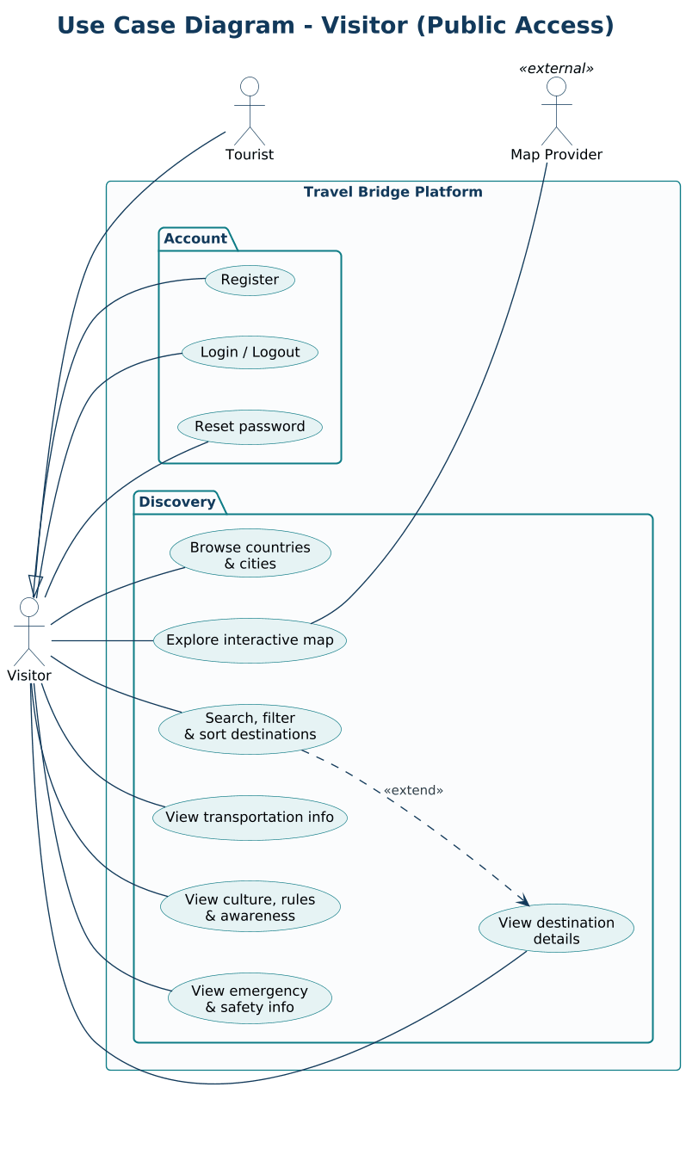

UC-02 Tourist – Profile, Community & Guides
Authenticated tourist capabilities for personalization, community contribution, and working with tour guides.
Traces to: F-02, F-09–F-11, F-18, F-19, F-29
- All use cases here require the Tourist role.
- Chat with a guide exists only after a guide request is accepted.
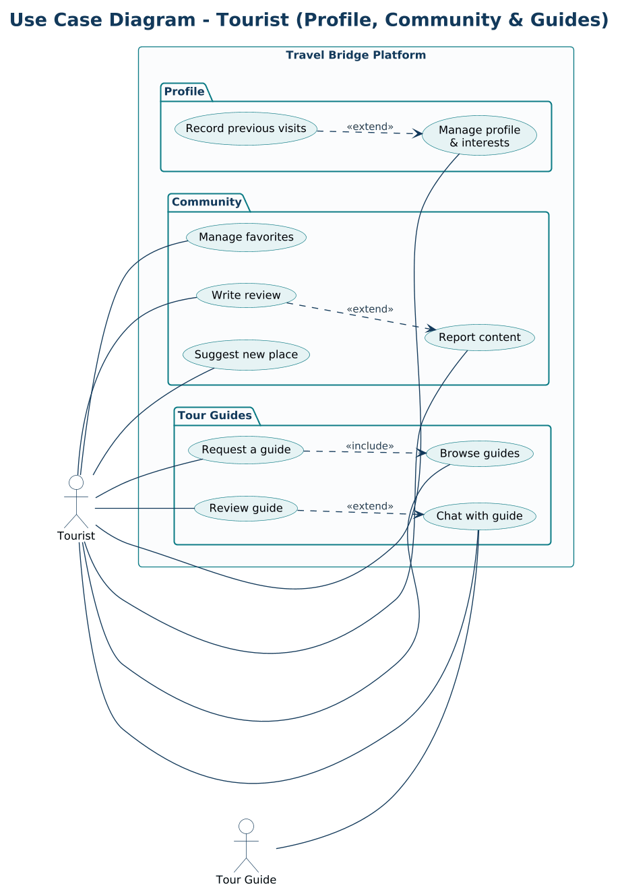

UC-03 Tourist – AI & Trip Planning
AI-assisted planning: conversation, journey generation and customization, cost estimation, trip management, sharing, offline use, and image recognition.
Traces to: F-12–F-17, F-27, F-28
- AI output is always validated by the platform before it is saved.
- Currency conversion uses a cached exchange-rate source.
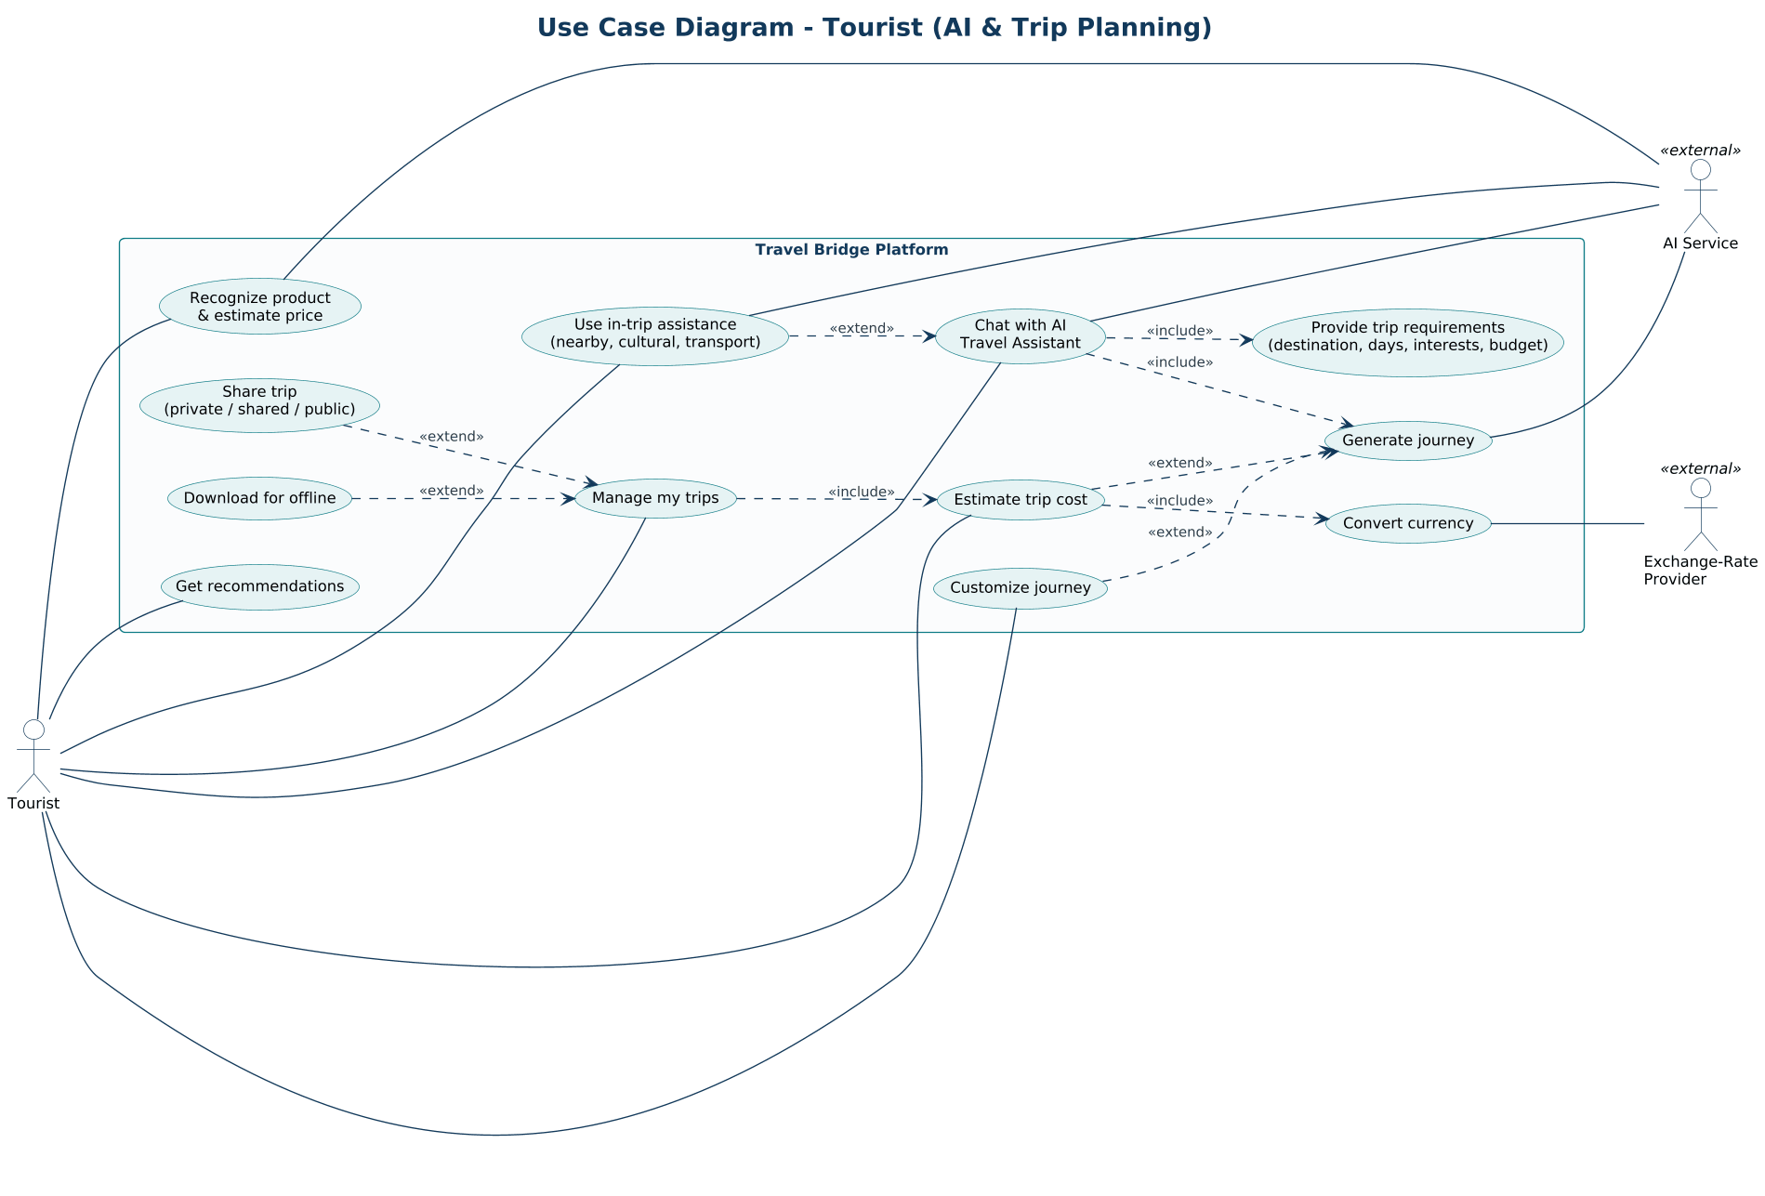

UC-04 Tour Guide
Guide capabilities: profile and availability management, handling incoming requests, chatting with tourists, and managing sessions.
Traces to: F-18, F-19, F-25, F-29
- A guide can act only after an admin approves the profile.
- Requests are created by tourists and consumed by guides.
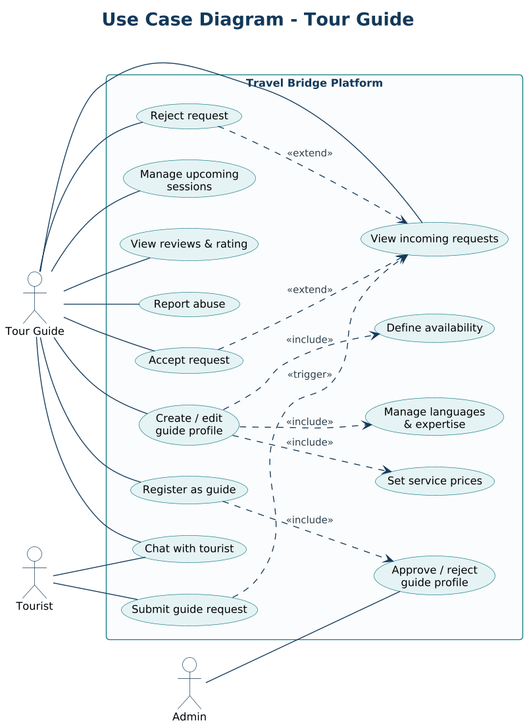

UC-05 Administrator – Content Management
Admin management of the tourism content hierarchy and supporting information.
Traces to: F-03–F-06, F-20, F-22–F-24
- A destination needs an existing city and category and at least one image before it can be published.
- Delete is implemented as archive.
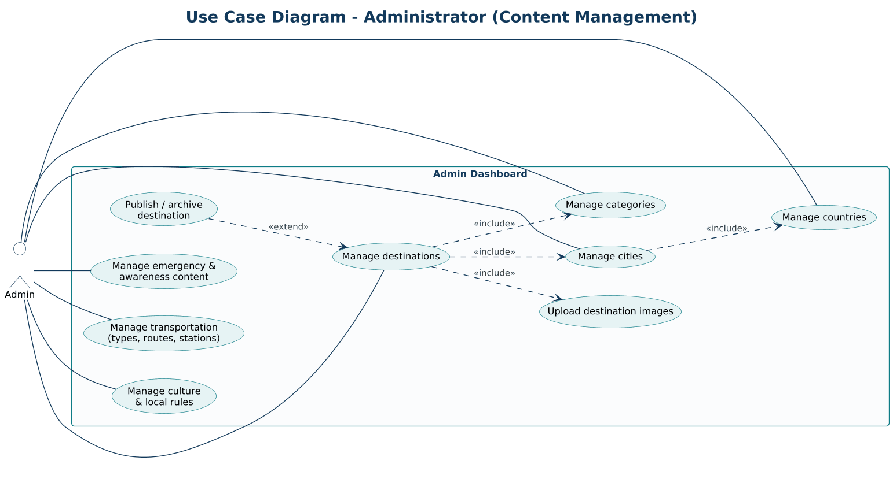

UC-06 Administrator – Moderation, People & Platform
Admin moderation, user and guide management, and platform-level configuration and monitoring.
Traces to: F-10, F-11, F-18, F-29–F-32
- Approving a place suggestion leads to creating a Draft destination.
- Every admin action is written to the audit log.
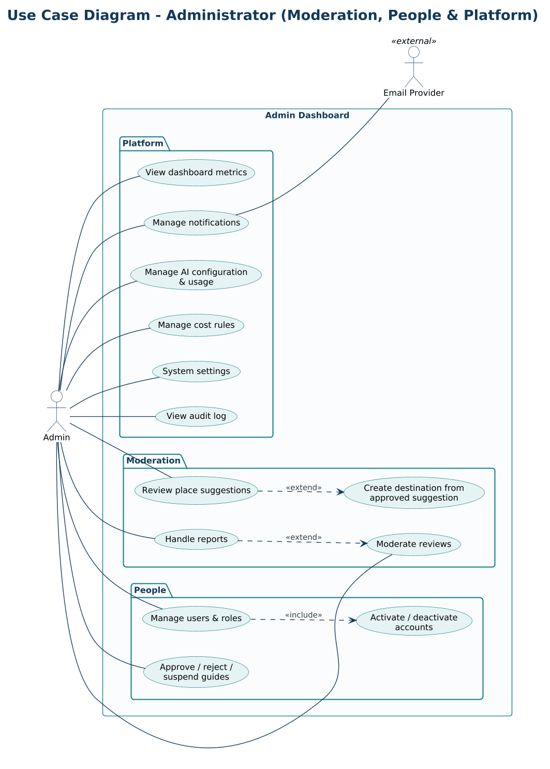

Part B – Class Diagrams (Domain Model & Design)
Domain classes with attributes, behavior, and relationships, plus the layered structure and extensibility patterns used by the backend.

CLS-01 Domain Model – Identity, Geography & Catalog
Core domain model for users, roles, tourist profiles, the Country → City → Destination hierarchy, categories, and localized destination content.
Traces to: F-01–F-06, F-26
- All aggregates inherit audit fields and soft delete from AuditableEntity.
- Translations live in separate tables so new languages need no schema change.
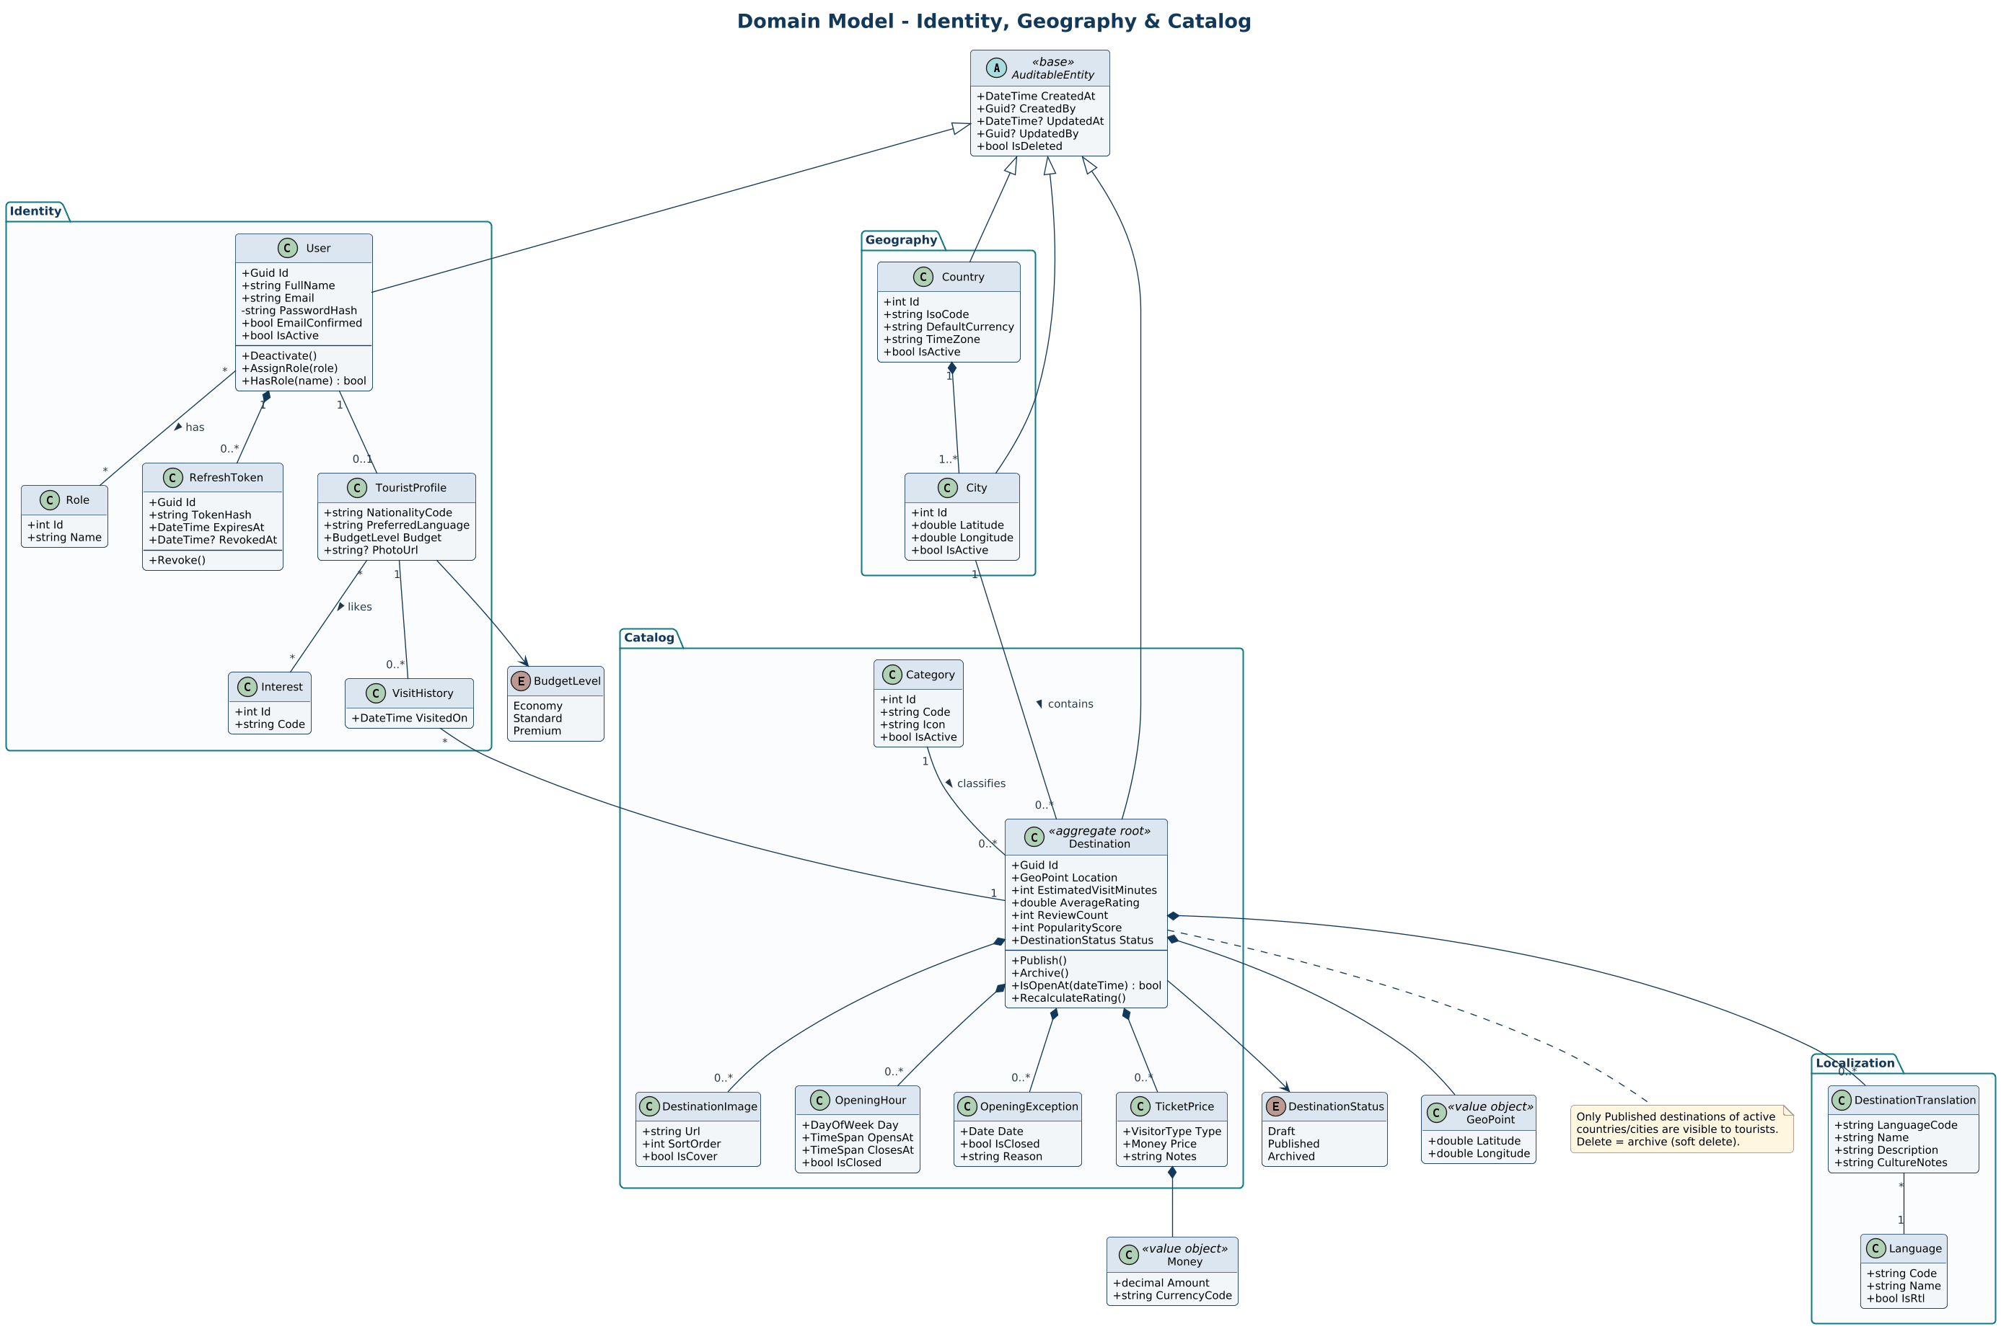

CLS-02 Domain Model – Community, Moderation & Notifications
Favorites, reviews, place suggestions, reports, notifications, and the audit log.
Traces to: F-09–F-11, F-25, F-29
- Report uses a polymorphic (TargetType, TargetId) reference to cover reviews, users, guides, and destinations.
- Review, PlaceSuggestion, and Report own their state transitions.
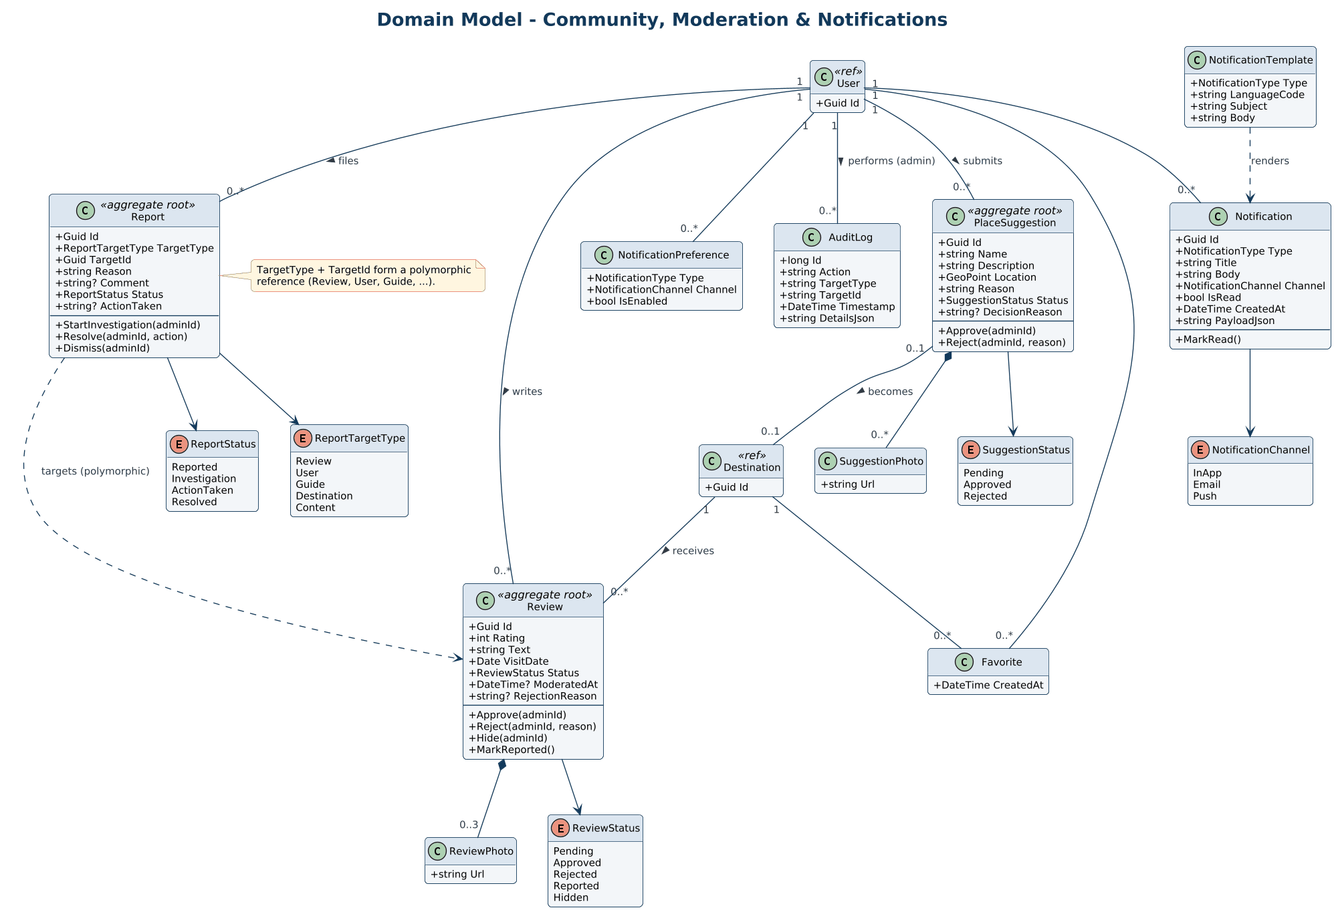

CLS-03 Domain Model – AI Assistant, Journey, Trip & Cost
Conversation and requirement extraction, journey structure, trip lifecycle and sharing, cost estimation, image analysis, and AI usage tracking.
Traces to: F-12–F-17
- Journey is the aggregate that guarantees itinerary validity; Trip adds dates, status, and visibility.
- CostEstimate rows are immutable, timestamped snapshots.
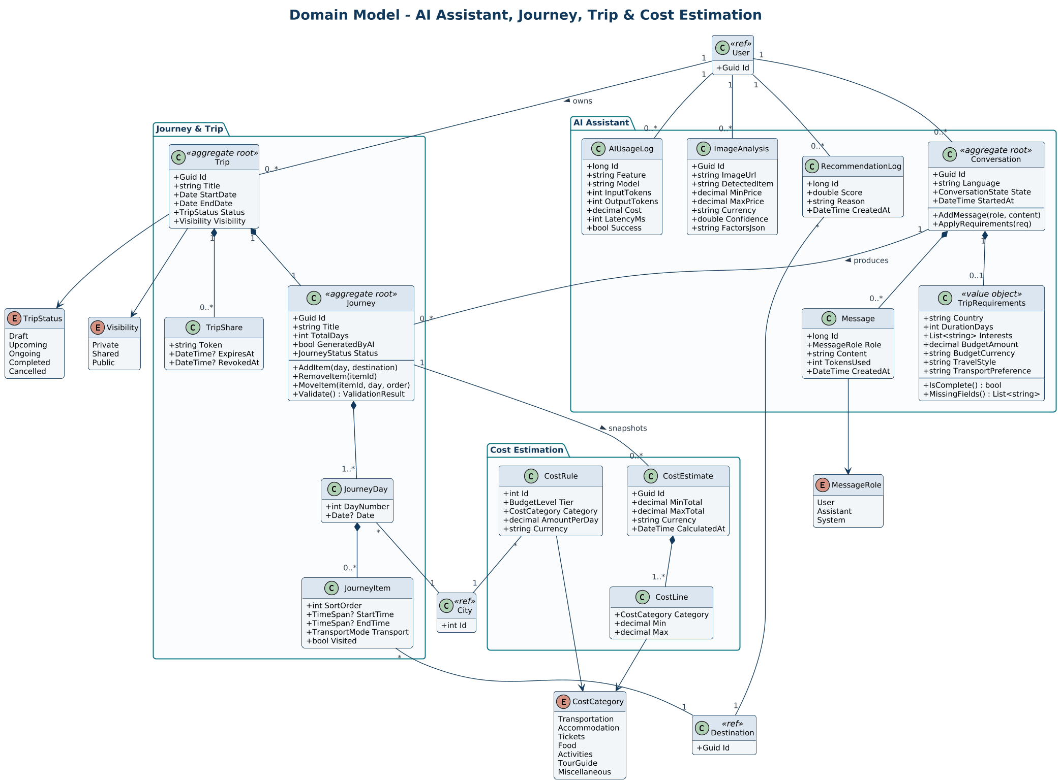

CLS-04 Domain Model – Tour Guides, Requests & Chat
Guide profiles with languages, expertise, availability, and pricing; guide requests; sessions; chat; and guide reviews.
Traces to: F-18, F-19
- GuideRequest owns accept, reject, cancel, and expire behavior.
- Accepting creates the session and chat thread in the same transaction.
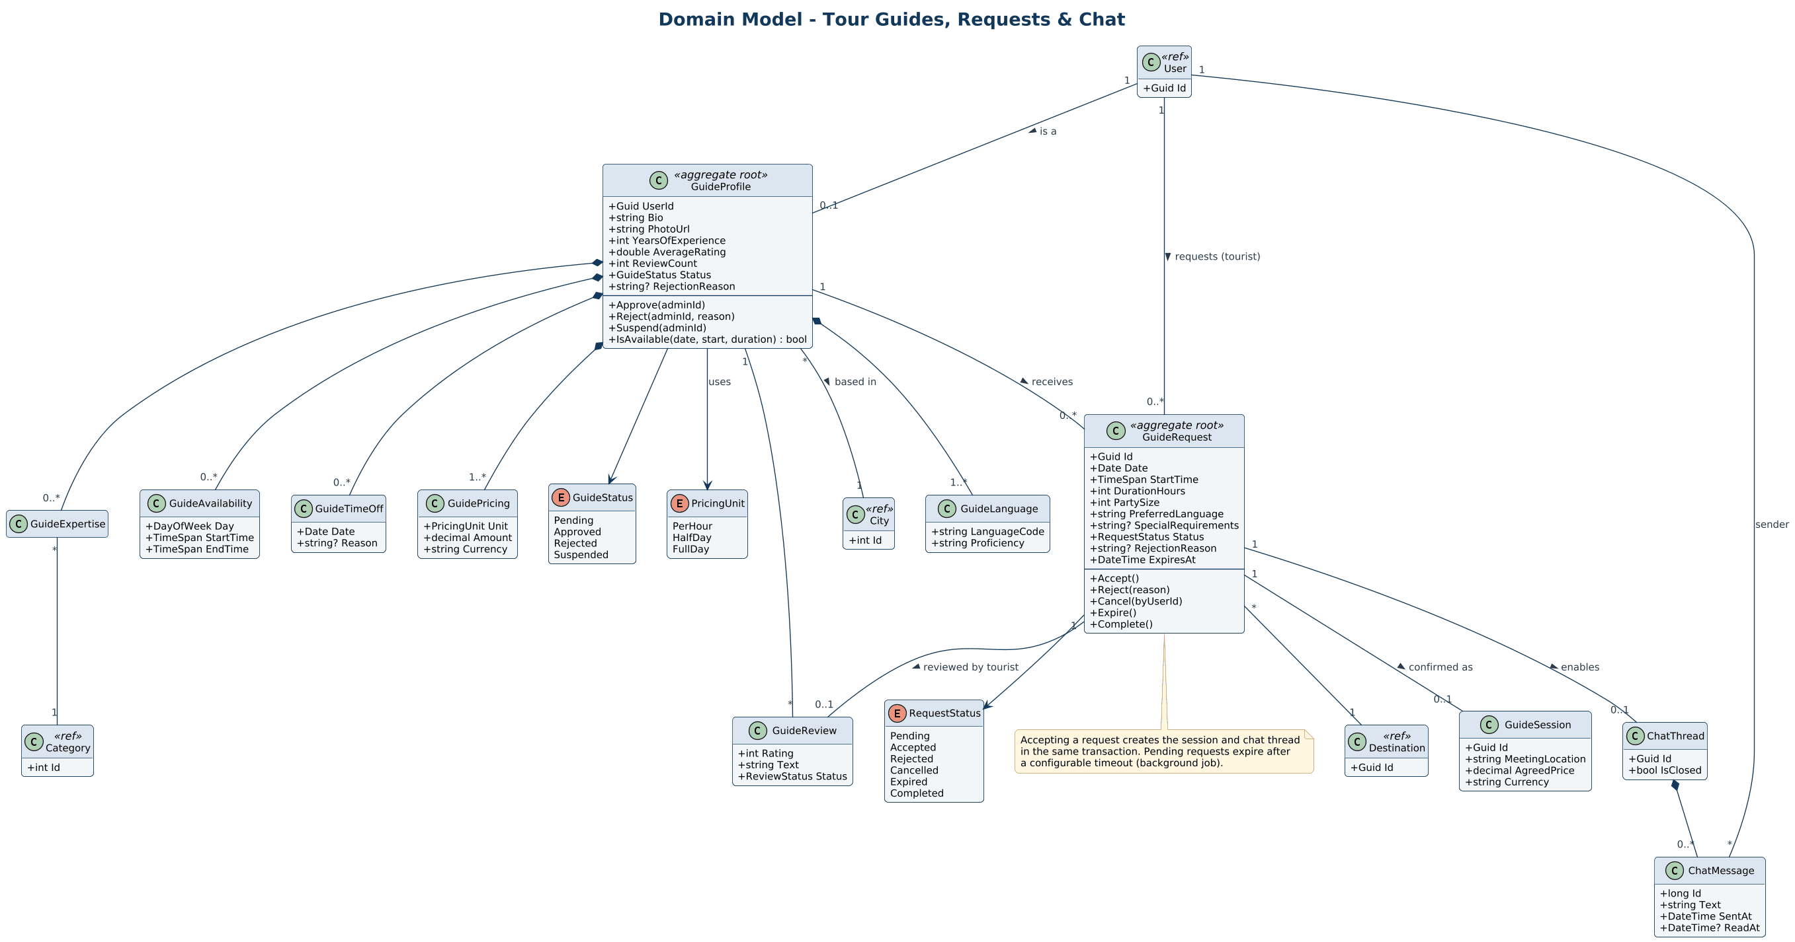

CLS-05 Domain Model – Transportation, Culture, Safety & Awareness
City transportation, local rules and customs, emergency contacts, embassies, safety guides, and awareness articles.
Traces to: F-20, F-22–F-24
- Rules and emergency contacts attach to a country, city, or destination through (Scope, ScopeId).
- Effective rules for a destination combine destination, city, and country rules.
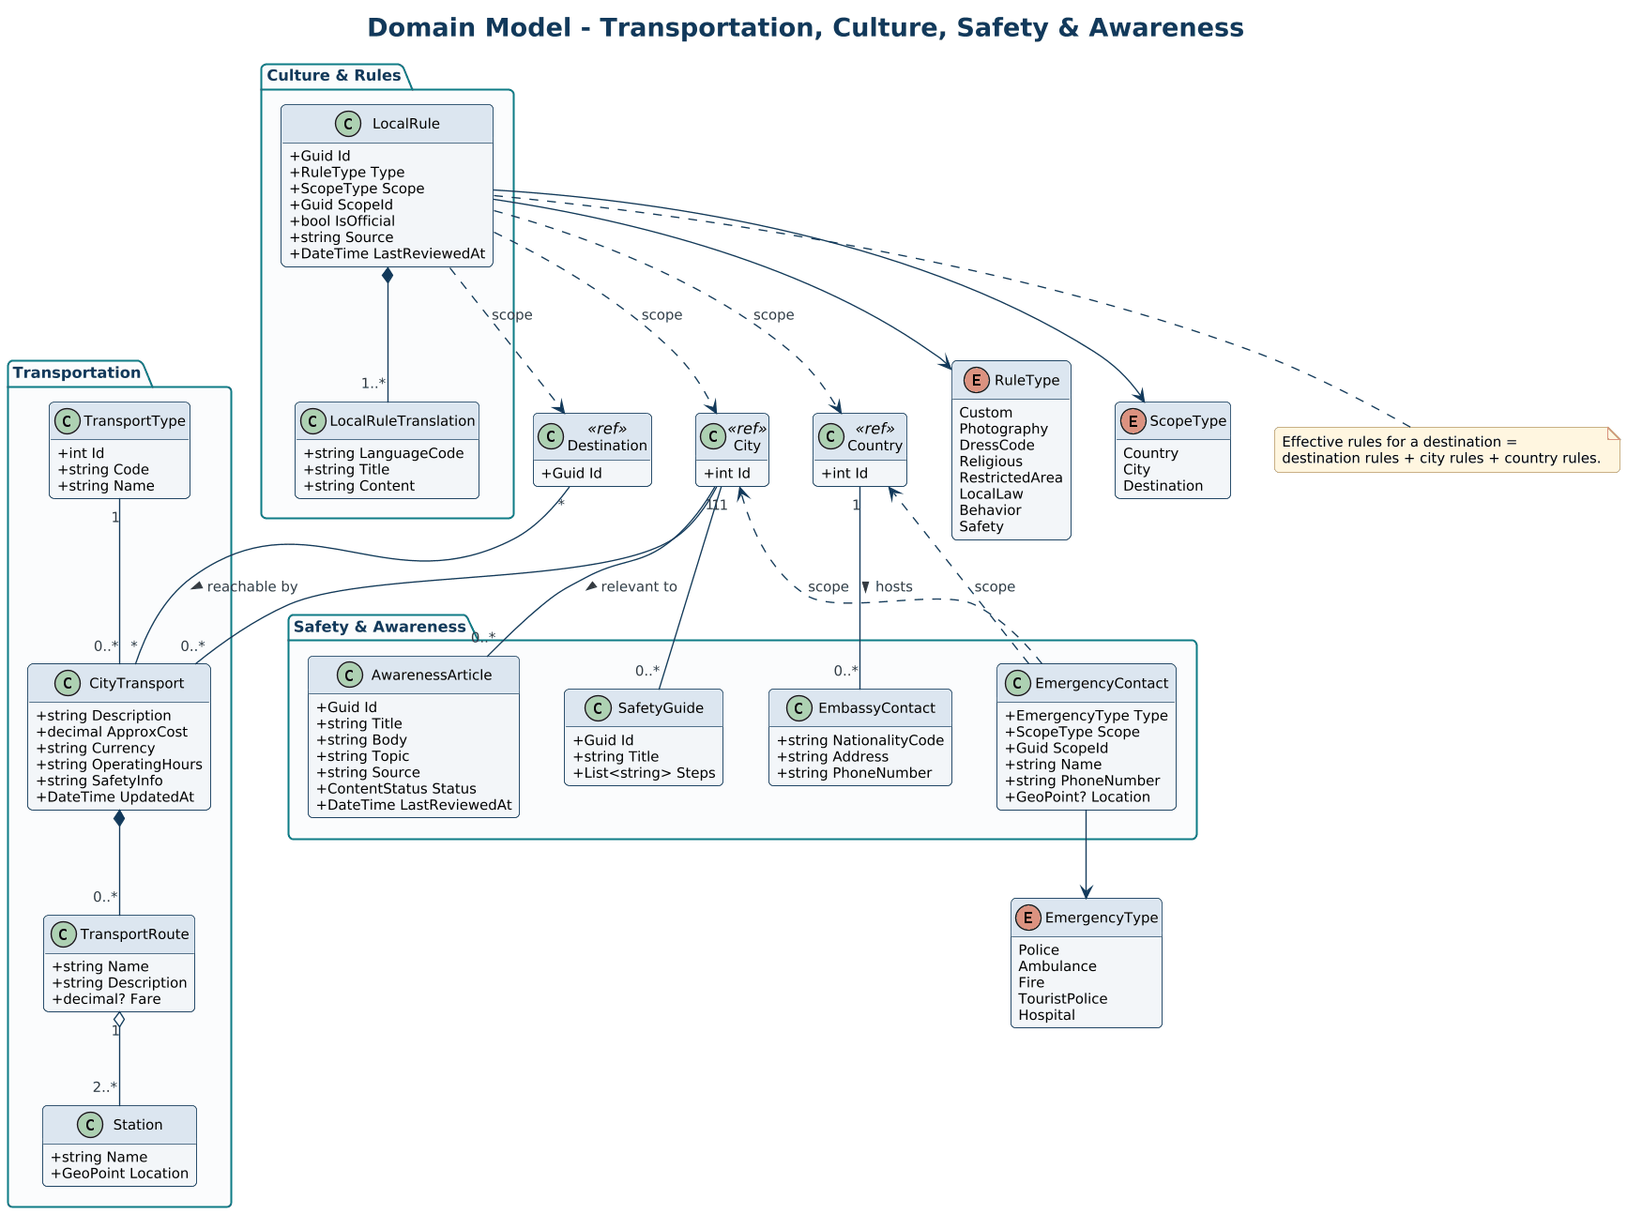

CLS-06 Layered Architecture – Destination Module Example
Shows how one module is layered: controllers, application services, domain aggregate and repository interfaces, and infrastructure implementations.
Traces to: F-06–F-08
- Dependencies point inward: API → Application → Domain; Infrastructure implements the interfaces.
- Every module follows the same structure.
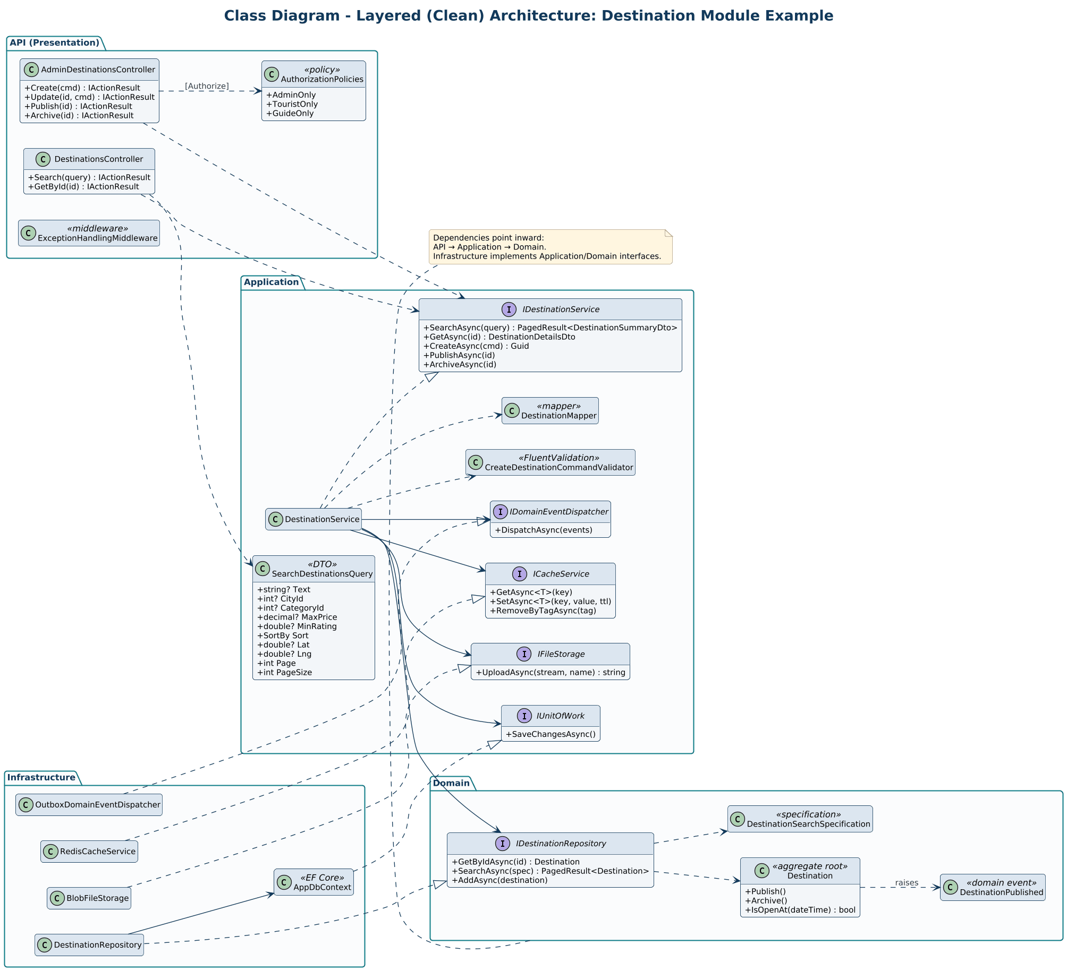

CLS-07 Extensibility Patterns (1/2) – AI Provider & Recommendations
Adapter and decorator around the AI provider, and a strategy pattern for recommendations.
Traces to: F-12, F-13, F-16, F-17
- Usage logging and rate limiting are decorators, so features never depend on a vendor.
- New recommendation strategies plug in without changing RecommendationService.
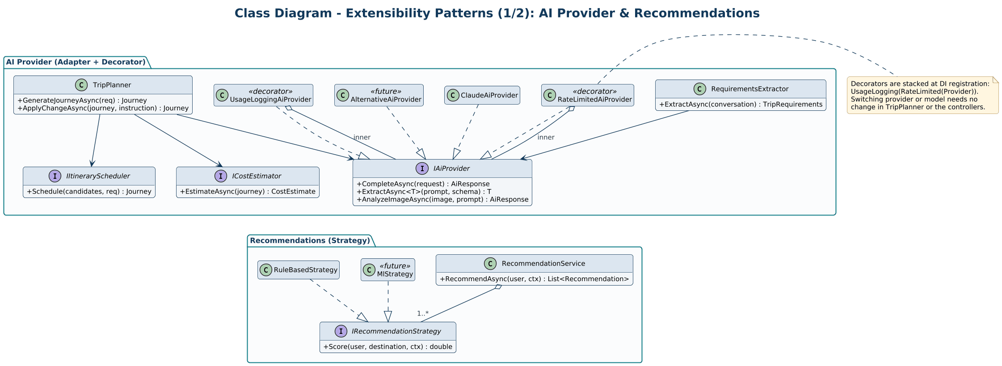

CLS-08 Extensibility Patterns (2/2) – Notifications & Currency
Pluggable notification channels with a transactional outbox, and a cached exchange-rate provider.
Traces to: F-25, F-27
- The outbox guarantees at-least-once delivery of events.
- CachedExchangeRateProvider falls back to the last known rate when the provider is down.
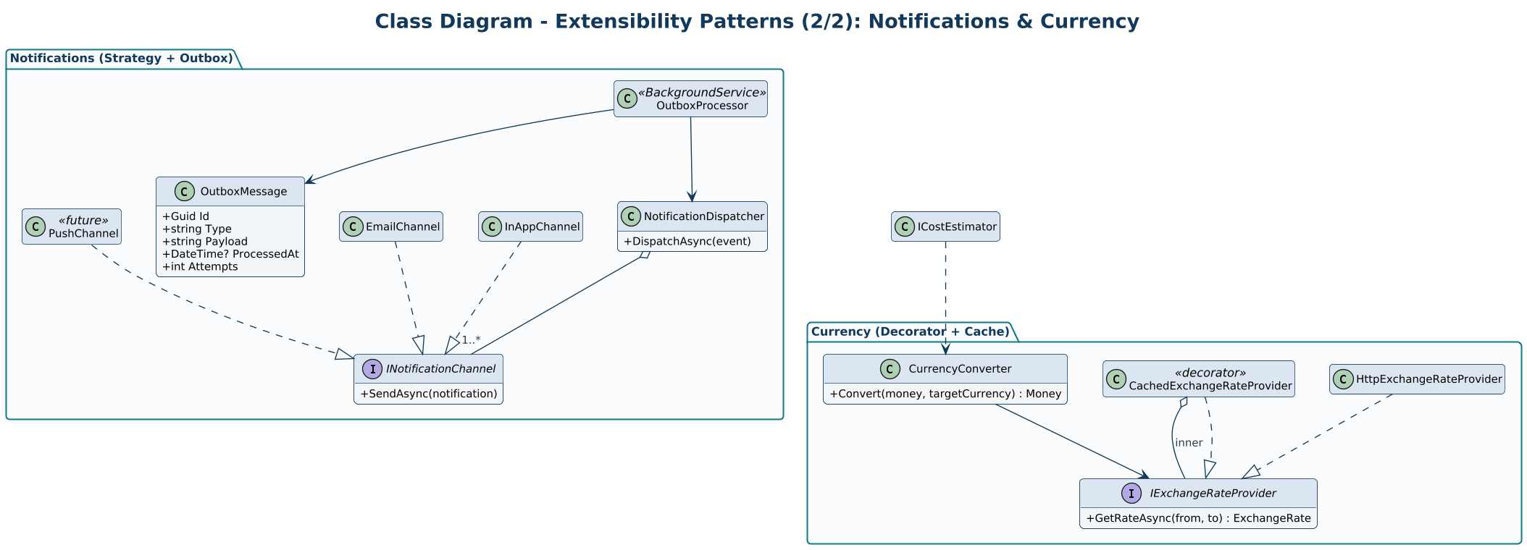

Part C – Sequence Diagrams
Key runtime interactions between clients, API, services, database, and external systems.

SEQ-01 Registration, Login & Token Refresh
Account creation with hashed passwords, JWT-based login, and refresh-token rotation.
Traces to: F-01
- Access tokens are short-lived; refresh tokens are stored hashed, rotated on use, and revoked when reuse is detected.
- Confirmation emails are sent asynchronously through the outbox.
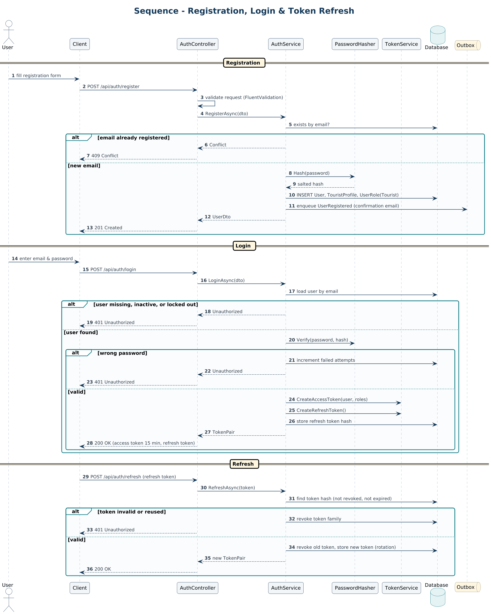

SEQ-02 Search, Filter & Sort Destinations
Request flow for destination search including cache lookup, filtered database query, and response mapping.
Traces to: F-07
- Only Published destinations in active cities and countries are searched.
- Cache entries are tagged and invalidated when content or ratings change.
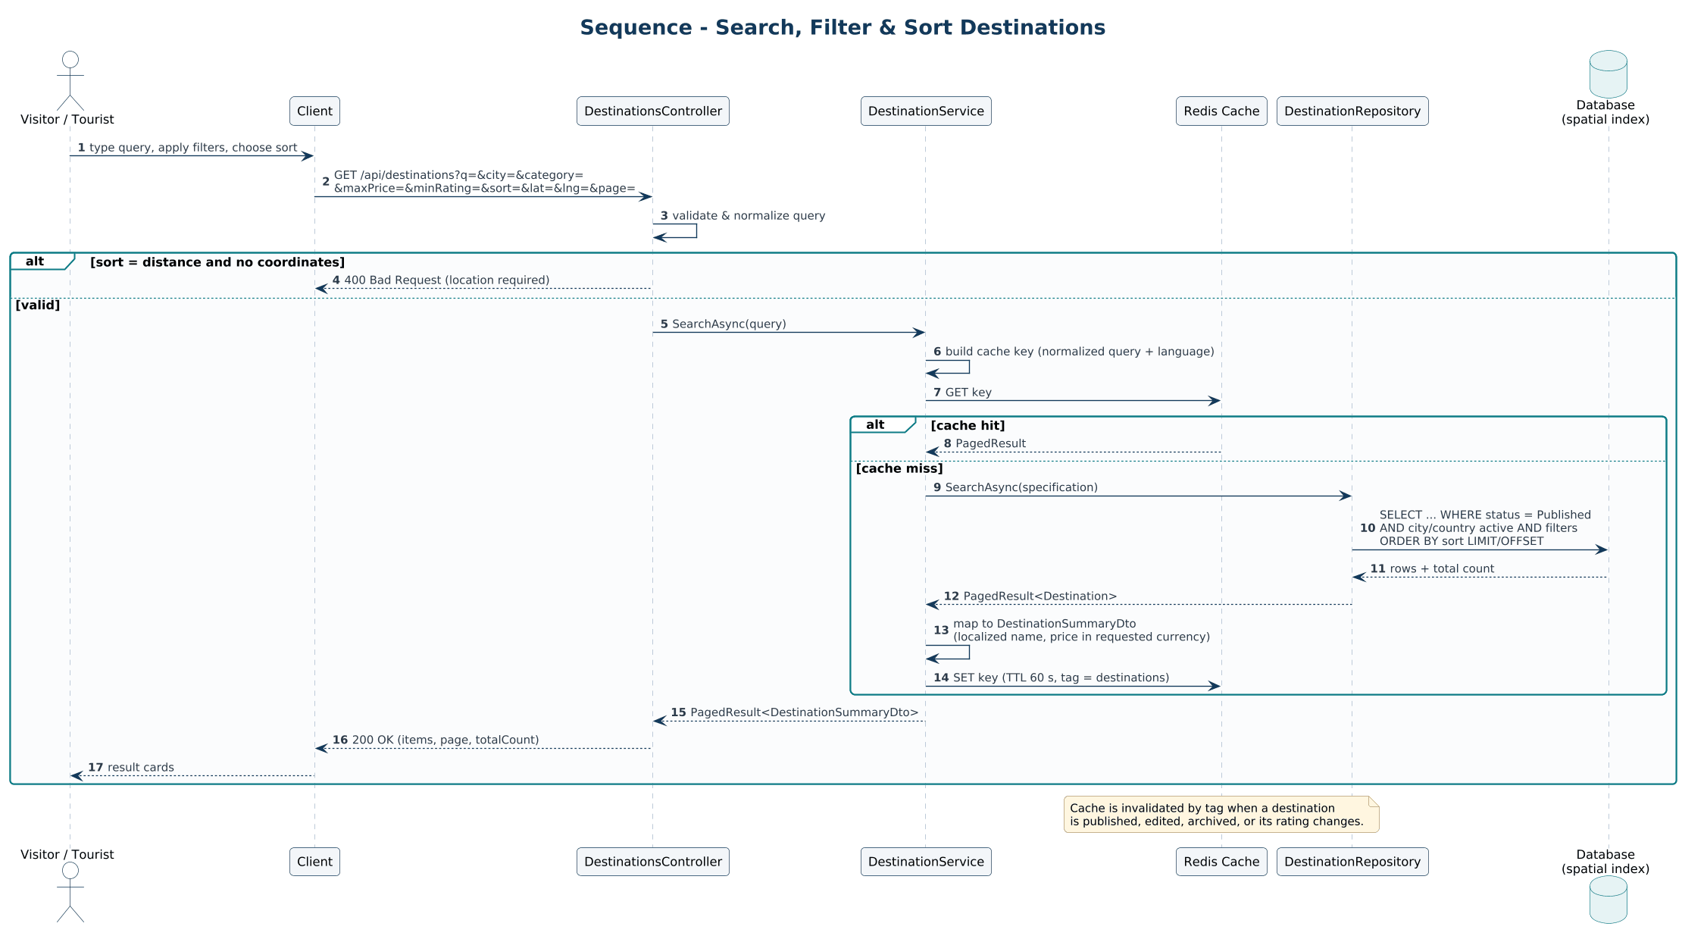

SEQ-03 Review Submission & Admin Moderation
A tourist submits a review, then an admin approves or rejects it, updating the destination rating.
Traces to: F-10, F-25
- Reviews start as Pending and become public only after approval.
- Rating aggregates are recalculated in the same request as the approval.
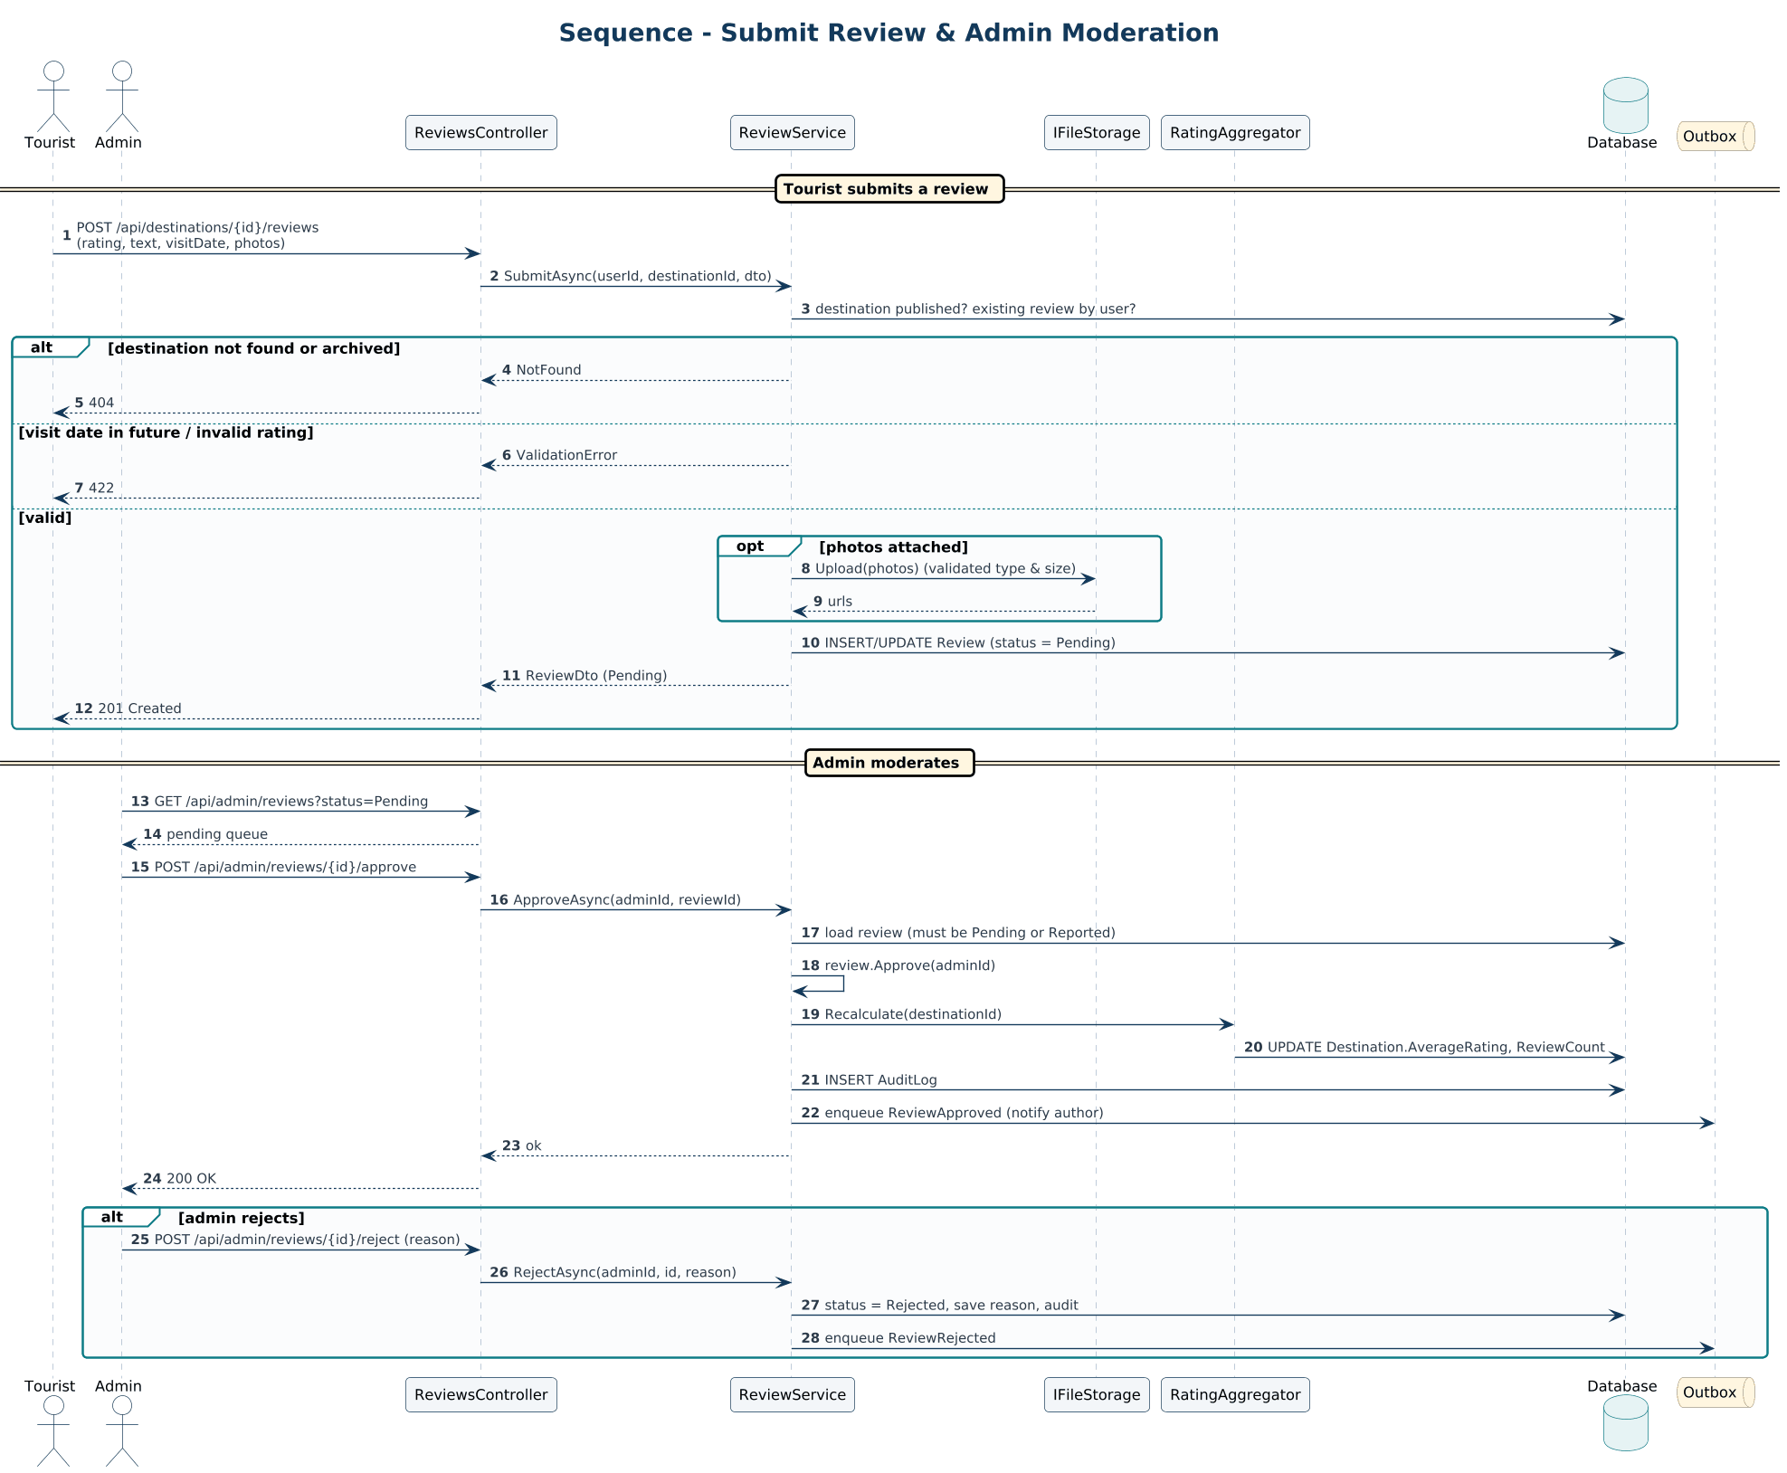

SEQ-04 Place Suggestion to Draft Destination
Submission, duplicate detection, admin decision, and creation of a Draft destination.
Traces to: F-06, F-11
- Approval and destination creation happen in one transaction.
- Publishing is a separate, explicit admin step.
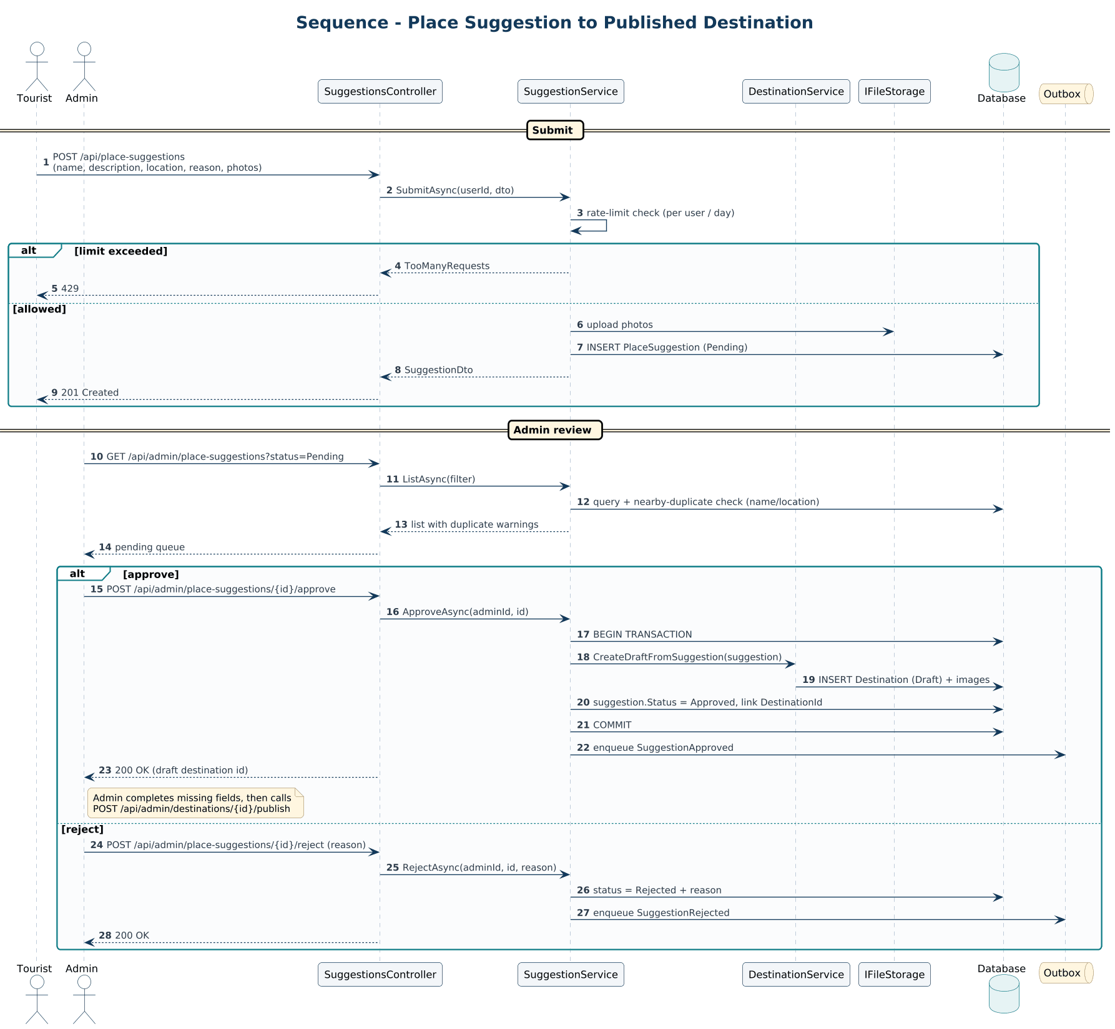

SEQ-05 AI Assistant – Requirement Gathering
How the assistant extracts trip requirements, asks for missing details, and hands over to journey generation.
Traces to: F-12
- One question is asked at a time; requirements are confirmed before generating.
- AI failure produces a retryable error instead of a broken conversation.
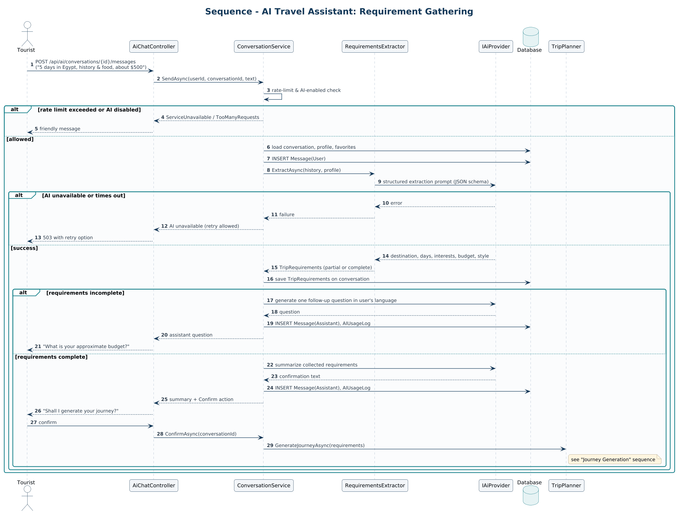

SEQ-06 Journey Generation
Candidate selection, scheduling under constraints, optional AI narrative, persistence, and cost estimate.
Traces to: F-13, F-14
- Places always come from the catalog; the AI only adds text about the selected destinations.
- The scheduler enforces opening hours and daily capacity.
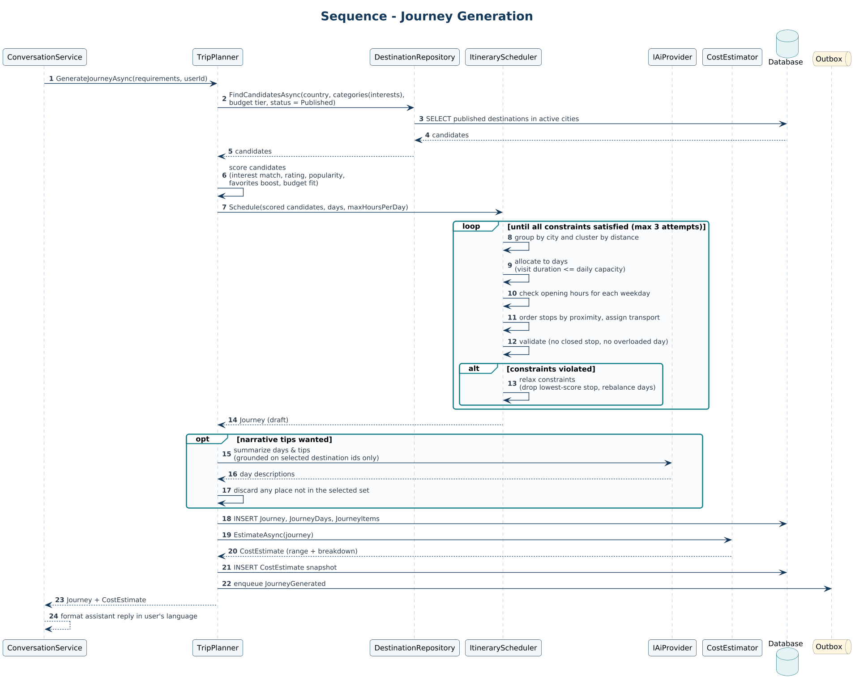

SEQ-07 Journey Customization via Natural Language
Turning a free-text change request into validated journey operations.
Traces to: F-13, F-14
- The AI proposes operations from a fixed schema; the domain model applies and validates them.
- Conflicts return alternatives instead of silently breaking the itinerary.
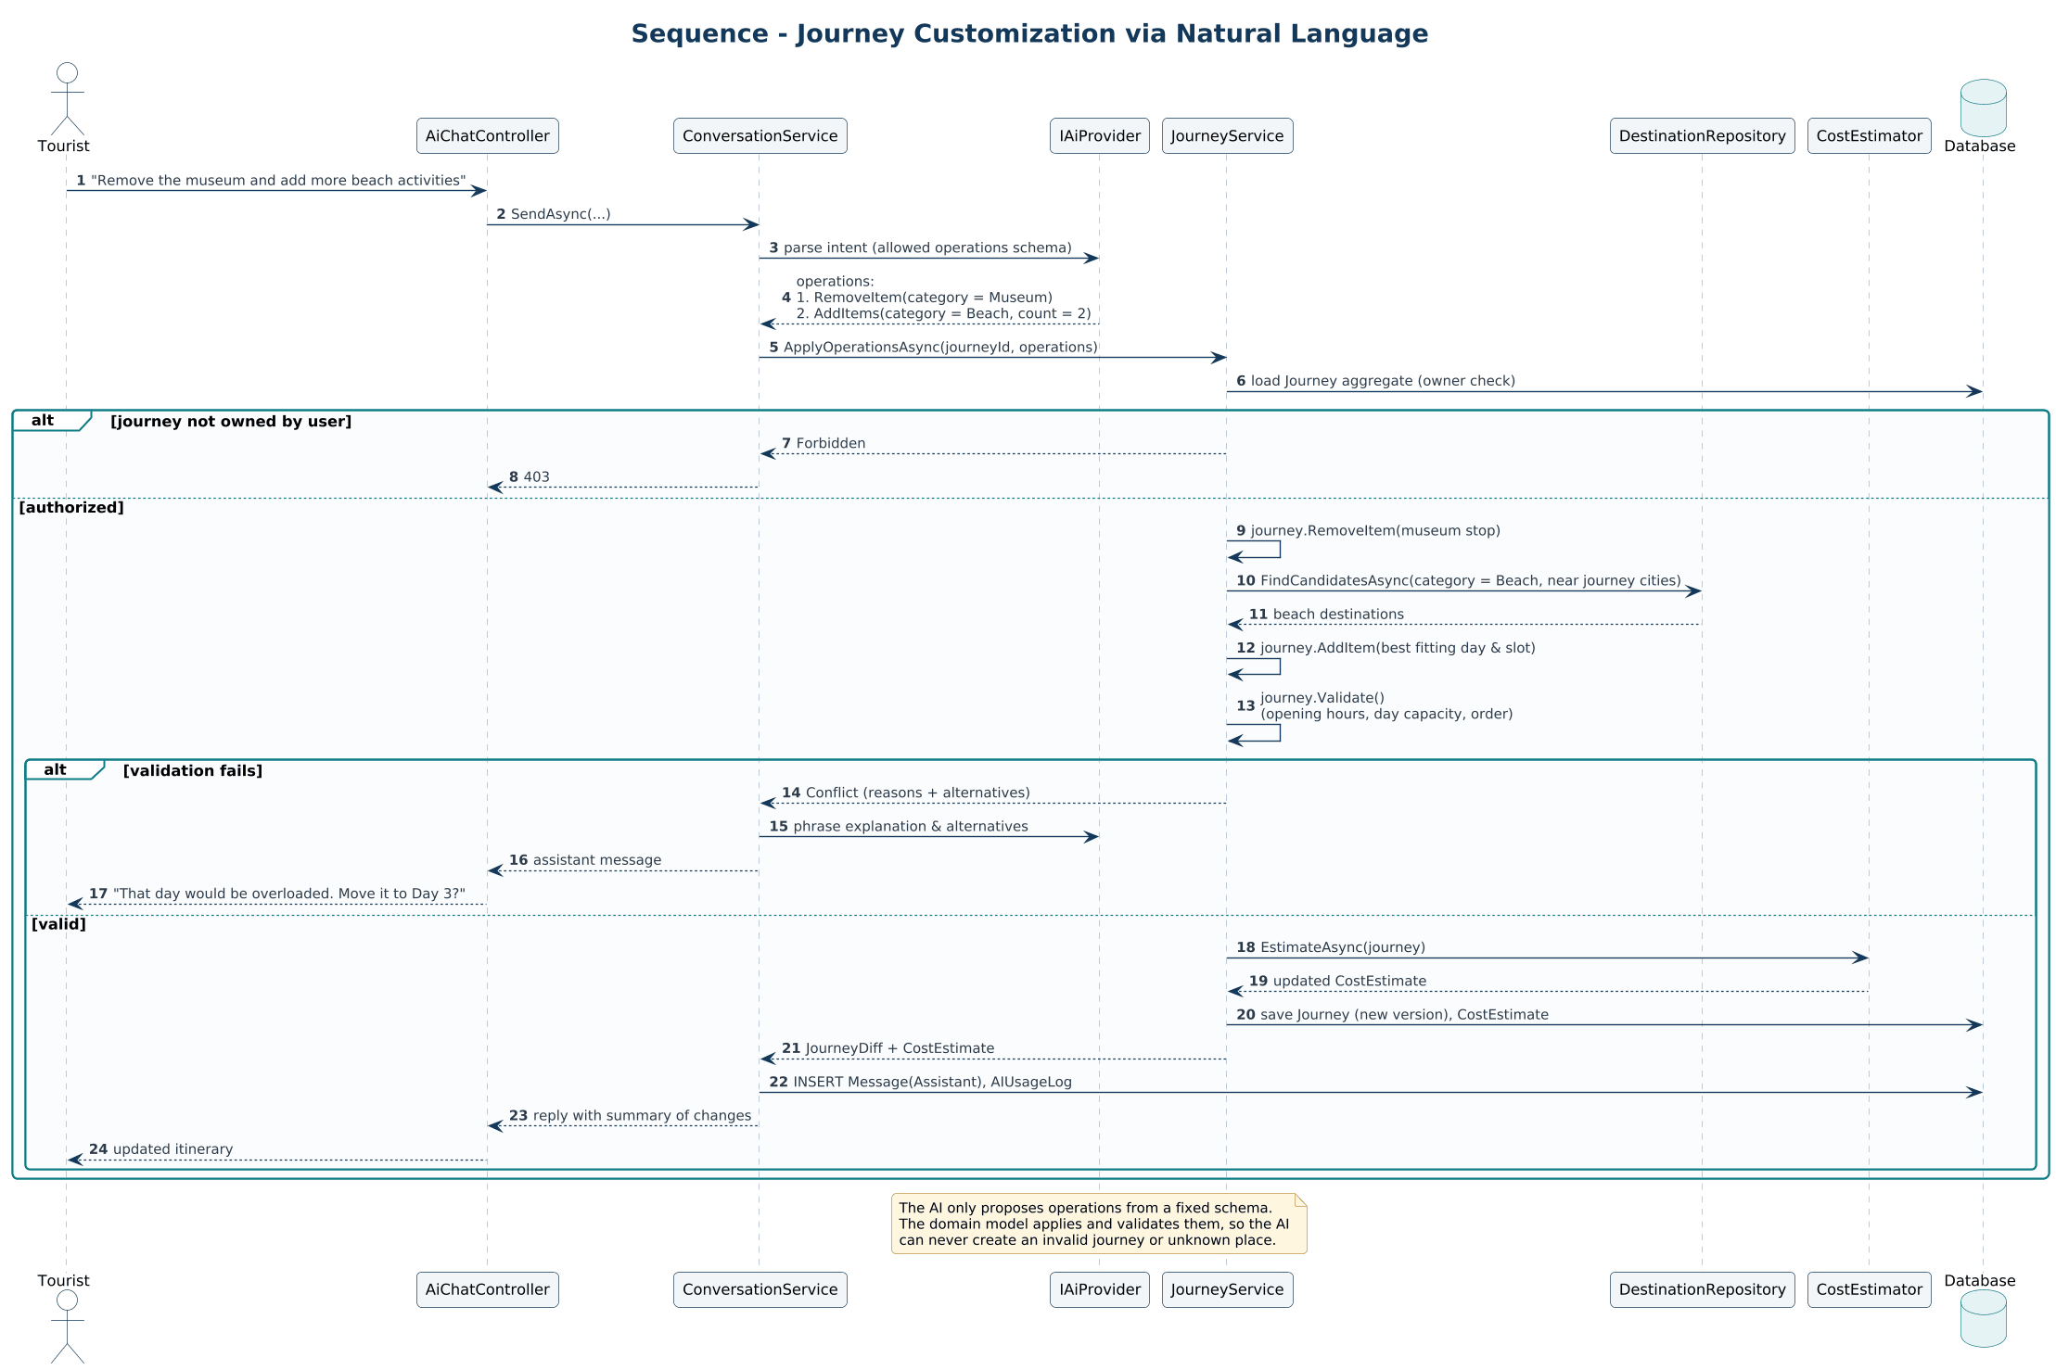

SEQ-08 Trip Cost Estimation
Computing an estimate range from tickets, transport, guide costs, and admin-configured rules, with currency conversion.
Traces to: F-14, F-27
- Cost components are gathered in parallel and returned as a range with a disclaimer.
- Exchange rates fall back to the last known value when the provider is unavailable.
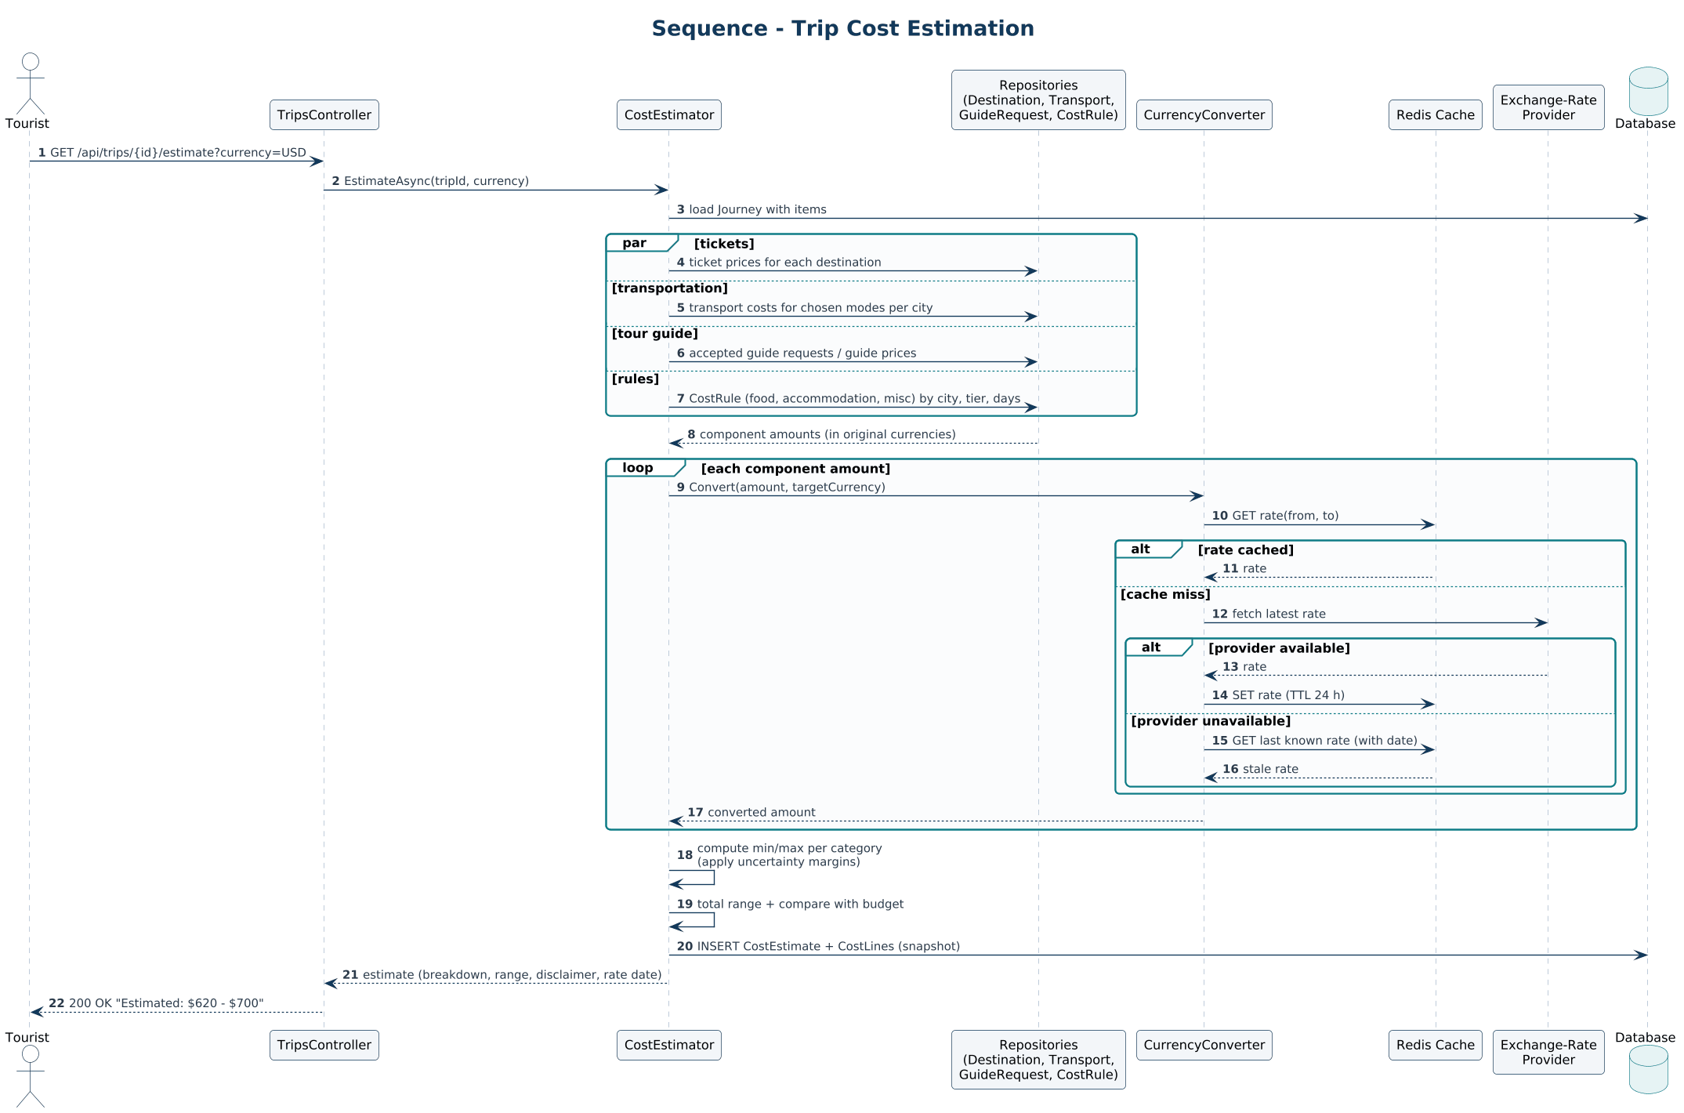

SEQ-09 Guide Request, Decision & Chat
Creating a request, guide acceptance or rejection, chat after acceptance, and automatic expiry.
Traces to: F-19, F-25
- Acceptance re-checks availability in a transaction with optimistic concurrency.
- A background job expires unanswered requests.
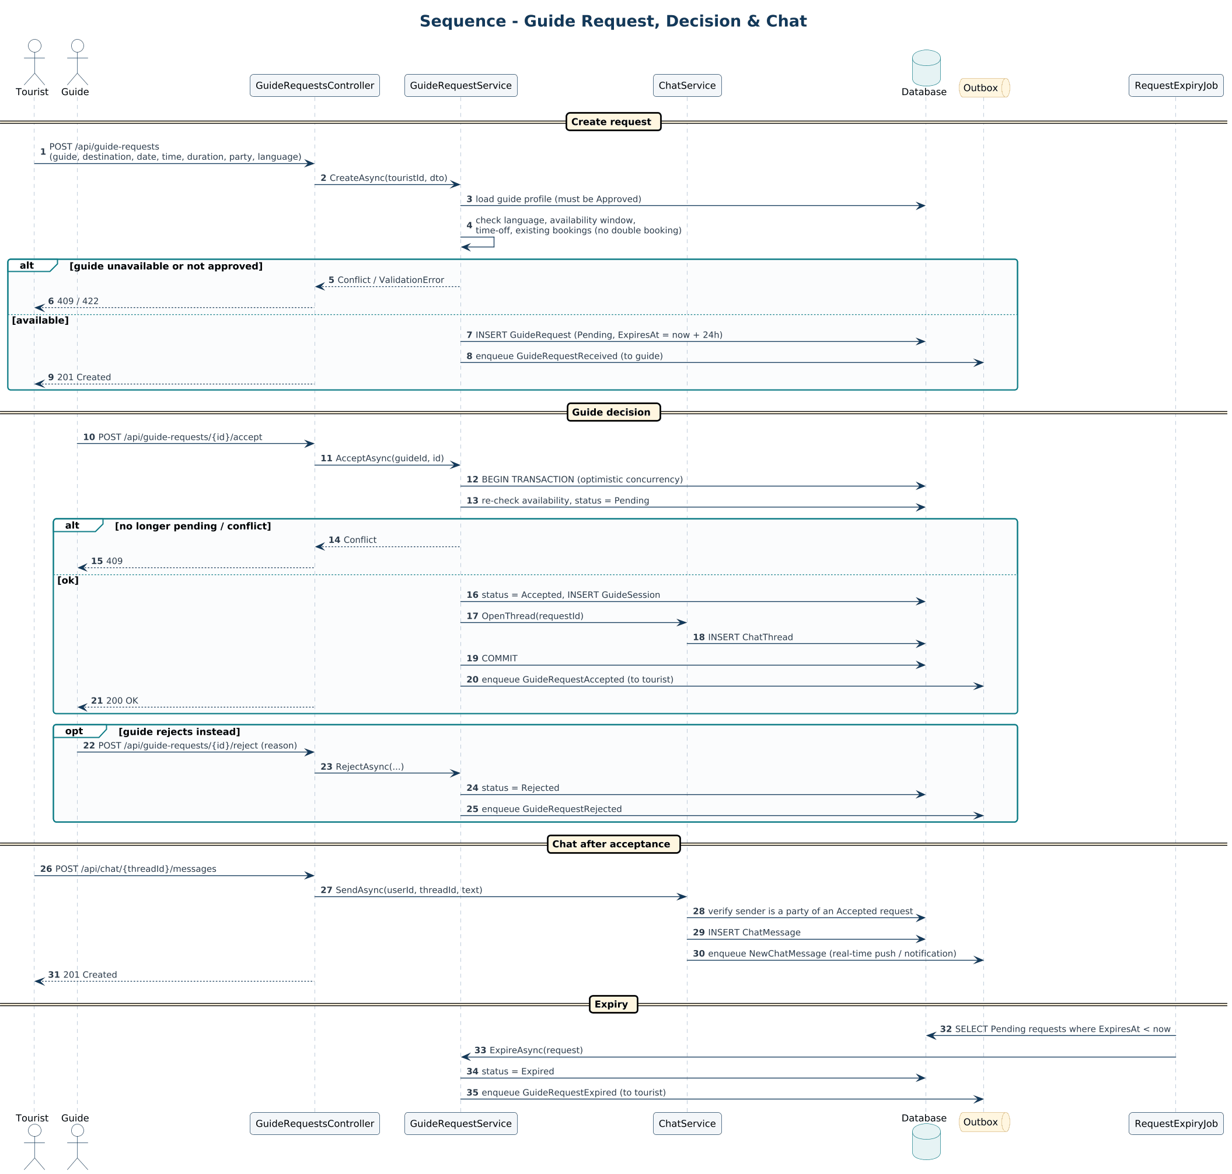

SEQ-10 AI Image Recognition & Price Estimate
Validating and analyzing an uploaded image and returning an estimated price range.
Traces to: F-17, F-27
- Low-confidence results ask for a new photo instead of guessing.
- Prices are always presented as estimates.
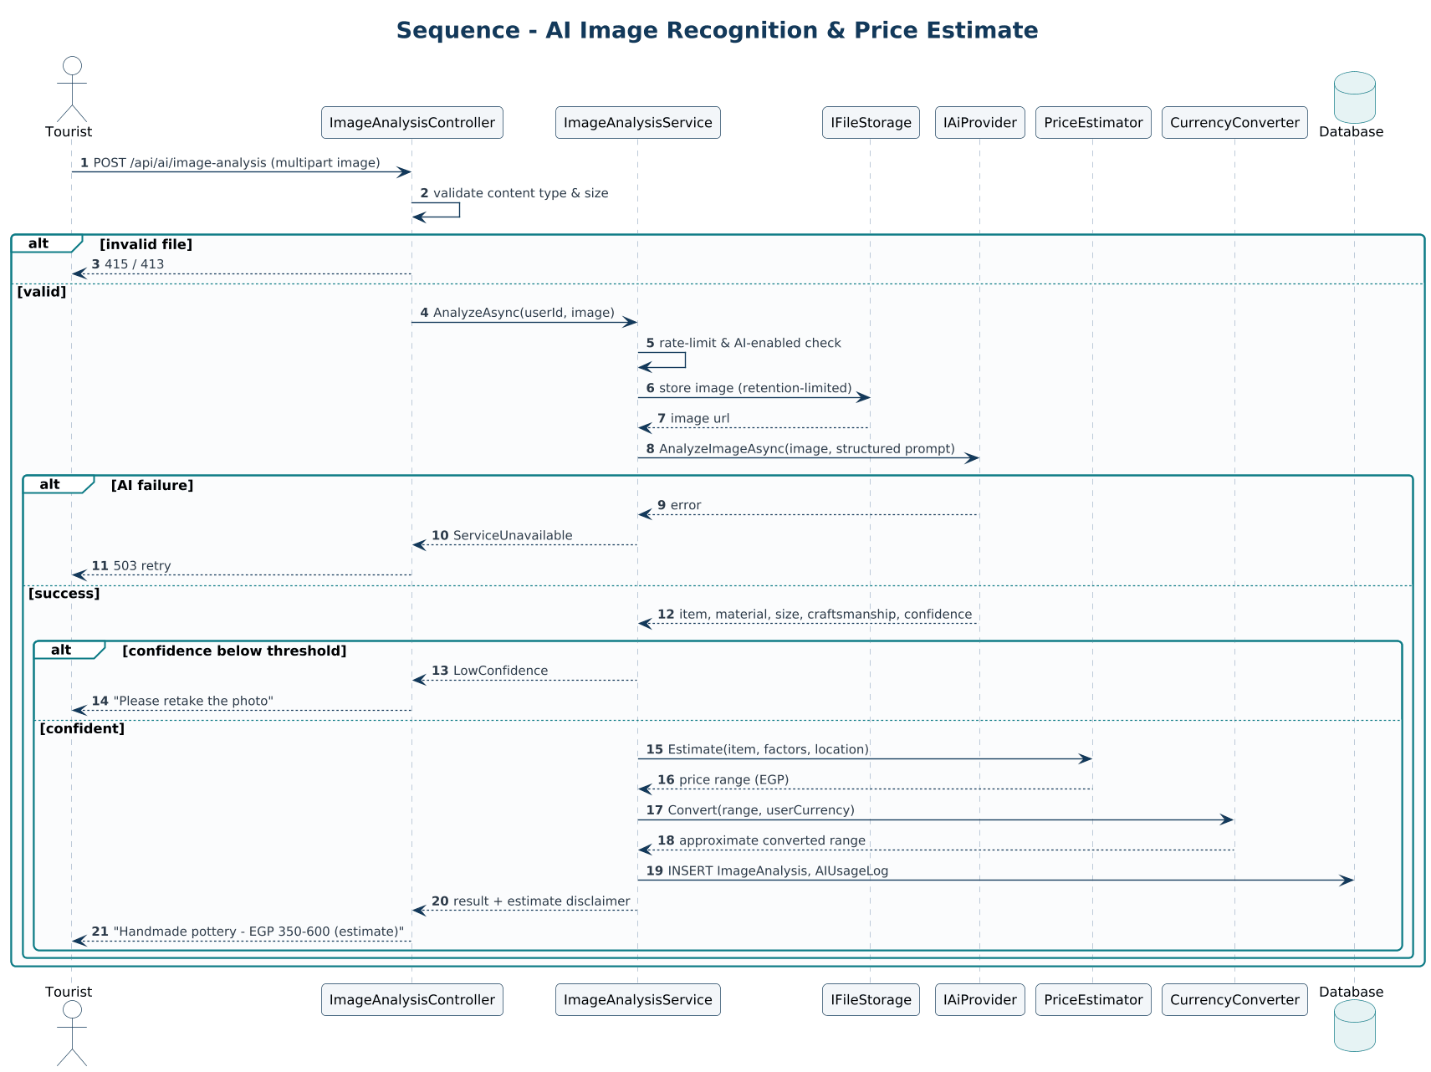

SEQ-11 Notification Delivery (Transactional Outbox)
Reliable event delivery to in-app and email channels using an outbox and a background processor.
Traces to: F-25
- The business change and the event are stored in one transaction.
- Failures retry with exponential backoff and end in a dead-letter state.
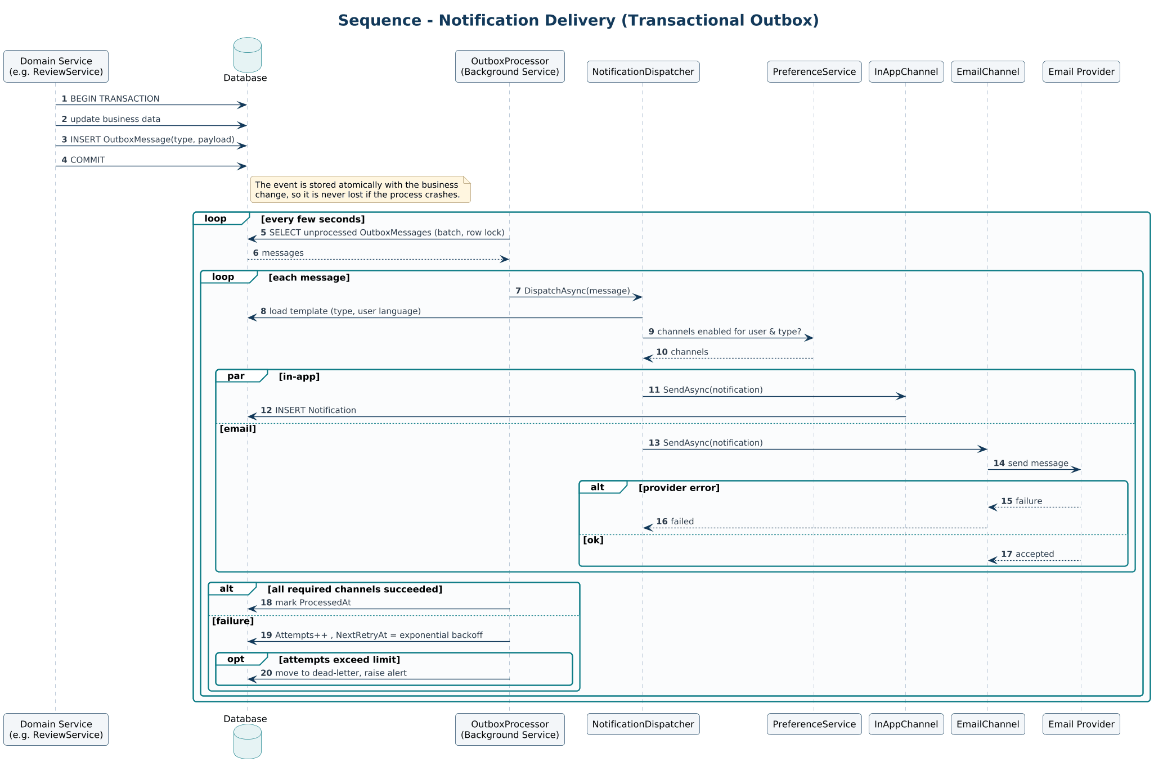

SEQ-12 Reporting & Moderation
Filing a report, investigation, admin action, and resolution.
Traces to: F-10, F-29
- Reporting a review flags it immediately; admins decide the final state.
- Every decision is written to the audit log.
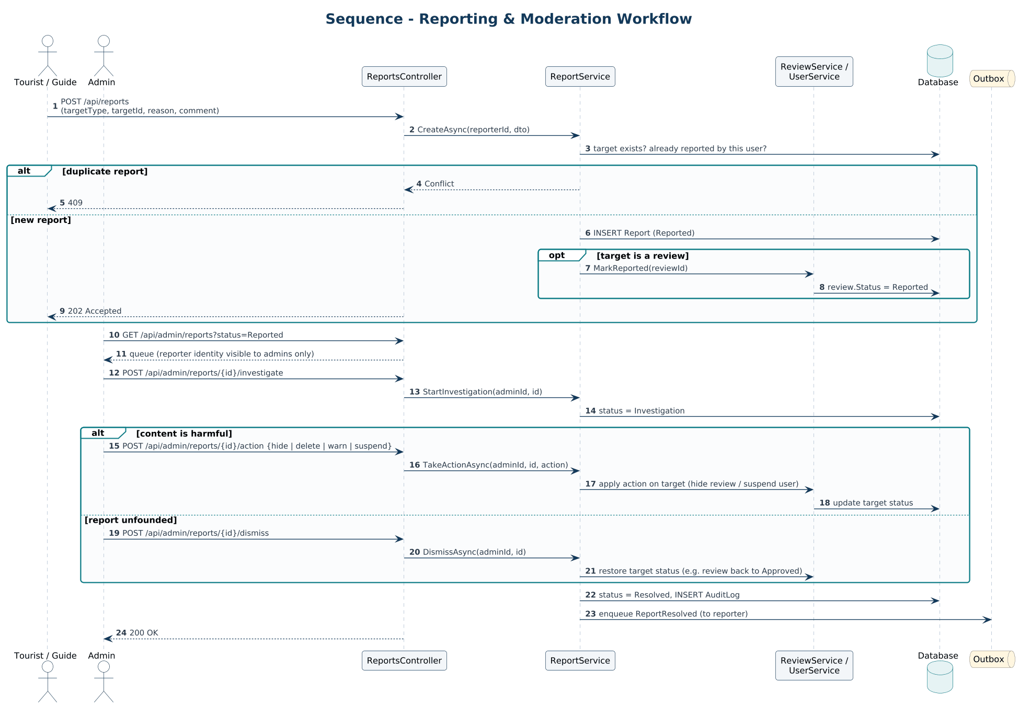

SEQ-13 Guide Onboarding & Admin Approval
Guide profile submission and the admin decision, including role assignment.
Traces to: F-01, F-18
- Approval and role grant happen atomically.
- Verification documents are kept in private storage.
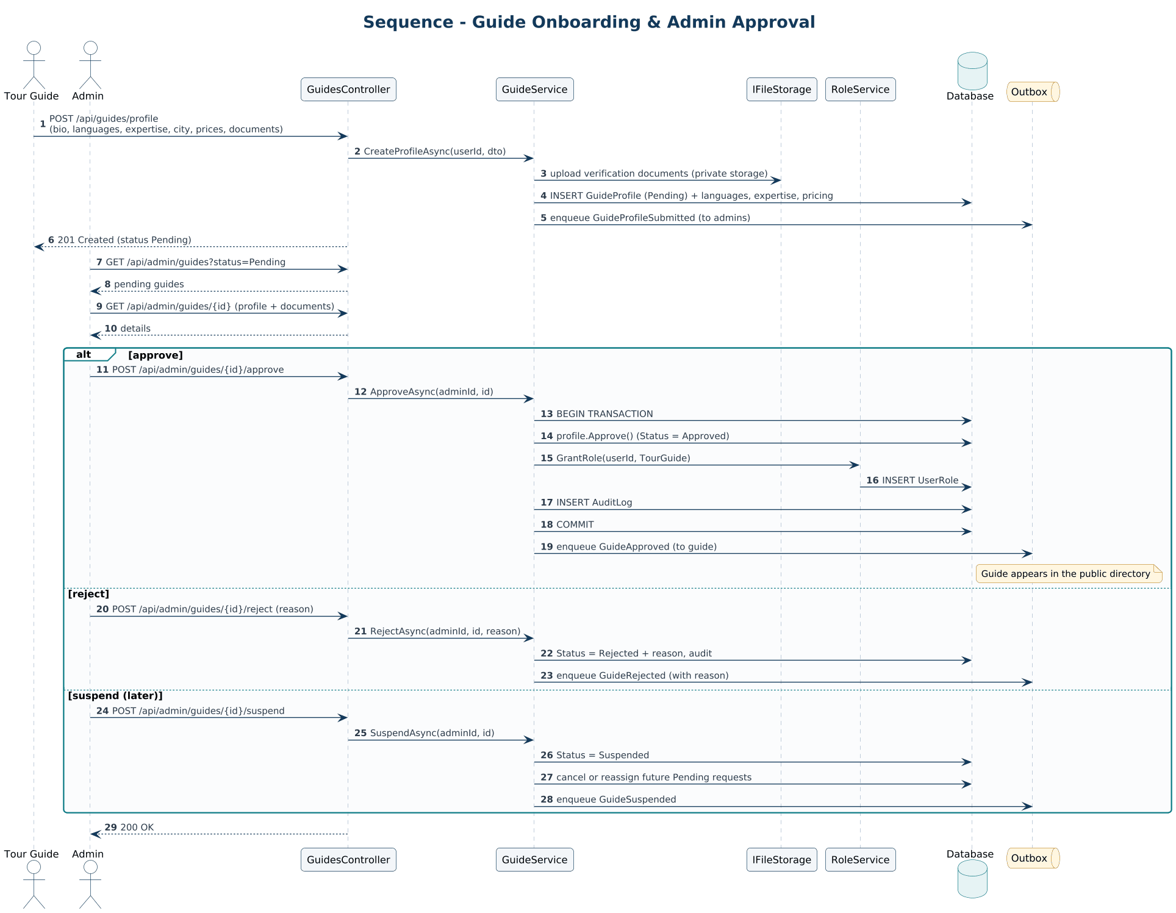

Part D – Activity Diagrams
Business and algorithmic workflows, including swimlanes for responsibilities.

ACT-01 Core Tourist Journey (End to End)
The complete tourist experience from registration to reviews, with the platform steps that support it.
Traces to: F-01, F-02, F-07, F-09, F-10, F-12–F-15, F-19
- Mirrors the core user journey in the PRD.
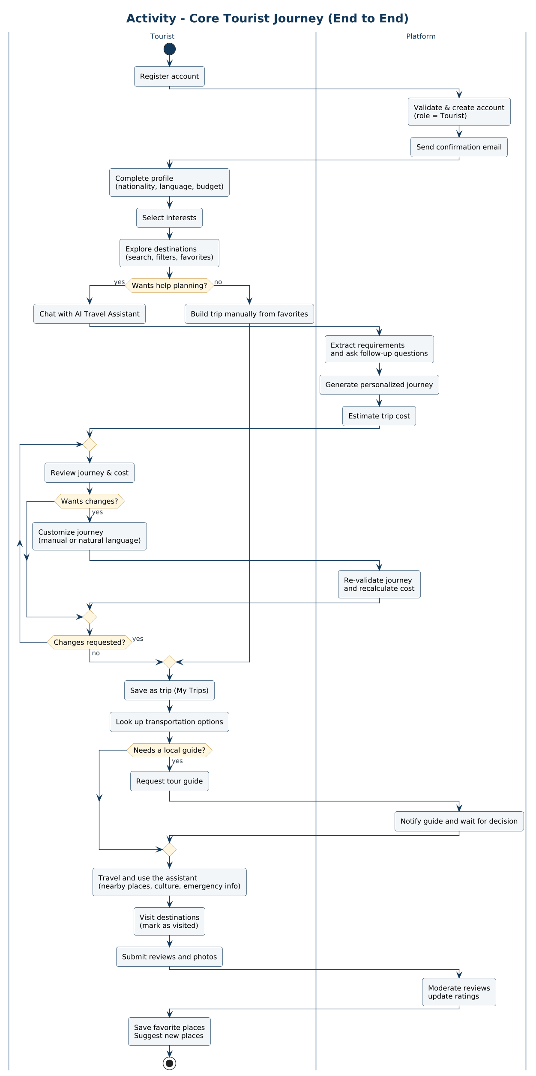

ACT-02 Journey Generation Algorithm
The backend algorithm that turns requirements into a feasible itinerary.
Traces to: F-13, F-14
- Constraint solving retries up to three times, dropping the lowest-scoring stops first.
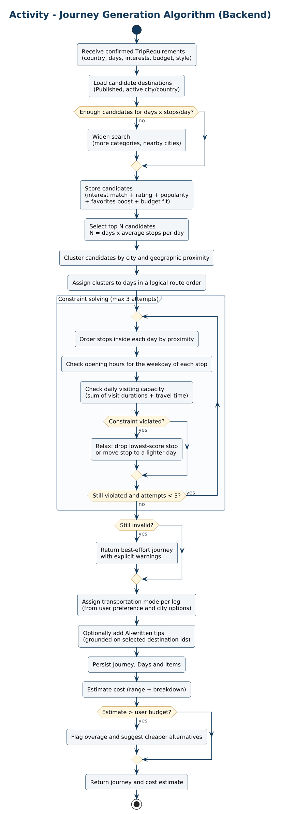

ACT-03 Guide Request Workflow
The guide request lifecycle across tourist, platform, and guide.
Traces to: F-18, F-19
- Every unhappy path ends with a notification to the tourist.
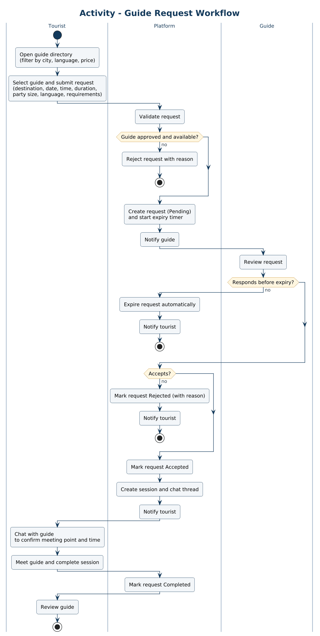

ACT-04 Place Suggestion to Published Destination
How a tourist suggestion becomes a published destination.
Traces to: F-06, F-11
- Publishing is blocked until all required fields are complete.
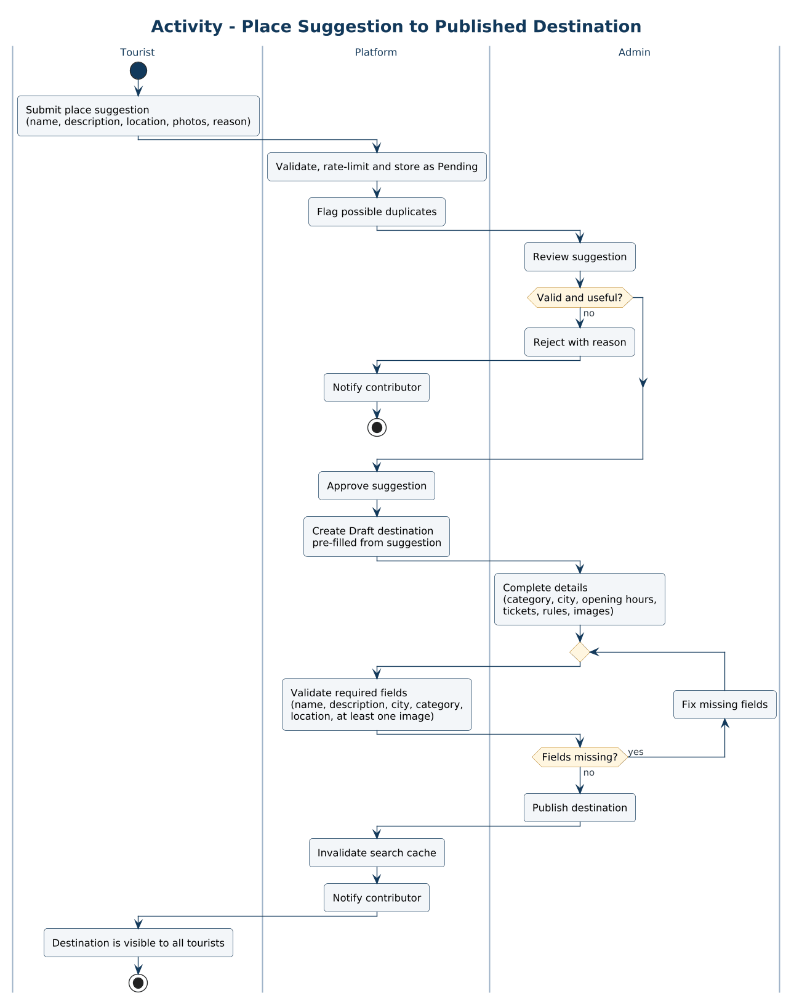

Part E – State Machine Diagrams
Lifecycle states and allowed transitions for the entities that carry workflow.

ST-01 Review
Moderation lifecycle of a review.
Traces to: F-10, F-29
- Only Approved reviews are public and counted in ratings.
- Editing an approved review sends it back to moderation.
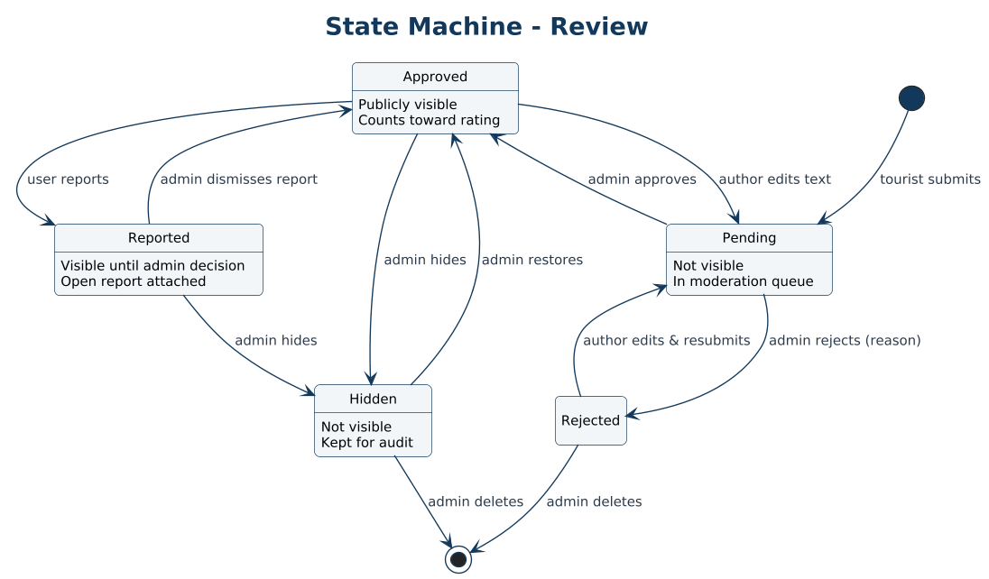

ST-02 Place Suggestion
Lifecycle of a tourist place suggestion.
Traces to: F-11
- Approval produces a Draft destination; rejection requires a reason.
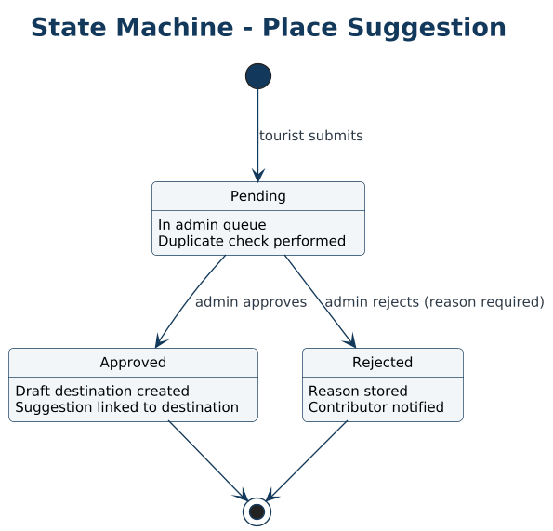

ST-03 Destination
Publication lifecycle of a destination.
Traces to: F-06
- Archived destinations stay in existing trips but are hidden from search.
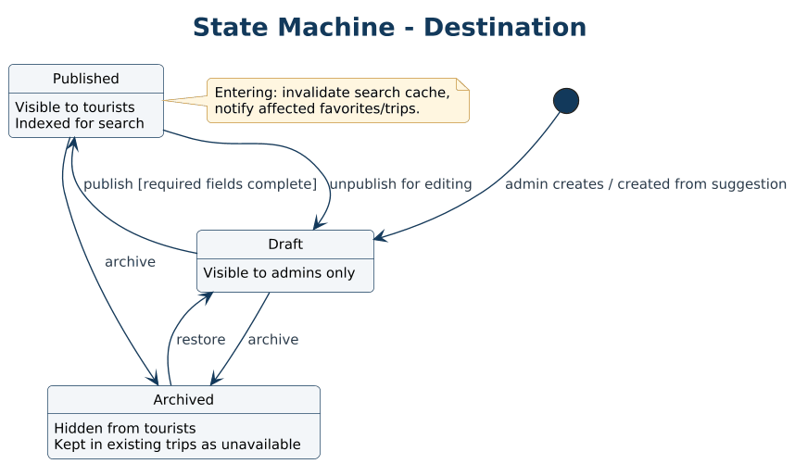

ST-04 Guide Profile
Approval lifecycle of a guide profile.
Traces to: F-18
- Changes to verification-sensitive data return the profile to Pending.
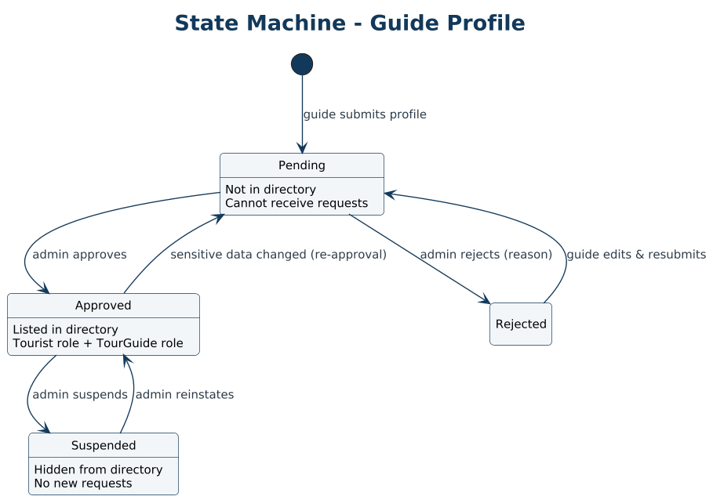

ST-05 Guide Request
Lifecycle of a guide request.
Traces to: F-19
- Pending requests expire automatically; only accepted requests can be completed.
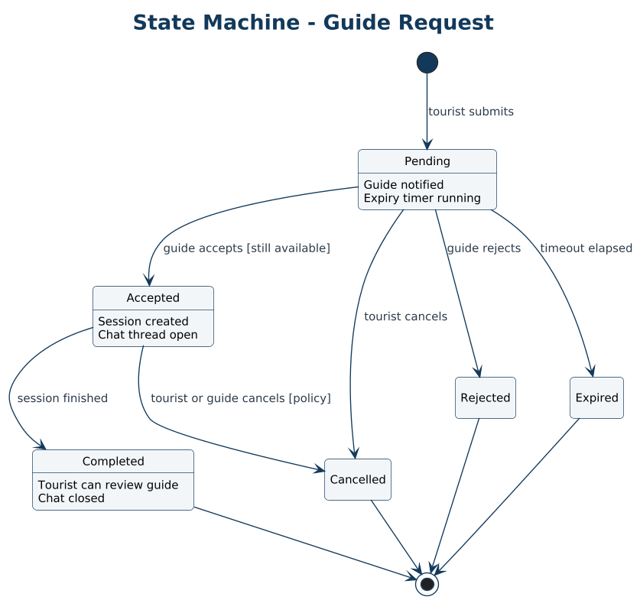

ST-06 Trip (Lifecycle and Visibility)
Trip status and its independent sharing visibility.
Traces to: F-15
- Lifecycle and visibility are orthogonal, shown as concurrent regions.
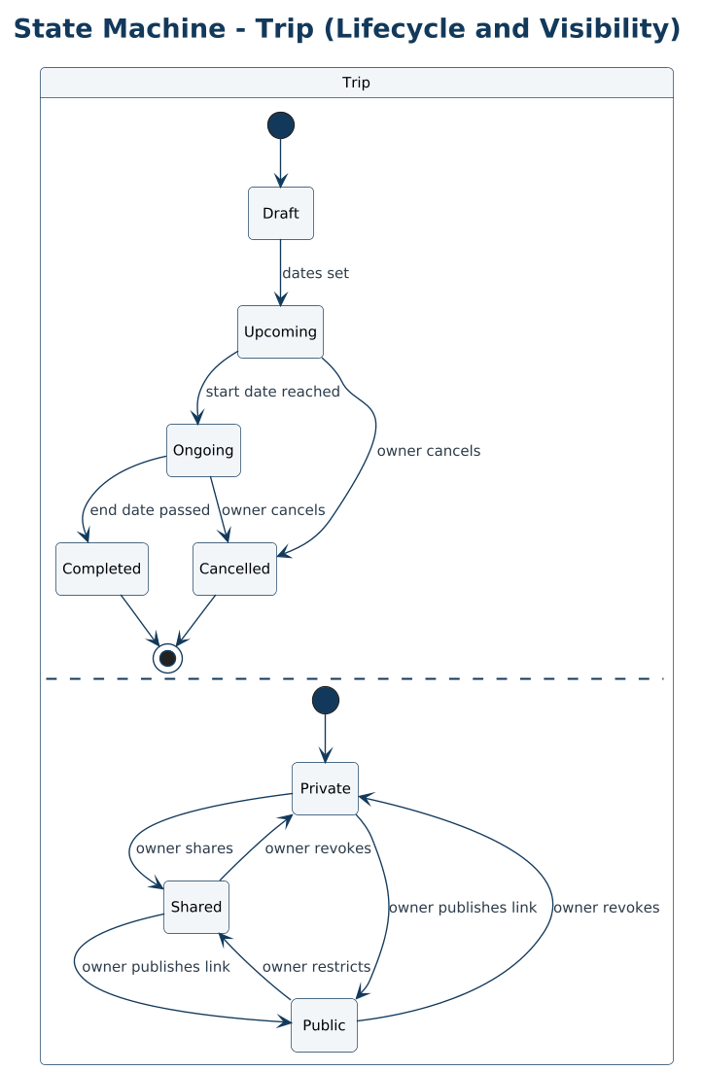

ST-07 Report
Moderation workflow of a report.
Traces to: F-29
- Every resolution is recorded in the audit log.
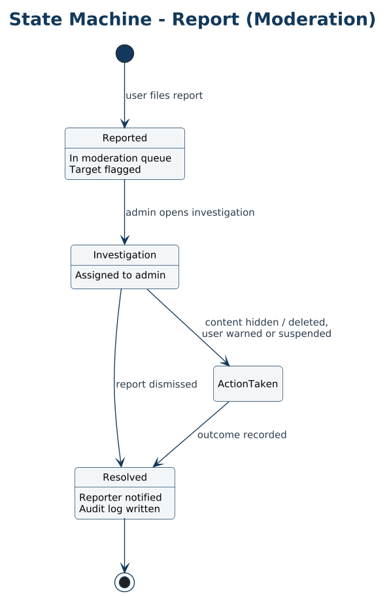

ST-08 User Account
Account states from registration to deletion.
Traces to: F-01, F-31
- Deactivation revokes all sessions immediately.
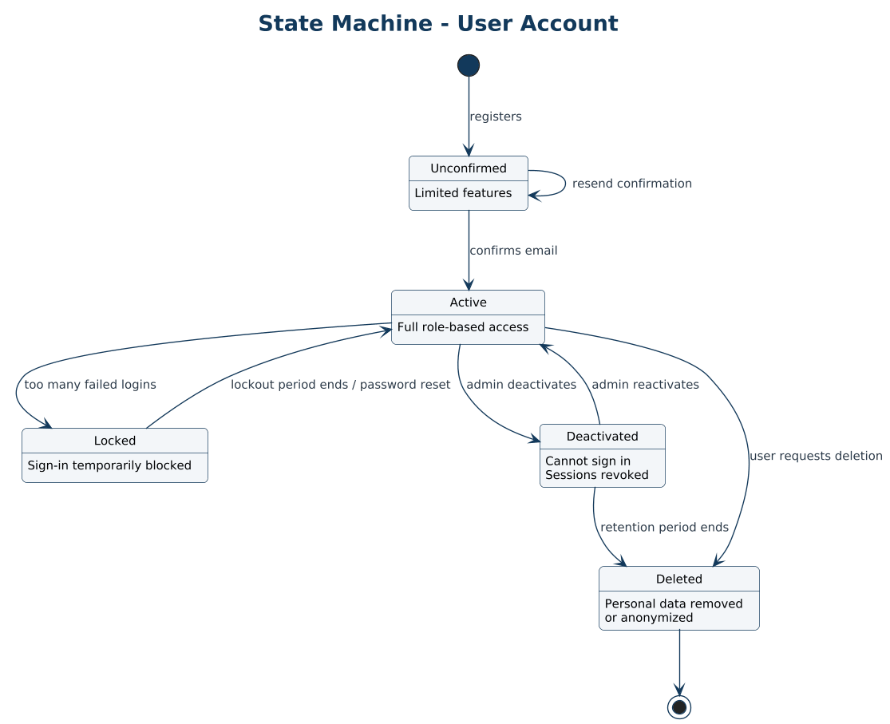

Part F – Architecture Diagrams
Module structure, logical components, and the proposed deployment topology.

ARCH-01 Package Diagram – Modular Monolith
Modules, their grouping, and the allowed dependency directions.
Traces to: F-01, F-03, F-06, F-10, F-13, F-18, F-25, F-30
- Modules talk through contracts or events, never through another module’s tables.
- Each module can be extracted into a service later without redesign.
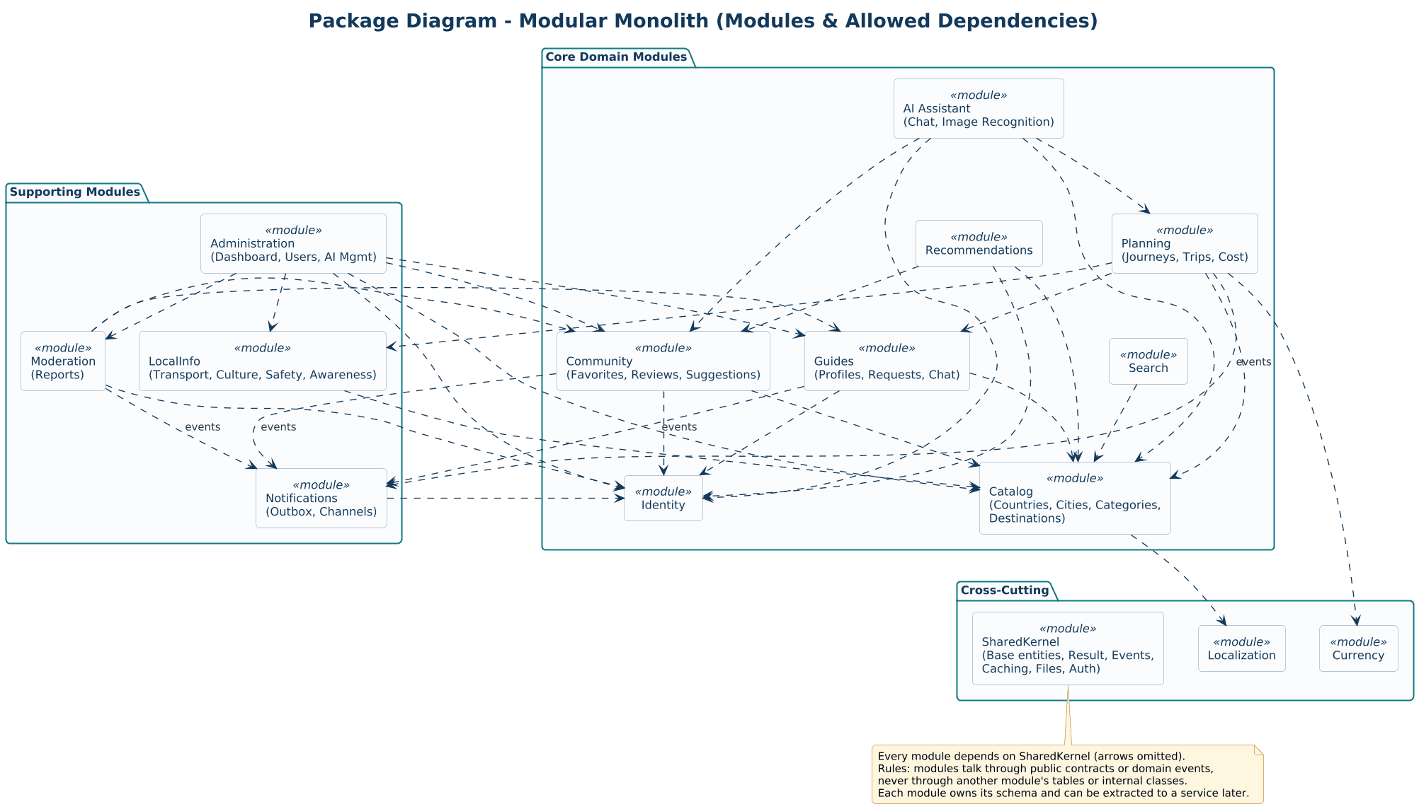

ARCH-02 Component Diagram – Logical Architecture
Clients, edge, API host, application modules, background worker, data stores, and external services.
Traces to: F-01, F-12, F-19, F-25, F-27, F-30
- Public and Admin APIs share modules but use separate authorization policies.
- The worker handles outbox delivery, request expiry, and exchange-rate refresh.
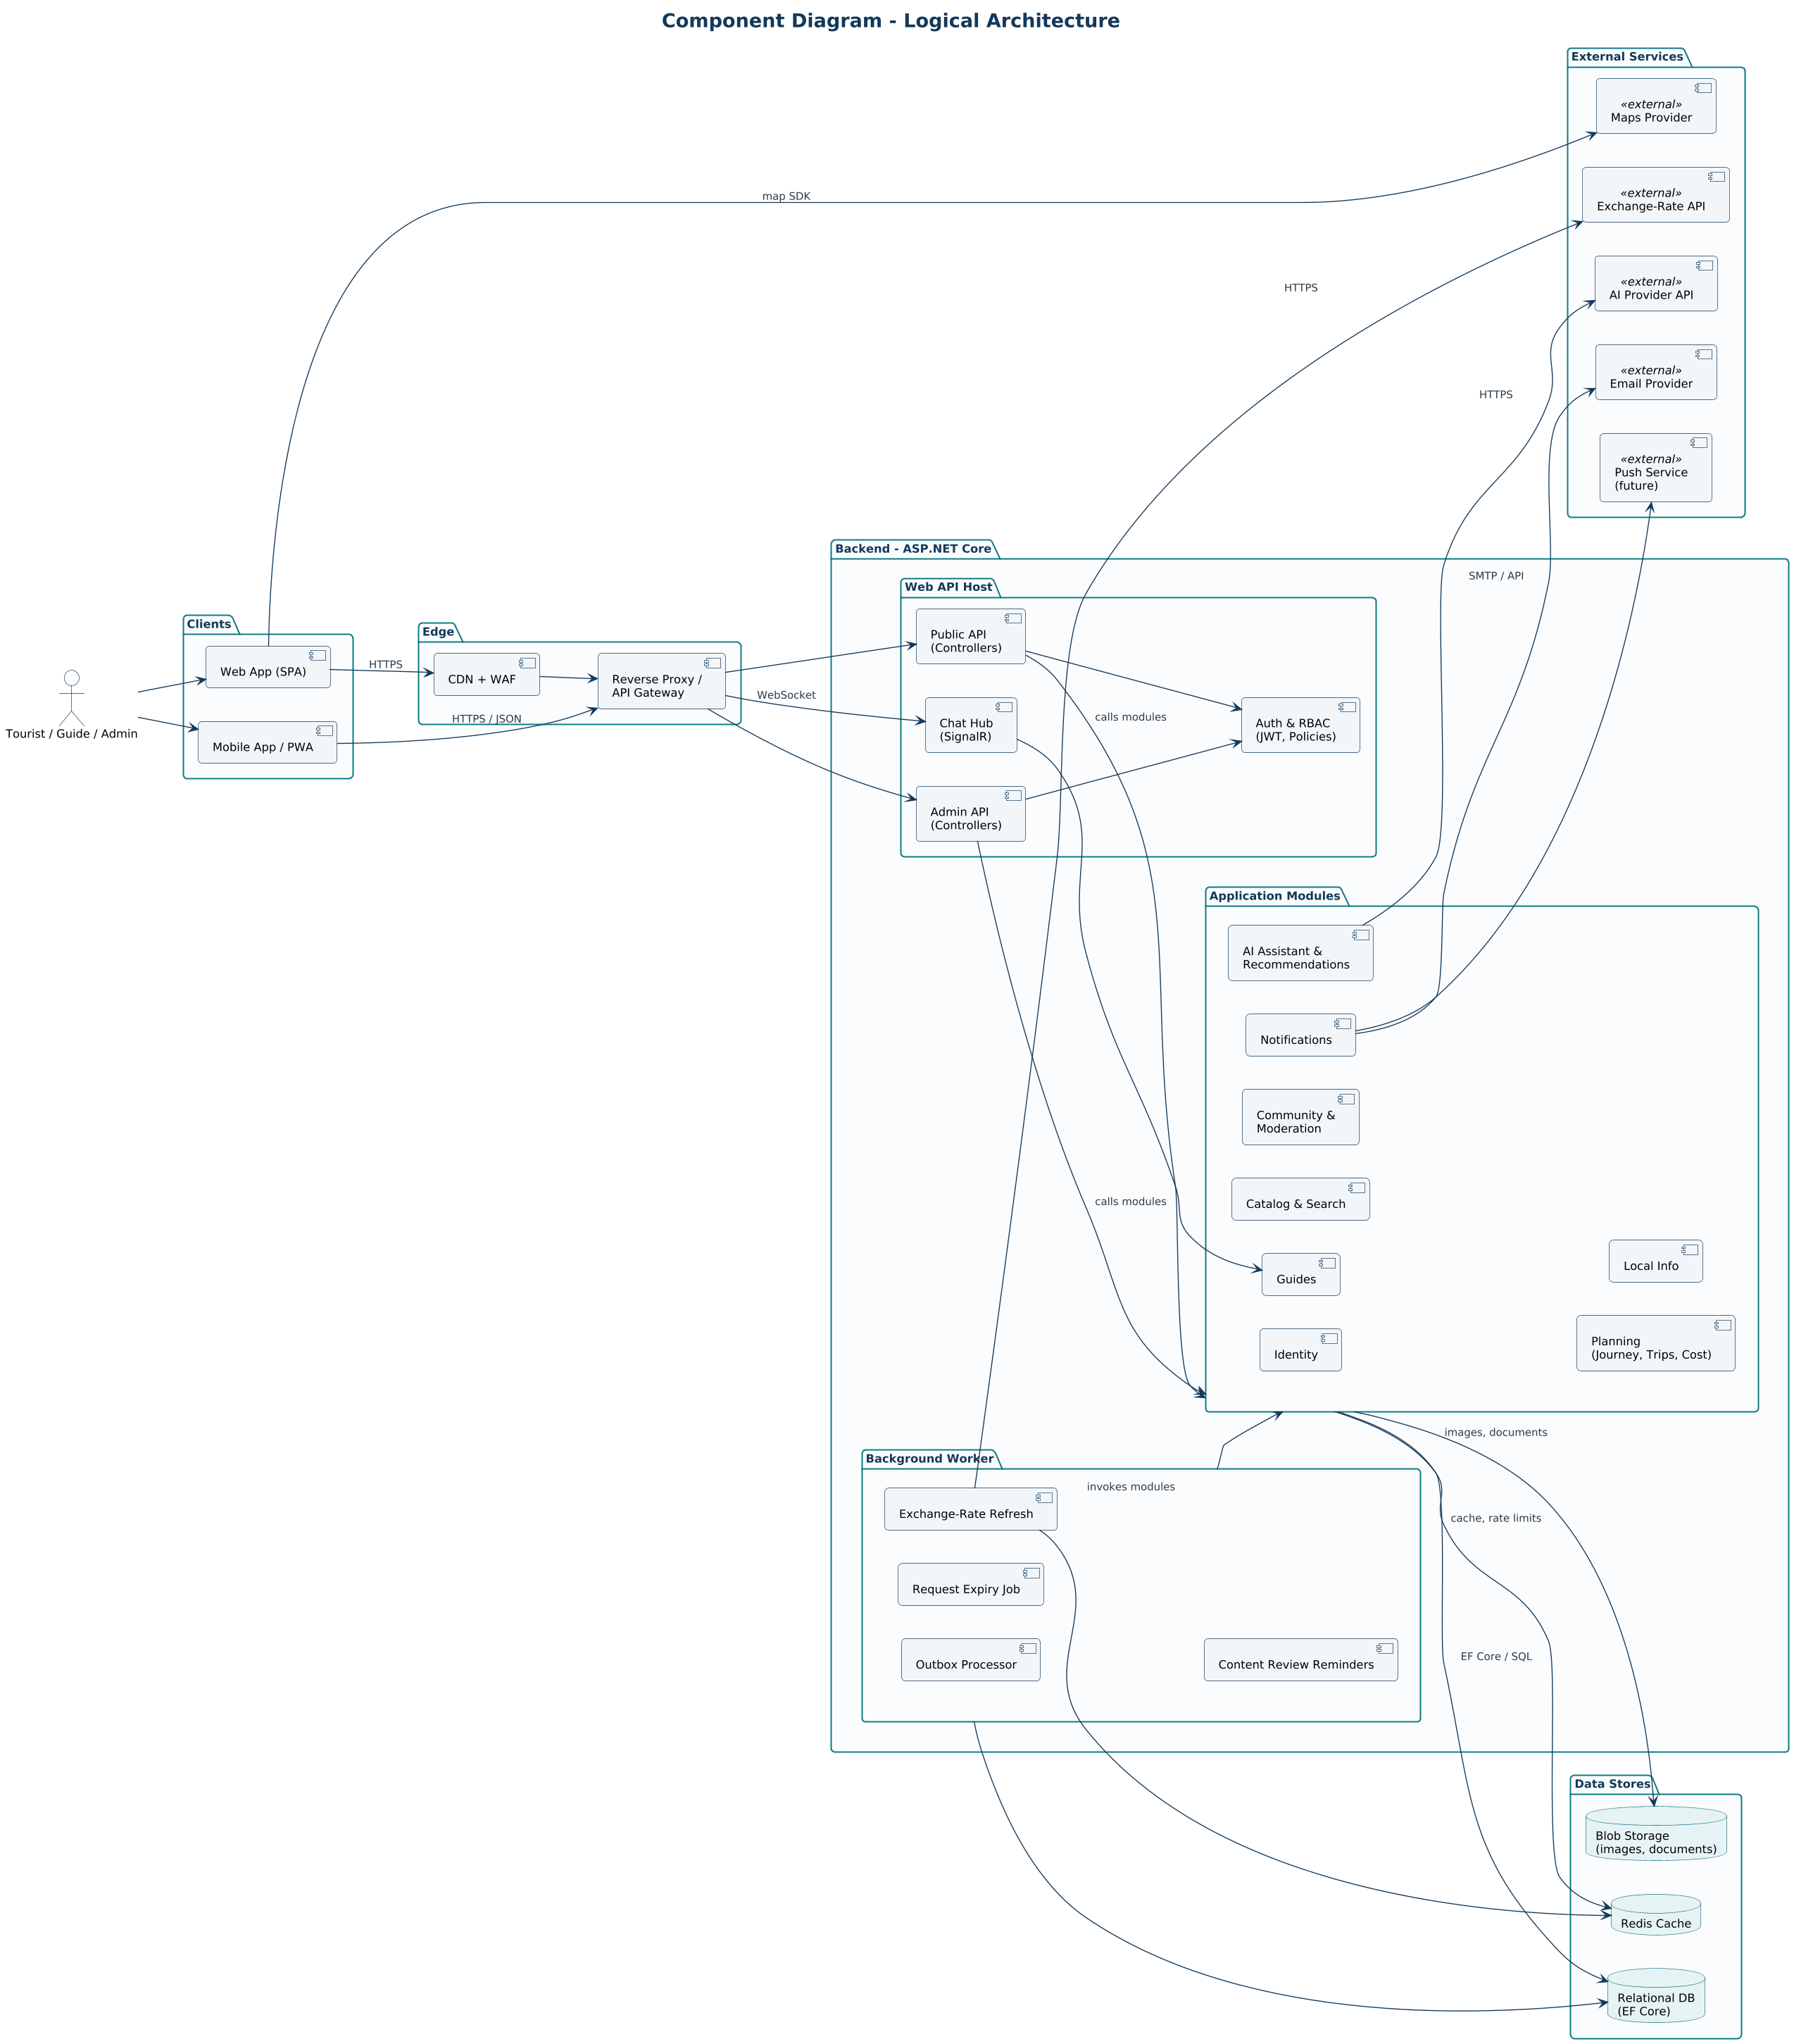

ARCH-03 Deployment Diagram – Proposed Topology
How the system is deployed: edge, load balancer, containers, data tier, platform services, CI/CD, and external providers.
Traces to: F-30
- API containers are stateless and scale horizontally.
- Read queries can use a replica; secrets come from a vault.
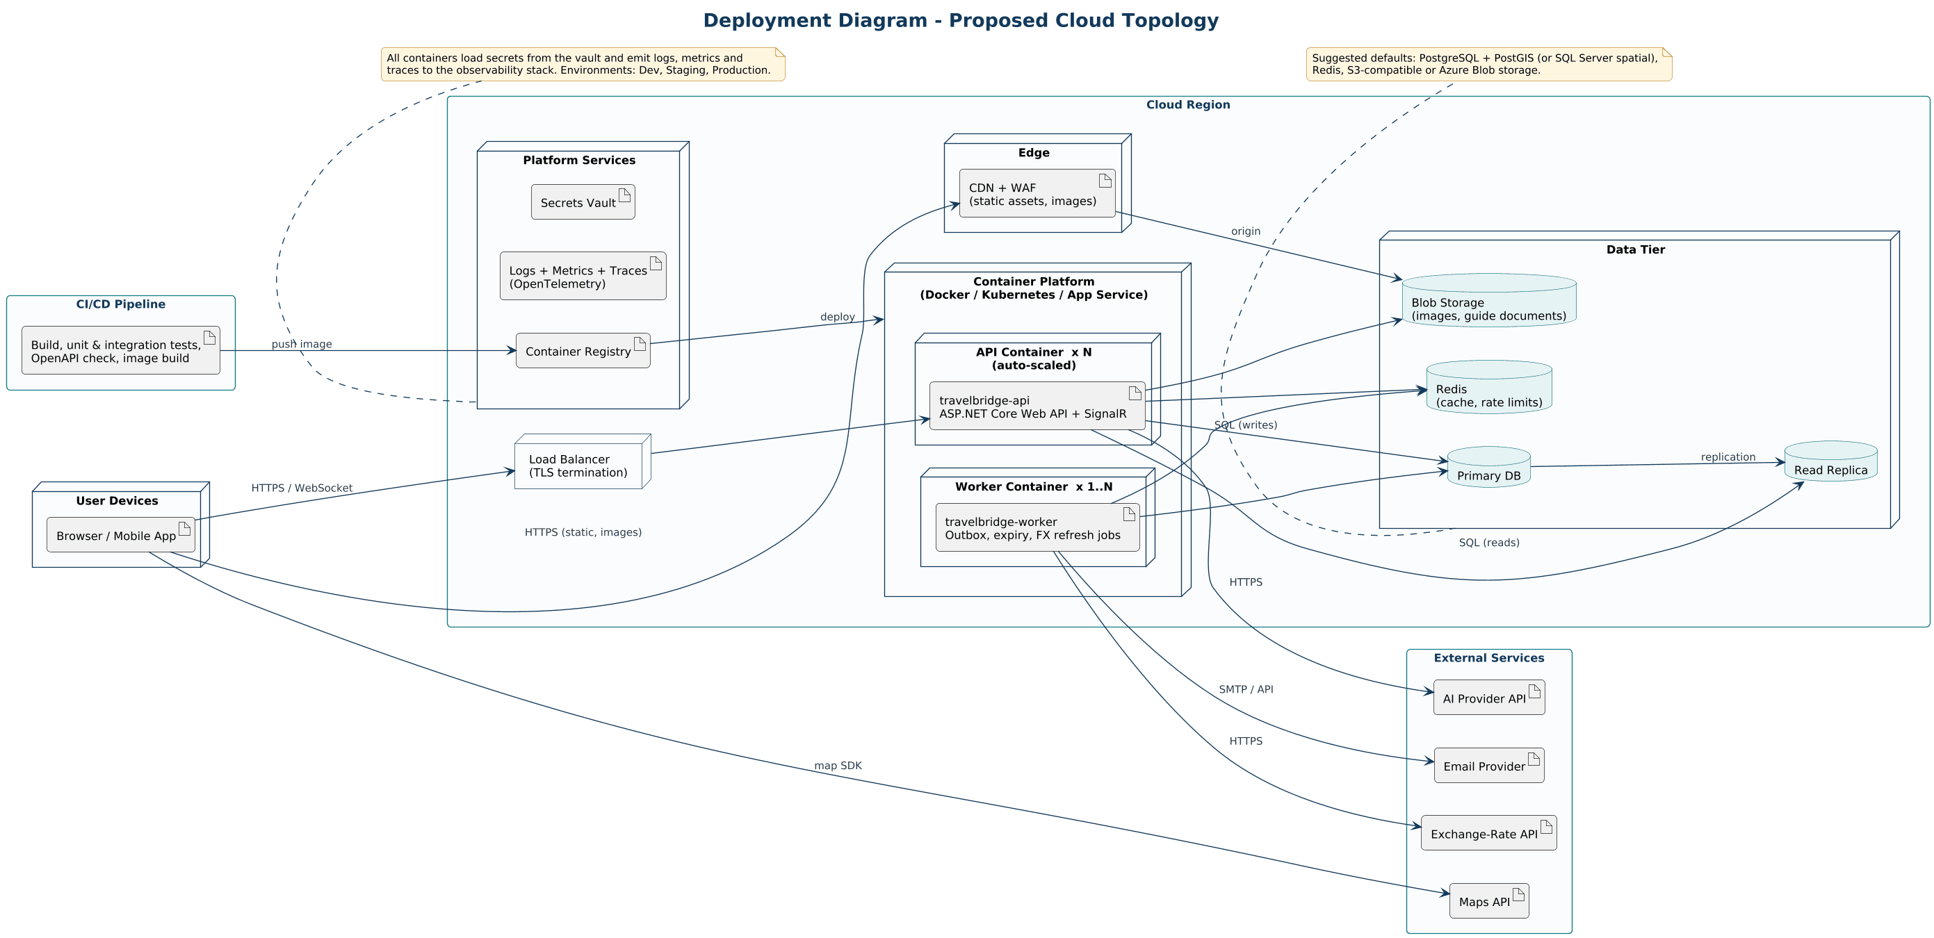

Part G – Entity-Relationship Diagrams
Physical data model. Types follow PostgreSQL naming and can be mapped to SQL Server equivalents.

ERD-01 Identity, Geography & Catalog
Tables, keys, and relationships for accounts, geography, and destination content.
Traces to: F-01–F-06, F-26
- Public entities use UUID keys; small reference tables use integer keys.
- Translation tables give every language its own row with English fallback.
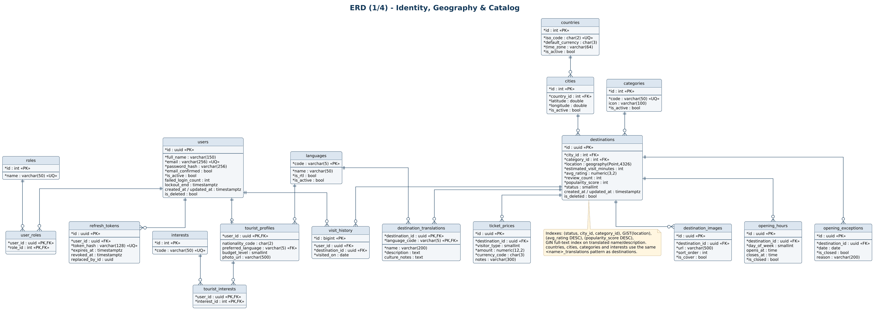

ERD-02 Community, Moderation, Notifications & Audit
Tables for favorites, reviews, suggestions, reports, notifications, the outbox, and audit logs.
Traces to: F-09–F-11, F-25, F-29
- One review per user per destination is enforced by a unique constraint.
- Reports use a polymorphic target, so integrity is enforced in the application layer.
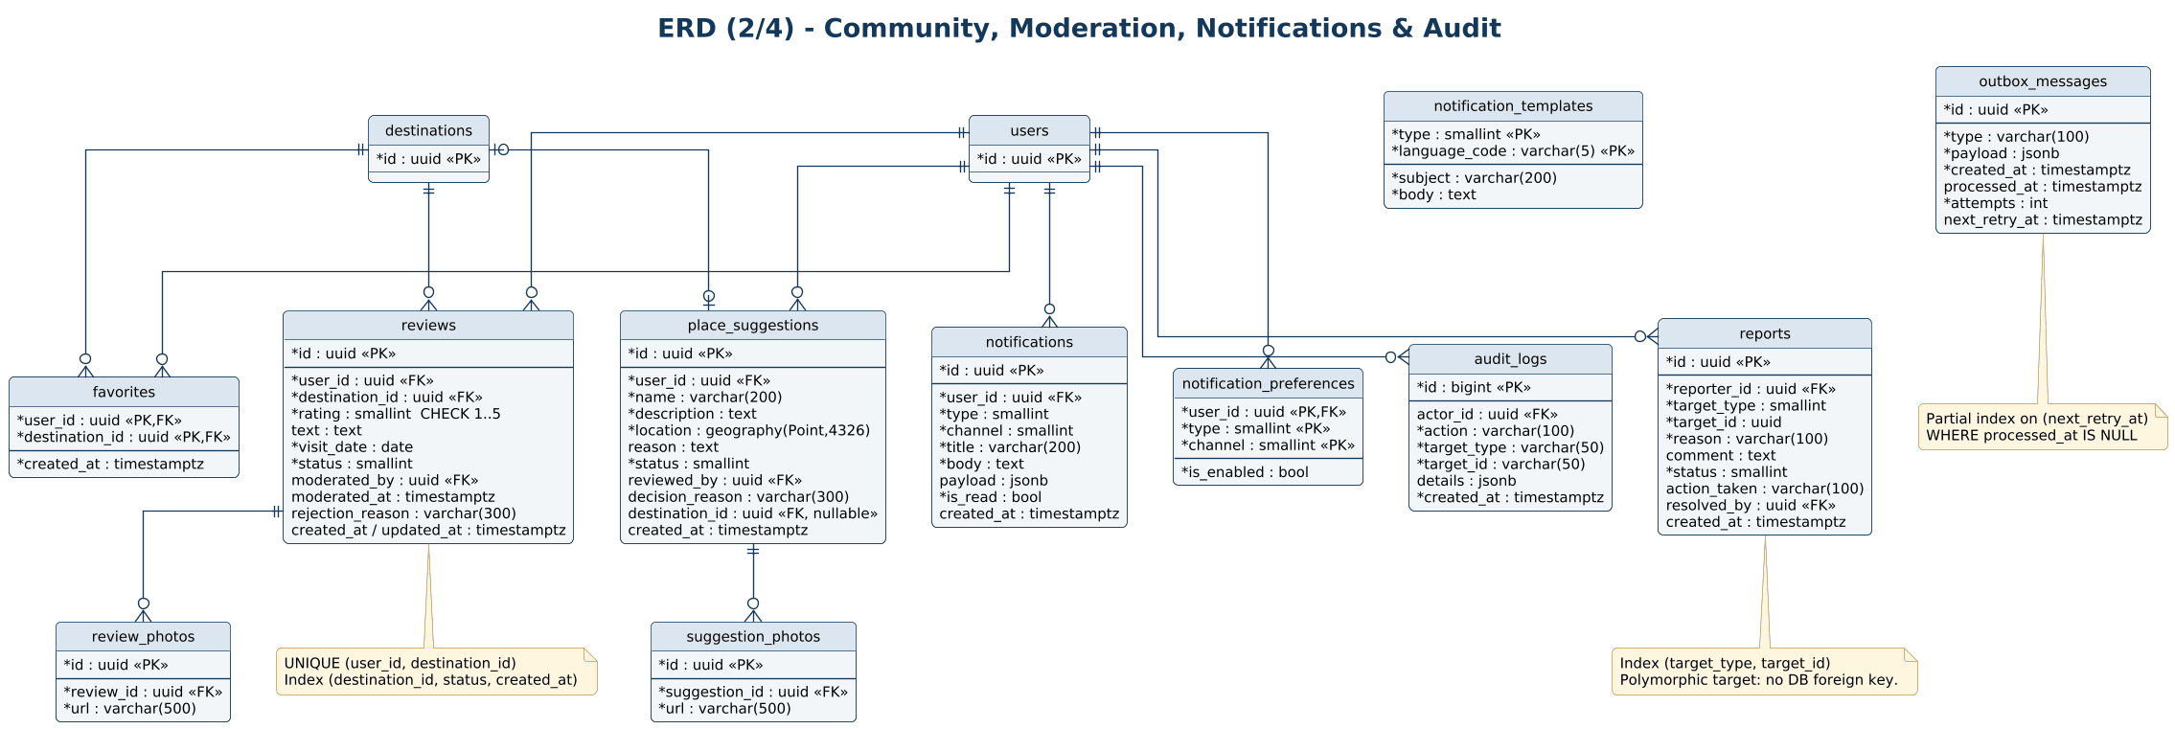

ERD-03 Conversations, Journeys, Trips, Cost & AI
Tables for AI conversations, itineraries, trips, cost estimates, exchange rates, and AI usage logs.
Traces to: F-12–F-17, F-27
- Cost estimates are stored as snapshots to keep history stable.
- Journeys carry a version number to support safe concurrent edits.
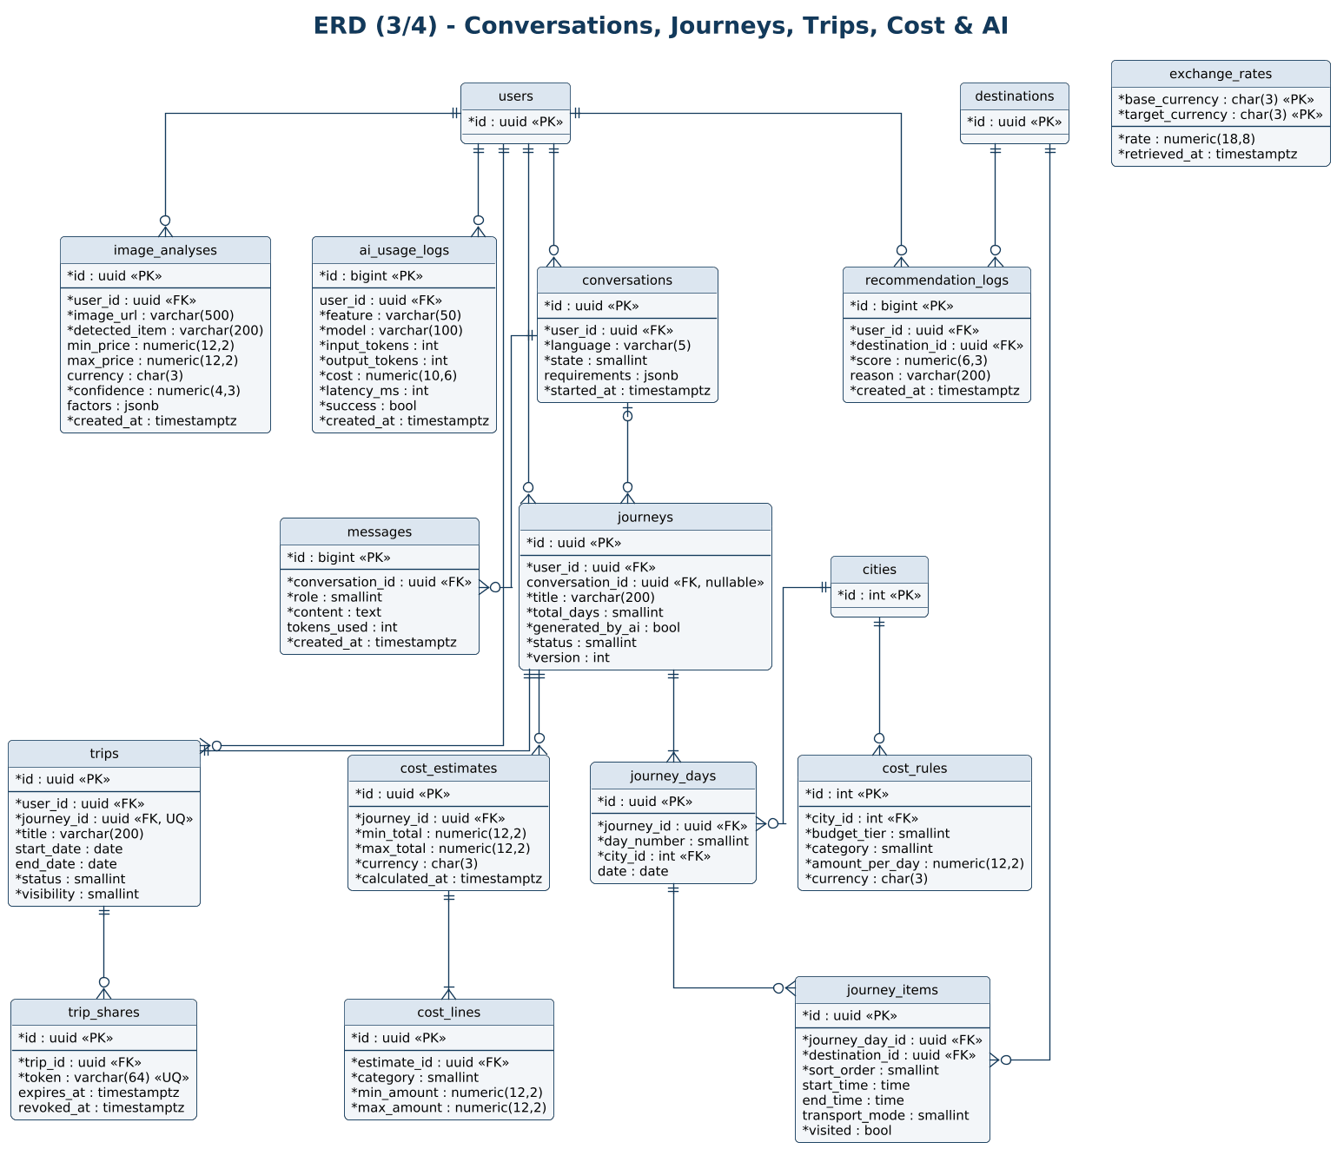

ERD-04 Guides, Chat, Transportation, Culture & Safety
Tables for guides, requests, chat, transportation, rules, emergency data, and awareness content.
Traces to: F-18–F-20, F-22–F-24
- A partial unique index prevents double-booking an accepted guide slot.
- Rules and emergency contacts use a (scope_type, scope_id) pair.
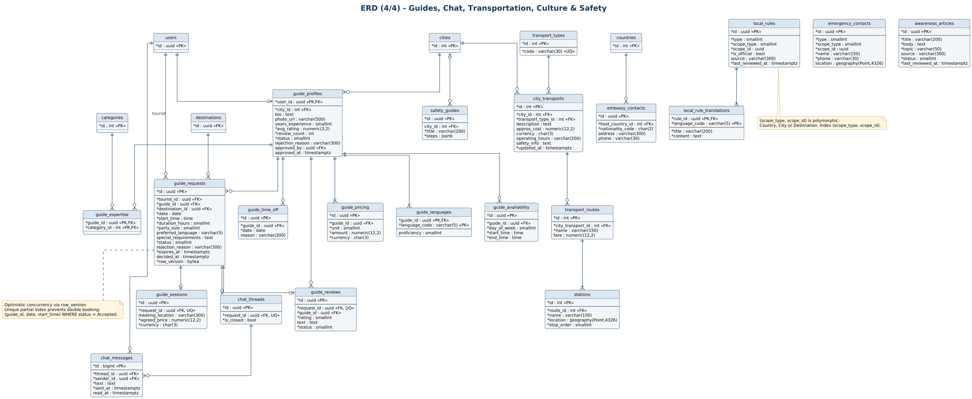

Appendix A. Feature-to-Diagram Traceability
Which diagrams describe each feature from the requirements specification.
Feature | Name | Diagrams
F-01 | Authentication & Authorization | UC-01, CLS-01, SEQ-01, SEQ-13, ACT-01, ST-08, ARCH-01, ARCH-02, ERD-01
F-02 | Tourist Profile & Preferences | UC-02, CLS-01, ACT-01, ERD-01
F-03 | Countries Management | UC-01, UC-05, CLS-01, ARCH-01, ERD-01
F-04 | Cities | UC-01, UC-05, CLS-01, ERD-01
F-05 | Destination Categories | UC-05, CLS-01, ERD-01
F-06 | Destinations | UC-01, UC-05, CLS-01, CLS-06, SEQ-04, ACT-04, ST-03, ARCH-01, ERD-01
F-07 | Explore & Search | UC-01, CLS-06, SEQ-02, ACT-01
F-08 | Destination Details | UC-01, CLS-06
F-09 | Favorites / Wishlist | UC-02, CLS-02, ACT-01, ERD-02
F-10 | Reviews & Feedback | UC-02, UC-06, CLS-02, SEQ-03, SEQ-12, ACT-01, ST-01, ARCH-01, ERD-02
F-11 | Place Suggestions | UC-02, UC-06, CLS-02, SEQ-04, ACT-04, ST-02, ERD-02
F-12 | AI Travel Assistant | UC-03, CLS-03, CLS-07, SEQ-05, ACT-01, ARCH-02, ERD-03
F-13 | Journey Generation & Customization | UC-03, CLS-03, CLS-07, SEQ-06, SEQ-07, ACT-01, ACT-02, ARCH-01, ERD-03
F-14 | Trip Cost Estimation | UC-03, CLS-03, SEQ-06, SEQ-07, SEQ-08, ACT-01, ACT-02, ERD-03
F-15 | My Trips & Trip Sharing | UC-03, CLS-03, ACT-01, ST-06, ERD-03
F-16 | Recommendation Engine | UC-03, CLS-03, CLS-07, ERD-03
F-17 | AI Image Recognition | UC-03, CLS-03, CLS-07, SEQ-10, ERD-03
F-18 | Tour Guide Profiles & Approval | UC-02, UC-04, UC-06, CLS-04, SEQ-13, ACT-03, ST-04, ARCH-01, ERD-04
F-19 | Guide Requests & Communication | UC-02, UC-04, CLS-04, SEQ-09, ACT-01, ACT-03, ST-05, ARCH-02, ERD-04
F-20 | Transportation Information | UC-01, UC-05, CLS-05, ERD-04
F-21 | Interactive Map | UC-01
F-22 | Culture, Customs & Local Rules | UC-01, UC-05, CLS-05, ERD-04
F-23 | Safety & Emergency Information | UC-01, UC-05, CLS-05, ERD-04
F-24 | Tourist Awareness | UC-01, UC-05, CLS-05, ERD-04
F-25 | Notifications | UC-04, CLS-02, CLS-08, SEQ-03, SEQ-09, SEQ-11, ARCH-01, ARCH-02, ERD-02
F-26 | Multi-Language Support | CLS-01, ERD-01
F-27 | Currency Support | UC-03, CLS-08, SEQ-08, SEQ-10, ARCH-02, ERD-03
F-28 | Offline Travel Information | UC-03
F-29 | Reporting & Moderation | UC-02, UC-04, UC-06, CLS-02, SEQ-12, ST-01, ST-07, ERD-02
F-30 | Admin Dashboard & Metrics | UC-06, ARCH-01, ARCH-02, ARCH-03
F-31 | Admin User Management | UC-06, ST-08
F-32 | Admin AI Management | UC-06

Appendix B. Regenerating the Diagrams
All diagrams are written in PlantUML so they can be versioned and reviewed like code. A shared style file (style.puml) is included by every diagram.
- Install Java 17 or later and Graphviz.
- Download plantuml.jar from the PlantUML releases page.
- Run: java -DPLANTUML_LIMIT_SIZE=8192 -jar plantuml.jar -tpng *.puml (use -tsvg for vector output).
- Edit the .puml file, re-render, and commit both source and output.
Most editors (VS Code, JetBrains IDEs) also have PlantUML plugins for live preview.

