System’s Name: Hotel Management System
Developer’s Name: Nova F. Baldres

TEST CASE

Test Case ID | Test Scenario | Preconditions | Steps to Execute | Expected Result | Actual Result | Status (Pass/Fail)
TC-GUEST-01 | Add guest with valid inputs | User is on Guest Management page | 1. Click Add Guest  2. Fill required fields  3. Click Save | Guest is saved successfully | Guest saved successfully | Pass
TC-GUEST-02 | Submit guest form with empty required fields | User is on Guest form | 1. Leave required fields empty  2. Click Save | Form should not submit | Browser validation prevents submission | Pass
TC-ROOM-01 | Add room with valid details | User is on Room Management page | 1. Click Add Room  2. Fill required fields  3. Click Save | Room added successfully | Room added successfully | Pass
TC-BOOK-01 | Create booking with valid data | Guest and Room exist | 1. Click Create Booking  2. Select guest and room  3. Set dates  4. Save | Booking created successfully | Booking created successfully | Pass
TC-BOOK-02 | Create booking with missing required fields | User is on Booking form | User is on Booking form | Booking not submitted | Browser validation blocks submission | Pass

System’s Name: Hotel Management System
Developer’s Name: Nova F. Baldres

BUG REPORT

Bug ID | Module | Severity | Steps to Reproduce | Expected | Actual | Screenshot | Status
BUG-01 | Guest Form Validation | High | 1. Submit guest form without required fields | Validation error | Form submission blocked | N/A | Closed
BUG-02 | Booking Form Validation | High | 1. Submit booking form with empty fields | Validation error | Browser prevents submission | N/A | Closed

System’s Name: Hotel Management System
Developer’s Name: Nova F. Baldres

TRACEABILITY

Run # | Date | Test Case IDs | Passed | Failed | Notes
1 | 2025-12-17 | TC-GUEST-01, TC-GUEST-02, TC-ROOM-01, TC-BOOK-01, TC-BOOK-02 | 5 | 0 | All bugs fixed and verified

System’s Name: Hotel Management System
Developer’s Name: Nova F. Baldres

RETEST LOGS

Requirement ID | Requirement Description | Test Case ID | Bug ID | Retest Verified
REQ-01 | System must validate guest form inputs | TC-GUEST-02 | BUG-01 | Yes
REQ-02 | System must validate booking form inputs | TC-BOOK-02 | BUG-02 | Yes

System’s Name: Hotel Management System
Developer’s Name: Nova F. Baldres

PENETRATION TESTING

Test ID | Vulnerability Type | Method | Expected | Actual | Severity | Status
PT-01 | Content Security Policy (CSP) Header Not Set | Inspect HTTP response headers using OWASP ZAP | CSP header should be present to mitigate XSS and injection attacks | CSP header not set on multiple pages | Medium | Fail
PT-02 | Broken Access Control | Attempt access to protected resources | Access should be denied | Access properly restricted | High | Pass

Or you can paste the result from OWASP Zap of before and after fixing

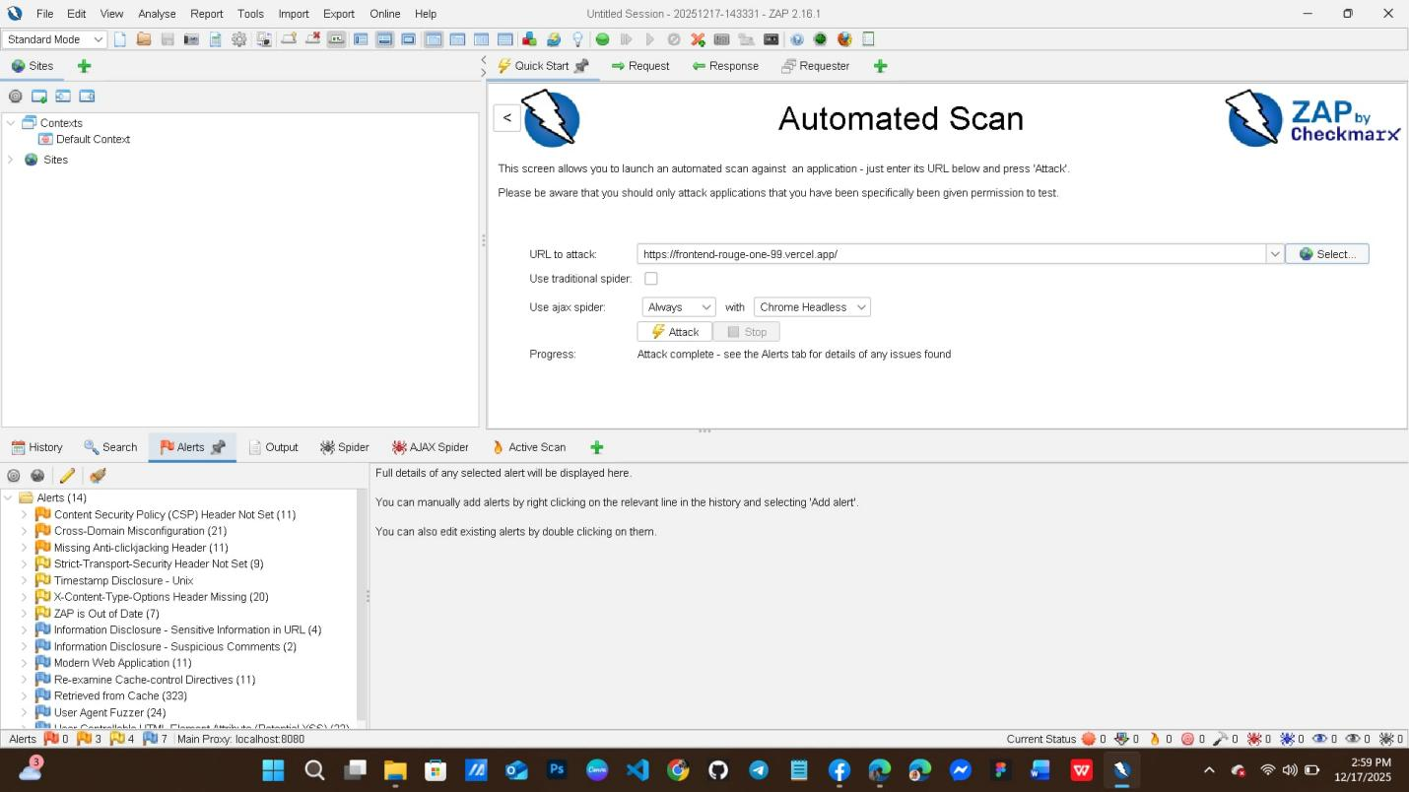
GuestBug Image
https://drive.google.com/file/d/17d64cF6GY5yZb9vJziPh0zJdvohalML_/view?usp=sharing

BookingBug Image
https://drive.google.com/file/d/1npEgGgw2ntIoyCP6yeI1wMlHmik6fLvO/view?usp=drive_link

