Formula-Driven Diagrams

Objective
Read a formula-driven diagram whose geometry responds to time, then inspect a
loop- and conditional-generated group whose membership stays fixed during
playback.

Prerequisites
Complete lesson 07. No earlier
data mappings or modules are required to run this example.

Desktop workflow
In OpenAMX Desktop, open this document from examples/. Select Run to
check its values, then Preview to inspect the mechanism and its playback
controls. The diagram starts at the lower time bound; use play, pause, reset,
scrub, and the optional loop control to inspect the crank-slider and generated
trace points.

Inputs and support files
This lesson is input-free and imports no modules. Its geometry uses only
ordinary AMX arithmetic, conditionals, abs, and sqrt.

A crank-slider mechanism
let crankRadius: Number = 34
let rodLength: Number = 105
let pivotX: Number = 70
fn crankX(t: Number, r: Number): Number = r * (1 - 2 * abs(t - 1))
fn crankY(t: Number, r: Number): Number = if t <= 1 then sqrt(r * r - crankX(t, r) * crankX(t, r)) else -sqrt(r * r - crankX(t, r) * crankX(t, r))
fn sliderX(t: Number, pivot: Number, r: Number, rod: Number): Number = pivot + crankX(t, r) + sqrt(rod * rod - crankY(t, r) * crankY(t, r))
diagram crankSlider {
title: "Crank-slider mechanism"
description: "A crank pin follows one full circular path and drives a piston through a fixed-length connecting rod."
width: 320
height: 200
time t from 0 to 2 duration 4
line lowerGuide {
x1: 115
y1: 88
x2: 260
y2: 88
stroke: "#52616B"
lineWidth: 2
arrow: "none"
}
line upperGuide {
x1: 115
y1: 112
x2: 260
y2: 112
stroke: "#52616B"
lineWidth: 2
arrow: "none"
}
line connectingRod {
x1: pivotX + crankX(t, crankRadius)
y1: 100 + crankY(t, crankRadius)
x2: sliderX(t, pivotX, crankRadius, rodLength)
y2: 100
stroke: "#D07A32"
lineWidth: 5
arrow: "none"
}
line crank {
x1: pivotX
y1: 100
x2: pivotX + crankX(t, crankRadius)
y2: 100 + crankY(t, crankRadius)
stroke: "#6950A1"
lineWidth: 4
arrow: "none"
}
circle pivot {
cx: pivotX
cy: 100
r: 7
stroke: "#263238"
fill: "#FFFFFF"
lineWidth: 2
}
circle crankPin {
cx: pivotX + crankX(t, crankRadius)
cy: 100 + crankY(t, crankRadius)
r: 6
stroke: "#263238"
fill: "#F3B64B"
lineWidth: 2
}
rectangle piston {
x: sliderX(t, pivotX, crankRadius, rodLength) - 12
y: 90
width: 24
height: 20
stroke: "#263238"
fill: "#DCE8F0"
lineWidth: 2
}
text timeLabel {
x: 18
y: 24
value: "t = ${round(t, 2)} s"
fill: "#263238"
}
for sample in [0, 1, 2, 3] {
if sample > 0 {
circle tracePoint {
cx: pivotX + crankX(t, crankRadius) + sample * 4
cy: 100 + crankY(t, crankRadius)
r: 2
stroke: "#263238"
fill: "#F3B64B"
lineWidth: 1
}
}
}
}

Crank-slider mechanism
A crank pin follows one full circular path and drives a piston through a fixed-length connecting rod.
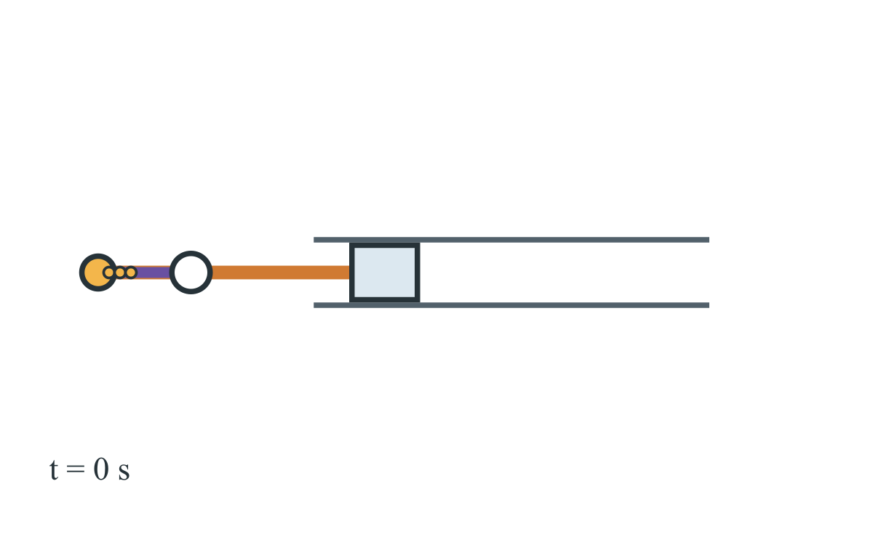

A generated trace group
The loop visits four values and the conditional omits sample == 0, emitting
three circles in source order. tracePoint is the one authored declaration
repeated by the loop, not a unique source name for each emitted circle. The
loop iterable and condition do not use t; the supported cx and cy
properties do. The three generated points keep the same membership and order
across frames while their positions follow the crank pin.

Expected outcome
The declared crank radius is 34 and the connecting-rod length is 105.
Diagram-local t runs from 0 to 2 over a four-second playback duration.
The loop and conditional emit exactly three trace circles when the diagram
model is created. Their membership and order remain fixed during playback;
their geometry, like the crank-slider geometry, is evaluated at each selected
time. This is not a stateful solver or an accumulated simulation.
Standalone HTML and desktop Preview provide the interactive controls. PDF and
DOCX exports contain a static frame at the lower time bound; neither includes
playback controls. DOCX uses an image rather than editable native Word shapes.
Canvas coordinates are schematic coordinates, not physical units or
engineering axes. The geometry uses no trigonometric function. No physical
dimension, accessibility conformance, or screen-reader support is claimed.
See the standalone battery-resistor circuit reference
for a separate schematic and its stated interpretation.

Navigation
Index |
Previous: Tables, Charts, and Named Outputs |
Next: Runtime Type Checks

