Static diagram export verification
The figures below are exported as static lower-bound frames.
let crankRadius: Number = 34
let rodLength: Number = 105
let pivotX: Number = 70
fn crankX(t: Number, r: Number): Number = r * (1 - 2 * abs(t - 1))
fn crankY(t: Number, r: Number): Number = if t <= 1 then sqrt(r * r - crankX(t, r) * crankX(t, r)) else -sqrt(r * r - crankX(t, r) * crankX(t, r))
fn sliderX(t: Number, pivot: Number, r: Number, rod: Number): Number = pivot + crankX(t, r) + sqrt(rod * rod - crankY(t, r) * crankY(t, r))
diagram crankSlider {
title: "Crank-slider mechanism"
description: "A crank pin follows one full circular path and drives a piston through a fixed-length connecting rod."
width: 320
height: 200
time t from 0 to 2 duration 4
line lowerGuide {
x1: 115
y1: 88
x2: 260
y2: 88
stroke: "#52616B"
lineWidth: 2
arrow: "none"
}
line upperGuide {
x1: 115
y1: 112
x2: 260
y2: 112
stroke: "#52616B"
lineWidth: 2
arrow: "none"
}
line connectingRod {
x1: pivotX + crankX(t, crankRadius)
y1: 100 + crankY(t, crankRadius)
x2: sliderX(t, pivotX, crankRadius, rodLength)
y2: 100
stroke: "#D07A32"
lineWidth: 5
arrow: "none"
}
line crank {
x1: pivotX
y1: 100
x2: pivotX + crankX(t, crankRadius)
y2: 100 + crankY(t, crankRadius)
stroke: "#6950A1"
lineWidth: 4
arrow: "none"
}
circle pivot {
cx: pivotX
cy: 100
r: 7
stroke: "#263238"
fill: "#FFFFFF"
lineWidth: 2
}
circle crankPin {
cx: pivotX + crankX(t, crankRadius)
cy: 100 + crankY(t, crankRadius)
r: 6
stroke: "#263238"
fill: "#F3B64B"
lineWidth: 2
}
rectangle piston {
x: sliderX(t, pivotX, crankRadius, rodLength) - 12
y: 90
width: 24
height: 20
stroke: "#263238"
fill: "#DCE8F0"
lineWidth: 2
}
text timeLabel {
x: 18
y: 24
value: "t = ${round(t, 2)} s"
fill: "#263238"
}
}
let supplyVoltage: Number = 9
let resistance: Number = 15
let current: Number = supplyVoltage / resistance
fn indicatorX(t: Number): Number = 58 + 25 * t
diagram batteryResistor {
title: "Battery-resistor DC circuit"
description: "A 9 volt battery drives a 15 ohm resistor; the arrow travels clockwise to indicate conventional current."
width: 320
height: 200
time t from 0 to 4 duration 4
line upperLeftWire {
x1: 50
y1: 130
x2: 188
y2: 130
stroke: "#52616B"
lineWidth: 3
arrow: "none"
}
line upperRightWire {
x1: 218
y1: 130
x2: 250
y2: 130
stroke: "#52616B"
lineWidth: 3
arrow: "none"
}
line leftUpperWire {
x1: 50
y1: 130
x2: 50
y2: 98
stroke: "#52616B"
lineWidth: 3
arrow: "none"
}
line leftLowerWire {
x1: 50
y1: 68
x2: 50
y2: 50
stroke: "#52616B"
lineWidth: 3
arrow: "none"
}
line rightWire {
x1: 250
y1: 130
x2: 250
y2: 50
stroke: "#52616B"
lineWidth: 3
arrow: "none"
}
line lowerWire {
x1: 250
y1: 50
x2: 50
y2: 50
stroke: "#52616B"
lineWidth: 3
arrow: "none"
}
line positivePlate {
x1: 39
y1: 92
x2: 61
y2: 92
stroke: "#263238"
lineWidth: 4
arrow: "none"
}
line negativePlate {
x1: 43
y1: 74
x2: 57
y2: 74
stroke: "#263238"
lineWidth: 3
arrow: "none"
}
rectangle resistor {
x: 188
y: 118
width: 30
height: 24
stroke: "#263238"
fill: "#FFF5E6"
lineWidth: 2
}
line currentIndicator {
x1: indicatorX(t)
y1: 130
x2: indicatorX(t) + 14
y2: 130
stroke: "#D04A3A"
lineWidth: 4
arrow: "end"
}
text voltageLabel {
x: 20
y: 24
value: "9 V"
fill: "#263238"
}
text resistanceLabel {
x: 180
y: 156
value: "15 ohm"
fill: "#263238"
}
text currentLabel {
x: 88
y: 154
value: "I = ${round(current, 2)} A"
fill: "#263238"
}
}

Crank-slider mechanism
A crank pin follows one full circular path and drives a piston through a fixed-length connecting rod.
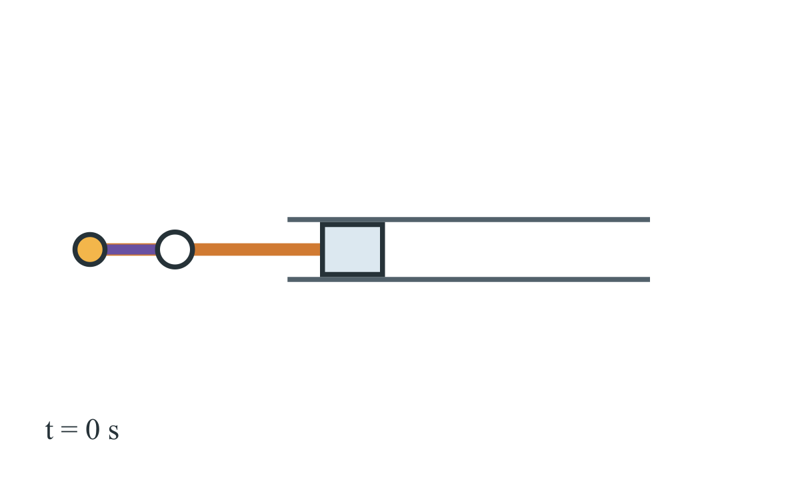

Battery-resistor DC circuit
A 9 volt battery drives a 15 ohm resistor; the arrow travels clockwise to indicate conventional current.
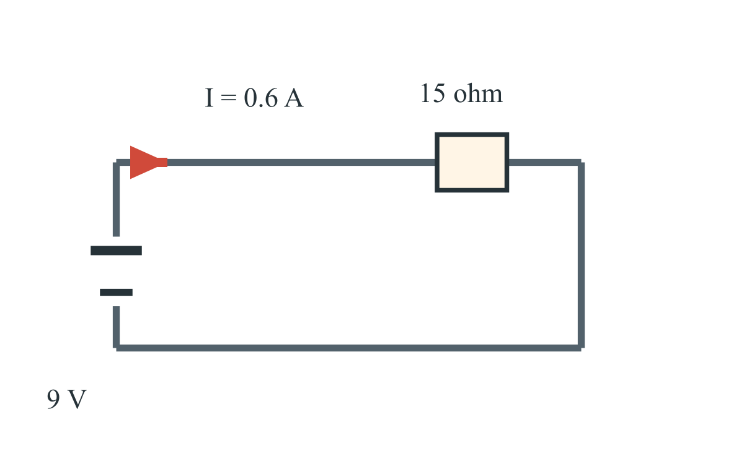
The crank-slider and battery-resistor examples reproduce the approved Sprint
078 D-CRANK-01 and D-BATTERY-01 diagram declarations.

