**Directory information:**

**CSV directory contains:**

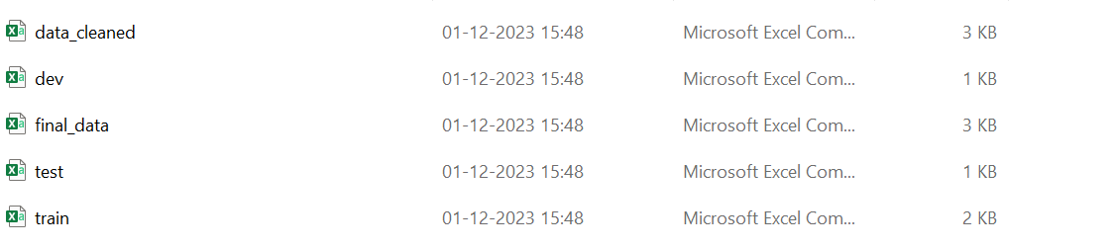

**transcript directory contains:**

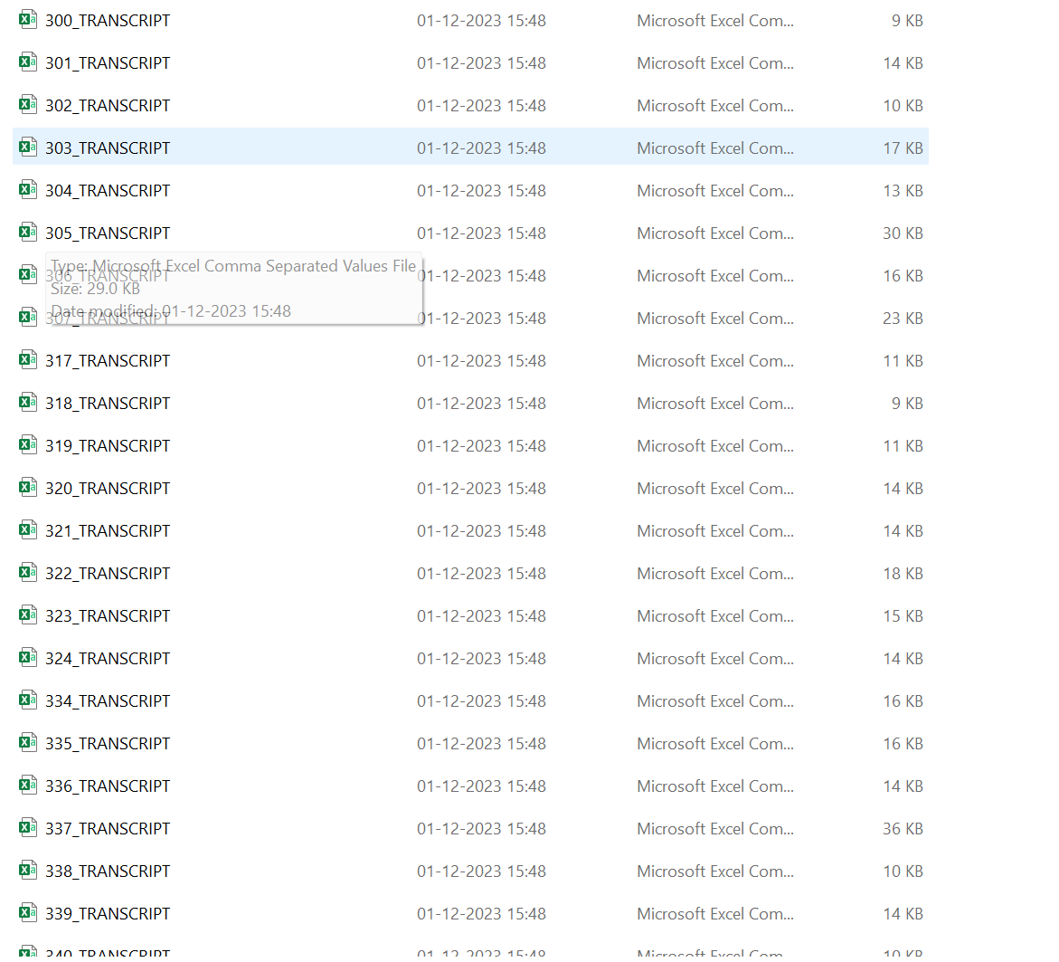

Run the notebook codes install required dependencies