
Application of Design of Experiments for Formulation Development and Mechanistic Evaluation of Iontophoretic Tacrine Hydrochloride Delivery

The objective of this research paper is to develop a mathematical equation to understand the impact of variables and establish statistical control over transdermal iontophoretic delivery of tacrine hydrochloride. Design of experiments (DoE) methodology is implemented to study the effect of independent variables on the dependent variable.
The factors (independent variables) examined are: X₁ = current strength (mA), X₂ = buffer molarity (mM) and X₃ = drug concentration (mg/ml). All the factors are continuous. The response (dependent variable) examined is: Y = tacrine permeation flux (μg/cm²/h). The applied DoE method is Central Composite design.
Isalos version used: 2.0.6
Scientific article: https://www.tandfonline.com/doi/abs/10.1080/03639045.2016.1181646

Step 1: Central Composite Design
In the first tab named “Action” define the factors in the column headers and fill each column with the low and high levels of the corresponding factors. This tab can be renamed “Central Composite”. Afterwards, apply the Central Composite method: DOE $→$ Response Surface $→$ Central Composite

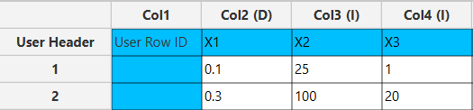

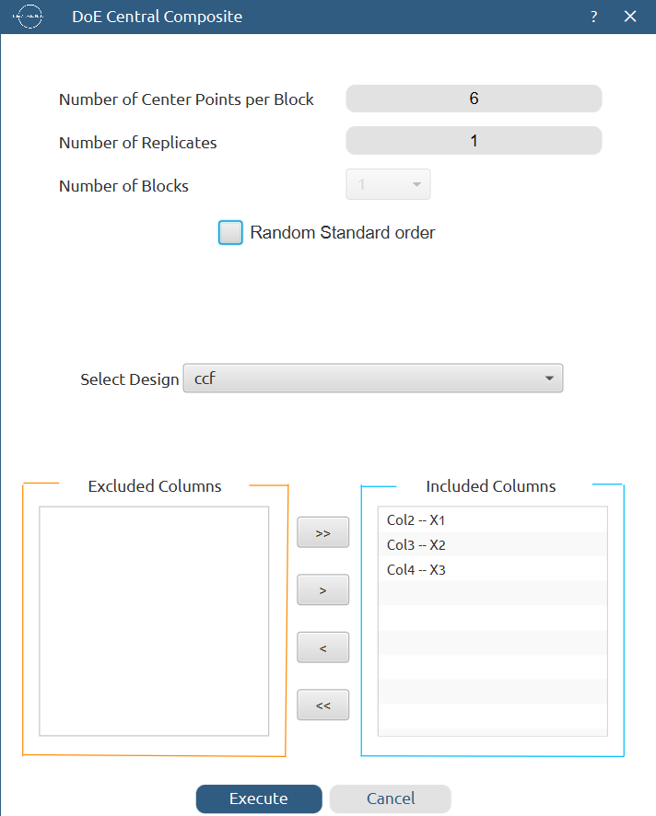

Results (right spreadsheet):
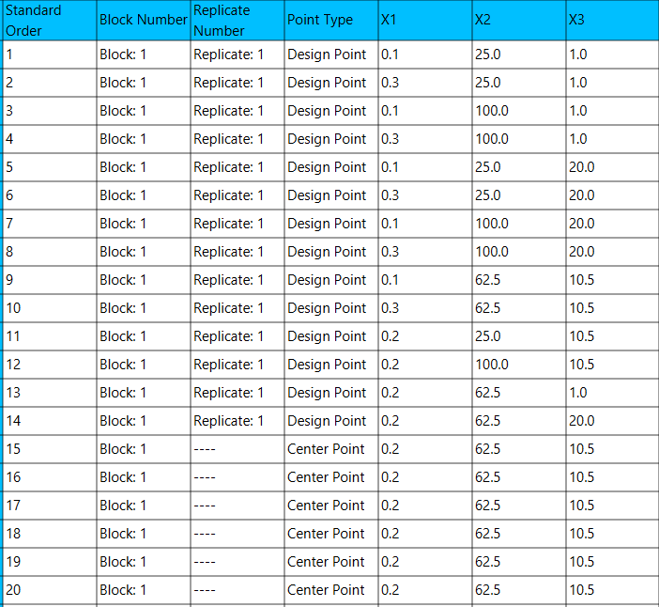

Step 2: Definition of response variables
Create a new tab named “Responses” and define the responses in the column headers. Fill each column with the values of the corresponding responses that were observed and make sure the values follow the order of the experiments as given by the Central Composite method. Then, select all columns to be transferred to the right spreadsheet: Data Transformation $→$ Data Manipulation $→$ Select Column(s)

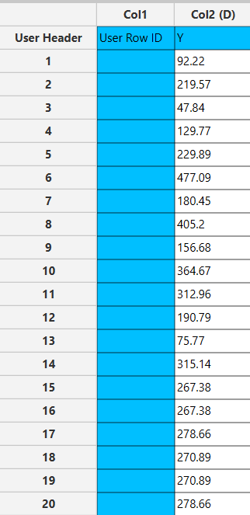

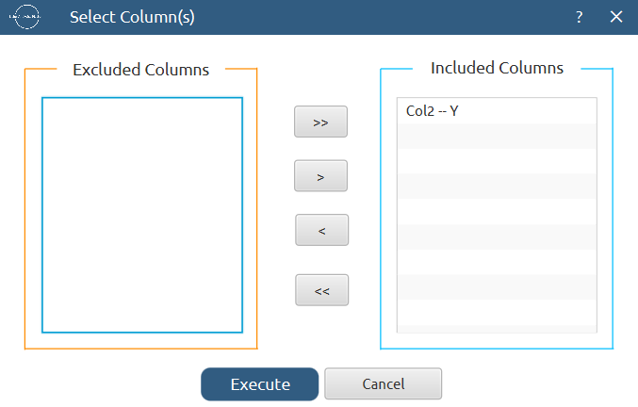

Step 3: Data isolation
Create a new tab named “Data” and import the results from the “Central Composite” and “Responses” spreadsheets by right clicking on the left spreadsheet. Then, select only the factors and responses columns to be transferred to the right spreadsheet: Data Transformation $→$ Data Manipulation $→$ Select Column(s)

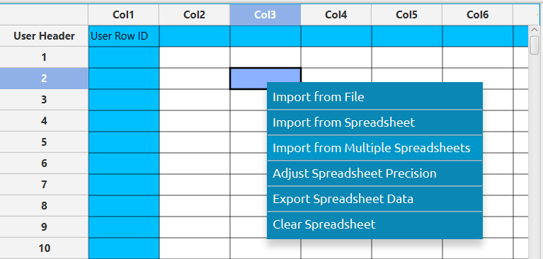

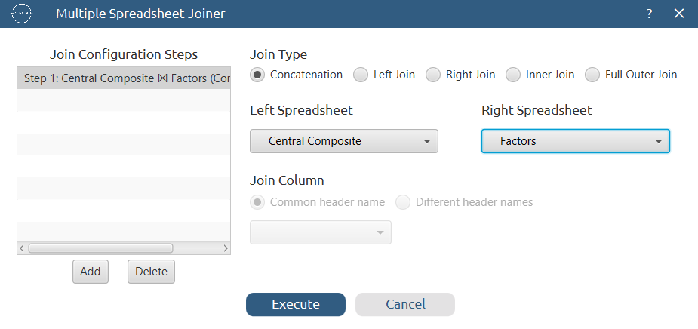

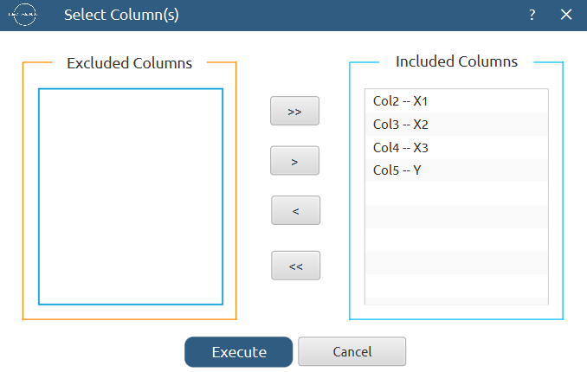
Results:
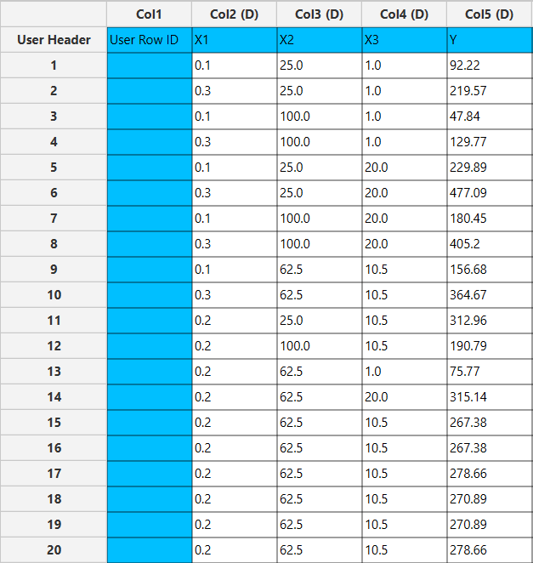

Step 4: Normalization
Create a new tab named “Normalized data” and import the results from the “Data” spreadsheet. Afterwards, normalize the factor columns to take values in the range [-1, 1]: Data Transformation $→$ Normalizers $→$ Min-Max



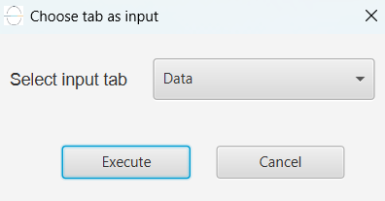

Results:
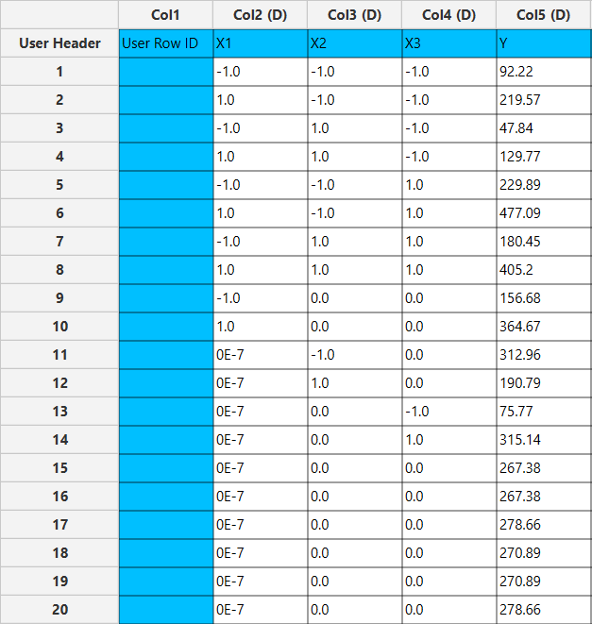

Step 5: Regression
The goal here is to produce a regression equation that includes main effects, two-factor interactions and quadratic effects for Y₁:
$$Y=b_{0}+b_{1}X_{1}+b_{2}X_{2}+b_{3}X_{3}+b_{12}X_{1}X_{2}+b_{13}X_{1}X_{3}+b_{23}X_{2}X_{3}+b_{11}{X_{1}}^{2}+b_{22}{X_{2}}^{2}+b_{33}{X_{3}}^{2}$$

Create a new tab named “Regression – Coded” and import the results from the spreadsheet “Normalized data”. Afterwards, fit a generalized linear model to the data: Analytics $→$ Regression $→$ Statistical fitting $→$ Generalized Linear Models

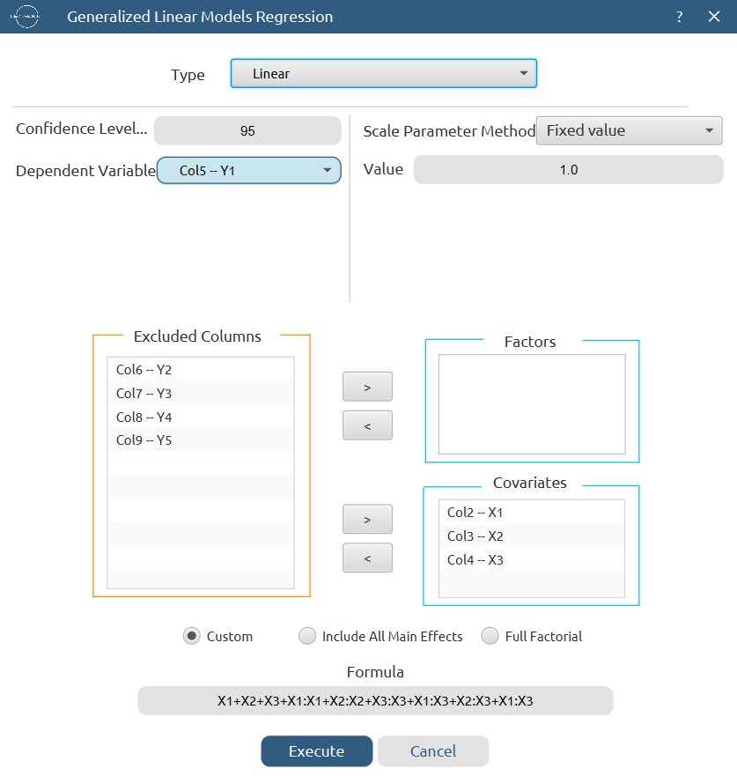

Results:

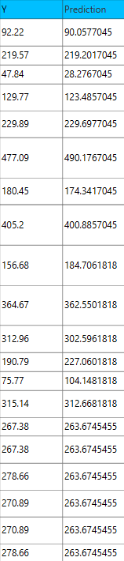
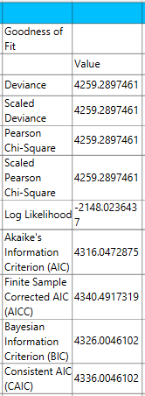

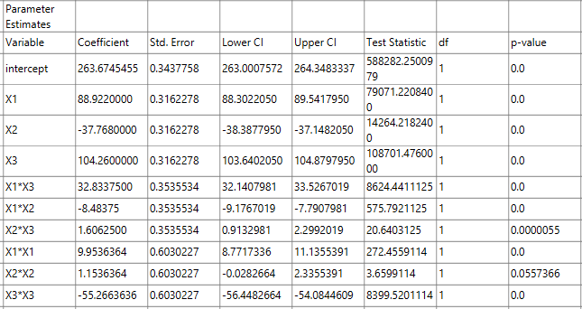

Repeat this step for the uncoded data. Results:

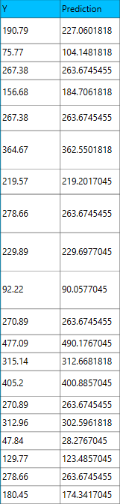
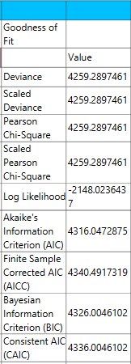

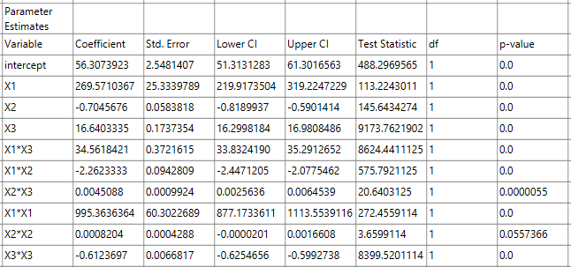

Step 6: Regression Metrics
Create a tab named “Metrics – Coded” and import the results from the spreadsheet “Regression – Coded”. Then, produce the regression metrics for the regression equation of the coded data: Statistics $→$ Model Metrics $→$ Regression Metrics

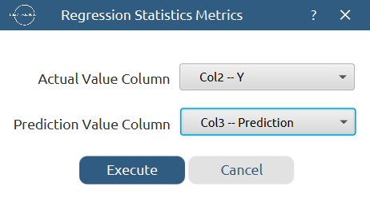

Results:
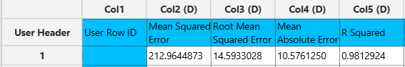

Repeat this step for the uncoded data. Results:
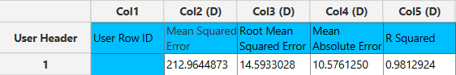

Step 7: Analysis of Covariance
Create a new tab named “ANCOVA – Coded” and import the results from the spreadsheet “Normalized data”. Afterwards perform analysis of covariance for Y: Statistics $→$ Analysis of (Co)Variance $→$ ANCOVA

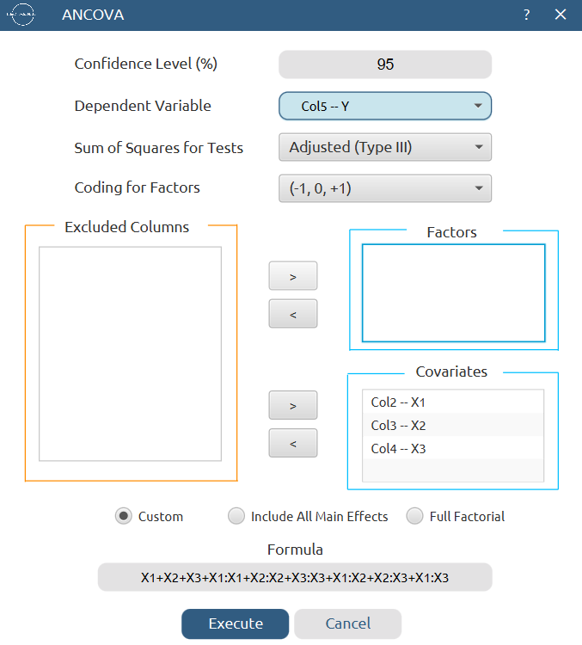

Results:
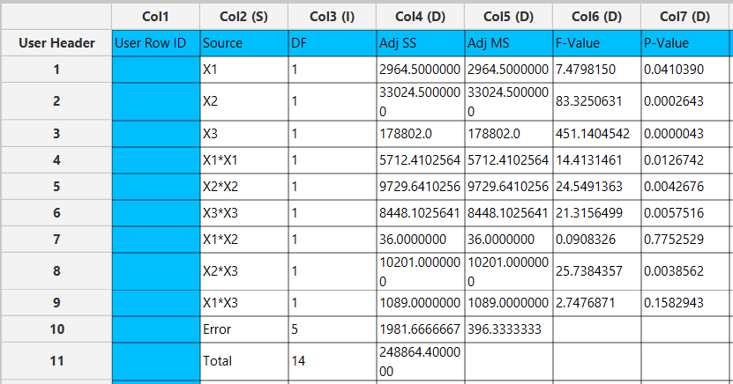

Final Isalos Workflow
The final workflow is presented below (weird-looking):

References
- Patel, N.; Jain, S.; Madan, P.; Lin, S. Application of Design of Experiments for Formulation Development and Mechanistic Evaluation of Iontophoretic Tacrine Hydrochloride Delivery. Drug Development and Industrial Pharmacy 2016, 42 (11), 1894–1902. https://doi.org/10.1080/03639045.2016.1181646.

