
Development of pellets for oral lysozyme delivery by using a quality by design approach

The objectives of this research paper are to identify how the critical process parameters influence the critical quality attributes of a lysozyme-containing multiparticulate dosage form, and to determine the critical points of API activity preservation. Design of experiments (DoE) methodology is implemented in order to determine the effects of the adjustable critical process parameters.
The factors (independent variables) examined are: X₁ = impeller speed (rpm), X₂ = liquid addition (ml/min), X₃ = extrusion speed (rpm), X₄ = spheronizer speed (rpm) and X₅ = spheronization time (min). All the factors are continuous. The responses (dependent variables) examined are: Y₁ = activity (%), Y₂ = hardness (N) and Y₃ = roundness. The applied DoE method is 2⁵ full factorial design.
Isalos version used: 2.0.6
Scientific article: https://www.sciencedirect.com/science/article/abs/pii/S0263876215004918

Step 1: Full Factorial Design
In the first tab named “Action” define the factors in the column headers and fill each column with the low and high levels of the corresponding factors. This tab can be renamed “Full Factorial”. Afterwards, apply the full factorial method: DOE $→$ Factorial $→$ Full Factorial

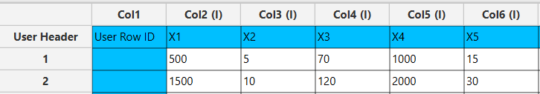

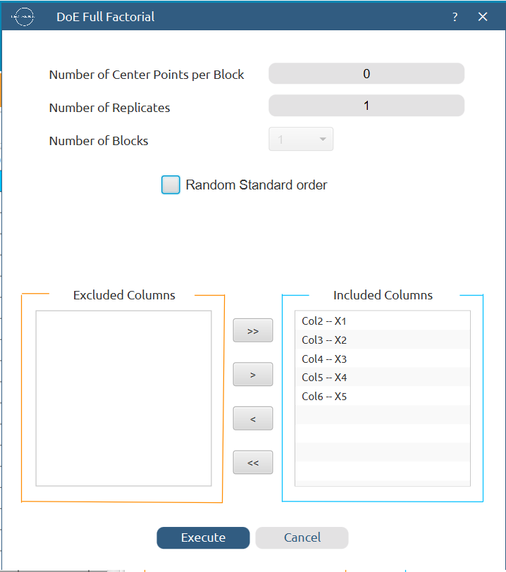

Results (right spreadsheet):
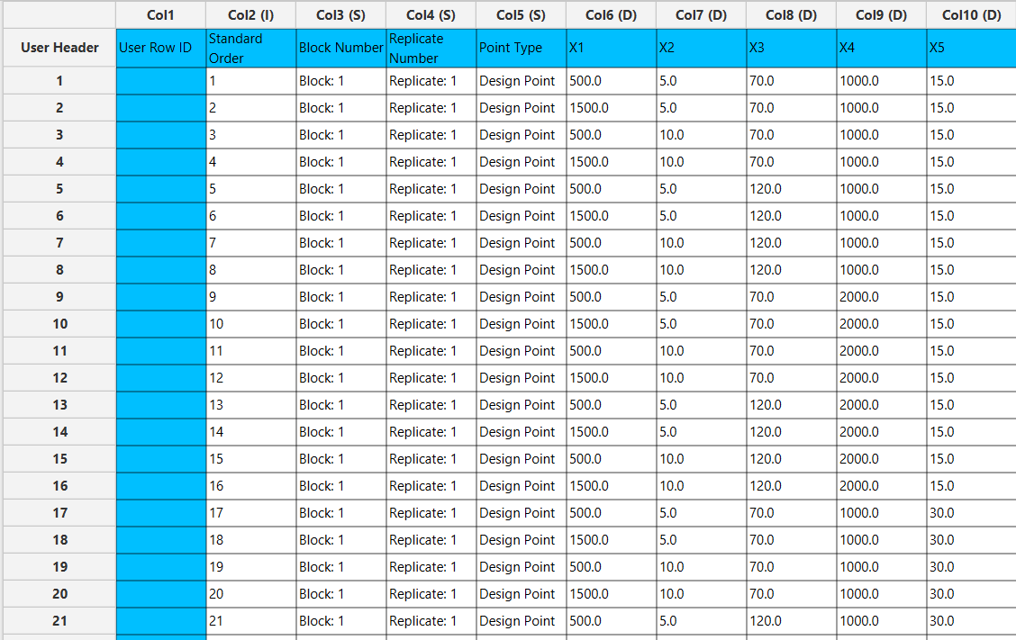

Step 2: Definition of response variables
Create a new tab named “Responses” and define the responses in the column headers. Fill each column with the values of the corresponding responses that were observed and make sure the values follow the order of the experiments as given by the full factorial method. Then, select all columns to be transferred to the right spreadsheet: Data Transformation $→$ Data Manipulation $→$ Select Column(s)

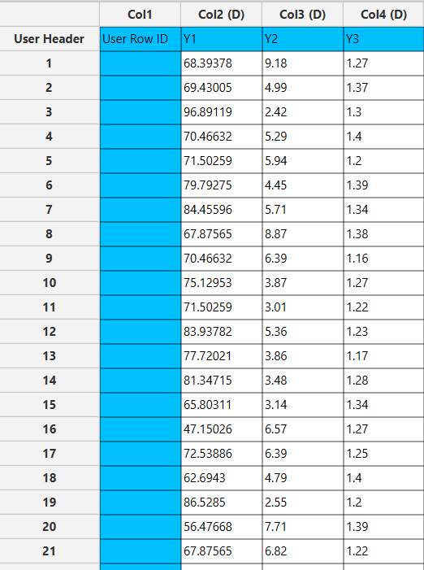

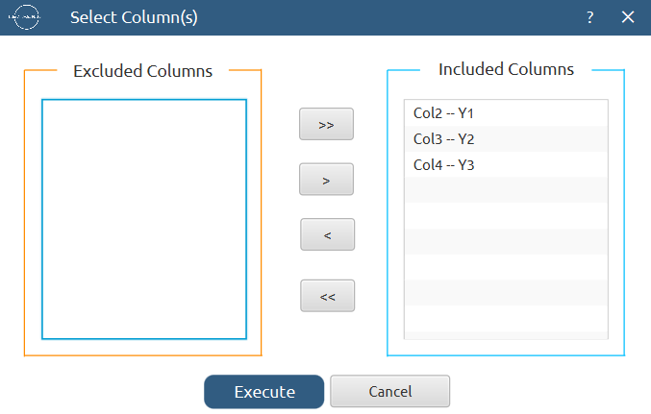

Step 3: Data isolation
Create a new tab named “Data” and import the results from the “Full Factorial” and “Responses” spreadsheets by right clicking on the left spreadsheet. Then, select only the factors and responses columns to be transferred to the right spreadsheet: Data Transformation $→$ Data Manipulation $→$ Select Column(s)

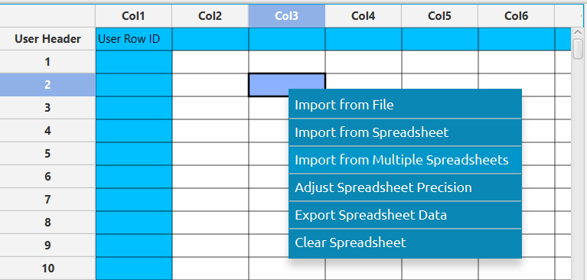

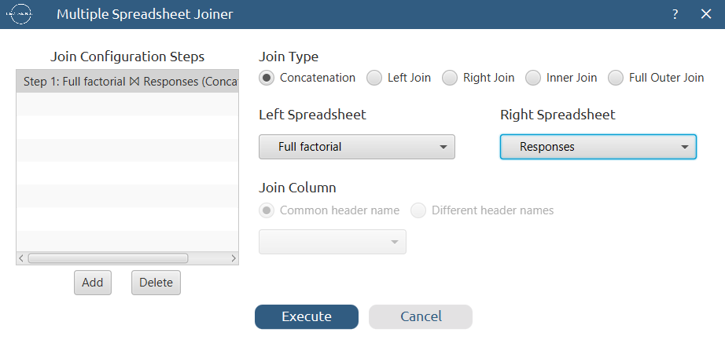

Results:
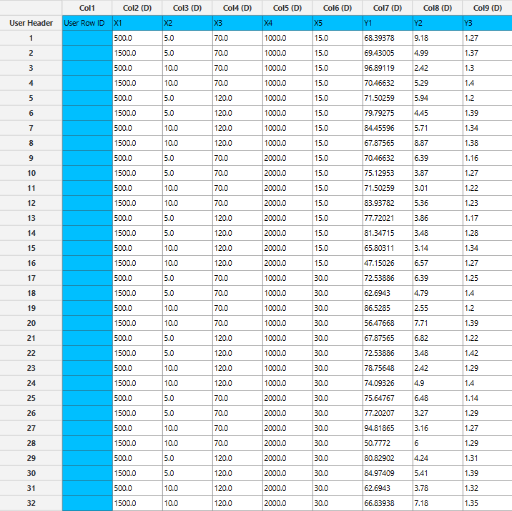

Step 4: Normalization
Create a new tab named “Normalized data” and import the results from the “Data” spreadsheet. Afterwards, normalize the factor columns to take values in the range [-1, 1]: Data Transformation $→$ Normalizers $→$ Min-Max



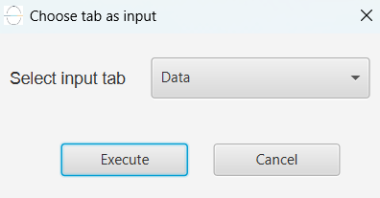

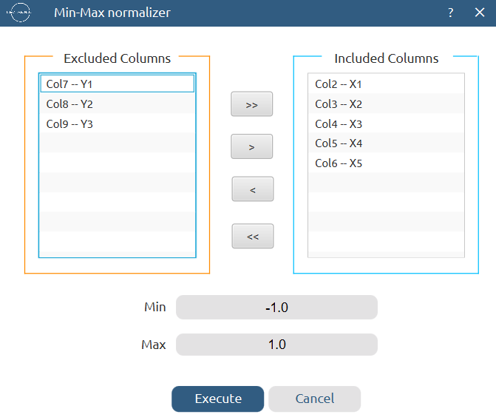

Results:
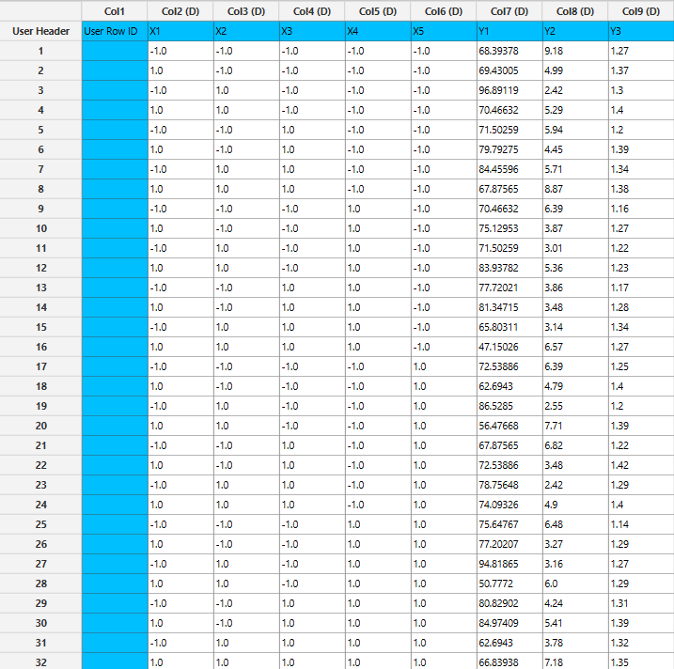

Step 5: Pareto analysis
Create a new tab named “Pareto Analysis – Y1” and import the results either from the spreadsheet “Data” or “Normalized data”. Then, conduct pareto analysis for the first response variable, Y₁: DOE $→$ Post DoE Analysis $→$ Pareto Analysis

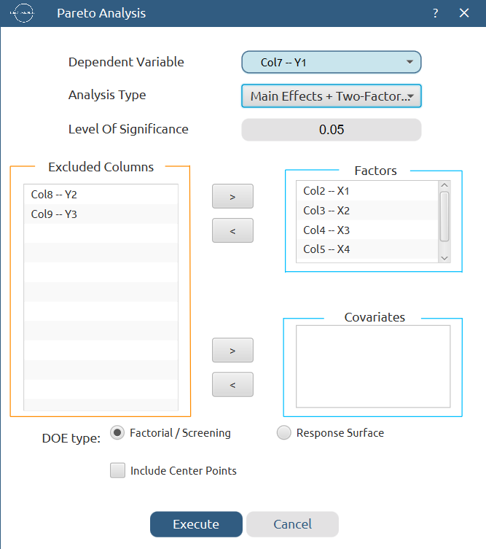
+Three-Factor

Results:
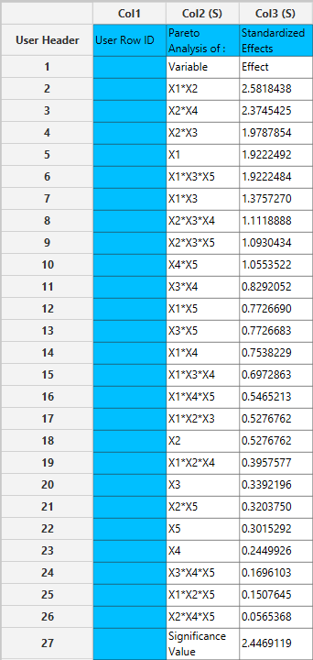

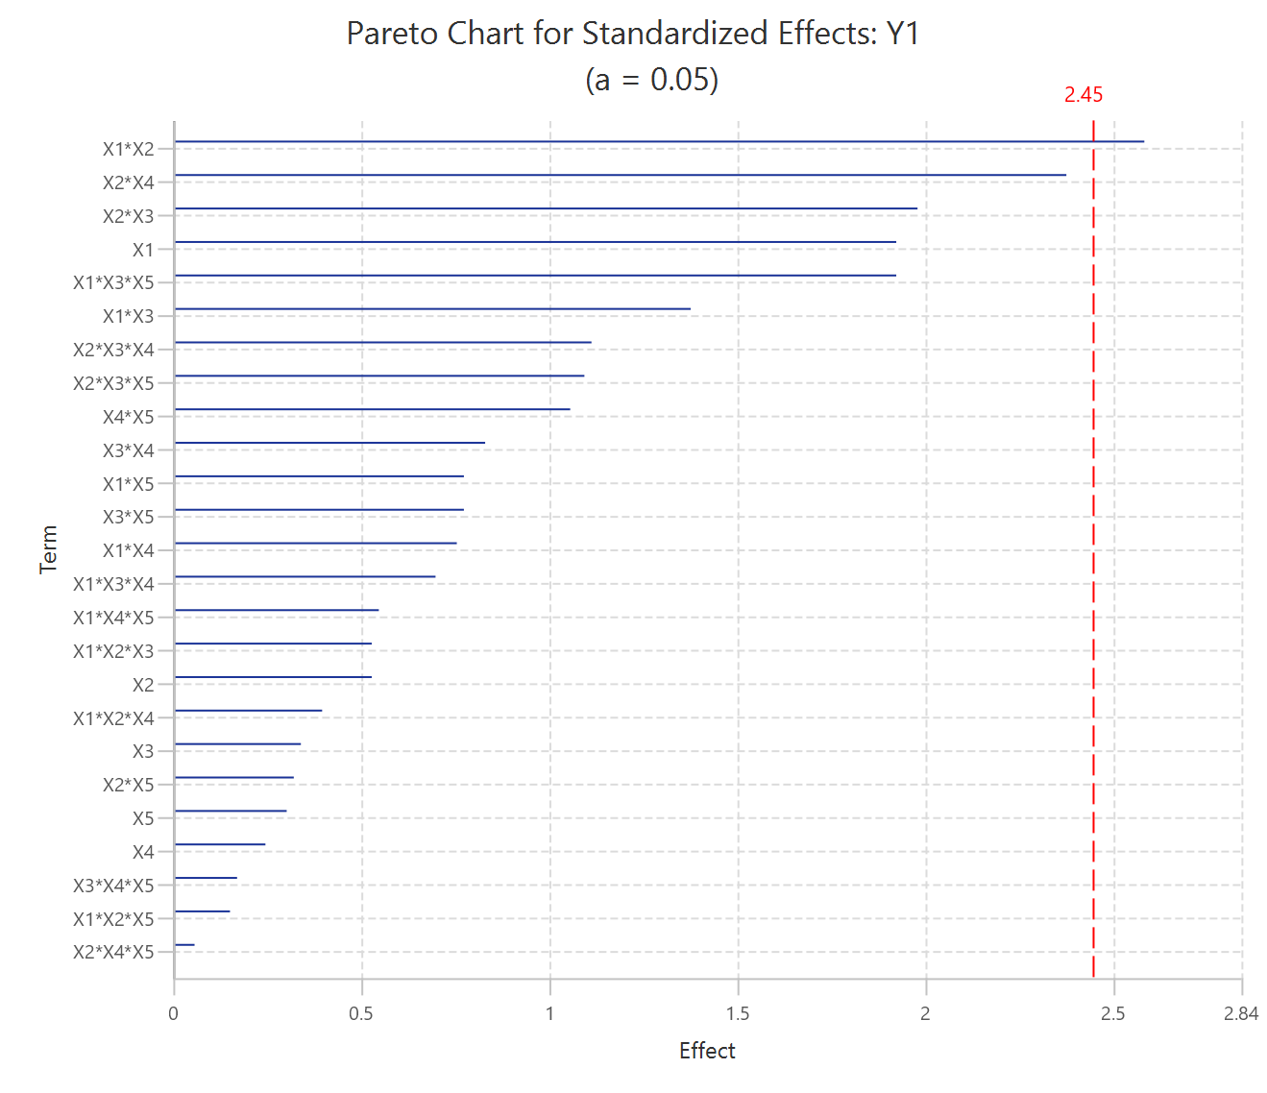
Repeat this step for the rest of the response variables. Results, Y₂:
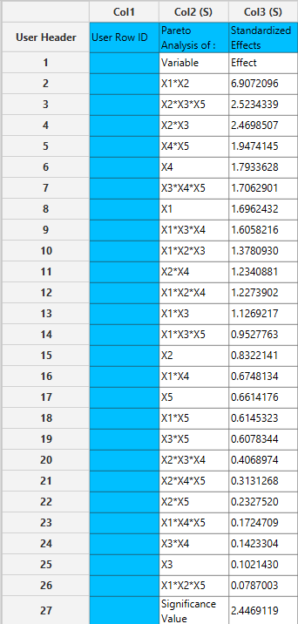

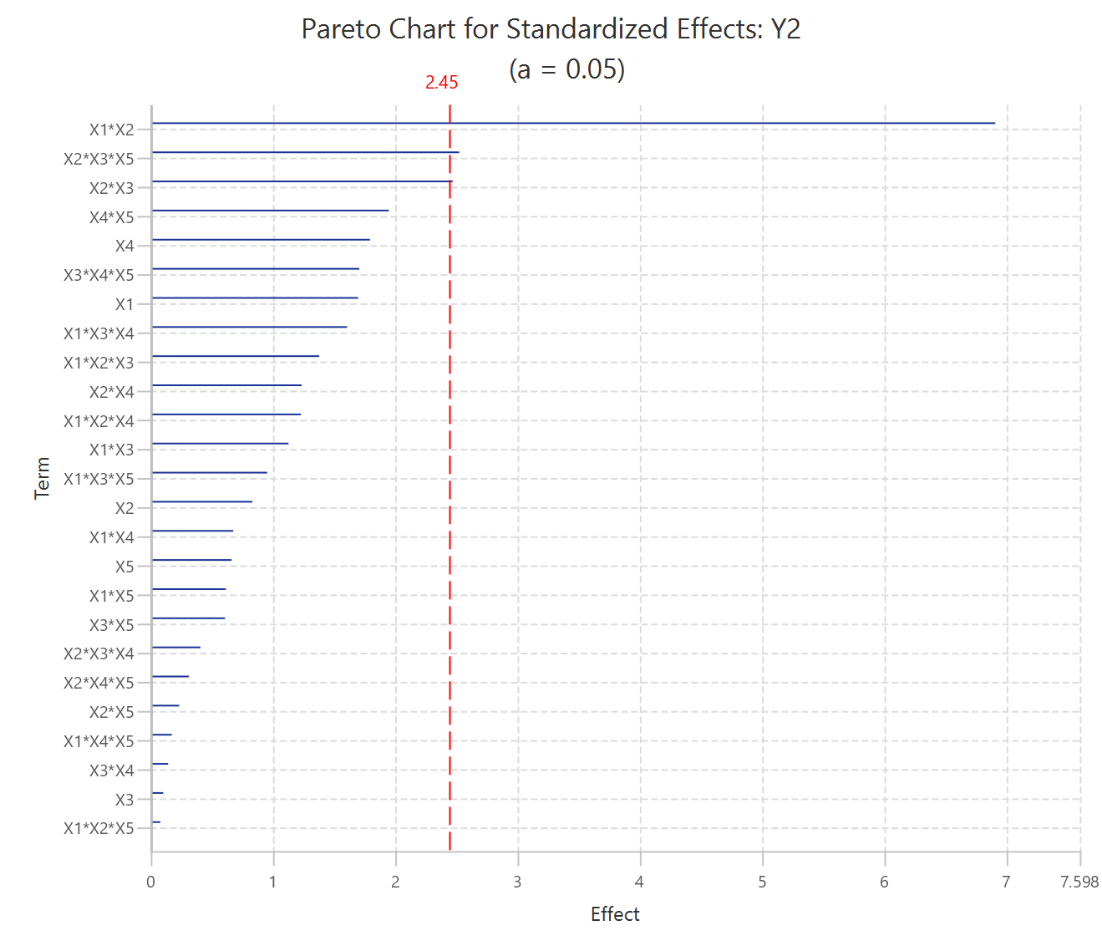
Results, Y₃:
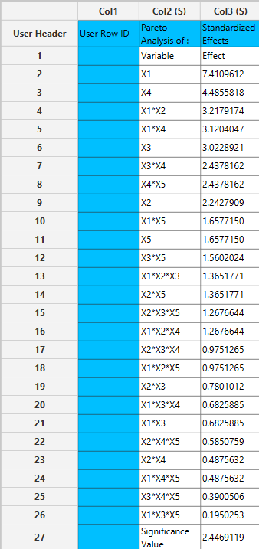

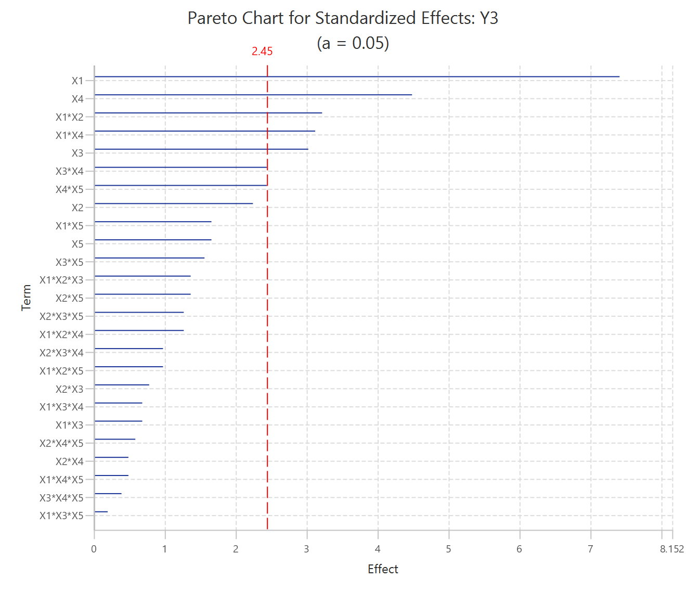

Step 6: Regression
The goal here is to produce a regression equation that includes main effects, two-factor and three-factor interactions for Y₁:
$Y=b_{0}+b_{1}X_{1}+b_{2}X_{2}+b_{3}X_{3}+b_{4}X_{4}+b_{5}X_{5}+b_{12}X_{1}X_{2}+b_{13}X_{1}X_{3}+b_{14}X_{1}X_{4}+b_{15}X_{1}X_{5}+b_{23}X_{2}X_{3}+b_{24}X_{2}X_{4}+b_{25}X_{2}X_{5}+b_{34}X_{3}X_{4}+b_{35}X_{3}X_{5}+b_{45}X_{4}X_{5}+b_{123}X_{1}X_{2}X_{3}+b_{124}X_{1}X_{2}X_{4}+b_{125}X_{1}X_{2}X_{5}+b_{134}X_{1}X_{3}X_{4}+b_{135}X_{1}X_{3}X_{5}+b_{145}X_{1}X_{4}X_{5}+b_{234}X_{2}X_{3}X_{4}+b_{235}X_{2}X_{3}X_{5}+b_{245}X_{2}X_{4}X_{5}+b_{345}X_{3}X_{4}X_{5}$
Create a new tab named “Regression – Y1” and import the results from the spreadsheet “Normalized data”. Afterwards, fit a generalized linear model to the data: Analytics $→$ Regression $→$ Statistical fitting $→$ Generalized Linear Models

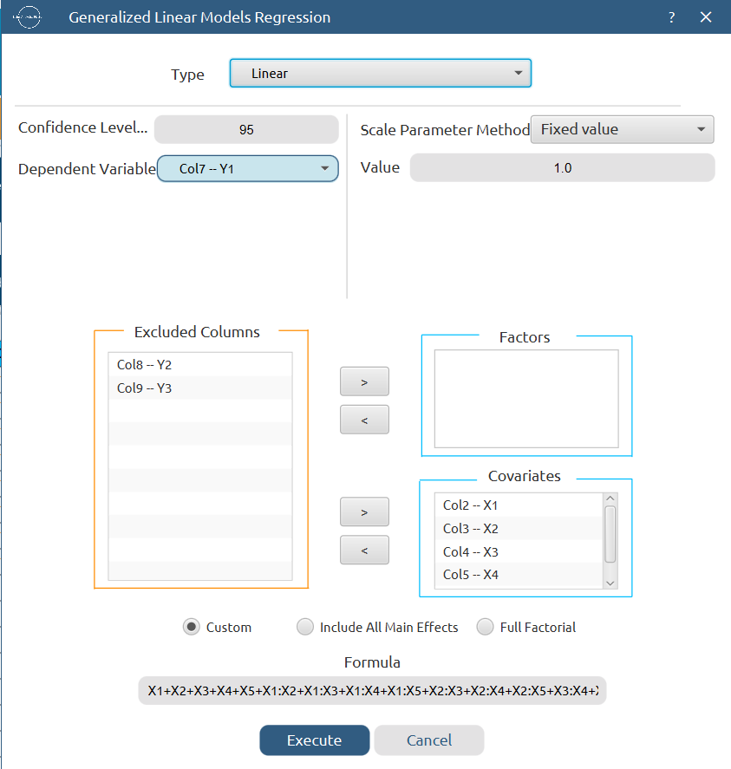

Results:

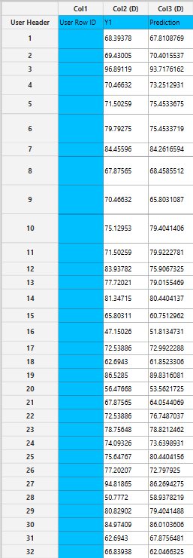
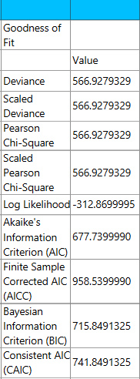

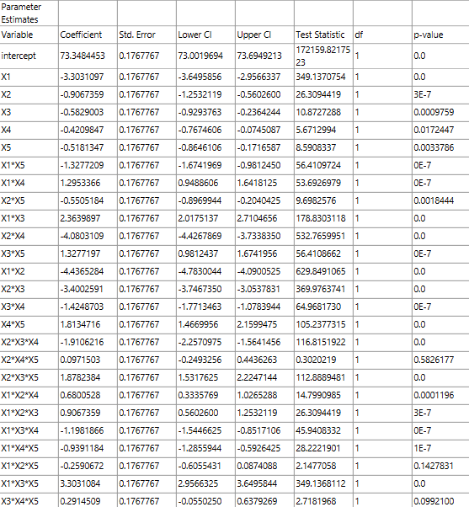

Repeat this step for the rest of the response variables. Results, Y₂:

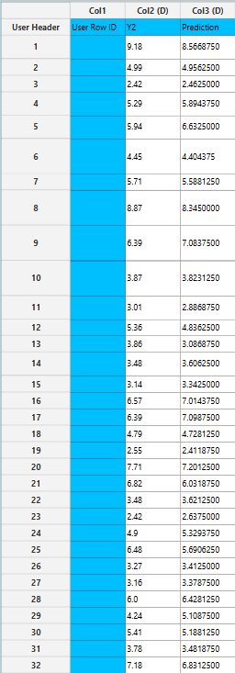
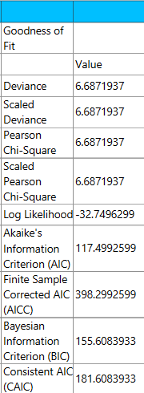

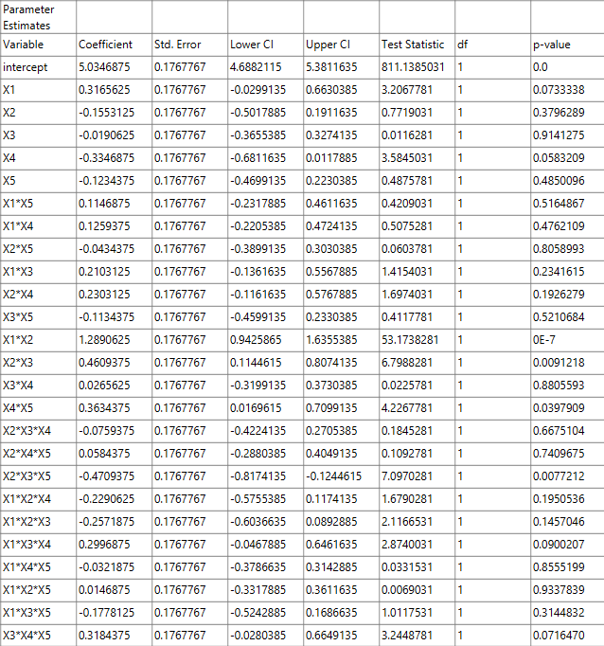
Results, Y₃:

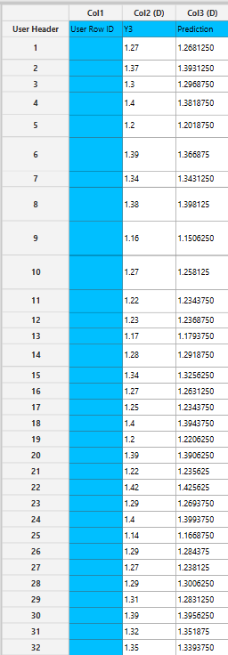
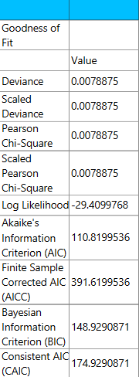

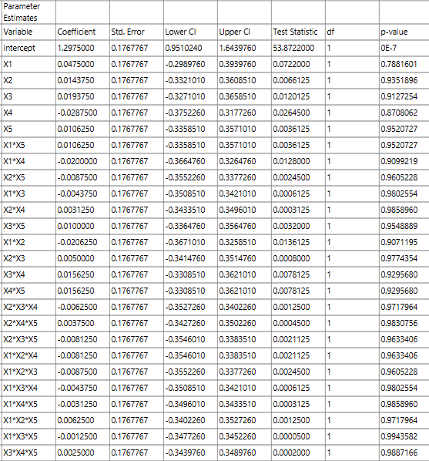

Step 7: Regression Metrics
Create a tab named “Metrics – Y1” and import the results from the spreadsheet “Regression – Y1”. Then, produce the regression metrics for the Y₁ regression equation: Statistics $→$ Model Metrics $→$ Regression Metrics

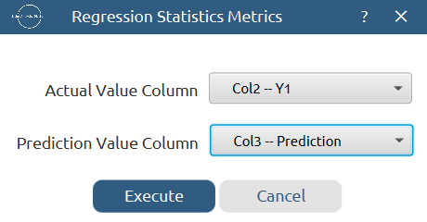

Results:
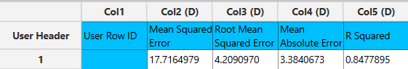

Repeat this step for the rest of the response variables. Results, Y₂:
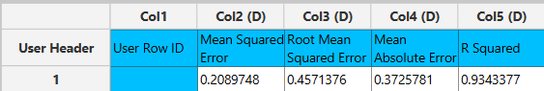

Results, Y₃:
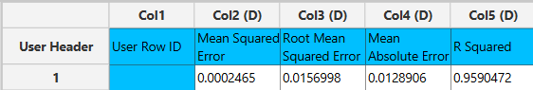

Step 8: Analysis of Covariance
Create a new tab named “ANCOVA – Y1” and import the results from the spreadsheet “Normalized data”. Afterwards perform analysis of covariance for Y₁: Statistics $→$ Analysis of (Co)Variance $→$ ANCOVA
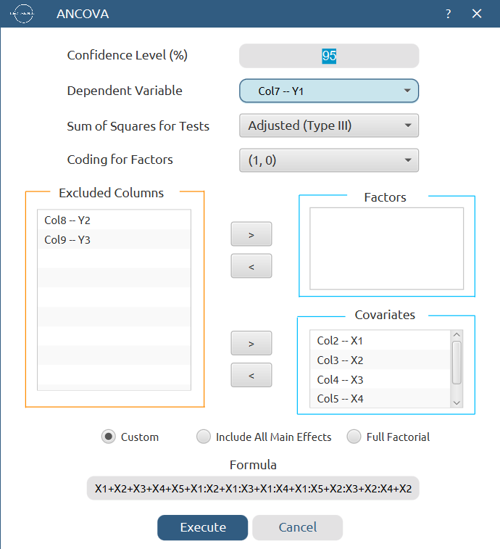

Results:
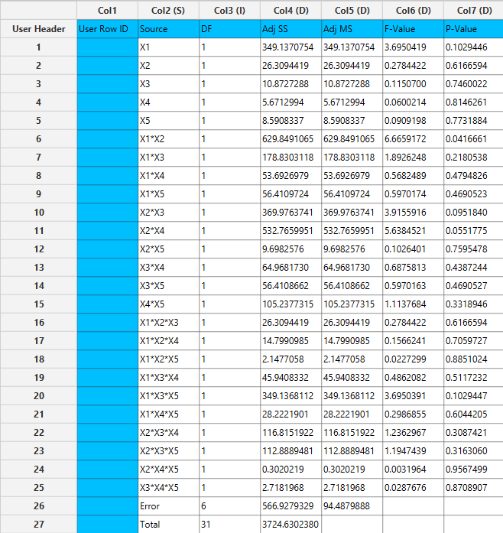
Repeat this step for the rest of the response variables. Results, Y₂:
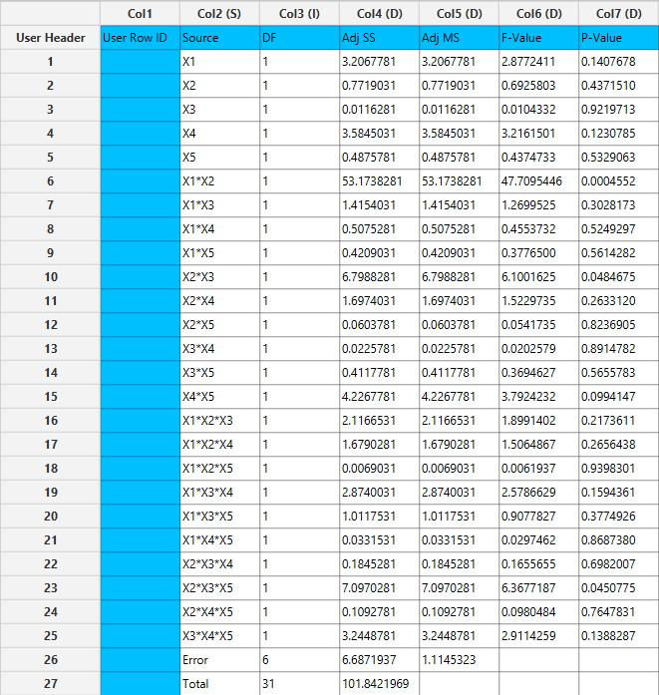

Results, Y₃:
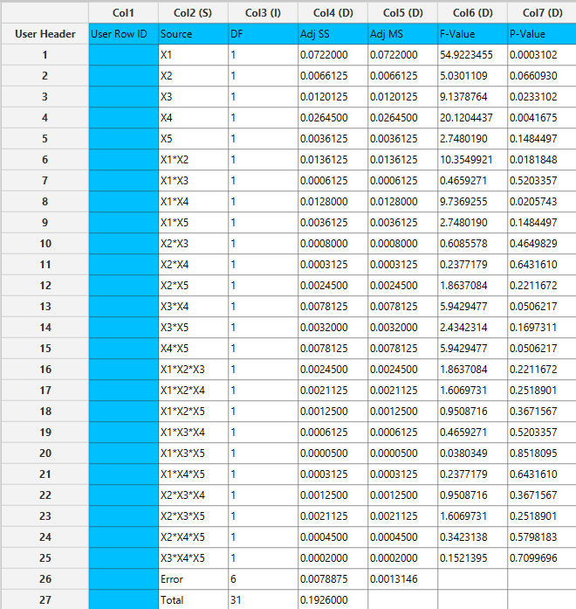

Final Isalos Workflow
The final workflow is presented below:
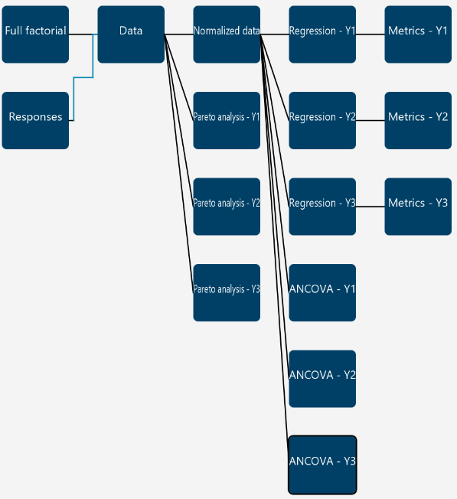

References
- Sovány, T.; Csordás, K.; Kelemen, A.; Regdon, G.; Pintye-Hódi, K. Development of Pellets for Oral Lysozyme Delivery by Using a Quality by Design Approach. Chemical Engineering Research and Design 2016, 106, 92–100. https://doi.org/10.1016/j.cherd.2015.11.022.

