
Quality by design based silymarin nanoemulsion for enhancement of oral bioavailability

The purpose of this research paper is to develop silymarin loaded nanoemulsions with good oral bioavailability. Design of experiments (DoE) methodology is implemented for the optimization of the silymarin loaded nanoemulsions.
The factors (independent variables) examined are: A = surfactant/cosurfactant mixture concentration (%), B = homogenization pressure (bar) and C = number of homogenization cycles. All the factors are continuous. The responses (dependent variables) examined are: R₁ = globule size (nm), R₂ = polydispersity index, R₃ = transmittance percentage (%) and R₄ = drug release (%). The applied DoE method is Box Behnken design.
Isalos version used: 2.0.6
Scientific article: https://www.sciencedirect.com/science/article/abs/pii/S0928098716305607

Step 1: Box Behnken Design
In the first tab named “Action” define the factors in the column headers and fill each column with the low and high levels of the corresponding factors. This tab can be renamed “Box Behnken”. Afterwards, apply the Box Behnken method: DOE $→$ Response Surface $→$ Box Behnken

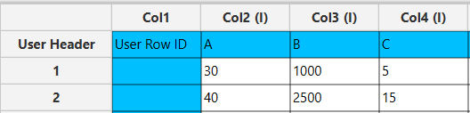

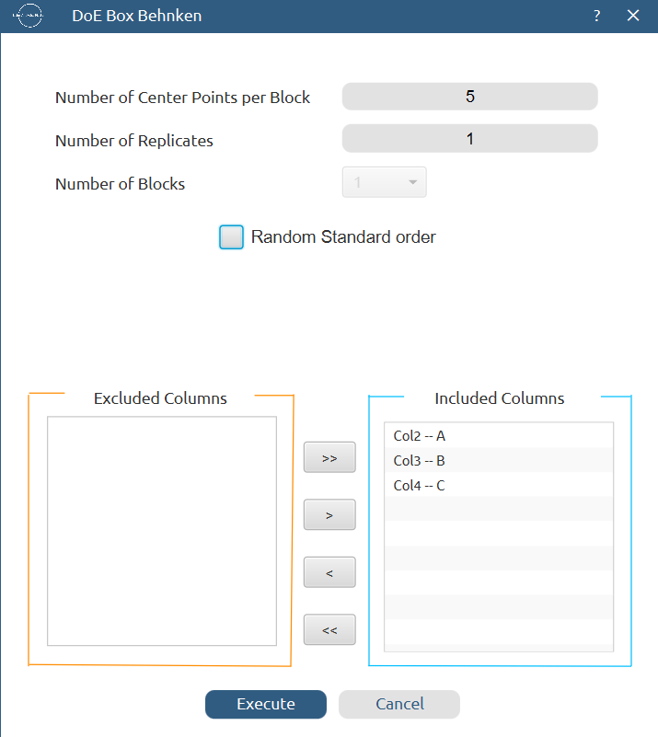

Results (right spreadsheet):
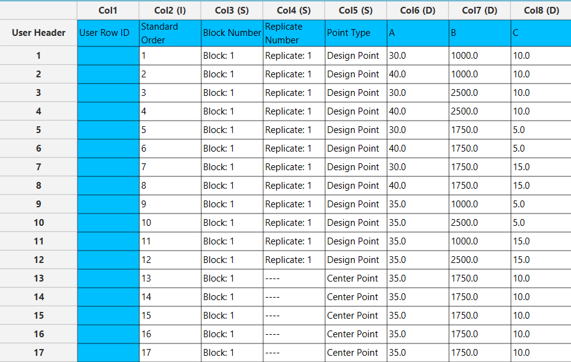

Step 2: Factor isolation
Create a new tab named “Factors” and import the results from the “Box Behnken” spreadsheet by right clicking on the left spreadsheet. Then, select only the factor columns to be transferred to the right spreadsheet: Data Transformation $→$ Data Manipulation $→$ Select Column(s)



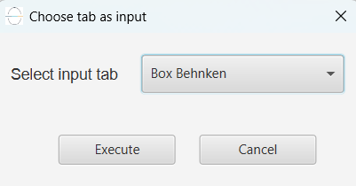

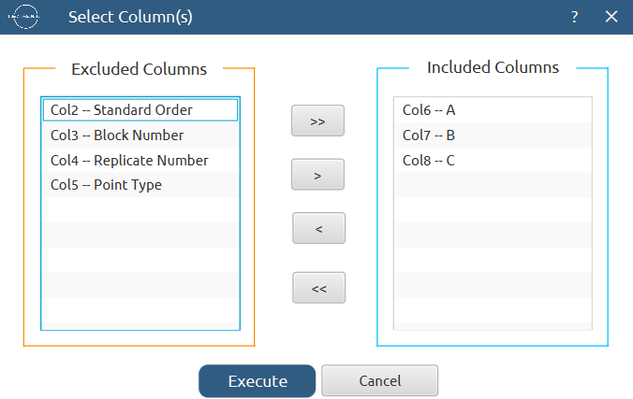

Results:
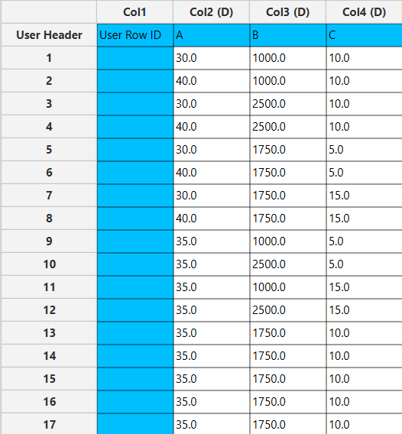

Step 3: Definition of response variables
Create a new tab named “Responses” and define the responses in the column headers. Fill each column with the values of the corresponding responses that were observed and make sure the values follow the order of the experiments as given by the Box Behnken design. Then, select all columns to be transferred to the right spreadsheet: Data Transformation $→$ Data Manipulation $→$ Select Column(s)

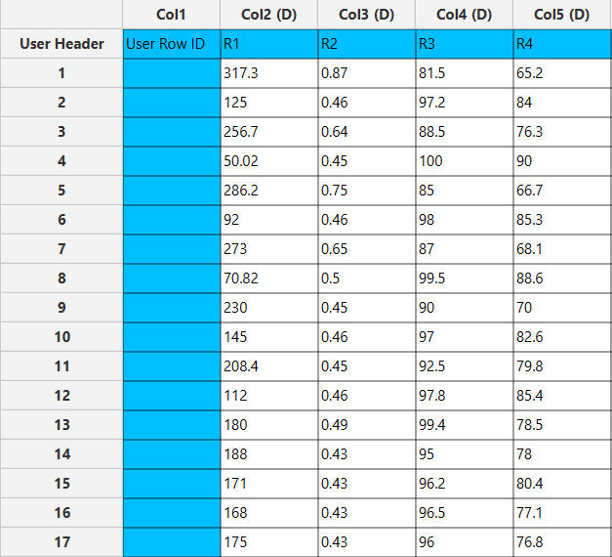

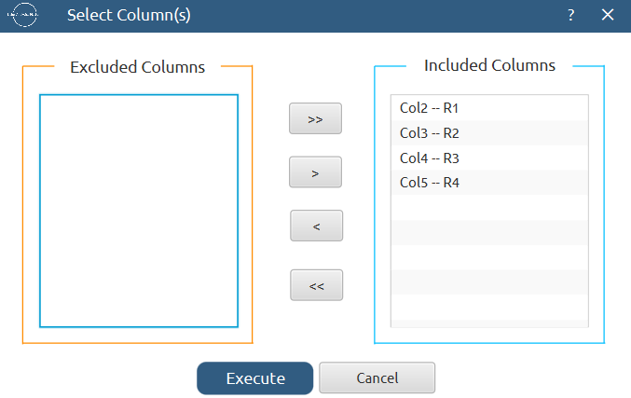

Step 4: Normalization
Create a new tab named “Normalized data” and import the results from the “Factors” and “Responses” spreadsheets. Afterwards, normalize the factor columns to take values in the range [-1, 1]: Data Transformation $→$ Normalizers $→$ Min-Max

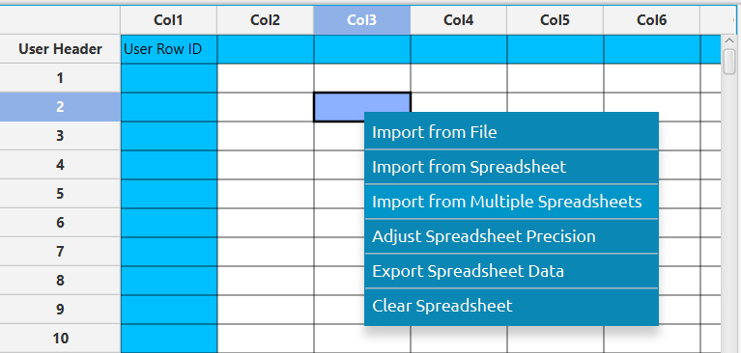

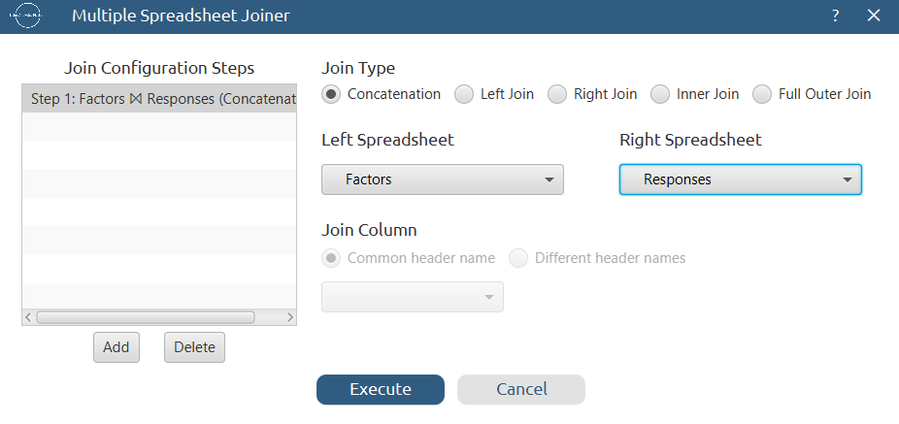

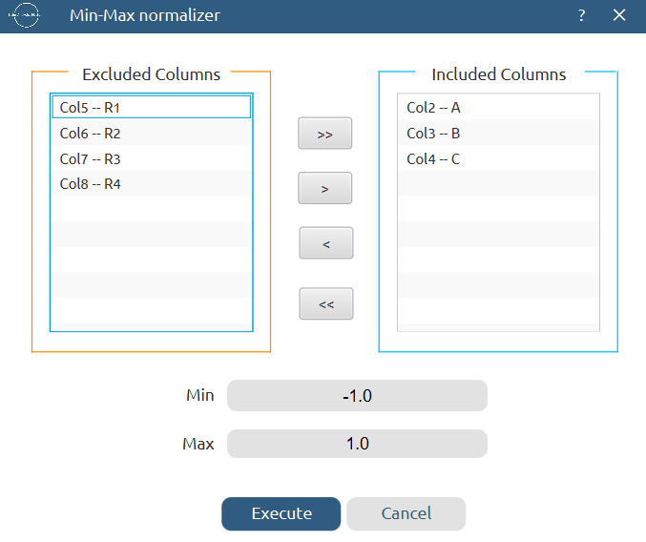
Results:
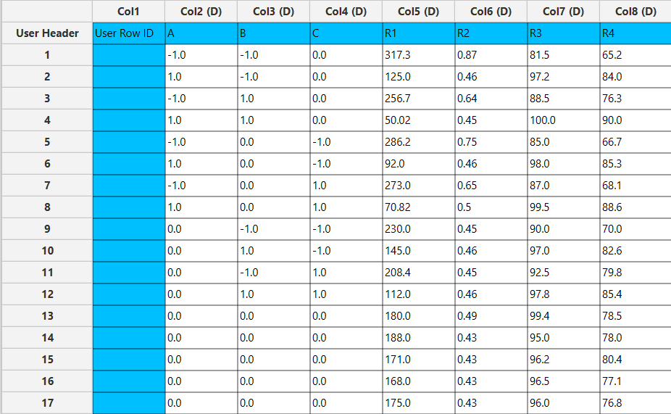

Step 5: Regression

The goal here is to produce a regression equation that includes main effects, two-factor interactions and quadratic effects for R₁:
$$R=b_{0}+b_{1}A+b_{2}B+b_{3}C+b_{4}AB+b_{5}AC+b_{6}BC+b_{7}A^{2}+b_{8}B^{2}+b_{9}C^{2}$$

Create a new tab named “Regression – R1” and import the results from the spreadsheet “Normalized data”. Afterwards, fit a generalized linear model to the data: Analytics $→$ Regression $→$ Statistical fitting $→$ Generalized Linear Models

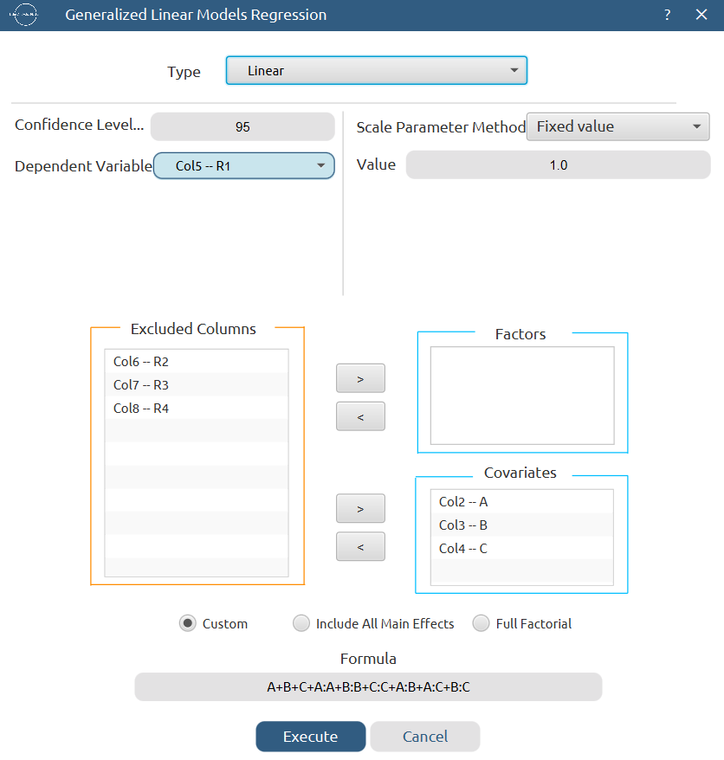

Results:
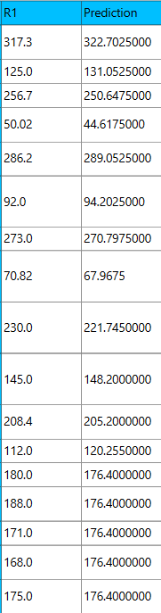
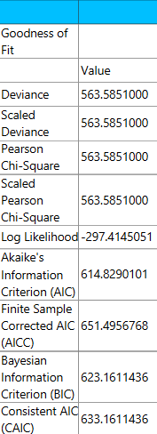

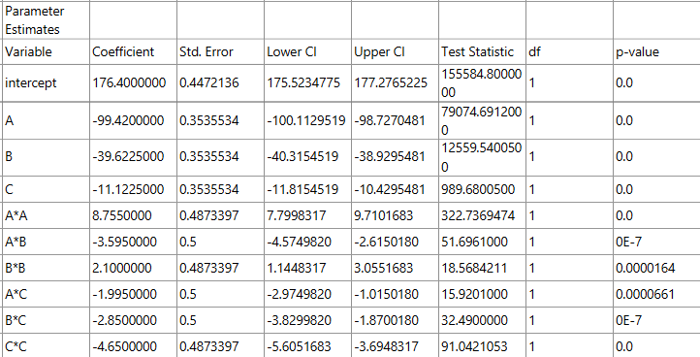

Repeat this step for the rest of the response variables. Results, R₂:

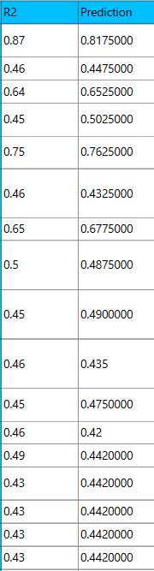
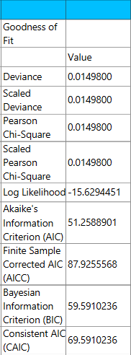

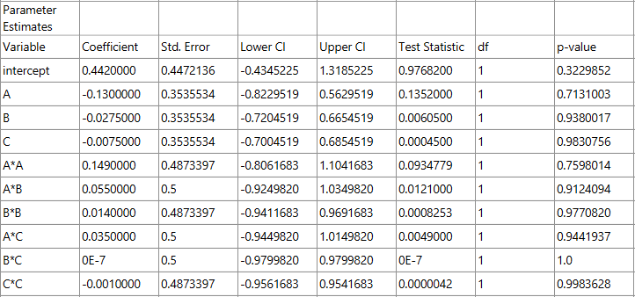

Results, R₃:

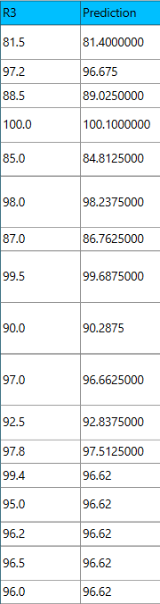
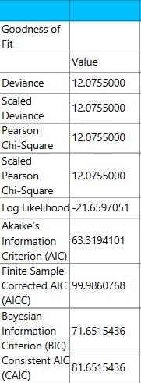

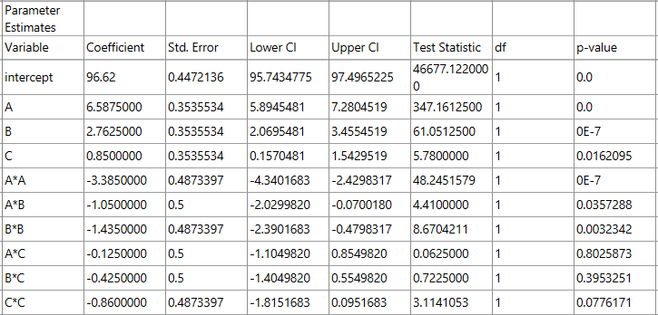

Results, R₄:

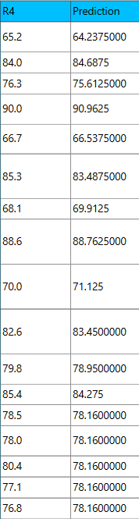
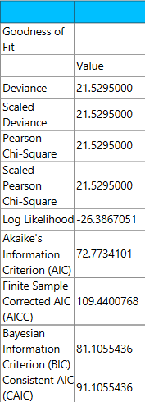

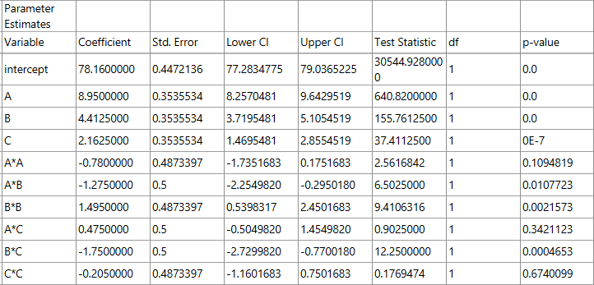

Step 6: Regression Metrics

Create a tab named “Metrics – R1” and import the results from the spreadsheet “Regression – R1”. Then, produce the regression metrics for the R₁ regression equation: Statistics $→$ Model Metrics $→$ Regression Metrics

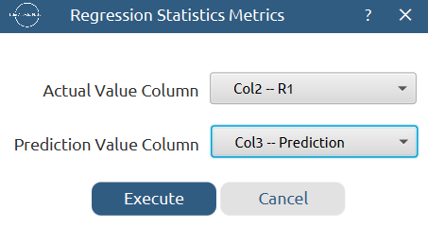

Results:
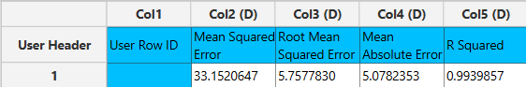

Repeat this step for the rest of the response variables. Results, R₂:
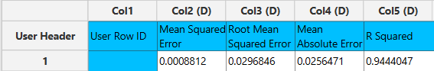

Results, R₃:
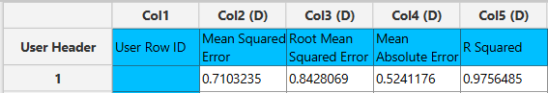

Results, R₄:
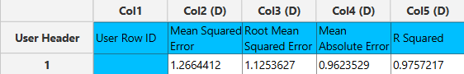

Step 7: Analysis of Covariance
Create a new tab named “ANCOVA – R1” and import the results from the spreadsheet “Normalized data”. Afterwards perform analysis of covariance for R₁: Statistics $→$ Analysis of (Co)Variance $→$ ANCOVA

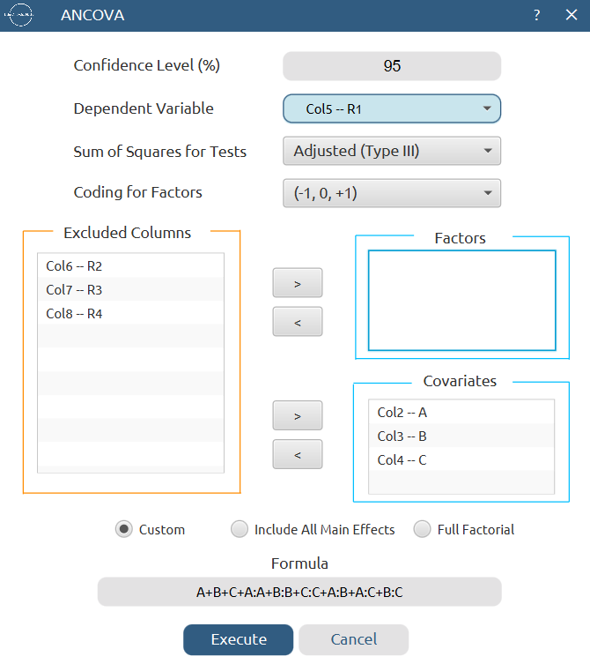

Results:
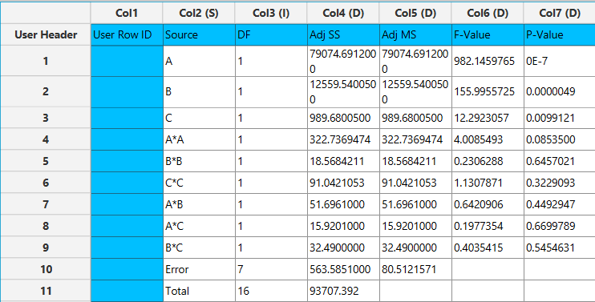

Repeat this step for the rest of the response variables. Results, R₂:
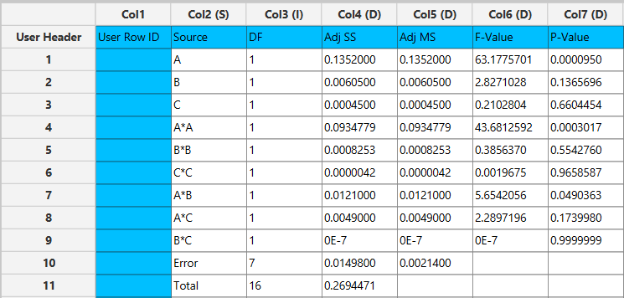

Results, R₃:
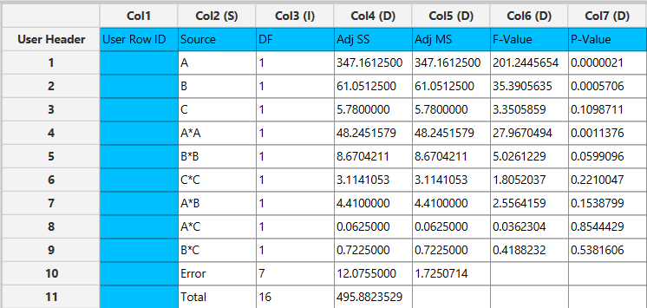

Results, R₄:
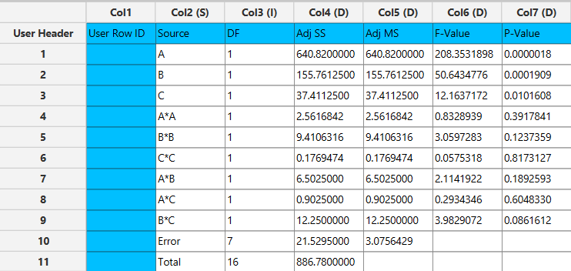

Final Isalos Workflow
The final workflow is presented below (doesn’t fully fit):
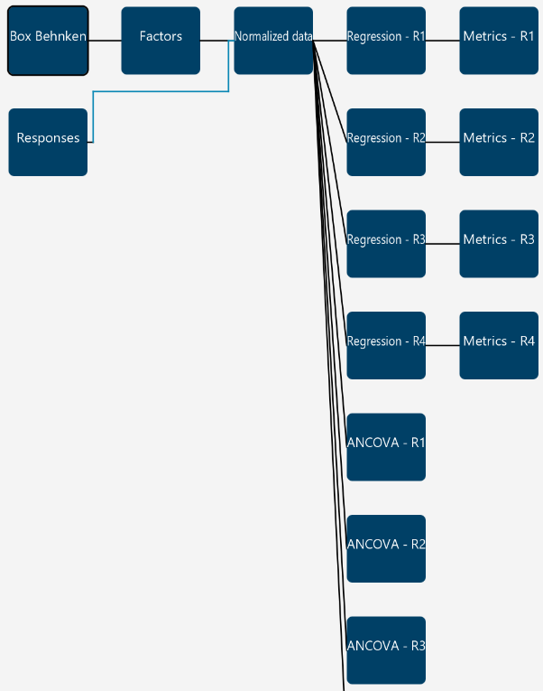

References
- Nagi, A.; Iqbal, B.; Kumar, S.; Sharma, S.; Ali, J.; Baboota, S. Quality by Design Based Silymarin Nanoemulsion for Enhancement of Oral Bioavailability. Journal of Drug Delivery Science and Technology 2017, 40, 35–44. https://doi.org/10.1016/j.jddst.2017.05.019.

