
Development and characterization of miltefosine-loaded polymeric micelles for cancer treatment

This research paper aims to develop a formulation of miltefosine-loaded polymeric micelles of the copolymer Pluronic-F127 to decrease the hemolytic potential of miltefosine. Design of experiments (DoE) methodology is implemented in order to evaluate the effect of the independent variables on the responses.
The factors (independent variables) examined are: X₁ = hydration temperature (ºC), X₂ = stirring speed (rpm) and X₃ = stirring time (min). All the factors are continuous. The response (dependent variable) examined is: Y₁ = polydispersity index. The applied DoE method is 2³ full factorial design.
Isalos version used: 2.0.6
Scientific article: https://www.sciencedirect.com/science/article/pii/S0928493117320921

Step 1: Full Factorial Design
In the first tab named “Action” define the factors in the column headers and fill each column with the low and high levels of the corresponding factors. This tab can be renamed “Full Factorial”. Afterwards, apply the full factorial method: DOE $→$ Factorial $→$ Full Factorial

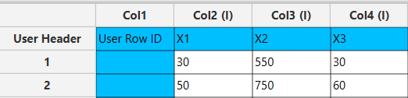

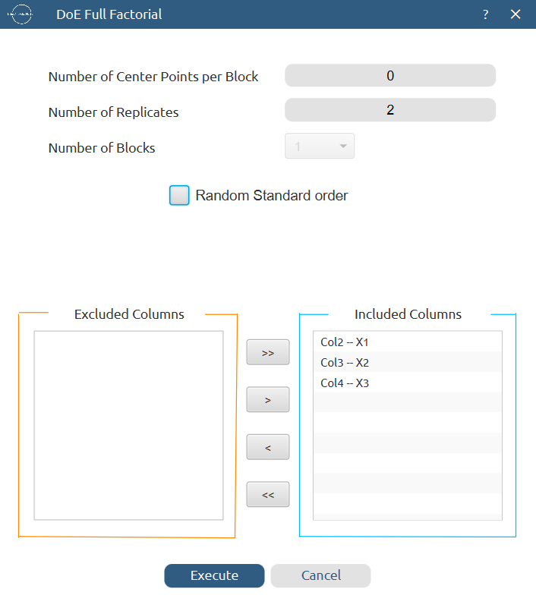

Results (right spreadsheet):
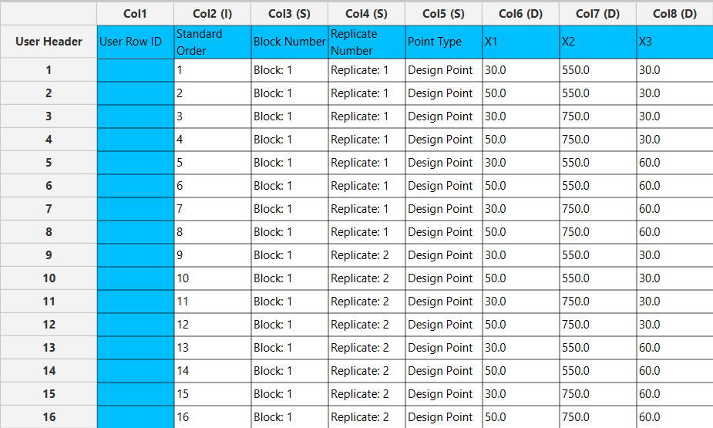

Step 2: Definition of response variables
Create a new tab named “Responses” and define the response in the column headers. Fill a column with the values of the response variable that were observed and make sure the values follow the order of the experiments as given by the full factorial method. Then, select the column to be transferred to the right spreadsheet: Data Transformation $→$ Data Manipulation $→$ Select Column(s)

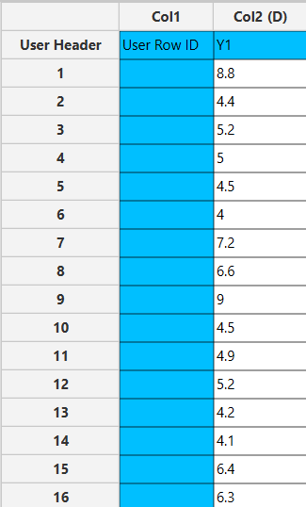

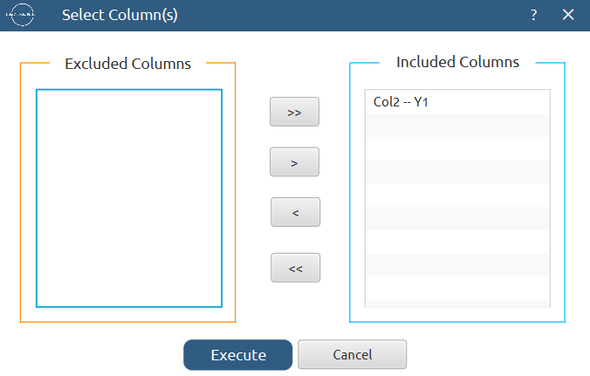

Step 3: Data isolation
Create a new tab named “Data” and import the results from the “Full Factorial” and “Responses” spreadsheets by right clicking on the left spreadsheet. Then, select only the factors and response columns to be transferred to the right spreadsheet: Data Transformation $→$ Data Manipulation $→$ Select Column(s)

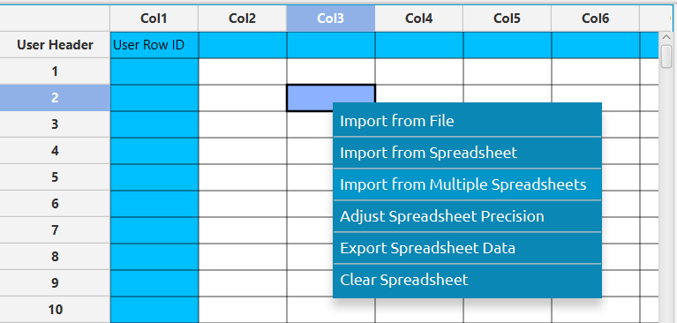

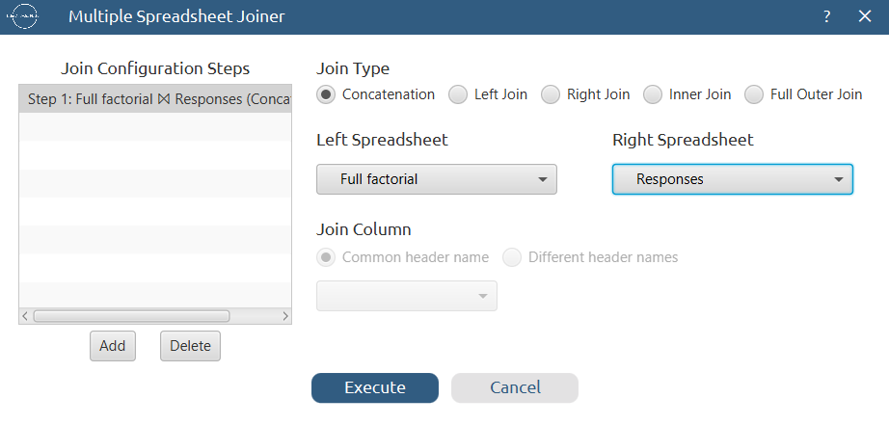

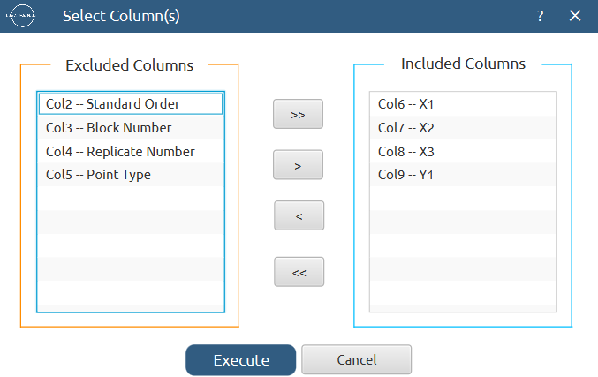

Results:
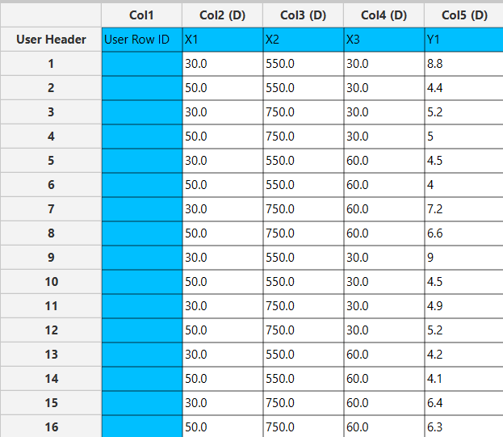

Step 4: Normalization
Create a new tab named “Normalized data” and import the results from the “Data” spreadsheet. Afterwards, normalize the factor columns to take values in the range [-1, 1]: Data Transformation $→$ Normalizers $→$ Min-Max


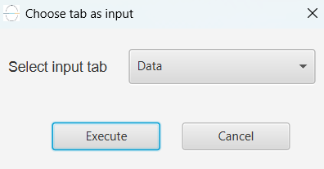

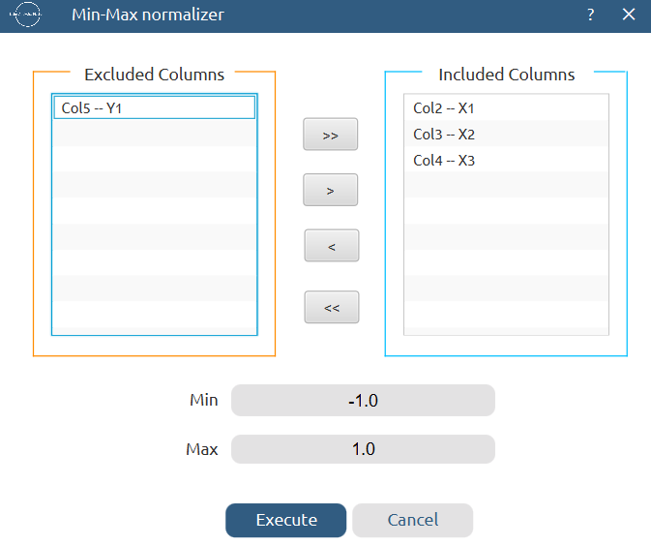

Results:
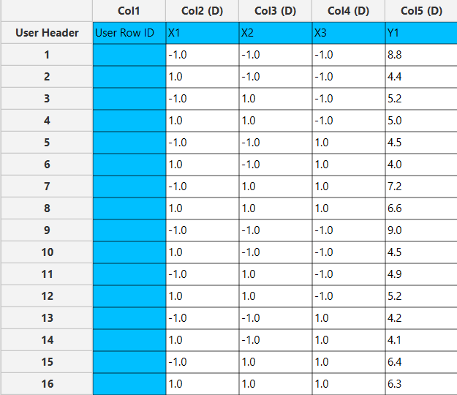

Step 5: Regression
The goal here is to produce a regression equation that includes main effects, two-factor interactions and quadratic effects for Y₁: $Y=b_{0}+b_{1}X_{1}+b_{2}X_{2}+b_{12}X_{1}X_{2}+b_{11}{X_{1}}^{2}+b_{22}{X_{2}}^{2}$
Create a new tab named “Regression – Y1” and import the results from the spreadsheet “Normalized data”. Afterwards, fit a generalized linear model to the data: Analytics $→$ Regression $→$ Statistical fitting $→$ Generalized Linear Models

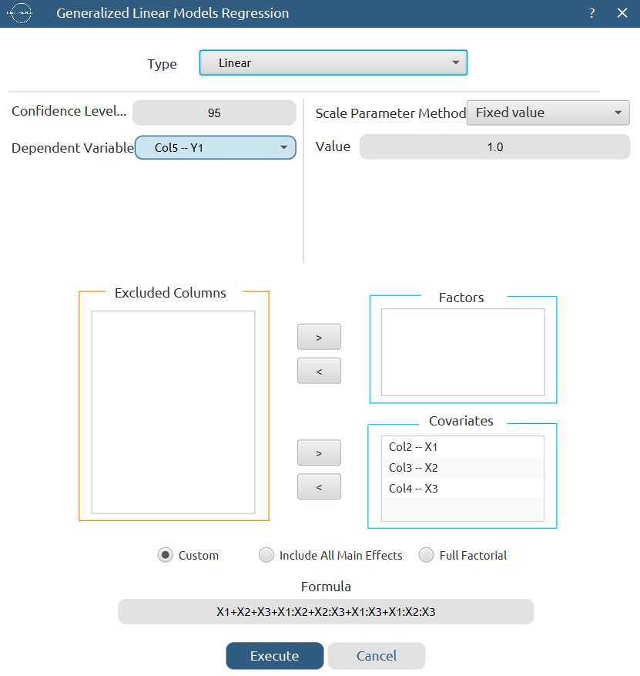

Results:

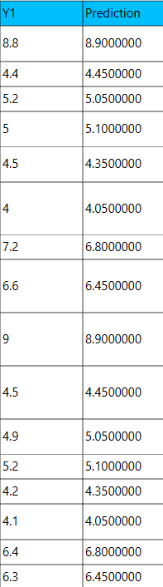
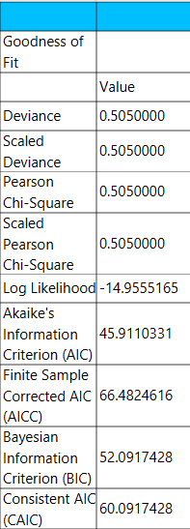

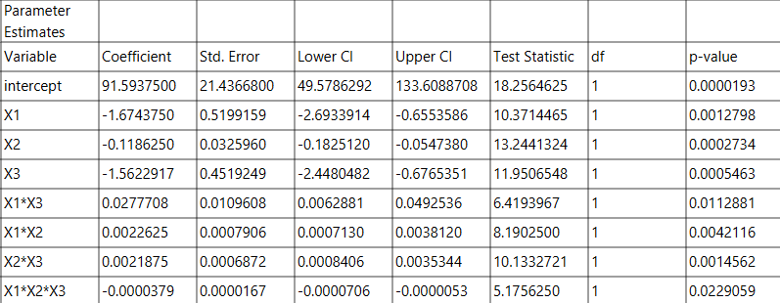

Step 6: Regression Metrics
Create a tab named “Metrics – Y1” and import the results from the spreadsheet “Regression – Y1”. Then, produce the regression metrics for the Y₁ regression equation: Statistics $→$ Model Metrics $→$ Regression Metrics

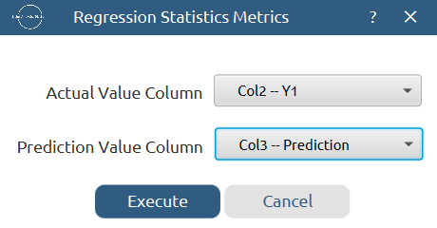

Results:
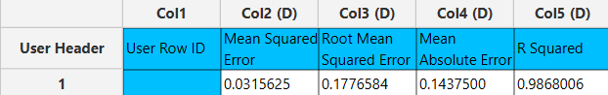

Step 7: Analysis of Covariance
Create a new tab named “ANCOVA – Y1” and import the results from the spreadsheet “Normalized data”. Afterwards perform analysis of covariance for Y₁: Statistics $→$ Analysis of (Co)Variance $→$ ANCOVA
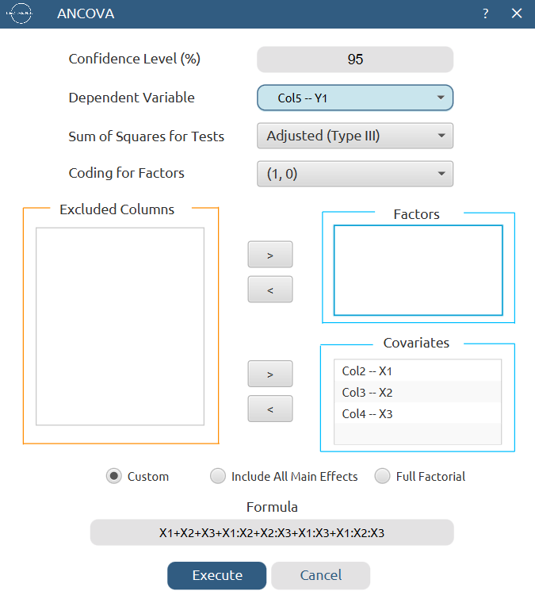

Results:
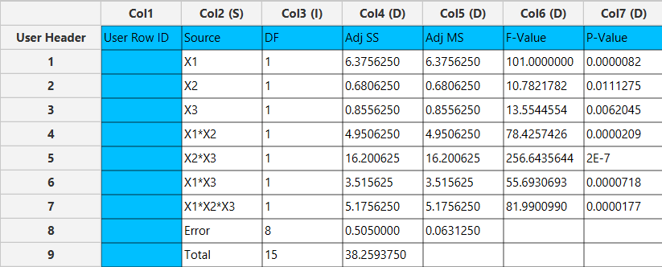

References
- Valenzuela-Oses, J. K.; García, M. C.; Feitosa, V. A.; Pachioni-Vasconcelos, J. A.; Gomes-Filho, S. M.; Lourenço, F. R.; Cerize, N. N. P.; Bassères, D. S.; Rangel-Yagui, C. O. Development and Characterization of Miltefosine-Loaded Polymeric Micelles for Cancer Treatment. Materials Science and Engineering: C 2017, 81, 327–333. https://doi.org/10.1016/j.msec.2017.07.040.

