
Self-assembled liquid crystalline nanoparticles as an ophthalmic drug delivery system. Part I: influence of process parameters on their preparation studied by experimental design

This research paper aims to develop and optimize self-assembled liquid crystalline nanoparticles as a drug delivery system for keratoconus treatment. Design of experiments (DoE) methodology is implemented to estimate the main effects and interaction effects of process parameters on the examined responses.
The factors (independent variables) examined are: X₁ = homogenization heating temperature (ºC), X₂ = duration of emulsification (min), X₃ = homogenization heating (without/with), X₄ = number of cycles and X₅ = pressure (bar). All the factors are continuous except X₃, which is categorical. The responses (dependent variables) examined are: Y₁ = particle size (nm) and Y₂ = encapsulation efficiency (%). The applied DoE method is fractional factorial design with a resolution of V.
Isalos version used: 2.0.6
Scientific article: https://www.tandfonline.com/doi/abs/10.3109/03639045.2014.884113

Step 1: Fractional Factorial Design
In the first tab named “Action” define the factors in the column headers and fill each column with the low and high levels of the corresponding factors. This tab can be renamed “Fractional Factorial”. Afterwards, apply the fractional factorial method: DOE $→$ Screening $→$ Fractional Factorial

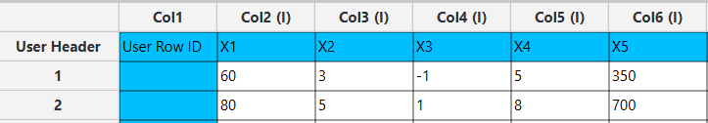

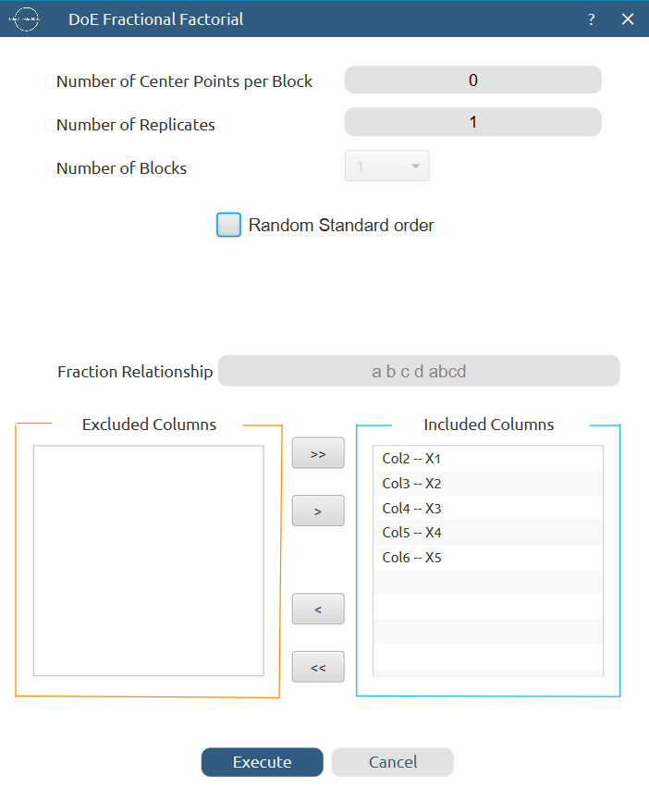

Results (right spreadsheet):
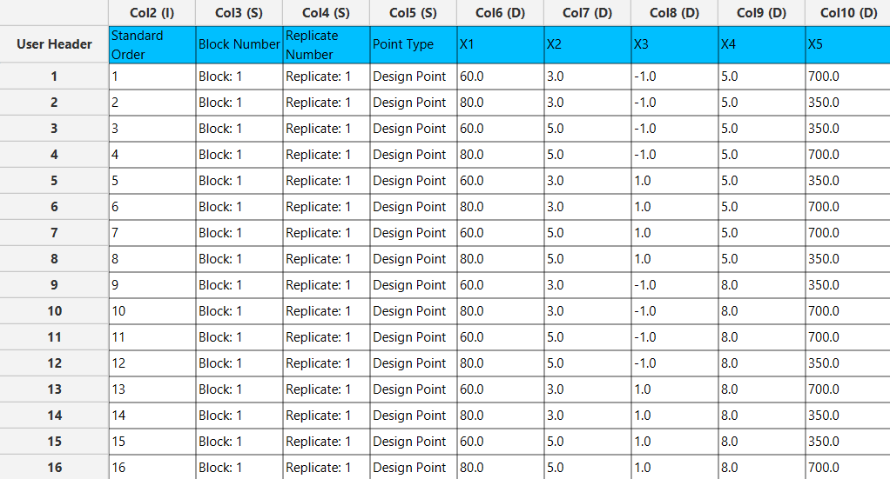

Step 2: Factor isolation
Create a new tab named “Factors” and import the results from the “Fractional Factorial” spreadsheet by right clicking on the left spreadsheet. Then, select only the factor columns to be transferred to the right spreadsheet: Data Transformation $→$ Data Manipulation $→$ Select Column(s)



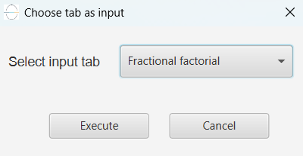

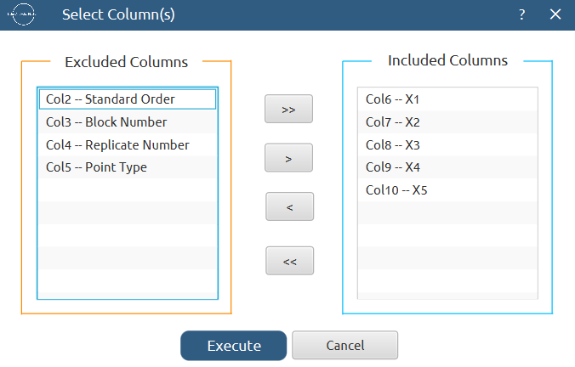
Results:
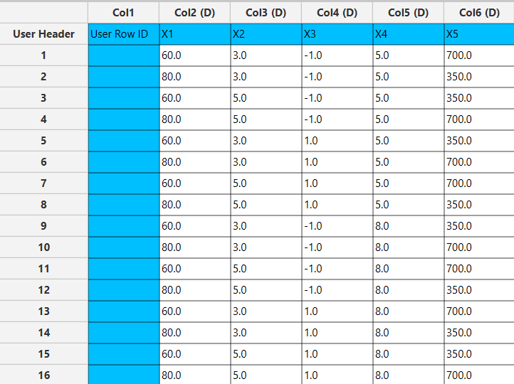

Step 3: Definition of response variables
Create a new tab named “Responses” and define the responses in the column headers. Fill each column with the values of the corresponding responses that were observed and make sure the values follow the order of the experiments as given by the fractional factorial design. Then, select all columns to be transferred to the right spreadsheet: Data Transformation $→$ Data Manipulation $→$ Select Column(s)

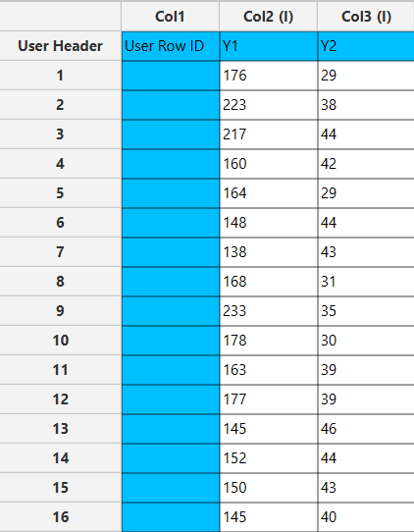

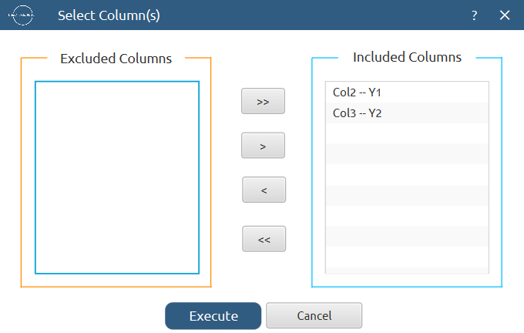

Step 4: Normalization
Create a new tab named “Normalized data” and import the results from the “Factors” and “Responses” spreadsheets. Afterwards, normalize the factor columns to take values in the range [-1, 1]: Data Transformation $→$ Normalizers $→$ Min-Max

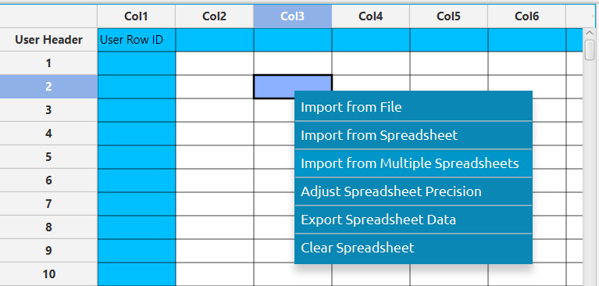

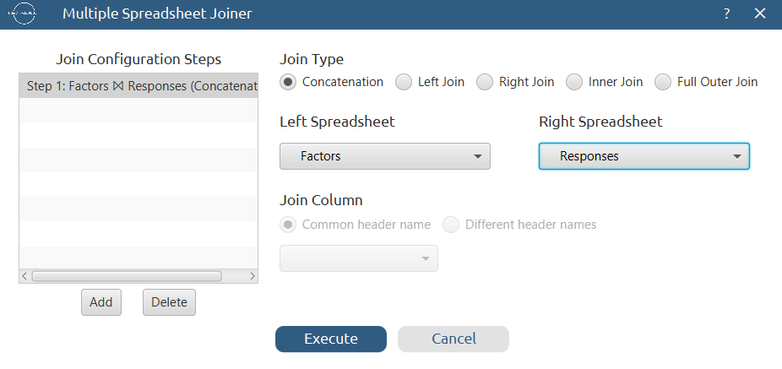

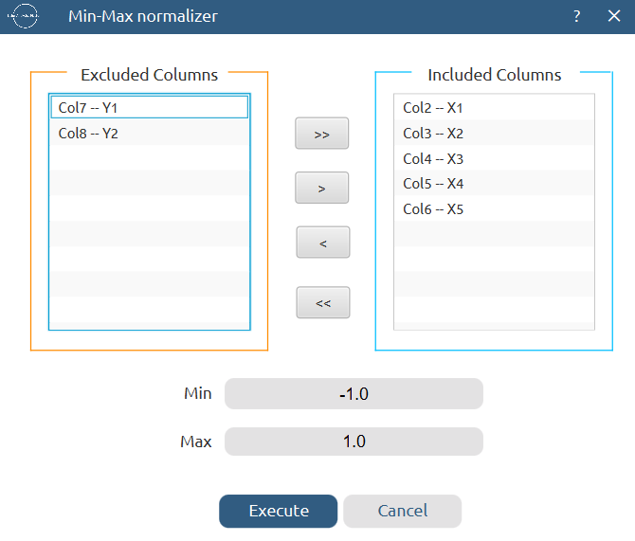
Results:
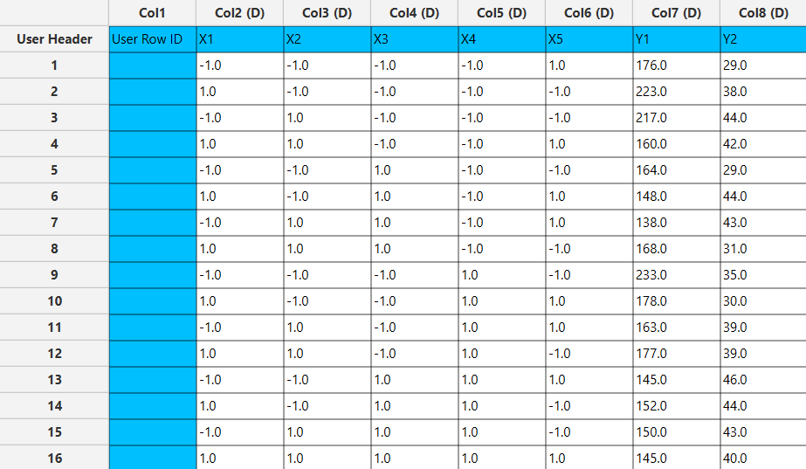

Step 5: Regression
The goal here is to produce a regression equation that includes main effects and two-factor interactions for Y₁:
$$Y=b_{0}+b_{1}X_{1}+b_{2}X_{2}+b_{3}X_{3}+b_{4}X_{4}+b_{5}X_{5}+b_{12}X_{1}X_{2}+b_{13}X_{1}X_{3}+b_{14}X_{1}X_{4}+b_{15}X_{1}X_{5}+b_{23}X_{2}X_{3}+b_{24}X_{2}X_{4}+b_{25}X_{2}X_{5}+b_{34}X_{3}X_{4}+b_{35}X_{3}X_{5}+b_{45}X_{4}X_{5}$$
Create a new tab named “Regression – Y1” and import the results from the spreadsheet “Normalized data”. Afterwards, fit a generalized linear model to the data: Analytics $→$ Regression $→$ Statistical fitting $→$ Generalized Linear Models

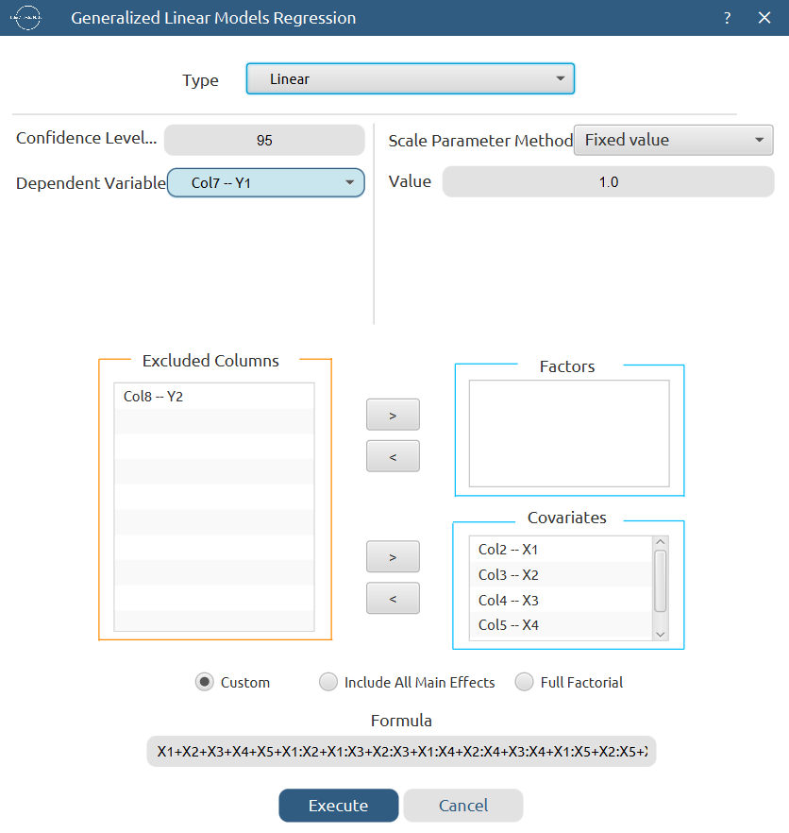

Results:

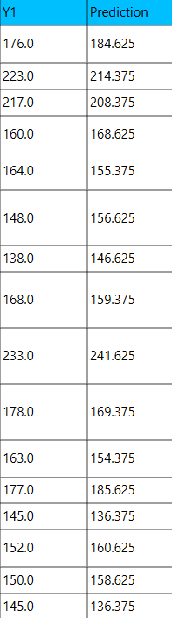
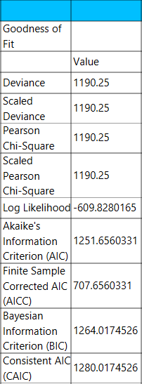

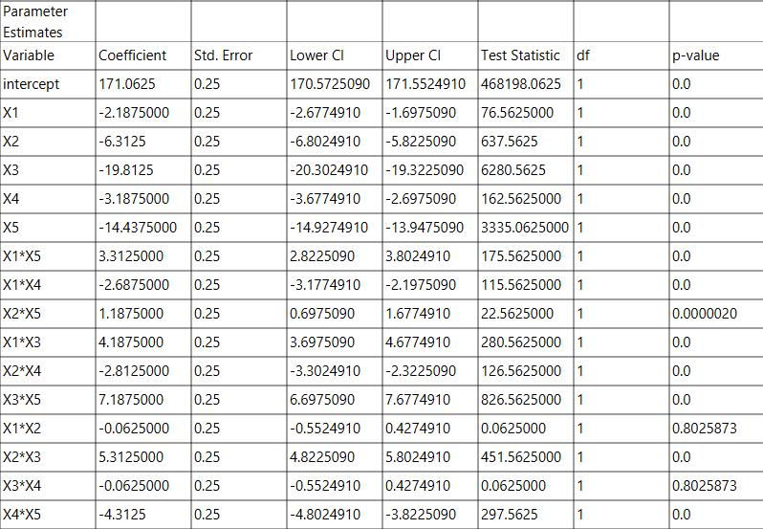

Repeat this step for the second response variable, Y₂. Results:

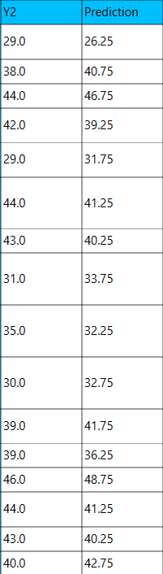
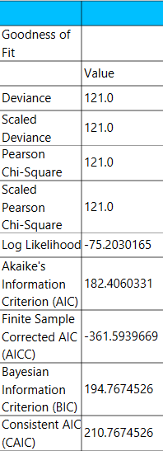

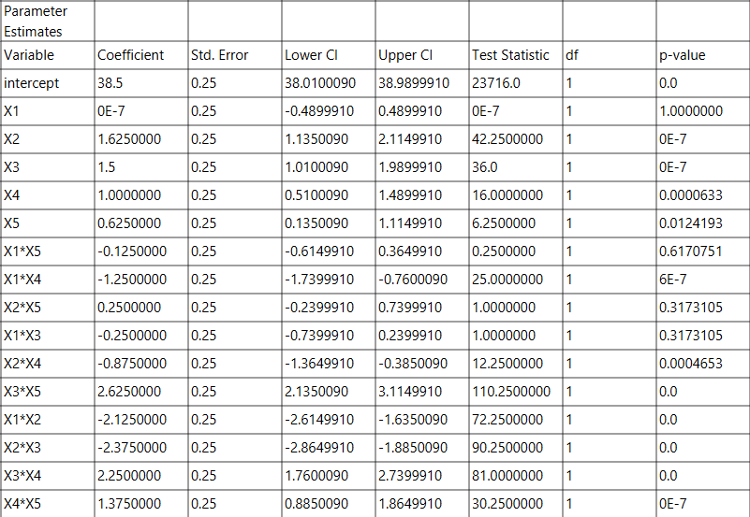

Step 6: Regression Metrics
Create a tab named “Metrics – Y1” and import the results from the spreadsheet “Regression – Y1”. Then, produce the regression metrics for the Y₁ regression equation: Statistics $→$ Model Metrics $→$ Regression Metrics

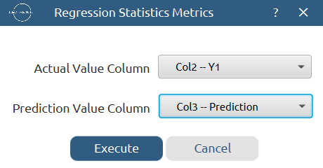

Results:
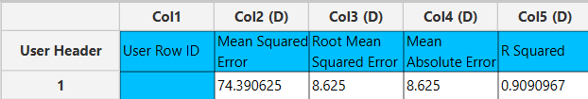

Repeat this step for the second response variable, Y₂. Results:
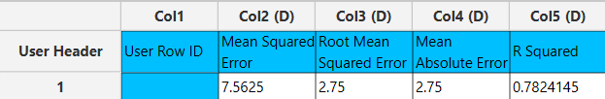

Step 7: Analysis of Covariance
Create a new tab named “ANCOVA – Y1” and import the results from the spreadsheet “Normalized data”. Afterwards perform analysis of covariance for Y₁: Statistics $→$ Analysis of (Co)Variance $→$ ANCOVA

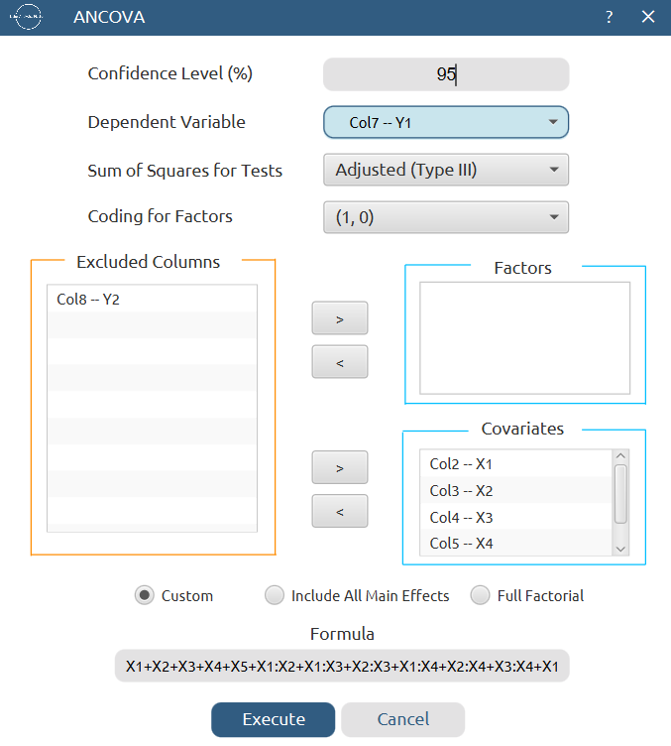

Results:
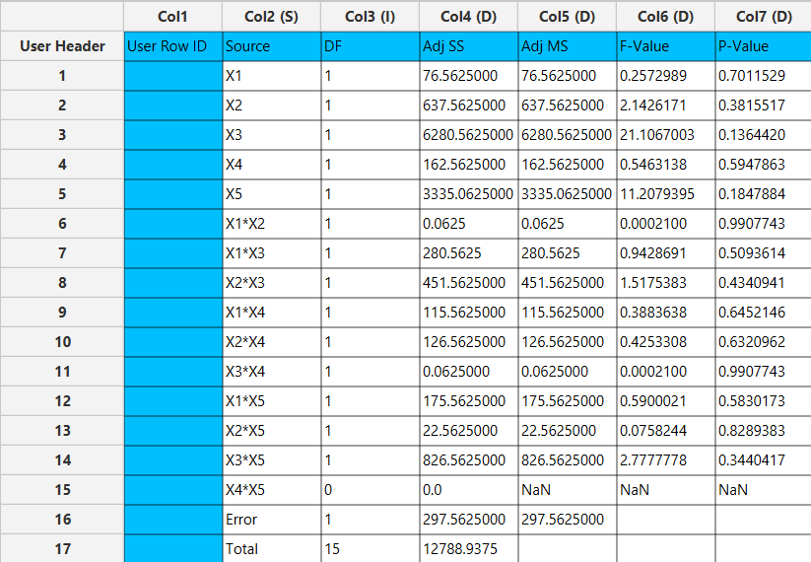
Repeat this step for the second response variable, Y₂. Results:
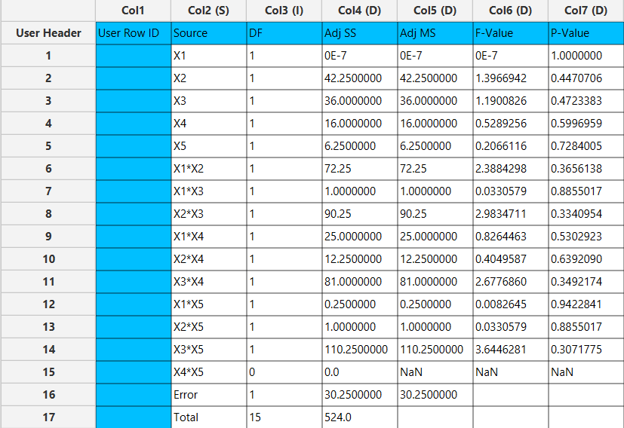

Step 8: Coefficient plots
Create a new tab named “Coefficient plots”. Copy and paste the regression coefficients from the spreadsheets “Regression – Y1” and “Regression – Y2” on the left spreadsheet. Afterwards, produce one bar chart for each response’s coefficients: Business Intelligence $→$ Create New Dashboard $→$ Add Plot $→$ Comparison Charts $→$ Add Bar Chart
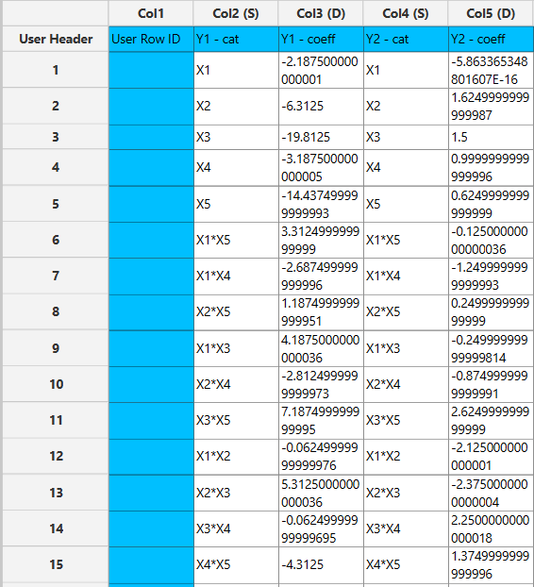
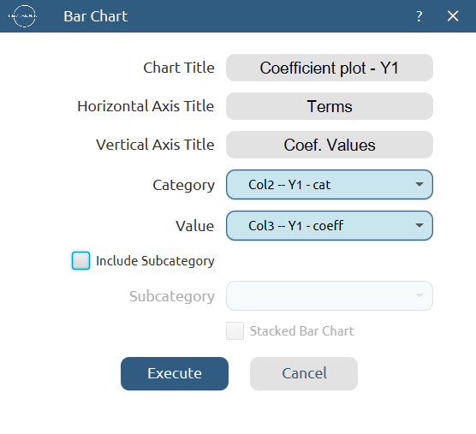

Results Y₁, Y₂:
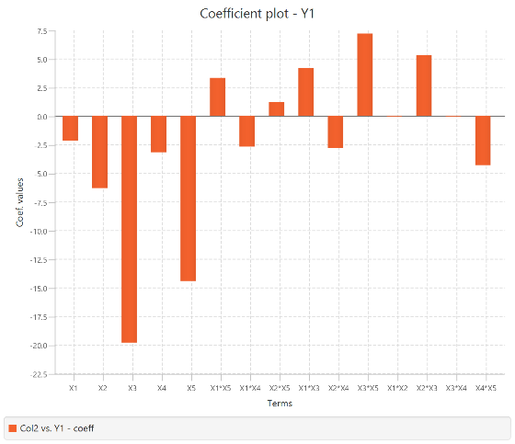
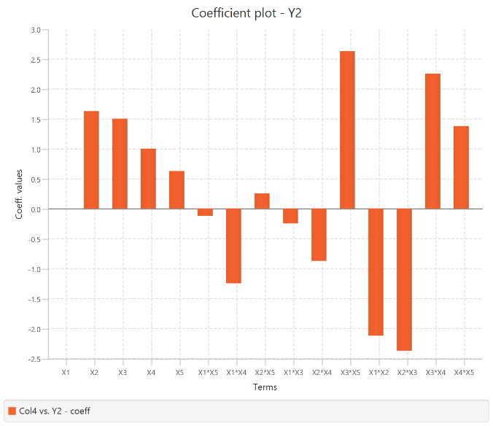

Final Isalos Workflow
The final workflow is presented below:
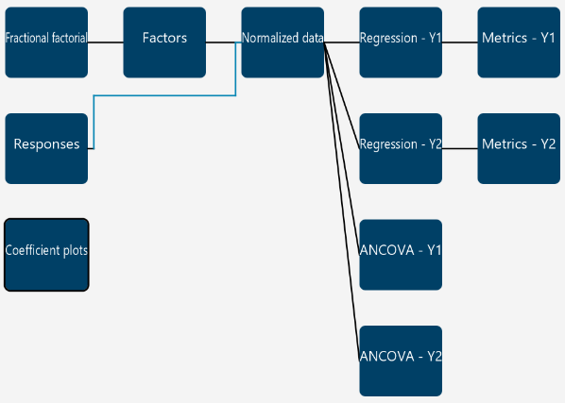

References
- Achouri, D.; Hornebecq, V.; Piccerelle, P.; Andrieu, V.; Sergent, M. Self-Assembled Liquid Crystalline Nanoparticles as an Ophthalmic Drug Delivery System. Part I: Influence of Process Parameters on Their Preparation Studied by Experimental Design. Drug Development and Industrial Pharmacy 2015, 41 (1), 109–115. https://doi.org/10.3109/03639045.2013.850707.

