
Development and evaluation of metronidazole loaded microsponge based gel for superficial surgical wound infections

The purpose of this research paper is to optimize, characterize and develop a microsponge drug delivery system for topical delivery. Design of experiments (DoE) methodology is implemented for the statistical optimization process.
The factors (independent variables) examined are: X₁ = amount of dichloromethane (mL), X₂ = amount of xanthan gum (% w/v) and X₃ = amount of sodium chloride (% w/v). All the factors are continuous. The responses (dependent variables) examined are: Y₁ = drug entrapment efficiency (%), Y₂ = particle size (μm) and Y₃ = cumulative permeability drug release at 8 h (%). The applied DoE method is Box Behnken design.
Isalos version used: 2.0.6
Scientific article: https://www.sciencedirect.com/science/article/abs/pii/S1773224715300162

Step 1: Box Behnken Design
In the first tab named “Action” define the factors in the column headers and fill each column with the low and high levels of the corresponding factors. This tab can be renamed “Box Behnken”. Afterwards, apply the Box Behnken method: DOE $→$ Response Surface $→$ Box Behnken

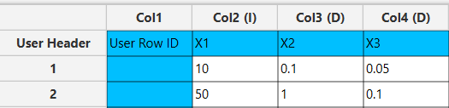

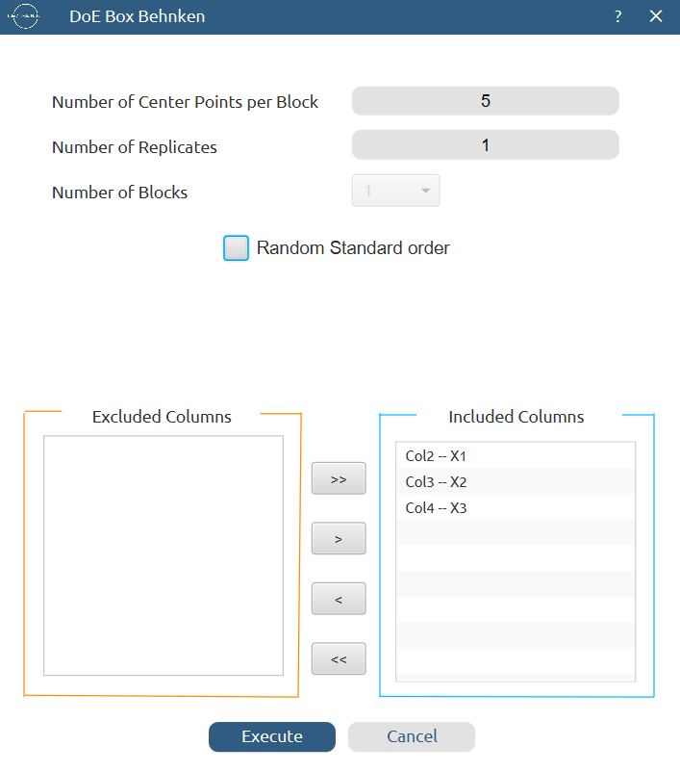

Results (right spreadsheet):
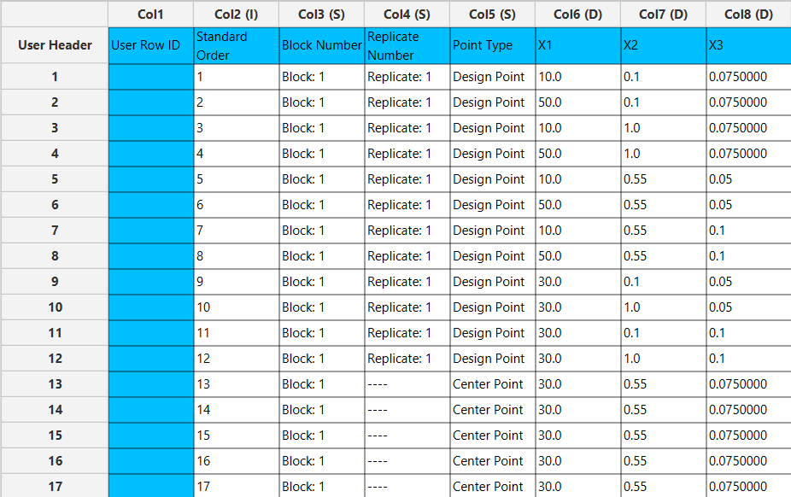

Step 2: Factor isolation
Create a new tab named “Factors” and import the results from the “Box Behnken” spreadsheet by right clicking on the left spreadsheet. Then, select only the factor columns to be transferred to the right spreadsheet: Data Transformation $→$ Data Manipulation $→$ Select Column(s)



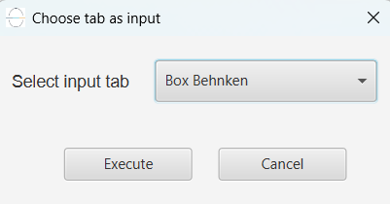

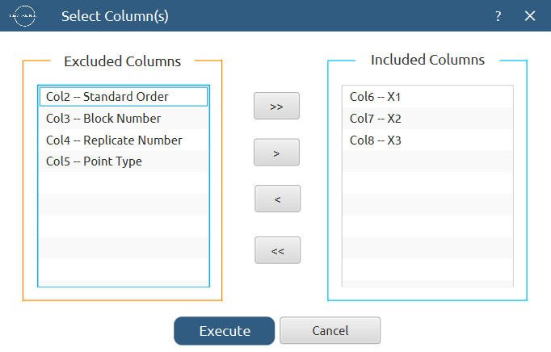
Results:
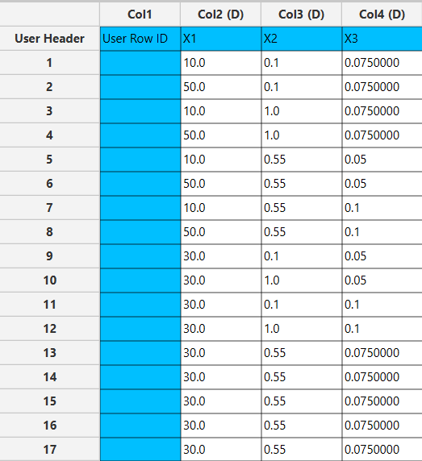

Step 3: Definition of response variables
Create a new tab named “Responses” and define the responses in the column headers. Fill each column with the values of the corresponding responses that were observed and make sure the values follow the order of the experiments as given by the Box Behnken design. Then, select all columns to be transferred to the right spreadsheet: Data Transformation $→$ Data Manipulation $→$ Select Column(s)

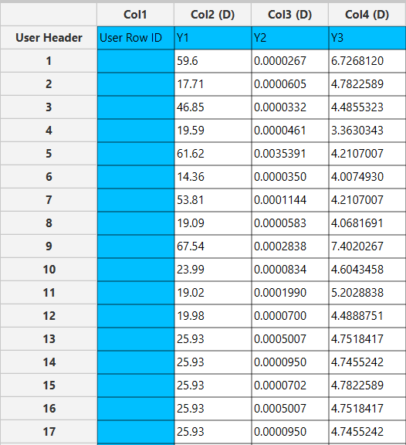

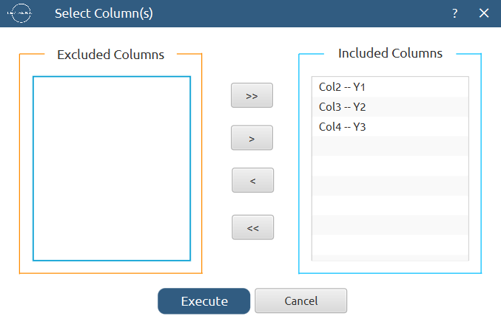

Step 4: Normalization
Create a new tab named “Normalized data” and import the results from the “Factors” and “Responses” spreadsheets. Afterwards, normalize the factor columns to take values in the range [-1, 1]: Data Transformation $→$ Normalizers $→$ Min-Max

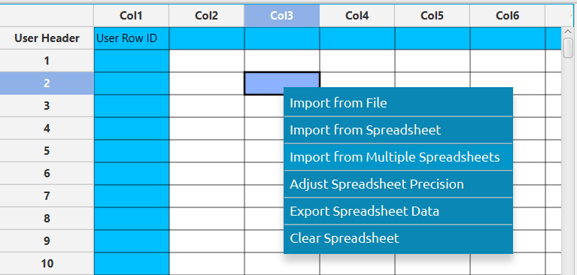

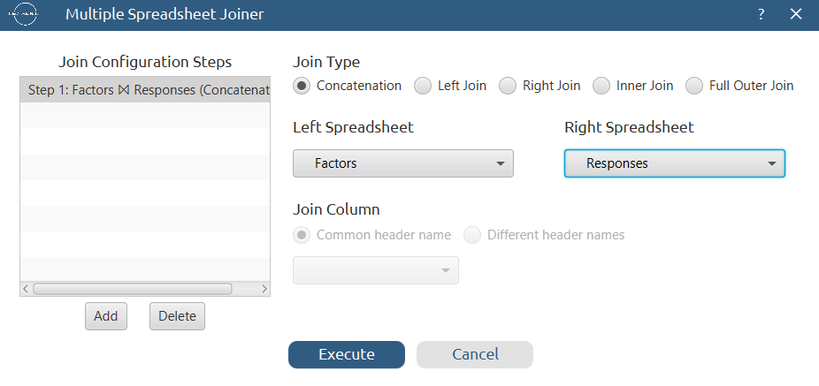

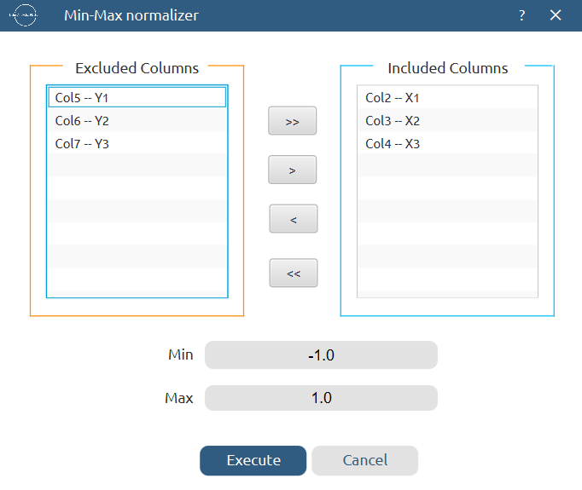
Results:
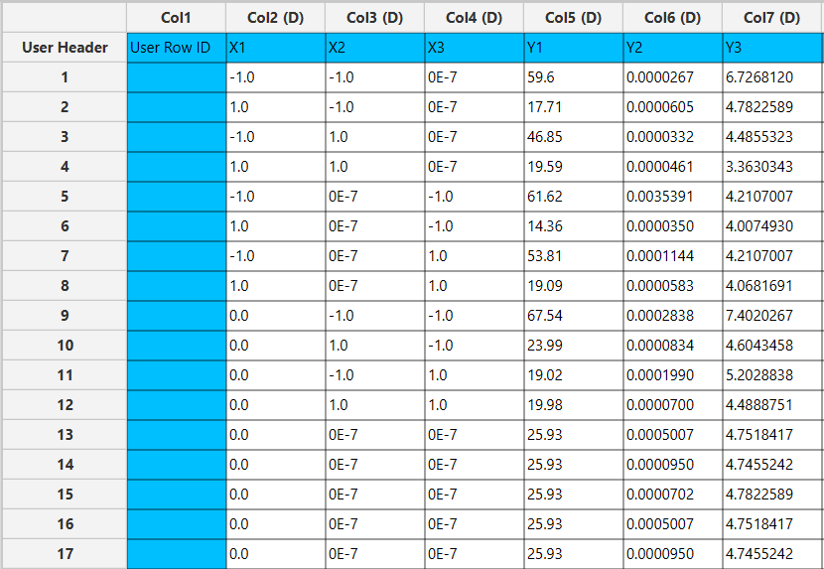

Step 5: Regression
The goal here is to produce a regression equation that includes main effects, two-factor interactions and quadratic effects for Y₁:
$$Y=b_{0}+b_{1}X_{1}+b_{2}X_{2}+b_{3}X_{3}+b_{12}X_{1}X_{2}+b_{13}X_{1}X_{3}+b_{23}X_{2}X_{3}+b_{11}{X_{1}}^{2}+b_{22}{X_{2}}^{2}+b_{33}{X_{3}}^{2}$$

Create a new tab named “Regression – Y1” and import the results from the spreadsheet “Normalized data”. Afterwards, fit a generalized linear model to the data: Analytics $→$ Regression $→$ Statistical fitting $→$ Generalized Linear Models

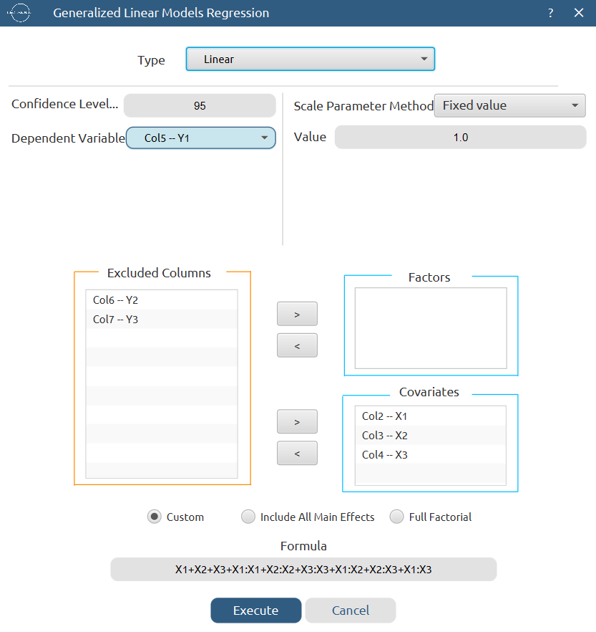

Results:

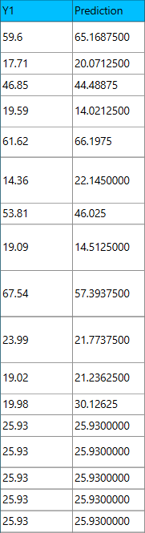
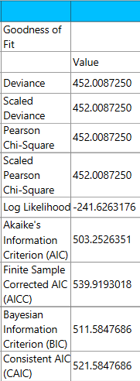

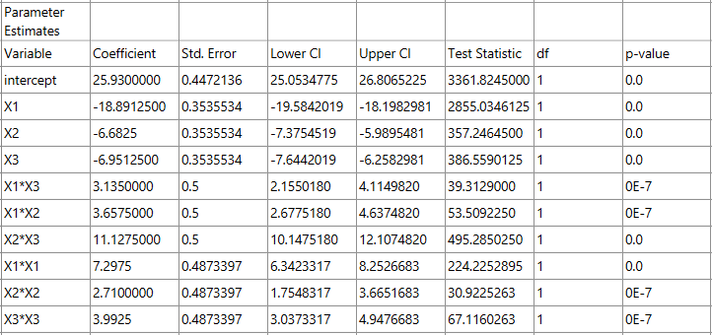

Repeat this step for the rest of the response variables. Results, Y₂:

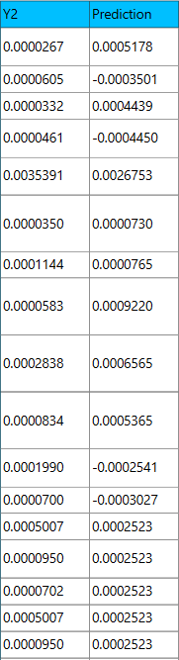
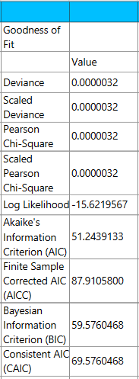

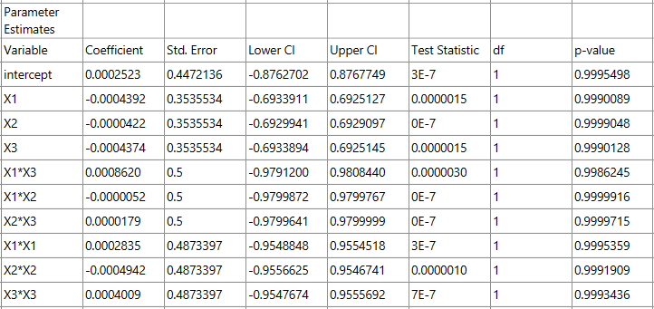

Results, Y₃:

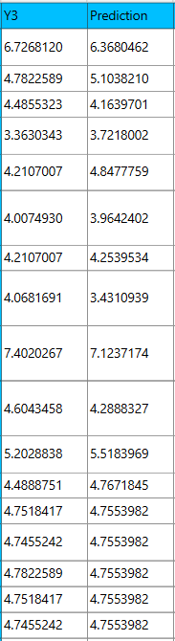
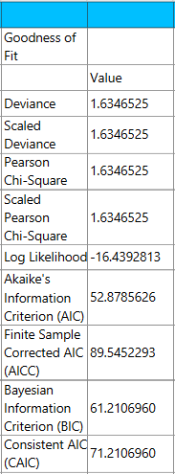

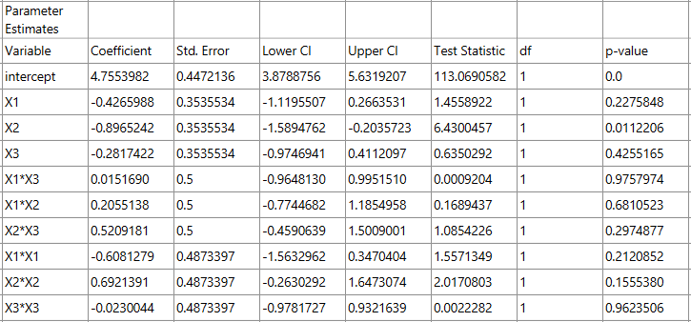

Step 6: Regression Metrics
Create a tab named “Metrics – Y1” and import the results from the spreadsheet “Regression – Y1”. Then, produce the regression metrics for the Y₁ regression equation: Statistics $→$ Model Metrics $→$ Regression Metrics

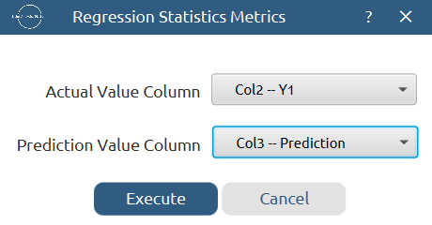

Results:
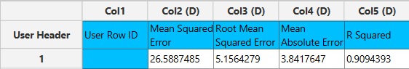

Repeat this step for the rest of the response variables. Results, Y₂:
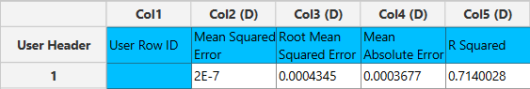

Results, Y₃:
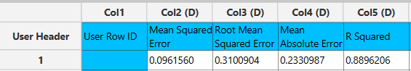

Step 7: Analysis of Covariance
Create a new tab named “ANCOVA – Y1” and import the results from the spreadsheet “Normalized data”. Afterwards perform analysis of covariance for Y₁: Statistics $→$ Analysis of (Co)Variance $→$ ANCOVA

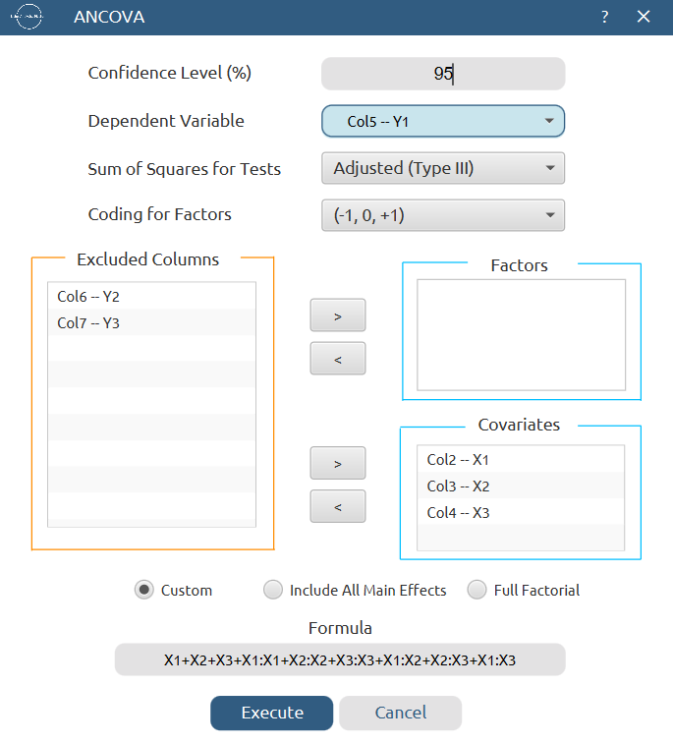

Results:
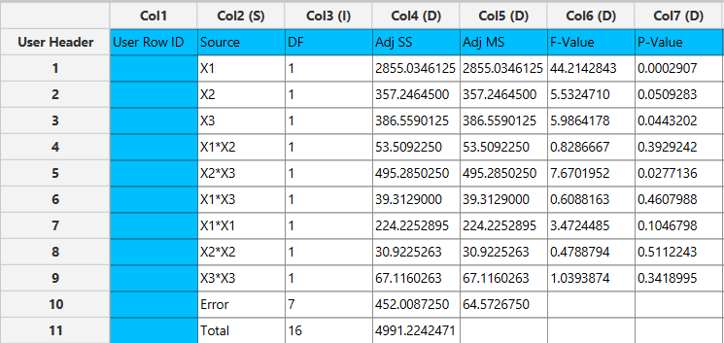

Repeat this step for the rest of the response variables. Results, Y₂:
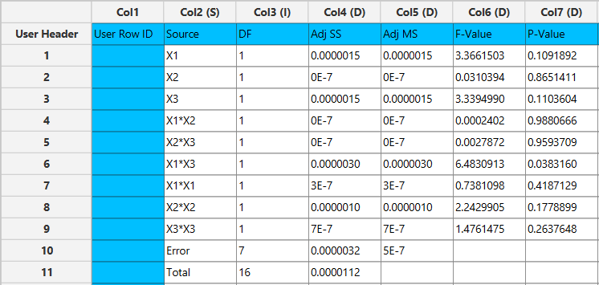

Results, Y₃:
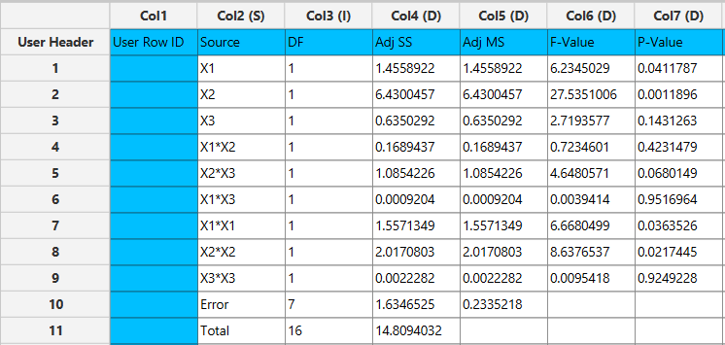

Final Isalos Workflow
The final workflow is presented below:
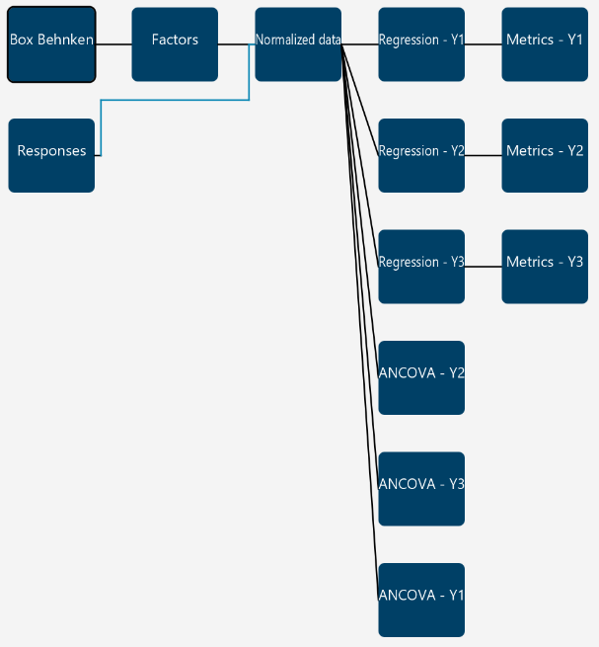

References
- Mahesh Kumar, P.; Ghosh, A. Development and Evaluation of Metronidazole Loaded Microsponge Based Gel for Superficial Surgical Wound Infections. Journal of Drug Delivery Science and Technology 2015, 30, 15–29. https://doi.org/10.1016/j.jddst.2015.09.006.

